个人页面信息模板
（1）中文内容

个人简介（可包含一张个人照片，横纵像素比为192:150）

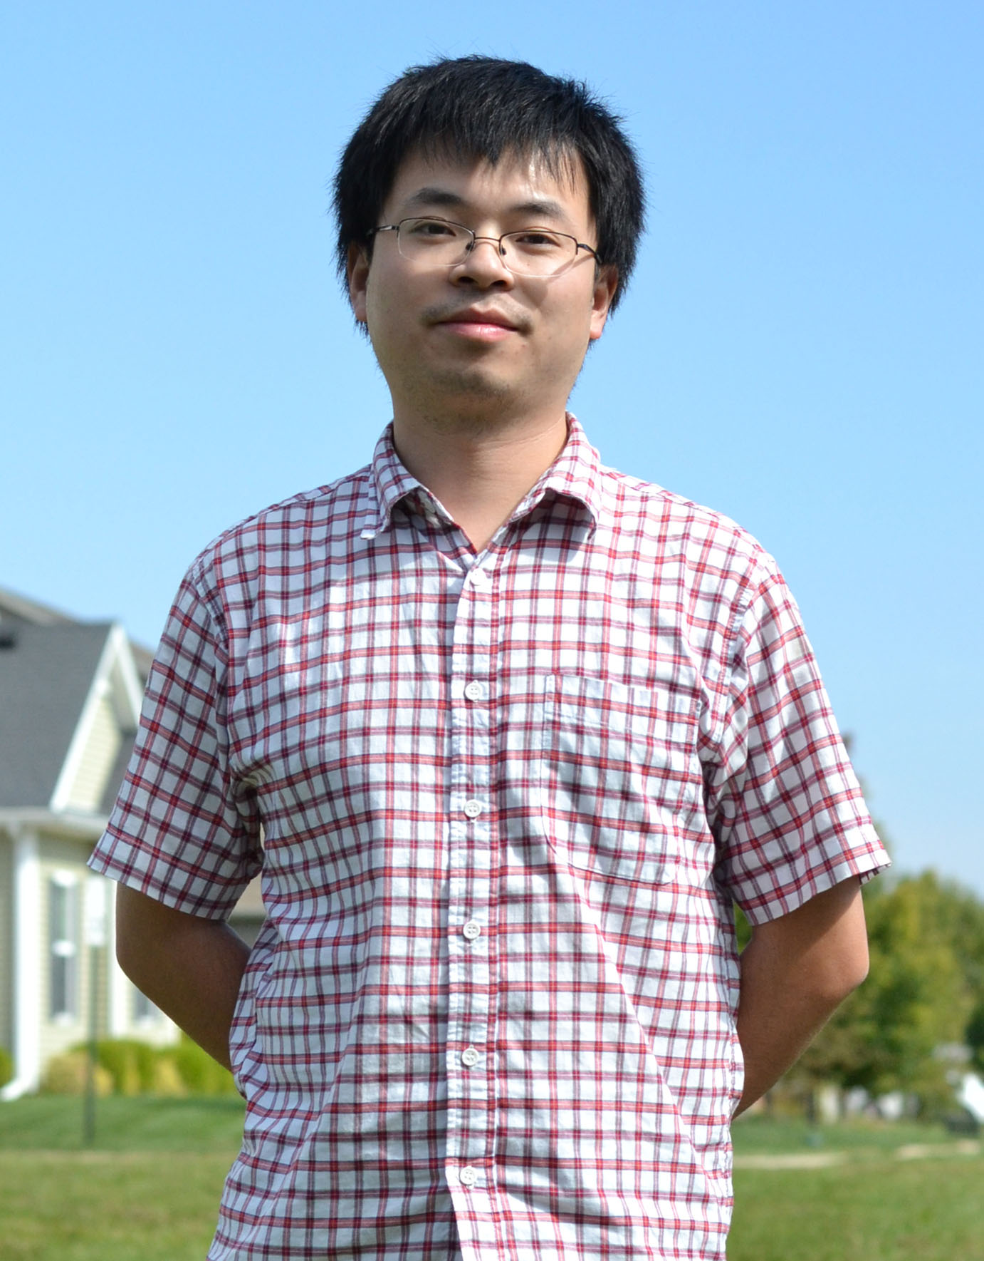

盛兴 助理教授，博士生导师

中国北京市清华大学电子工程系，罗姆楼710，100084

邮箱：xingsheng (at) tsinghua.edu.cn

实验室网站：https://shengxingstars.github.io/www/

课题组招收电子、光学、材料、物理等相关背景的博士生、博士后，也欢迎感兴趣的本科生加入实验室。

教育背景

2012年，麻省理工学院，博士
2007年，清华大学，工学学士

工作履历

2015年至今，清华大学 电子工程系，助理教授
2012年 – 2015年，美国伊利诺伊大学香槟分校，博士后研究员

研究领域

新型光电子材料与器件，及其在新能源、信息与生物医疗技术等领域的应用。

奖励与荣誉

2015年，国家青年千人计划

学术成果

代表性论文：

  - R. Fu, W. Luo, R. Nazempour, D. Tan, H. Ding, K. Zhang, L. Yin, J. Guan*, X. Sheng*, “Implantable and Biodegradable Poly(L-lactic acid) Fibers for Optical Neural Interfaces”, Advanced Optical Materials XX, 1700941 (2018).
  - L. Li, C. Liu, Y. Su, J. Bai, J. Wu, Y. Han, Y. Hou, S. Qi, Y. Zhao, H. Ding, Y. Yan, L. Yin, P. Wang, Y. Luo, X. Sheng*, “Heterogeneous Integration of Microscale GaN Light Emitting Diodes and Their Electrical, Optical and Thermal Characteristics on Flexible Substrates”, Advanced Materials Technologies XX, 1700239 (2018).
  - Z. Shi, L. Li, Y. Zhao, R. Fu, X. Sheng*, “Implantable Optoelectronic Devices and Systems for Biomedicine: Review and Prospect”, 中国激光 (Chinese Journal of Lasers) XX, XXX (2018) (In Chinese) (Invited) (Front Cover).
  - X. Sheng#, C. Robert#, S. Wang, G. Pakeltis, B. Corbett*, J. A. Rogers*, “Transfer Printing of Fully Formed Thin-Film Microscale GaAs Lasers on Silicon with a Thermally Conductive Interface Material”, Laser and Photonics Reviews 9, L17 (2015) (Back Cover).
  - X. Sheng#, C. A. Bower#, S. Bonafede, J. W. Wilson, B. Fisher, M. Meitl, H. Yuen, S. Wang, L. Shen, A. R. Banks, C. J. Corcoran, R. G. Nuzzo, S. Burroughs*, J. A. Rogers*, “Printing-based assembly of quadruple junction, four-terminal microscale solar cells and their use in high-efficiency modules”, Nature Materials 13, 593 (2014).
  - X. Sheng#, C. Yu#, V. Malyarchuk, Y. Lee, S. Kim, T. Kim, L. Shen, C. Horng, J. Lutz, N. C. Giebink, J. Park, J. A. Rogers*, “Silicon based visible-blind ultraviolet detection and imaging using down-shifting luminophores”, Advanced Optical Materials 2, 313 (2014) (Frontispiece Cover).
  - X. Sheng, J. Liu, I. Kozinsky, A. M. Agawal, J. Michel*, L. C. Kimerling, “Design and non-lithographic fabrication of light trapping structures for thin film silicon solar cells”, Advanced Materials 23, 843 (2011).

国际专利：4项

（2）英文内容
Introduction

Xing Sheng, Ph.D., Assistant Professor

Department of Electronic Engineering, Rohm Building 710, Tsinghua University, Beijing, China, 100084

Email: xingsheng (at) tsinghua.edu.cn

Group Website: https://shengxingstars.github.io/www/

We welcome Ph.D. and postdoctoral candidates with backgrounds and interests in the area of electronics, optics, materials science and physics to join our team.

Education Background

Ph.D., Massachusetts Institute of Technology, 2012
B.Eng., Tsinghua University, 2007

Experience

Assistant Professor, Department of Electronic Engineering, Tsinghua University, 2015 – present
Postdoctoral Research Associate, University of Illinois at Urbana-Champaign, 2012 – 2015

Areas of Research Interests/Research Projects

Optoelectronic materials and devices for renewable energy, communication and healthcare

Honors and Awards

‘1000 Youth Talents’ Program, 2015

Academic Achievement

Selected publications:

- R. Fu, W. Luo, R. Nazempour, D. Tan, H. Ding, K. Zhang, L. Yin, J. Guan*, X. Sheng*, “Implantable and Biodegradable Poly(L-lactic acid) Fibers for Optical Neural Interfaces”, Advanced Optical Materials XX, 1700941 (2018).
- L. Li, C. Liu, Y. Su, J. Bai, J. Wu, Y. Han, Y. Hou, S. Qi, Y. Zhao, H. Ding, Y. Yan, L. Yin, P. Wang, Y. Luo, X. Sheng*, “Heterogeneous Integration of Microscale GaN Light Emitting Diodes and Their Electrical, Optical and Thermal Characteristics on Flexible Substrates”, Advanced Materials Technologies XX, 1700239 (2018).
- Z. Shi, L. Li, Y. Zhao, R. Fu, X. Sheng*, “Implantable Optoelectronic Devices and Systems for Biomedicine: Review and Prospect”, 中国激光 (Chinese Journal of Lasers) XX, XXX (2018) (In Chinese) (Invited) (Front Cover).
- X. Sheng#, C. Robert#, S. Wang, G. Pakeltis, B. Corbett*, J. A. Rogers*, “Transfer Printing of Fully Formed Thin-Film Microscale GaAs Lasers on Silicon with a Thermally Conductive Interface Material”, Laser and Photonics Reviews 9, L17 (2015) (Back Cover).
- X. Sheng#, C. A. Bower#, S. Bonafede, J. W. Wilson, B. Fisher, M. Meitl, H. Yuen, S. Wang, L. Shen, A. R. Banks, C. J. Corcoran, R. G. Nuzzo, S. Burroughs*, J. A. Rogers*, “Printing-based assembly of quadruple junction, four-terminal microscale solar cells and their use in high-efficiency modules”, Nature Materials 13, 593 (2014).
- X. Sheng#, C. Yu#, V. Malyarchuk, Y. Lee, S. Kim, T. Kim, L. Shen, C. Horng, J. Lutz, N. C. Giebink, J. Park, J. A. Rogers*, “Silicon based visible-blind ultraviolet detection and imaging using down-shifting luminophores”, Advanced Optical Materials 2, 313 (2014) (Frontispiece Cover).
- X. Sheng, J. Liu, I. Kozinsky, A. M. Agawal, J. Michel*, L. C. Kimerling, “Design and non-lithographic fabrication of light trapping structures for thin film silicon solar cells”, Advanced Materials 23, 843 (2011).

Pending and filed patents: 4

