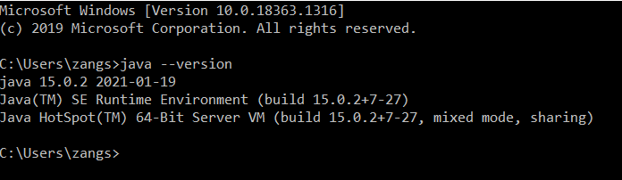

The screenshot above is to show the successful installation of the latest version of Java.



The screenshot above is to show the successful setting of JAVA_HOME.



The screenshot above is to show the successful installation of JavaFX.

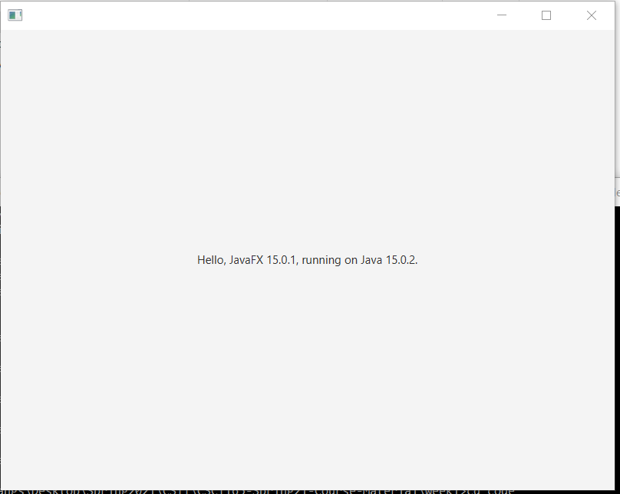

The screenshot above shows successful execution of a JavaFX application.

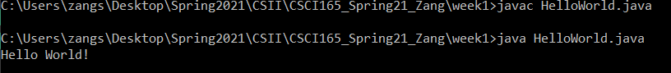

The screenshot above shows the successful execution of HelloWorld.java.