CompSyn: A Tool for Automatically Synthesizing Decoders
ShengYu Shen, Ying Qin, JianMin Zhang, and SiKun Li School of Computer, National University of Defense Technology, China {syshen,yingqin,jmzhang,skli}@nudt.edu.cn http://www.ssypub.org/

Abstract. CompSyn is a tool that automatically synthesizes a decoder circuit from an encoder and a predefined assertion. This tool has two usage modes: the synthesis mode and the inferring mode.
When the correct assertion is known, the synthesis mode is used to determine the existence of the decoder and generate it. On the other hand, when the assertion is not known, the inferring mode is used to infer this assertion and generate all possible decoders. To help the user select the correct decoder, this mode also infers each decoder’s precondition formula, which represents the set of assertions that can generate this decoder.
Experimental results show that this tool can infer assertions and generate decoders for several complex encoders, including PCI-E and Ethernet, and the human effort in specifying assertion is significantly reduced.

Keywords: Complementary Synthesis, Inferring Assertion, Craig Interpolation, Functional Dependency

1 Introduction
One of the most difficult jobs in designing communication and multimedia chips is to design and verify the complex complementary circuit pair (E,E−1), in which the encoder E transforms information into a format suitable for transmission and storage, while its complementary circuit (or decoder) E−1 recovers this information.
To facilitate this job, we have proposed the complementary synthesis algorithm [1–4] and developed the CompSyn tool to automatically synthesize the decoder circuit of an encoder. This tool has two usage modes:
- When the correct assertion is known, the synthesis mode determines the existence of the decoder [3] by iteratively checking whether its input letter can be uniquely determined by its output sequence, and characterizes the decoder’s Boolean function [2] with Craig interpolation.
- When the assertion is not known, the inferring mode infers this assertion [4] by iteratively detecting and ruling out those invalid configuration values that can lead to the nonexistence of the decoder. To generate the Boolean

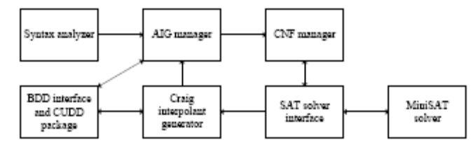
Fig. 1. The architecture of CompSyn
relations of all decoders that may exist simultaneously under this inferred assertion [5], this mode uses the functional dependency approach [11] to iteratively test whether R, the Boolean relation that uniquely determines the input letter, can be expressed as a combination of all those already discovered decoders. To help the user select the correct decoder, this mode also infers each decoder’s precondition formula [5], which represents the set of assertions that can generate this decoder.
The benchmark set includes several complex encoders from industrial projects (e.g., PCI-E[9] and Ethernet[10]). Some of them have more than 1000 lines of source code or 100 state variables. Experimental results show that this tool can always infer correct assertions and generate decoders for them. Furthermore, by using the inferring mode, the human effort in specifying assertion and selecting decoder can be significantly reduced. All the experimental results and programs can be downloaded from http://www.ssypub.org.
The remainder of this paper is organized as follows. Section 2 introduces the CompSyn tool’s software architecture. Section 3 presents the synthesis mode, while Section 4 introduces the inferring mode. Section 5 presents the experimental results, and lastly, Section 6 provides the conclusion.

2 The software architecture
The CompSyn tool is implemented in the OCaml language. Its architecture is shown in Figure 1, which comprises the following major components:
2.1 Syntax analyzer
This analyzer analyzes the encoder’s Verilog source code and assertions, and generates the transition relation’s circuit description in an AND-inverted graph (AIG) [12].
2.2 AIG manager
This AIG manager represents a circuit with an array. The access time of the array type in OCaml language is much faster than that of the list type, because it can be accessed directly with an integer index, while the access time of the list type is propositional to the list’s length. Elements of this array are of the following types:
1. True: A logic constant 1 without parameter.
2. False: A logic constant 0 without parameter.
3. Variable: A node with an integer parameter, which is this variable’s encoding number.
4. Inverter: An inverter with an integer parameter, which refers to the index of the element that drives this inverter.
5. Buffer: A non-invert buffer with an integer parameter, which refers to the index of the element that drives this buffer.
6. AND: A two-input AND gate with two integer parameters that refer to the indices of the elements that drive this AND gate.
This AIG manager provides some procedures to manipulate the circuit represented in AIG, such as removing redundant elements, propagating constance, and translating an AIG circuit into CNF format formula.
2.3 CNF manager
This manager takes care of all CNF formulas generated by the syntax analyzer, unrolled transition relations used to determine the existence of the decoder, the formulas used to generate Craig interpolant, and the formulas used to test functional dependency [11].
The set of clauses of a CNF formula is stored in the OCaml list, while each element of this list is another list that stores the set of literals of this clause. The reason for selecting a list to represent a CNF formula is that the clauses in a CNF formula do not need to be randomly accessed, and the list type provides the flexibility to increase the size of the formula.
2.4 The SAT solver interface and the SAT solver
The SAT solver used in this study is the minisat solver v1.14 [8]. This solver provides the ability to generate a proof for an unsatisfiable formula, which can be analyzed to generate a Craig interpolant.
The proof generated by the minisat solver often includes most of the clauses appearing in the original formula, which causes huge runtime overhead in generating Craig interpolant. To reduce this overhead, the minisat solver is modified to minimize the proof, by removing those redundant clauses.
The OCaml to C-interface that links CompSyn and minisat together is MiniSat-ocaml [13], developed by Flavio Lerda. However, one of its major shortcomings is that it does not provide the ability to read back the proof from the minisat solver. Hence, such a procedure is added.
The other major shortcoming of this interface is that it only provides a procedure to allocate new variables one-by-one. As the overhead of calling C-procedure from OCaml is very high, this will lead to very large runtime overhead for large formulas. To reduce this overhead, a new procedure that allocates all new variables in one calling is added.

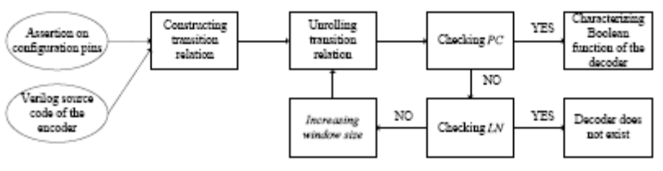
Fig. 2. The flow of the synthesis mode

2.5 The Craig interpolant generator and the BDD interface
The Craig interpolant generator works on the proof return from the minisat solver, and generates the interpolant in AIG form. One shortcoming of our Craig interpolant generator, which is also shared by other implementations of the same algorithm [14], is that the generated interpolant contains lots of redundant gates.
To remove these redundant gates, the CUDD package is invoked to generate a canonical representation of the interpolant. The OCaml to C-interface that links CUDD to CompSyn is taken from Blast model checker [15].
After the simplification, the BDD is converted back to a much more compact AIG by enumerating all cubes of this BDD.

3 An overview of the synthesis mode
The overall flow of the synthesis mode is shown in Figure 2.

3.1 Constructing transition relation
This step takes two inputs – one is the encoder’s Verilog source code and the other is the assertion on the encoder’s configuration pins. Normally, an encoder has several modes, each of which corresponds to a non-overlapped state set.
One of the most important modes is the working mode, in which the encoder encodes its input. Hence, the encoder’s input can be determined by its output, which leads to the existence of its decoder.
On the other hand, the encoder still has many other non-working modes, such as the testing and sleep mode, in which the encoder processes test commands or does nothing, respectively. Therefore, in these modes, the encoder’s input cannot be determined by its output, which leads to the nonexistence of its decoder.
Thus, in this study, the assertion is used to constrain the correct value of the encoder’s configuration pins, such that the encoder can be put in the correct working modes.
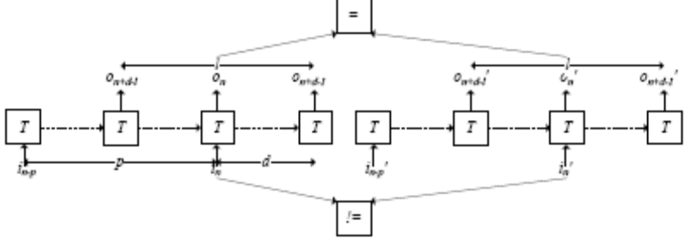
Fig. 3. The PC condition
Normally, writing a correct assertion needs the user to read the source code or the documentation carefully, and try many combinations. This may be a lengthy process and error-prone. This is the reason for developing the inferring mode that infers the assertion automatically.
3.2 Unrolling transition relation and checking PC
PC is the abbreviation of Parameterized Complementary Condition, defined in [1], which is used to determine the existence of the decoder. Its meaning is intuitively shown in Figure 3, where T is the encoder’s transition relation constructed in the previous step, while in and on are the input and output letter, respectively, and p, d, and l are the lengths of the unfolded transition relation, which are also called the window size.
This figure, and thus PC, indicates that the decoder exists if and only if there exist p, d, and l, such that the output sequence < on+d−l, . . . , on+d−1 > can uniquely determine the input letter in. In other words, there does not exist two different input letters in and i0 n that can be recovered from the same output sequence < on+d−l, . . . , on+d−1 >.
This condition can be encoded into a SAT instance and solved with the minisat solver [8]. If the result is unsatisfiable, then the decoder exists; otherwise, the decoder does not exist for this particular value of p, d, and l. CompSyn needs to check LN or increase the window size.

3.3 Checking LN
In addition to the PC mentioned in the last subsection, another condition LN has been defined in [3] to determine the nonexistence of the decoder. Its meaning is intuitively shown in Figure 4, indicating that the decoder does not exist if and only if there exists p, d, and l, such that the output sequence < on+d−l, . . . , on+d−1 > can NOT uniquely determine the input letter in, and there are three loops on state sequences < sn−p, . . . , sn+d−l >,< sn+d−l+1, . . . , sn > and < sn+1, . . . , sn+d >.

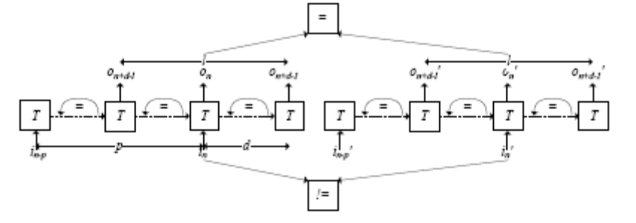
Fig. 4. The LN condition
This condition can be encoded into a SAT instance, and solved with the minisat solver [8]. If this SAT instance is satisfiable, then the nonexistence of the decoder for all those longer paths can be proved by unfolding these three loops. Otherwise, the window size will be increased and a new iteration will begin. We have proven in [3] that this loop between LN and PC will eventually terminate.

3.4 Characterizing the Boolean function of the decoder
If the PC checking succeeds, then there exists a function that maps the output sequence < on+d−l, . . . , on+d−1 > back to the input letter in. This function can be characterized from the Boolean relation shown in Figure 3, with the ALLSAT algorithm proposed in [2].
Recently, Liu et al. [6] proposed a much faster algorithm based on Craig interpolant [7] to characterize this function. The timing and area of the decoder generated by it is comparable to our ALLSAT algorithm.
This algorithm has also been implemented in CompSyn. To simplify the presentation, we denote in as Y, Y j as the j-th bit Y, and < on+d−l, . . . , on+d−1 > as X. R(X, Y) is the Boolean relation shown in Figure 3, which succeeds in checking PC. As R can uniquely determine the value of Y from X, a Craig interpolant of R(X, Y ) ^ Y j _ 1 with respect to R(X, Y 0) ^ Y 0j _ 0 can be generated. This Craig interpolant is exactly the Boolean function that computes the j-th bit of Y from X.

4 An overview of the inferring mode
The flow of the inferring mode is shown in Figure 5. It is similar to Figure 2, with some new steps in gray color. The assertion is not needed here.

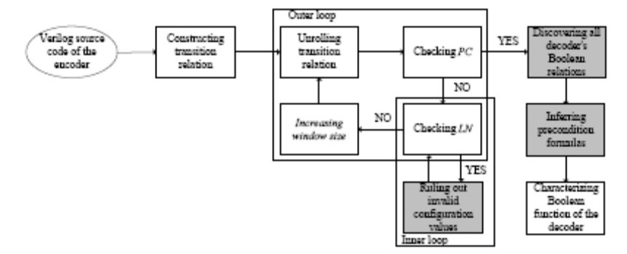
Fig. 5. The flow of the inferring mode
4.1 Ruling out invalid configuration values
If the LN checking succeeds, an invalid configuration value that leads to the nonexistence of the decoder can be obtained from the satisfying assignment returned from the minisat SAT solver [8]. We can simply rule out this invalid configuration value and return to the previous step to check LN again. However, to reduce the runtime overhead, an algorithm has been proposed in [4] to enlarge this value to a larger set of invalid configuration values with Craig interpolant [7], such that there can be rule out altogether.
The formula used in enlarging is shown in Figure 6. This formula is very similar to that presented in Figure 4, except that the existence of the six loops and the equality of the two output sequences is added together to generate a new Boolean variable t. By assigning the satisfying assignment of the SAT instance shown in Figure 4, this formula can be transformed into a new formula, F(c, t), which defines a circuit, whose input is the configuration value c, and output is t.

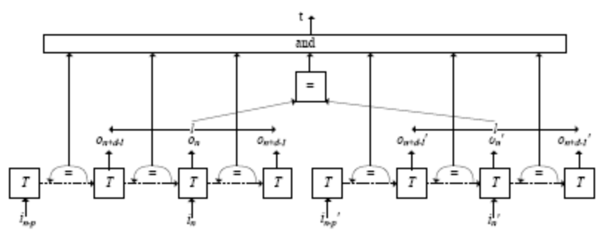
Fig. 6. Enlarging the invalid configuration value with Craig interpolant

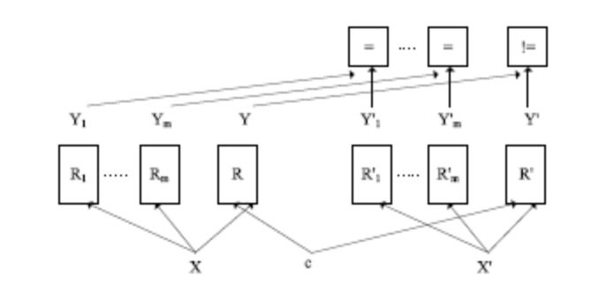
Fig. 7. The SAT instance that discovers all decoders
The Boolean function of this circuit can be characterized by generating the Craig interpolant of F(c, 1) with respect to F(c, 0). Thus, this Boolean function is exactly the enlarged set of invalid configuration values.
The inner loop between this step and the Checking LN step will eventually terminate after such invalid configuration values are all ruled out. Then, the window size is increased to check PC again..
We have proven in [4] that the outer loop between LN and PC will eventually terminate. Let us assume that the set of all configuration values ruled out is NA, and the final inferred assertion is ^na2NA￢na.

4.2 Discovering all decoders’ Boolean relations
The final inferred assertion is a formula that actually contains many different configuration values. This means that there may exist multiple decoders for this inferred assertion.
Thus, we need to find out the set of all decoders’ Boolean relations {R1, . . . ,Rn} step–by-step. Let us assume {R1, . . . ,Rm} is a set of decoders’ Boolean relations, which has already been discovered. To test whether it contains {R1, . . . ,Rn}, that is, whether all decoders have already been discovered, the SAT instance shown in Figure 7 is constructed based on functional dependency [11].
In Figure 7, we have denoted in as Y, < on+d−l, . . . , on+d−1 > as X, and the configuration value as c. R(c,X, Y) is the Boolean relation shown in Figure 3, which succeeds in checking PC.
According to [5], if this SAT instance is unsatisfiable, then all decoders have been discovered. Otherwise, a new decoder’s Boolean relation can be discovered by assigning the satisfying assignment of c to R.
A new round of functional dependency test will be performed again, until no more decoder can be discovered. Subsequently, these Boolean relations will be used to characterize their corresponding decoders’ Boolean functions.

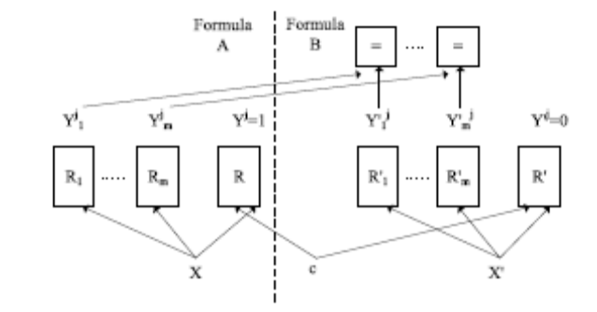
Fig. 8. The SAT instance that infers precondition formulas

4.3 Inferring precondition formulas
Let us assume that {R1, . . . ,Rm} is the set of all decoders’ Boolean relations discovered in the last step, and {IA1, . . . , IAm} is their corresponding set of configuration letters. To help the user determine which Ri in {R1, . . . ,Rm} is the correct decoder, each IAi in {IA1, . . . , IAm} must be characterized.
Let us assume Y and all Yi in Figure 7 are vectors of the same length v, and their j-th bit are Y j and Y j i, respectively. If the precondition formulas IAj i for the j-th bit of IAi can be characterized, then IAi can be defined as Vv−1 j=0 IAj i.
To achieve this goal, the unsatisfiable SAT instance, shown in Figure 8, is constructed, which represents a functional dependency problem. As the set of common variables between formula A and B is {c, Y j 1 , . . . , Y jm}, the generated interpolant of A with respect to B is a function F(c, Y j 1 , . . . , Y jm ) that computes the value of Y j. By setting the value of Y j i to 1 and all other {Y j k |k 6= i} to 0 in F(c, Y j 1 , . . . , Y jm ), we can obtain the formula IAj i.

5 Experimental results
5.1 The usage model
All the above-mentioned steps are connected together by the standard tool in Linux. To use the synthesis mode, the user needs to run the command “make halting fast” under the bash shell in the benchmark directory. To use the inferring mode, the user needs to run the command “make infer multidec not charfirst.”

5.2 Benchmarks
The benchmarks used in the experiments include several complex encoders from industrial projects, as follows:
1. An XGXS encoder compliant to clause 48 of IEEE-802.3ae 2002 standard [10].

Table 1. Information on Benchmarks
 | XGXS | XFI | Scrambler | PCIE | T2 Ethernet
Line number of verilog source code | 214 | 466 | 24 | 1139 | 1073
No. of state variables | 15 | 135 | 58 | 22 | 48
Data path width | 8 | 64 | 66 | 10 | 10

2. An XFI encoder compliant to clause 49 of the same IEEE standard.
3. A 66-bit scrambler to ensure that a data sequence has sufficient 0–1
transitions, so that it can run through a high-speed noisy serial transmission
channel.
4. A PCI-E physical coding module [9].
5. The Ethernet module of Sun’s OpenSparc T2 processor.
The profile of these benchmarks is shown in Table 1. Some of these large benchmarks have more than 1000 lines of source code, while the XFI encoder has more than 100 state variables.

5.3 The experimental result of the synthesis mode
According to Table 2 and [3], when given the assertion, the synthesis mode can determine the existence of the decoders within 40 seconds, and build the decoders within 10 seconds with an algorithm similar to that developed by Liu et al. [6]. Moreover, we inserted some bugs into these encoders, which generated the same output letter for two different input letters. CompSyn was found to successfully detect all these bugs within 10 seconds.

5.4 The experimental result of the inferring mode
According to [4, 5], when the assertions are not known, the inferring mode can infer assertions, generate decoders, and infer these decoders’ precondition formulas in 400 seconds. Moreover, only two out of the five benchmarks have two decoders, while the other three have only one decoder. This means that in most of the cases, our algorithm generates only one decoder. For other cases with multiple decoders, the user needs to inspect {IA1, . . . , IAm} to select the correct decoder.
Table 2. Experimental results on properly designed encoders
 |  | XGXS | XFI | Scrambler | PCI-E | T2 Ethernet
For correct encoder | Time to check PC(sec) | 0.29 | 17.86 | 2.67 | 0.47 | 29.64
For correct encoder | d, p, l | 1,2,1 | 0,3,2 | 0,2,2 | 2,2,1 | 4,4,1
For incorrect encoder | Time to check PC (sec) | 0.16 | 7.59 | 1.17 | 0.33 | 2.19

Table 3. Experimental Results
 | XGXS | XFI | Scrambler | PCI-E | T2 ether
Config.  pin number | 3 | 120 | 1 | 16 | 26
Runtime | 2.33 | 364.36 | 14.20 | 4.49 | 125.69
d, p, l | 1,3,1 | 0,3,2 | 0,2,2 | 2,3,1 | 4,4,1
Number of  decoders | 1 | 2 | 2 | 1 | 1

For example, for the two decoders of the most complex XFI encoder, which are compliant to 10G Ethernet standard [10], their corresponding IA1 is RESET & !TEST MODE, while IA2 is !RESET & !TEST MODE & DATA V ALID. The essential difference between them is the value of RESET. On inspecting the Verilog source code of XFI, we found that the RESET is used to reset the XFI encoder when it is True. Thus, the XFI encoder will work in normal mode when RESET is False. Therefore, the second decoder is the correct decoder, and the dynamic simulation also confirmed its correctness.
In this process, the user only needs to inspect the meaning of one configuration pin, instead of all 120 configuration pins of the XFI encoder. In this way, the human effort in specifying assertion and selecting the correct decoder is significantly reduced.

6 Conclusions
The CompSyn tool can infer correct assertions and generate decoder circuits for several complex encoders. Furthermore, it can significantly reduce the human effort in specifying assertion and selecting the correct decoder.
References
1. ShengYu Shen, Jianmin Zhang, Ying Qin, Sikun Li: Synthesizing complementary circuits automatically. ICCAD 2009: 381-388
2. ShengYu Shen, Ying Qin, KeFei Wang, LiQuan Xiao, Jianmin Zhang, Sikun Li: Synthesizing Complementary Circuits Automatically. IEEE Trans. on CAD of Integrated Circuits and Systems 29(8): 1191-1202 (2010)
3. ShengYu Shen, Ying Qin, LiQuan Xiao, KeFei Wang, Jianmin Zhang, Sikun Li: A Halting Algorithm to Determine the Existence of the Decoder. IEEE Trans. On CAD of Integrated Circuits and Systems 30(10): 1556-1563 (2011)
4. ShengYu Shen, Ying Qin, Jianmin Zhang, Sikun Li: Synthesizing complementary circuits automatically. accepted by ICCAD11.
5. ShengYu Shen, Ying Qin, LiQuan Xiao, KeFei Wang, Jianmin Zhang, Sikun Li: Inferring Assertion for Complementary Synthesis. submitted to IEEE transaction on CAD of Integrated Circuits and Systems.
6. Siou-Yuan Liu, Yen-Cheng Chou, Chen-Hsuan Lin, Jie-Hong Roland Jiang : Completely Automatic Decoder Synthesis. accepted by ICCAD11.
7. Craig, W. : Linear reasoning: A new form of the Herbrand-Gentzen theorem. J. Symbolic Logic. 22(3), 250–268 (1957)
8. Niklas E´en, Niklas S¨orensson: An Extensible SAT-solver. SAT 2003: 502-518
9. PCI Express Base Specification Revision 1.0. http://www.pcisig.com
10. IEEE Standard for Information technology Telecommunications and information exchange between systems Local and metropolitan area networks Specific require- ments Part 3: Carrier Sense Multiple Access with Collision Detection (CSMA/CD) Access Method and Physical Layer Specifications Amendment: Media Access Con- trol (MAC) Parameters, Physical Layers, and Management Parameters for 10 Gb/s Operation, IEEE Std. 802.3, 2002.
11. Chih-Chun Lee, Jie-Hong Roland Jiang, Chung-Yang Huang, Alan Mishchenko: Scalable exploration of functional dependency by interpolation and incremental SAT solving. ICCAD 2007: 227-233
12. Alan Mishchenko, Satrajit Chatterjee, Robert K. Brayton: DAG-aware AIG rewriting a fresh look at combinational logic synthesis. DAC 2006: 532-535
13. https://github.com/flerda/MiniSat-ocaml/wiki
14. Kenneth L. McMillan: Interpolation and SAT-Based Model Checking. CAV 2003: 1-13
15. Dirk Beyer, Thomas A. Henzinger, Ranjit Jhala, Rupak Majumdar: The software model checker Blast. STTT 9(5-6): 505-525 (2007)

