Complementary Synthesis for Encoder with Flow Control Mechanism

YING QIN and SHENGYU SHEN and YAN JIA, School of Computer, National University of Defense Technology

Complementary synthesis automatically generates an encoder’s decoder with the assumption that the encoder’s input can always be uniquely determined by its output. However, many modern encoders employ flow control mechanism that inserts invalid data into the encoder’s input sequence, which prevents some input signals from being uniquely determined. None of the current algorithms can handle such cases.
By studying several complex encoders, we found that all flow control mechanisms classify the encoder’s input signals into two sets: the flow control signals that can always be uniquely determined, and the data signals whose validness is indicated by a predicate over the flow control signals. When the data signals are invalid, the decoder is supposed to recover only the flow control signals and ignore the data signals.
Thus, we propose a three-step algorithm to handle such encoders with flow control mechanism. First, it finds out all signals that can be uniquely determined and taken as flow control signals. Second, it infers a predicate over these flow control signals that enable all other data signals to be uniquely determined. Third, it characterizes the decoder’s Boolean function for each input signal, by first building a conjunction of two formulas that assign conflicting values to this input signal, and then generating a Craig interpolant from its unsatisfiability proof. But for the data signals, the inferred predicate must be enforced first.
The proposed algorithm is used on several complex encoders and the results indicate that it can always correctly find out the flow control signals, infer the predicates and generate the decoder’s Boolean functions.

Categories and Subject Descriptors: B.5.2 [Design Aids]: Automatic synthesis; B.6.3 [Design Aids]: Automatic synthesis

General Terms: Algorithms, Logic synthesis, Verification

Additional Key Words and Phrases: Craig interpolation, decoder, encoder, finite-state transition system, satisfiability solving

ACM Reference Format:
Ying Qin, Shengyu Shen, and Yan Jia, 2014. Complementary Synthesis for Encoder with Flow Control Mechanism. ACM Trans. Des. Autom. Electron. Syst. 9, 4, Article 39 (March 2010), 15 pages.
DOI:http://dx.doi.org/10.1145/0000000.0000000

This work was funded by projects 61070132 and 61133007, supported by National Natural Science Foundation of China.
Authors’ address: School of Computer, National University of Defense Technology.
Permission to make digital or hard copies of this work, either in full or in part, for personal or classroom use is granted without fee, provided that no copies are made or distributed for profit or commercial advantage, and that copies of this work show this notice on the first page or initial screen of a display along with the full citation. Copyrights for components of this work, owned by other than ACM must be honored. Abstracting with due credit is permitted. All other cases, such as copyingto republish, to post on servers, to redistribute to others, or to use any component of this work in other works, require prior permission and/or a payment of fee. Requests for permissions may be addressed to Publications Dept., ACM, Inc., 2 Penn Plaza, Suite 701, New York, NY 10121-0701 USA, fax +1 (212) 869-0481, or permissions@acm.org.
© 2010 ACM 1084-4309/2010/03-ART39 $15.00
DOI:http://dx.doi.org/10.1145/0000000.0000000
1. INTRODUCTION
One of the most difficult jobs in making communication and multimedia chips is to design and verify complex encoder and decoder pairs. The encoder maps its input signals [?] to its output signals [?] , according to some predefined rules, while the decoder recovers [?] from [?]. Complementary synthesis [Shen et al. 2009] facilitates this job by automatically generating an encoders’ decoder. As shown in Figure 1a), this algorithm assumes that the encoder eventually reaches and never leaves the unique state set,

Fig. 1. An encoder with flow control mechanism

in which [?] can always be uniquely determined by a bounded sequence of [?]. The set of all other states is called the non-unique state set, because [?] cannot be uniquely determined in it by a bounded sequence of [?].
At the same time, high speed communication systems, such as Ethernet [wikipedia 2013b] and PCIE [wikipedia 2013d], run at several Giga bits per second. It is impossible to distribute, so fast as to cope with that speed, a clock to both the transmitter and the receiver; so, they must be driven by clocks with slightly different frequencies. To prevent the faster transmitter from overwhelming the slower receiver, flow control mechanism [wikipedia 2013c] is widely employed to insert invalid data into the sequence of input signals [?], so that the decoder can recognize and discard them.
As shown in Figure 1b), an encoder with flow control mechanism partitions its input signals [?] into two sets: the data signals [?] to be encoded, and the flow control signals [?] indicating the validness of [?] with a predicate valid([?]). When valid([?]) ≡ 1, the encoder maps [?] with an encoding function enc to the output signals [?]: = enc([?]), in which case both [?] and [?] can be uniquely determined by a bounded sequence of [?].
However, when valid([?]) ≡ 0, the encoder drives some predefined patterns to [?] , independent of [?], such as the K28.5 character defined in clause 36 of IEEE 802.3 standard[IEEE 2012b], which can uniquely determine only [?], but not [?]. In this case, the decoder is supposed to recognize only the validness of [?] instead of their exact value, which means that recovering [?] is enough.
So, just like the path 2 in Figure 1a), such an encoder may visit the non-unique state set infinite times. Thus, none of the current complementary synthesis algorithms can handle such encoders, because they all assume that [?] can always be uniquely determined by [?]; so, they enforce this by manually specified assertion [Shen et al. 2009; 2010; 2011], or automatically inferred assertion [Shen et al. 2012].
We propose in this paper a novel three-step algorithm to handle such encoders with flow control mechanism. First, we apply the classical halting complementary synthesis algorithm [Shen et al. 2011] to identify all the flow control signals [?] that can be uniquely determined. Second, we infer a sufficient and necessary predicate valid ([?]) that enables [?] to be uniquely determined by a bounded sequence of the encoder’s output [?]. Finally, we characterize the decoder’s Boolean function for each flow control signal f ∈ [?] by building two copies of unrolled transition function sequence with common output sequences [?], but different values on f. The conjunction of these two copies is unsatisfiable; so, a Craig interpolant [McMillan 2003] can be built and used as the decoder’s Boolean function that computes f. On the other hand, for other input data signals [?], their values are meaningful only when valid([?]) ≡ 1. Thus, the decoder’s Boolean functional computing can be built similarly for each d ∈ [?], but only after enforcing valid([?]) ≡ 1.
The second step of this algorithm seems somewhat similar to that of [Shen et al. 2012] in that both algorithms infer assertions to uniquely determine [?] or [?]. But the essential difference between them is that the algorithm of [Shen et al. 2012] infers a global assertion that must be enforced at all cycles, so that the encoder eventually reaches and never leaves the unique state set, whereas our algorithm infers a local predicate that is enforced at the current cycle only when we need to recover the value of [?]. So, our algorithm is the first algorithm that allows the unique and non-unique states to be interleaved freely.
Experimental results indicate that, for several complex encoders from real projects (e.g., Ethernet [wikipedia 2013b] and PCIE [wikipedia 2013d]), our algorithms can always find out the flow control signals, infer the predicates and generate the decoders.
The remainder of this paper is organized as follows. Section 2 introduces the background material; Section 3 presents the algorithm that finds out the flow control signals, while Section 4 infers the predicate that enables [?] to be uniquely determined by a bounded sequence of [?]; Section 5 presents the algorithm to characterize the decoder’s Boolean function; Sections 6 and 7 present the experimental results and related works. Finally, Section 8 sums up the conclusion.
2. PRELIMINARIES
2.1. Propositional satisfiability
The Boolean value set is denoted as B = {0, 1}. A vector of variables is represented as [?] = (v, . . .). If a variable v is a member of [?], that is [?] = (. . . , v, . . .), then we say v ∈ [?]; otherwise we say v [?] [?]. For a variable v and a vector [?], if v [?] [?], then the new vector that contains both v and all members of [?] is denoted as v ∪ [?]. If v ∈ [?], then the new vector that contains all members of [?] except v, is denoted as [?] − v. For the two vectors [?] and [?], the new vector with all members of [?] and [?] is denoted as [?]. The set of truth valuations of [?] is denoted as [?]; for instance, [(v₁, v₂)] = {(0, 0), (0, 1), (1, 0), (1, 1)}.
A Boolean formula F over a variable set V is constructed by connecting variables from V with symbols ¬, ∧, ∨, and ⇒, which stand for logical connectives negation, conjunction, disjunction, and implication, respectively.
The propositional satisfiability problem (abbreviated as SAT) for a Boolean formula F over a variable set V is to find a satisfying assignment A : V → B, so that F can be evaluated to 1. If such a satisfying assignment exists, then F is satisfiable; otherwise, it is unsatisfiable.
According to [Ganai et al. 2004], the positive and negative cofactors of f(v₁ . . . v . . . . v_{n}) with respect to variable v are f_{v} = f(v₁ . . . . 1 . . . v_{n}) and [?] = f(v₁ . . . 0 . . . v_{n}), respectively. Cofactoring is the action that applies 1 or 0 to v to get f_{v} or [?].
Given the two first order logic formulas φ_{A} and φ_{B}, with φ_{A} ∧ φ_{B} unsatisfiable, there exists a formula φ_{I} referring only to the common variables of φ_{A} and φ_{B} such that φ_{A} ⇒ φ_{I} and φ_{I} ∧ φ_{B} is unsatisfiable. We call φ_{I} the interpolant [Craig 1957] of φ_{A} with respect to φ_{B} and use McMillan’s algorithm [McMillan 2003] to generate it.

2.2. Finite state machine
The encoder is modeled by a finite state machine M = ([?], [?], [?], T), consisting of a state variable vector [?], an input variable vector [?], an output variable vector [?], and a transition function T : [[?]] × [[?]] → [[?]] × [[?]] that computes the next state and output vector from the current state and input vector.
We denote the state variable s ∈ [?], input variable i ∈ [?] and output variable o ∈ [?] at the n-th cycle respectively as s_{n}, i_{n} and o_{n}. We further denote the state, the input and the output vectors at the n-th cycle respectively as [?], [?] and [?]. A path is a state sequence < [?], . . . , [?] > with [?][?]([?]_{j+1}, [?]) ≡ T([?], [?]) for all n ≤ j < m. A loop is a path < [?], . . . , [?] > with [?] ≡ [?].

2.3. The halting algorithm to determine if an input signal can be uniquely determined by a bounded sequence of output vector
All the state-of-the-art complementary synthesis algorithms [Shen et al. 2009; Liu et al. 2011; Tu and Jiang 2013] assume that [?] can be uniquely determined; so, they always take [?] as a whole, and never consider individual variables i ∈ [?]. But in this paper, we

Fig. 2. Checking whether or not the input can be uniquely determined by the output
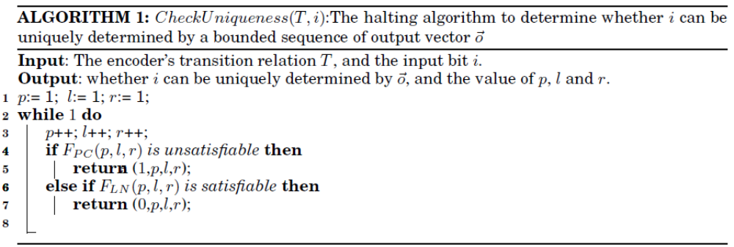

need to check each i ∈ [?] , one by one; so, there may be a minor difference between our presentation and that of [Shen et al. 2009; Liu et al. 2011; Tu and Jiang 2013].
As shown in Figure 2a), i ∈ [?] can be uniquely determined, if there exist p, l and r, such that for any particular valuation of the output sequence < [?], . . . , [?]_{p+l+r} >, i_{p+l} can not take on two different values. This can be checked by solving F_{PC}(p, l, r) in Equation (1).
(1)
Here, p is the length of the prefix state transition sequence that leads the encoder into the unique state set, in which i can be uniquely determined. l and r are the lengths of the two output sequences < [?]_{p+1}, . . . , [?]_{p+l} > and < [?]_{p+l+1}, . . . , [?]_{p+l+r} > that are on the left-hand and right-hand sides of i_{p+l} , which is used to determine i_{p+l}. Line 1 of Equation (1) corresponds to the path in Figure 2a), while Line 2 is its copy. Line 3 forces these two paths’ output sequences to be the same, while Line 4 forces their i_{p+l} to be different.
Thus, we have the following proposition:
PROPOSITION 2.1. If F_{PC}(p, l, r) is unsatisfiable, then i_{p+l} can be uniquely determined by < [?], . . . , [?]_{p+l+r} >.
On the other hand, if F_{PC}(p, l, r) is satisfiable, then i_{p+l} cannot be uniquely determined by < [?], . . . , [?]_{p+l+r} > for these particular values of p, l and r. It may be uniquely determined for larger p, l and r, or it may not be uniquely determined at all for any p, l and r . If it is the first case, then we can iteratively increase the value of p, l and r, and eventually make F_{PC}(p, l, r) unsatisfiable. But, if it is the second case, then this iterative algorithm will never terminate.
So, to obtain a halting algorithm, we need to distinguish between these two cases. One such solution is shown in Figure 2b), which is similar to Figure 2a) but with three additional constraints to detect loops on the three state sequences < [?]₀, . . . , [?]_{p} > , < [?]_{p+1}, . . . , [?]_{p+l} > and < [?]_{p+l+1}, . . . , [?]_{p+l+r} >. It is formally defined in Equation (2) with the last three lines corresponding to the three constraints used to detect loops.
(2)
dist

When F_{LN}(p, l, r) is satisfiable, then i_{p+l} cannot be uniquely determined by < [?], . . . , [?]_{p+l+r} >. More importantly, by unrolling these three loops, we can further prove that:
PROPOSITION 2.2. If F_{LN}(p, l, r) is satisfiable, then [?] can not be uniquely determined by < [?], . . . , [?] > for any larger [?] ≥ [?], [?] ≥ l and [?] ≥ r.
Thus, with Propositions 2.1 and 2.2, Algorithm 1 is a halting algorithm, which determines if there exists p, l and r that make an input bit i_{p+l} to be uniquely determined by the encoder’s output sequence < [?], . . . , [?]_{p+l+r} >. On the one hand, if there actually exist such p, l and r, then eventually F_{PC}(p, l, r) will become unsatisfiable in Line 4; on the other hand, if there exist no such p, l and r, then eventually p, l and r will be larger than the longest path without loop, which means that there will be three loops in < [?], . . . , [?] > , < [?]_{p+1}, . . . , [?]_{p+l} > and < [?]_{p+l+1}, . . . , [?]_{p+l+r} >. This will make F_{LN}(p, l, r) satisfiable in Line 5. Both cases will lead to this Algorithm’s termination. Please refer to [Shen et al. 2011] for more details.

3. FINDING OUT FLOW CONTROL SIGNALS
To facilitate the presentation of our algorithm, we partition the input vector [?] into two vectors: the vector of flow control signals [?] and the vector of input data signals [?].
The flow control signals [?] are intended to represent the validness of [?]. So, for a properly designed encoder, [?] should always be uniquely determined by a bounded sequence of the encoder’s output [?], or else the decoder cannot recognize the encoded invalid data.
Thus, we propose Algorithm 2 to find out [?].
At Line 3, it simply applies Algorithm 1 to each input bit i ∈ [?] of the encoder, to find out whether i_{p+l} can be uniquely determined by < [?], . . . , [?]_{p+l+r} >. If yes, the values of p, l and r are also computed.
At Line 5, the input bit i that can be uniquely determined will be added to the vector [?]. And, at the following three lines, the maximal values of p, l and r are computed.
On the other hand, when [?] is very long, the run time overhead of testing each i ∈ [?] , one by one, would also be very large. To speed up this testing procedure, when the result of CheckUniqueness is 0 at Line 3, every i ∈ [?] that has different values for i_{p+l} and [?]_{p+l} in solving F_{LN}(p, l, r) can also be ruled out at Line 12, because they also satisfy their own F_{LN}(p, l, r).

4. INFERRING PREDICATE THAT MAKES THE ENCODER’S INPUT DATA TO BE UNIQUELY DETERMINED
We propose in subsection 4.1 an algorithm to characterize a formula over a particular set of variables that makes a SAT instance satisfiable, and then in subsection 4.2, we apply this algorithm to infer valid([?]).

4.1. ALLSAT algorithm based on Craig Interpolant and Cofactoring
Here I come
Assume that R ([?], [?], t) is a Boolean relation with R ([?], [?], 0) ∧ R([?], [?], 1) and is unsatisfiable. [?] and [?] are respectively called the important and the non-important variable vectors, while t is the target variable.
We need to characterize a formula FSAT ([?]), which covers and only covers all the valuations of [?] that can make R([?], [?], 1) satisfiable. It is formally defined below:
(3)
Thus, a naive method of computing FSAT*([?]) is to enumerate all valuations of [?], and collect all those valuations that make R([?], [?], 1) satisfiable. But this naive method would run in exponential time with respect to the length of [?]. For a long [?], it may not be possible to terminate in reasonable time.
We can speed up this naive algorithm by expanding each valuation of [?] to a larger set with Craig interpolant [McMillan 2003]. Intuitively, we assume that R([?], [?], 1) is satisfiable with a satisfying assignment A : [?] ∪ [?] ∪ {t} → {0, 1}. Then we can construct the following new formula by cofactoring.
(4)
Because R([?], A([?]), 0) ∧ R([?], A([?]), 1) is unsatisfiable, the Craig interpolant ITP([?]) of R([?], A([?]), 1) with respect to R([?], A([?]), 0) can be computed and used as an over-approximation of R([?], A([?]), 1). At the same time, ITP([?]) ∧ R([?], A([?]), 0) is unsatisfiable; so, ITP([?]) covers nothing that can make R([?], A([?]), 0) satisfiable. Thus, ITP([?]) covers exactly the set of valuations of [?] that can make R([?], A([?]), 1) satisfiable.
Based on the foregoing discussion, Algorithm 3 is proposed to characterize FSAT([?]). Line 1 initializes FSAT to an empty formula. Line 2 checks whether there is still some new valuation of [?] that can make R([?], [?], 1) satisfiable, but has not been covered by FSAT. Lines 4 and 5 assign the value of [?] from the satisfying assignment to R([?], [?], 1) and R([?], [?], 0) respectively, to remove [?] from them.
Thus, φ_{A} ∧ φ_{B} in Line 6 is unsatisfiable, and the common variables vector of φ_{A} and φ_{B} is [?], the important variables over which the formula to be characterized. So a Craig interpolant ITP ([?]) can be generated with the Mcmillian’s algorithm [McMillan 2003].
ITP([?]) is added to FSAT in Line 7 and ruled out in Line 2.
Each iteration of the whole loop in Algorithm 3 adds at least a valuation of [?] to FSAT, which means that FSAT is a formula that covers a bounded and strictly increasing set of valuations of [?]. So Algorithm 3 is a halting one.
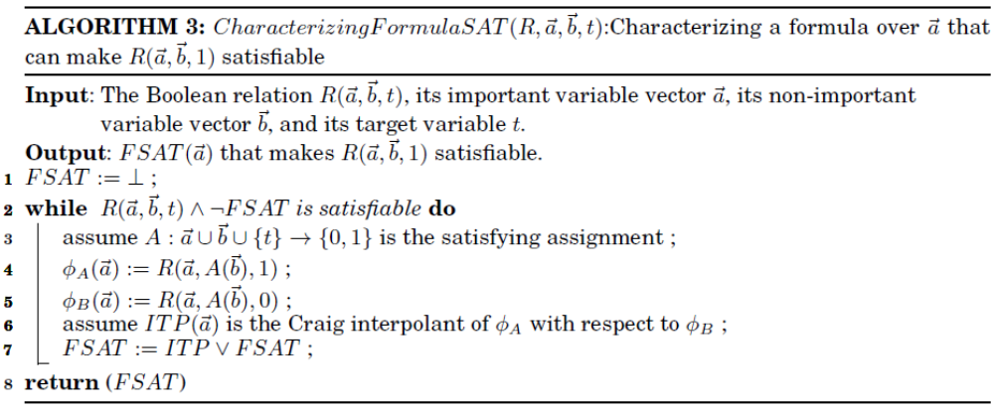

4.2. Inferring valid([?]) that enables [?] to be uniquely determined
By replacing i in Equation (1) with [?], we have:
(5)
If [?](p, l, r) is satisfiable, then [?] cannot be uniquely determined by < [?], . . . , [?]_{p+l+r} >. Let us define a new formula T_{PC}(p, l, r) by collecting the 3rd line of Equation (5):
(6)
Then [?] cannot be uniquely determined for particular p, l and r if [?](p, l, r, 1) is satisfiable, where [?](p, l, r, t) is defined below:
(7)
Let us define:
(8)
(9)
[?] ∪ [?] is the vector that contains all the input vectors < [?], . . . , [?]_{p+l+r} > and < [?], . . . , [?]_{p+l+r} > at all cycles for the two unrolled transition function sequences. It also contains the two initial states [?] and [?]. And T is a function that computes the next state and the output vector from the current state and input vector. So [?] and [?] can uniquely determine the value of t in [?](p, l, r, t). Thus, for a particular combination of p, l and r, the formula over [?]_{p+l} that makes [?](p, l, r, 1) satisfiable can be computed by calling Algorithm 3 with [?](p, l, r, t), [?] and [?] defined above:
(10)
Thus, we have the following proposition:
PROPOSITION 4.1.
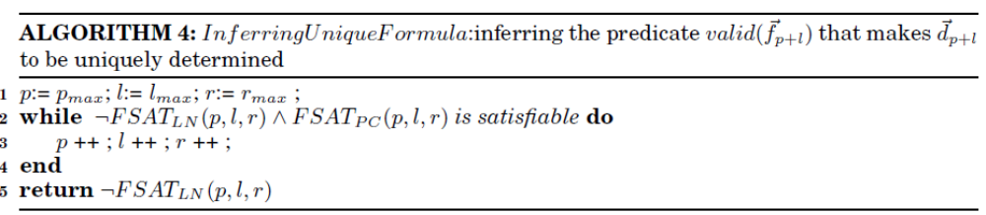
Similarly, by replacing i in Equation (2) with [?], we have:
(11)
If [?](p, l, r) is satisfiable, then [?] cannot be uniquely determined by < [?], . . . , [?]_{p+l+r} >. Furthermore, by unrolling those three loops, we can prove that [?] cannot be uniquely determined for any larger [?] ≥ p, [?] ≥ l and [?] ≥ r. Let us define a new formula T_{PC}(p, l, r) by collecting the 3rd line and the last three lines of Equation (11):
(12)
Then [?] cannot be uniquely determined for any larger [?] ≥ p, [?] ≥ l and [?] ≥ r if [?](p, l, r, 1) is satisfiable, where [?](p, l, r, t) is defined below:
(13)
Thus, for a particular combination of p, l and r, the formula over [?]_{p+l} that makes [?](p, l, r, 1) satisfiable can be computed by
(14)
Thus we have the following proposition:
PROPOSITION 4.2. FSAT_{LN} (p, l, r) is the formula over [?]_{p+l} that makes [?] to be not uniquely determined for every [?] ≥ p, [?] ≥ l and [?] ≥ r.
With Propositions 4.1 and 4.2, the algorithm that infers the predicate valid([?]_{p+l}) is shown in Algorithm 4. The proofs of its termination and correctness are given in the next subsection.

4.3. Proofs of termination and correctness
First we need to prove the following three lemmas:
LEMMA 4.3. FSAT_{PC}(p, l, r) in Algorithm 4 monotonically decreases.
PROOF: According to the definition of [?](p, l, r, t) in Equation (7), for any [?] > p, [?] > l and [?] > l, we have [?]([?], [?], [?], 1) ⇒ [?](p, l, r, 1). So, FSAT_{PC}([?], [?], [?]) ⇒ FSAT_{PC}(p, l, r). Thus, FSAT_{PC}(p, l, r) monotonically decreases.
LEMMA 4.4. FSAT_{LN}(p, l, r) in Algorithm 4 monotonically increases.
PROOF. According to the definition of [?](p, l, r, t) in Equation (13), with any satisfying assignment of [?](p, l, r, 1), those three loops in T_{LN}(p, l, r) can be unrolled to make [?]([?], [?], [?], 1) satisfiable with larger [?], [?] and [?]. So, we have FSAT_{LN}(p, l, r) ⇒ FSAT_{LN}([?], [?], [?]), that is, FSAT_{LN}(p, l, r) monotonically increases.

Fig. 3. The monotonicity of ¬FSAT_{LN}(p, l, r) ∧ FSAT_{PC}(p, l, r)

LEMMA 4.5. FSAT_{LN}(p, l, r) ⇒ FSAT_{PC}(p, l, r)
PROOF. It is obvious that [?](p, l, r, 1) ⇒ [?](p, l, r, 1); so, FSAT_{LN}(p, l, r) ⇒ FSAT_{PC}(p, l, r) holds.
These three lemmas are depicted intuitively in Figure 3, which make it obvious that ¬FSAT_{LN}(p, l, r) ∧ FSAT_{PC}(p, l, r) monotonically decreases in Algorithm 4. With these lemmas, let’s first prove that Algorithm 4 is a halting one.
THEOREM 4.6. Algorithm 4 is a halting algorithm.
PROOF. As the encoder is represented by a finite state machine, the length of the longest path without loop is finite. If Algorithm 4 does not halt, then eventually the values of p, l and r in Algorithm 4 will be larger than the length of the longest path without loop, which means there will be loops in these three state sequences < [?], . . . , [?] >,< [?]_{p+1}, . . . , [?]_{p+l} > and < [?]_{p+l+1}, . . . , [?]_{p+l+r} >. Thus, every satisfying assignment of [?](p, l, r, 1) also satisfies [?](p, l, r, 1), which means ¬FSAT_{LN}(p, l, r)∧ FSAT_{PC}(p, l, r) is unsatisfiable. This will lead to the termination of Algorithm 4. So, it is a halting algorithm.
We will then prove the correctness of Algorithm 4.
THEOREM 4.7. ¬FSAT_{LN}(p, l, r) returned by Algorithm 4 covers and only covers all valuations of [?] that enables [?] to be uniquely determined by a bounded sequence of [?].
PROOF. Let’s first prove the covering case. FSAT_{LN}(p, l, r) covers a set of valuations of [?] that make [?] to be not uniquely determined for some particular p, l and r. So ¬FSAT_{LN}(p, l, r) rules them out and covers all valuations of [?] that can make [?] to be uniquely determined.
We then prove the only covering case. If ¬FSAT_{LN}(p, l, r) covers a valuation of [?] that makes [?] to be NOT uniquely determined for some particular [?], [?] and [?], then FSAT_{LN}([?], [?], [?]) also covers this valuation but FSAT_{LN}(p, l, r) does not. But according to Lemmas 4.3, 4.4 and 4.5, this is impossible, because FSAT_{LN}(p, l, r) is the maximal FSAT_{LN}([?], [?], [?]) for all possible [?], [?] and [?]. So ¬FSAT_{LN}(p, l, r) covers no valuation of [?] that makes [?] to be NOT uniquely determined. This proves the only covering case.

5. CHARACTERIZING THE DECODER’S BOOLEAN FUNCTION
In Section 3, the encoder’s input [?] has been partitioned into two vectors: the flow control vector [?] and the data vector [?]. The algorithms to characterize their Boolean functions are different; so, they are discussed separately in the following two subsections.

5.1. Characterizing the decoder’s Boolean function of [?]
Because each bit f ∈ [?] can be uniquely determined by the encoder’s output, defining the two formulas φ_{A} and φ_{B} is straightforward and simple as shown below:
(15)
(16)
It is obvious that φ_{A} ∧ φ_{B} equals FPC(p, l, r) in Equation (1); so, it is unsatisfiable. The common variable set of φ_{A} and φ_{B} is < [?], . . . , [?]_{p+l+r} >. So, a Craig interpolant ITP can be derived by Mcmillian’s algorithm[McMillan 2003] from the unsatisfiability proof of φ_{A} ∧ φ_{B}, which covers all values of <[?], . . . , [?]_{p+l+r} > that make f_{p+l} ≡ 1. At the same time, ITP ∧ φ_{B} is unsatisfiable; so, ITP covers nothing that can make f_{p+l} 0. Thus, ITP is the decoder’s Boolean function that computes f ∈ [?].

5.2. Characterizing the decoder’s Boolean function of [?]
Assume that the predicate over [?]_{p+l} ,inferred by Algorithm 4, is valid([?]_{p+l}). Let’s define the following two formulas for each data bit d ∈ [?]:
(17)
(18)
Each bit d ∈ [?] can be uniquely determined by the encoder’s output only when valid([?]_{p+l}) holds. So, [?]_{A} ∧ [?]_{B} is unsatisfiable. Thus, a Craig interpolant ITP can be derived by Mcmillian’s algorithm [McMillan 2003] from the unsatisfiability proof of [?]_{A} ∧ [?]_{B}, which covers and only covers all valuations of < [?], . . . , [?]_{p+l+r} > that make d_{p+l} ≡ 1. Thus, ITP is the decoder’s Boolean function that computes d ∈ [?].
Furthermore, when valid([?]_{p+l}) does not hold, the data bit d ∈ [?] cannot be uniquely determined; so, no function can be used to calculate its value. But this is not a problem, because the decoder is supposed to recognize the invalid data by computing the value of control flow vector [?], instead of recovering the exact value of [?].

6. EXPERIMENTAL RESULTS
We have implemented these algorithms and solved the generated SAT instances with Minisat [Eén and Sörensson 2003]. All experiments have been run on a PC with a 2.4GHz Intel Core 2 Q6600 processor, 8 GB memory, and Ubuntu Linux 12.04.
By studying the benchmarks used in our previous papers [Shen et al. 2009; 2010; 2011; 2012], we found that most of them have built-in flow control mechanism, but that mechanism was turned off by enforcing manually specified assertion [Shen et al. 2009;2010; 2011] or automatically inferred assertions [Shen et al. 2012]. Thus, the algorithm presented here is the first one that allows the flow control mechanism to be turned on and off freely. We will discuss these benchmarks, one by one, in the following subsections.
Furthermore, we have also found that the benchmarks used in [Tu and Jiang 2013] contain no flow control mechanism, and hence they will not be discussed here.

6.1. PCI Express 2.0 encoder
This encoder is compliant with the PCI Express 2.0 standard [PCI-SIG 2009]. After deleting empty line and comments, its source code has 259 lines of verilog. After mapping to LSI10K library, it contains 113 AND2 gates, 212 OR2 gates, 68 inverters and 23 registers, the total area being 879.
The list of input and output signals is shown in Table I. According to the 8b/10b encoding scheme’s coding table [wikipedia 2013a], when TXDATAK ≡ 0, TXDATA can be of any value. But when TXDATAK ≡ 1, TXDATA can only be 1C, 3C, 5C, 7C, 9C, BC, DC, FC, F7, FB, FD and FE. So, we write an assertion to rule out the combinations that are not in this coding table and embed it into the transition function T so that it can be enforced at every cycle in the unrolled state sequences.
Algorithm 2 costs 0.924754 seconds to find out the flow control signal CNTL_TXEnable_P0 and Algorithm 4 2.067509 seconds to infer the predicate

Table I. The input and output signals of the PCI Express 2.0 encoder
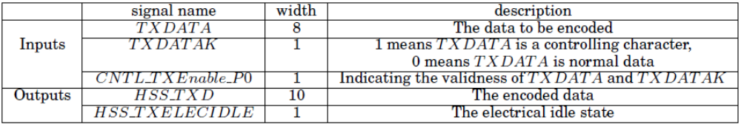

Table II. The input and output signals of the 10G Ethernet encoder
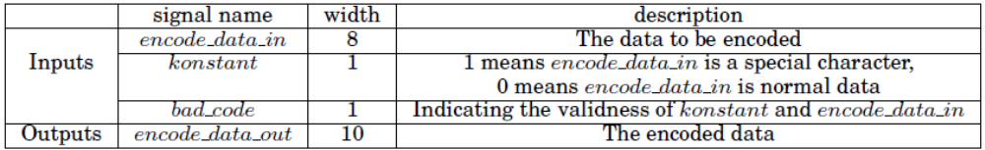

CNTL_TXEnable_P0 ≡ 1 that makes all other data signals to be uniquely determined. Finally, with the inferred predicate, generating the decoder’s Boolean functions for CNTL_TXEnable_P0, TXDATA and TXDATAK costs 3.121821 seconds. After being mapped to LSI10K library, the decoder contains 614 AND2, 198 OR2 and 22 registers, the total area being 1778.
The major breakthrough of this paper consists in its handling invalid data; so, it should be interesting to show how the invalid data is mapped to output vector [?]. By studying the source code of this encoder, we find that, when and only when CNTL_TXEnable_P0 ≡ 0 holds, that is, TXDATA and TXDATAK are invalid, the output electrical idle signal HSS_TXELECIDLE becomes 1. So, the decoder can determine the value of input signal CNTL_TXEnable_P0 with output signal HSS_TXELECIDLE.
6.2. 10G Ethernet encoder

This encoder is compliant with clause 48 of IEEE 802.3 standard [IEEE 2012a]. After deleting empty line and comments, this encoder has 214 lines of verilog. After being mapped to LSI10K library, it contains 65 AND2 gates, 192 OR2 gates, 75 inverters and 17 registers, the total area being 708.
The list of input and output signals is shown in Table II. This encoder also employs an 8b/10b encoding scheme [wikipedia 2013a] with two inputs: the 8-bit encode_data_in to be encoded and 1-bit konstant indicating a controlling character. According to the coding table in [wikipedia 2013a], when konstant ≡ 0, encode_data_in can be of any value. But when konstant ≡ 1, encode_data_in can only be 1C, 3C, 5C, 7C, 9C, BC, DC, FC, F7, FB, FD and FE. So, we write an assertion to exclude the combinations that are not in this table and embed it into the transition function T.
Algorithm 2 costs 0.619508 seconds to find out the flow control signal bad_code and Algorithm 4 1.443065 seconds to infer the predicate bad_code ≡ 0 that makes all other data signals to be uniquely determined. Finally, generating the decoder’s Boolean functions for bad_code, encode_data_in and konstant costs 2.202401 seconds. After being mapped to LSI10K library, the decoder contains 597 AND2, 174 OR2 and 30 registers, the total area being 1752.
Although this encoder uses the same coding mechanism as does the PCI Express 2.0 encoder mentioned above, the way it handles the invalid data is different. This encoder does not have a separate output signal to indicate the validness of the output data; instead, the validness is encoded in encode_data_out. By studying this encoder’s source code, we find that when and only when bad_code ≡ 1, that is, encode_data_in and konstant are invalid, the output signal encode_data_out will become 0010111101. So the decoder can use the

Table III. The input and output signals of the UltraSPARC T2 Ethernet encoder
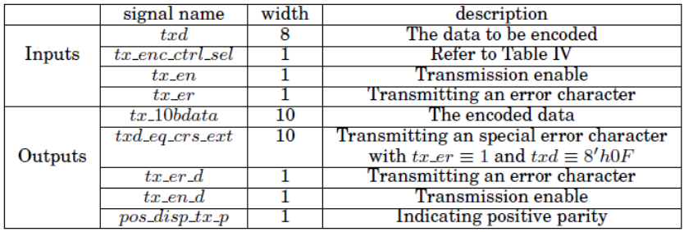

output signal encode_data_out to uniquely determine the value of the flow control signal bad_code.

6.3. UltraSPARC T2 Ethernet encoder
This encoder comes from the UltraSPARC T2 open source processor, designed by Sun Microsystems. It is compliant with clause 36 of IEEE 802.3 standard [IEEE 2012a]. After deleting empty line and comments, this encoder’s source code has 864 lines of verilog. After being mapped to LSI10K library, it contains 344 AND2 gates, 649 OR2 gates, 128 inverters and 53 registers, the total area being 2485.
The list of input and output signals is shown in Table III. This encoder also employs an 8b/10b encoding scheme [wikipedia 2013a], but with another style of flow control mechanism that is significantly different from that of the above two encoders. The data to be encoded is the 8-bit txd, but there is no standalone signal to indicate the control symbol. But, only a 4-bit tx_enc_ctrl_sel is used to define the action to be performed, as shown in Table IV. It is obvious that the functionalities of the control symbol indication and of flow control mechanism are combined in tx_enc_ctrl_sel. The last four cases in Table IV can never be uniquely determined, because they cannot be distinguished from the case of ‘PCS_ENC_DATA. So we write an assertion to rule them out.
Algorithm 2 costs 11.750317 seconds to find out the flow control signals tx_enc_ctrl_sel, tx_en and tx_er, and Algorithm 4 27.456717 seconds to infer the predicate tx_enc_ctrl_sel ≡ ‘PCS_ENC_DATA that makes all other data signals to be uniquely determined. Finally, generating the decoder’s Boolean functions for txd, tx_enc_ctrl_sel, tx_en and tx_er costs 22.156704 seconds. After being mapped to LSI10K library, the decoder contains 2245 AND2, 794 OR2 and 22 registers, the total area being 6232.
As shown in the last column of Table IV, the first 5 cases have their particular control symbol values that are assigned to tx_10bdata; so, the decoder can recover the value of the flow control signal tx_enc_ctrl_sel from the output signal tx_10bdata.
Table IV. Actions to be performed in UltraSPARC T2 Ethernet encoder
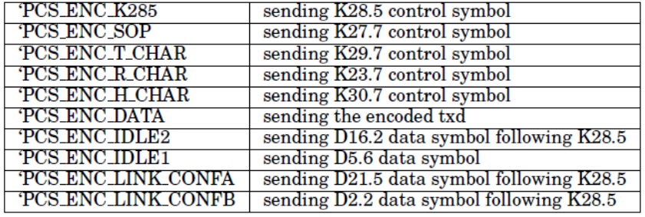

7. RELATED PUBLICATIONS
7.1. Complementary synthesis
The first complementary synthesis algorithm was proposed by [Shen et al. 2009]. It checks the decoder’s existence by iteratively increasing the bound of unrolled transition function sequence, and generates the decoder’s Boolean function by enumerating all satisfying assignments of the decoder’s output. Its major shortcomings are that it may not halt and that it has large runtime overhead in building the decoder.
Shen et al.[2011] and Liu et al.[2011] tackled the halting problem independently by searching for loops in the state sequence, while the runtime overhead problem was addressed in [Shen et al. 2012; Liu et al. 2011] by Craig interpolant [McMillan 2003].
Shen et al.[2012] automatically inferred an assertion for configuration pins, which can lead to the decoder’s existence. It can be seen as a special case of Algorithm 4 in Section 4, with the restriction that the inferred assertion holds good for all cycles. Our Algorithm 4 allows states with and without the inferred assertion to be interleaved freely with each other.
Tu and Jiang [2013] propose a break-through algorithm, based on property-directed reachability analysis [Bradley 2011; Eén et al. 2011] that can take the encoder’s initial state into consideration, so that the infinite history of the encoder and the decoder can be used to generate the decoder’s output. This algorithm can handle some special encoders that cannot be handled by the state-of-the-art algorithms. But for the encoders with flow control mechanism used in our experiments, our algorithm is enough, and therefore we have not implemented their algorithm in our framework.

7.2. Program inversion
According to Gulwani [2010], program inversion involves deriving a program P⁻¹ that negates the computation of a given program P. So, the definition of program inversion is similar to complementary synthesis.
Program inversion is derived initially by using proof-based approaches [Dijkstra 1979], which could handle only very small programs and very simple syntax structures.
Glück et al. [2005] inverted first-order functional programs by eliminating nondeterminism with LR-based parsing methods. But, the use of functional languages in that work is incompatible with our complementary synthesis.
Srivastava et al. [2010; 2011] assume that inverse program is typically related to the original program, and so the space of possible inversions can be inferred by automatically mining the original program for expressions, predicates, and control flow. This algorithm inductively rules out invalid paths that cannot fulfill the requirement of inversion to narrow down the space of candidate programs until only the valid ones remain. So, it can only guarantee the existence of a solution, but not the correctness of this solution if its assumptions do not hold.

7.3. Protocol converter synthesis
Protocol converter synthesis is a process that automatically generates a translator between two different communication protocols. This is relevant to our work, because both the protocols focus on synthesizing communication circuits.
Avnit et al. [2008; 2009] first defined a general model for describing different protocols and then provided an algorithm to decide whether there is some functionality of a protocol that cannot be translated into another. Finally, they synthesized a translator by computing the greatest fixed point for the update function of the buffer’s control states. Later, they (Avnit et al.[2009]) improved their algorithm with a more efficient design space exploration algorithm.

8. CONCLUSIONS
In this paper, we propose, for the first time, a framework to handle control flow mechanism in complementary synthesis problems. Experimental results indicate that our frame-work can successfully handle many complex encoders from real industrial projects, such as PCIE [wikipedia 2013d] and Ethernet [wikipedia 2013b].

ELECTRONIC APPENDIX
The electronic appendix for this article can be accessed in the ACM Digital Library.

ACKNOWLEDGMENTS
The authors thank the anonymous reviewers for their hard work.
REFERENCES
Karin Avnit, Vijay D’Silva, Arcot Sowmya, S. Ramesh, and Sri Parameswaran. 2009. Provably Correct On-chip Communication: A Formal Approach to Automatic Protocol Converter Synthesis. ACM Transactions on Design Automation of Electronic Systems 14, 2 (March 2009), 14:1–14:41. DOI:http://dx.doi.org/10.1145/1497561.1497562
Karin Avnit and Arcot Sowmya. 2009. A Formal Approach to Design Space Exploration of Protocol Converters. In Proceedings of the Conference on Design, Automation and Test in Europe, DATE 2009 (DATE ’09). European Design and Automation Association, 3001 Leuven, Belgium, Belgium, 129–134.
Karin Avnit, Vijay D’Silvaand Arcot Sowmya, and S. Rameshand Sri Parameswaran. 2008. A Formal Approach to the Protocol Converter Problem. In Proceedings of the conference on Design, automation and test in Europe, DATE 2008 (DATE ’08). ACM Press, Munich, Germany, 294–299. DOI:http://dx.doi.org/10.1109/DATE.2008.4484695
Aaron R. Bradley. 2011. SAT-based Model Checking without Unrolling. In Verification, Model Checking, and Abstract Interpretation, 12th International Conference, VMCAI 2011, David A. Schmidt Ranjit Jhala (Ed.). Lecture Notes in Computer Science, Vol. 6538. Springer-Verlag, Berlin Heidelberg, 70–87. DOI:http://dx.doi.org/10.1007/978-3-642-18275-4_7
William Craig. 1957. Linear Reasoning: A New Form of the Herbrand-gentzen Theorem. The Journal of Symbolic Logic 22, 3 (Sept. 1957), 250–268.
Edsger W. Dijkstra. 1979. Program Inversion. In Proceeding of Program Construction, International Summer School. Springer-Verlag, London, UK, 54–57.
Niklas Eén, Alan Mishchenko, and Robert K. Brayton. 2011. Efficient Implementation of Property-directed Reachability. In Proceedings of the International Conference on Formal Methods in Computer-aided Design, FMCAD 2011 (FMCAD ’11). FMCAD Inc, Austin, TX, USA, 125–134.
Niklas Eén and Niklas Sörensson. 2003. An Extensible Sat-solver. In Theory and Applications of Satisfiability Testing, 6th International Conference, SAT 2003, Armando Tacchella Enrico Giunchiglia (Ed.). Lecture Notes in Computer Science, Vol. 2919. Springer-Verlag, Berlin Heidelberg, 502–518. DOI:http://dx.doi.org/10.1007/978-3-540-24605-3_37
Malay K. Ganai, Aarti Gupta, and Pranav Ashar. 2004. Efficient Sat-based Unbounded Symbolic Model Checking Using Circuit Cofactoring. In Proceedings of the 2004 IEEE/ACM International conference on Computer-aided design, ICCAD 2004 (ICCAD ’04). IEEE Computer Society, San Jose, CA, USA, 510–517. DOI:http://dx.doi.org/10.1109/ICCAD.2004.1382631
Robert Glück and Masahiko Kawabe. 2005. A Method for Automatic Program Inversion Based on LR(0) Parsing. Journal Fundamenta Informaticae 66, 4 (January 2005), 367–395. DOI:http://dx.doi.org/10.1109/TCAD.2012.2191288
Sumit Gulwani. 2010. Dimensions in Program Synthesis. In Proceedings of the 12th International ACM SIG- PLAN Symposium on Principles and Practice of Declarative Programming, PPDP 2010 (PPDP ’10). ACM Press, Hagenberg, Austria, 13–24. DOI:http://dx.doi.org/10.1145/1836089.1836091
IEEE. 2012a. IEEE Standard for Ethernet SECTION FOURTH. (2012). Retrieved January 25, 2013 from http://standards.ieee.org/getieee802/download/802.3-2012_section4.pdf
IEEE. 2012b. IEEE Standard for Ethernet SECTION THREE. (2012). Retrieved January 25, 2013 from http://standards.ieee.org/getieee802/download/802.3-2012_section3.pdf
Hsiou-Yuan Liu, Yen-Cheng Chou, Chen-Hsuan Lin, and Jie-Hong R. Jiang. 2011. Towards Completely Automatic Decoder Synthesis. In Proceedings of the 2011 International Conference on Computer-aided Design, ICCAD 2011 (ICCAD ’11). IEEE Press, San Jose, CA, USA, 389–395. DOI:http://dx.doi.org/10.1109/ICCAD.2011.6105359
Kenneth L. McMillan. 2003. Interpolation and Sat-based Model Checking. In Computer-aided Verification, 15th International Conference, CAV 2003, Fabio Somenzi Warren A. Hunt Jr. (Ed.). Lecture Notes in Computer Science, Vol. 2725. Springer-Verlag, Berlin Heidelberg, 1–13. DOI:http://dx.doi.org/10.1007/978-3-540-45069-6_1
PCI-SIG. 2009. PCI Express Base 2.1 Specification. (2009). Retrieved January 25, 2013 from http://www. pcisig.com/members/downloads/specifications/pciexpress/PCI_Express_Base_r2_1_04Mar09.pdf
ShengYu Shen, Ying Qin, KeFeiWang, Zhengbin Pang, Jianmin Zhang, and Sikun Li. 2012. Inferring Assertion for Complementary Synthesis. IEEE Transactions on Computer-aided Design of Integrated Circuits and Systems 31, 8 (August 2012), 31:1288–31:1292. DOI:http://dx.doi.org/10.1109/TCAD.2012.2190735
ShengYu Shen, Ying Qin, KeFei Wang, LiQuan Xiao, Jianmin Zhang, and Sikun Li. 2010. Synthesizing Complementary Circuits Automatically. IEEE Transactions on Computer-aided Design of Integrated Circuits and Systems 29, 8 (August 2010), 29:1191–29:1202. DOI:http://dx.doi.org/10.1109/TCAD.2010.2049152
ShengYu Shen, Ying Qin, LiQuan Xiao, KeFei Wang, Jianmin Zhang, and Sikun Li. 2011. A Halting Algorithm to Determine the Existence of the Decoder. IEEE Transactions on Computer-aided Design of Integrated Circuits and Systems 30, 10 (October 2011), 30:1556–30:1563. DOI:http://dx.doi.org/10.1109/TCAD.2011.2159792
ShengYu Shen, Jianmin Zhang, Ying Qin, and Sikun Li. 2009. Synthesizing Complementary Circuits Automatically. In Proceedings of the 2009 International Conference on Computer-aided Design (ICCAD ’09). IEEE Press, San Jose, CA, USA, 381–388. DOI:http://dx.doi.org/10.1145/1687399.1687472
S. Srivastava, S. Gulwani, S. Chaudhuri, and J. Foster. 2010. Program Inversion Revisited. Technical Report MSR-TR-2010-34. Microsoft Research.
Saurabh Srivastava, Sumit Gulwani, Swarat Chaudhuri, and Jeffrey S. Foster. 2011. Path-based Inductive Synthesis for Program Inversion. In Proceedings of the 32nd ACM SIGPLAN Conference on ProgrammingLlanguage Design and Implementation, PLDI 2011 (PLDI ’11). ACM Press, San Jose, CA, USA, 492–503. DOI:http://dx.doi.org/10.1145/1993498.1993557
Kuan-Hua Tu and Jie-Hong R. Jiang. 2013. Synthesis of Feedback Decoders for Initialized Encoders. In Proceedings of the 50th Annual Design Automation Conference, DAC 2013 (DAC ’13). ACM Press, Austin, TX, USA, 1–6. DOI:http://dx.doi.org/10.1145/2463209.2488794
wikipedia. 2013a. 8b/10b encoding. (25 Jan. 2013). Retrieved January 25, 2013 from http://en.wikipedia.org/wiki/8b/10b_encoding
wikipedia. 2013b. Ethernet. (25 Jan. 2013). Retrieved January 25, 2013 from http://en.wikipedia.org/wiki/Ethernet
wikipedia. 2013c. Flow control. (25 Jan. 2013). Retrieved January 25, 2013 from http://en.wikipedia.org/wiki/Flow_control_(data)
wikipedia. 2013d. PCI Express. (25 Jan. 2013). Retrieved January 25, 2013 from http://en.wikipedia.org/wiki/PCI_Express

