哈尔滨工业大学深圳研究生院
2008年 秋 季学期期末考试试卷
HIT Shenzhen Graduate School Examination Paper
Course Name: Lecturer:
Question | One | Two | Three | Four | Five | Six | Seven | Eight | Nine | Ten | Total
Mark
General directions:
This exam is closed book. You may not use the text book, your notes, computer, or any other materials during the exam.
No credit will be given for questions left unanswered, so you should be sure to answer all questions, even if you are only taking your best guess.
Write your answer to each question or problem in the paper provided. If necessary, extra sheets will be provided. Make sure your name is written on all of these pages.
Please be sure to write neatly and answer all questions unambiguously.
This exam has a total of _100_ points, and you have 120 minutes.
Time: 09:00-11:00, Monday, Dec. 8, 2008

Error: Reference source not found Single choice [10 points]
1、Which of the following sorting algorithms is not stable? ( B )
(A) Insertion sort (B) Quick sort
(C) Merge sort (D) Bubble sort
2、We say that 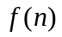is asymptotically larger than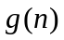if ( D ).
(A) 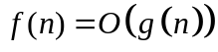 (B) 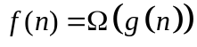
(C) 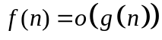 (D) 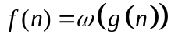
3、An order-statistic tree is an augmented red-black tree. In addition to its usual fields, each node x has a field
size[x], which is the number of nodes in the subtree rooted at x , For an order-statistic tree with n nodes, the time for insertion, deletion and maintenance of the size field are ( A )
(A) 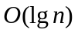
(B) 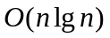
(C) 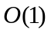
(D) 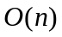
4、There’s a B-tree whose minimum degree is t, every node other than the root must have at least __ keys, at most __ keys, every internal node other than the root has at least __ children ( B ).
(A) t-1 2t t (B) t-1 2t-1 t
(C) t 2t t+1 (D) t-1 2t+1 t
5、Which of the following statements about P, NP,NPC is correct? ( C )
(A) P = NP , NPC 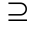 NP (B) P NP , NPC P
(C) P NP , NPC NP (D) P = NPC , P NP

Error: Reference source not found short answer [30 points]
- Consider inserting the keys 10, 22, 31, 4, 15, 28, 17, 88, 59 into a hash table of length m = 11 using open addressing with the primary hash function h1(k) = k mod m. Illustrate the result of inserting these keys using linear probing, using quadratic probing with c1 = 1 and c2 = 3. The final results are required to be expressed as charts. [6 points]

Linear probing:
0 | 1 | 2 | 3 | 4 | 5 | 6 | 7 | 8 | 9 | 10
22 | 88 |  |  | 4 | 15 | 28 | 17 | 59 | 31 | 10
Quadratic probing:
0 | 1 | 2 | 3 | 4 | 5 | 6 | 7 | 8 | 9 | 10
22 |  | 88 | 17 | 4 |  | 28 | 59 | 15 | 31 | 10

- Use the arithmetic expression ((a+b)+c*(d+e)+f)*(g+h) to construct a binary tree. [6 points]

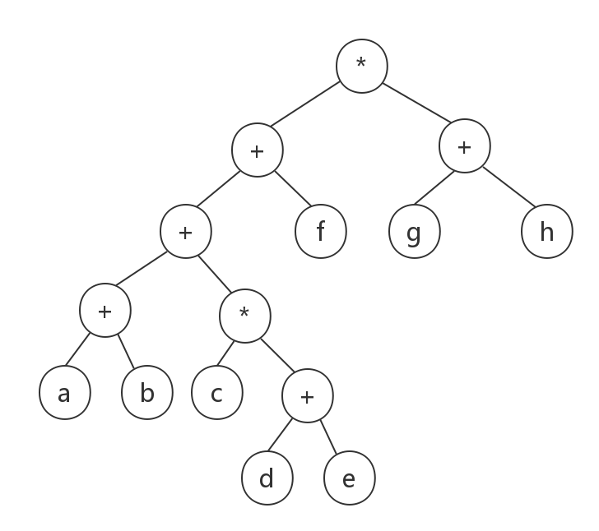

- Explain how to implement two stacks in one array A[1 .. n] in such a way that neither stack overflows unless the total number of elements in both stacks together is n. The PUSH and POP operations should run in O(1) time. [6 points]

The stack 1’s bottom is A[1], then push elements from left to right. The stack 2’s bottom is A[n], then push elements form right to left. They grow in opposite direction. Only if the top of stack 1 are adjacent to the top of stack 2, the stacks are full, which contains n elements totally.

- Tell the difference between dynamic programming and greedy programming. [6 points]

DP considers all possible sequences in order to obtain the optimum solution; Greedy programming do not always yield optimal solutions, it just chooses the best choice in every step.
DP determines the best choices is overkill; Greedy programming is simpler and more efficient.
The elements of dynamic programming: optimal substructure, overlapping subproblem; The elements of greedy programming: optimal substructure, greedy choice property

- We are given a directed graph G=(V, E) on which each edge (u, v)∈E has an associated value r(u, v), which is a real number in the range 0 ≤ r(u, v) ≤ 1 that represents the failure rate of a communication channel from vertex u to vertex v. We assume that these probabilities are independent. Give an efficient algorithm to find the most reliable path between two given vertices. [6 points]

Any minimum spanning tree algorithm is OK.

Error: Reference source not found [60 points]
11、Consider the searching problem:
- Input: A sequence of n numbers A = 〈a₁, a₂, . . . , a_{n}〉 and a value v.
- Output: An index i such that v = A[i] or the special value NIL if v does not appear in A.
Write pseudocode for linear search, which scans through the sequence, looking for v. Using a loop invariant, prove that your algorithm is correct. Make sure that your loop invariant fulfills the three necessary properties. [10 points]
SEARCH(A, v):
for i = 1 to A.length
if A[i] == v
return i
return NIL
At the start of each iteration of the for loop, the subarray A[1..i−1] consists of elements that are different than ν.
Initialization: Now i=1, if A[i] = v, then we return the index 1, if A[i]! = v, then until now we are sure that there is no v in the array.
Maintenance: On each step, we know that A[1..i−1] does not contain ν. We compare it with A[i]. If they are the same, we return i, which is a correct result. Otherwise, we continue to the next step. We have already insured that A[A..i−1] does not contain ν and that A[i] is different from ν, so this step preserves the invariant.
Termination: The loop terminates when i>A.length. Since i increases by 1 and i>A.length, we know that all the elements in A have been checked and it has been found that ν is not among them. Thus, we return NIL.

- Use a recursion tree to give an asymptotically tight solution to the recurrence T(n) = T(αn) + T((1 - α)n) + cn, where α is a constant in the range 0 <α < 1 and c > 0 is also a constant. [12 points]

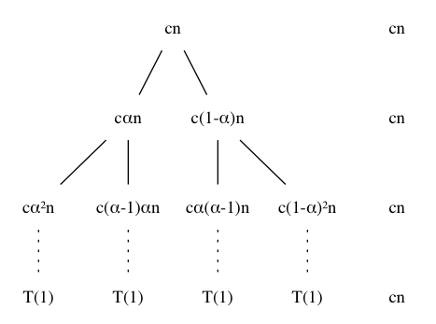
Because α is uncertain ,there is three situations:
a. 0 < α < 1/2 b. α = 1/2 c. 1 > α > 1/2
The value of α will influence the height of the recursion tree ,but the final answer is the same, so we just consider α = 1/2 here.
The 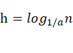, so the 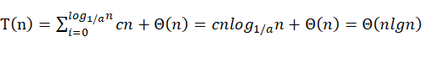.

13、A red-black tree is a binary search tree with one extra bit of storage per node: its color, which can be either RED or BLACK, and the red-black is a nearly balanced tree. [13 points]
1) A binary search tree is a red-black tree if it satisfies the following red-black properties:
- Every node is either red or black.
- The root is black.
- Every leaf (NIL) is black.
- (1) Every path from node to descendent leaf contains the same number of black nodes.
- (2) If a node is red, both children are black.
Please give the missing property 4 and property 5. [2 points]
- What is the largest possible number of internal nodes in a red-black tree with black-height k? What is the smallest possible number? [3 points]

Largest number: 2^{2k} - 1
Smallest number: 2^{k} - 1

3) There is the RBT insertion pseudo-code ,which insert a given node z into a RBT T. Suppose you can use LEFT-ROTATE(T, z) and RIGHT-ROTATE(T, z) operation directly ,Please fill the blank! [8 points]

RB-INSERT(T, z)
1 y ← nil[T]
2 x ← root[T]
3 while x ≠ nil[T]
4 do y ← x
5 if key[z] < key[x]
6 then x ← left[x]
7 else (1) x ← right[x]
8 p[z] ← y
9 if y = nil[T]
10 then root[T] ← z
11 else if key[z] < key[y]
12 then (2)left[y] ← z
13 else right[y] ← z
14 left[z] ← nil[T]
15 right[z] ← nil[T]
16 (3)color[z]=RED
17 RB-INSERT-FIXUP(T, z)

RB-INSERT-FIXUP(T, z)
1 while color[p[z]] = RED
2 do if p[z] = left[p[p[z]]]
3 then y ← right[p[p[z]]]
4 if color[y] = RED
5 then (4) color[p[z]]=BLACK ▹ Case 1
6 (5) color[y]=BLACK ▹ Case 1
7 (6) color[p[p[z]]]=RED ▹ Case 1
8 z ← p[p[z]] ▹ Case 1
9 else if z = right[p[z]]
10 then z ← p[z] ▹ Case 2
11 (7) LEFT-ROTATE(T, z) ▹ Case 2
12 color[p[z]] ← BLACK ▹ Case 3
13 (8) color[p[p[z]]]=RED ▹ Case 3
14 RIGHT-ROTATE(T, p[p[z]]) ▹ Case 3
15 else (same as then clause with "right" and "left" exchanged)
16 color[root[T]] ← BLACK

- Find an optimal parenthesizing of a matrix-chain product whose sequence of dimensions is <5, 10, 3, 12, 5, 50, 6 >. [10 points]

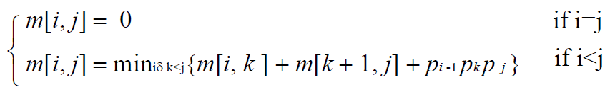

m |  | 1 |  | 2 |  | 3 |  | 4 |  | 5 |  | 6
1 |  | 0 |  | 150 |  | 330 |  | 405 |  | 1655 |  | 2010
2 |  |  |  | 0 |  | 360 |  | 330 |  | 2430 |  | 1950
3 |  |  |  |  |  | 0 |  | 180 |  | 930 |  | 1770
4 |  |  |  |  |  |  |  | 0 |  | 3000 |  | 1860
5 |  |  |  |  |  |  |  |  |  | 0 |  | 1500
6 |  |  |  |  |  |  |  |  |  |  |  | 0

s |  | 1 |  | 2 |  | 3 |  | 4 |  | 5 |  | 6
1 |  | 0 |  | 1 |  | 2 |  | 2 |  | 4 |  | 2
2 |  |  |  | 0 |  | 2 |  | 2 |  | 2 |  | 2
3 |  |  |  |  |  | 0 |  | 3 |  | 4 |  | 4
4 |  |  |  |  |  |  |  | 0 |  | 4 |  | 4
5 |  |  |  |  |  |  |  |  |  | 0 |  | 5
6 |  |  |  |  |  |  |  |  |  |  |  | 0

((A1A2)((A3A4)(A5A6)))

15、 A full k-tree with the depth L has the following properties: All the nodes on the Lth layer are leaves; Every node on other layers has k non-empty subtrees. If we number all the nodes from the first layer to the Lth layer and from left to right with 1,2,3..., please answer the following questions: [15 points]
1) How many nodes does the i^{th} layer have? [3 points]

k^{h-1}

- What is the number of the parent of node n, if it exists. [4 points]

suppose the parent is i, if the student can give “(i-1)k+2<=n<=ik+1” , take it right

- What is the number of the i^{th} child from left of node n, if it exists. [4 points]

(n-1)*k+1+i

4) In what condition does node n have a right brother? If it has, what is the number of its right brother? [4 points]

If it has a right brother, than it must not be the first child from right of its parent, which is (n-1)%k!=0, the number of its right brother is n+1

