- Using figure to illustrate the operation of RADIX-SORT on the following list of English words: COW, DOG, SEA, RUG, ROW, MOB, BOX, TAB.
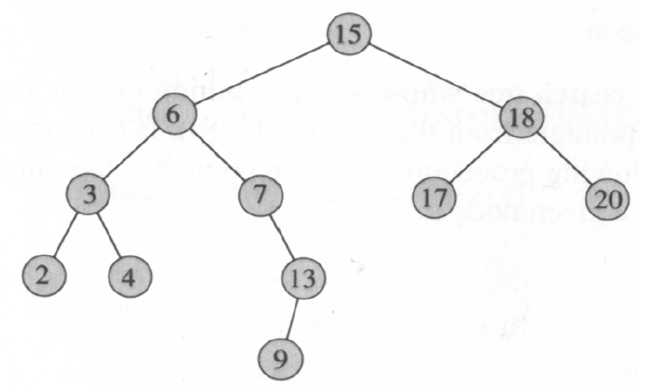
- Please write inorder, preorder and postorder tree walks of the following binary search tree.

- Please write down the elements of dynamic programming.
- Using a recursion tree to give an asymptotically tight solution to the recurrence T(n) = T(n/3)+T(2n/3)+cn.
- Please give an optimal Huffman code for the following set of frequencies.

a b c d e f
Frequency 5 9 16 12 13 45
- Converting the following linear program into standard form:
Minimize 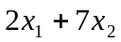
Subject to 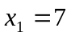
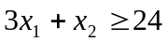
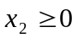
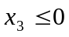
- Solve the following linear program using SIMPLEX:
maximize 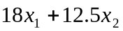
Subject to 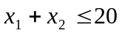
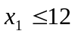
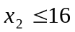
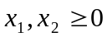
- Suppose A1 a 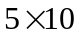 matrix, A2 a 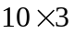 matrix, A3 a 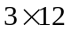 matrix, A4 a 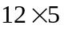 matrix, A5 a 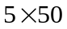 matrix, A6 a 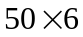 matrix. Please give an optimal parenthesization of a matrix-chain A1A2A3A4A5A6.
- Using a recursion tree to give an asymptotically tight solution to the recurrence T(n) = T(n/4)+T(n/2)+ n².
- Using figure to illustrate the operation of COUNTING-SORT on the array A=<6,0,2,0,1,3,4,6,1,3,2>
- Using figure to illustrate the operation of RADIX-SORT on the following list of English words: COW, DOG, SEA, RUG, ROW, MOB, BOX, TAB.
- Please write inorder, preorder and postorder tree walks of the following binary search tree.
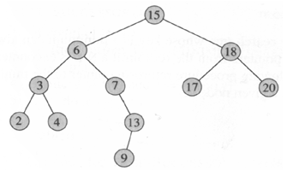
- X=<A, E, B, D, B, C, A, E>, Y=<E, F, B, A, C, A, F, E>. Please illustrate the whole procedure for finding the longest common sequence of X and Y using dynamic programming.
- Please give an optimal Huffman code for the following set of frequencies.
- Please draw the result after the operation Left-Rotate(9)
.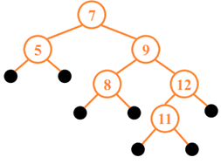
- X=<A, E, B, D, B, C, A, E>, Y=<E, F, B, A, C, A, F, E>. Please illustrate the whole procedure for finding the longest common sequence of X and Y using dynamic programming.
- Please give an optimal Huffman code for the following set of frequencies.
a b c d e f
Frequency 15 19 6 12 13 35
- A red-black tree (RB tree) is a binary search tree with one extra bit of storage per node: its color, which can be either RED or BLACK, and the red-black is a nearly balanced tree. Please prove n-node RB tree has height 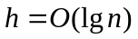
- Solve the following linear program using SIMPLEX:
maximize
Subject to
- In the activity-selection problem, 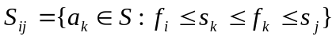 represents the activities that start after an activity 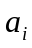 finishes and finish before one activity 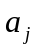 starts. Here, an activity occurs during period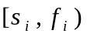, and activities are sorted by monotonically increasing finish time. Let 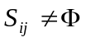, and let 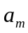 be the activity in 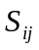 with the earliest finish time: 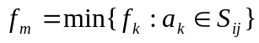. Then prove 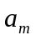 is used in some maximum-size subset of mutually compatible activities of

