- Using figure to illustrate the operation of RADIX-SORT on the following list of English words: COW, DOG, SEA, RUG, ROW, MOB, BOX, TAB.
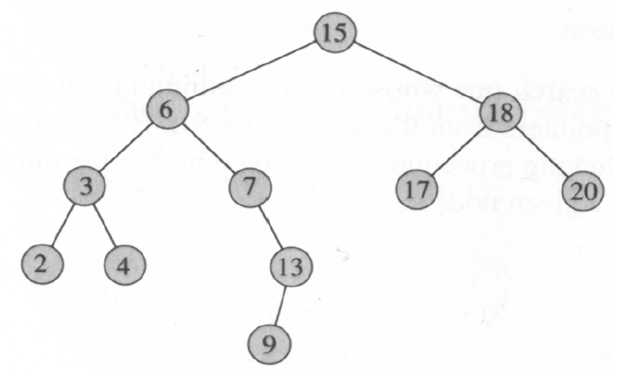
- Please write inorder, preorder and postorder tree walks of the following binary search tree.

- Please write down the elements of dynamic programming.
Using a recursion tree to give an asymptotically tight solution to the recurrence T(n) = T(n/3)+T(2n/3)+cn.
12、Please give an optimal Huffman code for the following set of frequencies.

a b c d e f
Frequency 5 9 16 12 13 45
13、 Converting the following linear program into standard form:
Minimize 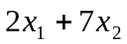
Subject to 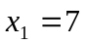
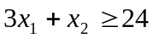
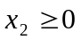
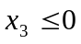
14、 Solve the following linear program using SIMPLEX:
maximize 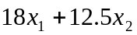
Subject to 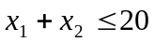
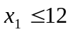
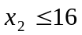
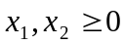
15、Suppose A₁ a 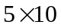 matrix, A₂ a 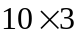 matrix, A₃ a 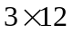 matrix, A₄ a 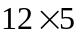 matrix, A₅ a 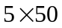 matrix, A₆ a 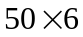 matrix. Please give an optimal parenthesization of a matrix-chain A₁A₂A₃A₄A₅A₆.

