- B
- D
- A
- B
- C
6、
Linear probing Quadratic probing
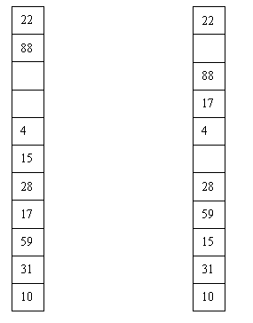
7、
*
+
+
g
h
f
+
+
*
a
b
+
c
d
e

8、Two stacks can be implemented in a single array without overflows occurring if they grow from each end and towards the middle.

9、The elements of dynamic programming: optimal substructure, overlapping
The elements of greedy programming: optimal substructure, greedy choice property
They share the optimal substructure property, but we may not use dynamic programming when a greedy solution suffices, or reverse.
The greedy choice property is that a globally optimal solution can be arrived at by making a locally optimal (greedy) choice. We must prove that a greedy choice at each step yields a globally optimal solution. First consider a globally optimal solution, and then modify the optimal solution, to make it to begin as a greedy choice.

10、Any minimum spanning tree algorithm is OK.

11、Searching(A)
for i1 to length(A)
do
if A[i] = v
return i
return NIL

Loop invariant proof:
Initialization:
Loop invariant holds before the first loop iteration. Now i=1, if A[i] = v, then we return the index 1, if A[i]! = v, then until now we are sure that there is no v in the array!
Maintenance:
Each iteration maintains the loop invariant. The for loop compare v to the current array element A[i], to make sure there is no v in A[1…i-1], if A[i] = v, then we return the index i.
Termination:
If there is an element matched, the index is returned from early detect, or the program will return a NIL if we come to the end. So the loop invariant holds.

12、Use a recursion tree to give an asymptotically tight solution to the recurrence T(n) = T(αn) + T((1 - α)n) + cn, where α is a constant in the range 0 <α < 1 and c > 0 is also a constant
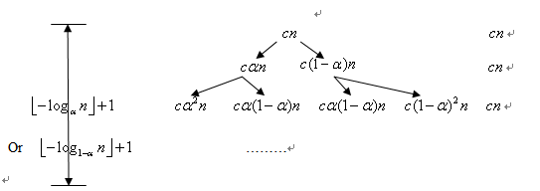
Because α is uncertain ,there is three situations:
a. 0 < α < 1/2 b. α = 1/2 c. 1 > α > 1/2
The value of α will influence the height of the recursion tree ,but the final answer is the same, so we just consider α = 1/2 here.
From the recursion tree, we can calculate :
T(n) =(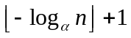)*cn
=Θ(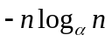)
=Θ（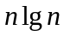）

13、
1）
4.If a node is red, then both its children are black.
5.For each node, all paths from the node to descendant leaves contain the same number of black nodes.

2）
Consider a red-black tree with black-height k. If every node is black the total number of internal nodes is 2^{k} - 1. If only every other nodes is black we can construct a tree with 2^{2k} - 1 nodes.

3）
RB-INSERT(T, z)
1 y ← nil[T]
2 x ← root[T]
3 while x ≠ nil[T]
4 do y ← x
5 if key[z] < key[x]
6 then x ← left[x]
7 else x ← right[x]
8 p[z] ← y
9 if y = nil[T]
10 then root[T] ← z
11 else if key[z] < key[y]
12 then left[y] ← z
13 else right[y] ← z
14 left[z] ← nil[T]
15 right[z] ← nil[T]
16 color[z] ← RED
17 RB-INSERT-FIXUP(T, z)

RB-INSERT-FIXUP(T, z)
1 while color[p[z]] = RED
2 do if p[z] = left[p[p[z]]]
3 then y ← right[p[p[z]]]
4 if color[y] = RED
5 then color[p[z]] ← BLACK ▹ Case 1
6 color[y] ← BLACK ▹ Case 1
7 color[p[p[z]]] ← RED ▹ Case 1
8 z ← p[p[z]] ▹ Case 1
9 else if z = right[p[z]]
10 then z ← p[z] ▹ Case 2
11 LEFT-ROTATE(T, z) ▹ Case 2
12 color[p[z]] ← BLACK ▹ Case 3
13 color[p[p[z]]] ← RED ▹ Case 3
14 RIGHT-ROTATE(T, p[p[z]]) ▹ Case 3
15 else (same as then clause
with "right" and "left" exchanged)
16 color[root[T]] ← BLACK

14、
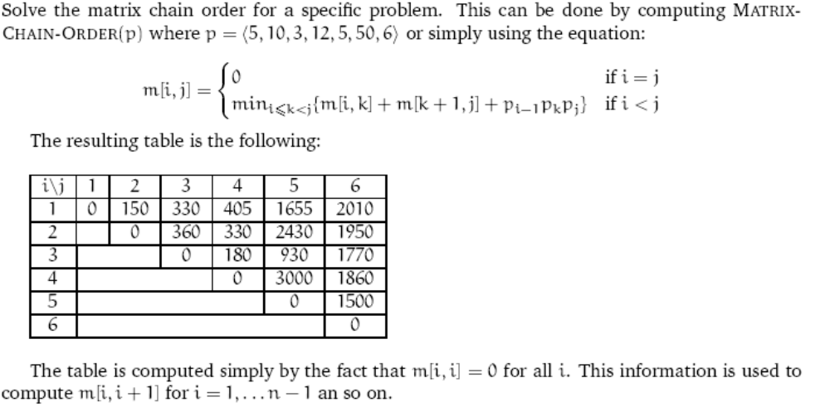
The final result is ((A₁A₂)((A₃A₄)(A₅A₆))) (Detailed process is omit here).

15、
1）k^{h-1}
2）suppose the parent is i, if the student can give “(i-1)k+2<=n<=ik+1” , take it right
3) (n-1)*k+1+i
4) If it has a right brother, than it must not be the first child from right of its parent, which is (n-1)%k!=0, the number of its right brother is n+1

