**HOMEWORK PROBLEMS #2**

**2-1**Are the following two graphs Eulerian, semi-Eulerian, non-Eulerian, Hamiltonian, semi-Hamiltonian, and/or non-Hamiltonian graphs?

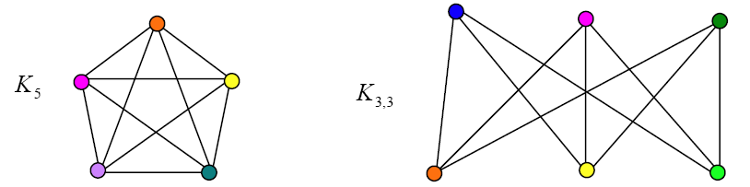

**2-2** Find the shortest path length from A to G in the following graph:

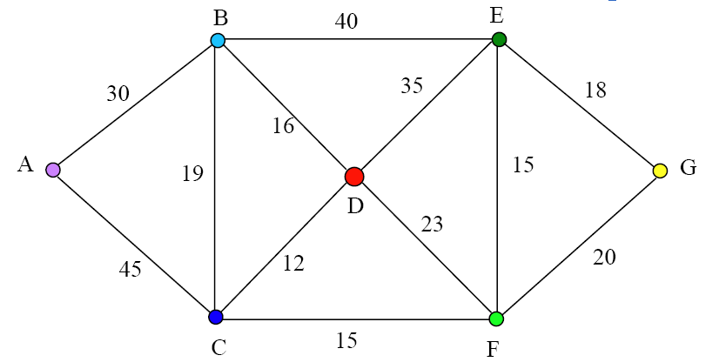

**2-3** Solve the following Chinese postman problem:

