**HOMEWORK PROBLEMS #3**

**3-1** Can you find a disconnected graph such that its complementary graph is also disconnected? If so, show an example; if not, tell why.

**Answer:**

We can not show an example because complementary graph of disconnected graph is connected.

It is in general not true that each vertex in V1 will be adjacent to all other vertices in V1. That would only be the case with graphs that are a union of several complete graphs.  
So the complementary graph is certainly not always a complete bipartite graph, it could have more edges as well. But the important thing here is that this complete bipartite graphs is always a subgraph of G¯ containing all vertices of G¯. Therefore it is indeed connected.

**3-2** Consider a computer network in a lab, as shown by the following figure, where each node is a computer (Router or PC) and the numbers indicate the lengths of optical fibers needed if the computers are connected.

(a) Design a best cost-effective Personal Area Network (PAN) by connecting all nodes together, so that every computer can communicate with every other one while the total optical fiber used is the shortest possible. Explain your steps, and what is the total length of optical fibers you need?

(b) Find the shortest path from computer A to computer B, which uses the shorter possible optical fiber. Show your reasoning.

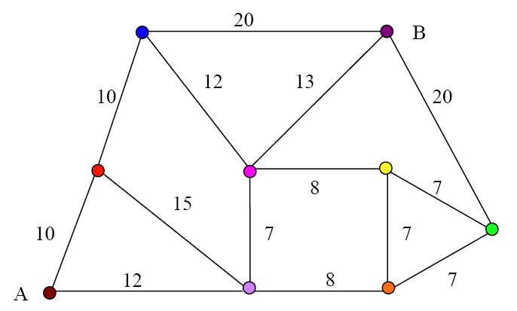

**ANSWER:**

a)

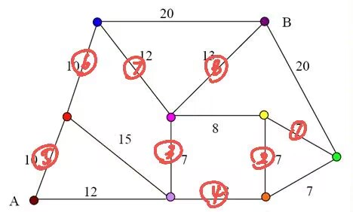

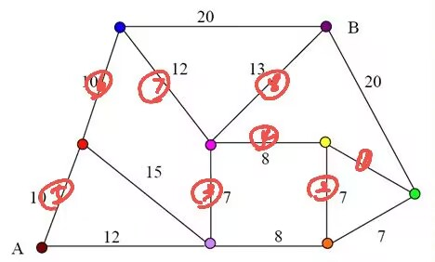

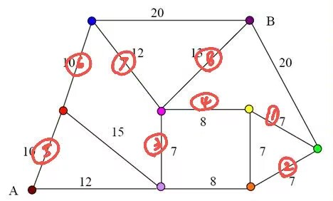

We can use Kruskal algorithm for minimal spanning tree

We can find many approaches in this problem. Each cost is same.

The total cost is 7+7+7+8+10+10+12+13 = 74

b)

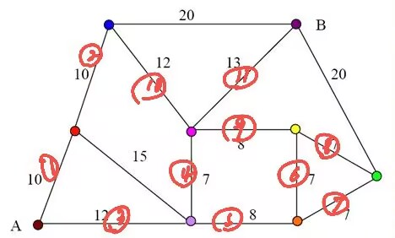

We can use Single-source shortest path – Dijkstra's algorithm

L(red) = 10

L(blue)=20

L(purple)=12

L(pink)=19

L(orange)=20

L(yellow) = 27

L(green) = 27 L(B)=L(green)+20 = 47

L(yellow) =min ( L(green)+7 , 27) = 27

L(pink) =min ( L(yellow)+8 , 19) = 19

L(B)= min( 47,L(pink)+13 ) = 32

We find the shortest path is 12+7+13 = 32

