**HOMEWORK PROBLEMS #4**

**4-1** Find the 1-core, 2-core, … of the following network, and the coreness of each colored node:

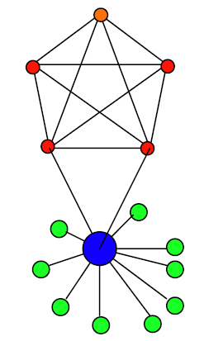

**ANSWER:**

1-core:



2-core:

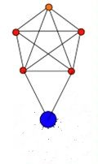

3-core and 4-core:

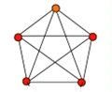

coreness 1: green nodes

coreness 2: blue nodes

coreness 4: red and orange nodes

**4-2** Find the node-betweenness of Node *A* and edge-betweenness of Edge *e* in the following network:

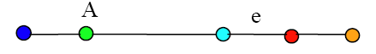

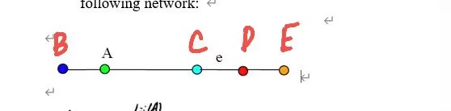

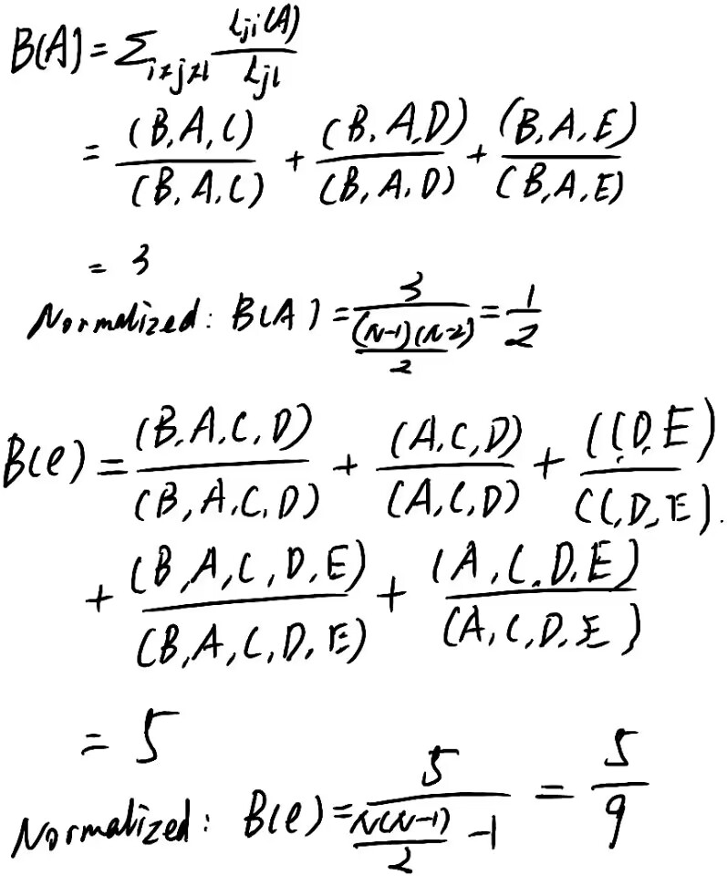

**4-3**

(a) Assume that the Internet is a scale-free non-hierarchical network, and you have all real data about the topology of such an Internet model stored on your computer. You may write a program to compute the degrees of all nodes (Routers and PCs) and then identify a hub (Router) by comparing their degrees, which is a straightforward exhaustive search scheme but is obviously very expensive using global information. Design a simple and cost-effective algorithm that utilizes only local information but can very likely find a hub in just two or three steps.

(b) Assume that a social community is a small-world network, and an epidemic is now spreading over it. You may vaccine everybody to prevent the cascading virus propagation, which is a straightforward exhaustive immunization scheme but is obviously very expensive. Design a simple and cost-effective vaccine strategy that immunize only a small number of people but may effectively block the virus spreading over the community.

ANSWER:

a) calculate the coreness of the graph ,remove the node which of degree less than k-1and keep hubs and routers the largest coreness node in the graph.

b) we can simulate acquaintance immunization. Select a few people randomly and select their acquaintances .Let these people newly select be immunized .Then vaccinate people who has the most acquaintances from the acquaintances of each selected person.

**This HW is due in class on Thursday, 20 Oct. 2022**