**HOMEWORK PROBLEMS #2**

**2-1**Are the following two graphs Eulerian, semi-Eulerian, non-Eulerian, Hamiltonian, semi-Hamiltonian, and/or non-Hamiltonian graphs?

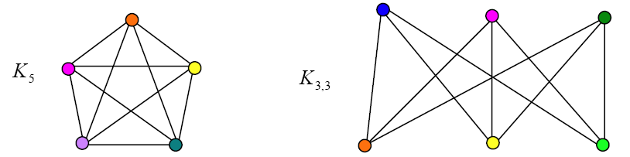

K5 is Eulerian, because the number of points with odd degrees is 0. Also, K5 is connected and there can be no isolated points.

K33 is a non-Eulerian, because the number of points with odd degrees is 6,not 2, so it is not a semi-Eulerian.

K5 and K33 are Hamiltonian.

We can find the way

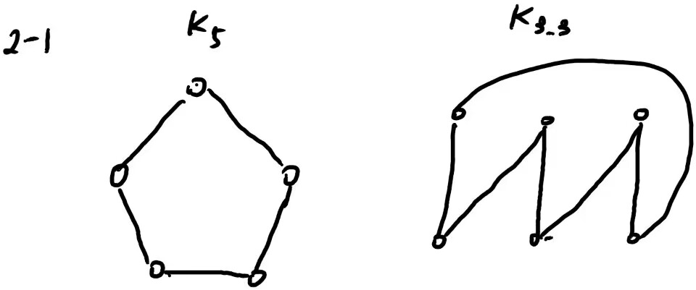

**2-2** Find the shortest path length from A to G in the following graph:

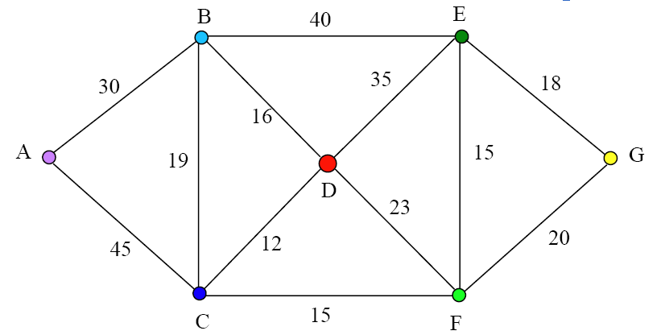

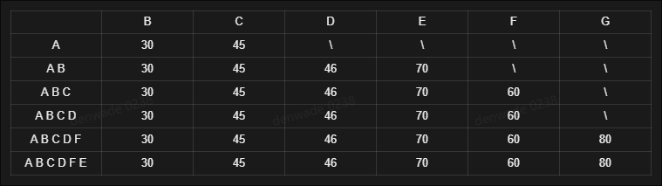

We can use the Dijkstra

Path= A -> C -> F-> G the shortest length = 80

**2-3** Solve the following Chinese postman problem:

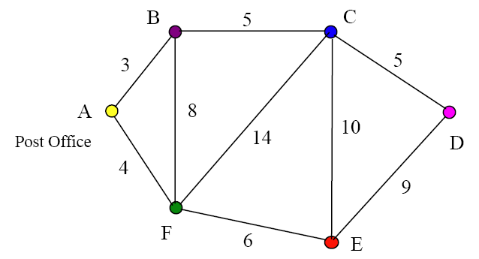

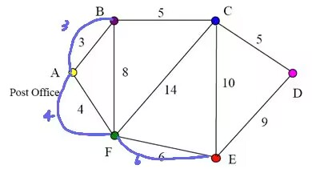

We use Tpl represents “Total path-length”, add three edges

For each loop, we can find the increment is not longer than the original loop

So it is a solution

A -> F -> E -> D -> C -> D -> F -> C -> B -> A -> B -> F -> A

And total path length is 3+3+4+4+6+6+8+5+14+10+5+9 = 77