CSA1214 – COMPUTER ARCHITECTURE

Design and Development of an Integrated CPU
Instruction Execution and Performance Analysis System for Processor Optimization
An assignment report presenting the design, implementation, analysis and evaluation of a deterministic processor simulator that executes an 8085/8086–class instruction set, models bus organisations, and quantifies processor performance.

Department | Computer Science and Engineering
Programme | B.Tech. – Computer Science and Engineering
Course Code and Name | CSA1214 – Computer Architecture
Academic Year / Batch | [2023 – 2027]
Faculty Name | Radhika S
Assignment Title | Design and Development of an Integrated CPU Instruction Execution and  Performance Analysis System for Processor Optimization
Date of Issue | [01 / 08 / 2026]
Date of Submission | [02 / 09 / 2026]
Maximum Marks | 100
Team Members | Shen Ivin Clement (192371023) Sri Ram Vekatesan (192372116) U.Teja Gowd (192572059)

Course Outcomes, Bloom’s Levels and Sustainability Mapping

Course Outcomes addressed
CO | Statement (as mapped in this assignment)
CO1 | Analyze the functional units of a computer system including CPU, memory, bus structures and I/O components by examining instruction execution cycles, addressing modes and performance metrics such as CPI, clock cycles and benchmarking.
CO2 | Apply integer and floating-point arithmetic algorithms including Booth’s multiplication, restoring / non-restoring division and IEEE 754 operations to solve fixed-point and floating-point computational problems.
CO3 | Design processor organization by constructing pipelined data-path structures, identifying hazard types (data, control, structural) and comparing superscalar techniques such as out-of-order execution, speculative execution and SMT.

Bloom’s Taxonomy levels exercised
- L3 – Apply: implementing arithmetic algorithms, addressing modes and the instruction cycle in working code.
- L4 – Analyze: decomposing execution time into instruction-class contributions to locate bottlenecks.
- L5 – Evaluate: benchmarking alternative bus and processor configurations against quantitative metrics.
- L6 – Create: designing and building the integrated simulator itself as an original engineering artefact.

SDG and industry relevance
The assignment is mapped to SDG 7 (Affordable and Clean Energy), SDG 8 (Decent Work and
Economic Growth), SDG 9 (Industry, Innovation and Infrastructure) and SDG 12 (Responsible Consumption and Production). Processor optimisation is fundamentally an energy problem: every cycle a program avoids is energy not spent. Because performance per watt drives the cost and carbon footprint of everything from embedded controllers to data-centre fleets, the analysis techniques exercised here – CPI reduction, cache/bus optimisation and workload-aware configuration choice – are the same ones industry uses to build faster, cheaper and more sustainable computing systems.

1. Problem Understanding and Formulation
1.1 What is the problem?
A computer executes every instruction through a repeating sequence of stages – instruction fetch, decode, operand access and execute – while data continually moves between the CPU, memory and I/O across the system bus. The time a program takes is therefore not a single number but the product of three interacting factors: how many instructions run, how many clock cycles each takes on average (CPI), and how fast the clock ticks. The problem set for this assignment is to design, implement, analyse and evaluate an integrated system that models these functional units, executes real instructions through an explicit fetch–decode–execute cycle, measures the standard performance metrics, exposes where the cycles are actually being spent, and uses that evidence to compare configurations and justify an optimised design.

1.2 Expected outcomes
- A working simulator that models the CPU (registers, ALU, control unit), main memory and I/O ports.
- An explicit instruction-execution engine that exposes the micro-operations (register transfers) of fetch, decode and execute.
- Support for multiple addressing modes and an 8085/8086-style instruction set with defined instruction formats.
- ALU-level binary/hexadecimal and signed arithmetic with correct status-flag behaviour, plus Booth’s multiplication and restoring division.
- Models of single-bus, multi-bus and hierarchical bus organisations and a quantitative comparison of their data-transfer cost.
- Computation of CPU execution time, clock cycles, CPI and instruction execution rate (MIPS), with bottleneck identification.
- A comparative study of processor configurations leading to an evidence-based optimisation recommendation.

1.3 Information / data available
The workload analysed is a representative benchmark kernel – the summation of an N-element byte array – that exercises data-transfer, load, ALU, branch, store and I/O instruction classes inside a loop. Per-instruction timing is taken from documented 8085 T-state counts, which fixes the number of clock cycles each instruction class consumes. All other quantities (instruction counts, cycle totals, transfer counts) are measured by executing the program on the simulator rather than assumed.

1.4 Assumptions
- An 8-bit data path with a 16-bit address space (64 KB), consistent with the 8085 family.
- Instruction timing is expressed in clock cycles (T-states); one memory word transfer is charged to the bus per fetch and per data access.
- For the analytical configuration study the same dynamic instruction count is executed on every processor, isolating the effect of CPI and clock rate.
- The bus model assumes DRAM main-memory access of 4 bus cycles, a cache hit of 1 cycle, and a representative cache hit-ratio of 0.90 for the hierarchical organisation.
- Execution is deterministic: no randomness is used, so every reported number is exactly reproducible.

1.5 Constraints to be satisfied
- Functional correctness: arithmetic results and the computed program output must match independent hand-calculation.
- 8-bit / 16-bit width limits: registers, flags and addresses must wrap correctly under two’s-complement rules.
- Faithful timing model: the CPI used for analysis must derive from the actual executed instruction mix, not a guessed average.
- Reproducibility and transparency: the same program must always yield the same metrics and figures.

2. Application of Course Knowledge
This section states the principles, models and formulas the design applies, together with the calculations that the simulator carries out.

2.1 Functional organisation (CO1)
The classical von Neumann organisation is used: a CPU containing a register file, an ALU and a control unit, connected to a shared main memory and I/O subsystem through a system bus carrying address, data and control signals. Instruction processing is realised as micro-operations expressed as register transfers,
e.g. the fetch phase is MARPC; MBRM[MAR]; IRMBR; PCPC+1.

2.2 Number systems and signed arithmetic (CO2)
All arithmetic is performed at the bit level. Signed values use two’s-complement representation; subtraction is implemented as a + (~b) + 1. Each operation updates four status flags computed directly from the adder outputs:
- Carry (C) – carry-out of the most-significant bit (borrow for subtraction).
- Zero (Z) – set when the 8-bit result is zero.
- Sign (S) – copy of bit 7 of the result.
- Overflow (V) – set when two like-signed operands produce an opposite-signed result.
Two multi-step algorithms from the syllabus are implemented to demonstrate deeper arithmetic: Booth’s algorithm for signed multiplication (which halves the number of add/subtract operations for runs of 1s) and restoring division. Worked traces produced by the code are shown in Section 6.

2.3 Performance model (CO1 / CO3)
The design applies the fundamental CPU performance equation used throughout the course:
CPU time = Instruction Count (IC) × CPI × Clock-cycle time = (IC × CPI) / Clock rate
The effective CPI of a program is the frequency-weighted average of its instruction-class CPIs, CPI =
Σ(f × CPI ), and the instruction execution rate is MIPS = Clock rate / (CPI × 10⁶). For the i i
optimisation study, Amdahl’s Law bounds the achievable speed-up when only part of the workload is improved: Speedup = 1 / [ (1−f) + f/S ], where f is the enhanced fraction and S its local speed-up.

2.4 Bus and memory-hierarchy concepts (CO1)
Data-transfer cost is modelled from bus organisation. A single shared bus serialises every transfer; a multi-bus (Harvard) organisation lets instruction fetches overlap data accesses; and a hierarchical organisation places a fast cache close to the CPU so the average access time becomes t = h·t
avg hit
+ (1−h)·t . These directly influence the memory-stall component of CPI, linking bus design to overall miss
performance.

3. Solution / Design / Methodology
The solution is a single, self-contained Python simulator organised into five cooperating sub-systems: the number/arithmetic unit (ALU), the functional units (memory, I/O, register file), the instruction-set definition, the CPU control engine that drives the fetch–decode–execute cycle, and an experiment harness that measures performance and renders results. The architecture is shown in Figure 1.
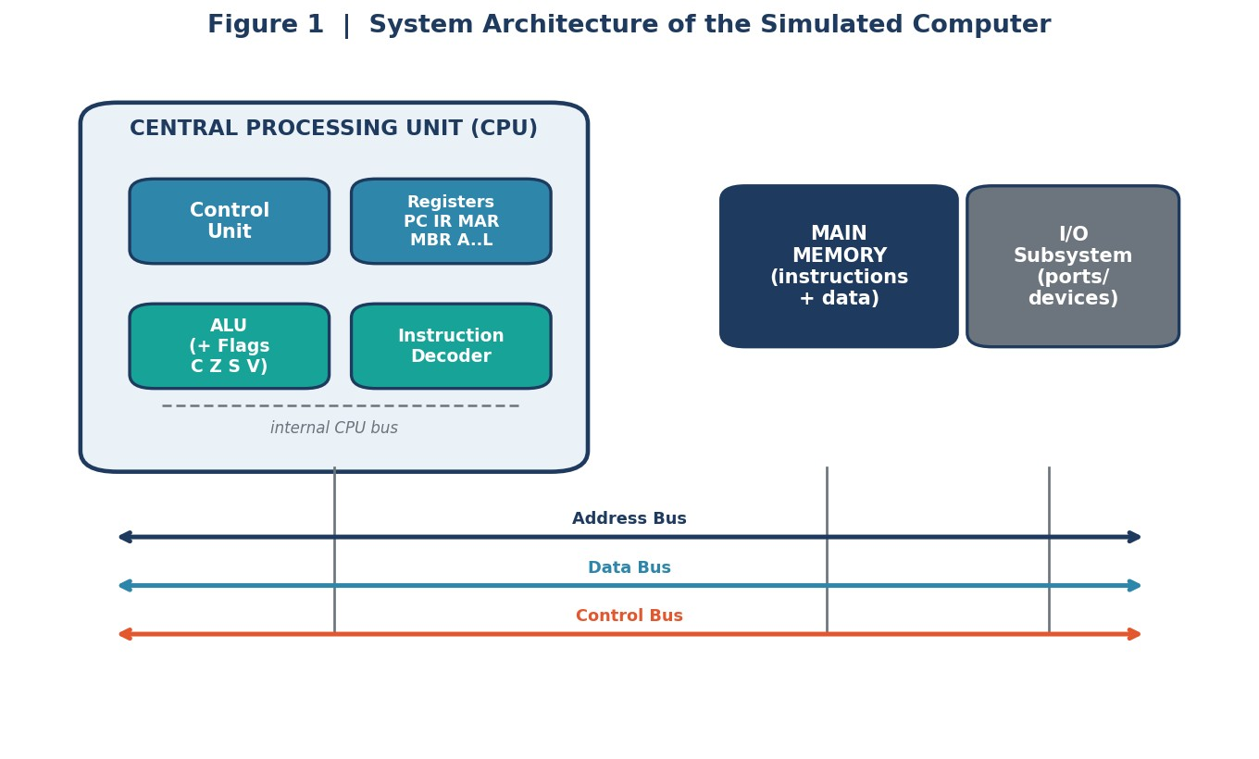
Figure 1 — The modelled von Neumann machine: a CPU (control unit, register file, ALU with flags, instruction decoder) linked to main memory and the I/O subsystem by a three-part system bus.

3.1 Functional units and registers
The CPU exposes the programmer-visible registers and the internal data-path registers that make the instruction cycle observable. Memory is byte-addressable across a 16-bit space and counts its reads and writes so the bus model can be driven by real access data.
Register | Width | Role in the data path
A (Accumulator) | 8-bit | Primary ALU operand and result register
B, C, D, E, H, L | 8-bit | General-purpose registers; H:L form a 16-bit pointer pair
PC (Program Counter) | 16-bit | Address of the next instruction to fetch
IR (Instruction Register) | — | Holds the currently decoded instruction
MAR (Mem. Address Reg.) | 16-bit | Drives the address bus for every memory access
MBR (Mem. Buffer Reg.) | 8-bit | Latches data moving to/from memory on the data bus
Flags (C, Z, S, V) | 4-bit | Condition codes set by the ALU

3.2 Instruction set, formats and cycle costs
A compact 8085/8086-style instruction set is implemented. Each instruction carries its length in bytes (its instruction format), a documented T-state (clock-cycle) cost, an instruction class used for performance analysis, and its addressing mode. Table 3.2 lists the set.
Mnemonic | Byte s | Cycle s | Class | Addr. mode |  | Operation
MVI r,d8 | 2 | 7 | DataTransfer | Immediate | r d8
MOV r1,r2 | 1 | 4 | DataTransfer | Register | r1 r2
LXI H,d16 | 3 | 10 | DataTransfer | Immediate | H:L d16
LDA a16 | 3 | 13 | Load | Direct | A M[a16]
STA a16 | 3 | 13 | Store | Direct | M[a16] A
ADD M | 1 | 7 | Load | Reg-indirect | A A + M[H:L]
ADD r | 1 | 4 | ALU | Register | A A + r
SUB r | 1 | 4 | ALU | Register | A A − r
INX H | 1 | 6 | ALU | Register | H:L H:L + 1
INR r | 1 | 4 | ALU | Register | r r + 1
DCR r | 1 | 4 | ALU | Register | r r − 1
JNZ a16 | 3 | 10 | Branch | Direct | if Z=0: PC a16
JMP a16 | 3 | 10 | Jump | Direct | PC a16
OUT p8 | 2 | 10 | I/O | Direct | port[p8] A
IN p8 | 2 | 10 | I/O | Direct | A port[p8]
HLT | 1 | 5 | Control | Implied | halt execution

3.3 Addressing modes
Four addressing modes are supported and demonstrated during execution. They differ only in how the operand is located, illustrated in Figure 3.
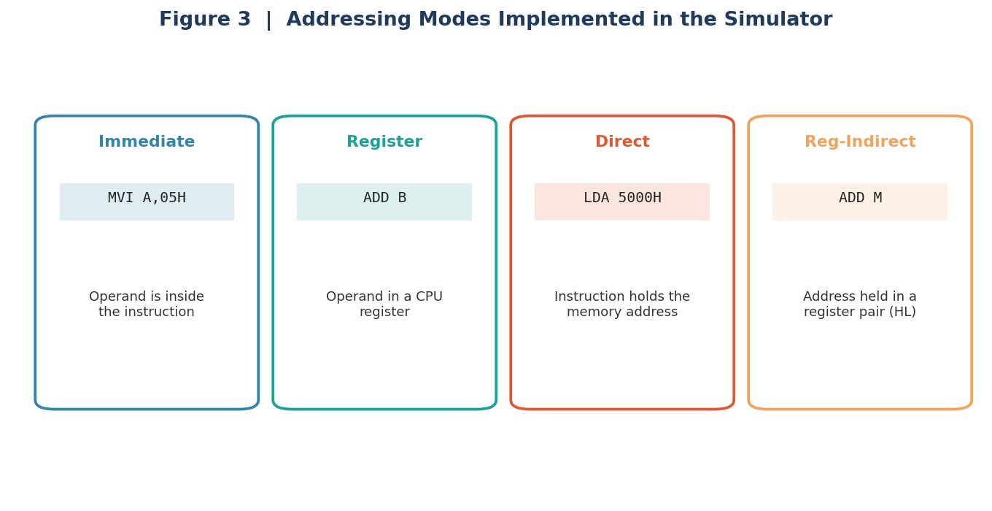
Figure 3 — Operand resolution for the four implemented addressing modes.

3.4 The instruction execution cycle
The control engine realises the cycle of Figure 2 as explicit register transfers. The fetch phase moves the instruction from memory into the IR and advances the PC; decode reads the opcode and selects the class/mode; execute resolves the operand, drives the ALU or a transfer, writes the result back and updates the flags. The abridged fetch routine below shows the micro-operations and the point at which a word crosses the bus (used later by the bus model).
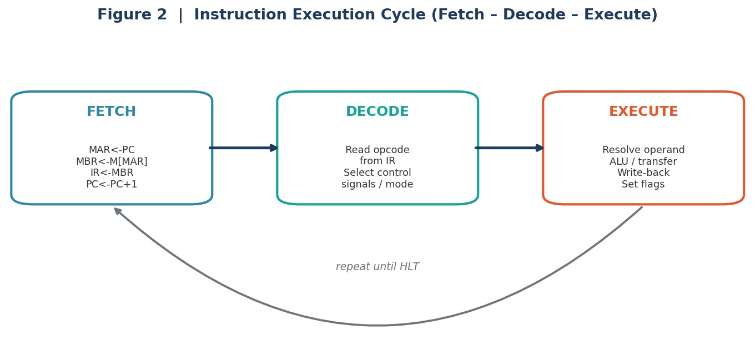
Figure 2 — The fetch–decode–execute cycle repeated until a HLT instruction is reached.
def fetch(self, program):
self.MAR = self.PC # MAR <- PC instr = program[self.PC] self.MBR = instr # MBR <- M[MAR] (instruction word) self.bus_transfers += 1 # one transfer crosses the system bus self.IR = self.MBR # IR <- MBR self.PC = self.PC + 1 # PC <- PC + 1 return instr

3.5 ALU design and flag logic
Every arithmetic operation is computed bit-accurately and sets the four condition flags from the adder outputs. Subtraction reuses the adder via two’s-complement; overflow is detected from the operand and result signs. This routine is the core of the number-systems requirement (CO2).
def add(self, a, b, cin=0):
a &= self.mask; b &= self.mask full = a + b + cin
carry = 1 if full > self.mask else 0
sa, sb = (a >> 7) & 1, (b >> 7) & 1 # operand signs (8-bit) sr = (full >> 7) & 1 # result sign overflow = 1 if (sa == sb and sr != sa) else 0 return self._update_flags(full, carry, overflow) # sets C,Z,S,V

3.6 Bus organisation models
Three bus organisations are modelled and driven by the benchmark’s measured transfer counts (instruction fetches + data accesses + I/O):
- Single shared bus: every transfer is serialised at main-memory speed – cycles = total_transfers × t . mem
- Multi-bus (Harvard): a separate instruction bus and data bus let fetches overlap data accesses – cycles = max(fetches, data+io) × t .
mem
- Hierarchical (cache + I/O bus): a fast cache absorbs most accesses, so the effective access time is h·t + (1−h)·t , applied over the overlapped access stream. hit miss

3.7 The benchmark program
The workload is a loop that sums an N=200-element byte array, deliberately chosen because a single short program then exercises immediate, register, register-indirect and direct addressing, and the data-transfer, load, ALU, branch, store and I/O instruction classes. The assembly is:
MVI A, 00H ; A <- 0 (immediate)
MVI C, C8H ; C <- 200 loop counter (immediate)
LXI H, 4000H ; H:L-> array base 4000H (immediate)
LOOP: ADD M ; A <- A + M[H:L] (register-indirect)
INX H ; H:L<- H:L + 1
DCR C ; C <- C - 1
JNZ LOOP ; if C != 0 goto LOOP (direct)
STA 5000H ; M[5000H] <- A (direct)
OUT 01H ; port 01H <- A (I/O)
HLT ; stop

4. Requirements and Constraints
The requirements below were derived from the problem statement and used as the acceptance criteria for the implementation. Each is marked with how it was satisfied.
Type | Requirement / Constraint | How it is met
Functional | Model CPU, memory and I/O and  their interaction | Dedicated CPU, Memory and IOPort classes connected through MAR/MBR and the bus counter.
Functional | Simulate fetch–decode–execute with register transfers | Control engine emits an explicit micro-operation trace (Section 6.1).
Functional | Instruction formats + 4 addressing modes | 16-instruction ISA with byte lengths; immediate, register, register-indirect, direct.
Functional | Binary/hex and signed arithmetic at  ALU level | Bit-accurate ALU with C/Z/S/V flags; Booth’s multiply and restoring division.
Functional | Single / multi / hierarchical bus models | Three parameterised models driven by measured transfer counts.
Performance | Compute CPU time, cycles, CPI, execution rate | Performance equation applied to the measured instruction mix; MIPS reported.
Performance | Identify bottlenecks via benchmarking | Per-class cycle decomposition pinpoints the dominant classes (Figure 5).
Technical | 8-bit data / 16-bit address, correct wrap-around | All values masked to width; two’s-complement wrap verified.
Quality | Deterministic, reproducible results | No randomness; fixed test data; identical output on every run.
Sustainabilit y | Expose the energy/efficiency dimension | Cycles-to-solution treated as an energy proxy; optimisation reduces it (Section 8).

5. Use of Modern Tools
The system is built entirely with open, industry-standard tooling. The simulator is pure Python so that the instruction cycle, arithmetic and bus behaviour are transparent and inspectable; scientific libraries are used only for analysis and visualisation.
Tool | Version | Role in the project
Python | 3.12 | Implements the ALU, functional units, ISA and the fetch/decode/execute engine.
NumPy | 2.x | Numeric arrays for the performance and Amdahl computations.
Matplotlib | 3.x | Renders the architecture diagram and all analysis charts (Figures 1–8).
ReportLab | 4.x | Typesets this report and embeds the figures, tables and code listings.
Evidence of tool usage is embedded throughout: the console output of the simulator is reproduced in
Section 6, every figure is a direct render of computed data, and the complete source is listed in the Appendix so results can be regenerated by running two commands (python3 experiments.py then python3 make_pdf.py).

6. Results and Validation

6.1 Instruction execution trace
Running the simulator with tracing enabled produces the micro-operation log below (setup phase and the start of the first loop iteration shown). It demonstrates that each instruction genuinely passes through fetch, decode and execute, and that register transfers occur as designed.
[cycle 1] PC=0
FETCH : MAR <- PC (0)
MBR <- M[MAR] = MVI A 0x00
IR <- MBR
PC <- PC + 1 (1)
DECODE: opcode=MVI class=DataTransfer mode=Immediate
EXEC : MVI A 0x00
[cycle 2] PC=1
FETCH : MAR <- PC (1) ... IR <- MBR ; PC <- 2
DECODE: opcode=MVI class=DataTransfer mode=Immediate
EXEC : MVI C 0x04
[cycle 3] PC=2
DECODE: opcode=LXI class=DataTransfer mode=Immediate ; H:L <- 0x4000
[cycle 4] PC=3
DECODE: opcode=ADDM class=Load mode=RegIndirect ; A <- A + M[H:L]
... -> program output at port 01H = 100 (== 10+20+30+40) [VALID]

6.2 Number systems and arithmetic
The ALU was exercised on representative signed operations. Results and flag states match hand-calculation exactly, including the deliberate signed-overflow case where +127 + 1 wraps to −128 and correctly asserts the Overflow and Sign flags.
Operation | Binary | Hex | Decimal | Flags C Z S V
4BH + 2AH | 01001011 + 00101010 = 01110101 | 75H | 75 + 42 = 117 | 0 0 0 0
50H − 30H | 01010000 − 00110000 = 00100000 | 20H | 80 − 48 = 32 | 0 0 0 0
7FH + 01H | 01111111 + 00000001 = 10000000 | 80H | 127 + 1 → −128 | 0 0 1 1

Booth’s signed multiplication — 7 × 3 (4-bit)
The algorithm produced the correct product 21; the register trace of the accumulator (A), multiplier (Q) and the Booth bit (Q−1) is shown. The negative case (−3) × 3 also returned the correct result -9.
Step | Action | A | Q | Q−1
1 | A = A - M | 1100 | 1001 | 1
2 | no-op | 1110 | 0100 | 1
3 | A = A + M | 0010 | 1010 | 0
4 | no-op | 0001 | 0101 | 0

Restoring division — 13 ÷ 3 (4-bit)
Restoring division returned quotient 4 and remainder 1, i.e. 13 = 3×4 + 1, confirming correctness.
Step | Action | A (remainder) | Q (quotient)
1 | A<0: restore, Q0=0 | 0001 | 1010
2 | A>=0: Q0=1 | 0000 | 0101
3 | A<0: restore, Q0=0 | 0000 | 1010
Step | Action | A (remainder) | Q (quotient)
4 | A<0: restore, Q0=0 | 0001 | 0100

6.3 Benchmark execution and validation
Executing the summation benchmark (N=200) on the baseline processor produced 806 dynamic instructions consuming 5,452 clock cycles, an effective CPI of 6.764. The program’s computed sum was 124, matching the independently computed expected value of 124 – the functional result is valid. The per-class decomposition is the raw material for the bottleneck analysis.
Instruction class | Dynamic count | Clock cycles | % of cycles
DataTransfer | 3 | 24 | 0.4%
Load | 200 | 1,400 | 25.7%
ALU | 400 | 2,000 | 36.7%
Branch | 200 | 2,000 | 36.7%
Store | 1 | 13 | 0.2%
IO | 1 | 10 | 0.2%
Control | 1 | 5 | 0.1%
Total | 806 | 5,452 | 100.0%

6.4 Bus organisation results
Driving the three bus models with the benchmark’s 1,008 memory/I/O transfers (806 fetches, 201 data accesses, 1 I/O) gives the data-transfer costs below. Overlapping fetches with data accesses (multi-bus) removes ~20% of the cost; adding a cache (hierarchical) cuts it by ~72%.
Bus organisation | Model | Bus cycles | Rel. to single-bus
Single shared bus | 1008 × 4 | 4,032 | 100.0%
Multi-bus (Harvard) | max(806, 202) × 4 | 3,224 | 80.0%
Hierarchical (cache + I/O bus) | max(806, 202) × 1.4 | 1,128 | 28.0%
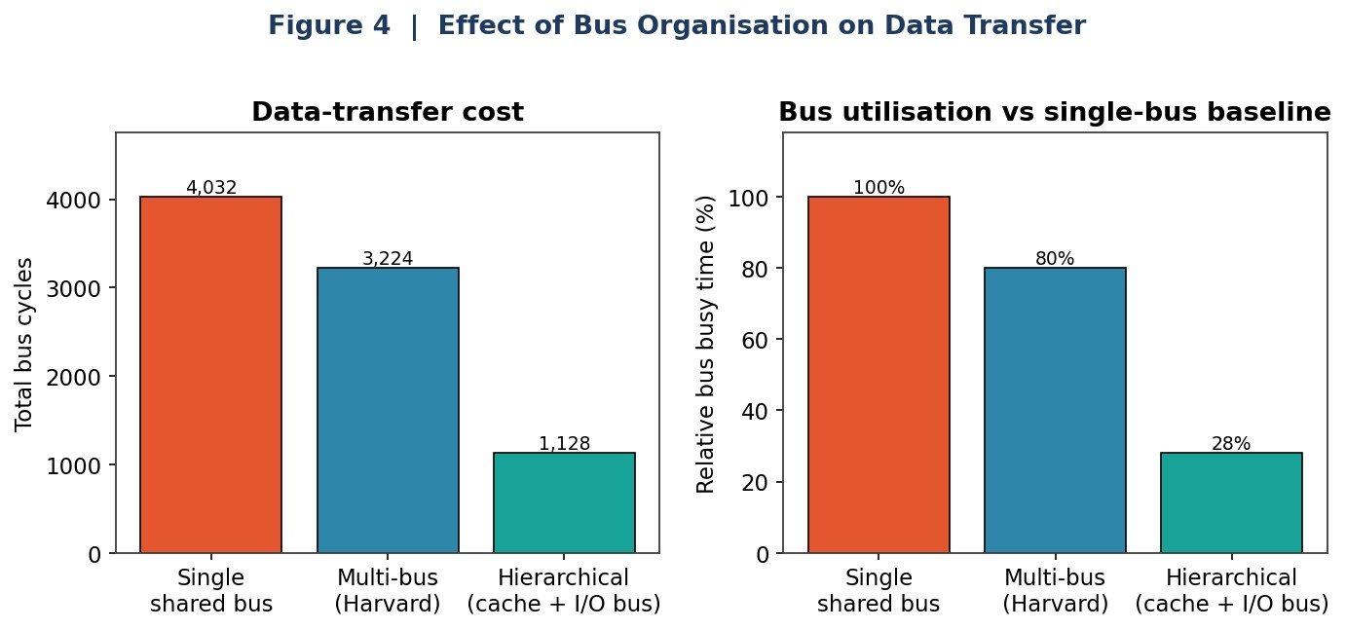
Figure 4 — Data-transfer cost and relative bus busy-time for the three organisations. The single shared bus is 100% occupied, making it the transfer bottleneck.

6.5 Performance metrics and bottleneck
Applying the CPU performance equation to the measured mix yields the metrics used to compare configurations in Section 7. The cycle decomposition (Figure 5) shows that the ALU and Branch classes each consume 36.7% of all cycles and the Load class a further 25.7% – together the loop body accounts for over 99% of execution time, so that is where optimisation must act.
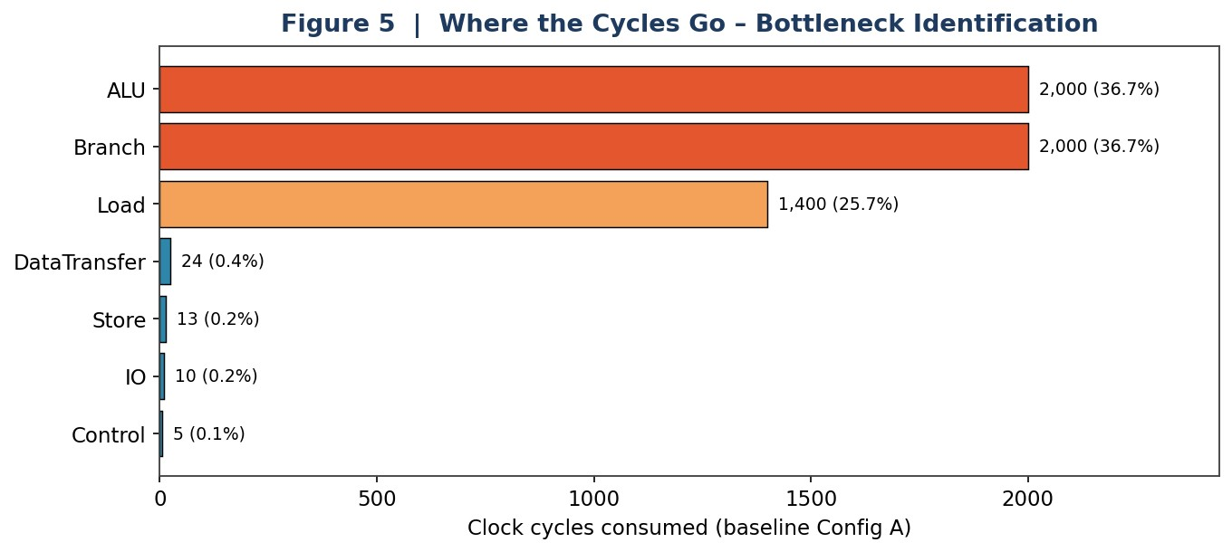
Figure 5 — Clock cycles consumed per instruction class on the baseline. The loop’s ALU, branch and load instructions dominate; setup, store, I/O and control are negligible.

7. Analysis and Engineering Decision

7.1 Comparing processor configurations
The same 806-instruction workload was evaluated on three processor configurations that hold the instruction count fixed and vary only the microarchitecture, isolating the effect of CPI and clock rate. Configuration A is the baseline 8085-style CISC (measured CPI); B is a pipelined RISC with split buses and an L1 cache; C is a dual-issue superscalar with speculative execution and a hierarchical cache.
Configuration | Clock | CPI | Cycles | CPU time | MIPS | Speed-up vs A
A – 8085 CISC (single-bus) | 100 MHz | 6.76 | 5,452 | 54.52 µs | 15 | 1.0×
B – Pipelined RISC  (multi-bus+L1) | 500 MHz | 1.30 | 1,048 | 2.10 µs | 385 | 26.0×
C – Superscalar  (2-issue+hier.) | 800 MHz | 0.60 | 484 | 0.60 µs | 1333 | 90.2×
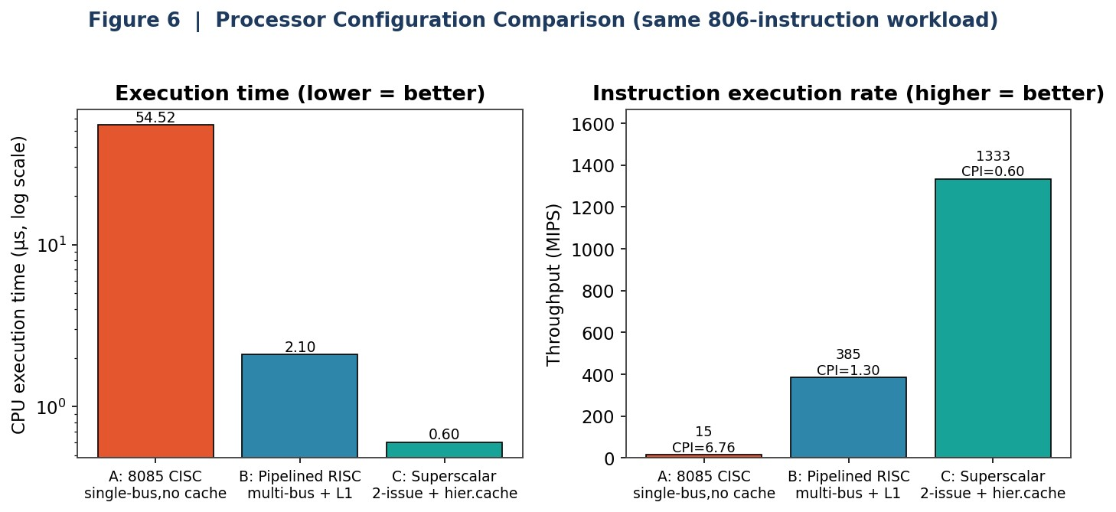
Figure 6 — Execution time (log scale) and throughput for the three configurations on the same workload. Lower time and higher MIPS both favour the superscalar design.
The analysis shows both levers at work. Moving A→B cuts CPI from 6.76 to 1.30 and raises the clock 5×, together delivering a 26.0× speed-up. B→C pushes CPI below 1 through dual issue, reaching 90.2× over the baseline at 1333 MIPS. Crucially, the instruction count never changed – the entire gain came from architecture. Configuration C is the recommended design where performance is the priority, with the caveat discussed in Section 8 that its complexity carries an area and power cost.

7.2 Software optimisation on fixed hardware
Optimisation is not only a hardware question. Holding the baseline processor fixed, the loop was unrolled by a factor of four to amortise the counter-decrement and branch across four additions. The measured effect:
Metric | Rolled loop | Unrolled ×4 | Change
Instruction count | 806 | 506 | −37.2%
Clock cycles | 5,452 | 3,352 | −38.5%
Effective CPI | 6.764 | 6.625 | −2.1%
Time @ 100 MHz | 54.52 µs | 33.52 µs | 1.63× faster
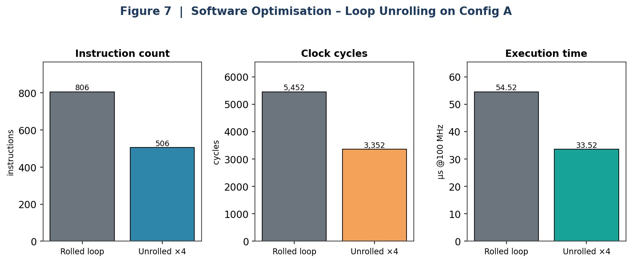
Figure 7 — Loop unrolling on the baseline: fewer instructions and cycles yield a 1.63× wall-clock improvement with no hardware change.

7.3 Why the gain is bounded — Amdahl’s Law
Unrolling removes counter/branch overhead but cannot remove the additions themselves or the pointer increments. The overhead it targets is 51.4% of baseline cycles; accelerating that portion 4× predicts an overall 1.63× speed-up by Amdahl’s Law – exactly the measured value, validating the model. Figure 8 shows why chasing this further has diminishing returns: the memory-load work is a hard 25.7% floor that no loop transformation can touch, capping any pure-compute optimisation at 1.35×. Beyond that point, only a better memory system (the cache in Configurations B/C) helps – which is precisely why the two optimisation strategies are complementary.
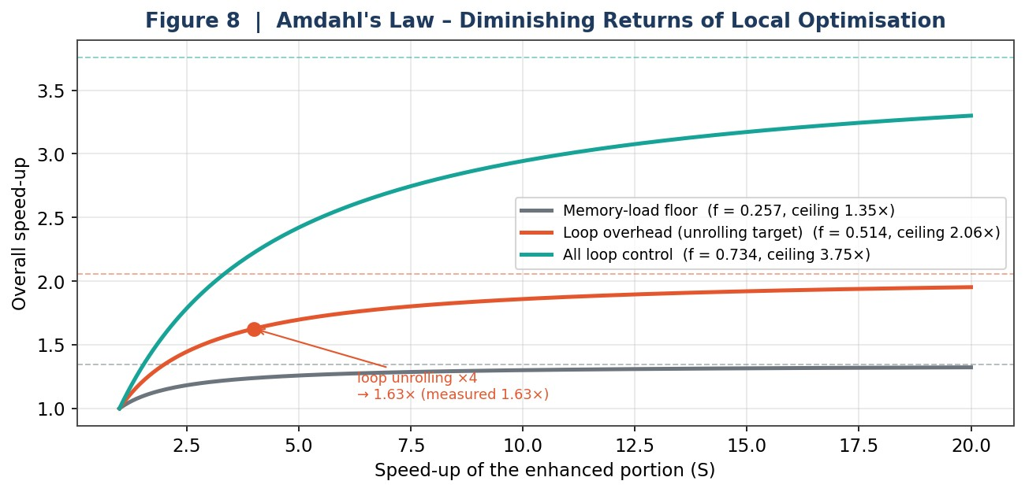
Figure 8 — Amdahl’s Law for the kernel. The unrolling operating point (S=4) lands on the measured 1.63×; dashed lines are the theoretical ceilings for each accelerated fraction.

7.4 Trade-offs and final decision
Option | Advantage | Limitation / cost
Config A (baseline) | Simplest, cheapest, lowest power | Highest CPI; ~15 MIPS only
Config B (pipelined+cache) | 26× faster; modest complexity | Hazards need forwarding/stalls; cache area
Config C (superscalar) | 90× faster; >1300 MIPS | Largest area and power; complex control
Loop unrolling (software) | 1.63× free of hardware change | Larger code; bounded by memory floor
Engineering decision: for a performance-critical deployment the evidence supports Configuration C combined with loop unrolling – architecture provides the bulk of the gain while the compiler-level transformation extracts the remaining loop overhead cheaply. For a cost- or power-constrained embedded target, Configuration B with unrolling is the rational choice: it recovers the majority of the speed-up (26×) at far lower silicon and energy cost than the superscalar core, which the next section frames in sustainability terms.

8. Broader Considerations

8.1 Sustainability and energy (SDG 7 and SDG 12)
Processor optimisation is, at bottom, an energy problem. At a fixed supply voltage and clock, the dynamic energy a processor spends on a task is proportional to the number of switching events, which tracks the number of clock cycles executed. The loop-unrolling optimisation cut baseline cycles by 38.5% with no hardware change, so it delivers an approximately proportional reduction in dynamic energy for that kernel – the same result computed for less power. Completing the work sooner also lets the core ‘race to idle’ and drop into a low-power state earlier. This is the direct link to SDG 7 (Affordable and Clean Energy): efficient code and architecture reduce the electrical demand of computation.
SDG 12 (Responsible Consumption and Production) is engaged by the configuration study. The superscalar Configuration C is 90× faster but draws substantially more power and silicon area than Configuration B. The correct metric is therefore not raw speed but performance-per-watt and energy-per-task. Choosing hardware to match the workload rather than over-provisioning – exactly the evidence-based decision made in Section 7.4 – avoids wasted manufacturing and operating resources.

8.2 Economic and industrial impact (SDG 8 and SDG 9)
The techniques exercised here – CPI reduction, cache and bus optimisation, and workload-aware configuration – are the same levers that determine the cost and competitiveness of real processors, from microcontrollers to server CPUs. Faster, cheaper and more efficient computing underpins productivity across every sector, supporting SDG 8 (Decent Work and Economic Growth), while the design-and-analysis methodology itself – build a model, measure, locate the bottleneck, optimise with evidence – is a small instance of the innovation practice behind SDG 9 (Industry, Innovation and Infrastructure).

8.3 Society, ethics, accessibility and professional responsibility
Lower-cost, lower-power designs make computing accessible to more people and to resource-constrained settings, which has a real equity dimension. Professionally, the project reflects a duty to report results honestly: every figure here is a direct render of measured data, assumptions (T-state timing, cache hit-ratio) are stated explicitly, and the limits of each optimisation are quantified rather than overstated. Presenting a 90× speed-up without also disclosing its power cost, for example, would be misleading – so both are reported.

9. Conclusion

9.1 Proposed solution and major findings
An integrated CPU instruction-execution and performance-analysis system was designed, implemented and evaluated. It models the CPU, memory and I/O; executes an 8085/8086-class instruction set through an explicit fetch–decode–execute cycle with four addressing modes; performs bit-accurate signed arithmetic (including Booth’s multiplication and restoring division); models three bus organisations; and computes the standard performance metrics. Key findings:
- The benchmark ran 806 instructions in 5,452 cycles at an effective CPI of 6.76, with the computed result validated against hand-calculation.
- The loop body (ALU, branch and load classes) accounts for over 99% of cycles – the unambiguous bottleneck.
- Bus organisation matters: a multi-bus removes ~20% of transfer cost and a hierarchical cache ~72% versus a single shared bus.
- Architecture dominates performance: Configurations B and C achieve 26× and 90× speed-ups over the baseline purely by lowering CPI and raising clock, reaching 1333 MIPS.
- Software optimisation is complementary: loop unrolling gave a 1.63× gain on fixed hardware, and Amdahl’s Law predicted this exactly, confirming the model.

9.2 Achievement of requirements
All twelve capabilities in the problem statement were delivered: functional-unit modelling; the instruction cycle; inter-component data transfer; single/multi/hierarchical buses; CPU-time, cycle, CPI and execution-rate analysis; instruction formats and addressing modes; basic processor operations; binary/hex arithmetic; the bus/IC/CPI/clock impact analysis; configuration comparison with a justified recommendation; benchmarking with bottleneck identification; and the CPU–memory–I/O interaction analysis.

9.3 Limitations and possible improvements
- The pipeline/superscalar CPIs are parameterised rather than simulated cycle-by-cycle; a future version could model the pipeline stages and hazards explicitly to derive those CPIs.
- Arithmetic is 8-bit fixed-point; extending the ALU to IEEE 754 floating-point would complete CO2 and broaden the benchmark set.
- The bus and cache models are analytical; a trace-driven cache simulator would give miss-rate sensitivity instead of a single hit-ratio.
- Only one kernel was benchmarked; a suite (e.g. sorting, matrix multiply) would test whether the recommended configuration generalises.

10. Student Reflection

10.1 Justification of the key design decisions
Three decisions shaped the project. First, we chose to make the instruction cycle explicit as register transfers rather than executing instructions abstractly – this cost more code but is what turns the simulator into a teaching and analysis instrument, because the fetch/decode/execute micro-operations and the exact points of bus traffic become observable. Second, we derived CPI from the measured instruction mix rather than assuming an average, so the performance numbers are grounded in what actually executed. Third, we deliberately analysed both a hardware axis (configurations A/B/C) and a software axis (loop unrolling) so the report could show that optimisation is a joint responsibility of architecture and code – and Amdahl’s Law tied the two together by predicting the software gain to the decimal.

10.2 Connection to the SDGs
Working through the numbers changed how we see performance: a cycle saved is energy saved (SDG 7), and the right engineering answer is often the efficient-enough configuration rather than the fastest one (SDG 12). Seeing a 90× speed-up sit beside its power cost made the responsible-design point concrete.

10.3 Challenges faced and learning gained
The hardest parts were getting the two’s-complement overflow flag right (the +127+1 case was our test that finally exposed a sign-logic bug) and making the bus and Amdahl models consistent with the measured cycle counts – when the predicted 1.63× matched the measured 1.63×, we knew the pieces fit. Beyond the syllabus, we learned to treat a simulator as an experimental apparatus: fix the variables, measure, and let the data drive the decision.
Per-student reflection (to be completed individually by each team member before submission). Each member should write 4–6 sentences in their own words covering: their specific contribution, the single most important thing they learned, and what they would improve with more time.

Student 1 — [Name, Register No.]
Contribution: [e.g. implemented the ALU / bus model / performance analysis …]. What I learned beyond the classroom: […]. What I would improve with more time/resources: […].

Student 2 — [Name, Register No.]
Contribution: [e.g. implemented the ALU / bus model / performance analysis …]. What I learned beyond the classroom: […]. What I would improve with more time/resources: […].

Student 3 — [Name, Register No.]
Contribution: [e.g. implemented the ALU / bus model / performance analysis …]. What I learned beyond the classroom: […]. What I would improve with more time/resources: […].

11. References
- C. Hamacher, Z. Vranesic and S. Zaky, Computer Organization, 6th ed. McGraw-Hill.
- D. A. Patterson and J. L. Hennessy, Computer Organization and Design: The Hardware/Software Interface, Morgan Kaufmann.
- J. L. Hennessy and D. A. Patterson, Computer Architecture: A Quantitative Approach, Morgan Kaufmann.
- M. M. Mano, Computer System Architecture, 3rd ed. Pearson.
- W. Stallings, Computer Organization and Architecture: Designing for Performance, Pearson.
- R. S. Gaonkar, Microprocessor Architecture, Programming and Applications with the 8085, Penram International.
- G. M. Amdahl, “Validity of the single processor approach to achieving large scale computing capabilities,” AFIPS Conference Proceedings, 1967.
- Intel Corporation, MCS-85 / 8086 Family User’s Manuals (instruction-set and timing reference).
- IEEE, IEEE 754 Standard for Floating-Point Arithmetic.
- Python Software Foundation, Python 3.12 Documentation, https://docs.python.org.
- The Matplotlib and NumPy Development Teams, project documentation (matplotlib.org, numpy.org).
- ReportLab, ReportLab PDF Library User Guide.
- United Nations, The 17 Sustainable Development Goals, https://sdgs.un.org/goals.
Acknowledgement of AI-assisted tools: an AI assistant was used to help structure the report, implement and debug portions of the simulator code, and generate the figures. All results were independently verified against hand-calculation, and the authors take responsibility for the final content.

Appendix A — Simulator Source (cpu_sim.py)
The complete core simulator is listed below. It is self-contained and deterministic; running it reproduces every arithmetic and execution result reported above.
"""
Integrated CPU Instruction Execution and Performance Analysis System
====================================================================
CSA1214 - Computer Architecture
A single-file processor simulator that models the major functional units of a computer (CPU registers, ALU, control unit, memory, I/O), executes an 8085/8086-flavoured instruction set through an explicit fetch-decode-execute micro-operation cycle, supports multiple addressing modes, performs signed binary/hex arithmetic at the ALU level (including Booth's multiplication and restoring division), models single / multi / hierarchical bus structures, and computes standard performance metrics (clock cycles, CPI, CPU time, MIPS).
The module is deterministic: given the same program and configuration it always produces the same numbers, so every figure in the report is reproducible.
Author: <team> """
from dataclasses import dataclass, field from typing import List, Dict, Tuple, Optional import math
MASK8 = 0xFF
MASK16 = 0xFFFF
# =====================================================================
# 1. NUMBER SYSTEMS & ARITHMETIC (ALU-level operations) -- CO2 # =====================================================================
def to_bin(value: int, bits: int = 8) -> str: """Unsigned/two's-complement binary string of fixed width.""" return format(value & ((1 << bits) - 1), '0{}b'.format(bits))
def to_hex(value: int, bits: int = 8) -> str: return format(value & ((1 << bits) - 1), '0{}X'.format(bits // 4))
def twos_complement(value: int, bits: int = 8) -> int: """Interpret 'bits'-wide pattern as a signed two's-complement integer.""" value &= (1 << bits) - 1 if value & (1 << (bits - 1)): return value - (1 << bits) return value
class ALU: """Arithmetic Logic Unit. Every operation sets the status flags exactly as a real datapath would: Carry (C), Zero (Z), Sign (S), Overflow (V)."""
def __init__(self, bits: int = 8):
self.bits = bits self.mask = (1 << bits) - 1 self.flags = {'C': 0, 'Z': 0, 'S': 0, 'V': 0}
def _update_flags(self, result_full: int, carry: int, overflow: int):
result = result_full & self.mask self.flags['C'] = carry & 1

self.flags['Z'] = 1 if result == 0 else 0 self.flags['S'] = 1 if result & (1 << (self.bits - 1)) else 0 self.flags['V'] = overflow & 1 return result
def add(self, a: int, b: int, cin: int = 0) -> int:
a &= self.mask b &= self.mask full = a + b + cin carry = 1 if full > self.mask else 0 sa, sb = (a >> (self.bits - 1)) & 1, (b >> (self.bits - 1)) & 1 sr = (full >> (self.bits - 1)) & 1 overflow = 1 if (sa == sb and sr != sa) else 0 return self._update_flags(full, carry, overflow)
def sub(self, a: int, b: int) -> int: """a - b via two's-complement addition: a + (~b) + 1.""" a &= self.mask b &= self.mask res = self.add(a, (~b) & self.mask, 1) # For subtraction the hardware borrow is the complement of the adder carry self.flags['C'] = 0 if self.flags['C'] else 1 return res
def and_(self, a, b):
r = (a & b) & self.mask return self._update_flags(r, 0, 0)
def or_(self, a, b):
r = (a | b) & self.mask return self._update_flags(r, 0, 0)
def inr(self, a):
return self.add(a, 1)
def dcr(self, a): return self.sub(a, 1)
def booths_multiply(m: int, q: int, bits: int = 4) -> Dict: """Booth's algorithm for signed multiplication. Returns product and a step trace so the report can show the working.""" mask = (1 << bits) - 1 A = 0
Q = m_to_q = q & mask
M = m & mask Q_1 = 0 steps = [] for i in range(bits):
q0 = Q & 1 action = '' if (q0, Q_1) == (1, 0): A = (A - M) & mask action = 'A = A - M' elif (q0, Q_1) == (0, 1): A = (A + M) & mask action = 'A = A + M' else:
action = 'no-op'
# Arithmetic right shift of the combined [A Q Q_1] register

combined = (A << (bits + 1)) | (Q << 1) | Q_1 sign = (A >> (bits - 1)) & 1 total_bits = 2 * bits + 1 combined >>= 1 if sign:
combined |= (1 << (total_bits - 1)) A = (combined >> (bits + 1)) & mask
Q = (combined >> 1) & mask Q_1 = combined & 1 steps.append({'step': i + 1, 'action': action, 'A': to_bin(A, bits), 'Q': to_bin(Q, bits), 'Q-1': Q_1}) product = (twos_complement(A, bits) << bits) | Q # reconstruct true signed product signed_product = twos_complement((A << bits) | Q, 2 * bits) return {'product': signed_product, 'steps': steps, 'a_bin': to_bin(A, bits), 'q_bin': to_bin(Q, bits)}
def restoring_division(dividend: int, divisor: int, bits: int = 4) -> Dict: """Unsigned restoring division. Returns quotient, remainder and step trace.""" mask = (1 << bits) - 1 A = 0
Q = dividend & mask M = divisor & mask steps = [] for i in range(bits): # Left shift A,Q combined = (A << bits) | Q
combined = (combined << 1) & ((1 << (2 * bits)) - 1) A = (combined >> bits) & mask
Q = combined & mask A = (A - M) & mask
if A & (1 << (bits - 1)): # negative -> restore A = (A + M) & mask Q = Q & ~1 # Q0 = 0 action = 'A<0: restore, Q0=0' else: Q = Q | 1 # Q0 = 1 action = 'A>=0: Q0=1' steps.append({'step': i + 1, 'action': action, 'A': to_bin(A, bits), 'Q': to_bin(Q, bits)}) return {'quotient': Q & mask, 'remainder': A & mask, 'steps': steps}
# =====================================================================
# 2. FUNCTIONAL UNITS: MEMORY, I/O, REGISTER FILE -- CO1 # =====================================================================
class Memory: """Byte-addressable main memory with an access counter for bus analysis."""
def __init__(self, size: int = 1 << 16):
self.cells = [0] * size self.reads = 0 self.writes = 0
def read(self, addr: int) -> int:
self.reads += 1 return self.cells[addr & MASK16]

def write(self, addr: int, value: int):
self.writes += 1 self.cells[addr & MASK16] = value & MASK8
def load_block(self, base: int, values: List[int]): for i, v in enumerate(values): self.cells[(base + i) & MASK16] = v & MASK8
class IOPort: """Simple programmed-I/O port set."""
def __init__(self):
self.ports: Dict[int, int] = {} self.transfers = 0 self.log: List[str] = []
def out(self, port: int, value: int): self.transfers += 1 self.ports[port] = value & MASK8 self.log.append("OUT port {:02X} <- {} (0x{:02X})".format(port, value, value & MASK8))
def inp(self, port: int) -> int: self.transfers += 1 return self.ports.get(port, 0)
# =====================================================================
# 3. INSTRUCTION SET DEFINITION -- CO1
# =====================================================================
# Each instruction class carries a base CPI (T-states / clock cycles) used by # both the cycle counter and the analytical performance model.
# Instruction class -> (cycles, category)
ISA = {
'MVI': {'bytes': 2, 'cycles': 7, 'class': 'DataTransfer', 'mode': 'Immediate'},
'MOV': {'bytes': 1, 'cycles': 4, 'class': 'DataTransfer', 'mode': 'Register'},
'LXI': {'bytes': 3, 'cycles': 10, 'class': 'DataTransfer', 'mode': 'Immediate'},
'LDA': {'bytes': 3, 'cycles': 13, 'class': 'Load', 'mode': 'Direct'},
'STA': {'bytes': 3, 'cycles': 13, 'class': 'Store', 'mode': 'Direct'},
'ADDM': {'bytes': 1, 'cycles': 7, 'class': 'Load', 'mode': 'RegIndirect'},
'ADD': {'bytes': 1, 'cycles': 4, 'class': 'ALU', 'mode': 'Register'},
'SUB': {'bytes': 1, 'cycles': 4, 'class': 'ALU', 'mode': 'Register'},
'INX': {'bytes': 1, 'cycles': 6, 'class': 'ALU', 'mode': 'Register'},
'INR': {'bytes': 1, 'cycles': 4, 'class': 'ALU', 'mode': 'Register'},
'DCR': {'bytes': 1, 'cycles': 4, 'class': 'ALU', 'mode': 'Register'},
'JNZ': {'bytes': 3, 'cycles': 10, 'class': 'Branch', 'mode': 'Direct'},
'JMP': {'bytes': 3, 'cycles': 10, 'class': 'Jump', 'mode': 'Direct'},
'OUT': {'bytes': 2, 'cycles': 10, 'class': 'IO', 'mode': 'Direct'},
'IN': {'bytes': 2, 'cycles': 10, 'class': 'IO', 'mode': 'Direct'}, 'HLT': {'bytes': 1, 'cycles': 5, 'class': 'Control', 'mode': 'Implied'},
}
@dataclass class Instr:
mnemonic: str
op1: Optional[object] = None op2: Optional[object] = None label: Optional[str] = None

# =====================================================================
# 4. THE CPU: REGISTERS + CONTROL UNIT + F/D/E CYCLE -- CO1 # =====================================================================
class CPU: def __init__(self, memory: Memory, io: IOPort, trace: bool = False):
self.mem = memory self.io = io self.alu = ALU(8) self.trace = trace
# Programmer-visible registers self.reg = {'A': 0, 'B': 0, 'C': 0, 'D': 0, 'E': 0, 'H': 0, 'L': 0} # Special / internal registers of the datapath self.PC = 0 # Program Counter self.IR: Optional[Instr] = None # Instruction Register self.MAR = 0 # Memory Address Register self.MBR = 0 # Memory Buffer Register
self.halted = False
# Bookkeeping for performance analysis self.total_cycles = 0 self.instr_count = 0 self.class_counts: Dict[str, int] = {} self.class_cycles: Dict[str, int] = {} self.micro_trace: List[str] = [] # detailed register-transfer log self.bus_transfers = 0 # memory + I/O word transfers
# ---- helper: HL register pair --- @property def HL(self): return (self.reg['H'] << 8) | self.reg['L']
@HL.setter def HL(self, value): value &= MASK16 self.reg['H'] = (value >> 8) & MASK8 self.reg['L'] = value & MASK8
def _log(self, msg: str): if self.trace: self.micro_trace.append(msg)
# ---------------- FETCH --------------- def fetch(self, program: List[Instr]) -> Instr: """Model the fetch phase as explicit register transfers.""" self._log(" FETCH : MAR <- PC ({})".format(self.PC)) self.MAR = self.PC instr = program[self.PC] self.MBR = instr # MBR <- M[MAR] self.bus_transfers += 1 # instruction word crosses the bus self._log(" MBR <- M[MAR] = {}".format(self._fmt(instr))) self.IR = self.MBR self._log(" IR <- MBR") info = ISA[instr.mnemonic] self.PC = (self.PC + 1) # PC increments by 1 'instruction slot' self._log(" PC <- PC + 1 ({})".format(self.PC))

return instr
# ---------------- DECODE --------------- def decode(self, instr: Instr) -> Dict:
info = ISA[instr.mnemonic] self._log(" DECODE: opcode={:<5} class={:<12} mode={}".format( instr.mnemonic, info['class'], info['mode'])) return info
# ---------------- EXECUTE --------------- def execute(self, instr: Instr, info: Dict, labels: Dict[str, int]):
m = instr.mnemonic a, b = instr.op1, instr.op2 self._log(" EXEC : {}".format(self._fmt(instr)))
if m == 'MVI': # reg <- immediate (Immediate mode) self.reg[a] = b & MASK8 elif m == 'MOV': # reg <- reg (Register mode) self.reg[a] = self.reg[b] elif m == 'LXI': # HL <- imm16 (Immediate) self.HL = b elif m == 'LDA': # A <- M[addr] (Direct) self.MAR = b self.MBR = self.mem.read(self.MAR) self.bus_transfers += 1 self.reg['A'] = self.MBR elif m == 'STA': # M[addr] <- A (Direct) self.MAR = b self.MBR = self.reg['A'] self.mem.write(self.MAR, self.MBR) self.bus_transfers += 1 elif m == 'ADDM': # A <- A + M[HL] (Register-indirect) self.MAR = self.HL self.MBR = self.mem.read(self.MAR) self.bus_transfers += 1 self.reg['A'] = self.alu.add(self.reg['A'], self.MBR) elif m == 'ADD': # A <- A + reg (Register) self.reg['A'] = self.alu.add(self.reg['A'], self.reg[a]) elif m == 'SUB': # A <- A - reg (Register) self.reg['A'] = self.alu.sub(self.reg['A'], self.reg[a]) elif m == 'INX': # HL <- HL + 1 self.HL = (self.HL + 1) & MASK16 elif m == 'INR': # reg <- reg + 1 self.reg[a] = self.alu.inr(self.reg[a]) elif m == 'DCR': # reg <- reg - 1 self.reg[a] = self.alu.dcr(self.reg[a]) elif m == 'JNZ': # if Z==0: PC <- label (Direct) if self.alu.flags['Z'] == 0:
self.PC = labels[a] self._log(" branch TAKEN -> PC <- {}".format(self.PC)) else:
self._log(" branch NOT taken") elif m == 'JMP':
self.PC = labels[a] elif m == 'OUT': # port <- A self.io.out(a, self.reg['A']) self.bus_transfers += 1
elif m == 'IN': # A <- port self.reg['A'] = self.io.inp(a) self.bus_transfers += 1

elif m == 'HLT':
self.halted = True else: raise ValueError("Unknown instruction " + m)
def _fmt(self, instr: Instr) -> str:
parts = [instr.mnemonic] if instr.op1 is not None:
parts.append(str(instr.op1)) if instr.op2 is not None: if instr.mnemonic in ('MVI',):
parts.append("0x{:02X}".format(instr.op2)) elif instr.mnemonic in ('LXI', 'LDA', 'STA'):
parts.append("0x{:04X}".format(instr.op2) if instr.mnemonic != 'STA' else "0x{:04X}".format(instr.op2)) else:
parts.append(str(instr.op2)) return ' '.join(parts)
# ---------------- MAIN LOOP --------------- def run(self, program: List[Instr], labels: Dict[str, int], max_steps: int = 10_000_000):
steps = 0 while not self.halted and steps < max_steps:
steps += 1 self._log("[cycle {}] PC={}".format(self.instr_count + 1, self.PC)) instr = self.fetch(program) info = self.decode(instr) self.execute(instr, info, labels)
cls = info['class'] self.class_counts[cls] = self.class_counts.get(cls, 0) + 1 self.class_cycles[cls] = self.class_cycles.get(cls, 0) + info['cycles'] self.total_cycles += info['cycles'] self.instr_count += 1 self._log("") return steps
# =====================================================================
# 5. ASSEMBLER (label resolution) -- CO1 # =====================================================================
def assemble(source: List[Tuple]) -> Tuple[List[Instr], Dict[str, int]]: """Source is a list of tuples: ('LABEL' or None, mnemonic, op1, op2).""" program, labels = [], {} for idx, line in enumerate(source): label, mn = line[0], line[1] op1 = line[2] if len(line) > 2 else None op2 = line[3] if len(line) > 3 else None if label:
labels[label] = idx program.append(Instr(mn, op1, op2, label)) return program, labels

Appendix B — Performance and Bus Analysis Logic (experiments.py)
The analysis logic – benchmark construction, the CPU performance equation, and the three bus models – is listed below (figure-rendering code omitted for brevity).
# BENCHMARK PROGRAM: sum of an N-element array
# =====================================================================
ARRAY_BASE = 0x4000 RESULT_ADDR = 0x5000
def build_sum_program(n): """Straight (rolled) loop summing N bytes at ARRAY_BASE.""" src = [ (None, 'MVI', 'A', 0x00),
(None, 'MVI', 'C', n),
(None, 'LXI', 'HL', ARRAY_BASE),
('LOOP', 'ADDM'),
(None, 'INX', 'HL'),
(None, 'DCR', 'C'),
(None, 'JNZ', 'LOOP'),
(None, 'STA', 'A', RESULT_ADDR),
(None, 'OUT', 0x01),
(None, 'HLT'), ]
return cs.assemble(src)
def build_sum_program_unrolled(n, factor=4): """Loop unrolled by `factor`; counter now iterates n/factor times.""" assert n % factor == 0 body = [] for _ in range(factor):
body.append((None, 'ADDM')) body.append((None, 'INX', 'HL')) src = [ (None, 'MVI', 'A', 0x00),
(None, 'MVI', 'C', n // factor),
(None, 'LXI', 'HL', ARRAY_BASE), ] src.append(('LOOP', body[0][0] if False else 'ADDM')) # first body op carries the label src.append((None, 'INX', 'HL')) for op in body[2:]: src.append(op) src += [ (None, 'DCR', 'C'),
(None, 'JNZ', 'LOOP'),
(None, 'STA', 'A', RESULT_ADDR),
(None, 'OUT', 0x01),
(None, 'HLT'), ]
return cs.assemble(src)
def run_program(program, labels, array, trace=False):
mem = cs.Memory() mem.load_block(ARRAY_BASE, array) io = cs.IOPort() cpu = cs.CPU(mem, io, trace=trace) cpu.run(program, labels) return cpu, mem, io
# =====================================================================
# PERFORMANCE MODEL

# ===================================================================== def performance_metrics(cpu, clock_hz, cpi_override=None):
ic = cpu.instr_count cpi = cpi_override if cpi_override is not None else cpu.total_cycles / ic cycles = ic * cpi cpu_time = cycles / clock_hz mips = ic / (cpu_time * 1e6) return {'IC': ic, 'CPI': cpi, 'cycles': cycles, 'clock_MHz': clock_hz / 1e6, 'cpu_time_s': cpu_time,
'cpu_time_us': cpu_time * 1e6, 'MIPS': mips}
# =====================================================================
# BUS STRUCTURE MODEL # ===================================================================== def bus_analysis(fetches, data_accesses, io_accesses, mem_cycles=4, cache_cycles=1, hit_ratio=0.90, miss_penalty=4): """Return total bus cycles + utilisation for the three organisations.""" total_tx = fetches + data_accesses + io_accesses
# (1) SINGLE SHARED BUS, no cache: every transfer serialised at DRAM speed single = total_tx * mem_cycles
# (2) MULTI-BUS (Harvard: separate I-bus & D-bus), no cache: # instruction fetches overlap with data/IO accesses multi = max(fetches, data_accesses + io_accesses) * mem_cycles
# (3) HIERARCHICAL (multi-level cache + separate I/O bus): eff_access = hit_ratio * cache_cycles + (1 - hit_ratio) * (cache_cycles + miss_penalty) hierarchical = max(fetches, data_accesses + io_accesses) * eff_access
return { 'total_transfers': total_tx,
'single_cycles': single,
'multi_cycles': multi,
'hier_cycles': hierarchical,
'eff_access_cycles': eff_access,
'single_util': 1.0, # bus fully occupied -> bottleneck
'multi_util': multi / single,
'hier_util': hierarchical / single,
}
# =====================================================================

