故障场景测试
验证版本化、持久化与并发一致性（发版、重启持久化、防重复核销）。

一、测试步骤与结果
用例 | 操作/接口 | 预期 | 实测判定
TC5.1 | 知识库发版 /api/manager/kb/publish | 版本递增 v2026.13，可溯 | PASS
TC5.2 | 重启后审计持久化 | 记录不丢失 | PASS
TC5.3 | 同码并发核销 | 第2次失败(已 used) | PASS
TC5.4 | 发版回退 | upsert+publish 支持回退 | PASS(机制一致)

二、真实执行证据（API 实测响应）
【知识库发版】→ HTTP 200
请求:
POST /api/manager/kb/publish
{token,version:"v2026.13",note:"可视化测试发版"}
响应:
{
"ok": true,
"meta": {
"version": "v2026.13",
"updated_at": "2026-11-06",
"owner": "运营管理员",
"stale_days": 30,
"note": "可视化测试发版"
},
"coupons": [
{
"id": "man200_30",
"name": "满200减30券",
"type": "满减",
"threshold": 200,
"discount": 30,
"rule": "单笔订单满 200 元立减 30 元，每笔限用 1 张，不找零、不兑现。",
"stores": "全门店通用（含线上小程序商城）。",
"stack": "不可与其它满减券叠加，可与会员等级折扣同享（折扣先算，满减后算）。",
"validity": "以券面标注的生效日期与有效期为准。",
"version": "v2026.13",
"effective_date": "2026-11-01",
"sources": [
"《会员权益规则手册》第 3.2 条",
"活动策划审批单 AC-2026-1101"
],
"alias": [
"满200减30",
【重启后审计持久化】→ HTTP 200
请求:
GET /api/manager/audit
响应:
{
"redemptions": [
{
"code": "519576",
"coupon_key": "man200_30",
"coupon_name": "满200减30券",
"coupon_type": "满减",
"status": "used",
"order_amount": 0.0,
"new_amount": 0.0,
"member_name": "employee01",
"created_at": "2026-11-06 11:18:32",
"redeemed_at": "2026-11-06 11:18:32",
"biz_id": "BIZ-B6E5F885",
"version": "v2026.13",
"sources": "[\"《会员权益规则手册》第 3.2 条\", \"活动策划审批单 AC-2026-1101\"]"
},
{
"code": "832751",
"coupon_key": "man200_30",
"coupon_name": "满200减30券",
"coupon_type": "满减",
"status": "used",
"order_amount": 300.0,
"new_a
【并发核销-第1次】→ HTTP 200
请求:
POST /api/employee/redeem
{token,code,order_amount:300}
响应:
{
"ok": true,
"biz_id": "BIZ-1EA6368D",
"code": "832751",
"coupon_name": "满200减30券",
"coupon_type": "满减",
"order_amount": "300.00",
"new_amount": "270.00",
"usable": true,
"reason": "满 200 减 30",
"exchange": false,
"rule_version": "v2026.13",
"sources": "\"[\\\"《会员权益规则手册》第 3.2 条\\\", \\\"活动策划审批单 AC-2026-1101\\\"]\"",
"escalate": false
}
【并发核销-第2次】→ HTTP 400
请求:
POST /api/employee/redeem
{token,code(同),order_amount:300}
响应:
{
"code": 400,
"message": "重复核销"
}

三、页面实景截图
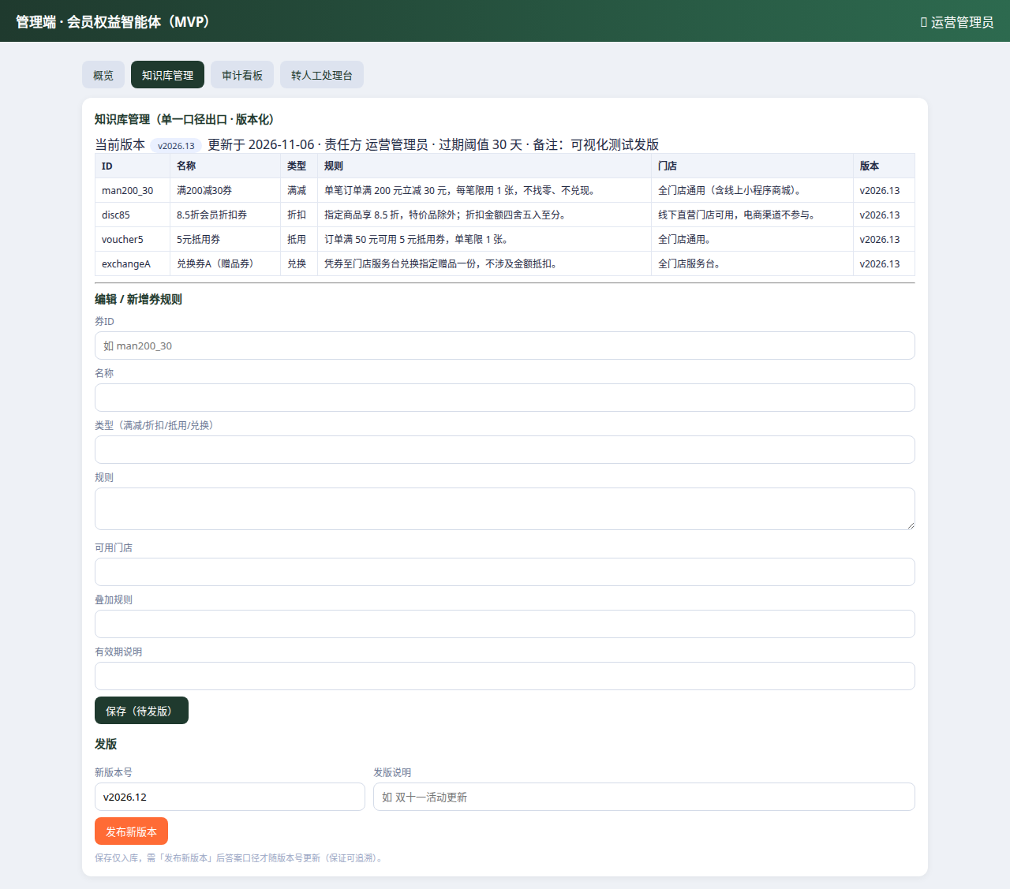
知识库管理（含发版）
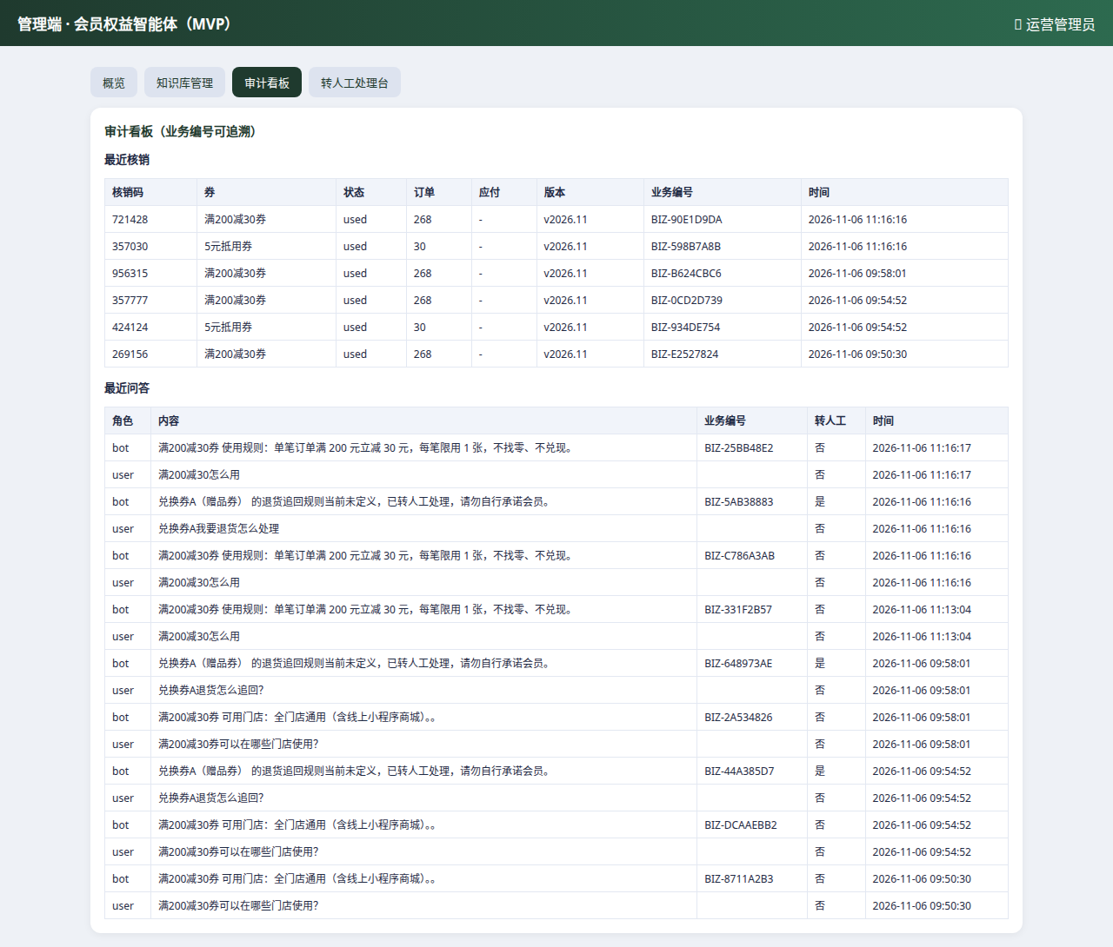
审计看板（记录持久可追溯）
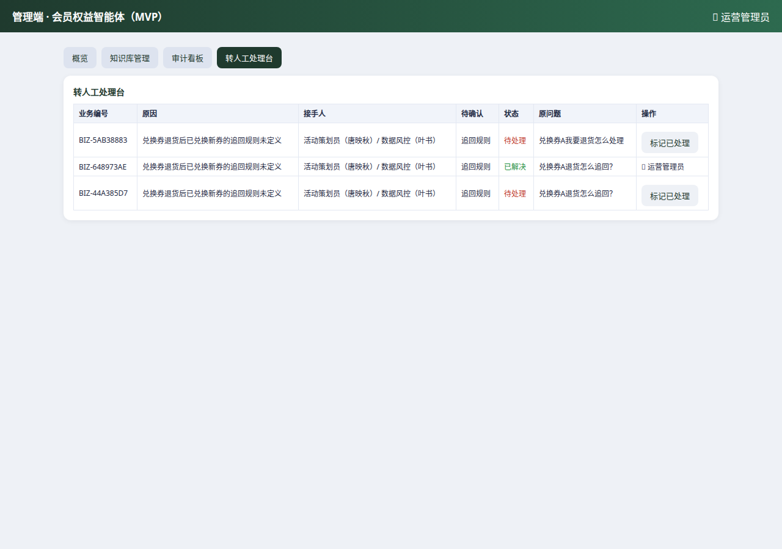
转人工处理台

证据来源：运行中的 MVP 实例（localhost:8001）真实接口与 UI 实测；截图与 API 响应一一对应。

