introduction
This template allows using PlantUML directly from MS Word 2010/2013 on Windows (32/64 bit) without need to alter document templates or edit VBA macro's. MS Word Version 2007 may work, but is not tested.

If you cannot see the green boxes in this file, please use the ‘show PlantUML’ button.

Example

@startuml
actor User
participant Word
participant PlantUML
User-->Word: Type text\nstartuml…enduml

User-->Word: Click [Add-ins:Uml]
activate Word
Word-->PlantUML: Generate pictures
activate PlantUML
PlantUML--//Word: Done
deactivate PlantUML
deactivate Word
User->User: ;-) pictures!
@enduml
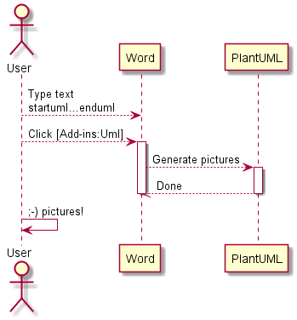

Installation
First time:
- install this template in Word
  - copy this (docm) file in to %appdata%\Microsoft\Word\STARTUP
- install Plantuml.jar in %appdata%
- install GraphViz
  - http://www.graphviz.org/Download_windows.php
    - use installer if you have rights to install applications; this will install graphviz in your program files (x86)
    - use zip for portable installation
      - extract in %appdata%
      - (executable is then in %appdata%\release\bin\dot.exe)
  - if alternative portable installation, please set GRAPHVIZ_DOT to location of DOT.EXE
- restart Word. You now should have a PlantUML menu!

Installation
First time:
- install this template in Word
  - copy this (dotm) file in to %appdata%\Microsoft\Word\STARTUP
  - note: .dotm = Word Doc Template (office 2007/2010) with Macro's enabled
- install Plantuml.jar in %appdata%
- install GraphViz
  - http://www.graphviz.org/Download_windows.php
    - use installer if you have rights to install applications; this will install graphviz in your program files (x86)
    - use zip for portable installation
      - extract in %appdata%
      - (executable is then in %appdata%\release\bin\dot.exe)
  - if alternative portable installation, please set GRAPHVIZ_DOT to location of DOT.EXE
- restart Word. You now should have a PlantUML menu!

Using
Once installed, a special menu (PlantUML) should be available in Word as tab “PlantUML”

P =  : show paragraph marks
Show PlantUML: reveal (green text) of PlantUML image sources (for editing)
Hide PlantUML : hide source, just show generated pictures (before releasing a document for review/UCC)
UML.1 : Generate current diagram (cursor in green PlantUML definition)
UML.* : Generate all (note: this may take seconds up to a minute for 100+ pictures). Press Ctrl-Break to abort.

If you don’t see the toolbar, please check installation instructions. If you load the .dotm file from word (Open file, not double click from explorer) then you should also see the toolbar (or twice if you’ve installed it already).

About word template
This document contains VBA scripts (based on plantuml007.bas).
Improvements made by Adriaan van den Brand:
- Easy distribution and integration (as a word.docm)
- performance (no new documents created, direct writing of text files)
- fixed issue of images at wrong locations
- better sync with plantuml java (by using ShellandWait module)
- no unnecessary delays
- can be aborted with ctrl-break

Contact:adriaan.plantuml@gmail.com

I appreciate feedback and improved versions.
@startuml
left to right direction
class WordTemplate {
by Adriaan van den Brand
+PlantUML.bas
+ShellAndWait.bas
---
UML.1()
UML.*()
ShowPlantUML()
HidePlantUML()
}

class PlantUML.jar {
}
class GraphViz.DOT

WordTemplate --|> PlantUML.jar
PlantUML.jar --|> GraphViz.DOT

@enduml
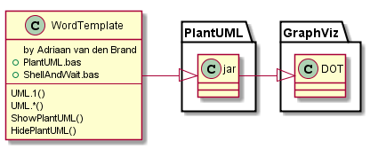

Background
My name is Adriaan van den Brand and I work as system architect at Philips Innovation Services. I am using plantuml for my technical documents, and wanted to have a straightforward Word integration. This is primarily for my own work, and I gladly share it with the community. The code is not my finest (minimal changes from original vba scripts) but it seems to do the trick. If you have improvements, please contact me.

Notes for version 2.6/2.7/2.8/2.9/3.0
- Version 3.0
  - added ftp mode (advanced use, high performance)
  - improved uml.1
  - added long help text with toolbar
  - to use ftp mode (experimental!)
    - enable in preferences

ensure that plantuml is started in ftp mode (java -jar plantuml.jar -ftp)
currently only works for png mode.
see http://plantuml.sourceforge.net/ftp.html
  - fixed visibility issue images (introduced in 2.9)

- Version 2.9
  - auto-scale-down to fit page
  - copy/paste compatibility (hidden text is not copy/paste compatible; changed style handling)
  - 64 bit compatibility (thanks to Andreas Brusinsky, Gil Fuchs, Ren Vleer, who hinted on the PtrSafe keyword. I cannot try it on a 32bit office. )
- added @rescale keyword (see 1.8)
- better support for non-English Office versions (reference to ‘normal’ style is done by magic number instead of name)
- use of UTF-8 instead of ascii. This may help people using non-ascii characters, but it will cause problems with MS Word autoformatting. Consider disabling autoformat (quotes need to be straight for plantuml to work)
- Version 2.7: added preferences button and support for EPS vector graphics (better print quality)
Note: preferences are stored in registry under hkeycurrentuser\PlantUML
- added authors and fixed text in toolbar for UML.1
- version 2.8: added includepath

Future features :
- more help for the visually impaired

Known issues
- When is at the end of a table cell, no image is inserted (at least, no image becomes visible). This seems related to the odd table structures in word. There is a next paragraph, yet it is not visible.

- If an error occurs inserting the picture, the macro’s may assume that is at the end of the document. So if pictures appear at the end of the document, please check that there is a line after each

- autoformat (automatic bullets/arrows) are not compatible with plantuml. Use toolbar button for quick access. Note that this will not change the autoformat as you type (--> into →).
- formatting plantuml can be improved
- add-ins from previous version are still created (so 2 methods of invoking plantuml after first Uml.* run)
- mismatched startuml/enduml pairs will cause pictures to be inserted in the wrong place

- ftp mode only works for png files

Rescale
Plantuml supports a scale keyword. This will scale the generated png file. However, when downscaling, text may become coarse. To solve this, the @rescale (use in plantuml comment!) provides a post-processing scale. Scale is supported only as a float number between 0.1 and 10
Example: 2.4 Components (and @rescale)
Note: should not be needed often from 2.9 onwards (automatic scale to page)

Version info plantUML
The following picture should be updated when you select PlantUML (menu) UML.1 or UML.*
@startuml
version
@enduml
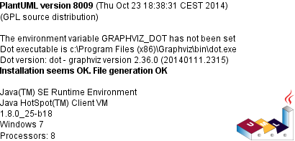

Check for updates
@startuml
checkversion
@enduml
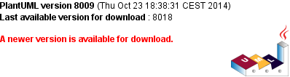

License information
For license information of PlantUML, please check out http://plantuml.sourceforge.net/
The code below will generate a copyright image (if correctly installed)
@startuml
license
@enduml
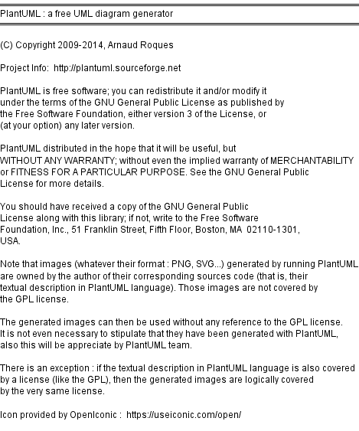

Authors
@startuml
authors
@enduml
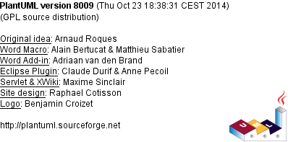

VBA code Shellandwait
' By Chip Pearson, chip@cpearson.com, www.cpearson.com
' This page on the web site: www.cpearson.com/Excel/ShellAndWait.aspx
' 9-September-2008

(Public domain)

VBA Registry code
Based on macro’s published on http://www.slipstick.com/developer/read-and-change-a-registry-key-using-vba/

Examples
See http://plantuml.sourceforge.net for more information and examples

Basic sequence diagram

@startuml

title <u>Simple</u> communication example\non several lines

Alice -> Bob: Authentication Request
Bob -> Alice: Authentication Response

@enduml
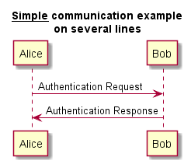

Class example

@startuml
skinparam classAttributeIconSize 0
class Dummy {
-field1
#field2
~method1()
+method2()
}

@enduml
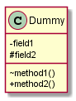

Activity (parallel)
@startuml

start

if (multiprocessor?) then (yes)
fork
:Treatment 1;
fork again
:Treatment 2;
end fork
else (monoproc)
:Treatment 1;
:Treatment 2;
endif

@enduml
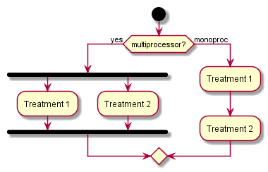

Components (and @rescale)
@startuml
'@rescale 0.7
package "Some Group" {
HTTP - [First Component]
[Another Component]
}

node "Other Groups" {
FTP - [Second Component]
[First Component] --> FTP
}

cloud {
[Example 1]
}

database "MySql" {
folder "This is my folder" {
[Folder 3]
}
frame "Foo" {
[Frame 4]
}
}
@enduml
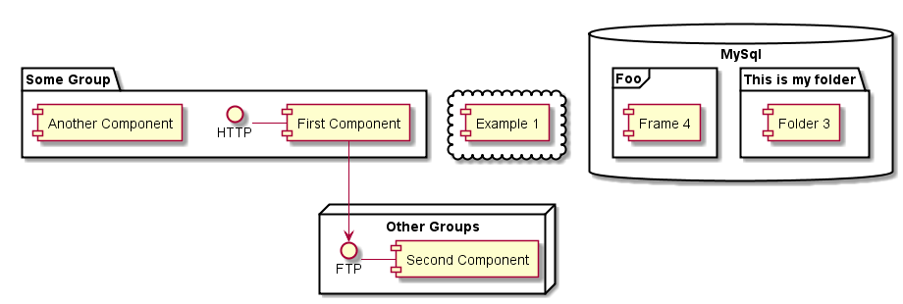

Statechart
@startuml
scale 350 width
[*] --> NotShooting

state NotShooting {
[*] --> Idle
Idle --> Configuring : EvConfig
Configuring --> Idle : EvConfig
}

state Configuring {
[*] --> NewValueSelection
NewValueSelection --> NewValuePreview : EvNewValue
NewValuePreview --> NewValueSelection : EvNewValueRejected
NewValuePreview --> NewValueSelection : EvNewValueSaved

state NewValuePreview {
State1 -> State2
}

}
@enduml
