公共交通乘客行程系统

需求分析报告

专业班级：自动化校交1901

小组成员：沈磊U201915616

邹搏进U201910415

指导教师：周纯杰，何顶新，左峥嵘，高常鑫，汪国有，桑农，彭刚，周凯波，陈忠

**目录**

**一、 前言 4**

**编写目的： 4**

**参考资料： 4**

**参考软件： 4**

**二、运行环境和配置 5**

**硬件接口 5**

**软件接口 5**

**三、需求分析 6**

**1.功能需求： 6**

**(1)选择使用模式： 6**

**(2) 登录与注册： 6**

**(3) 添加乘车记录 7**

**(4) 乘车记录轨迹可视化显示： 7**

**(5) 每个乘车车次关联乘客轨迹图形化显示 7**

**(6) 游客模式 7**

**四、系统设计 8**

**1.总框架设计： 8**

**2.软件结构设计： 9**

**(1)登录注册模块基本框架： 9**

**(2)登录： 10**

**(3)注册： 11**

**(4)乘车记录模块： 12**

**(5) 乘车轨迹查询模块 ： 13**

**(6) 乘车车次关联乘客轨迹模块： 14**

**(7)游客模块： 15**

**3.模块的调用与接口设计 16**

**(1)界面跳转设计 16**

**(2)数据流和功能之间的设计 17**

**(3)数据结构设计 18**

**(4)算法设计 18**

**五、具体功能函数及其代码 18**

1. **头文件及其代码 18**
2. **功能函数代码 26**

**六、界面设计 125**

**七、 时间安排 13****5**

**八、代码工作量分配** **13****6**

**九、总结** **13****8**

**(1)个人总结 13****8**

**(2)程序亮点 13****9**

**(3)程序亮点 13****9**

一、前言

(1)编写目的

随着国家城市化进程的不断推进，城市公共交通愈发成为市民生活中不可或缺的一部分，然而出于对隐私的担忧和对行程管理的重视不足，针对单个用户的行程记录和查询的软件发展得较为缓慢。

然而在这次疫情中，针对单个用户的行程分析在追溯病毒来源和疑似感染者中扮演了举足轻重的作用，国内疫情的有效控制很大程度上也要归功于较为完善的行程追踪机制，因此人们对行程管理的重视度也有了显著提高。值得注意的是，行程管理不仅对传染病的管控有着重要意义，其在刑事案件的侦察中也会发挥显著的作用。

基于以上实际的考量，编者希望编写出一款简单的公共交通行程系统，以帮助用户管理自己的行程信息，查询乘坐过同车次公共交通工具的其他乘客，以更好地应对意外情况发生后的追溯和紧急处理。

(2)参考资料

1.王士元 C高级实用程序设计 北京: 清华大学出版社. 1996

2.杨将新 C语言开发全程指南 电子工业出版社. 2008

3.严蔚敏，吴伟民 数据结构（C语言版） 北京：清华大学出版社. 2018年

(3)参考软件

微信小程序乘车码

支付宝乘车码

二、运行环境及配置

(1)硬件接口

1.处理器：Intel Pentium 166 MX 或以上。

2.硬盘：空间500MB以上。

3.屏幕适配器：VGA接口。

4.系统运行内存：要求32MB以上。

(2)软件接口

1.运行调试软件:Borland C 3.0

2.代码编辑软件:Visual Studio professional 2019 、Visual Studio Code

3.数据储存文件:记事本(文本文件)

4.DOS、Windows XP、Windows 7、Windows 10

三、需求分析

(1)功能需求:

1、用户自行选择使用模式

我们设计了用户模式和游客模式，以适应需求不同功能的用户的使用。

如果用户选择以用户模式登录，进入用户界面后其可以使用查看以往乘车记录的功能，并可将新添加的乘车记录轨迹图形化展示给用户，还可以查询每个乘车车次关联的乘客的信息。

而如果以游客模式使用，不需要登录即可查询对应车次的行车轨迹并查询某车次的乘客信息。

2、用户的登录与注册

登录:用户输入已注册用户的用户名和对应密码以进入用户界面。

注册:用户输入新的用户名，密码以及手机号来注册新用户。

忘记密码：用户正确输入用户名和注册时所用手机号后，系统会显示其密码。

3、用户登录后,自行添加乘车记录（车次）

我们通过让用户选择已乘坐过的车次，来添加其乘车记录，并在文件中查询用户以往的乘车记录，和添加的乘车记录一并以列表的方式显示在屏幕上，供用户查看以了解自己近来的行程。

4、乘车记录可视化显示

在用户添加完其乘车记录后，根据行车记录的车次，输出对应的路径在地图上显示出来，使用户了解其乘车路径，方便用户之后选择乘车方案。

5、每个乘车车次关联乘客轨迹图形化显示功能

用户可以选择已有的某个车次，在文件中读出车次上所有的乘客用户名，并以图形化的方式显示出所有的乘客的相关信息，以查询在乘坐公交系统的过程中，用户直接或间接地接触了哪些人。

6、游客模式

游客模式的设计是为了方便那些仅仅希望查询路线线路和某一车次上所搭载的所有乘客，而不关心过往的乘车记录的用户，这可以为他们省去登陆注册所用的时间。

四、系统设计

(1)系统总架构设计：

a.我们设计了欢迎页并用于选择用户模式和游客模式，以适应需求不同功能的用户的使用

b.功能方面，我们将每个功能分为一个模块，让用户自主在菜单里选择对应的功能

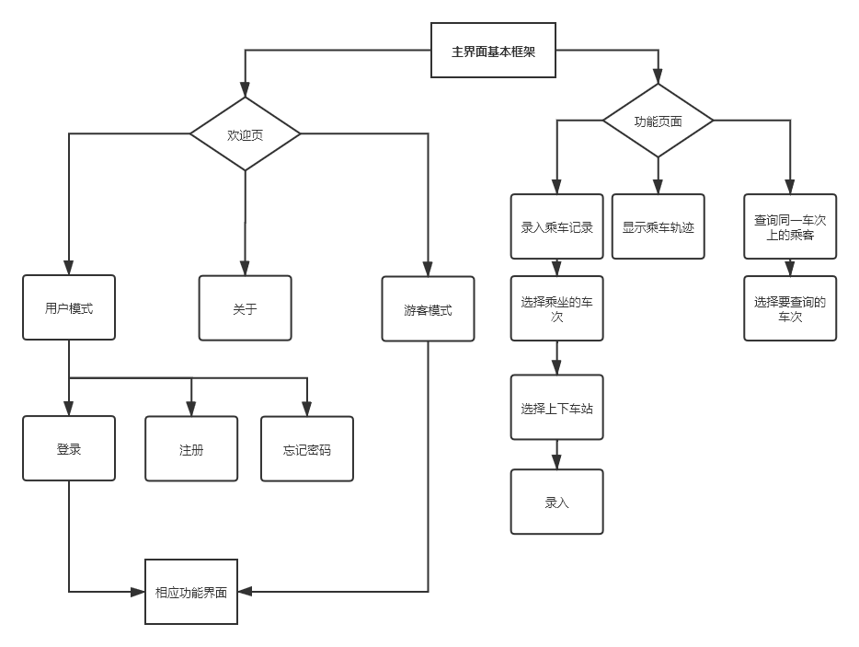

(2)软件结构设计：

1. 登录注册模块
2. 要进入用户界面，必须输入已注册用户的用户名和密码。
3. 注册完后，会自动跳转到登录界面，以刚注册的用户名和密码进入用户界面。
4. 我们特地设计了找回密码的功能，使得用户能够找回自己的密码。

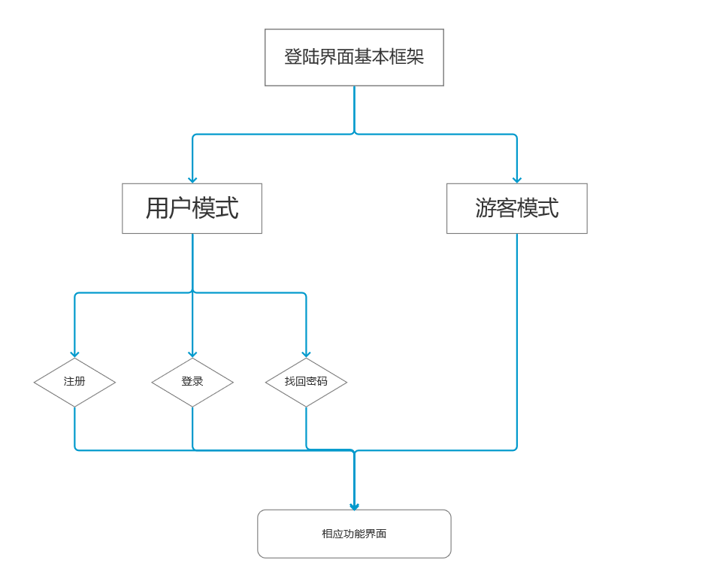

2.登录

a.在登陆功能中，系统会自动判断用户输入的信息是否符合规定长度，若超出规定长度，系统自动中断输入。

b.用户也能通过按Enter键提前中断用户名和密码的输入。

按下登录按钮，系统会判断已输入用户名和密码是否匹配，若不匹配，会输出错误提示信息，若匹配，则进入用户界面。

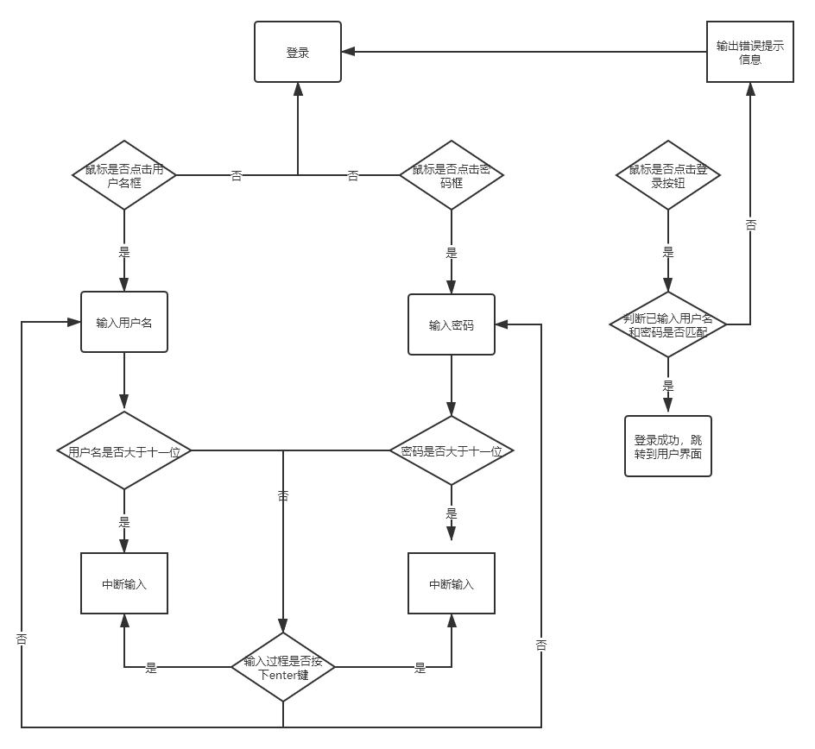

3.注册

a.注册功能中我们也设计了类似登录系统中的自动中断输入的功能和用户自主控制中断输入的功能。

b.当用户名或电话号码重复，系统会输出错误提示信息，而当各项均符合规范，注册成功，系统跳转到登陆界面。

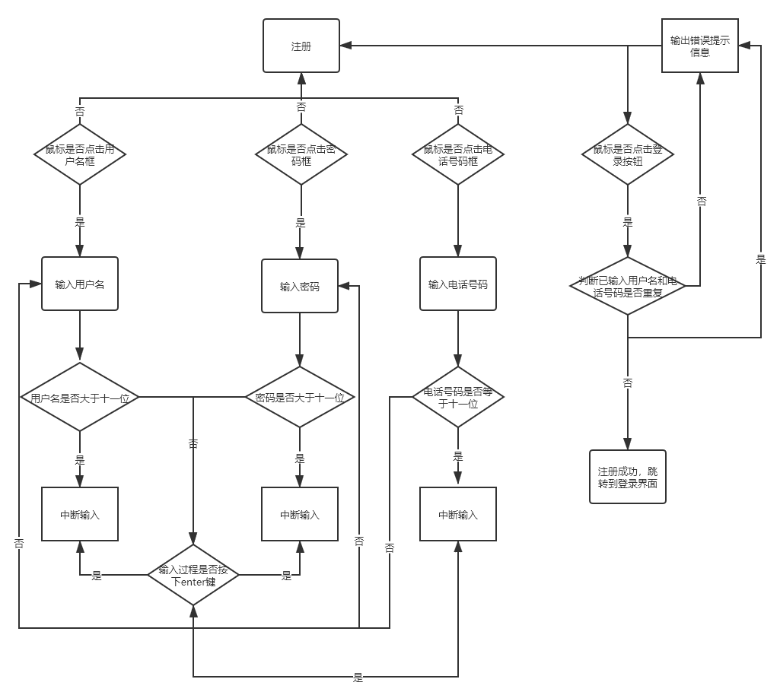

4.乘车情况记录模块

a.设计菜单以让用户选择已乘坐过的车次

b.通过多级菜单用户选择上下车站

b.查询用户以往的乘车记录，和添加的乘车记录一并以列表的方式显示在屏幕上，供用户查看。

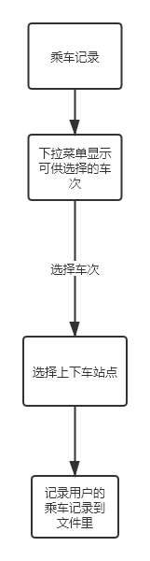

5.乘车轨迹查询模块

a.根据乘客新录入的乘车记录，判断车次和上下车站，输出对应的图形化乘车轨迹。

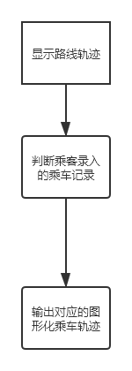

6.乘车车次关联乘客轨迹模块

a.用户选择要查看的乘车车次，输出对应乘车车次上搭载的乘客的名单。

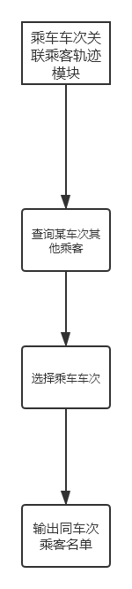

7.游客模块

对于不想记录自己乘车记录的用户，我们提供了游客模块，以满足他们查询车次线路图以及某车次上搭载的乘客的需求

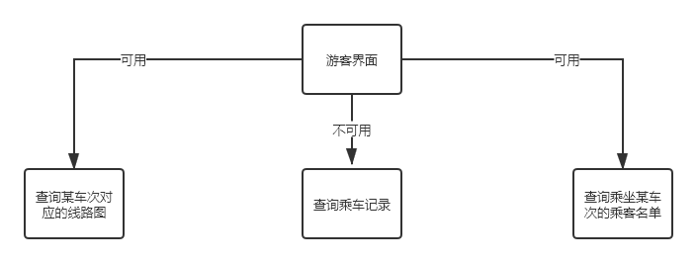

(3)模块的调用与接口设计：

1.界面跳转设计

我们通过各个功能函数的返回值传递给main函数的整形变量page，通过不同的返回值切换功能界面，具体的page变量值与界面的对应关系如下图所示

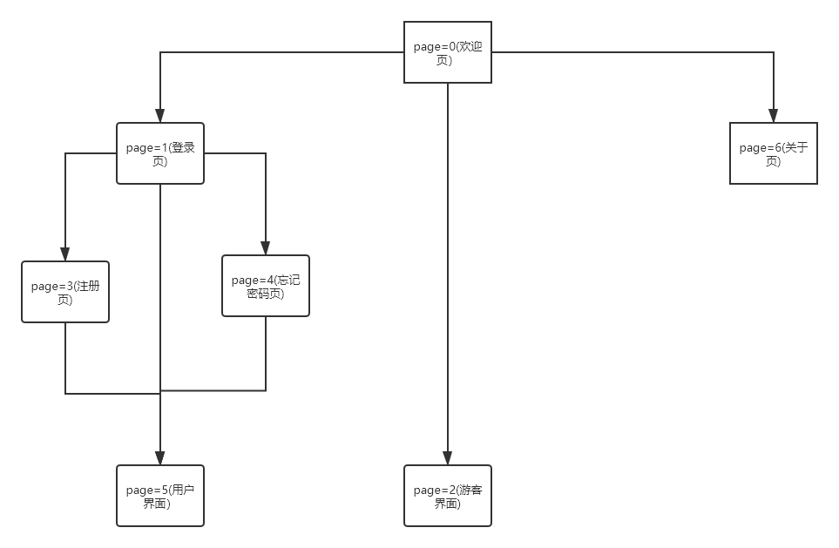

2.数据流和功能之间的设计：

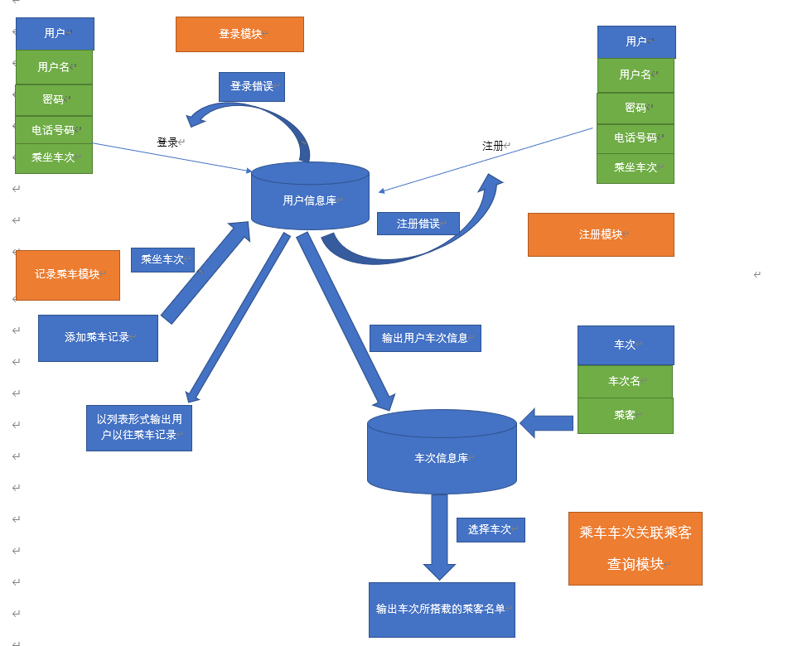

3.数据结构设计：

User:储存用户信息，如用户名、密码、手机号及乘车记录

typedef struct The_users

{

char username[20];

char password[20];

char phonenum[12];

struct user* next;

} user;

SetKeyValue:储存键值及其对应的字符

typedef struct

{

     int value;

     char ch;

}setKeyValue;

4.算法设计:

登录注册模块：

（1）验证用户名和密码是否匹配

顺序查找算法以寻找用户名及其对应的密码。

（2）添加新用户到储存用户信息的文件

顺序查找算法以寻找是否存在重复的用户名或电话号码。

记录乘车模块:

（1）将乘车记录录入record.txt文件中

顺序查找算法以寻找用户名，并通过寻找并记录用户名在user.txt文件中的行数，找到records.txt文件中其过往乘车记录,并通过temp.txt文件作为临时数据储存库来更新records.txt文件。

乘车车次关联乘客查询模块：

（1）通过输入车次名找出该车次所有乘客

顺序查找算法在车次文件内寻找改车次对应乘客列表

五、具体功能函数及其代码

**头文件及其代码:**

——————————————————FORGETPASS.H——————————————

#ifndef _fogetpass_h

#define _forgetpass_h

void fgpass_drawer();

int s_fgpass();

#endif

——————————————————HZ.H———————————————————

#ifndef __HZ_H__

#define __HZ_H__

void puthz(int x, int y,char *s,int flag,int part,int color);

#endif

——————————————————INPUT.H—————————————————

#ifndef _input_h

#define _input_h

int input_name(char* username, int nx, int ny);

int input_password(char* password, int nx, int ny);

#endif

——————————————————JUDGE.H—————————————————

#ifndef _judge_h

#define _judge_h

int judge_login(char* name, char* pass);

int judge_forgetpassword(char* name,char* pass, char* phone);

#endif

——————————————————KEYBOARD.H———————————————

#ifndef _keyboard_h

#define _keyboard_h

char get_key(int value);

#endif

——————————————————LOGIN.H—————————————————

#ifndef _login_h

#define _login_h

void g_login();

int s_login();

#endif _login_h

——————————————————MAIN.H——————————————————

#ifndef _MAIN_H_

#define _MAIN_H_

#include"welcome.h"

#include"login.h"

#include"register.h"

#endif

——————————————————MENU.H—————————————————

#ifndef _menu_h

#define _menu_h

void user_menu0();

int user_menu1();

void user_menu();

void menu_choice(int* state1,int* state2);

void station(int x,int y);

void draw_choosesta();

/*void guest_menu0();

void guest_menu1();

void guest_menu();*/

#endif

——————————————————MOUSE.H—————————————————

#ifndef _mouse_h_

#define _mouse_h_

int mouse_press(int x1, int y1, int x2, int y2);

void mouse(int,int);

void mouseinit(void);

//void mou_pos(int*,int*,int*);

void mread(int *,int *,int*);

void save_bk_mou(int x,int y);

void clrmous(int x,int y);

void drawmous(int x,int y);

void newmouse(int *nx,int *ny,int *nbuttons);

extern int MouseX;

extern int MouseY;

extern int MouseS;

extern int press;

extern union REGS regs;

#endif

——————————————————PUBLIC.H—————————————————

#ifndef _PUBLIC_H_

#define _PUBLIC_H_

#include<stdio.h>

#include<stdlib.h>

#include<string.h>

#include<graphics.h>

#include<math.h>

#include<bios.h>

#include<conio.h>

#include<dos.h>

#include<time.h>

#include"mouse.H"

#include"keyboard.h"

#include"hz.h"

#define NUM0 0x5230

#define NUM1 0x4f31

#define NUM2 0x5032

#define NUM3 0x5133

#define NUM4 0x4134

#define NUM5 0x4c35

#define NUM6 0x4d36

#define NUM7 0x4737

#define NUM8 0x4838

#define NUM9 0x4939

#define F2 0x3c00

#define F3 0x3d00

#define F4 0x3e00

#define F5 0x3f00

#define F6 0x4000

#define F7 0x4100

#define F8 0x4200

#define F9 0x4300

#define F10 0x4400

#define F1 0x3b00

#define ENTER 0x1c0d

#define BACK 0x0e08

#define ESC 0x011b

#define UP 0x4800

#define DOWN 0x5000

#define RIGHT 0x4d00

#define LEFT 0x4b00

#define ONE 0x0231

#define TWO 0x0332

#define THREE 0x0433

#define FOUR 0x0534

#define FIVE 0x0635

#define SIX 0x0736

#define SEVEN 0x0837

#define EIGHT 0x0938

#define NINE 0x0a39

#define ZERO 0x0b30

#endif

——————————————————RECORD.H————————————————

#ifndef _record_h_

#define _record_h_

int findline(char* name);

void readrecord(char* name,char* t);

void writeuser(char* name,int checi);

void record(char* name,int checi,int start,int end,char* t);

#endif

——————————————————REGISTER.H————————————————

#ifndef _register_h

#define _register_h

int s_register();//register是寄存器变量的关键字

void register_drawer();

#endif

——————————————————TRACK.H—————————————————

#ifndef _track_h

#define _track_h

void track000();

void track115();

void track112();

void track113();

void track114();

void track123();

void track124();

void track125();

void track134();

void track135();

void track145();

void track215();

void track212();

void track213();

void track214();

void track223();

void track224();

void track225();

void track234();

void track235();

void track245();

void track315();

void track312();

void track313();

void track314();

void track323();

void track324();

void track325();

void track334();

void track335();

void track345();

void track_sta();

#endif

——————————————————USER.H——————————————————

#ifndef _user_h

#define _user_h

typedef struct The_users

{

char username[20];

char password[20];

char phonenum[12];

int subway;

int station1;

int station2;

struct user* next;

} user;

void makefile();

user* getuser();

user* add_user(user* phead,char* name, char* pass, char* phone);

//user* finduser(char* name);

void writetofile(user* phead);

int f_register(char* name,char* pass,char* phone);

#endif

——————————————————VISUALIZE.H————————————————

#ifndef _visualize_h

#define _visualize_h

void judge_visual(int state3,int start,int end);

void judge_station(int *start,int *end);

#endif

——————————————————WELCOME.H——————————————

#ifndef _welcome_h

#define _welcome_h

void g_welcome();

int s_welcome();

#endif

——————————————————ABOUT.H—————————————————

#ifndef _about_h

#define _about_h

void g_about();

#endif

**功能函数文件及其代码：**

ABOUT.C

#include"public.h"

#include"about.h"

/*****************************************

about.c

COPYRIGHT: zoubojin

FUNCTION: information about the project

ABSTRACT:

information about the project

DATE:2020/10/12

******************************************/

/*********************************************

FUNCTION:fgpass_drawer

DESCRIPTION：关于界面的画图函数

INPUT:void

RETURN:void

***********************************************/

void g_about()

{

cleardevice();

setbkcolor(WHITE);

//clrscr();

setcolor(DARKGRAY);

settextstyle(1,0,2);

puthz(250, 0, "相关信息说明", 16, 17, DARKGRAY);

puthz(0, 16, "应用名称：", 16, 17, DARKGRAY);

puthz(0+16*5, 16, "公共交通乘客行程系统", 16, 17, DARKGRAY);

puthz(0, 16*2, "制作者：", 16, 17, DARKGRAY);

puthz(0+16*4, 16*2, "沈磊", 16, 17, DARKGRAY);

puthz(0+16*7, 16*2, "邹搏进", 16, 17, DARKGRAY);

puthz(0, 16*3, "指导教师：", 16, 17, DARKGRAY);

puthz(0+16*5, 16*3, "周纯杰", 16, 17, DARKGRAY);

puthz(0+16*9, 16*3, "周凯波", 16, 17, DARKGRAY);

puthz(0+16*13, 16*3, "彭刚", 16, 17, DARKGRAY);

puthz(0+16*16, 16*3, "何顶新", 16, 17, DARKGRAY);

puthz(0+16*20, 16*3, "左峥嵘", 16, 17, DARKGRAY);

puthz(0+16*24, 16*3, "高常鑫", 16, 17, DARKGRAY);

puthz(0+16*28, 16*3, "汪国有", 16, 17, DARKGRAY);

puthz(0+16*32, 16*3, "桑农", 16, 17, DARKGRAY);

puthz(0+16*35, 16*3, "陈忠", 16, 17, DARKGRAY);

puthz(0, 16*4, "编写目的：", 16, 17, DARKGRAY);

puthz(0, 16*5, "随着国家城市化进程的不断推进，城市公共交通愈发成为市民生活中不可或缺的一部", 16, 17, DARKGRAY);

puthz(0, 16*6, "分，然而出于对隐私的担忧和对行程管理的重视不足，针对单个用户的行程记录和查", 16, 17, DARKGRAY);

puthz(0, 16*7, "询的软件发展得较为缓慢。", 16, 17, DARKGRAY);

puthz(0, 16*8, "然而在这次疫情中，针对单个用户的行程分析在追溯病毒来源和疑似感染者中扮演了", 16, 17, DARKGRAY);

puthz(0, 16*9, "举足轻重的作用，国内疫情的有效控制很大程度上也要归功于较为完善的行程追踪机", 16, 17, DARKGRAY);

puthz(0, 16*10, "制，因此人们对行程管理的重视度也有了显著提高。值得注意的是，行程管理不仅对", 16, 17, DARKGRAY);

puthz(0, 16*11, "传染病的管控有着重要意义，其在刑事案件的侦察中也会发挥显著的作用。", 16, 17, DARKGRAY);

puthz(0, 16*12, "基于以上实际的考量，编者希望编写出一款简单的公共交通行程系统，以帮助用户管", 16, 17, DARKGRAY);

puthz(0, 16*13, "理自己的行程信息，查询乘坐过同车次公共交通工具的其他乘客，以更好地应对意外", 16, 17, DARKGRAY);

puthz(0, 16*14, "情况发生后的追溯和紧急处理。", 16, 17, DARKGRAY);

puthz(0, 16*15, "参考软件：", 16, 17, DARKGRAY);

puthz(0, 16*16, "微信小程序乘车码", 16, 17, DARKGRAY);

puthz(0, 16*17, "支付宝乘车码", 16, 17, DARKGRAY);

puthz(0, 16*18, "主要功能：", 16, 17, DARKGRAY);

puthz(0, 16*19, "分用户模式和游客模式", 16, 17, DARKGRAY);

puthz(0+16*11, 16*19, "游客模式仅供用户查询使用", 16, 17, DARKGRAY);

puthz(0, 16*20, "用户登录后自行添加乘车记录", 16, 17, DARKGRAY);

puthz(0, 16*21, "乘车记录可视化显示", 16, 17, DARKGRAY);

puthz(0, 16*22, "乘车车次关联乘客轨迹图形化显示功能", 16, 17, DARKGRAY);

outtextxy(500, 16*24, "VERSION:1.0.0");

puthz(450, 16*26, "二零二零年十月三十一日", 16, 17, DARKGRAY);

button_back();

}

/*********************************************

FUNCTION:fgpass_drawer

DESCRIPTION：关于界面的功能函数

INPUT:void

RETURN:0

***********************************************/

int s_about()

{

clrmous(MouseX,MouseY);

g_about();

while (1)

{

newmouse(&MouseX, &MouseY, &press);

if(mouse_press(610,0,640,30)==1)

{

clrmous(MouseX,MouseY);

delay(150);

return 0;

}

}

}

/*void main()//测试函数

{

int graphdriver, graphmode;

graphdriver = DETECT;

initgraph(&graphdriver, &graphmode, "C:\\BORLANDC\\BGI");

g_about();

getch();

}*/

HZ.C

#include <graphics.h>

#include<conio.h>

#include<stdio.h>

#include<stdlib.h>

#include<string.h>

#include"hz.h"

/*****************************************

hz.c

COPYRIGHT: zoubojin

FUNCTION: hanzi

ABSTRACT:

hanzi

DATE:2020/9/5

******************************************/

/*********************************************

FUNCTION:puthz

DESCRIPTION：输出汉字

INPUT:int x, int y,char *s,int flag,int part,int color

RETURN:void

***********************************************/

void puthz(int x, int y,char *s,int flag,int part,int color)

{

FILE *hzk_p=NULL;

unsigned char quma,weima;

unsigned long offset;

unsigned char mask[] = {0x80,0x40,0x20,0x10,0x08,0x04,0x02,0x01};

int i,j,pos;

switch(flag)

{

case 16 :

{

char mat[32];

int y0=y;

int x0=x;

hzk_p = fopen("HZK\\HZ16","rb");

if(hzk_p==NULL)

{

settextjustify(LEFT_TEXT,TOP_TEXT);

settextstyle(GOTHIC_FONT,HORIZ_DIR,1);

outtextxy(10,10,"Can't open hzk16 file!Press any key to quit...");

getch();

exit(1);

}

while(*s!=NULL)

{

while (x<640-flag && (*s!=NULL))

{

y=y0;

quma=s[0]-0xa0;

weima=s[1]-0xa0;

offset=(94*(quma-1)+(weima-1))*32L;

fseek(hzk_p,offset,SEEK_SET);

fread (mat,32,1,hzk_p);

for(i=0;i<16;i++)

{

pos=2*i;

for(j=0;j<16;j++)

{

if((mask[j%8]&mat[pos+j/8])!=NULL)

{

putpixel(x+j,y,color);

}

}

y++;

}

/*====================================================

====================================================*/

x+=part;

s+=2;

}

x=x0;y0+=flag+10;

}

break;

}

case 24 :

{

char mat[72];

int y0=y;

int x0=x;

hzk_p = fopen("HZK\\Hzk24k","rb");

if (hzk_p==NULL)

{

settextjustify(LEFT_TEXT,TOP_TEXT);

settextstyle(GOTHIC_FONT,HORIZ_DIR,3);

outtextxy(10,10,"Can't open hzk24 file!Press any key to quit...");

getch();

exit(1);

}

while(*s!=NULL)

{

while(x<640-flag && (*s!=NULL))

{

y=y0;

quma=s[0]-0xa0;

weima=s[1]-0xa0;

offset=(94*(quma-1)+(weima-1))*72L;

fseek(hzk_p,offset,SEEK_SET);

fread (mat,72,1,hzk_p);

for (i=0;i<24;i++)

{

pos=3*i;

for (j=0;j<24;j++)

{

if ((mask[j%8]&mat[pos+j/8])!=NULL)

putpixel(x+j,y,color);

}

y++;

}

x+=part;

s+=2;

}

x=x0;y0+=flag+10;

}

break;

}

case 32 :

{

char mat[128];

int y0=y;

int x0=x;

hzk_p = fopen("HZK\\HZK32S","rb");

if(hzk_p==NULL)

{

settextjustify(LEFT_TEXT,TOP_TEXT);

settextstyle(GOTHIC_FONT,HORIZ_DIR,3);

outtextxy(10,10,"Can't open hzk32 file!Press any key to quit...");

getch();

exit(1);

}

while(*s!=NULL)

{

while (x<640-flag && (*s!=NULL))

{

y=y0;

quma=s[0]-0xa0;

weima=s[1]-0xa0;

offset=(94*(quma-1)+(weima-1))*128L;

fseek(hzk_p,offset,SEEK_SET);

fread (mat,128,1,hzk_p);

for(i=0;i<32;i++)

{

pos=4*i;

for(j=0;j<32;j++)

{

if((mask[j%8]&mat[pos+j/8])!=NULL)

{

putpixel(x+j,y,color);

}

}

y++;

}

x+=part;

s+=2;

}

x=x0;y0+=flag+10;

}

break;

}

case 48:

{

char mat[288];

int y0=y;

int x0=x;

hzk_p = fopen("HZK\\Hzk48k","rb");

if(hzk_p==NULL)

{

settextjustify(LEFT_TEXT,TOP_TEXT);

settextstyle(GOTHIC_FONT,HORIZ_DIR,3);

outtextxy(10,10,"Can't open hzk48 file!Press any key to quit...");

getch();

exit(1);

}

while(*s!=NULL)

{

while (x<640-flag && (*s!=NULL))

{

y=y0;

quma=s[0]-0xa0;

weima=s[1]-0xa0;

offset=(94*(quma-1)+(weima-1))*288L;

fseek(hzk_p,offset,SEEK_SET);

fread (mat,288,1,hzk_p);

for(i=0;i<48;i++)

{

pos=6*i;

for(j=0;j<48;j++)

{

if((mask[j%8]&mat[pos+j/8])!=NULL)

{

putpixel(x+j,y,color);

}

}

y++;

}

x+=part;

s+=2;

}

x=x0;y0+=flag+10;

}

break;

}

default:

break;

}

fclose(hzk_p);

}

RECORD.C

#include"public.h"

#include"record.h"

#include"user.h"

/*****************************************

record.c

COPYRIGHT: zoubojin

FUNCTION: record user's data

ABSTRACT:

record user's data

DATE:2020/10/10

******************************************/

int findline(char* name)

{

user* temp=NULL,*phead=NULL;

int i=0;

char t[2];

t[1]='\0';

phead = getuser();

temp = phead->next;

while(temp!=NULL)//

{

if (strcmp(temp->username, name) == 0)

{

free(phead);

free(temp);

//setcolor(RED);

//settextstyle(1,0,6);

//t[0]=(char)(i-1+'1');

//outtextxy(100,200,t);

return i;//找到用户后，将乘车信息输入到用户所在行的末尾

}

else

{

temp = temp->next;

i++;

}

}

free(phead);

free(temp);

exit(-1);

}

void readrecord(char* name,char* t)

{

int i=0;

int j=0;

int k=0;

int count=0;

char s[1000];

int move=findline(name);

FILE* file_user;

memset(s,'\0',1000);

memset(t,'\0',1000);

if((file_user=fopen("records.txt","r"))!=NULL)

{

fseek(file_user,0L,SEEK_SET);

for(i=0;i<=move;i++)

{

fgets(s,1000,file_user);

}

strcpy(t,s);

fclose(file_user);

}

else

exit(-1);

}

void writerecord(char* name,char* route)//添加乘车记录

{

int i=0;

int j=0;

int k=0;

int distance=0;

int len_line=0;

char ch;

char s[1000];

char temp[1000];

char t[2];

FILE* file_temp;

FILE* file_record;

int move=findline(name);

memset(s,'\0',1000);

if((file_temp=fopen("temp.txt","w"))==NULL)//只允许可写

{

exit(-1);

}

if((file_record=fopen("records.txt","r"))!=NULL)//只允许可读，防止读取recoed.txt里的信息时因为写被全部修改

{

fseek(file_record,0L,SEEK_SET);

do

{

//len_line=strlen(s);

//distance+=len_line;

fgets(s,1000,file_record);//将文件指针移到文件中用户名对应的行

// if(i==move)

// {

// fseek(file_user,distance,SEEK_SET);

// strcpy(temp,route);

// strcat(temp,s);

// t[0]=(char)(distance-1+'1');

// outtextxy(300,300,t);

// //while((ch = getchar()) !='\n' && ch != EOF);

// fprintf(file_user,"%s\0",temp);

// }

fseek(file_record,0L,SEEK_CUR);//不能直接交替进行文件的读和写的操作

fprintf(file_temp,"%s",s);

}while(fgetc(file_record)!=EOF&&(!fseek(file_record,-1L,SEEK_CUR)));

fclose(file_record);

fclose(file_temp);

}

memset(s,'\0',1000);

len_line=0;

distance=0;

if((file_temp=fopen("temp.txt","r"))==NULL)//只允许可读,防止读取的时候temp.txt信息因为可写而被修改

{

exit(-1);

}

if((file_record=fopen("records.txt","w"))!=NULL)//只允许可写

{

fseek(file_record,0L,SEEK_SET);

do

{

//len_line=strlen(s);

//distance+=len_line;

fgets(s,1000,file_temp);//将文件指针移到文件中用户名对应的行

if(i==move)

{

fseek(file_temp,0L,SEEK_CUR);

strcpy(temp,route);

strcat(temp,s);

//while((ch = getchar()) !='\n' && ch != EOF);

fprintf(file_record,"%s",temp);

}

else

{

fseek(file_temp,0L,SEEK_CUR);//不能直接交替进行文件的读和写的操作

fprintf(file_record,"%s",s);

}

i++;

}while(fgetc(file_temp)!=EOF&&(!fseek(file_temp,-1L,SEEK_CUR)));

// while(s[j]!='\n')

// {

// j++;

// fseek(file_user,1L,SEEK_CUR);

// t[0]=(char)(i-1+'1');

// t[1]='\0';

// setcolor(RED);

// settextstyle(1,0,1);

// outtextxy(100,400,t);

// t[0]=(char)(distance-1+'1');

// outtextxy(300,400,t);

// while((ch = getchar()) !='\n' && ch != EOF);

//getch();

// }

fclose(file_record);

fclose(file_temp);

}

else

exit(-1);

}

void writeuser(char* name,int checi)

{

FILE* file_user;

char ch;

if(checi==1)

{

if((file_user=fopen("checi1.txt","a+"))!=NULL)

{

fseek(file_user,0L,SEEK_END);

//while((ch = getchar()) != '\n' && ch != EOF);

fprintf(file_user,"%s*",name);

fclose(file_user);

}

else

exit(-1);

}

else if(checi==2)

{

if((file_user=fopen("checi2.txt","a+"))!=NULL)

{

fseek(file_user,0L,SEEK_END);

//while(ch=(getchar()) != '\n' && ch != EOF);

fprintf(file_user,"%s*",name);

fclose(file_user);

}

else

exit(-1);

}

else

{

if((file_user=fopen("checi3.txt","a+"))!=NULL)

{

fseek(file_user,0L,SEEK_END);

//while((ch = getchar()) != '\n' && ch != EOF);

fprintf(file_user,"%s*",name);

fclose(file_user);

}

else

exit(-1);

}

}

void record(char* name,int checi,int start,int end,char* t)

{

int i=0;

char route[5];

route[0]=(char)(checi-1+'1');

route[1]=(char)(start-1+'1');

route[2]=(char)(end-1+'1');

route[3]='*';

route[4]='\0';

writerecord(name,route);

writeuser(name,checi);

readrecord(name,t);

cleardevice();

setbkcolor(CYAN);

setcolor(RED);

settextstyle(1,0,3);

//outtextxy(20,100,t);

while(t[i]!='\0')

{

if(((i+1)%4)!=0)

{

route[i%4]=t[i];

if((i%4)==0)

{

if(t[i]=='1')

puthz(40+320*(i/4)%2,30+40*(i/4)/2,"车次一",16,17,WHITE);

else if(t[i]=='2')

puthz(40+320*(i/4)%2,30+40*(i/4)/2,"车次二",16,17,WHITE);

else if(t[i]=='3')

puthz(40+320*(i/4)%2,30+40*(i/4)/2,"车次三",16,17,WHITE);

}

else if((i%4)==1)

{

if(t[i-1]=='1')

{

if(t[i]=='1')

puthz(120+320*(i/4)%2,30+40*(i/4)/2,"紫菘",16,17,WHITE);

else if(t[i]=='2')

puthz(120+320*(i/4)%2,30+40*(i/4)/2,"科技楼",16,17,WHITE);

else if(t[i]=='3')

puthz(120+320*(i/4)%2,30+40*(i/4)/2,"机械大楼",16,17,WHITE);

else if(t[i]=='4')

puthz(120+320*(i/4)%2,30+40*(i/4)/2,"喻园",16,17,WHITE);

}

else if(t[i-1]=='2')

{

if(t[i]=='1')

puthz(120+320*(i/4)%2,30+40*(i/4)/2,"校大门",16,17,RED);

else if(t[i]=='2')

puthz(120+320*(i/4)%2,30+40*(i/4)/2,"图书馆",16,17,RED);

else if(t[i]=='3')

puthz(120+320*(i/4)%2,30+40*(i/4)/2,"大活",16,17,RED);

else if(t[i]=='4')

puthz(120+320*(i/4)%2,30+40*(i/4)/2,"集贸市场",16,17,RED);

}

else if(t[i-1]=='3')

{

if(t[i]=='1')

puthz(120+320*(i/4)%2,30+40*(i/4)/2,"校大门",16,17,RED);

else if(t[i]=='2')

puthz(120+320*(i/4)%2,30+40*(i/4)/2,"图书馆",16,17,RED);

else if(t[i]=='3')

puthz(120+320*(i/4)%2,30+40*(i/4)/2,"幼儿园",16,17,RED);

else if(t[i]=='4')

puthz(120+320*(i/4)%2,30+40*(i/4)/2,"校医院",16,17,RED);

}

}

else if((i%4)==2)

{

if(t[i-2]=='1')

{

if(t[i]=='1')

puthz(210+320*(i/4)%2,30+40*(i/4)/2,"科技楼",16,17,WHITE);

else if(t[i]=='2')

puthz(210+320*(i/4)%2,30+40*(i/4)/2,"机械大楼",16,17,WHITE);

else if(t[i]=='3')

puthz(210+320*(i/4)%2,30+40*(i/4)/2,"喻园",16,17,WHITE);

else if(t[i]=='4')

puthz(210+320*(i/4)%2,30+40*(i/4)/2,"韵苑",16,17,WHITE);

}

else if(t[i-2]=='2')

{

if(t[i]=='1')

puthz(210+320*(i/4)%2,30+40*(i/4)/2,"图书馆",16,17,RED);

else if(t[i]=='2')

puthz(210+320*(i/4)%2,30+40*(i/4)/2,"大活",16,17,RED);

else if(t[i]=='3')

puthz(210+320*(i/4)%2,30+40*(i/4)/2,"集贸市场",16,17,RED);

else if(t[i]=='4')

puthz(210+320*(i/4)%2,30+40*(i/4)/2,"韵苑",16,17,RED);

}

else if(t[i-2]=='3')

{

if(t[i]=='1')

puthz(210+320*(i/4)%2,30+40*(i/4)/2,"图书馆",16,17,RED);

else if(t[i]=='2')

puthz(210+320*(i/4)%2,30+40*(i/4)/2,"幼儿园",16,17,RED);

else if(t[i]=='3')

puthz(210+320*(i/4)%2,30+40*(i/4)/2,"校医院",16,17,RED);

else if(t[i]=='4')

puthz(210+320*(i/4)%2,30+40*(i/4)/2,"喻园",16,17,RED);

}

}

}

else

{

setcolor(RED);

settextstyle(1,0,3);

//outtextxy(50+(i%4)*30,20+20*(i/4)*20,route);

}

i++;

}

getch();

}

TRACK.C

#include"public.h"

/*****************************************

track.c

COPYRIGHT: zoubojin

FUNCTION: a map of school's bus routes

ABSTRACT:

all bus routes

DATE:2020/9/25

******************************************/

void track000()//总的学校地图

{

int i,j;

setbkcolor(WHITE);

//clrscr();

setcolor(LIGHTGRAY);

setlinestyle(0, 1, 3);

for (i = 0; i <= 8; i++)

{

for(j=0;j<=3;j++)

{

line(100+50*i+3*j, 100, 100+50*i+3*j, 415);

}

}

for (i = 0; i <= 9; i++)

{

for(j=0;j<=3;j++)

{

line(100, 100+35*i+3*j, 500+9, 100+35*i+3*j);

}

}

setcolor(WHITE);

for(i=0;i<=3;i++)

{

line(100+4*3-1,170+3*i,150-2,170+3*i);

line(100+4*3-1,205+3*i,150-2,205+3*i);

line(150+4*3-1,135+3*i,200-2,135+3*i);

line(250+3*i,100+4*3-1,250+3*i,135-2);

}

setcolor(WHITE);

bar(300+4*3-1,305+4*3+3,400-2,415-2+4*3);

bar(450+4*3-1,275+4*3-1,500+4*3-1,415+4*3+1);

bar(350+4*3-1,100-1,450-2,170-2);

}

//第一条线

void track115()

{

int i,j;

for(i=0;i<=3;i++)

{

setcolor(RED);

setlinestyle(0,1,3);

line(100+4*3-2,275+3*i,400+4*3-2,275+3*i);

line(400+3*i,275,400+3*i,205);

line(400,205+3*i,450,205+3*i);

circle(106,281,6+1*i);

circle(256, 281, 6 + i);

circle(406,281,6+i);

circle(406,211,6+i);

circle(456,211,6+i);

}

setcolor(WHITE);

for(i=0;i<6;i++)

{

circle(106,281,i);

circle(256,281,i);

circle(406,281,i);

circle(406,211,i);

circle(456,211,i);

}

}

//第一条线路不同站点的轨迹图

void track112()

{

int i, j;

for (i = 0; i <= 3; i++)

{

setcolor(RED);

setlinestyle(0, 1, 3);

line(100 + 4 * 3 - 2, 275 + 3 * i, 256, 275 + 3 * i);

//line(400 + 3 * i, 275, 400 + 3 * i, 205);

//line(400, 205 + 3 * i, 450, 205 + 3 * i);

circle(106, 281, 6 + 1 * i);

circle(256, 281, 6 + i);

//circle(406, 281, 6 + i);

//circle(406, 211, 6 + i);

//circle(456, 211, 6 + i);

}

setcolor(WHITE);

for (i = 0; i < 6; i++)

{

circle(106, 281, i);

circle(256, 281, i);

//circle(406, 281, i);

//circle(406, 211, i);

//circle(456, 211, i);

}

}

void track113()

{

int i, j;

for (i = 0; i <= 3; i++)

{

setcolor(RED);

setlinestyle(0, 1, 3);

line(100 + 4 * 3 - 2, 275 + 3 * i, 406, 275 + 3 * i);

//line(400 + 3 * i, 275, 400 + 3 * i, 205);

//line(400, 205 + 3 * i, 450, 205 + 3 * i);

circle(106, 281, 6 + 1 * i);

circle(256, 281, 6 + i);

circle(406, 281, 6 + i);

//circle(406, 211, 6 + i);

//circle(456, 211, 6 + i);

}

setcolor(WHITE);

for (i = 0; i < 6; i++)

{

circle(106, 281, i);

circle(256, 281, i);

circle(406, 281, i);

//circle(406, 211, i);

//circle(456, 211, i);

}

}

void track114()

{

int i, j;

for (i = 0; i <= 3; i++)

{

setcolor(RED);

setlinestyle(0, 1, 3);

line(100 + 4 * 3 - 2, 275 + 3 * i, 400 + 4 * 3 - 2, 275 + 3 * i);

line(400 + 3 * i, 275, 400 + 3 * i, 205);

//line(400, 205 + 3 * i, 450, 205 + 3 * i);

circle(106, 281, 6 + 1 * i);

circle(256, 281, 6 + i);

circle(406, 281, 6 + i);

circle(406, 211, 6 + i);

//circle(456, 211, 6 + i);

}

setcolor(WHITE);

for (i = 0; i < 6; i++)

{

circle(106, 281, i);

circle(256, 281, i);

circle(406, 281, i);

circle(406, 211, i);

//circle(456, 211, i);

}

}

void track123()

{

int i, j;

for (i = 0; i <= 3; i++)

{

setcolor(RED);

setlinestyle(0, 1, 3);

line(256, 275 + 3 * i, 400 + 4 * 3 - 2, 275 + 3 * i);

//line(400 + 3 * i, 275, 400 + 3 * i, 205);

//line(400, 205 + 3 * i, 450, 205 + 3 * i);

//circle(106, 281, 6 + 1 * i);

circle(256, 281, 6 + i);

circle(406, 281, 6 + i);

//circle(406, 211, 6 + i);

//circle(456, 211, 6 + i);

}

setcolor(WHITE);

for (i = 0; i < 6; i++)

{

//circle(106, 281, i);

circle(256, 281, i);

circle(406, 281, i);

//circle(406, 211, i);

//circle(456, 211, i);

}

}

void track124()

{

int i, j;

for (i = 0; i <= 3; i++)

{

setcolor(RED);

setlinestyle(0, 1, 3);

line(256, 275 + 3 * i, 400 + 4 * 3 - 2, 275 + 3 * i);

line(400 + 3 * i, 275, 400 + 3 * i, 205);

//line(400, 205 + 3 * i, 450, 205 + 3 * i);

//circle(106, 281, 6 + 1 * i);

circle(256, 281, 6 + i);

circle(406, 281, 6 + i);

circle(406, 211, 6 + i);

//circle(456, 211, 6 + i);

}

setcolor(WHITE);

for (i = 0; i < 6; i++)

{

//circle(106, 281, i);

circle(256, 281, i);

circle(406, 281, i);

circle(406, 211, i);

//circle(456, 211, i);

}

}

void track125()

{

int i, j;

for (i = 0; i <= 3; i++)

{

setcolor(RED);

setlinestyle(0, 1, 3);

line(256, 275 + 3 * i, 400 + 4 * 3 - 2, 275 + 3 * i);

line(400 + 3 * i, 275, 400 + 3 * i, 205);

line(400, 205 + 3 * i, 450, 205 + 3 * i);

//circle(106, 281, 6 + 1 * i);

circle(256, 281, 6 + i);

circle(406, 281, 6 + i);

circle(406, 211, 6 + i);

circle(456, 211, 6 + i);

}

setcolor(WHITE);

for (i = 0; i < 6; i++)

{

//circle(106, 281, i);

circle(256, 281, i);

circle(406, 281, i);

circle(406, 211, i);

circle(456, 211, i);

}

}

void track134()

{

int i, j;

for (i = 0; i <= 3; i++)

{

setcolor(RED);

setlinestyle(0, 1, 3);

//line(100 + 4 * 3 - 2, 275 + 3 * i, 400 + 4 * 3 - 2, 275 + 3 * i);

line(400 + 3 * i, 275, 400 + 3 * i, 205);

//line(400, 205 + 3 * i, 450, 205 + 3 * i);

//circle(106, 281, 6 + 1 * i);

//circle(256, 281, 6 + i);

circle(406, 281, 6 + i);

circle(406, 211, 6 + i);

//circle(456, 211, 6 + i);

}

setcolor(WHITE);

for (i = 0; i < 6; i++)

{

//circle(106, 281, i);

//circle(256, 281, i);

circle(406, 281, i);

circle(406, 211, i);

//circle(456, 211, i);

}

}

void track135()

{

int i, j;

for (i = 0; i <= 3; i++)

{

setcolor(RED);

setlinestyle(0, 1, 3);

//line(100 + 4 * 3 - 2, 275 + 3 * i, 400 + 4 * 3 - 2, 275 + 3 * i);

line(400 + 3 * i, 275, 400 + 3 * i, 205);

line(400, 205 + 3 * i, 450, 205 + 3 * i);

//circle(106, 281, 6 + 1 * i);

//circle(256, 281, 6 + i);

circle(406, 281, 6 + i);

circle(406, 211, 6 + i);

circle(456, 211, 6 + i);

}

setcolor(WHITE);

for (i = 0; i < 6; i++)

{

//circle(106, 281, i);

//circle(256, 281, i);

circle(406, 281, i);

circle(406, 211, i);

circle(456, 211, i);

}

}

void track145()

{

int i, j;

for (i = 0; i <= 3; i++)

{

setcolor(RED);

setlinestyle(0, 1, 3);

//line(100 + 4 * 3 - 2, 275 + 3 * i, 400 + 4 * 3 - 2, 275 + 3 * i);

//line(400 + 3 * i, 275, 400 + 3 * i, 205);

line(400, 205 + 3 * i, 450, 205 + 3 * i);

//circle(106, 281, 6 + 1 * i);

//circle(256, 281, 6 + i);

//circle(406, 281, 6 + i);

circle(406, 211, 6 + i);

circle(456, 211, 6 + i);

}

setcolor(WHITE);

for (i = 0; i < 6; i++)

{

//circle(106, 281, i);

//circle(256, 281, i);

//circle(406, 281, i);

circle(406, 211, i);

circle(456, 211, i);

}

}

//第二条线

void track215()

{

int i,j;

for(i=0;i<=3;i++)

{

setcolor(GREEN);

setlinestyle(0,1,3);

line(200+3*i,415,200+3*i,275);

line(200,275+3*i,250,275+3*i);

line(250+3*i,275,250+3*i,205);

line(250,205+3*i,450,205+3*i);

circle(206,421,6+1*i);

circle(206,281,6+i);

circle(256,281,6+i);

circle(256,211,6+i);

circle(456,211,6+i);

}

setcolor(WHITE);

for(i=0;i<6;i++)

{

circle(206,421,1*i);

circle(206,281,i);

circle(256,281,i);

circle(256,211,i);

circle(456,211,i);

}

}

//第二条线路不同站点的轨迹图

void track212()

{

int i, j;

for (i = 0; i <= 3; i++)

{

setcolor(GREEN);

setlinestyle(0, 1, 3);

line(200 + 3 * i, 415, 200 + 3 * i, 275);

//line(200, 275 + 3 * i, 250, 275 + 3 * i);

//line(250 + 3 * i, 275, 250 + 3 * i, 205);

//line(250, 205 + 3 * i, 450, 205 + 3 * i);

circle(206, 421, 6 + 1 * i);

circle(206, 281, 6 + i);

//circle(256, 281, 6 + i);

//circle(256, 211, 6 + i);

//circle(456, 211, 6 + i);

}

setcolor(WHITE);

for (i = 0; i < 6; i++)

{

circle(206, 421, 1 * i);

circle(206, 281, i);

//circle(256, 281, i);

//circle(256, 211, i);

//circle(456, 211, i);

}

}

void track213()

{

int i, j;

for (i = 0; i <= 3; i++)

{

setcolor(GREEN);

setlinestyle(0, 1, 3);

line(200 + 3 * i, 415, 200 + 3 * i, 275);

line(200, 275 + 3 * i, 250, 275 + 3 * i);

//line(250 + 3 * i, 275, 250 + 3 * i, 205);

//line(250, 205 + 3 * i, 450, 205 + 3 * i);

circle(206, 421, 6 + 1 * i);

circle(206, 281, 6 + i);

circle(256, 281, 6 + i);

//circle(256, 211, 6 + i);

//circle(456, 211, 6 + i);

}

setcolor(WHITE);

for (i = 0; i < 6; i++)

{

circle(206, 421, 1 * i);

circle(206, 281, i);

circle(256, 281, i);

//circle(256, 211, i);

//circle(456, 211, i);

}

}

void track214()

{

int i, j;

for (i = 0; i <= 3; i++)

{

setcolor(GREEN);

setlinestyle(0, 1, 3);

line(200 + 3 * i, 415, 200 + 3 * i, 275);

line(200, 275 + 3 * i, 250, 275 + 3 * i);

line(250 + 3 * i, 275, 250 + 3 * i, 205);

//line(250, 205 + 3 * i, 450, 205 + 3 * i);

circle(206, 421, 6 + 1 * i);

circle(206, 281, 6 + i);

circle(256, 281, 6 + i);

circle(256, 211, 6 + i);

//circle(456, 211, 6 + i);

}

setcolor(WHITE);

for (i = 0; i < 6; i++)

{

circle(206, 421, 1 * i);

circle(206, 281, i);

circle(256, 281, i);

circle(256, 211, i);

//circle(456, 211, i);

}

}

void track223()

{

int i, j;

for (i = 0; i <= 3; i++)

{

setcolor(GREEN);

setlinestyle(0, 1, 3);

//line(200 + 3 * i, 415, 200 + 3 * i, 275);

line(200, 275 + 3 * i, 250, 275 + 3 * i);

//line(250 + 3 * i, 275, 250 + 3 * i, 205);

//line(250, 205 + 3 * i, 450, 205 + 3 * i);

//circle(206, 421, 6 + 1 * i);

circle(206, 281, 6 + i);

circle(256, 281, 6 + i);

//circle(256, 211, 6 + i);

//circle(456, 211, 6 + i);

}

setcolor(WHITE);

for (i = 0; i < 6; i++)

{

//circle(206, 421, 1 * i);

circle(206, 281, i);

circle(256, 281, i);

//circle(256, 211, i);

//circle(456, 211, i);

}

}

void track224()

{

int i, j;

for (i = 0; i <= 3; i++)

{

setcolor(GREEN);

setlinestyle(0, 1, 3);

//line(200 + 3 * i, 415, 200 + 3 * i, 275);

line(200, 275 + 3 * i, 250, 275 + 3 * i);

line(250 + 3 * i, 275, 250 + 3 * i, 205);

//line(250, 205 + 3 * i, 450, 205 + 3 * i);

//circle(206, 421, 6 + 1 * i);

circle(206, 281, 6 + i);

circle(256, 281, 6 + i);

circle(256, 211, 6 + i);

//circle(456, 211, 6 + i);

}

setcolor(WHITE);

for (i = 0; i < 6; i++)

{

//circle(206, 421, 1 * i);

circle(206, 281, i);

circle(256, 281, i);

circle(256, 211, i);

//circle(456, 211, i);

}

}

void track225()

{

int i, j;

for (i = 0; i <= 3; i++)

{

setcolor(GREEN);

setlinestyle(0, 1, 3);

//line(200 + 3 * i, 415, 200 + 3 * i, 275);

line(200, 275 + 3 * i, 250, 275 + 3 * i);

line(250 + 3 * i, 275, 250 + 3 * i, 205);

line(250, 205 + 3 * i, 450, 205 + 3 * i);

//circle(206, 421, 6 + 1 * i);

circle(206, 281, 6 + i);

circle(256, 281, 6 + i);

circle(256, 211, 6 + i);

circle(456, 211, 6 + i);

}

setcolor(WHITE);

for (i = 0; i < 6; i++)

{

//circle(206, 421, 1 * i);

circle(206, 281, i);

circle(256, 281, i);

circle(256, 211, i);

circle(456, 211, i);

}

}

void track234()

{

int i, j;

for (i = 0; i <= 3; i++)

{

setcolor(GREEN);

setlinestyle(0, 1, 3);

//line(200 + 3 * i, 415, 200 + 3 * i, 275);

//line(200, 275 + 3 * i, 250, 275 + 3 * i);

line(250 + 3 * i, 275, 250 + 3 * i, 205);

//line(250, 205 + 3 * i, 450, 205 + 3 * i);

//circle(206, 421, 6 + 1 * i);

//circle(206, 281, 6 + i);

circle(256, 281, 6 + i);

circle(256, 211, 6 + i);

//circle(456, 211, 6 + i);

}

setcolor(WHITE);

for (i = 0; i < 6; i++)

{

//circle(206, 421, 1 * i);

//circle(206, 281, i);

circle(256, 281, i);

circle(256, 211, i);

//circle(456, 211, i);

}

}

void track235()

{

int i, j;

for (i = 0; i <= 3; i++)

{

setcolor(GREEN);

setlinestyle(0, 1, 3);

//line(200 + 3 * i, 415, 200 + 3 * i, 275);

//line(200, 275 + 3 * i, 250, 275 + 3 * i);

line(250 + 3 * i, 275, 250 + 3 * i, 205);

line(250, 205 + 3 * i, 450, 205 + 3 * i);

//circle(206, 421, 6 + 1 * i);

//circle(206, 281, 6 + i);

circle(256, 281, 6 + i);

circle(256, 211, 6 + i);

circle(456, 211, 6 + i);

}

setcolor(WHITE);

for (i = 0; i < 6; i++)

{

//circle(206, 421, 1 * i);

//circle(206, 281, i);

circle(256, 281, i);

circle(256, 211, i);

circle(456, 211, i);

}

}

void track245()

{

int i, j;

for (i = 0; i <= 3; i++)

{

setcolor(GREEN);

setlinestyle(0, 1, 3);

//line(200 + 3 * i, 415, 200 + 3 * i, 275);

//line(200, 275 + 3 * i, 250, 275 + 3 * i);

//line(250 + 3 * i, 275, 250 + 3 * i, 205);

line(250, 205 + 3 * i, 450, 205 + 3 * i);

//circle(206, 421, 6 + 1 * i);

//circle(206, 281, 6 + i);

//circle(256, 281, 6 + i);

circle(256, 211, 6 + i);

circle(456, 211, 6 + i);

}

setcolor(WHITE);

for (i = 0; i < 6; i++)

{

//circle(206, 421, 1 * i);

//circle(206, 281, i);

//circle(256, 281, i);

circle(256, 211, i);

circle(456, 211, i);

}

}

//第三条线

void track315()

{

int i,j;

for(i=0;i<=3;i++)

{

setcolor(YELLOW);

setlinestyle(0,1,3);

line(200+3*i,415,200+3*i,135);

line(200,135+3*i,300,135+3*i);

line(300+3*i,135,300+3*i,205);

line(300,205+3*i,350,205+3*i);

circle(206,421,6+1*i);

circle(206,141,6+i);

circle(306,141,6+i);

circle(306,211,6+i);

circle(356,211,6+i);

}

setcolor(WHITE);

for(i=0;i<6;i++)

{

circle(206,421,1*i);

circle(206,141,i);

circle(306,141,i);

circle(306,211,i);

circle(356,211,i);

}

}

//第三条线路不同站点的轨迹图

void track312()

{

int i, j;

for (i = 0; i <= 3; i++)

{

setcolor(YELLOW);

setlinestyle(0, 1, 3);

line(200 + 3 * i, 421, 200 + 3 * i, 135);

//line(200, 135 + 3 * i, 300, 135 + 3 * i);

//line(300 + 3 * i, 135, 300 + 3 * i, 205);

//line(300, 205 + 3 * i, 350, 205 + 3 * i);

circle(206, 421, 6 + 1 * i);

circle(206, 141, 6 + i);

//circle(306, 141, 6 + i);

//circle(306, 211, 6 + i);

//circle(356, 211, 6 + i);

}

setcolor(WHITE);

for (i = 0; i < 6; i++)

{

circle(206, 421, 1 * i);

circle(206, 141, i);

//circle(306, 141, i);

//circle(306, 211, i);

//circle(356, 211, i);

}

}

void track313()

{

int i, j;

for (i = 0; i <= 3; i++)

{

setcolor(YELLOW);

setlinestyle(0, 1, 3);

line(200 + 3 * i, 415, 200 + 3 * i, 135);

line(200, 135 + 3 * i, 300, 135 + 3 * i);

//line(300 + 3 * i, 135, 300 + 3 * i, 205);

//line(300, 205 + 3 * i, 350, 205 + 3 * i);

circle(206, 421, 6 + 1 * i);

circle(206, 141, 6 + i);

circle(306, 141, 6 + i);

//circle(306, 211, 6 + i);

//circle(356, 211, 6 + i);

}

setcolor(WHITE);

for (i = 0; i < 6; i++)

{

circle(206, 421, 1 * i);

circle(206, 141, i);

circle(306, 141, i);

//circle(306, 211, i);

//circle(356, 211, i);

}

}

void track314()

{

int i, j;

for (i = 0; i <= 3; i++)

{

setcolor(YELLOW);

setlinestyle(0, 1, 3);

line(200 + 3 * i, 415, 200 + 3 * i, 135);

line(200, 135 + 3 * i, 300, 135 + 3 * i);

line(300 + 3 * i, 135, 300 + 3 * i, 205);

//line(300, 205 + 3 * i, 350, 205 + 3 * i);

circle(206, 421, 6 + 1 * i);

circle(206, 141, 6 + i);

circle(306, 141, 6 + i);

circle(306, 211, 6 + i);

//circle(356, 211, 6 + i);

}

setcolor(WHITE);

for (i = 0; i < 6; i++)

{

circle(206, 421, 1 * i);

circle(206, 141, i);

circle(306, 141, i);

circle(306, 211, i);

//circle(356, 211, i);

}

}

void track323()

{

int i, j;

for (i = 0; i <= 3; i++)

{

setcolor(YELLOW);

setlinestyle(0, 1, 3);

//line(200 + 3 * i, 415, 200 + 3 * i, 135);

line(200, 135 + 3 * i, 300, 135 + 3 * i);

//line(300 + 3 * i, 135, 300 + 3 * i, 205);

//line(300, 205 + 3 * i, 350, 205 + 3 * i);

//circle(206, 421, 6 + 1 * i);

circle(206, 141, 6 + i);

circle(306, 141, 6 + i);

//circle(306, 211, 6 + i);

//circle(356, 211, 6 + i);

}

setcolor(WHITE);

for (i = 0; i < 6; i++)

{

//circle(206, 421, 1 * i);

circle(206, 141, i);

circle(306, 141, i);

//circle(306, 211, i);

//circle(356, 211, i);

}

}

void track324()

{

int i, j;

for (i = 0; i <= 3; i++)

{

setcolor(YELLOW);

setlinestyle(0, 1, 3);

//line(200 + 3 * i, 415, 200 + 3 * i, 135);

line(200, 135 + 3 * i, 300, 135 + 3 * i);

line(300 + 3 * i, 135, 300 + 3 * i, 205);

//line(300, 205 + 3 * i, 350, 205 + 3 * i);

//circle(206, 421, 6 + 1 * i);

circle(206, 141, 6 + i);

circle(306, 141, 6 + i);

circle(306, 211, 6 + i);

//circle(356, 211, 6 + i);

}

setcolor(WHITE);

for (i = 0; i < 6; i++)

{

//circle(206, 421, 1 * i);

circle(206, 141, i);

circle(306, 141, i);

circle(306, 211, i);

//circle(356, 211, i);

}

}

void track325()

{

int i, j;

for (i = 0; i <= 3; i++)

{

setcolor(YELLOW);

setlinestyle(0, 1, 3);

//line(200 + 3 * i, 415, 200 + 3 * i, 135);

line(200, 135 + 3 * i, 300, 135 + 3 * i);

line(300 + 3 * i, 135, 300 + 3 * i, 205);

line(300, 205 + 3 * i, 350, 205 + 3 * i);

//circle(206, 421, 6 + 1 * i);

circle(206, 141, 6 + i);

circle(306, 141, 6 + i);

circle(306, 211, 6 + i);

circle(356, 211, 6 + i);

}

setcolor(WHITE);

for (i = 0; i < 6; i++)

{

//circle(206, 421, 1 * i);

circle(206, 141, i);

circle(306, 141, i);

circle(306, 211, i);

circle(356, 211, i);

}

}

void track334()

{

int i, j;

for (i = 0; i <= 3; i++)

{

setcolor(YELLOW);

setlinestyle(0, 1, 3);

//line(200 + 3 * i, 415, 200 + 3 * i, 135);

//line(200, 135 + 3 * i, 300, 135 + 3 * i);

line(300 + 3 * i, 135, 300 + 3 * i, 205);

//line(300, 205 + 3 * i, 350, 205 + 3 * i);

//circle(206, 421, 6 + 1 * i);

//circle(206, 141, 6 + i);

circle(306, 141, 6 + i);

circle(306, 211, 6 + i);

//circle(356, 211, 6 + i);

}

setcolor(WHITE);

for (i = 0; i < 6; i++)

{

//circle(206, 421, 1 * i);

//circle(206, 141, i);

circle(306, 141, i);

circle(306, 211, i);

//circle(356, 211, i);

}

}

void track335()

{

int i, j;

for (i = 0; i <= 3; i++)

{

setcolor(YELLOW);

setlinestyle(0, 1, 3);

//line(200 + 3 * i, 415, 200 + 3 * i, 135);

//line(200, 135 + 3 * i, 300, 135 + 3 * i);

line(300 + 3 * i, 135, 300 + 3 * i, 205);

line(300, 205 + 3 * i, 350, 205 + 3 * i);

//circle(206, 421, 6 + 1 * i);

//circle(206, 141, 6 + i);

circle(306, 141, 6 + i);

circle(306, 211, 6 + i);

circle(356, 211, 6 + i);

}

setcolor(WHITE);

for (i = 0; i < 6; i++)

{

//circle(206, 421, 1 * i);

//circle(206, 141, i);

circle(306, 141, i);

circle(306, 211, i);

circle(356, 211, i);

}

}

void track345()

{

int i, j;

for (i = 0; i <= 3; i++)

{

setcolor(YELLOW);

setlinestyle(0, 1, 3);

//line(200 + 3 * i, 415, 200 + 3 * i, 135);

//line(200, 135 + 3 * i, 300, 135 + 3 * i);

//line(300 + 3 * i, 135, 300 + 3 * i, 205);

line(300, 205 + 3 * i, 350, 205 + 3 * i);

//circle(206, 421, 6 + 1 * i);

//circle(206, 141, 6 + i);

//circle(306, 141, 6 + i);

circle(306, 211, 6 + i);

circle(356, 211, 6 + i);

}

setcolor(WHITE);

for (i = 0; i < 6; i++)

{

//circle(206, 421, 1 * i);

//circle(206, 141, i);

//circle(306, 141, i);

circle(306, 211, i);

circle(356, 211, i);

}

}

void track_sta()

{

int i,j;

setcolor(WHITE);

for (i = 0; i < 6; i++)

{

circle(106, 281, i);

circle(256, 281, i);

circle(406, 281, i);

circle(406, 211, i);

circle(456, 211, i);

circle(206, 421, i);

circle(206, 281, i);

//circle(256, 281, i);

circle(256, 211, i);

//circle(456, 211, i);

//circle(206, 421, i);

circle(206, 141, i);

circle(306, 141, i);

circle(306, 211, i);

circle(356, 211, i);

}

}

/*void main()//测试函数

{

int graphdriver, graphmode;

graphdriver = DETECT;

initgraph(&graphdriver, &graphmode, "C:\\BORLANDC\\BGI");

track000();

//track115();

//track112();

//track113();

//track114();

//track123();

//track124();

//track125();

//track134();

//track135();

//track145();

//track215();

//track212();

//track213();

//track214();

//track223();

//track224();

//track225();

//track234();

//track235();

//track245();

//track315();

//track312();

//track313();

//track314();

//track323();

//track324();

//track325();

//track334();

//track335();

//track345();

//track_sta();

getch();//delete

}

*/

MOUSE.C

#include<conio.h>

#include<graphics.h>

#include<dos.h>

#include<stdio.h>

#include<stdlib.h>

#include "mouse.h"

/**************************

MOUSE.c

UPDATER: zoubojin

FUNCTION: mouse action

ABSTRACT:

A.mread

B.newmouse

***************************/

int MouseX;

int MouseY;

int MouseS;

int press;

void *buffer;

union REGS regs;

int flag=0;

void mouseinit()

{

int retcode;

int xmin,xmax,ymin,ymax,x_max=625,y_max=480;

int size;

xmin=2;

xmax=x_max-1;

ymin=8;

ymax=y_max-2;

regs.x.ax=0;

int86(51,&regs,&regs);

retcode=regs.x.ax;

if(retcode==0)

{

printf("Mouse or Mouse Driver Obsent,Please Install!");

delay(5000);

}

else

{

regs.x.ax=7;

regs.x.cx=xmin;

regs.x.dx=xmax;

int86(51,&regs,&regs);

regs.x.ax=8;

regs.x.cx=ymin;

regs.x.dx=ymax;

int86(51,&regs,&regs);

}

MouseS = 0;

MouseX=320,MouseY=240;

save_bk_mou(320,240);

mouse(MouseX,MouseY);

flag=1;

}

void mouse(int x,int y)

{

switch(MouseS)

{

case 1:

{

setcolor(WHITE);

setlinestyle(0,0,1);

line(x-1,y+9,x-1,y+8);

line(x,y+7,x,y+11);

line(x+1,y+6,x+1,y+13);

line(x+2,y+8,x+2,y+14);

line(x+3,y-1,x+3,y+15);

arc(x+4,y-1,0,180,1);

line(x+4,y-2,x+4,y+15);

line(x+5,y-1,x+5,y+16);

arc(x+6,y+3,0,180,1);

line(x+6,y+2,x+6,y+16);

line(x+7,y+3,x+7,y+17);

arc(x+8,y+5,0,180,1);

line(x+8,y+4,x+8,y+17);

line(x+9,y+5,x+9,y+16);

arc(x+10,y+7,0,180,1);

line(x+10,y+6,x+10,y+16);

line(x+11,y+7,x+11,y+13);

setcolor(DARKGRAY);

line(x-1,y+9,x-1,y+8);

line(x-1,y+8,x+1,y+6);

line(x+1,y+6,x+3,y+10);

line(x+3,y+10,x+3,y-1);

arc(x+4,y-1,0,180,1);

line(x+5,y-1,x+5,y+5);

arc(x+6,y+3,0,180,1);

line(x+7,y+3,x+7,y+7);

arc(x+8,y+5,0,180,1);

line(x+9,y+5,x+9,y+9);

arc(x+10,y+7,0,180,1);

line(x+11,y+7,x+11,y+13);

arc(x+7,y+13,-90,0,4);

line(x+7,y+17,x+3,y+15);

line(x+3,y+15,x+1,y+13);

line(x+1,y+13,x-1,y+9);

}

break;

case 2:

{

setcolor(DARKGRAY);

setlinestyle(0,0,1);

line(x+1,y-1,x+9,y-1);

line(x+1,y+15,x+9,y+15);

line(x+5,y-1,x+5,y+15);

}

break;

case 3:

{

setcolor(WHITE);

setlinestyle(0,0,1);

line(x-1,y+7,x+11,y+7);

line(x+5,y-1,x+5,y+15);

}

break;

default:

{

setlinestyle(0,0,1);

setcolor(WHITE);

line(x,y,x,y+13);

line(x+1,y+1,x+1,y+12);

line(x+2,y+2,x+2,y+11);

line(x+3,y+3,x+3,y+10);

line(x+4,y+4,x+4,y+12);

line(x+5,y+5,x+5,y+9);

line(x+5,y+11,x+5,y+14);

line(x+6,y+6,x+6,y+9);

line(x+6,y+13,x+6,y+15);

line(x+7,y+7,x+7,y+9);

line(x+8,y+8,x+8,y+9);

line(x+9,y+9,x+9,y+9);

setcolor(DARKGRAY);

line(x-1,y-1,x-1,y+14);

line(x-1,y+14,x+3,y+11);

line(x+3,y+11,x+3,y+12);

line(x+3,y+12,x+4,y+13);

line(x+4,y+13,x+4,y+14);

line(x+4,y+14,x+7,y+17);

line(x+7,y+17,x+7,y+13);

line(x+7,y+13,x+6,y+12);

line(x+6,y+12,x+6,y+11);

line(x+6,y+11,x+5,y+10);

line(x+5,y+10,x+11,y+10);

line(x+11,y+10,x-1,y-2);

}

break;

}

}

/*void mou_pos(int *nx,int *ny,int*nbuttons)

{

int x0=*nx,y0=*ny;

mread(nx,ny,nbuttons);

clrmous(x0,y0);

save_bk_mou(*nx,*ny);

drawmous(*nx,*ny);

}

void mread(int *nx,int *ny,int*nbuttons)

{

int x0=*nx,y0=*ny,buttons0=*nbuttons;

int xnew,ynew,buttonsnew;

do{

regs.x.ax=3;

int86(51,&regs,&regs);

buttonsnew=regs.x.bx;

delay(10);

regs.x.ax=3;

int86(51,&regs,&regs);

if(regs.x.bx==buttonsnew)

*nbuttons=regs.x.bx;

else

*nbuttons=buttons0;

xnew=regs.x.cx;

ynew=regs.x.dx;

}while(xnew==x0&&ynew==y0&&*nbuttons==0);

*nx=xnew;

*ny=ynew;

}

*/

void mread(int *nx,int *ny,int *nbuttons)

{

regs.x.ax=3;

int86(51,&regs,&regs);

*nx = regs.x.cx;

*ny = regs.x.dx;

*nbuttons = regs.x.bx;

}

void newmouse(int *nx,int *ny,int *nbuttons)

{

int xn,yn,buttonsn;

int x0=*nx,y0=*ny,buttons0=*nbuttons;

mread(&xn,&yn,&buttonsn);

*nx = xn;

*ny = yn;

*nbuttons = buttonsn;

if(buttons0 == *nbuttons)

*nbuttons = 0;

if(xn == x0 && yn == y0 && buttonsn == buttons0)

return;

clrmous(x0,y0);

save_bk_mou(*nx,*ny);

drawmous(*nx,*ny);

}

void save_bk_mou(int nx,int ny)

{

int size;

size=imagesize(nx-1,ny-2,nx+11,ny+17);

buffer=malloc(size);

if(buffer!=NULL)

getimage(nx-1,ny-2,nx+11,ny+17,buffer);

else

printf("Error");

}

void clrmous(int nx,int ny)

{

if(flag==1)

{

setwritemode(XOR_PUT);

mouse(nx,ny);

putimage(nx-1,ny-2,buffer,COPY_PUT);

free(buffer);

flag=0;

setwritemode(COPY_PUT);

}

}

void drawmous(int nx,int ny)

{

if(flag==0)

{

setwritemode(COPY_PUT);

mouse(nx,ny);

flag=1;

}

}

int mouse_press(int x1, int y1, int x2, int y2)

{

if(MouseX > x1

&&MouseX < x2

&&MouseY > y1

&&MouseY < y2

&&press == 1)

{

return 1;

}

else if(MouseX > x1

&&MouseX < x2

&&MouseY > y1

&&MouseY < y2

&&press == 0)

{

return 2;

}

else if(MouseX > x1

&&MouseX < x2

&&MouseY > y1

&&MouseY < y2

&&press == 2)

{

return 3;

}

else

{

return 0;

}

}

forgerpass.c

#include"public.h"

#include"forget.h"

#include"user.h"

#include"judge.h"

/**************************

forgetpass.c

COPYRIGHT:  shenlei

FUNCTION:   find lost pass

ABSTRACT:

        A.find lost pass

DATE:2020/10/7

****************************/

void fgpass_drawer()

{

    int i;

    setbkcolor(GREEN);

    cleardevice();

    setcolor(WHITE);

    settextstyle(4, 0, 5);

    outtextxy(200, 10, "FORGETPASS");

    for (i = 0; i < 2; i++)

    {

        setcolor(WHITE);

        rectangle(120, 120 + 100 * i, 360, 120 + 30 + 100 * i);

        setfillstyle(1, LIGHTGRAY);

        floodfill(240, 135 + 100 * i, WHITE);

    }

    setcolor(RED);

    settextstyle(4, 0, 3);

    outtextxy(120, 74, "username:");

    outtextxy(120, 74 + 100, "phone number:");

    setfillstyle(1, CYAN);

    setcolor(BLUE);

    rectangle(150, 154 + 240, 260, 154 + 240 + 50);

    floodfill(160, 155 + 240, BLUE);

    setcolor(RED);

    settextstyle(1, 0, 3);

    outtextxy(165, 164 + 240, "confirm");

    button_back();

    /*getch();

    closegraph();*/

}

int s_fgpass()//找回密码功能实现

{

    char name[12] = { '\0' };

    char pass[15] = { '\0' };

    char phone[12] = { '\0' };

    fgpass_drawer();

    clrmous(MouseX, MouseY);

    while (1)

    {

        newmouse(&MouseX, &MouseY, &press);

        if (MouseX > 120 && MouseX < 360 && MouseY>120 && MouseY < 150)

        {

            if (mouse_press(120, 120, 360, 150) == 2)

                MouseS = 2;

            else if (mouse_press(120, 120, 360, 150) == 1)

            {

                clrmous(MouseX, MouseY);

                setfillstyle(1, LIGHTGRAY);

                bar(120 + 1, 120 + 1, 360 - 1, 150 - 1);

                input_name(name, 120, 120);

            }

        }

        else if (MouseX > 120 && MouseX < 360 && MouseY>220 && MouseY < 250)

        {

            if (mouse_press(120, 220, 360, 250) == 2)

                MouseS = 2;

            else if (mouse_press(120, 220, 360, 250) == 1)

            {

                clrmous(MouseX, MouseY);

                setfillstyle(1, LIGHTGRAY);

                bar(120 + 1, 220 + 1, 360 - 1, 250 - 1);

                input_password(phone, 120, 220);

            }

        }

        else if (MouseX > 150 && MouseX < 260 && MouseY>154 + 240 && MouseY < 154 + 240 + 50)//按下确认键

        {

            MouseS = 1;

            if (mouse_press(150, 154 + 240, 260, 154 + 240 + 50) == 2);

            else if (mouse_press(150, 154 + 240, 260, 154 + 240 + 50) == 1)

            {

                if (judge_forgetpassword(name,pass,phone) == 1)

                {

                    puthz(270, 154 + 240 + 50, "找回密码成功，密码为：", 16, 17, RED);

                    outtextxy(270+16*12,154+240+50,pass);

                    puthz(270,400, "按回车键继续",16,17,RED);

                    clrmous(MouseX, MouseY);

                    getch();

                    return 1;

                }

                else

                {

                    puthz(270, 154 + 240 + 50, "用户名或电话号码不正确", 16, 17, RED);

                    delay(1500);

                    return 4;

                }

            }

        }

        else if(mouse_press(610,0,640,30)==1)

        {

            clrmous(MouseX,MouseY);

            delay(150);

            return 1;

        }

        else

        {

            MouseS = 0;

        }

    }

}

input.c

#include "public.h"

#include "input.h"

/**************************

input.c

COPYRIGHT: shenlei

FUNCTION: input username and password

ABSTRACT:

A.find lost pass

DATE:2020/10/7

****************************/

/*********************************************

FUNCTION:input_name

DESCRIPTION：输入用户名

INPUT:char* username,int nx,int ny

RETURN:void

***********************************************/

void input_name(char* username,int nx,int ny)//

{

int i = 0;

char temp[2] = {'\0','\0'};//定义一个数组才能用outtext一个个显示输入的字符

int ch = 0;//

while (bioskey(1) != 0)

{

getch();

}//

while (1)

{

ch = bioskey(0);

if ((username[i] = get_key(ch)) == '\0' && ch != 0xe08)

break;

if (ch == 0xe08 && i > 0)//按下backspace退格

{

username[i - 1] = '\0';

setfillstyle(1, LIGHTGRAY);

bar(nx + 20 * (i - 1) + 1, ny + 1, nx + 20 * i - 1, ny + 30 - 1);//覆盖已显示的字符

i = i - 2;

}

else if (ch != 0xe08 && i >= 0)

{

setcolor(BLUE);

temp[0] = username[i];

settextstyle(1, 0, 1);

outtextxy(nx+10 + 20 * i, ny+5, temp);//输出字符

}

else

{

continue;

}

i++;

if (i > 10)

break;

}

}

/*********************************************

FUNCTION:input_name

DESCRIPTION：输入密码

INPUT:char* password,int nx,int ny

RETURN:void

***********************************************/

void input_password(char* password,int nx,int ny)

{

int i = 0;

int ch = 0;

while (bioskey(1) != 0)

{

getch();

}

while (1)

{

ch = bioskey(0);

if ((password[i] = get_key(ch)) == '\0' && ch != 0xe08)

break;

if (ch == 0xe08 && i > 0)//按下backspace

{

password[i - 1] = '\0';

setfillstyle(1, LIGHTGRAY);

bar(nx +20 *(i-1)+2, ny+1, nx + 5 + 20 *i+2, ny + 30-1);//覆盖已显示字符

i = i - 2;

}

else if (ch != 0xe08 && i >= 0)

{

password[i] = get_key(ch);

setcolor(WHITE);

circle(nx + 10 + 20 * i+2, ny + 15, 8);

setfillstyle(1,BLUE);

floodfill(nx + 10 + 20*i+2, ny + 15, WHITE);

}

else

{

continue;

}

i++;

if (i > 10)

break;

}

}

main.c

#include<public.h>

#include<main.h>

/**************************

main.c

COPYRIGHT: shenlei

FUNCTION: control the picture to skip

ABSTRACT:

A.main function

DATE:2020/9/6

****************************/

void main()

{

int page = 0;

char name[20];

int graphdriver, graphmode;

graphdriver = DETECT;

initgraph(&graphdriver, &graphmode, "C:\\BORLANDC\\BGI");

mouseinit();

while (1)

{

switch (page)

{

case 0:

g_welcome();

page = s_welcome();

break;

case 1:

page = s_login(name);

break;

case 2:

page=guest_menu1();

break;

case 3:

page = s_register();

break;

case 4:

page = s_fgpass();

break;

case 5:

page=user_menu1(name);

break;

case 7:

page=s_about();

break;

default:

closegraph();

exit(0);

}

}

}

welcome.c

#include"public.h"

#include"welcome.h"

/***************************

welcome.c

COPYRIGHT: shenlei

FUNCTION: welcome page

ABSTRACT:

A.welcome and choose pattern

DATE:2020/9/5

****************************/

/*********************************************

FUNCTION:button_back

DESCRIPTION:返回按钮的绘制

INPUT:void

RETURN:void

***********************************************/

void button_back()

{

setcolor(DARKGRAY);

settextstyle(1,0,3);

setfillstyle(1,LIGHTGRAY);

bar(610,0,639,30);

outtextxy(615,5,"X");

}

/*********************************************

FUNCTION:button_back

DESCRIPTION:欢迎界面的绘制

INPUT:void

RETURN:void

***********************************************/

void g_welcome()

{

int i;

setbkcolor(GREEN);//设置背景画布

cleardevice();

setfillstyle(1, 14);

bar(49, 401, 192, 440);//各个功能按键

bar(257, 401, 384, 440);

bar(449, 401, 576, 440);

setcolor(WHITE);

settextstyle(1, 0, 5);

puthz(70, 40, "公共交通乘客行程系统",48,51,WHITE);

setlinestyle(0, 1, 3);

for (i = 0; i <= 3; i++)//运用循环来加粗线条

{

setcolor(BROWN);//设置绘图颜色

line(100, 200 + 3 * i, 500, 200 + 3 * i);

setcolor(BLUE);//

line(110, 300 + 3 * i, 470, 130 + 3 * i);

line(70, 300 + 3 * i, 109, 300 + 3 * i);

line(470, 130 + 3 * i, 520, 150 + 3 * i);

setcolor(CYAN);//

line(200 + 3 * i, 120, 200 + 3 * i, 330);

line(210, 321 + 3 * i, 329, 321 + 3 * i);

line(330, 321 + 3 * i, 371, 360 + 3 * i);

setcolor(MAGENTA);//

line(530, 311 + 3 * i, 480, 311 + 3 * i);

line(480, 311 + 3 * i, 320, 140 + 3 * i);

line(319, 140 + 3 * i, 90, 140 + 3 * i);

}

settextstyle(1, 0, 4);

setcolor(RED);

outtextxy(89, 399, "User");

outtextxy(281, 399, "Guest");

outtextxy(473, 399, "About");

button_back();

/*getch();

closegraph();*/

}

/*********************************************

FUNCTION:s_welcome

DESCRIPTION:欢迎界面的绘制

INPUT:void

RETURN:int

***********************************************/

int s_welcome()

{

clrmous(MouseX,MouseY);

while (1)

{

newmouse(&MouseX, &MouseY, &press);//更新鼠标状态

if (mouse_press(49,401,192,440)==1)

{

clrmous(MouseX, MouseY);

delay(150);//延时函数，防止鼠标连点

return 1;

}

else if (mouse_press(257, 401, 384, 440) == 1)

{

clrmous(MouseX, MouseY);

delay(150);

return 2;

}

else if (mouse_press(449, 401, 576, 440) == 1)

{

clrmous(MouseX, MouseY);

delay(150);

return 7;

}

else if(mouse_press(610,0,640,30)==1)

{

clrmous(MouseX,MouseY);

delay(150);

exit(1);

}

}

}

/*void main()

{

int i, graphdriver, graphmode;

graphdriver = DETECT;

initgraph(&graphdriver, &graphmode, "C:\\BORLANDC\\BGI");

g_welcome();

}*/

login.c

#include"login.h"

#include"public.h"

#include"input.h"

#include"judge.h"

/*****************************************

login.c

COPYRIGHT: shenlei

FUNCTION: user login

ABSTRACT:

A.login for user

DATE:2020/9/6

******************************************/

/**********************************************

FUNCTION:g_login

DESCRIPTION:draw page for

INPUT:func,u

RETURN:void

***********************************************/

void g_login()

{

int i;

setbkcolor(GREEN);

cleardevice();

setcolor(WHITE);

settextstyle(4,0,6);

outtextxy(250,40,"LOGIN");

for(i = 0; i < 2;i++)

{

setcolor(WHITE);

rectangle(120,180+120*i,360,180+30+120*i);

setfillstyle(1,LIGHTGRAY);

floodfill(240, 195 + 120 * i, WHITE);

}

setcolor(RED);

settextstyle(4, 0, 3);

outtextxy(120, 134, "username:");

outtextxy(120, 134 + 120, "password:");

settextstyle(1,0,2);

outtextxy(330,114 + 240,"forget password?");

line(330,136+240,330+16*10,136+240);

outtextxy(330,154 + 240,"register");

line(330,176+240,330+8*10,176+240);

setfillstyle(1,CYAN);

setcolor(BLUE);

rectangle(150,134+240,260,134+240+50);

floodfill(160,135+240,BLUE);

setcolor(RED);

settextstyle(1,0,3);

outtextxy(165,144+240,"sign in");

button_back();

}

/*********************************************

FUNCTION:s_login

DESCRIPTION：登陆界面功能函数

INPUT:char* user

RETURN:0 or 3 or 4 or 5

***********************************************/

int s_login(char* user)

{

char name[20] ;

char ps[20] ;

g_login();

memset(name, '\0', 20);

memset(ps, '\0', 20);

clrmous(MouseX, MouseY);

while (1)

{

newmouse(&MouseX, &MouseY, &press);

if (MouseX > 120 && MouseX < 360 && MouseY>180 && MouseY < 210)

{

if (mouse_press(120, 180, 360, 210) == 2)

{

MouseS = 2;

}

else if(mouse_press(120, 180, 360, 210) == 1)

{

setfillstyle(1,LIGHTGRAY);

bar(120 + 1, 180 + 1, 360 - 1, 210 - 1);

memset(name, '\0', 20);

input_name(name,120,180);

}

continue;

}

else if (MouseX > 120 && MouseX < 360 && MouseY>300 && MouseY < 330)

{

if (mouse_press(120, 300, 360, 330) == 2)

{

MouseS = 2;

}

else if(mouse_press(120, 300, 360, 330) == 1)

{

setfillstyle(1,LIGHTGRAY);

bar(120 + 1, 300 + 1, 360 - 1, 330 - 1);

memset(ps, '\0', 20);

clrmous(MouseX, MouseY);

input_password(ps,120,300);

}

continue;

}

else if (MouseX > 150 && MouseX < 260 && MouseY>374 && MouseY < 424)//?????

{

if (mouse_press(150, 374, 260, 424) == 2)

{

MouseS = 1;

}

else if(mouse_press(150, 374, 260, 424) == 1)

{

if (judge_login(name, ps)==1)//

{

outtextxy(260,424,"welcome");

outtextxy(350,424,name);

strcpy(user,name);

clrmous(MouseX, MouseY);

delay(150);

return 5;

}

else

{

settextstyle(1, 0, 1);

setcolor(RED);

outtextxy(360, 185, "username or password error");

setfillstyle(1,LIGHTGRAY);

bar(120 + 1, 180 + 1, 360 - 1, 210 - 1);

bar(120 + 1, 300 + 1, 360 - 1, 330 - 1);

memset(name, '\0', 20);

memset(ps, '\0', 20);

delay(150);

}

}

continue;

}

else if (MouseX > 330 && MouseX < 330 + 160 && MouseY>114 + 240 && MouseY < 136 + 240)//????????

{

if (mouse_press(330, 114 + 240,330 + 16 * 10, 136 + 240) == 2)

{

MouseS = 1;

}

else if (mouse_press(330, 114 + 240,330 + 16 * 10, 136 + 240) == 1)

{

clrmous(MouseX, MouseY);

delay(150);

return 4;

}

}

else if (MouseX > 330 && MouseX < 330 + 80 && MouseY>114 + 240 && MouseY < 176 + 240)//???

{

if (mouse_press(330, 114 + 240, 330 + 8 * 10, 176 + 240) == 2)

{

MouseS = 1;

}

else if (mouse_press(330, 114 + 240, 330 + 8 * 10, 176 + 240) == 1)

{

clrmous(MouseX, MouseY);

delay(150);

return 3;

}

}

else if(mouse_press(610,0,640,30)==1)

{

clrmous(MouseX,MouseY);

delay(150);

return 0;

}

else

{

MouseS = 0;

}

}

}

/*void main()

{

int i, graphdriver, graphmode;

graphdriver = DETECT;

initgraph(&graphdriver, &graphmode, "C:\\BORLANDC\\BGI");

mouseinit();

s_login();

}*/

register.c

#include"public.h"

#include"register.h"

#include"user.h"

#include"judge.h"

/***************************

register.c

COPYRIGHT: shenlei

FUNCTION: user register

ABSTRACT:

A.register for user

DATE:2020/9/11

****************************/

/*********************************************

FUNCTION:register_drawer

DESCRIPTION:注册界面画图函数

INPUT:void

RETURN:void

***********************************************/

void register_drawer()

{

int i;

setbkcolor(GREEN);

cleardevice();

setcolor(WHITE);

settextstyle(4, 0, 5);

outtextxy(200, 10, "REGISTER");

for (i = 0; i < 3; i++)

{

setcolor(WHITE);

rectangle(120, 120 + 100 * i, 360, 120 + 30 + 100 * i);

setfillstyle(1, LIGHTGRAY);

floodfill(240, 135 + 100 * i, WHITE);

}

setcolor(RED);

settextstyle(4, 0, 3);

outtextxy(120, 74, "username:");

outtextxy(120, 74 + 100, "password:");

outtextxy(120, 74 + 200, "phone number:");

setfillstyle(1, CYAN);

setcolor(BLUE);

rectangle(150, 154 + 240, 260, 154 + 240 + 50);

floodfill(160, 155 + 240, BLUE);

setcolor(RED);

settextstyle(1, 0, 3);

outtextxy(165, 164 + 240, "enroll");

button_back();

/*getch();

closegraph();*/

}

/*********************************************

FUNCTION:s_register

DESCRIPTION:注册界面功能函数

INPUT:char* user

RETURN:1 or 3

***********************************************/

int s_register()//

{

char name[12] = { '\0' };

char pass[15] = { '\0' };

char phone[12] ={ '\0'};

register_drawer();

clrmous(MouseX, MouseY);

while (1)

{

newmouse(&MouseX, &MouseY, &press);

if (MouseX > 120 && MouseX < 360 && MouseY>120 && MouseY < 150)//

{

if (mouse_press(120, 120, 360, 150) == 2)//

MouseS = 2;

else if (mouse_press(120, 120, 360, 150) == 1)

{

setfillstyle(1, LIGHTGRAY);

bar(120 + 1, 120 + 1, 360 - 1, 150 - 1);

clrmous(MouseX, MouseY);//

input_name(name, 120, 120);//

}

}

else if (MouseX > 120 && MouseX < 360 && MouseY>220 && MouseY < 250)

{

if (mouse_press(120, 220, 360, 250) == 2)//

MouseS = 2;

else if (mouse_press(120, 220, 360, 250) == 1)

{

setfillstyle(1, LIGHTGRAY);

bar(120 + 1, 220 + 1, 360 - 1, 250 - 1);

clrmous(MouseX, MouseY);

input_password(pass, 120, 220);

}

}

else if (MouseX > 120 && MouseX < 360 && MouseY>320 && MouseY < 350)//

{

if (mouse_press(120, 320, 360, 350) == 2)//

MouseS = 2;

else if (mouse_press(120, 320, 360, 350) == 1)

{

setfillstyle(1, LIGHTGRAY);

bar(120 + 1, 320 + 1, 360 - 1, 350 - 1);

clrmous(MouseX, MouseY);

input_name(phone, 120, 320);//

}

}

else if (MouseX > 150 && MouseX < 260 && MouseY>154 + 240 && MouseY < 154 + 240 + 50)//???

{

MouseS = 1;

if (mouse_press(150, 154 + 240, 260, 154 + 240 + 50) == 2);

else if (mouse_press(150, 154 + 240, 260, 154 + 240 + 50) == 1)

{

if (f_register(name, pass, phone) == 1)

{

puthz(270,154+240+50,"注册成功",16,17,RED);

clrmous(MouseX, MouseY);

delay(150);

return 1;

}

else

{

clrmous(MouseX,MouseY);

delay(150);

return 3;

}

}

}

else if(mouse_press(610,0,640,30)==1)

{

clrmous(MouseX,MouseY);

delay(150);

return 1;

}

else

{

MouseS = 0;

}

}

}

/*void lightbutton()

{

}*/

user.c

#include"public.h"

#include"user.h"

/**************************

user.c

COPYRIGHT: shenlei

FUNCTION: read and write the users.txt to add registered user

ABSTRACT:

A.make file users.txt

B.get the users' information and make it a linked list

DATE:2020/9/11

****************************/

/*********************************************

FUNCTION:makefile

DESCRIPTION:检查是否有文档，若无，创建文档

INPUT:void

RETURN:void

***********************************************/

void makefile() //

{

FILE *file_user;

if (fopen("USERS.txt", "r")== NULL)

{

if ((file_user = fopen("USERS.txt", "w+")) == NULL)//

{

//printf("cannot make new file\n");

exit(-1);

}

}

}

/*********************************************

FUNCTION:getuser

DESCRIPTION:读取文件，生成用户链表

INPUT:void

RETURN:user* phead

***********************************************/

user* getuser()//

{

FILE* file_user;

user* cur=NULL;

user* phead=(user*)malloc(sizeof(user));//动态分配头节点的内存

phead->next = NULL;

cur = phead;//cur代表当前节点

if ((file_user=fopen("USERS.txt","r+")) == NULL)

{

outtextxy(180, 30, "NULL");

delay(1500);

//printf("file not found");

exit(-1);

}

while (1)

{

user* temp = (user*)malloc(sizeof(user));//

//char* s=NULL;//记得给指针赋初值，不然指针指向不确定

char s[60];//用数组避免指针无初始值的问题

char* a=NULL;

char name[20];

char* n=NULL;

n=name;

if (!temp)

exit(-1);

memset(s,'\0',60);

memset(temp->username,'\0' ,20);

memset(temp->password, '\0', 20);

memset(temp->phonenum, '\0', 12);

if (fscanf(file_user,"%s*%s*%s*",s)!=1)//

{

//outtextxy(0, 30, "don't exist");

temp=NULL;

//free(temp);

break;

}

a=s;

while(*a!='*')

{

*n=*a;

a++;

n++;

}

*n='\0';

a++;

strcpy(temp->username,name);

//outtextxy(0,150,temp->username);

n=name;

while(*a!='*')

{

*n=*a;

a++;

n++;

}

*n='\0';

a++;

strcpy(temp->password,name);

//outtextxy(0,170,temp->password);

n=name;

while(*a!='*')

{

*n=*a;

a++;

n++;

}

*n='\0';

a++;

strcpy(temp->phonenum,name);

//outtextxy(0,190,temp->phonenum);

n=name;

cur->next=temp;//

cur = temp;//

cur->next = NULL;//链表末尾置NULL

free(temp);

temp=NULL;

}

fclose(file_user);

return phead;

}

/*********************************************

FUNCTION:add_user

DESCRIPTION:往链表里加用户

INPUT:user* phead, char* name, char* pass, char* phone

RETURN:user* phead

***********************************************/

user* add_user(user* phead, char* name, char* pass, char* phone)//

{

user* temp = (user *)malloc(sizeof(user));//链表的临时节点

user* cur = phead;

user* p;

memset(p->username,'\0' ,20);

memset(p->password, '\0', 20);

memset(p->phonenum, '\0', 12);

strcpy(temp->username,name);

strcpy(temp->password,pass);

strcpy(temp->phonenum , phone);

while (1)

{

if (strcmp(cur->username, temp->username) == 0)//顺序比对文件中的用户名和输入的用户名

{

settextstyle(1, 0, 1);

setcolor(RED);

outtextxy(360, 120,"unavilable username");//输出错误信息

delay(1500);

return NULL;

}

if(strcmp(cur->phonenum,temp->phonenum)==0)

{

settextstyle(1, 0, 1);

setcolor(RED);

outtextxy(360, 320, "unaviable phonenumber");//输出错误信息

delay(1500);

return NULL;

}

if (cur->next == NULL)

{

cur->next = temp;

cur = cur->next;

cur->next = NULL;

p=phead->next;

temp=NULL;//释放指针前记得把指针置空，否则会连着指向的结构体一起释放

//free(temp);

settextstyle(1, 0, 1);

setcolor(RED);

outtextxy(360, 154 + 240,"successfully register");

delay(150);

return phead;

}

cur = cur->next;

}

}

/*********************************************

FUNCTION:writetofile

DESCRIPTION:将用户链表里的信息写入文件

INPUT:user* phead

RETURN:void

***********************************************/

void writetofile(user* phead)//

{

FILE* file_user;

user* cur = phead->next;//头节点为空

if ((file_user=fopen("USERS.txt","w+") )== NULL)//对于运算优先级不确定的表达式，一定要加上括号，否则可能会出现逻辑错误并且很难检查

{

//outtextxy(180, 30, "NULL");

//printf("file not found");

exit(1);

}

while (1)

{

if (cur == NULL)//??cur???????β??????????

{

//outtextxy(0,50,"no information");

break;

}

/*outtextxy(0,70,cur->username);

outtextxy(0,90,cur->password);

outtextxy(0,110,cur->phonenum);*/

/*fwrite(cur->username,sizeof(char),sizeof(cur->username)/sizeof(char),file_user);//无论用fprintf还是fwrite输出到文本文件还是有问题，试试dat格式

fprintf(file_user,"*");

fwrite(cur->password,sizeof(char),sizeof(cur->password)/sizeof(char),file_user);

fprintf(file_user,"*");

fwrite(cur->phonenum,sizeof(char),sizeof(cur->phonenum)/sizeof(char),file_user);*/

fprintf(file_user,"%s*%s*%s*",cur->username,cur->password,cur->phonenum);

fprintf(file_user,'\0');

fprintf(file_user,"\n");

fflush(file_user);

cur = cur->next;

//delay(150);

}

fclose(file_user);

}

/*user* finduser(char* name)

{

user* head = getuser();//?????????????????

user* cur;//???????????????????????????????????????????????????

user* aim;

cur = head->next;

while (1)

{

if (strcmp(cur->username, name) == 0)

{

aim = cur;

free(head);

return aim;

}

else if (cur == NULL)

{

free(head);

return NULL;

}

else

{

cur = cur->next;

}

}

}*/

/*********************************************

FUNCTION:f_register

DESCRIPTION:判断注册用户信息是否符合规范

INPUT:char* name,char* pass,char* phone

RETURN:0 or 1

***********************************************/

int f_register(char* name,char* pass,char* phone)

{

user* u;

FILE* file_user;

makefile();

u=getuser();

u=add_user(u,name,pass,phone);

if(u!=NULL)

{

writetofile(u);

if((file_user=fopen("records.txt","a+"))==NULL)

{

exit(-1);

}

fprintf(file_user,"\n");

fclose(file_user);

free(u);

return 1;

}

else

{

free(u);

return 0;

}

}

judge.c

#include"public.h"

#include"judge.h"

#include"user.h"

/**************************

judge.c

COPYRIGHT: shenlei

FUNCTION: judge the rightness of password or phonenum

ABSTRACT:

A.judge phonenum to find lost pass

B.judge password to log in

DATE:2020/9/10

****************************/

/*********************************************

FUNCTION:judge_login

DESCRIPTION：判断密码和用户名是否匹配

INPUT:char* name, char* pass

RETURN:1 or 0

***********************************************/

int judge_login(char* name, char* pass)//判断密码和用户名是否匹配

{

user* temp=NULL,*phead=NULL;

phead = getuser();

temp = phead->next;

while(temp!=NULL)//

{

//outtextxy(0,200,temp->username);

//outtextxy(0,200,temp->password);

if (strcmp(temp->username, name) == 0)

{

if (strcmp(temp->password, pass) == 0)

{

free(temp);

return 1;

}

else

{

free(temp);

return 0;

}

}

else

{

temp = temp->next;

}

}

free(phead);

free(temp);

return 0;

}

/*********************************************

FUNCTION:judge_login

DESCRIPTION：判断手机号和用户名是否匹配

INPUT:char* name, char* pass,char* phone

RETURN:1 or 0

***********************************************/

int judge_forgetpassword(char* name,char* pass,char* phone)

{

user* temp=NULL,*phead=NULL;

phead = getuser();

temp = phead->next;

while(temp!=NULL)//

{

//outtextxy(0,200,temp->username);

//outtextxy(0,200,temp->password);

if (strcmp(temp->username, name) == 0)

{

if (strcmp(temp->phonenum,phone) == 0)

{

strcpy(pass,temp->password);

free(temp);

return 1;

}

else

{

free(temp);

return 0;

}

}

else

{

temp = temp->next;

}

}

free(phead);

free(temp);

return 0;

}

menu.c

#include"menu.h"

#include"public.h"

#include"track.h"

#include"visualize.h"

#include"record.h"

#include"user.h"

/**********************************

menu .c

COPYRIGHT: shenlei

FUNCTION: user login

ABSTRACT:

A.menu for user

B.menu for guest

DATE:2020/9/16

***********************************/

/*********************************************

FUNCTION:user_menu0

DESCRIPTION：用户界面画图函数

INPUT:void

RETURN:void

***********************************************/

void user_menu0()//画用户界面

{

cleardevice();

setbkcolor(CYAN);

//clrscr();

setfillstyle(1, WHITE);

bar(0, 0, 80, 20);

bar(80, 0, 160, 20);

bar(160, 0, 240, 20);

puthz(0,0,"添加记录",16,17,RED);

puthz(80,0,"乘车轨迹",16,17,RED);

puthz(160,0,"同车次乘客",16,17,RED);

button_back();

}

/*********************************************

FUNCTION:user_menu1

DESCRIPTION：用户菜单功能函数

INPUT:char* name

RETURN:0 or 5

***********************************************/

int user_menu1(char* name)//用户菜单功能实现

{

int state1 = 0;//判断添加记录菜单是否处于展开状态

int state2 = 0;//判断同车次乘客菜单是否处于展开状态

int state3=0;//判断添加记录的车次是哪车次

int start=0;//判断起点

int end=0;//判断终点

int state4=0;//判断要查询的是什么车次的乘客信息

char temp[1000];

void* saveimage1 = (void *)malloc(imagesize(10, 20, 80, 80));

void* saveimage2 = (void *)malloc(imagesize(170, 20, 240,100));

void* saveimage3 = (void *)malloc(imagesize(10, 20, 80, 30));

void* saveimage4 = (void *)malloc(imagesize(170, 20, 240, 30));

user_menu0();

clrmous(MouseX,MouseY);

getimage(10, 20, 80, 80, saveimage1);

getimage(170, 20, 240,100, saveimage2);

getimage(10, 20, 80, 30, saveimage3);

getimage(170, 20, 240,30, saveimage4);

memset(temp,'\0',1000);

while (1)

{

newmouse(&MouseX, &MouseY, &press);//

MouseS=0;

//添加记录

if(MouseX>0&&MouseX<80&&MouseY>0&&MouseY<20)

{

if (mouse_press(0,0,80,20) == 1)

{

clrmous(MouseX,MouseY);

setfillstyle(1, WHITE);

bar(10, 20, 80, 80);

puthz(10,20, "车次一",16,17,RED);

puthz(10, 40, "车次二",16,17,RED);

puthz(10,60, "车次三",16,17,RED);

state1=1;

}

else if (mouse_press(0, 0, 80, 20) == 2)

{

continue;

}

}

//显示轨迹

else if(MouseX>80&&MouseX<160&&MouseY>0&&MouseY<20)

{

if ((mouse_press(80, 0,160, 20) == 1) && (state3 != 0) && (start != 0) && (end != 0))

{

judge_visual(state3,start,end);

record(name,state3,start,end,temp);

free(saveimage1);

free(saveimage2);

free(saveimage3);

free(saveimage4);

return 5;

}

else if (mouse_press(80,0,160,20) != 1)

{

continue;

}

}

//乘车车次关联乘客查询

else if (MouseX > 160 && MouseX < 240 && MouseY>0 && MouseY < 20)

{

if (mouse_press(160, 0, 240, 20) == 1)

{

clrmous(MouseX,MouseY);

setfillstyle(1,WHITE);

bar(170, 20, 240, 80);

puthz(170, 20, "车次一", 16, 17, RED);

puthz(170, 40, "车次二", 16, 17, RED);

puthz(170, 60, "车次三", 16, 17, RED);

state2 = 1;

}

else if (mouse_press(80, 0, 160, 20) != 1)

{

continue;

}

}

else if (state1 == 1&& MouseX > 0 && MouseX < 80 && MouseY>20 && MouseY < 80)//选择车次和上下车站点

{

if (mouse_press(10,20, 80, 40) == 1)//选择车次一

{

clrmous(MouseX,MouseY);

state3=1;

putimage(10, 20, saveimage3, 0);

putimage(170, 20, saveimage4, 0);

menu_choice(&state1,&state2);

draw_choosesta();

puthz(50,120,"起点站",48,50,RED);

puthz(50,120+210,"终点站",48,50,RED);

puthz(200+120-10,80,"紫菘",32,34,RED);

puthz(200+10+80*3,80,"科技楼",32,34,RED);

puthz(200+120-40-10,180,"机械大楼",32,34,RED);

puthz(200+10+80*3+20,180,"喻园",32,34,RED);

puthz(200+120-30,80+210,"科技楼",32,34,RED);

puthz(200+10+80*3-10,80+210,"机械大楼",32,34,RED);

puthz(200+120-30,180+210,"喻园",32,34,RED);

puthz(200+10+80*3+20,180+210,"韵苑",32,34,RED);

getimage(10, 20, 80, 80, saveimage1);

getimage(170, 20, 240,100, saveimage2);

}

else if(mouse_press(10,40,80,60)==1)//选择车次二

{

clrmous(MouseX,MouseY);

state3=2;

putimage(10, 20, saveimage3, 0);

putimage(170, 20, saveimage4, 0);

//上车车站和下车车站

menu_choice(&state1,&state2);

draw_choosesta();

puthz(50,120,"起点站",48,50,RED);

puthz(50,120+210,"终点站",48,50,RED);

puthz(200+120-40,80,"校大门",32,34,RED);

puthz(200+10+80*3+10,80,"图书馆",32,34,RED);

puthz(200+120-40+10,180,"大活",32,34,RED);

puthz(200+10+80*3,180,"集贸市场",32,34,RED);

puthz(200+120-30,80+210,"图书馆",32,34,RED);

puthz(200+10+80*3+10,80+210,"大活",32,34,RED);

puthz(200+120-40,180+210,"集贸市场",32,34,RED);

puthz(200+10+80*3+20,180+210,"韵苑",32,34,RED);

getimage(10, 20, 80, 80, saveimage1);

getimage(170, 20, 240,100, saveimage2);

}

else if (mouse_press(10, 60, 80, 80) == 1)//选择车次三

{

clrmous(MouseX,MouseY);

state3=3;

putimage(10, 20, saveimage3, 0);

putimage(170, 20, saveimage4, 0);

//上车车站和下车车站

menu_choice(&state1,&state2);

draw_choosesta();

puthz(50,120,"起点站",48,50,RED);

puthz(50,120+210,"终点站",48,50,RED);

puthz(200+120-10,80,"校大门",32,34,RED);

puthz(200+10+80*3,80,"图书馆",32,34,RED);

puthz(200+120-40-10,180,"幼儿园",32,34,RED);

puthz(200+10+80*3+20,180,"校医院",32,34,RED);

puthz(200+120-30,80+210,"图书馆",32,34,RED);

puthz(200+10+80*3-10,80+210,"幼儿园",32,34,RED);

puthz(200+120-30,180+210,"校医院",32,34,RED);

puthz(200+10+80*3+20,180+210,"喻园",32,34,RED);

getimage(10, 20, 80, 80, saveimage1);

getimage(170, 20, 240,100, saveimage2);

}

}

else if (state2 == 1 && MouseX > 160 && MouseX < 240 && MouseY>20 && MouseY < 100)//选择要查询的车次或者选择查询所有乘坐过同一车次的人

{

if (mouse_press(170, 20, 240, 40) == 1)

{

clrmous(MouseX,MouseY);

state3 = 0;

putimage(10, 20, saveimage3, 0);

putimage(170, 20, saveimage4, 0);

setfillstyle(1, CYAN);

bar(10,30,80,80);

menu_choice(&state1,&state2);

passenger_list(1);

getimage(10, 20, 80, 80, saveimage1);

getimage(170, 20, 240,100, saveimage2);

}

else if (mouse_press(170, 40, 240, 60) == 1)

{

clrmous(MouseX,MouseY);

state3 = 0;

putimage(10, 20, saveimage3, 0);

putimage(170, 20, saveimage4, 0);

setfillstyle(1, CYAN);

bar(10,30,80,80);

menu_choice(&state1,&state2);

passenger_list(2);

getimage(10, 20, 80, 80, saveimage1);

getimage(170, 20, 240,100, saveimage2);

}

else if (mouse_press(170, 60, 240, 80) == 1)

{

clrmous(MouseX,MouseY);

state3 = 0;

putimage(10, 20, saveimage3, 0);

putimage(170, 20, saveimage4, 0);

setfillstyle(1, CYAN);

bar(10,30,80,80);

menu_choice(&state1,&state2);

passenger_list(3);

getimage(10, 20, 80, 80, saveimage1);

getimage(170, 20, 240,100, saveimage2);

}

else if (mouse_press(170, 80, 240, 100) == 1)

{

clrmous(MouseX,MouseY);

putimage(10, 20, saveimage3, 0);

putimage(170, 20, saveimage4, 0);

setfillstyle(1, CYAN);

bar(10,30,80,80);

menu_choice(&state1,&state2);

getimage(10, 20, 80, 80, saveimage1);

getimage(170, 20, 240,100, saveimage2);

}

}

else if(state3!=0)//选择上下车站

{

if (judge_station(state3,&start,&end)!=1)//利用judge_station的返回值来判断鼠标是否在功能窗口内

{

if((mouse_press(0,20,640,480)==1)&&(mouse_press(10,20,80,80)!=1)&&(mouse_press(170,20,240,100)!=1))

{

putimage(10, 20, saveimage1, 0);

putimage(170, 20, saveimage2, 0);

state1 = 0;

state2 = 0;

}

else

{

continue;

}

}

}

else if(mouse_press(610,0,640,30)==1)

{

clrmous(MouseX,MouseY);

delay(150);

free(saveimage1);

free(saveimage2);

free(saveimage3);

free(saveimage4);

return 0;

}

else

{

if ((mouse_press(0, 20, 640, 480) == 1) && (mouse_press(10, 20, 80, 80) != 1) && (mouse_press(170, 20, 240, 100) != 1))

{

putimage(10, 20, saveimage1,0);

putimage(170, 20, saveimage2,0);

state1 = 0;

state2 = 0;

}

}

}

free(saveimage1);

free(saveimage2);

free(saveimage3);

free(saveimage4);

}

/*********************************************

FUNCTION:menu_choice

DESCRIPTION:绘制功能界面框并重置state1，state2

INPUT:int* state1,int* state2

RETURN:void

***********************************************/

void menu_choice(int* state1,int* state2)//

{

*state1 = 0;

*state2 = 0;

setfillstyle(1,CYAN);

bar(40, 30, 600, 450);//清除功能界面，防止后面切换功能界面会和该功能界面重叠

setfillstyle(1,YELLOW);

setcolor(DARKGRAY);

rectangle(40, 30, 600, 450);

floodfill(50,40,DARKGRAY);

}

/*********************************************

FUNCTION:station

DESCRIPTION:以x，y为中心的正向公交站台标识

INPUT:void

RETURN:void

***********************************************/

void station(int x,int y)//

{

int sta[14];

sta[0]=x;

sta[1]=y;

sta[2]=x-30;

sta[3]=y-30;

sta[4]=x+60;

sta[5]=y-30;

sta[6]=x+90;

sta[7]=y;

sta[8]=x+60;

sta[9]=y+30;

sta[10]=x-30;

sta[11]=y+30;

sta[12]=x;

sta[13]=y;

setcolor(BLUE);

setfillstyle(1,BROWN);

ellipse(x+30,y-60,0,360,10,5);

line(x+20,y-60,x+20,y+60);

line(x+40,y-60,x+40,y+60);

ellipse(x+30,y+60,180,360,10,5);

floodfill(x+30,y-60,BLUE);

floodfill(x+30,y,BLUE);

setfillstyle(1, LIGHTGREEN);

setcolor(RED);

drawpoly(7,sta);

floodfill(x+30,y,RED);

}

/*********************************************

FUNCTION:draw_choosesta

DESCRIPTION:绘制选择站点框

INPUT:void

RETURN:void

***********************************************/

void draw_choosesta()//

{

setfillstyle(1, CYAN);

bar(10,30,40,80);

station(90,120);

station(90,120+210);

setcolor(DARKGRAY);

line(250,30,250,450);

line(420,30,420,450);

line(250,135,600,135);

line(40,240,600,240);

line(250,345,600,345);

}

/*********************************************

FUNCTION:guest_menu0

DESCRIPTION：游客菜单功能函数

INPUT:void

RETURN:void

***********************************************/

void guest_menu0()//游客界面

{

cleardevice();

setbkcolor(CYAN);

setfillstyle(1, WHITE);

bar(0, 0, 80, 20);

bar(80, 0, 160, 20);

bar(160, 0, 240, 20);

puthz(0,0,"添加记录",16,17,RED);

puthz(80,0,"乘车轨迹",16,17,RED);

puthz(160,0,"同车次乘客",16,17,RED);

button_back();

}

/*********************************************

FUNCTION:guest_menu1

DESCRIPTION：游客菜单功能函数

INPUT:void

RETURN:0 or 2

***********************************************/

int guest_menu1()//游客菜单功能实现

{

int state1 = 0;//判断添加记录菜单是否处于展开状态

int state2 = 0;//判断同车次乘客菜单是否处于展开状态

int state3=0;//判断添加记录的车次是哪车次

int start=0;//判断起点

int end=0;//判断终点

int state4=0;//判断要查询的是什么车次的乘客信息

void* saveimage1 = (void *)malloc(imagesize(10, 20, 80, 80));

void* saveimage2 = (void *)malloc(imagesize(170, 20, 240,100));

void* saveimage3 = (void *)malloc(imagesize(10, 20, 80, 30));

void* saveimage4 = (void *)malloc(imagesize(170, 20, 240, 30));

clrmous(MouseX,MouseY);

guest_menu0();

getimage(10, 20, 80, 80, saveimage1);

getimage(170, 20, 240,100, saveimage2);

getimage(10, 20, 80, 30, saveimage3);

getimage(170, 20, 240,30, saveimage4);

while (1)

{

newmouse(&MouseX, &MouseY, &press);//

MouseS=0;

//添加记录

if(MouseX>0&&MouseX<80&&MouseY>0&&MouseY<20)

{

if (mouse_press(0,0,80,20) == 1)

{

clrmous(MouseX,MouseY);

setfillstyle(1, WHITE);

bar(10, 20, 80, 80);

puthz(10,20, "车次一",16,17,RED);

puthz(10, 40, "车次二",16,17,RED);

puthz(10,60, "车次三",16,17,RED);

state1=1;

}

else if (mouse_press(0, 0, 80, 20) == 2)

{

continue;

}

}

//显示轨迹

else if(MouseX>80&&MouseX<160&&MouseY>0&&MouseY<20)

{

if ((mouse_press(80, 0,160, 20) == 1)&&state3!=0&&start!=0&&end!=0)

{

judge_visual(state3,start,end);

free(saveimage1);

free(saveimage2);

free(saveimage3);

free(saveimage4);

return 2;

}

else if (mouse_press(80,0,160,20) != 1)

{

continue;

}

}

//乘车车次关联乘客查询

else if (MouseX > 160 && MouseX < 240 && MouseY>0 && MouseY < 20)

{

if (mouse_press(160, 0, 240, 20) == 1)

{

clrmous(MouseX,MouseY);

setfillstyle(1,WHITE);

bar(170, 20, 240, 80);

puthz(170, 20, "车次一", 16, 17, RED);

puthz(170, 40, "车次二", 16, 17, RED);

puthz(170, 60, "车次三", 16, 17, RED);

state2 = 1;

}

else if (mouse_press(80, 0, 160, 20) != 1)

{

continue;

}

}

else if (state1 == 1&& MouseX > 0 && MouseX < 80 && MouseY>20 && MouseY < 80)//选择车次和上下车站点

{

if (mouse_press(10,20, 80, 40) == 1)//选择车次一

{

clrmous(MouseX,MouseY);

state3=1;

putimage(10, 20, saveimage3, 0);

putimage(170, 20, saveimage4, 0);

menu_choice(&state1,&state2);

draw_choosesta();

puthz(50,120,"起点站",48,50,RED);

puthz(50,120+210,"终点站",48,50,RED);

puthz(200+120-10,80,"紫菘",32,34,RED);

puthz(200+10+80*3,80,"科技楼",32,34,RED);

puthz(200+120-40-10,180,"机械大楼",32,34,RED);

puthz(200+10+80*3+20,180,"喻园",32,34,RED);

puthz(200+120-30,80+210,"科技楼",32,34,RED);

puthz(200+10+80*3-10,80+210,"机械大楼",32,34,RED);

puthz(200+120-30,180+210,"喻园",32,34,RED);

puthz(200+10+80*3+20,180+210,"韵苑",32,34,RED);

getimage(10, 20, 80, 80, saveimage1);

getimage(170, 20, 240,100, saveimage2);

}

else if(mouse_press(10,40,80,60)==1)//选择车次二

{

clrmous(MouseX,MouseY);

state3=2;

putimage(10, 20, saveimage3, 0);

putimage(170, 20, saveimage4, 0);

//上车车站和下车车站

menu_choice(&state1,&state2);

draw_choosesta();

puthz(50,120,"起点站",48,50,RED);

puthz(50,120+210,"终点站",48,50,RED);

puthz(200+120-40,80,"校大门",32,34,RED);

puthz(200+10+80*3+10,80,"图书馆",32,34,RED);

puthz(200+120-40+10,180,"大活",32,34,RED);

puthz(200+10+80*3,180,"集贸市场",32,34,RED);

puthz(200+120-30,80+210,"图书馆",32,34,RED);

puthz(200+10+80*3+10,80+210,"大活",32,34,RED);

puthz(200+120-40,180+210,"集贸市场",32,34,RED);

puthz(200+10+80*3+20,180+210,"韵苑",32,34,RED);

getimage(10, 20, 80, 80, saveimage1);

getimage(170, 20, 240,100, saveimage2);

}

else if (mouse_press(10, 60, 80, 80) == 1)//选择车次三

{

clrmous(MouseX,MouseY);

state3=3;

putimage(10, 20, saveimage3, 0);

putimage(170, 20, saveimage4, 0);

//上车车站和下车车站

menu_choice(&state1,&state2);

draw_choosesta();

puthz(50,120,"起点站",48,50,RED);

puthz(50,120+210,"终点站",48,50,RED);

puthz(200+120-10,80,"校大门",32,34,RED);

puthz(200+10+80*3,80,"图书馆",32,34,RED);

puthz(200+120-40-10,180,"幼儿园",32,34,RED);

puthz(200+10+80*3+20,180,"校医院",32,34,RED);

puthz(200+120-30,80+210,"图书馆",32,34,RED);

puthz(200+10+80*3-10,80+210,"幼儿园",32,34,RED);

puthz(200+120-30,180+210,"校医院",32,34,RED);

puthz(200+10+80*3+20,180+210,"喻园",32,34,RED);

getimage(10, 20, 80, 80, saveimage1);

getimage(170, 20, 240,100, saveimage2);

}

}

else if (state2 == 1 && MouseX > 160 && MouseX < 240 && MouseY>20 && MouseY < 100)//选择要查询的车次(不能选择查询所有乘坐过同一车次的人)

{

if (mouse_press(170, 20, 240, 40) == 1)

{

clrmous(MouseX,MouseY);

state3 = 0;

putimage(10, 20, saveimage3, 0);

putimage(170, 20, saveimage4, 0);

setfillstyle(1, CYAN);

bar(10,30,80,80);

menu_choice(&state1,&state2);

passenger_list(1);

getimage(10, 20, 80, 80, saveimage1);

getimage(170, 20, 240,100, saveimage2);

}

else if (mouse_press(170, 40, 240, 60) == 1)

{

clrmous(MouseX,MouseY);

state3 = 0;

putimage(10, 20, saveimage3, 0);

putimage(170, 20, saveimage4, 0);

setfillstyle(1, CYAN);

bar(10,30,80,80);

menu_choice(&state1,&state2);

passenger_list(2);

getimage(10, 20, 80, 80, saveimage1);

getimage(170, 20, 240,100, saveimage2);

}

else if (mouse_press(170, 60, 240, 80) == 1)

{

clrmous(MouseX,MouseY);

state3 = 0;

putimage(10, 20, saveimage3, 0);

putimage(170, 20, saveimage4, 0);

setfillstyle(1, CYAN);

bar(10,30,80,80);

menu_choice(&state1,&state2);

passenger_list(3);

getimage(10, 20, 80, 80, saveimage1);

getimage(170, 20, 240,100, saveimage2);

}

}

else if(state3!=0)//选择上下车站

{

if (judge_station(state3,&start,&end)!=1)//利用judge_station的返回值来判断鼠标是否在功能窗口内

{

if((mouse_press(0,20,640,480)==1)&&(mouse_press(10,20,80,80)!=1)&&(mouse_press(170,20,240,100)!=1))

{

putimage(10, 20, saveimage1, 0);

putimage(170, 20, saveimage2, 0);

state1 = 0;

state2 = 0;

}

else

{

continue;

}

}

}

else if(mouse_press(610,0,640,30)==1)

{

clrmous(MouseX,MouseY);

delay(150);

free(saveimage1);

free(saveimage2);

free(saveimage3);

free(saveimage4);

return 0;

}

else

{

if ((mouse_press(0, 20, 640, 480) == 1) && (mouse_press(10, 20, 80, 80) != 1) && (mouse_press(170, 20, 240, 100) != 1))

{

putimage(10, 20, saveimage1,0);

putimage(170, 20, saveimage2,0);

state1 = 0;

state2 = 0;

}

}

}

free(saveimage1);

free(saveimage2);

free(saveimage3);

free(saveimage4);

}

/*void main()

{

int graphdriver, graphmode;

graphdriver = DETECT;

initgraph(&graphdriver, &graphmode, "C:\\BORLANDC\\BGI");

mouseinit();

user_menu();

}*/

visualize.c

#include"public.h"

#include"track.h"

#include"visualize.h"

/**************************

visualize.c

COPYRIGHT: shenlei

FUNCTION: visualize the track and the list of the name of passengers,choose the information of trip

ABSTRACT:

A.visualize the track

B.visualize the list of the name of passengers

C.choose the information

DATE:2020/10/11

****************************/

/*********************************************

FUNCTION:judge_visual

DESCRIPTION:在显示轨迹时判断输出哪张图并输出

INPUT:int state3,int start,int end

RETURN:void

***********************************************/

void judge_visual(int state3,int start,int end)//

{

if(state3==1)

{

switch(end)

{

case 1:

cleardevice();

track000();

track112();

getch();

break;

case 2:

if(start==1)

{

cleardevice();

track000();

track113();

getch();

}

else if(start==2)

{

cleardevice();

track000();

track123();

getch();

}

break;

case 3:

if(start==1)

{

cleardevice();

track000();

track114();

getch();

}

else if(start==2)

{

cleardevice();

track000();

track124();

getch();

}

else if(start==3)

{

cleardevice();

track000();

track134();

getch();

}

break;

case 4:

if(start==1)

{

cleardevice();

track000();

track115();

getch();

}

else if(start==2)

{

cleardevice();

track000();

track125();

getch();

}

else if(start==3)

{

cleardevice();

track000();

track135();

getch();

}

else if(start==4)

{

cleardevice();

track000();

track145();

getch();

}

break;

}

}

else if(state3==2)

{

switch(end)

{

case 1:

cleardevice();

track000();

track212();

getch();

break;

case 2:

if(start==1)

{

cleardevice();

track000();

track213();

getch();

}

else if(start==2)

{

cleardevice();

track000();

track223();

getch();

}

break;

case 3:

if(start==1)

{

cleardevice();

track000();

track214();

getch();

}

else if(start==2)

{

cleardevice();

track000();

track224();

getch();

}

else if(start==3)

{

cleardevice();

track000();

track234();

getch();

}

break;

case 4:

if(start==1)

{

cleardevice();

track000();

track215();

getch();

}

else if(start==2)

{

cleardevice();

track000();

track225();

getch();

}

else if(start==3)

{

cleardevice();

track000();

track235();

getch();

}

else if(start==4)

{

cleardevice();

track000();

track245();

getch();

}

break;

}

}

else if(state3==3)

{

switch(end)

{

case 1:

cleardevice();

track000();

track312();

getch();

break;

case 2:

if(start==1)

{

cleardevice();

track000();

track313();

getch();

}

else if(start==2)

{

cleardevice();

track000();

track323();

getch();

}

break;

case 3:

if(start==1)

{

cleardevice();

track000();

track314();

getch();

}

else if(start==2)

{

cleardevice();

track000();

track324();

getch();

}

else if(start==3)

{

cleardevice();

track000();

track334();

getch();

}

break;

case 4:

if(start==1)

{

cleardevice();

track000();

track315();

getch();

}

else if(start==2)

{

cleardevice();

track000();

track325();

getch();

}

else if(start==3)

{

cleardevice();

track000();

track335();

getch();

}

else if(start==4)

{

cleardevice();

track000();

track345();

getch();

}

break;

}

}

}

/*********************************************

FUNCTION:judge_station

DESCRIPTION:判断选择的起点和终点

INPUT:int state3,int *start,int *end

RETURN:0 or 1

***********************************************/

int judge_station(int state3,int *start,int *end)//判断选择的起点和终点

{

MouseS=0;

if (MouseX > 250 && MouseX < 420 && MouseY>30 && MouseY < 135)

{

if (mouse_press(250, 30, 420, 135) == 2)

{

MouseS = 1;

}

else if(mouse_press(250, 30, 420, 135) == 1)

{

choice_switch(state3,1);

*start=1;

}

}

else if (MouseX > 420 && MouseX < 600 && MouseY>30 && MouseY < 135)

{

if (mouse_press(420, 30, 600, 135) == 2)

{

MouseS = 1;

}

else if(mouse_press(420, 30, 600, 135) == 1)

{

choice_switch(state3,2);

*start=2;

}

}

else if (MouseX > 250 && MouseX < 420 && MouseY>135 && MouseY < 240)

{

if (mouse_press(250, 135, 420, 240) == 2)

{

MouseS = 1;

}

else if(mouse_press(250, 135, 420, 240) == 1)

{

choice_switch(state3,3);

*start=3;

}

}

else if (MouseX > 420 && MouseX < 600 && MouseY>135 && MouseY < 240)

{

if (mouse_press(420, 135, 600, 240) == 2)

{

MouseS = 1;

}

else if(mouse_press(420, 135, 600, 240) == 1)

{

clrmous(MouseX,MouseY);

choice_switch(state3,4);

*start=4;

}

}

else if (MouseX > 250 && MouseX < 420 && MouseY>30+210 && MouseY < 135+210)

{

if (mouse_press(250, 30+210, 420, 135+210) == 2)

{

MouseS = 1;

}

else if(mouse_press(250, 30+210, 420, 135+210) == 1)

{

choice_switch(state3,5);

*end=1;

}

}

else if (MouseX > 420 && MouseX < 600 && MouseY>30+210 && MouseY < 135+210)

{

if (mouse_press(420, 30+210, 600, 135+210) == 2)

{

MouseS = 1;

}

else if(mouse_press(420, 30+210, 600, 135+210) == 1)

{

choice_switch(state3,6);

*end=2;

}

}

else if (MouseX > 250 && MouseX < 420 && MouseY>135+210 && MouseY < 240+210)

{

if (mouse_press(250, 135+210, 420, 240+210) == 2)

{

MouseS = 1;

}

else if(mouse_press(250, 135+210, 420, 240+210) == 1)

{

choice_switch(state3,7);

*end=3;

}

}

else if (MouseX > 420 && MouseX < 600 && MouseY>135+210 && MouseY < 240+210)

{

if (mouse_press(420, 135+210, 600, 240+210) == 2)

{

MouseS = 1;

}

else if(mouse_press(420, 135+210, 600, 240+210) == 1)

{

choice_switch(state3,8);

*end=4;

}

}

else

{

return 0;

}

return 1;

}

/*********************************************

FUNCTION:choice_switch

DESCRIPTION:选择乘车信息时单元格的按键及字符变化

INPUT:int state3,int botton

RETURN:void

***********************************************/

void choice_switch(int state3,int botton)//

{

clrmous(MouseX,MouseY);

setfillstyle(1,YELLOW);

if(botton<=4)

{

floodfill(255,35,DARKGRAY);

floodfill(200+10+80*3,80,DARKGRAY);

floodfill(200+120-40-10,180,DARKGRAY);

floodfill(200+10+80*3+20,180,DARKGRAY);

}

else

{

floodfill(200+120-30,80+210,DARKGRAY);

floodfill(200+10+80*3-10,80+210,DARKGRAY);

floodfill(200+120-30,180+210,DARKGRAY);

floodfill(200+10+80*3+20,180+210,DARKGRAY);

}

if(state3==1)

{

puthz(200+120-10,80,"紫菘",32,34,RED);

puthz(200+10+80*3,80,"科技楼",32,34,RED);

puthz(200+120-40-10,180,"机械大楼",32,34,RED);

puthz(200+10+80*3+20,180,"喻园",32,34,RED);

puthz(200+120-30,80+210,"科技楼",32,34,RED);

puthz(200+10+80*3-10,80+210,"机械大楼",32,34,RED);

puthz(200+120-30,180+210,"喻园",32,34,RED);

puthz(200+10+80*3+20,180+210,"韵苑",32,34,RED);

clrmous(MouseX,MouseY);

setcolor(DARKGRAY);

setfillstyle(1,LIGHTRED);

switch(botton)

{

case 1:

floodfill(255,35,DARKGRAY);

puthz(200+120-10,80,"紫菘",32,34,RED);

break;

case 2:

floodfill(200+10+80*3,80,DARKGRAY);

puthz(200+10+80*3,80,"科技楼",32,34,RED);

break;

case 3:

floodfill(200+120-40-10,180,DARKGRAY);

puthz(200+120-40-10,180,"机械大楼",32,34,RED);

break;

case 4:

floodfill(200+10+80*3+20,180,DARKGRAY);

puthz(200+10+80*3+20,180,"喻园",32,34,RED);

break;

case 5:

floodfill(200+120-30,80+210,DARKGRAY);

puthz(200+120-30,80+210,"科技楼",32,34,RED);

break;

case 6:

floodfill(200+10+80*3-10,80+210,DARKGRAY);

puthz(200+10+80*3-10,80+210,"机械大楼",32,34,RED);

break;

case 7:

floodfill(200+120-30,180+210,DARKGRAY);

puthz(200+120-30,180+210,"喻园",32,34,RED);

break;

case 8:

floodfill(200+10+80*3+20,180+210,DARKGRAY);

puthz(200+10+80*3+20,180+210,"韵苑",32,34,RED);

break;

}

}

else if(state3==2)

{

puthz(200+120-40,80,"校大门",32,34,RED);

puthz(200+10+80*3+10,80,"图书馆",32,34,RED);

puthz(200+120-40+10,180,"大活",32,34,RED);

puthz(200+10+80*3,180,"集贸市场",32,34,RED);

puthz(200+120-30,80+210,"图书馆",32,34,RED);

puthz(200+10+80*3+10,80+210,"大活",32,34,RED);

puthz(200+120-40,180+210,"集贸市场",32,34,RED);

puthz(200+10+80*3+20,180+210,"韵苑",32,34,RED);

clrmous(MouseX,MouseY);

setcolor(DARKGRAY);

setfillstyle(1,LIGHTGREEN);

switch(botton)//字符变化

{

case 1:

floodfill(200+120-10,80,DARKGRAY);

puthz(200+120-40,80,"校大门",32,34,RED);

break;

case 2:

floodfill(200+10+80*3,80,DARKGRAY);

puthz(200+10+80*3+10,80,"图书馆",32,34,RED);

break;

case 3:

floodfill(200+120-40-10,180,DARKGRAY);

puthz(200+120-40+10,180,"大活",32,34,RED);

break;

case 4:

floodfill(200+10+80*3+20,180,DARKGRAY);

puthz(200+10+80*3,180,"集贸市场",32,34,RED);

break;

case 5:

floodfill(200+120-30,80+210,DARKGRAY);

puthz(200+120-30,80+210,"图书馆",32,34,RED);

break;

case 6:

floodfill(200+10+80*3-10,80+210,DARKGRAY);

puthz(200+10+80*3+10,80+210,"大活",32,34,RED);

break;

case 7:

floodfill(200+120-30,180+210,DARKGRAY);

puthz(200+120-40,180+210,"集贸市场",32,34,RED);

break;

case 8:

floodfill(200+10+80*3+20,180+210,DARKGRAY);

puthz(200+10+80*3+20,180+210,"韵苑",32,34,RED);

break;

}

}

else if(state3==3)

{

clrmous(MouseX,MouseY);

setcolor(DARKGRAY);

setfillstyle(1,LIGHTBLUE);

puthz(200+120-10,80,"校大门",32,34,RED);

puthz(200+10+80*3,80,"图书馆",32,34,RED);

puthz(200+120-40-10,180,"幼儿园",32,34,RED);

puthz(200+10+80*3+20,180,"校医院",32,34,RED);

puthz(200+120-30,80+210,"图书馆",32,34,RED);

puthz(200+10+80*3-10,80+210,"幼儿园",32,34,RED);

puthz(200+120-30,180+210,"校医院",32,34,RED);

puthz(200+10+80*3+20,180+210,"喻园",32,34,RED);

switch(botton)//字符变化

{

case 1:

floodfill(200+120-10,80,DARKGRAY);

puthz(200+120-10,80,"校大门",32,34,RED);

break;

case 2:

floodfill(200+10+80*3,80,DARKGRAY);

puthz(200+10+80*3,80,"图书馆",32,34,RED);

break;

case 3:

floodfill(200+120-40-10,180,DARKGRAY);

puthz(200+120-40-10,180,"幼儿园",32,34,RED);

break;

case 4:

floodfill(200+10+80*3+20,180,DARKGRAY);

puthz(200+10+80*3+20,180,"校医院",32,34,RED);

break;

case 5:

floodfill(200+120-30,80+210,DARKGRAY);

puthz(200+120-30,80+210,"图书馆",32,34,RED);

break;

case 6:

floodfill(200+10+80*3-10,80+210,DARKGRAY);

puthz(200+10+80*3-10,80+210,"幼儿园",32,34,RED);

break;

case 7:

floodfill(200+120-30,180+210,DARKGRAY);

puthz(200+120-30,180+210,"校医院",32,34,RED);

break;

case 8:

floodfill(200+10+80*3+20,180+210,DARKGRAY);

puthz(200+10+80*3+20,180+210,"喻园",32,34,RED);

break;

}

}

}

/*********************************************

FUNCTION:passenger_list

DESCRIPTION:打印乘客名单并可视化

INPUT:int checi

RETURN:0 or 1

***********************************************/

void passenger_list(int checi)

{

FILE* fp=NULL;

int i=0;

int j=0;

int k=0;

char s[1000];

char name[20];

memset(s,'\0',1000);

memset(name,'\0',20);

bar(40, 30, 600, 450);//清除功能界面，防止后面切换功能界面会和该功能界面重叠

setfillstyle(1,YELLOW);

setcolor(DARKGRAY);

rectangle(40, 30, 600, 450);

floodfill(50,40,DARKGRAY);

if(checi==1)

{

for(k=0;k<50;k++)

{

draw_seat(125+(k/5)*50,80+(k%5)*80,1);

}

if((fp=fopen("checi1.txt","r"))!=NULL)

{

fgets(s,1000,fp);

fclose(fp);

}

else

{

exit(-1);

}

}

else if(checi==2)

{

for(k=0;k<50;k++)

{

draw_seat(125+(k/5)*50,80+(k%5)*80,2);

}

if((fp=fopen("checi2.txt","r"))!=NULL)

{

fgets(s,1000,fp);

fclose(fp);

}

else

{

exit(-1);

}

}

else

{

for(k=0;k<50;k++)

{

draw_seat(125+(k/5)*50,80+(k%5)*80,3);

}

if((fp=fopen("checi3.txt","r"))!=NULL)

{

fgets(s,1000,fp);

fclose(fp);

}

else

{

exit(-1);

}

}

k=0;

while(s[i]!='\0')

{

while(s[i]!='*')

{

name[j]=s[i];

j++;

i++;

}

setcolor(DARKGRAY);

settextstyle(0,1,1);

outtextxy(125+(k/5)*50,80+(k%5)*80,name);

k++;

i++;

j=0;

memset(name,'\0',20);

}

memset(s,'\0',1000);

}

void draw_seat(int x,int y,int color)

{

setcolor(RED);

line(x-20,y-30,x-20,y+30);

line(x+20,y-30,x+20,y+30);

line(x-15,y-35,x+15,y-35);

line(x-15,y+35,x+15,y+35);

arc(x-15,y-30,90,180,5);

arc(x-15,y+30,180,270,5);

arc(x+15,y-30,0,90,5);

arc(x+15,y+30,270,360,5);

if(color==1)

{

setfillstyle(1,LIGHTRED);

}

else if(color==2)

{

setfillstyle(1,LIGHTGREEN);

}

else

{

setfillstyle(1,LIGHTBLUE);

}

floodfill(x,y,RED);

}

keyboard.c

#include"keyboard.h"

#include<stdio.h>

#include<bios.h>

/**************************

keyboard.c

COPYRIGHT: shenlei

FUNCTION: judge the rightness of password or phonenum

ABSTRACT:

A.judge phonenum to find lost pass

B.judge password to log in

DATE:2020/9/7

****************************/

typedef struct

{

int value;

char ch;

}setKeyValue;

/*26个字母,及数字等符号的键值*/

setKeyValue KeyValue[74] = {

{0x1e61,'a'},{0x3062,'b'},{0x2e63,'c'},{0x2064,'d'},{0x1265,'e'},

{0x2166,'f'},{0x2267,'g'},{0x2368,'h'},{0x1769,'i'},{0x246a,'j'},

{0x256b,'k'},{0x266c,'l'},{0x326d,'m'},{0x316e,'n'},{0x186f,'o'},

{0x1970,'p'},{0x1071,'q'},{0x1372,'r'},{0x1f73,'s'},{0x1474,'t'},

{0x1675,'u'},{0x2f76,'v'},{0x1177,'w'},{0x2d78,'x'},{0x1579,'y'},

{0x2c7a,'z'},

{0x1e41,'A'},{0x3042,'B'},{0x2e43,'C'},{0x2044,'D'},{0x1245,'E'},

{0x2146,'F'},{0x2247,'G'},{0x2348,'H'},{0x1749,'I'},{0x244a,'J'},

{0x254b,'K'},{0x264c,'L'},{0x324d,'M'},{0x314e,'N'},{0x184f,'O'},

{0x1950,'P'},{0x1051,'Q'},{0x1352,'R'},{0x1f53,'S'},{0x1454,'T'},

{0x1655,'U'},{0x2f56,'V'},{0x1157,'W'},{0x2d58,'X'},{0x1559,'Y'},

{0x2c5a,'Z'},

{0x4f31,'1'},{0x5032,'2'},{0x5133,'3'},{0x4b34,'4'},{0x4c35,'5'},

{0x4d36,'6'},{0x4737,'7'},{0x4838,'8'},{0x4939,'9'},{0x5230,'0'},

{0x231,'1'},{0x332,'2'},{0x433,'3'},{0x534,'4'},{0x635,'5'},

{0x736,'6'},{0x837,'7'},{0x938,'8'},{0xa39,'9'},{0xb30,'0'},{0x532e,'.'},

{0x342e,'.'} };

/*********************************************

FUNCTION:get_key

DESCRIPTION：判断键值并返回相应的字符

INPUT:int value

RETURN:KeyValue[i].ch or '\0'

***********************************************/

char get_key(int value)

{

int i;

for (i = 0; i < 74; i++)

{

if (value == KeyValue[i].value)

break;

}

if (i < 74)

return KeyValue[i].ch;

else return '\0';

}

六、界面设计

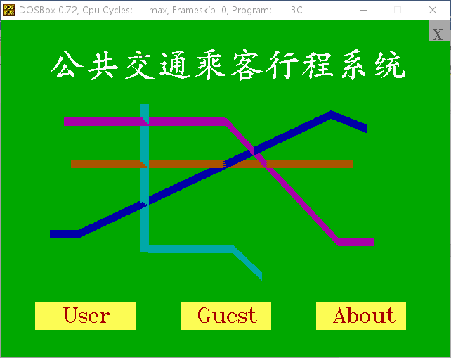

欢迎界面

点击User会跳转到登陆界面,点击Guest会跳转到游客的功能界面，点击about会跳转到关于（包含作者声明等）

设计灵感来源于武汉地铁线路图

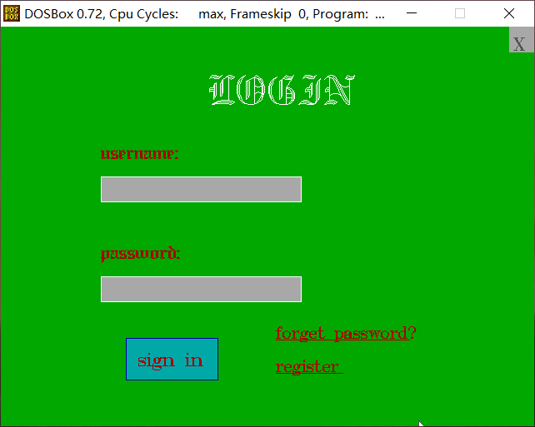

登录界面

点击forget password跳转到找回密码页面，点击register跳转到注册界面，当登录失败时会给出错误提示

登录成功后跳转到用户功能界面

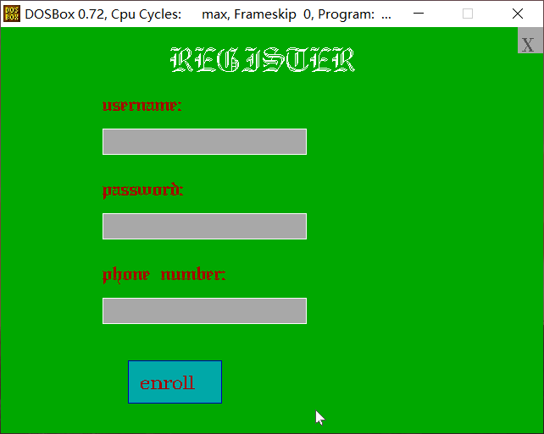

注册界面，当注册失败时会给出错误提示

注册成功后也会显示提示注册成功的字样“successfully register”

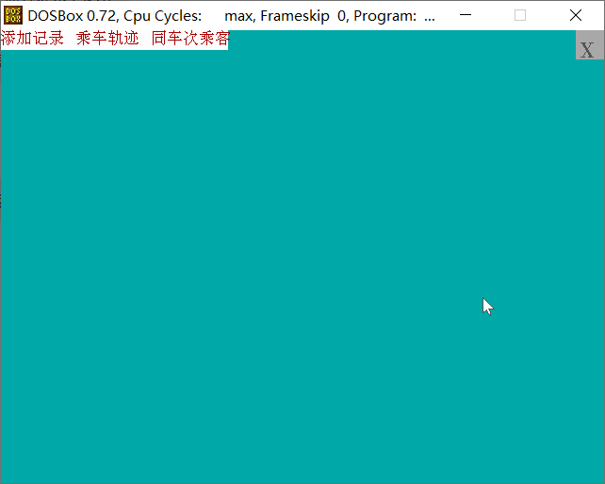

用户界面，我们设计了下拉菜单以方便用户选择乘坐的车次，后续还会设计多级菜单以细化用户的选择（如选择上下车站的站点名字，查询同车次乘客或者近端时间乘坐过同辆车的所有乘客）

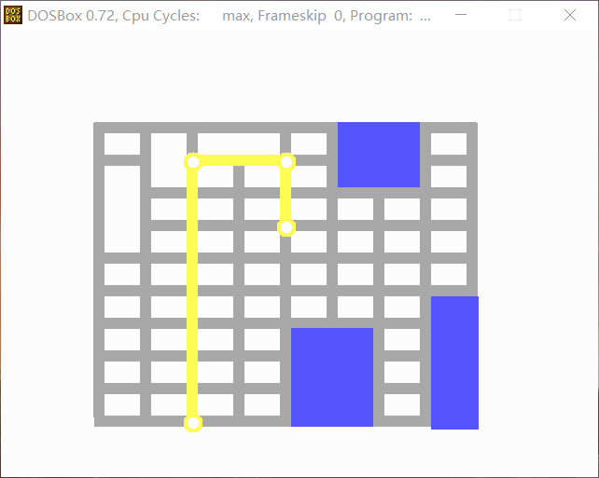

一种路线的轨迹图

后续会设计根据用户选择的不同上下车站，显示不同路段的轨迹

灵感来自于学校公交车

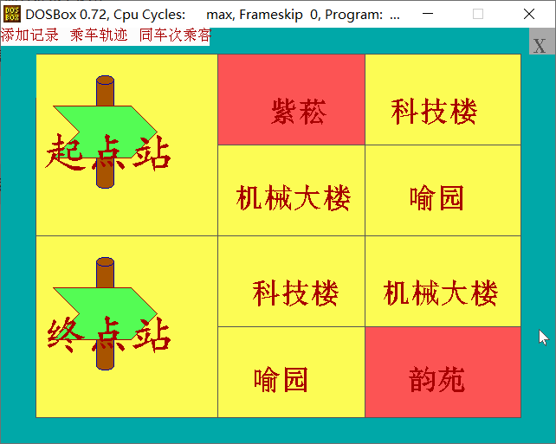

选择车次、起始站点、终点的界面

我们设计了转盘式的选择界面，省去了用户自己输入乘车信息的麻烦，并以较为清晰的方式提醒用户如何选择。

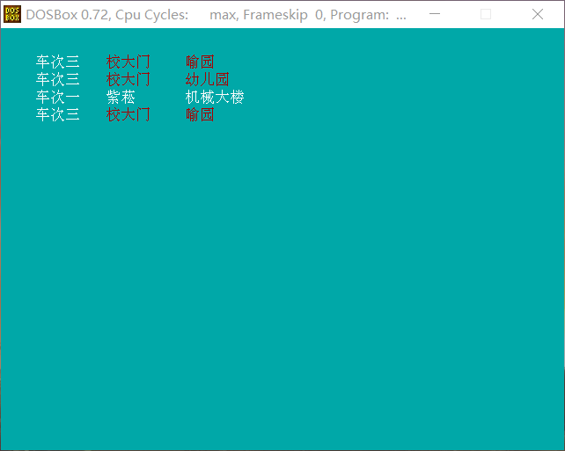

乘车记录以列表形式显示

车次、起始站、终点的信息都清楚整齐地排列出来，一目了然，顺序是从最近时间排列，即最靠前的记录录入的最晚。

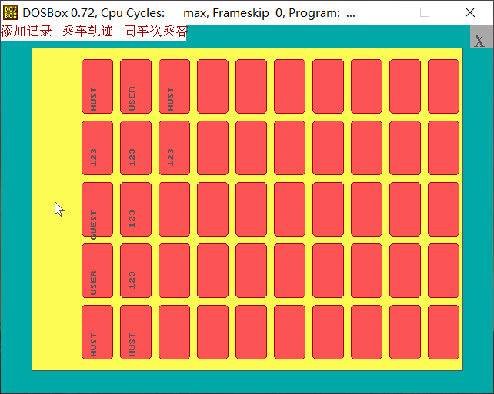

图形化显示同行乘客的功能

我们设计了类似座位一样的排列方式，较为生动地显示了同车次的乘客的名单。

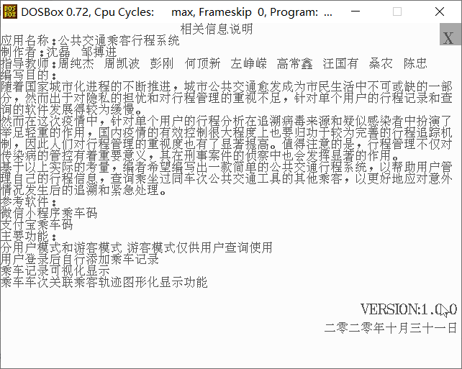

关于页

七、时间安排

|  |  |
| --- | --- |
| 周次 | 计划任务 |
| 第一周 | 进行需求分析，绘制欢迎页、登录注册界面 |
| 第二周 | 优化鼠标键盘以适应功能需求 |
| 第三周 | 进行登陆注册功能的实现，学习汉字库的使用，构思中期报告 |
| 第四周 | 完成登录注册的数据输入输出功能，开始功能界面的绘制和功能菜单的制作，撰写中期报告 |
| 第五周 | 完成乘车记录的记录与显示功能，绘制乘车路径图，完成乘车轨迹可视化的功能 |
| 第六周 | 完成乘车轨迹关联乘客图形化显示功能，完善部分功能代码和界面设计，并对算法做优化 |
| 第七周 | 调试程序，完成终期验收报告 |

八、代码工作量分配

**组员分工**

|  |  |
| --- | --- |
| 姓名 | 分工 |
| 沈磊 | 初始欢迎界面  登录、忘记密码、注册  用户界面  游客界面  功能菜单  用户登录信息的储存和读取  键盘 |
| 邹搏进 | 关于界面的绘制  鼠标  汉字库  记录用户行程 |

**组员文件统计与代码量**

|  |  |  |  |  |
| --- | --- | --- | --- | --- |
| 组员姓名 | 文件名 | 功能简介 | 代码行数 | 总代码量 |
| 沈磊 | main.c | 主函数，调用界面函数 | 42 | 2020 |
| welcome.c | 欢迎界面，选择使用模式 | 79 |
| login.c | 登录界面的绘制和功能实现 | 149 |
| register.c | 注册界面的绘制和功能实现 | 112 |
| forgetpass.c | 找回密码界面和功能实现 | 101 |
| input.c | 账号、密码等信息的输入功能 | 76 |
| judge.c | 判断用户名和密码是否一致 | 62 |
| keyboard.c | 模拟键盘用以输入信息 | 38 |
| menu.c | 菜单的绘制，以及对各种功能的调用 | 539 |
| user.c | 将用户信息从文件中调出并生成链表用以存储 | 176 |
| visualize.c | 判断输入的乘车信息，调用不同的路程图，可视化同行乘客信息 | 628 |
| 邹搏进 | about.c | 关于页 | 63 | 1428 |
| hz.c | 调用汉字库，输出汉字 | 190 |
| MOUSE.C | 模拟鼠标，实现鼠标按键等操作 | 227 |
| record.c | 记录用户行程的功能，输出用户行程等 | 267 |
| track.c | 用画图函数绘制各条路线图 | 681 |

九、总结

1.个人总结

沈磊

为期接近五个月的课设终于要落下帷幕了，在这五个月中，我虽然付出了许多时间，但同时也收获了许多知识和实操的技巧，从一开始看到文件操作就头痛，到最后能较为熟练地运用文件操作有关的函数，从一开始总是画出奇形怪状的图形，到最后画图基本都能一次到位，中间有努力，有思考，通过这次C语言课程设计，我确实受益匪浅，无论是独立编程的能力，还是小组合作的精神和意识，都是我从课设中学到的宝贵经验。

七月一开始布置任务，我就试着在电脑上跑跑学长学姐的代码，看着他们的代码，动辄几百行的原文件，丰富多彩的功能，我既向往又担心：向往自己是不是也能做出这样的程序，担心要学的东西太多太难。拿到学长学姐建的群里的C高级实用程序设计，几百页密密麻麻的内容顿时浇灭我对C课设的热情，然后抱着试试的心态，我先用C语言高级编程技术学习了画图，在自己动手学着画了几个图后发现其实做图形化的程序没有想象中的那么困难，接着我就慢慢的学习文件操作方面的内容，然而由于这方面的内容较为抽象，其实看完书也只是一知半解，动手实际编程时仍然出现了很多的错误，我就上各种论坛，搜索引擎，一个个搜寻程序存在的问题，终于当一个个问题被解决的同时，我对文件操作的熟练程度和理解也加深了。

这次C课设给我很深的印象就是编程是人和电脑交流思想的过程，一定要完全精确才能确保程序正常运行并实现我们希望的功能。比如说，在编写登录注册相关的文件操作时，我有一个打开文件语句if(file_user=fopen(“users.txt”,”w+”)==NULL),结果发现文件一直打不开，我先是检查路径，改成绝对路径又改成相对路径，打开方式全都试了一遍，然而它还是一直打不开，就这么来回折腾了几天，我只能寻求学长学姐的帮助，终于在一位学长长达两个小时的找错后，终于发现是运算符优先级的问题使得文件一直读不出来，除了这个错误外还有很多难解的错误，其实它们最终往往不是最复杂的功能出了问题，而是难以发现的小小的细节。

这是我们第一次做模拟实际应用场景的应用，其中当然会有很多的不足，比如说界面设计不太美观，代码不够精简等，然而我们的程序也是有着亮点的，用户输入信息错误时出现的错误信息，对用户某些不合理操作自动地控制，都保证了我们程序的健壮性，简单直观的界面也使得用户的使用更加方便。

总的来说，我们的课程设计过程并非一帆风顺，但多亏有各位老师的答疑解惑，学长学姐的悉心指导和信息提供，队友和我的共同的努力和合作，我们能最终做出一个实用的程序，还是比较有成就感的。

邹搏进

刚得知自动化学院有c语言课程设计时，我内心其实是崩溃的，好不容易结束了C语言的学习，以为能休息一阵，但突如其来的c课设消息让我大惊失色。一想到暑假便要开始准备c课设，我心中便充满了焦虑与困惑，对课程设计的一无所知，对c语言的迷茫与害怕，让我迟迟没有开始c课设的准备，在暑假的末期才刚开始准备c语言高级编程的学习。

不过幸好有学长学姐创的互帮互助群，让我能对课设有个基础的构思，也对自己要做的项目有个基础的框架。在队友的帮助下，我终于开始了课设的漫长征途。

刚开始对C课设的攻克时，我是一脸茫然的。学长学姐们的文件完全看不懂，各种鼠标汉字库让我找不到方向，更不必说什么登陆注册的功能实现。幸好有我的队友，在他的帮助下，我逐渐找到了自己工作的方向。起初先使用简单的图形函数，进行简单的界面绘制，在对画图函数的不断学习中，我逐渐找到了做c课设的动力，对完成这个艰难的任务有了些许信心。

时间进入九月中旬，经过短暂的假期后，我仍处于c课设的摸索阶段，但是时间似乎已经不允许我继续迷迷糊糊的摸索，毕竟大二紧张的课程已经开始了，留给我编程序的时间可能只剩下周末，我再次陷入了紧张与恐惧当中。

时间推进到十月初，我们终于定下了程序的基本框架和主要功能，趁着课程较少的几天加紧赶工程序。终于，在我们的不懈努力之下，程序渐渐初具雏形，我悬着的心也能放下一阵子。

眼看着程序越来越完善，warning和error不断减少，各部分功能也都能发挥出自己的作用，我知道，课程设计应该可以接近尾声了。

在这次难得的设计程序中，我得到了最重要的三个教训，一是方法一定要找好，方法不对，事倍功半。二是要细致，如果在开始编写前就能对函数功能有个基本的框架，也许就不用多走那么多弯路了。三是沟通要做好，我与队友的沟通不够及时有效，就导致了很多不必要的麻烦。

这几个月留下了很多关于课设的记忆，我为了课设付出了很多努力，也收获了很多。虽然课设确实很是折磨我，但是运行程序成功的那一刻，我的内心还是充满了喜悦和自豪。

1. 程序亮点
2. 较为人性化的报错机制
3. 应对用户可能出现的各种错误操作所做的限制，增强了程序健壮性
4. 用链表存储用户信息，增加了信息存储的灵活度
5. 使用的存储内存较小，没有调整BC的内存模式
6. 忘记密码的找回方式较有创新性
7. 程序不足
8. 界面内容不够丰富
9. 轨迹没有动态显示
10. 登陆时没有人机检验机制