9439B 10:30-12:00 TF

26 GONZALEZ , Jepanee Abishei

28 LEONES , Alfa Leizel

10 LICUD , Ronald

13 MALICDEM , Leo

14 MALONES , David Benedict

29 MARCELO , Aira Joy

31 MAURI , Diane Kaye

32 PAGADUAN, Sherene Joyce

19 SOY , Tyrone Joshua

34 TORRES , Princess Janyl

21 VIRAY , Froilan Mark

May 16, 2017

Module Accomplishment Report

Admin Module

* The main server-side scripting technology used for the implementation of the Admin Module is Python.
* The frameworks that are used in this module are Flask and Bootstrap.

Service Provider Module

* The main server-side scripting technology used for the implementation of the Service Provider Module is Jsp.
* The framework used in this module is Bootstrap.

Customer Module

* The framework used in this module is Bootstrap.
* The main server-side scripting technology used for the implementation of the customer module is Apache
* Together with the server used we used phpMyAdmin, MySQL Servers for the database
* jQuery – for other functionalities of the front end of the website

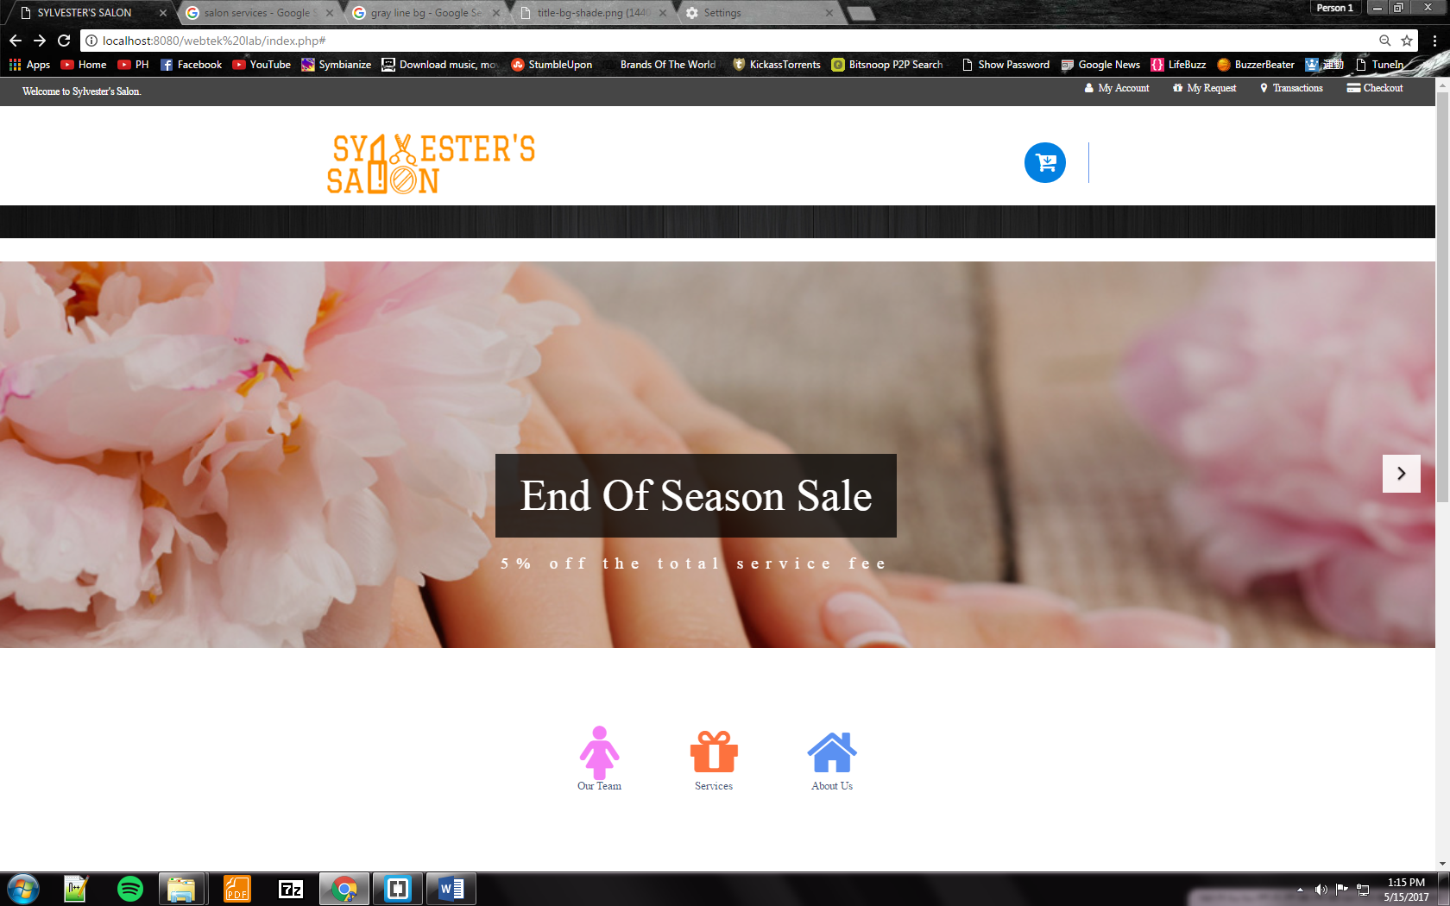CUSTOMER MODULE

* The Homepage for Customer Module

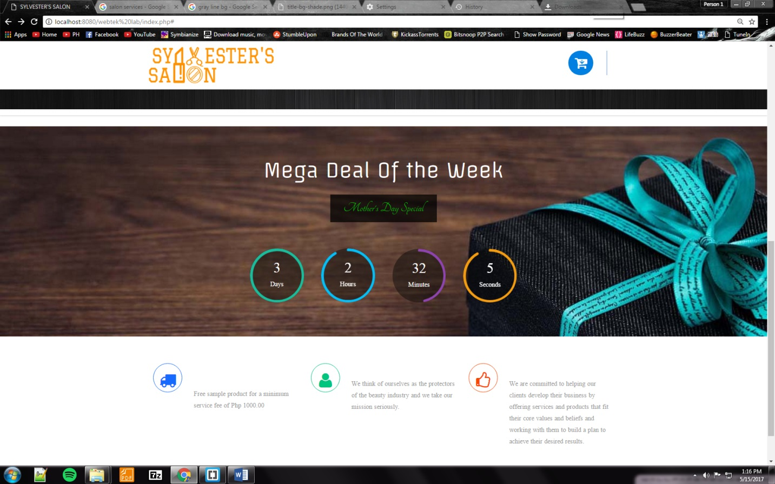

* 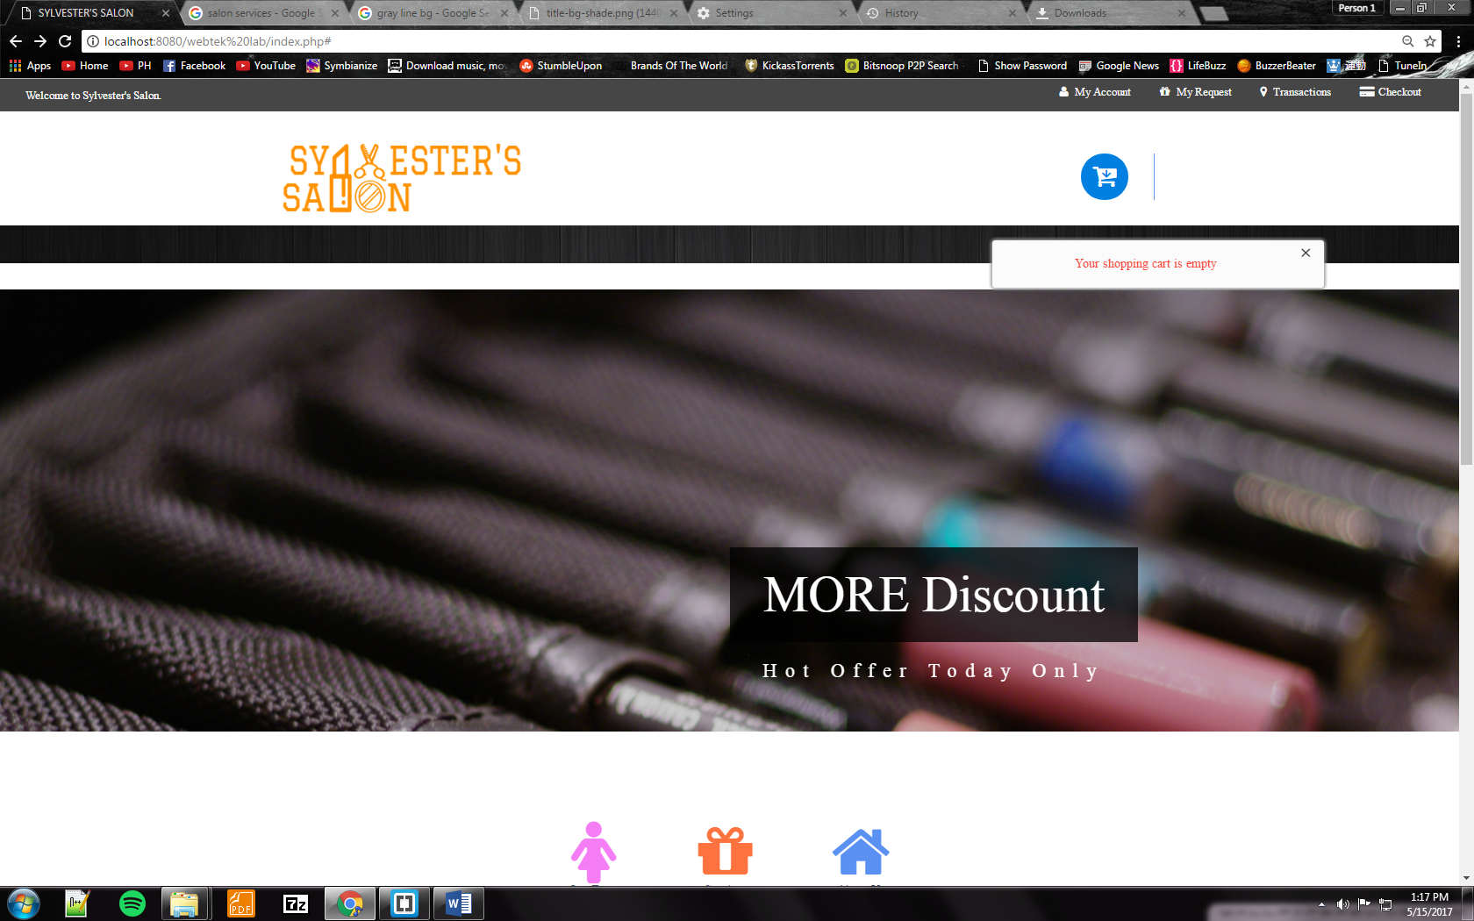
* Shows the items or services you added in your cart

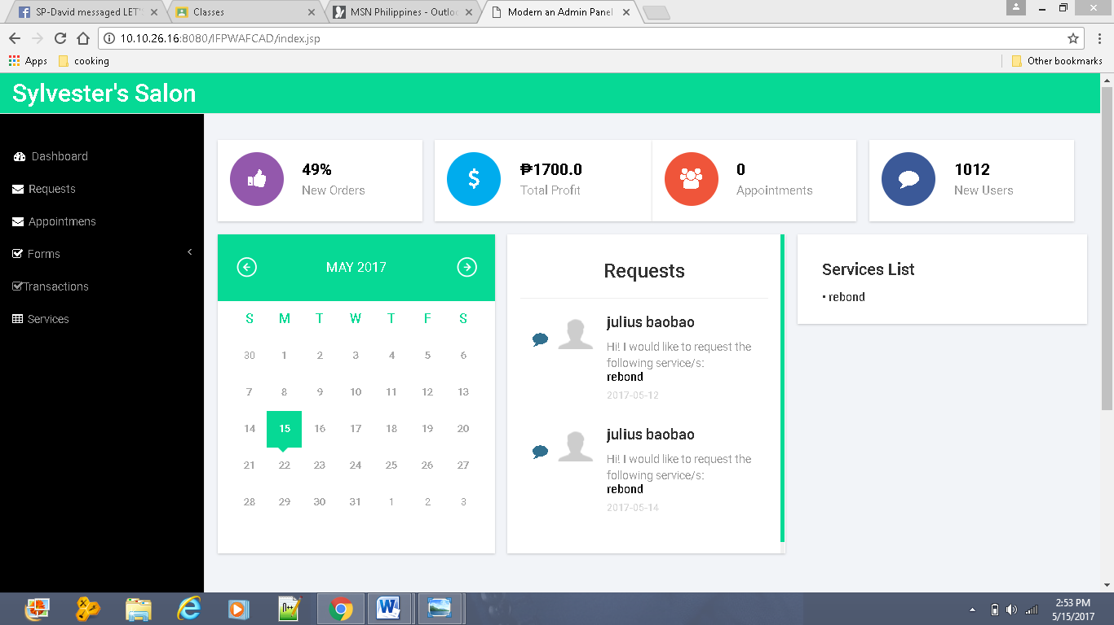SERVICE PROVIDER MODULE

* Home page for the Service provider module

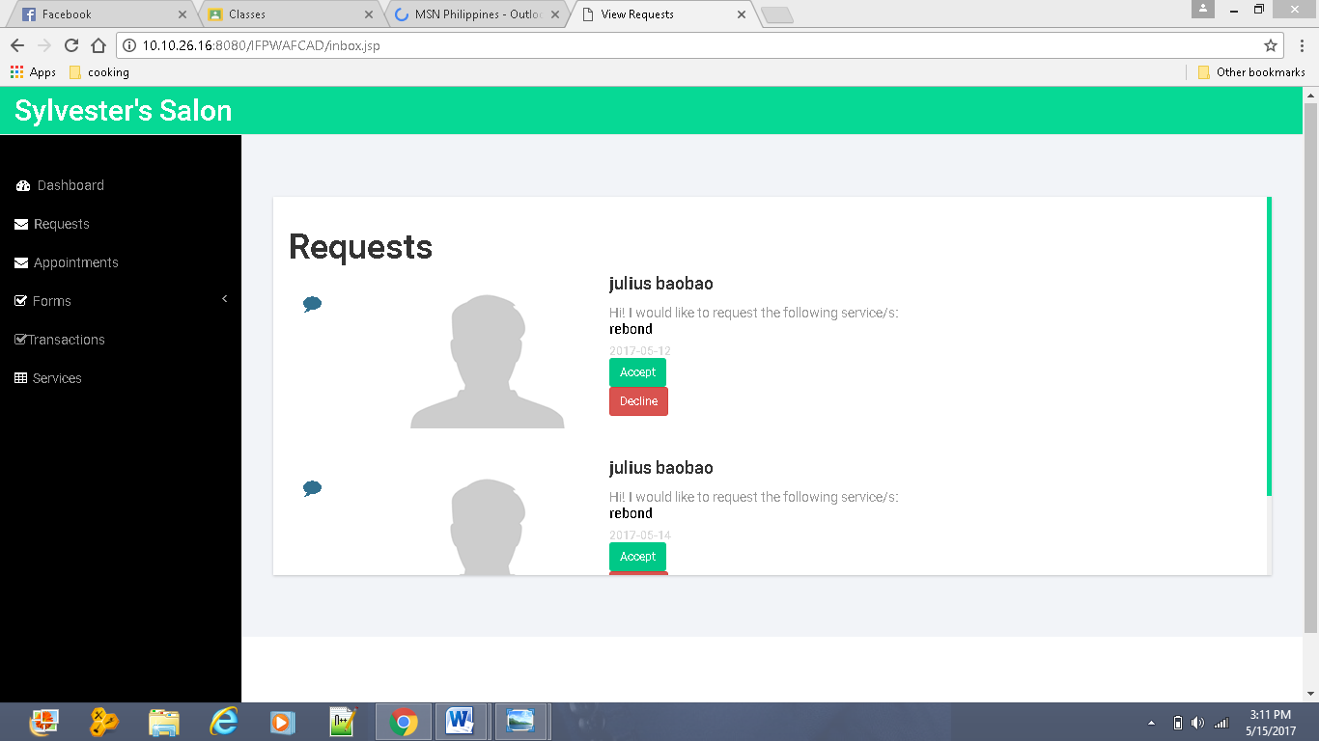

* This page lets the Service Provider view the customer’s request. Once accepted, the appointments table will be updated. If declined, the status will be changed to declined

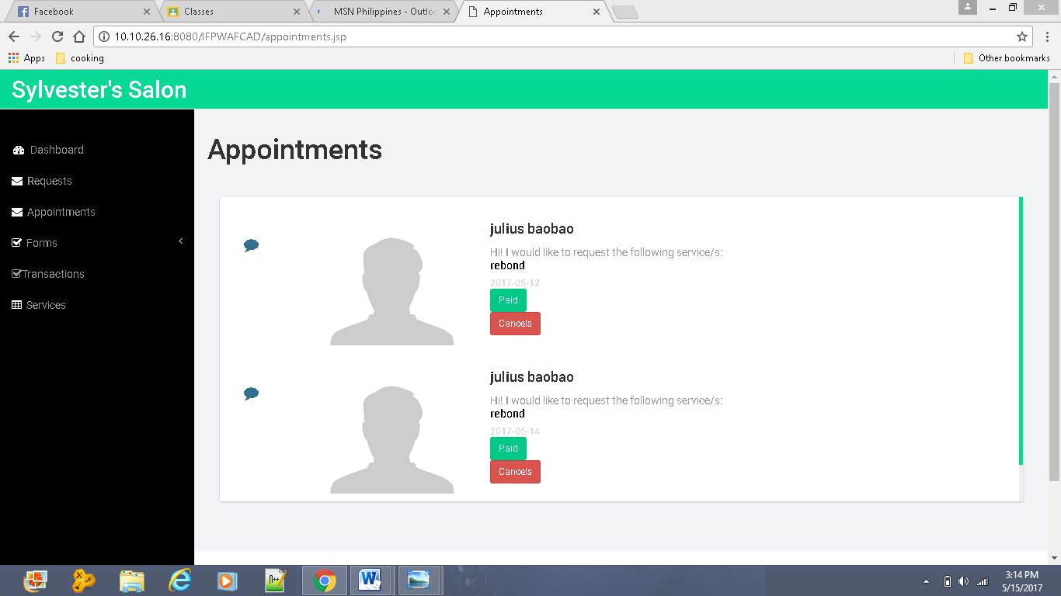

* For this page it lets the service provider view his/her appointments.

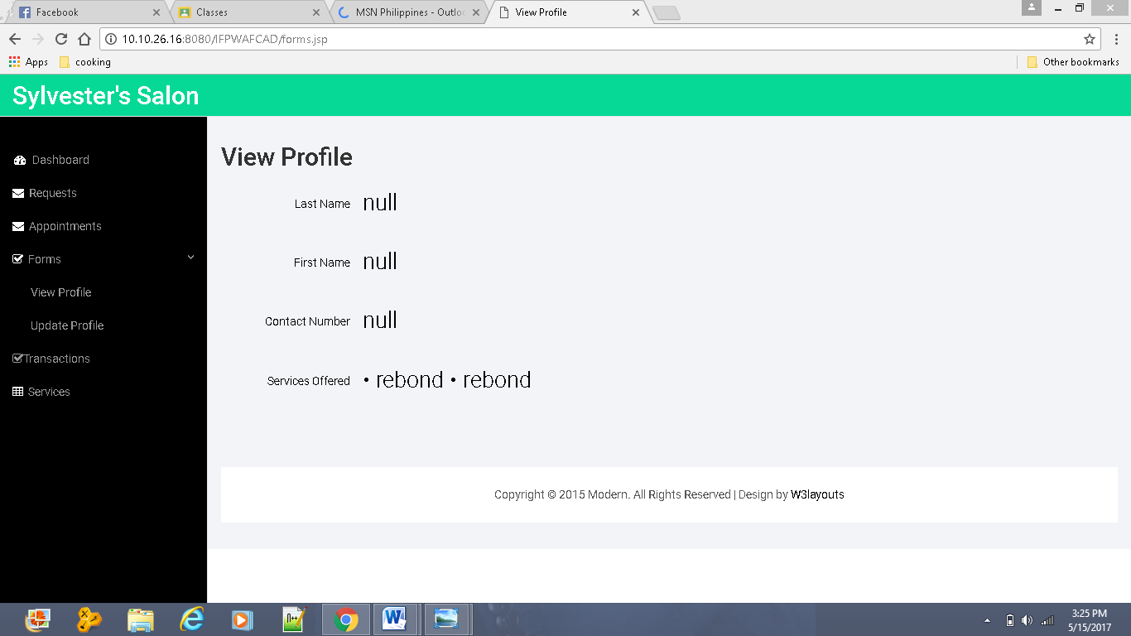

* This page lets the Service Provider view his/her Profile.

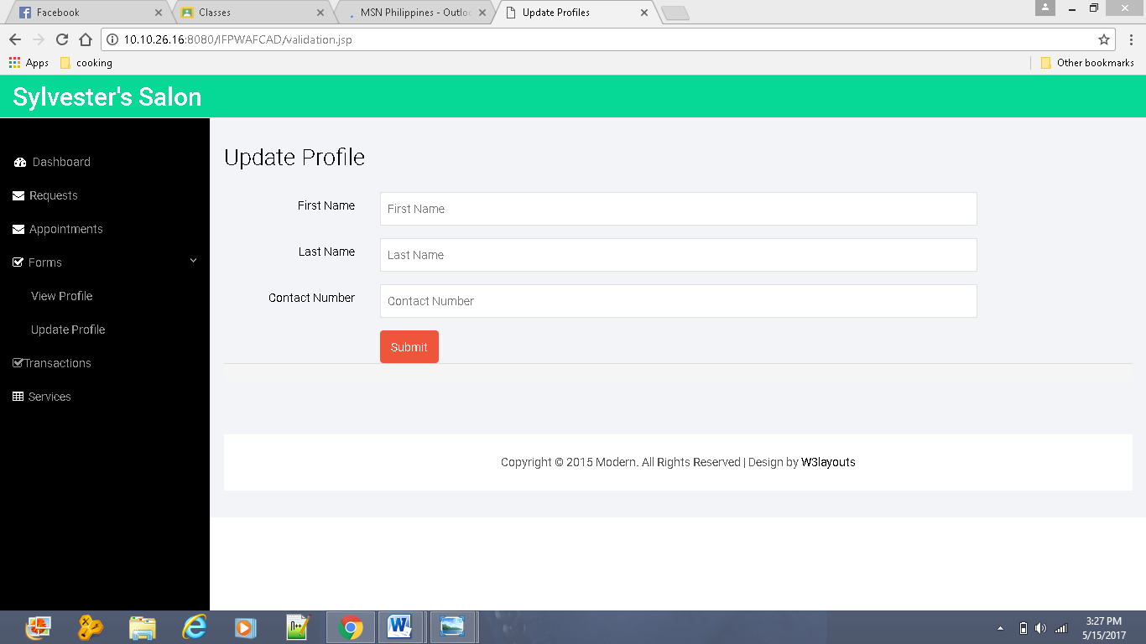

* This page lets the Service Provider update his/her profile.

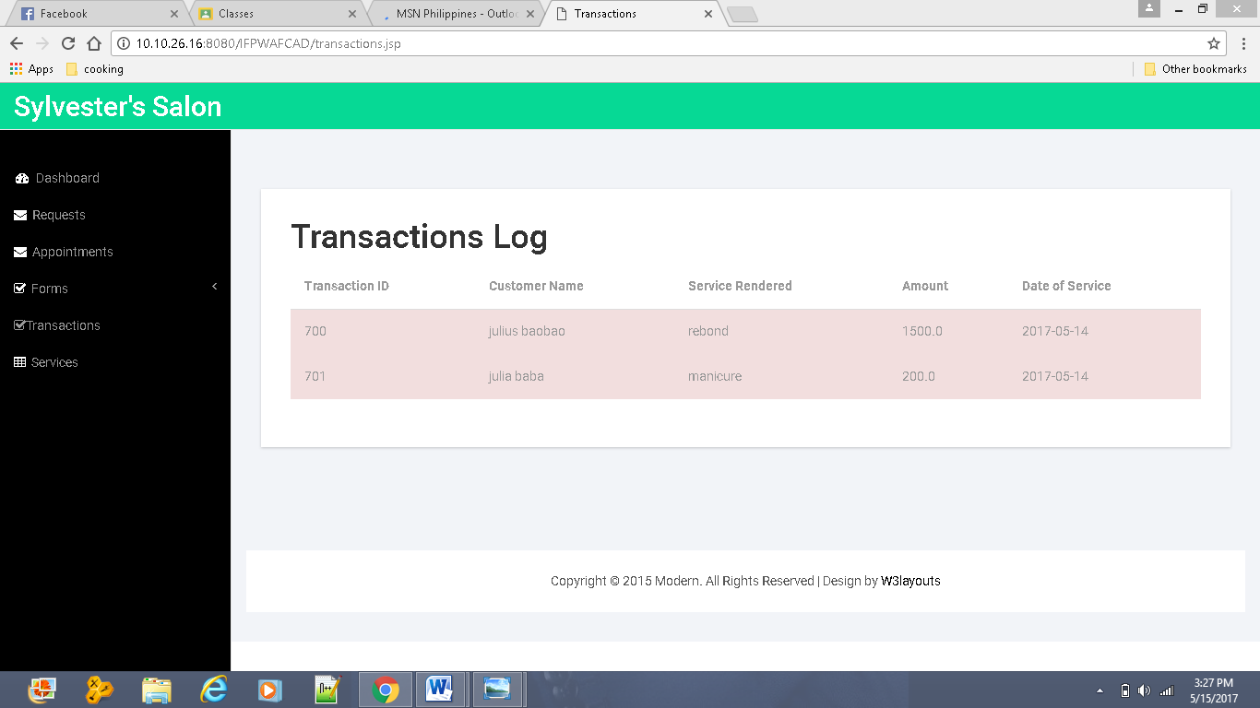

* In this page, the Service Provider can view the transactions made.

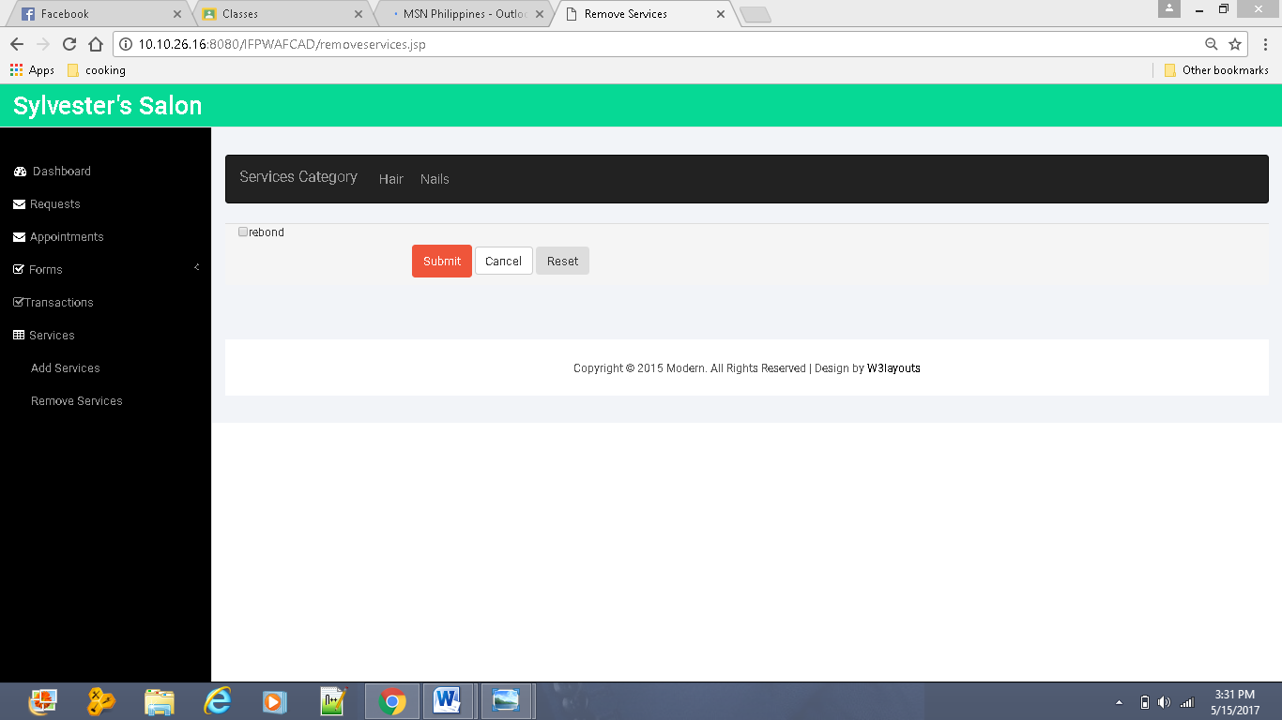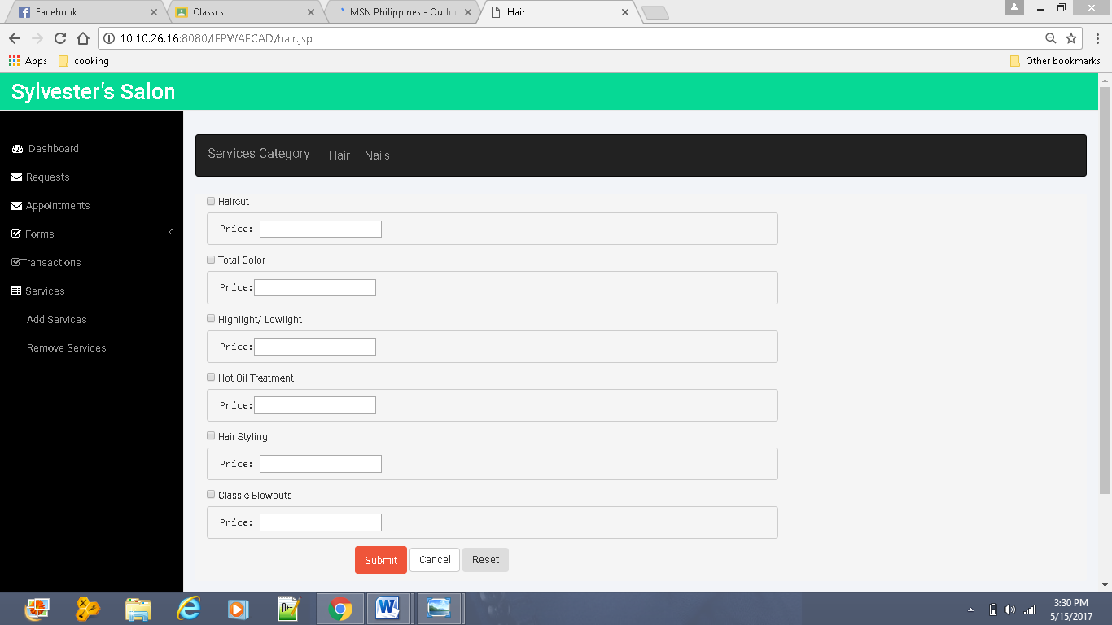

* This page should be for adding services. Unfotunately it was not implemented.
* This page lets the Service Provider remove his/her Services. It is also not implemented.

ADMIN MODULE

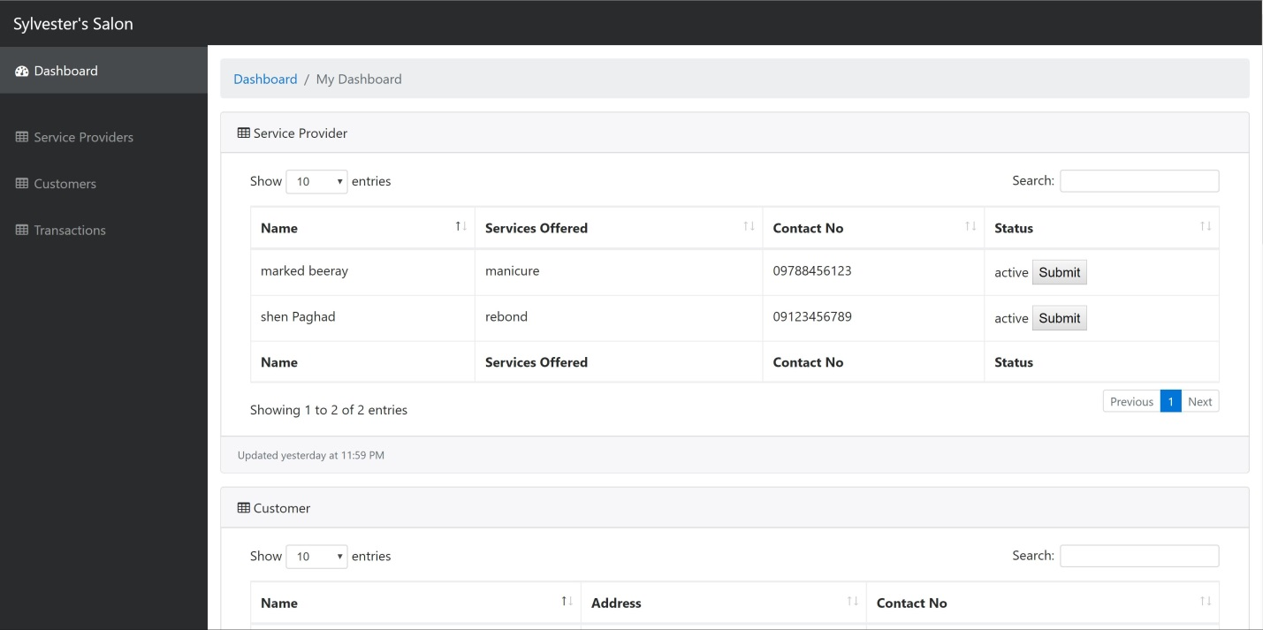

* This page is the list for the service provider.

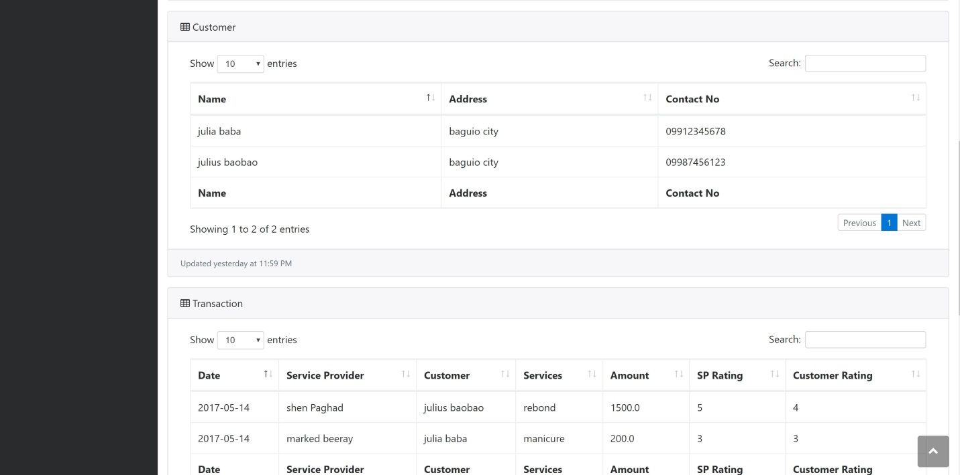

* This page is a list for the customer and transaction.

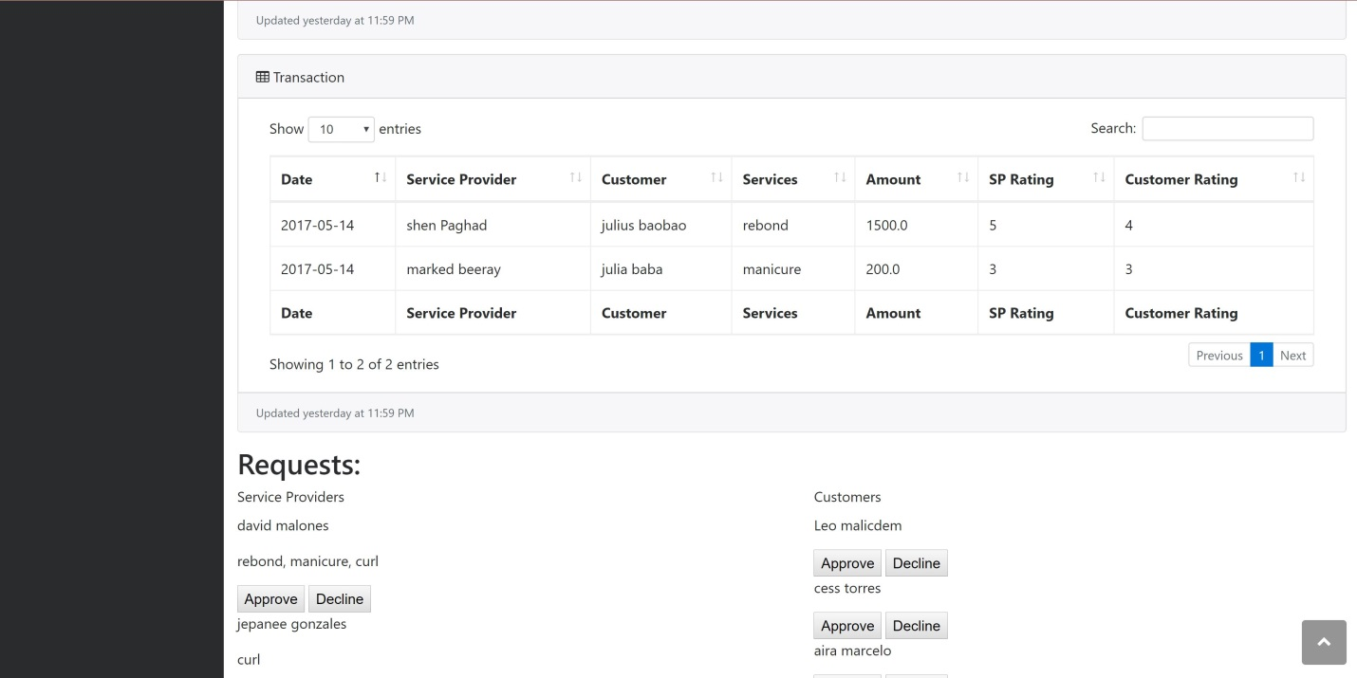

* This page is a list of the requests