MALTRACER
Incident Response & Threat Detection Tool

System Analysis & Design Document
Team Members
Rodina Mohamed
Youssef Samir
Mohamed Yahia
Marwan Samy
Shenoda Amir

1. Problem Statement & Objectives

1.1 Problem Statement
With the rapid increase in sophisticated cyber threats such as ransomware, phishing attacks, data exfiltration, and command-and-control (C2) communications, traditional security solutions are no longer sufficient.Conventional systems often rely only on signature-based detection methods, which are unable to identify unknown or zero-day threats. In addition, they usually lack real-time automated response, behavioral analysis, and digital forensic capabilities.
Therefore, there is a need for an intelligent endpoint security solution that can monitor system activities in real time, detect suspicious behavior, and automatically respond to threats.
.

1.2 Project Objectives
- Detect cyber threats on endpoints in real time
- Automatically respond to incidents without human intervention
- Minimize response time and limit damage during security incidents
- Collect and store basic forensic data for investigation
- Assign unique Incident IDs for structured tracking and documentation
- Provide security analysts with structured logs and incident reports

1.3 Use Case Diagram & Descriptions

System Actors
Actor | Type | Description
Actor | Type | Description
Security Analyst | Primary User | Reviews incident reports, analyzes alerts, and monitors system activity through the local dashboard. Responsible for investigating incidents and configuring system policies
MalTracer Core Engine | System Component (Automated) | Central orchestrator of the system that manages the Event Bus and coordinates all modules (monitoring, detection, containment, sandbox, and forensics)
Monitoring Modules | Internal System Component | Includes process, file, and network monitors that continuously collect system events and send them to the Event Bus
Detection Engine | Internal System Component | Consumes events from the Event Bus, performs behavioral analysis, assigns risk scores, and classifies threats

Use Case Table
Use Case | Actor | Description
Monitor File Integrity | MalTracer Core Engine | Continuously monitors specified directories, computes SHA-256 file hashes, and sends change events to the internal Event Bus for analysis
Detect Suspicious Process | MalTracer Core Engine | Collects process data and uses the Detection Engine to identify abnormal behavior such as unknown executables or high CPU/memory usage
Scan Emails (.eml) | MalTracer Core Engine | Analyzes locally stored email files for phishing indicators, malicious links, and suspicious attachments
Isolate Device | MalTracer Core Engine | Automatically enforces network isolation by applying firewall rules when a high-severity threat is detected
Quarantine File | MalTracer Core Engine | Moves malicious files to a secure quarantine directory and records file metadata and hash for forensic tracking
Capture Snapshot | MalTracer Core Engine | Captures system state (running processes, network connections, and file hashes) at the time of an incident
Run Sandbox Analysis | MalTracer Core Engine | Executes suspicious files inside a Docker-based sandbox to observe behavior in an isolated environment
Generate Report | MalTracer Core Engine | Aggregates incident data (alerts, logs, snapshots) and generates structured reports in JSON
View Reports | Security Analyst | Accesses and reviews incident reports, logs, and forensic data through the dashboard interface

1.4 Functional Requirements
ID | Module | Requirement
FR-01 | File Monitoring Module | The system shall monitor specified directories, compute SHA-256 file hashes at configurable intervals, and publish file events to the internal Event Bus
FR-02 | File Monitoring Module | The system shall generate an alert event when a file hash changes unexpectedly and forward it to the Detection Engine
FR-03 | Process Monitoring Module | The system shall continuously enumerate running processes and send process data to the Event Bus for analysis
FR-04 | Detection Engine | The system shall analyze process events and detect abnormal behavior such as unknown executables or high CPU/memory usage
FR-05 | Email Analyzer | The system shall analyze locally stored email files (.eml), including headers, links, and attachments, to detect phishing and malware indicators
FR-06 | Containment Engine (Isolation) | The system shall automatically isolate compromised devices by enforcing network restrictions when a high-severity threat is detected
FR-07 | Containment Engine (Quarantine) | The system shall move malicious files to a secure quarantine directory, preserve original paths, and record file hashes for forensic tracking
FR-08 | Forensics Module (Snapshot) | The system shall capture system state (process list, network connections, and file hashes) at the time of an incident
FR-09 | Incident Manager (Core Engine) | The system shall generate a unique Incident ID (UUID) and link all related events, alerts, and actions to the incident
FR-10 | Report Generator | The system shall aggregate incident data (alerts, logs, snapshots) and generate structured reports in JSON and HTML formats

1.5 Non-Functional Requirements
ID | Category | Requirement
NFR-01 | Performance | The system shall detect and respond to security threats in near real-time (within a few seconds) using event-driven processing via the Core Engine and Event Bus
NFR-02 | Performance | The system shall maintain low CPU usage during continuous monitoring and moderate resource consumption during detection, sandbox analysis, and forensic operations
NFR-03 | Reliability | The system shall ensure high availability by running as a persistent daemon and support automatic recovery from module or process failures
NFR-04 | Security | All audit logs shall be protected against tampering using cryptographic integrity mechanisms such as hashing and append-only logging
NFR-05 | Security | The quarantine directory shall be strictly isolated with controlled access permissions and protected from unauthorized modification
NFR-06 | Portability | The system shall primarily support Linux environments with containerized sandboxing, with future extensibility to Windows platforms
NFR-07 | Usability | Generated reports shall be structured, readable, and aligned with standard incident response formats, accessible dashboard interface
NFR-08 | Maintainability | The system shall follow a modular architecture with loosely coupled components connected عبر the Event Bus to allow easy updates and extension
NFR-09 | Scalability | The system shall support multi-threaded monitoring and scalable event processing for handling multiple simultaneous system events
NFR-10 | Isolation | The sandbox environment shall be fully containerized (Docker-based) to ensure complete isolation from the host system during analysis

1.6 Software Architecture
MalTracer uses a Modular Monolith architecture with a centralized Core Engine. All detection and response modules are independent but communicate through an internal event bus managed by the Core. This ensures loose coupling while keeping a single deployable system.

Architecture Style: Modular Monolith + Event-Driven Internal Communication

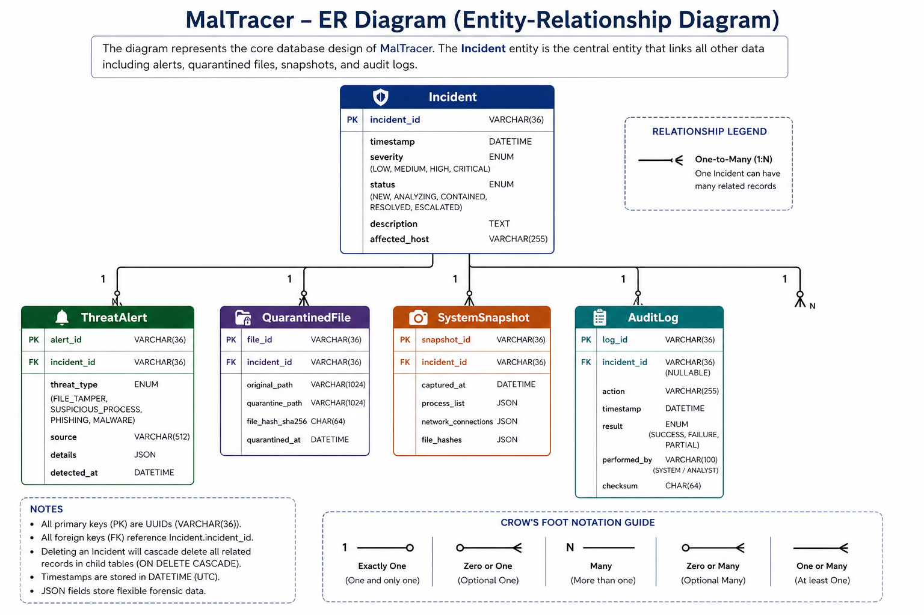

2. Database Design & Data Modeling

2.1 ER Diagram (Entity-Relationship Diagram)
The MalTracer data model is structured around the Incident entity, which serves as the central reference point for all security-related activities within the system.
As described in the system architecture, MalTracer operates through multiple layers (Monitoring, Detection, Containment, Sandbox, and Forensics). Each layer generates structured events that are processed through the internal Event Bus and then persisted as forensic data.
Every detection event, containment action, sandbox result, system snapshot, and audit record is linked to a specific Incident using foreign key relationships. This ensures that all system activities follow the evidence-first principle, where each event is recorded and associated with an Incident ID before any response action is executed.
The database is therefore designed to reflect the actual system workflow, where:
- Monitoring and detection outputs are stored as Threat Alerts
- Containment actions are reflected in Quarantined Files and Audit Logs
- Sandbox and forensic analysis results are stored as System Snapshots
- All records are grouped and correlated through a unified Incident ID

Entities and Relationships
The ER Diagram represents the following relationships:
- One Incident can generate multiple Threat Alerts (detection layer output)
- One Incident can result in multiple Quarantined Files (containment actions)
- One Incident can have multiple System Snapshots (forensics and sandbox analysis)
- One Incident can produce multiple Audit Log entries (system actions and logging)
These relationships follow a one-to-many (1:N) model, where the Incident entity acts as the parent entity and all other entities depend on it.
This design ensures:
- Complete traceability of all actions and events
- Clear mapping between system layers and stored data
- Efficient incident investigation and forensic analysis

2.2 Logical & Physical Schema

Table: Incident
Column | Type | Key | Description
incident_id | VARCHAR(36) | PK | Unique identifier (UUID) generated by the Incident Manager within the Core Engine
timestamp | DATETIME |  | Timestamp when the incident was first detected by the Detection Engine
severity | ENUM |  | Threat severity level assigned by the Detection Engine (LOW / MEDIUM / HIGH / CRITICAL)
status | ENUM |  | Current incident state managed by the Core Engine (NEW / ANALYZING / CONTAINED / RESOLVED / ESCALATED)
description | TEXT |  | Human-readable summary generated during detection and analysis
affected host | VARCHAR (255) |  | Hostname or IP address of the affected endpoint monitored by the system

Table: Threat Alert
Column | Type | Key | Description
alert_id | VARCHAR (36) | PK | Unique identifier (UUID) for each alert generated by the Detection Engine
incident_id | VARCHAR (36) | FK | References Incident.incident_id to link alerts with their corresponding incident
threat_type | ENUM |  | Type of detected threat (FILE_TAMPER / SUSPICIOUS_PROCESS / PHISHING / MALWARE)
source | VARCHAR (512) |  | Origin of the alert (file path, process name, or email subject)
details | JSON |  | Structured forensic data (hash values, process PID, attachment metadata, etc.)
detected_at | DATETIME |  | Exact timestamp when the detection event occurred

Table: QuarantinedFile
Column | Type | Key | Description
ile_id | VARCHAR(36) | PK | Unique identifier (UUID) for each quarantined file
incident_id | VARCHAR(36) | FK | References Incident.incident_id to associate the file with an incident
original_path | VARCHAR(1024) |  | Original file location before containment
quarantine_path | VARCHAR(1024) |  | File location inside the secure quarantine directory
file_hash_sha256 | CHAR(64) |  | SHA-256 hash used for file integrity verification and tracking
quarantined_at | DATETIME |  | Timestamp when the file was quarantined by the Containment Engine

Table: System Snapshot
Column | Type | Key | Description
snapshot_id | VARCHAR(36) | PK | Unique identifier (UUID) for each snapshot captured by the Forensics Module
incident_id | VARCHAR(36) | FK | References Incident.incident_id to link snapshot data to a specific incident
captured_at | DATETIME |  | Timestamp when the snapshot was taken
process_list | JSON |  | JSON array containing all active processes at the time of the incident
network_connections | JSON |  | JSON array of active network connections
file_hashes | JSON |  | JSON object mapping monitored file paths to their hash values

Table: AuditLog
Column | Type | Key | Description
log_id | VARCHAR(36) | PK | Unique identifier (UUID) for each log entry
incident_id | VARCHAR(36) | FK | References Incident.incident_id (nullable for system-wide actions not tied to a specific incident)
action | VARCHAR(255) |  | Action executed by the system (e.g., SCAN_STARTED, FILE_QUARANTINED, DEVICE_ISOLATED)
timestamp | DATETIME |  | Timestamp when the action was performed
result | ENUM |  | Outcome of the action (SUCCESS / FAILURE / PARTIAL)
performed_by | VARCHAR(100) |  | Entity performing the action (SYSTEM or Security Analyst)
checksu

Normalization Notes
- All tables are designed in Third Normal Form (3NF) to reduce data redundancy and avoid unnecessary dependencies.
- JSON columns are used to store flexible forensic data (such as process lists and file hashes) without making the database structure too complex.
- The Incident ID is used as the main reference to link all related data, making it easy to track each incident.

3. Data Flow & System Behavior

3.1 Sequence Diagram — File Tampering Incident
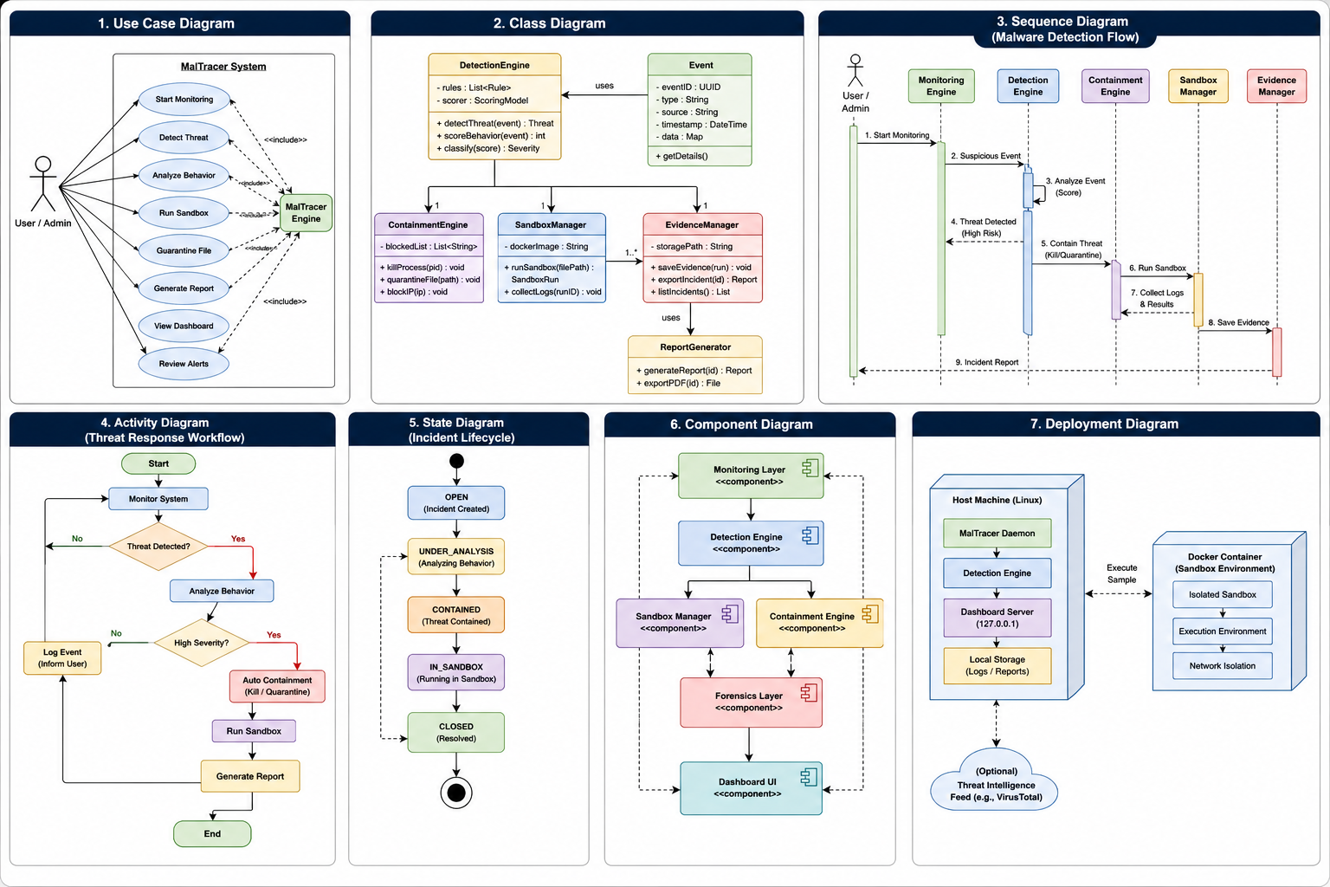

3.2 Activity Diagram — Full Incident Response Workflow


3.3 State Diagram — Incident Lifecycle


3.4 Class Diagram


4. UI/UX Design & Prototyping

4.1 Wireframes & Mockups
MalTracer's user interface is a native desktop popup and local dashboard — not a browser extension. All screens are delivered as a lightweight local web UI served on 127.0.0.1, plus native OS notification popups via libnotify for real-time alerts. There are four primary screens.

Screen 1 — Main Dashboard Popup

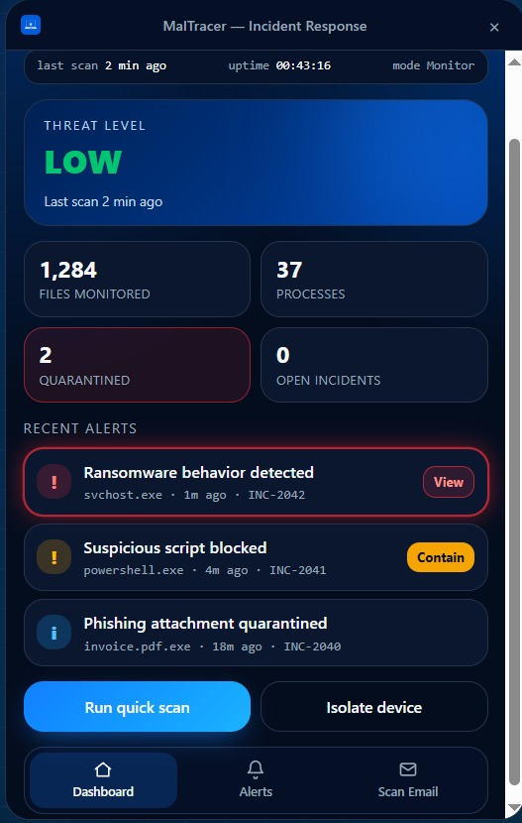

The main dashboard is the primary view the user sees when opening MalTracer. It provides a real-time snapshot of the system's security state.

UI Element | Description & Behavior
Title bar | Draggable bar with MalTracer logo, window title, status indicator (● Active / ● Paused / ● Isolated), and close button. Status dot is a clickable toggle to pause/resume monitoring.
Threat Level badge | Full-width card showing current threat level: LOW (white text), MEDIUM (amber), HIGH (red pulsing). Shows last scan timestamp below the level.
Stats grid | 2×2 grid: Files Monitored (top-left), Processes (top-right), Quarantined with red border highlight (bottom-left), Open Incidents (bottom-right). All values update in real time.
Recent Alerts | Last 3 alerts with: severity icon (red/amber/blue/green), title, process name · timestamp · Incident ID. Medium-severity rows show a 'Contain' button on the right. High-severity rows show a pulsing red border and 'View' button.
Action buttons | 'Run quick scan' (filled blue, primary action) and 'Isolate device' (outlined, destructive action). Both show a confirmation modal before executing.
Bottom navigation | Three icon tabs: Dashboard (home), Alerts (bell with badge count), Scan Email (envelope). Active tab highlighted in blue.

Screen 2 — All Alerts
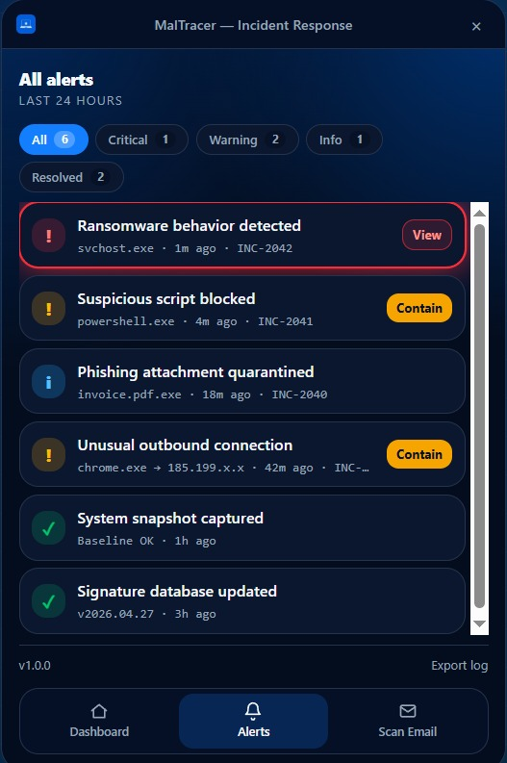

Accessible via the Alerts tab or the 'VIEW ALL' link on the dashboard. Shows every alert from the last 24 hours with full filter and export capability.
UI Element | Description & Behavior
Header | 'All alerts — Last 24 Hours' title. Back arrow to return to Dashboard. Alert count badge (6) at top right.
Filter tabs | Pill-style tabs: All · Critical · Warning · Info · Resolved. Active tab filled blue. Each tab shows the count of alerts in that category.
Alert rows | Each row: severity icon (colored square) + title (bold) + subtitle (process · time · INC-XXXX). Clicking any row opens the Incident Detail panel. Contain/View buttons appear on medium/high rows.
Export log | Bottom-right link. Exports all visible alerts to a structured JSON or Markdown file saved to the user's Downloads folder.

Screen 3 — Scan Email (.eml)

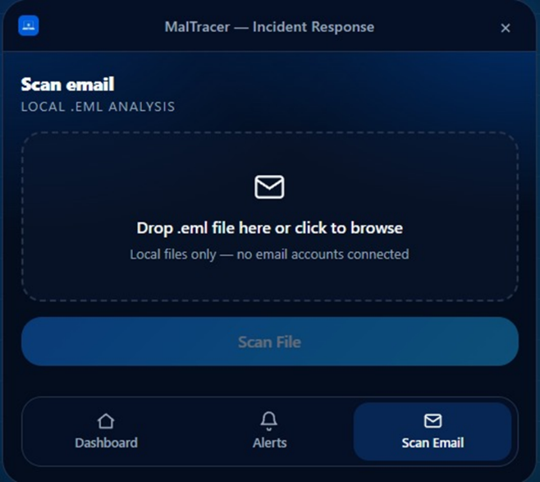

Accessible via the Scan Email tab. Allows the user to scan a locally downloaded .eml file for phishing, malware, and spoofing indicators. No browser connection or email account is required

UI Element | Description & Behavior
Drop zone | Large dashed-border area: 'Drop .eml file here or click to browse'. Subtitle: 'Local files only — no email accounts connected'. Accepts .eml files only — rejects all other types with an inline error.
File display | Once a file is selected: shows filename, file size, and a remove (×) button. The 'Scan File' button becomes active (blue).
Results panel | Appears below after scan completes. Overall verdict badge: Clean (green) / Suspicious (amber) / Malicious (red). Three expandable accordion sections: Headers Analysis (SPF/DKIM/DMARC results), Body Analysis (phishing patterns found, URLs extracted), Attachments Found (each attachment with hash and verdict).
Send to sandbox | If any attachment is flagged Suspicious or Malicious, a 'Detonate in Sandbox' button appears below the attachment row. Clicking opens a confirmation modal.

Screen 4 — Incident Detail Panel
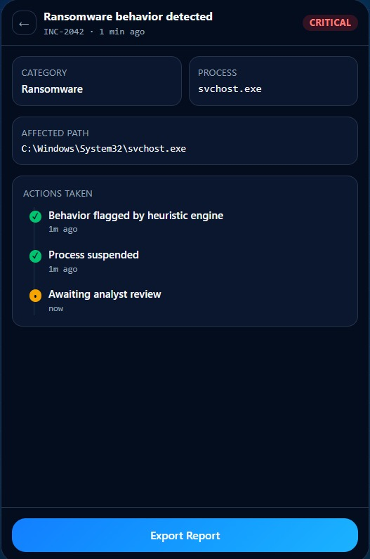

Slides in from the right when any alert row is clicked on any screen. Provides the full forensic record for a single incident.

UI Element | Description & Behavior
Header | Incident ID (monospace, copyable), severity badge, threat category label, timestamp.
Affected item | Process name / file path (monospace). Parent process. PID. File hash if applicable.
Action timeline | Vertical chronological timeline of every automated step: Detection → Scoring → Sandbox start → Sandbox complete → Containment → Report generated. Each step shows its exact timestamp.
Evidence links | Clickable links to open the evidence directory: strace log, pcap file, filesystem diff, YARA matches.
Export Report | Button at bottom. Saves the incident report as Markdown + JSON to the user's chosen path.

Notification Popup (native OS alert)

Triggered by the MalTracer daemon directly via libnotify/notify-send. Appears at the OS level regardless of whether the dashboard is open.

Severity | Content | Actions
MEDIUM | Process name · Threat category · Incident ID · 'Suspicious behavior detected' | Contain now | Dismiss (60s countdown timer)
HIGH | Containment already applied · Process/file name · Action taken | View in dashboard | Undo containment

4.2 UI/UX Guidelines

Design Principles
- Clarity over density: security tools must communicate severity instantly. MalTracer uses color, iconography, and size hierarchy so the user understands the threat state within 2 seconds of opening the popup.
- Progressive disclosure: the main dashboard shows only the most critical information. Details are one tap/click away in the Incident Detail panel — never shown by default.
- Destructive actions require confirmation: Isolate device, Confirm Containment, and Detonate in Sandbox all require an explicit confirmation modal before executing. No single-click irreversible action.
- Accessible severity signaling: severity is communicated via color AND icon AND text label simultaneously — never color alone. This ensures accessibility for color-blind users.

Color Scheme
Color | Hex | Usage
■ Navy | #1A3A6B | Primary background, heading text, branding
■ Blue | #2E75B6 | Primary actions, active states, links, section borders
■ Light Blue | #D5E8F0 | Section banners, table header alternates
■ Amber | #E67E22 | Medium severity, warning alerts, Contain buttons, countdown ring
■ Red | #C0392B | High severity, pulsing border animation, critical alerts
■ Green | #1E8449 | Resolved alerts, clean verdict, system snapshot captured
Dark background | #1E1E2E | Card backgrounds, code blocks

Typography
- Primary font: Inter or system-ui sans-serif (falls back to Arial). Used for all UI labels, body text, and headings.
- Monospace font: JetBrains Mono or Courier New. Used exclusively for: Incident IDs, process names, file paths, hashes, code output.
- Size scale: 24px (threat level), 18px (section headings), 14px (body text), 12px (metadata labels like timestamps and process names).

Accessibility Considerations
- Minimum contrast ratio 4.5:1 for all text against backgrounds (WCAG AA compliance).
- All interactive elements have a visible focus ring for keyboard navigation.
- Alert severity communicated via icon shape + color + text — never color alone.
- Countdown timer in containment modal shown as both a visual ring and a numeric second count.
- All action buttons have descriptive aria-labels for screen reader compatibility.

5. System Deployment & Integration

5.1 Technology Stack

Layer | Technology | Justification
Core language | Python 3.11+ | Cross-platform stdlib (email, os, subprocess), rich ecosystem for security tools (psutil, scapy, yara-python, watchdog). No compilation step.
Process/system | psutil | Cross-platform process and system monitoring. Provides CPU, memory, process tree, and network connection data without root for most operations.
Network monitoring | scapy | Packet capture and analysis. Used for beaconing detection and connection tracking on the primary network interface.
Threat detection | yara-python | Python bindings for YARA. Enables fast pattern matching against files, memory regions, and email content using the .yar rule files in config/rules/.
File monitoring | watchdog | Cross-platform filesystem event monitoring using inotify (Linux). Triggers real-time alerts on file creation, modification, or deletion in watched paths.
Sandbox | Docker + seccomp | Container-based isolation for suspicious file detonation. Uses a custom seccomp profile to restrict syscalls and --no-new-privileges to prevent privilege escalation within the container.
Email parsing | Python email stdlib | Built-in MIME parser for .eml files. No external dependency required. Handles multipart messages, attachment extraction, and header parsing natively.
Office file analysis | oletools | Extracts and analyzes macros from Office documents (.docx, .xls, .ppt). Detects auto-execute macros and suspicious VBA code in email attachments.
PDF analysis | pdfid + pdf-parser | Identifies suspicious PDF structures: JavaScript, embedded files, auto-open actions. Runs inside the sandbox — never on the host directly.
Dashboard backend | FastAPI | Lightweight async Python web framework. Serves the local dashboard on 127.0.0.1 only. Chosen over Flask for built-in async support and automatic API documentation.
Dashboard frontend | HTML/CSS/JS (vanilla) | No frontend framework dependency. The dashboard is a single-page UI served as static files by FastAPI. Uses the MalTracer dark blue design system.
OS notifications | libnotify / notify-send | Native Linux notification system. Raises popups at the OS level without requiring the dashboard to be open. Supports action buttons (Contain / Dismiss) via notification actions.
Threat intelligence | VirusTotal API v3 | Optional external integration. File hashes submitted for reputation lookup. API key stored in the OS keyring — never in config files. Rate-limit aware (free tier: 4 req/min).
Key storage | keyring (Python) | Stores the VirusTotal API key in the OS native keyring (Kwallet on KDE, GNOME Keyring on GNOME, macOS Keychain). Accessed at runtime, never written to disk.
Logging | Python logging + JSON | Structured JSON log output to append-only files. Colored terminal output using the rich library for the interactive CLI mode.

5.2 Deployment Diagram
MalTracer is deployed entirely on a single endpoint. There are no server-side components, no cloud services, and no external data transmission except for the optional VirusTotal hash lookup.

┌─────────────────────────────────────────────────────┐
│ ENDPOINT (User's Machine) │
│ │
│ ┌──────────────┐ ┌──────────────────────────┐ │
│ │ MalTracer │ │ Docker Sandbox │ │
│ │ Daemon │◄──►│ (isolated container) │ │
│ │ (service usr) │ │ seccomp + no-new-privs │ │
│ └──────┬───────┘ └──────────────────────────┘ │
│ │ │
│ ├──► Fast API dashboard (127.0.0.1 only) │
│ ├──► Li notify (OS popups) │
│ ├──► /var/maltracer/incidents/ (evidence) │
│ └──► /var/maltracer/logs/ (append-only) │
│ │
└────────────────────────┬────────────────────────────┘
│ HTTPS (optional, outbound only)
▼
VirusTotal API v3 (hash lookup only)

Key deployment properties:
- Single-machine deployment — no server, no cloud, no shared infrastructure
- Runs as a systemd service on Linux — starts on boot, restarts on crash via the watchdog unit
- The sandbox uses Docker's default bridge network with internet access disabled by default
- All data (logs, evidence, quarantine) stays on the local machine under /var/maltracer/
- VirusTotal hash lookup is the only outbound network call — it sends only a SHA-256 hash, never the file itself

5.3 Component Diagram
The component diagram shows the high-level modules of MalTracer and their dependencies. Arrows indicate data flow direction.

Component | Depends on | Provides
Engine (core) | Event Bus, Incident Manager | Orchestration of all modules, routing of events, lifecycle management
Event Bus | None (standalone) | Thread-safe publish/subscribe channel for all inter-module communication
Monitoring modules (×4) | Event Bus, psutil, scapy, watchdog | Continuous observation of memory, processes, network, and files. Publishes raw events to the bus.
Detection Engine | YARA, Scoring Model, Threat Classifier | Receives events, applies rules and scoring, outputs ScoredEvent with severity and threat category
Containment Engine | Process Killer, Quarantine Manager, setuid helper | Executes containment actions (kill, block, quarantine) in response to high/confirmed-medium events
Sandbox Manager | Docker, Behavior Tracer, Snapshot Diff | Manages container lifecycle, queues detonation requests, exports behavioral evidence
Forensics | Evidence Manager, Timeline Builder | Organises all incident evidence, builds chronological timelines, feeds the report generator
Alert Manager | libnotify, Dashboard Server | Routes alerts to the correct channel: OS popup for medium/high, dashboard-only for low
Dashboard Server | FastAPI, Incident Manager, Evidence Manager | Serves the local web UI. Exposes read-only endpoints for the frontend. Session-token authenticated.
Email Module | Python email, oletools, pdfid, Sandbox Manager | Parses local .eml files, runs phishing and malware detection, triggers sandbox for suspicious attachments
VirusTotal Integration | keyring, requests | Submits file hashes for reputation lookup. Fully optional — tool operates without it.

6. Additional Deliverables

6.1 API Documentation
MalTracer exposes a local REST API via its FastAPI dashboard server. This API is used exclusively by the local dashboard frontend — it is not a public API. All endpoints are available only on 127.0.0.1 and require a session token in the Authorization header.

Authentication
All requests must include: Authorization: Bearer <session_token>
The session token is generated on daemon start and stored at /run/maltracer/session.key (mode 600). It rotates on every daemon restart.

Endpoints
Method | Endpoint | Parameters | Response
GET | /status | None | { threat_level, daemon_uptime, last_scan, mode, files_monitored, processes, quarantined, open_incidents }
GET | /alerts | ?severity=&limit=&since= | Array of alert objects: { id, incident_id, severity, title, process, timestamp, status }
GET | /incidents/{id} | Incident ID in path | Full incident object: { id, severity, category, process, file, timeline[], evidence_paths[], report_path }
GET | /quarantine | None | Array of quarantined items: { filename, original_path, incident_id, timestamp, hash }
POST | /contain/{incident_id} | { action: 'kill'|'block'|'quarantine' } | { success, action_taken, timestamp, incident_id }
POST | /scan/email | { file_path: '/abs/path/to/file.eml' } | { incident_id, verdict, headers_result, body_result, attachments[] } — asynchronous, returns job_id immediately
POST | /scan/quick | None | { job_id } — triggers a quick scan of all monitors; result available via /status when complete
POST | /isolate | { confirm: true } | { success, rules_applied, timestamp } — blocks all outbound traffic except localhost via iptables
GET | /report/{incident_id} | ?format=json|md | Returns the incident report file as a download in the requested format

Error Responses
All error responses follow the same structure:
HTTP Code | Meaning | When it occurs
401 Unauthorized | Invalid or missing token | Every request without a valid session token
404 Not Found | Resource not found | Incident ID or quarantine item does not exist
409 Conflict | Already contained | Containment requested on an already-contained incident
429 Too Many Requests | Rate limit hit | Sandbox queue is full (max 3 concurrent, 10 queued)
500 Internal Error | Daemon error | Unexpected failure — check /var/maltracer/logs/ for details

6.2 Testing & Validation
MalTracer is validated across three testing levels: unit tests for individual modules, integration tests for inter-module communication, and user acceptance tests for end-to-end scenarios.

Unit Tests
Module | Test cases
scoring_model.py | Score outputs for known-clean events (expected: 0–20). Score outputs for known-malicious events (expected: 75–100). Aggregation window behavior (scores reset after 60s). Multiplier logic for parent process context.
threat_classifier.py | Category assignment for ransomware score profile (expected: ransomware). Category for C2 beaconing profile. Category for unknown/mixed signals (expected: unknown). Severity threshold boundaries (39/40, 74/75).
eml_parser.py | Parse valid single-part .eml. Parse multipart with attachments. Handle malformed MIME boundaries without crash. Reject non-.eml file types. ZIP bomb detection (max attachment size limit).
snapshot_diff.py | Detect new files added between snapshots. Detect modified files (hash change). Detect deleted files. Handle empty pre/post snapshots gracefully. Output structure validation.
hashing.py (integrity) | Manifest builds correctly on first run. Modified core file detected on second run. Unmodified file passes check. Missing file detected and flagged.

Integration Tests
Test scenario | Expected behavior
Process monitor → Event Bus → Detection Engine | A synthetic suspicious process event published to the bus is received by the detection engine, scored, and returns a ScoredEvent with correct severity within 2 seconds.
Detection Engine → Containment Engine (high) | A HIGH severity ScoredEvent triggers process kill + network block + quarantine within 5 seconds. All three actions are logged with their timestamps and the correct Incident ID.
Detection Engine → Alert Manager → Popup (medium) | A MEDIUM severity event triggers a libnotify notification with 'Contain now' and 'Dismiss' actions. Selecting 'Contain now' calls the containment engine. Selecting 'Dismiss' logs the decision.
Sandbox Manager → Behavior Tracer → Evidence Manager | A test sample submitted to the sandbox produces a BehaviorReport containing strace output, a pcap file, and a filesystem diff. All three files appear in /var/maltracer/incidents/<ID>/.
Email Module → Sandbox (malicious attachment) | A test .eml file with a known-malicious attachment triggers phishing detection, hash lookup via VirusTotal (mocked), and sandbox detonation. The final incident report reflects the email as the source.
Dashboard API authentication | All API endpoints return 401 without a valid session token. Valid token allows access. Expired/rotated token is rejected.

User Acceptance Tests (UAT)
UAT scenario | Acceptance criteria
Ransomware simulation | Running a script that rapidly creates/modifies/deletes files triggers a HIGH alert, automatic containment, and a popup notification within 10 seconds. Incident report is generated.
Phishing email scan | Scanning a known-phishing .eml file returns verdict: Malicious, identifies the spoofed sender domain, and lists all extracted URLs with at least one flagged as phishing.
Manual containment via popup | A MEDIUM alert popup appears. User clicks 'Contain now'. Confirmation modal appears with correct process name and Incident ID. User confirms. Process is killed within 3 seconds. Dashboard reflects the incident as CONTAINED.
Dashboard loads correctly | Opening the dashboard URL in a browser shows the current threat level, correct stats, and recent alerts. All data matches the current state of the daemon.
Isolate device | Clicking 'Isolate device' triggers a confirmation modal. Confirming blocks all outbound traffic. The dashboard status indicator changes to '● Isolated'. A test ping to 8.8.8.8 fails.
Startup integrity check | Modifying a core .py file and restarting MalTracer produces an integrity failure alert before the daemon completes startup. The daemon refuses to start.

Test Tools & Framework
- Unit tests: pytest with pytest-mock for subprocess and OS call mocking
- Integration tests: pytest with a test Docker environment. A test_fixtures/ directory provides known-good and known-malicious samples.
- API tests: httpx (async HTTP client) against a live test instance of the dashboard server
- Coverage target: 80% line coverage on all files in core/, detection/, and containment/

6.3 Deployment Strategy

Target Environment
- Primary target: Linux (Ubuntu 22.04+, Debian 12+, Fedora 38+)
- Requires: Python 3.11+, Docker Engine 24+, libnotify-bin, iptables
- Recommended: 4GB RAM minimum (2GB for host, 2GB headroom for sandbox containers)
- Does not require: a display server for the daemon — only for popups and dashboard. Can run headless with CLI-only mode.

Installation
MalTracer installs via a single installer script that handles all system configuration:
Step | Action | Detail
1 | Create service user | useradd --system --no-create-home maltracer. The daemon runs as this user after privilege drop.
2 | Install Python deps | pip install -r requirements.txt inside a virtualenv at /opt/maltracer/venv/
3 | Configure directories | Create /var/maltracer/{logs,incidents,quarantine}/. Set ownership and permissions. Apply chattr +a to logs/.
4 | Lock rules directory | Set config/rules/ to root:root 644. Build the startup integrity manifest and store at /etc/maltracer/integrity.manifest (root:root 400).
5 | Install systemd unit | Copy maltracer.service to /etc/systemd/system/. Enable with systemctl enable --now maltracer. A companion maltracer-watchdog.service restarts the daemon if it exits unexpectedly.
6 | Pull Docker image | docker pull maltracer/sandbox:latest — the pre-built minimal Alpine sandbox image with strace, tcpdump, and inotify-tools.
7 | First-run setup | On first start, the daemon generates a random session token, stores it at /run/maltracer/session.key (mode 600), and prompts the user to optionally enter a VirusTotal API key (stored in OS keyring).

Scaling Considerations
MalTracer is an endpoint tool designed for single-machine deployment. It does not scale horizontally. For enterprise environments with multiple endpoints, the recommended architecture is:
- Deploy MalTracer independently on each endpoint via a configuration management tool (Ansible, Puppet, Chef).
- Configure each instance to forward its structured JSON logs to a central SIEM (Splunk, Elastic, Wazuh) via syslog or a log shipper (Filebeat, Promtail).
- The SIEM provides cross-endpoint correlation — MalTracer provides per-endpoint detection and containment.
- This architecture keeps MalTracer simple and auditable while enabling enterprise-scale visibility.

Update Strategy
- YARA rules: updated manually by copying new .yar files into config/rules/ as root. Signature updates do not require a daemon restart — the engine reloads rules on a configurable schedule (default: every 6 hours).
- Python code: updated via git pull + pip install -r requirements.txt inside the virtualenv. Requires a daemon restart (systemctl restart maltracer).
- Sandbox image: updated via docker pull maltracer/sandbox:latest. The updated image is used for the next sandbox spawn — no restart required.
- v2 target: signed auto-update channel for YARA rules with GPG verification before loading.

