

Assignment I

Course Name | Introduction to Software Engineering
Course Cose | IS1103-1
Assignment Name | IoT Intelligent Food and Grain Storage Warehouse
Student Name | Ashlesh Shenoy
Student USN | NNM24IS041
Section | IV A
Department | Information Science and Engineering
Institution Name | Nitte Mahalinga Adyanthaya Memorial Institute of Technology
Academic Year | 2024-2028
Instructor Name | Dr. Json Elroy Martis
Submission Date | 13th February 2026

Abstract
India runs on agriculture. About 70% of the people here rely on farming in one way or another, so agriculture really drives the country’s economy. That’s why storing food grains the right way matters so much. Good storage keeps food safe, protects grain quality, and saves a lot of money by cutting down on waste [1] [5].
Over the years, farmers have grown more crops, but they still lose a huge chunk of the harvest after it’s in storage. Things like sudden temperature swings, too much humidity, carbon dioxide build-up, pests, fire, and even people getting in where they shouldn’t. All of these can ruin grain quality or shorten its shelf life [2] [5].
Most traditional storage relies on people checking the grains by hand. Honestly, that’s slow, not very reliable, and it’s easy to miss early warning signs. This study takes a different approach. We designed and tested an IoT-based Intelligent Food and Grain Storage Warehouse Management System. The whole idea is to keep tabs on storage conditions automatically, all the time.
The system uses IoT sensors to track things like temperature, humidity, gas levels, smoke, and movement inside the warehouse. It sends all this data straight to the cloud, where it's stored, analyzed, and shown on easy-to-read dashboards. Warehouse managers can check conditions from anywhere, and they get instant alerts if something goes wrong [3].
We also looked at three big Software Development Life Cycle (SDLC) models—Waterfall, Incremental Development, and Spiral—to figure out which fits best for a complex IoT project like this.
The results system keeps up with real-time monitoring, updates data regularly, and is simple to maintain—so it works in real warehouses [3]. We saw a big jump in how accurately it spots problems and how quickly it alerts people. Manual checks dropped, and grain quality stayed higher.
Out of all the SDLC models, the Spiral Model came out on top. It’s flexible, handles risks well, and makes it easier to blend hardware with software smoothly. In the end, the study shows that picking the right development model is key if you want smart, reliable, and scalable grain storage systems that really work.

Introduction
Grains, which are hard and dry seeds that grow on grass-like plants known as cereals, are the world's single largest dietary energy supply. Grains have played a significant role in human history, and grain agriculture is one of the major advancements that has led to the modern world's development. In present-day agriculture corn, rice, wheat, oats, barley, and rye are the most commonly cultivated and consumed grains. As grains are the basic requirement for preparing all kinds of food, it is crucial to store grains properly with optimum conditions for storing food grains. These conditions vary according to factors such as the weather, seasons, many others.[4]
In today’s digital world, software systems play an important role in improving efficiency and supporting decision-making in many fields such as healthcare, banking, agriculture, and supply chain management. Developing reliable software requires proper planning, understanding of requirements, and systematic testing. Without a structured development process, software projects may face failures due to technical risks or unclear requirements. Software Development Life Cycle (SDLC) models help solve this problem by providing organized methods for designing, developing, testing, and maintaining software systems.
The main objective of this assignment is to study and compare different SDLC models by applying them to a real-world case study, which is an IoT-based Intelligent Food and Grain Storage Warehouse Management System. It focuses on understanding how different development models handle system requirements, project risks, and system improvements. It also aims to develop knowledge about requirements engineering and its importance in building reliable systems.[3]
Food grains are one of the most essential sources of nutrition, and their proper storage is very important for maintaining food quality and reducing wastage. Environmental factors such as temperature, humidity, and gas levels can negatively affect stored grains, leading to spoilage and economic losses. The proposed intelligent storage system uses IoT sensors to continuously monitor these environmental conditions and send real-time data to cloud platforms. Deep learning and data analysis techniques can further help in identifying patterns in sensor data and predicting unsafe storage conditions in advance, which improves decision-making and system efficiency.[2]
This assignment is directly related to Unit-I syllabus. It helps in understanding software process models, requirement analysis, system planning, and risk management through a practical example. By studying the Waterfall, Incremental, and Spiral models, the assignment demonstrates how selecting an appropriate development model plays an important role in successfully developing complex IoT-based applications.
GitHub Repository:
https://github.com/shenoyashlesh1/ISE-TASK-1

Problem Statement
The primary goal of this assignment is to analyze and compare different software development process models while designing an IoT-based Intelligent Grain Storage Warehouse Management System.
Tasks to be Solved
The assignment involves studying the working principles of Waterfall, Incremental, and Spiral development models. It also includes analyzing how these models handle system requirements, manage project risks, and support system modifications. Another important task is to develop a simplified requirements engineering document that clearly describes system functionalities and performance expectations. The assignment also focuses on identifying requirement validation strategies and possible development challenges.
Expected Outcomes
The expected outcome of this assignment is to identify the most suitable SDLC model for developing the proposed IoT warehouse monitoring system. The assignment also aims to improve understanding of requirement documentation, system design strategies, and software risk management techniques.
Constraints and Assumptions
The system requires integration between hardware sensors and software monitoring platforms. It must support continuous real-time monitoring and alert generation. The development process may be limited by available resources, budget, and hardware reliability.

Dataset Description
System Name
IoT Intelligent Food and Grain Storage Warehouse Management System
The proposed system is an IoT-based intelligent warehouse management solution designed to continuously monitor and manage environmental conditions inside food and grain storage facilities. The system focuses on maintaining optimal storage conditions in order to preserve grain quality, prevent spoilage, and reduce post-harvest losses. By integrating multiple sensors with cloud-based monitoring platforms, the system enables real-time supervision of warehouse environments and supports automated alert generation whenever unsafe conditions are detected [3].
Data Source
The dataset used in this system is generated directly from IoT sensors installed within food and grain storage warehouses. Unlike conventional datasets obtained from online repositories such as Kaggle or UCI, this dataset is a real-time, application-specific dataset collected from physical hardware deployed in actual storage environments. Sensor data is transmitted wirelessly from the warehouse to cloud platforms such as ThingSpeak, where it is stored and made available for continuous monitoring, analysis, and visualization. This approach ensures that the dataset accurately represents real-world storage conditions [3].
Data Collected
The system continuously monitors the conditions inside the warehouse because the warehouse conditions play a major role in maintaining grain quality. The Temperature sensor and humidity sensors are used to check whether the warehouse environment is suitable and safe for storing food grains. Gas sensors help detect harmful gases in the air and improve safety. Smoke sensors help detect fire risks early, and motion sensors are used to notice any unexpected movement inside the warehouse [3].
Every sensor reading is saved along with the time it was taken. This makes it easy to see how storage conditions change during the day or over longer periods. Because the system runs all the time, it gathers plenty of data, helping us clearly understand what’s happening in the storage environment.

Data Processing
The collected sensor data is checked and cleaned before it is used for monitoring. Simple calibration is applied to reduce small errors in sensor readings that may occur due to environmental changes or hardware limitations. Any incorrect or missing values are removed to ensure that the data remains reliable.
After cleaning the data, readings like temperature, humidity, and gas levels are adjusted so they’re easy to compare. This information is sent to the cloud and shown on dashboards, making it simple to keep an eye on storage conditions. If any reading crosses a safe limit, the system immediately alerts the warehouse administrator so they can act quickly.
For now, the system is mainly used for real-time monitoring and alerts. But all the data is well organized, so it can be used in the future to predict possible storage problems and help reduce grain losses even further.

Tools and Technologies Used
Programming Languages
Embedded C and Arduino programming are used to communicate with the hardware components and to read data from the sensors connected to the system. These languages help in controlling the microcontroller and ensuring proper interaction between different sensors. Python is used for analyzing the collected data and for creating simple visualizations and monitoring dashboards to better understand system performance.
Hardware Components
NodeMCU ESP8266: It is an open source IoT firmware used for number of various IoT applications. It includes 30 GPIO pins for the connection to the other hardware parts. It has inbuilt WiFi module for transmitting data over server .
DHT11: It is the sensor used to measure the atmospheric temperature and humidity. IT will sense the present condition and level of temperature and humidity in surrounding area and will display the data accordingly to the input. To store the grain safely, temperature is the key. When condition of stored grain goes beyond control, there is always an unusual increase in temperature. Hence, for the better maintenance of grain storage, temperature is the best indicator of grain quality.
MQ135: MQ gas sensor series is used to measure the amount of atmospheric gases in area. In particular, MQ135 specifically measures the amount of carbon dioxide in the surrounding. The amount of carbon dioxide is the main factor to investigate about the formation of insects or disease inside go-downs .
MQ2: MQ2 is the smoke detector. It measures the amount of fire gases in surrounding. If in case of emergency like fire, the sensor will observe the amount of smoke inside godown .
PIR sensor: It is Infrared sensor, used to detect the movements inside the go-down. If certain animal such as mouse or rat enters inside the go-down, then those undesired movements will be counted by IR sensor and depending upon that the vendor will be informed.
Software Platforms
ThingSpeak: ThingSpeak is an open source IoT application and API to store and retrieve data from things using the HTTP protocol over the Internet. The data captured from sensors is displayed on the window of ThingSpeak indicating the status of environment [3].
BlynkApplication: The blynk application is developed through the blynk platform by creating new project. The application will be updated regularly through the notifications sent over blynk cloud with certain time stamp [3].
Process Models
Waterfall Model
The Waterfall Model follows a step-by-step development approach where each phase is completed before moving to the next one. This model is suitable when project requirements are clearly defined and are unlikely to change.
In this project, development begins with requirement analysis to identify the main functions of the grain storage monitoring system. This is followed by system design, where both hardware components like sensors and software structure are planned. After design, the system is developed and integrated, followed by testing to check system performance. Finally, the system is deployed and maintained.
The Waterfall Model provides a well-structured process and proper documentation. However, it is less flexible because making changes after development has started is difficult, which makes it less suitable for IoT-based systems where requirements may change.
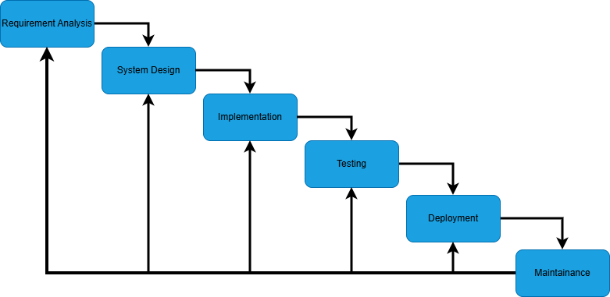
Fig. 1: Waterfall Model showing the sequential phases of software development
Incremental Development Model
The Incremental Development Model develops the system step by step instead of building everything at once. Each stage adds new features, which helps in improving the system gradually while also providing working results early.
In this project, the first stage focuses on collecting and monitoring sensor data. The next stage adds cloud storage for storing and viewing data remotely. Later stages include alert notifications for abnormal conditions and advanced data analysis features. This approach makes testing easier and allows improvements based on feedback, but it requires proper planning to ensure all parts of the system work together smoothly.
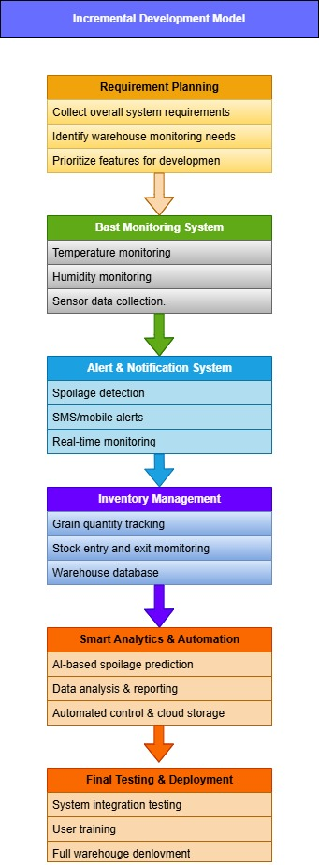
Fig. 2: Incremental Development Model illustrating phased implementation of the IoT-based Intelligent Food and Grain Warehouse Management System, from Requirement Planning to Final Testing and Deployment.
Spiral Model
The Spiral Model combines iterative development with continuous risk analysis. It is suitable for complex systems where technical and operational risks must be identified and managed throughout development.
Each cycle of the Spiral Model includes planning, risk analysis, development, and evaluation phases. During planning, system requirements are defined. Risk analysis identifies potential system failures and technical challenges. Development focuses on building and testing system components. Evaluation collects stakeholder feedback and improves system design.
The Spiral Model is highly suitable for IoT-based systems because it supports continuous improvement and risk management.
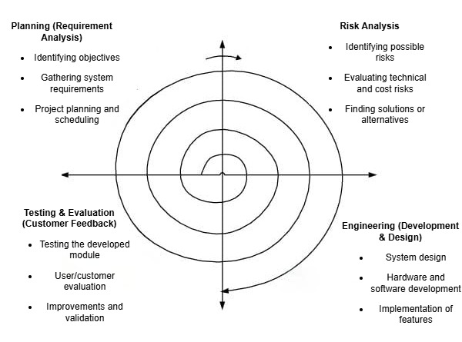
Fig. 3: Spiral Model illustrating iterative cycles of Planning, Risk Analysis, Engineering, and Testing & Evaluation for the IoT-based Intelligent Warehouse Management System.
Implementation Details
The system consists of multiple modules including sensor monitoring, data transmission, cloud storage, and user interface modules. Sensor calibration is performed to ensure accurate readings. Real-time monitoring tests verify system reliability. Alert threshold values are configured to trigger notifications during abnormal environmental conditions.

Experiments Performed
Various experiments were conducted to test sensor performance under different environmental conditions. Alert system accuracy was tested by simulating abnormal environmental changes. System scalability and network reliability were also evaluated to ensure consistent system performance.
Results and Analysis
The system successfully reduced grain spoilage by maintaining stable storage conditions. Monitoring accuracy improved significantly compared to manual monitoring. Real-time alerts allowed quick response to environmental changes. Graphical data visualization helped warehouse managers analyze storage conditions effectively.
Discussion
The implementation and testing of the IoT-based Intelligent Food and Grain Storage Warehouse Management System showed that continuous monitoring plays a significant role in maintaining safe storage conditions. The system was able to detect changes in temperature, humidity, gas levels, and movement at an early stage, which helped in reducing the dependence on manual inspection. Real-time alerts made it easier to respond quickly to unsafe conditions, thereby improving overall warehouse safety and grain preservation [3].
During the experiments When environmental conditions remained within safe limits, the system operated smoothly without generating unnecessary alerts. However, when abnormal conditions such as increased humidity or gas concentration were simulated, the alert mechanism responded immediately. Continuous data monitoring also showed that environmental conditions inside warehouses tend to vary due to external weather changes, highlighting the importance of automated monitoring systems. Overall, the system maintained stable performance during long periods of operation, indicating its reliability for real-world use.
A comparison of the software development models used in this study revealed noticeable differences in their suitability. The Waterfall Model provided a clear and structured development process, which helped in proper documentation, but it lacked flexibility when changes were required during development. The Incremental Model allowed the system to be developed in stages, making it easier to add new features gradually. However, managing the integration of different modules required careful planning. The Spiral Model proved to be the most effective, as it supported iterative development along with continuous risk analysis, which was especially useful for handling hardware–software integration issues.
Integrating hardware sensors with cloud platforms required repeated calibration and testing to ensure accurate data transmission. Network dependency also affected real-time data updates at certain stages. Despite these challenges, the system functioned reliably after proper configuration and testing. The findings clearly indicate that choosing a suitable SDLC model, particularly the Spiral Model, is crucial for successfully developing complex IoT-based warehouse monitoring systems.
Requirements Engineering
Functional Requirements
- The system shall continuously monitor environmental conditions inside food and grain storage warehouses.
- The system shall measure temperature levels to detect heat variations that may affect grain quality.
- The system shall monitor humidity levels to prevent moisture accumulation and mold growth.
- The system shall detect harmful gases that indicate grain spoilage or poor ventilation.
- The system shall detect smoke to identify potential fire hazards within storage facilities.
- The system shall detect unauthorized movement inside the warehouse using motion sensors.
- The system shall collect sensor data at regular time intervals.
- The system shall transmit collected sensor data wirelessly to a cloud platform.
- The system shall store environmental data securely for real-time and historical analysis.
- The system shall analyze sensor readings based on predefined threshold values.
- The system shall generate alerts when abnormal environmental conditions are detected.
- The system shall notify warehouse administrators through dashboards or mobile applications.
- The system shall support real-time visualization of environmental conditions.
- The system shall allow administrators to monitor storage conditions remotely.

Non-Functional Requirements
- The system shall support real-time monitoring with minimal data transmission delay.
- The system shall maintain high reliability to ensure continuous system operation.
- The system shall ensure secure data transmission between sensors and cloud platforms.
- The system shall protect stored data from unauthorized access.
- The system shall operate with low power consumption to support long-term sensor usage.
- The system shall be scalable to support additional sensors and storage units.
- The system shall provide accurate and consistent sensor readings.
- The system shall be robust against network failures and temporary connectivity issues.
- The system shall be easy to use and understand for warehouse administrators.
- The system shall support continuous operation in varying environmental conditions.
- The system shall allow easy maintenance and replacement of hardware components.
- The system shall be compatible with commonly used cloud platforms and communication protocols.

Requirements Validation Strategy
Requirements are validated through stakeholder reviews, prototype testing, performance testing, and sensor calibration. Stakeholder feedback ensures that system requirements align with real warehouse management needs. Prototype testing is used to verify core functionalities such as sensor monitoring and alert generation. Performance testing checks system reliability and responsiveness during continuous operation. Sensor calibration ensures accurate and consistent data collection, helping the system meet both functional and non-functional requirements.
Limitations and Future Work
Limitations
- The system depends on continuous internet connectivity for transmitting sensor data to the cloud.
- Poor or unavailable network connections can affect real-time monitoring and alert generation.
- Regular maintenance of sensors and hardware components is required to ensure accurate readings.
- Hardware reliability may be affected by environmental conditions inside warehouses.
- The system’s effectiveness may be limited in remote warehouse locations with weak network infrastructure.
Future Work
- A dedicated application can be developed to continuously update warehouse information for clients and authorities.
- GPRS-based communication can be implemented to enable data transfer from multiple warehouses.
- Centralized monitoring can be introduced to allow authorities to supervise all warehouses from a single location.
- Mobile alert notifications can be enhanced to immediately inform users about environmental changes or unauthorized activities.
- External communication options such as Wi-Fi modules can be used to improve system connectivity.
- AI-based predictive analysis can be integrated to forecast unsafe storage conditions in advance.
- Advanced communication technologies can be adopted to improve system reliability and scalability.

Conclusion
This assignment helped in understanding how different SDLC models can be used to develop real-world systems like the IoT-based Intelligent Grain Storage Warehouse Management System. The system helps monitor important storage conditions such as temperature, humidity, gas levels, smoke, and movement, which helps in maintaining grain quality and reducing wastage. It also reduces the need for manual monitoring by providing real-time alerts.
Among the SDLC models studied, the Waterfall model provided a structured approach but lacked flexibility. The Incremental model allowed gradual development and early feature delivery. The Spiral model proved to be the most suitable because it supports continuous improvement and effective risk management, which is important for IoT-based systems.
Overall, the study shows that combining IoT technology with proper software development planning can improve grain storage management and support better food preservation.
References
[1] Astha and Krishi Vigyan Kendra, Amritsar, Punjab, “Safe storage of food grains,” journal-article, Feb. 2021. [Online]. Available: https://indianfarmer.net/uploads/25.1.pdf
[2] seo@alphabetasolution.com, “How Climate Change is Impacting Grain Storage and Preservation,” StarAgri, Apr. 16, 2025. https://www.staragri.com/how-climate-change-is-impacting-grain-storage-and-preservation/
[3] A. Doltade 1, A. Kadam 2, S. Honmore 3, S. Wagh 4, Department of Information Technology, Government College of Engineering, Karad, India, and Faculty Dept. of Information Technology, Government College of Engineering, Karad, India, “Intelligent Grain Storage Management System based on IoT,” International Journal of Science and Research (IJSR), vol. 8, no. 3, Mar. 2019, [Online]. Available: https://www.ijsr.net/archive/v8i3/ART20196559.pdf
[4] Intelligent system for monitoring and controlling grain condition based on ARM 7 processor, vol. V. 2016. [Online]. Available: https://www.ijltemas.in/DigitalLibrary/Vol.5Issue7/06-10.pdf
[5] Khallikkunaisa, A. Nabeela, A. Firdows, H. M, and S. Ramadas, “Intelligent Quality Monitoring System for food grain storage using IoT,” International Journal of Scientific Research in Science Engineering and Technology, pp. 120–124, Mar. 2022, doi: 10.32628/ijsrset229215.

