B06901090 電機二 沈哲瑋 LA hw6
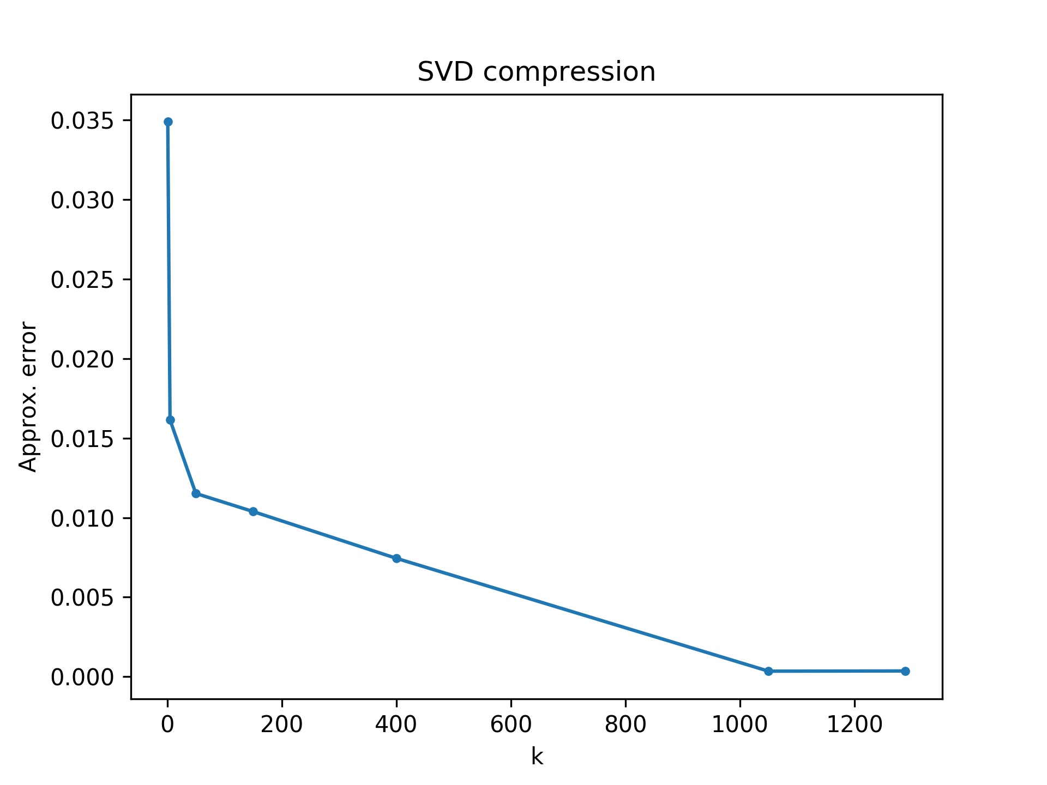
1. A plot includes curve describing the relation of k and approximation error
2.Analyze the rank of R channel of the provided image and explain how you analyze.
3.Plots in page 6 but on G channel(A_{i,G} , ∀1 ≤ i ≤ 5)

