B06901090 電機二 沈哲瑋 LA hw6

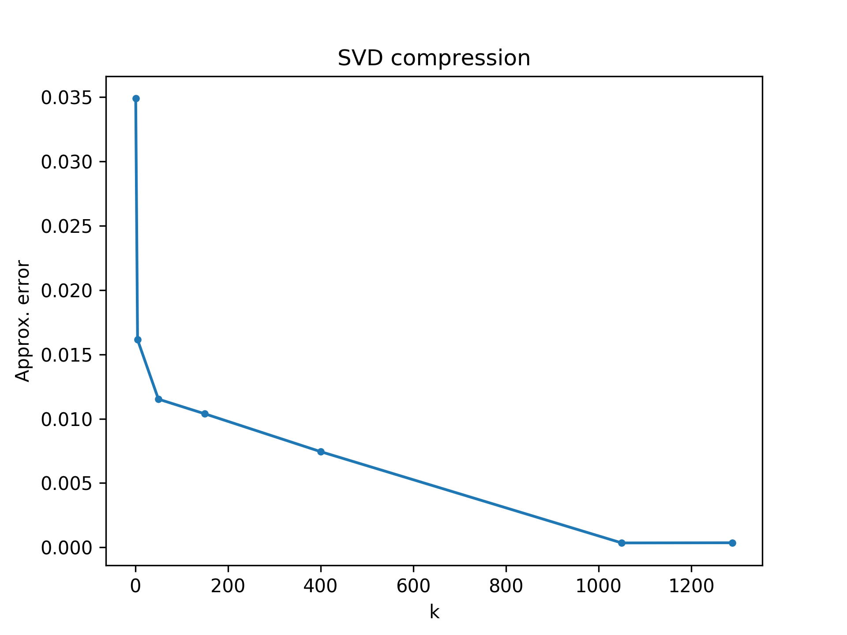1. A plot includes curve describing the relation of k and approximation error

2.Analyze the rank of R channel of the provided image and explain how you analyze.

3.Plots in page 6 but on G channel(Ai,G , ∀1 ≤ i ≤ 5)

|  |  |  |
| --- | --- | --- |
| 1 | 2 | 3 |
|  |  |  |
| 4 | 5 | 1+2+3+4+5 |
|  |  |  |

註：是灰階而不是綠色是因為我把他降一個維度，這部份的code寫在py檔的main。