死锁

[死锁是指两个或两个以上的线程在执行过程中，由于竞争资源或者由于彼此通信而造成的一种阻塞的现象，若无外力作用，它们都将无法推进下去。此时称系统处于死锁状态或系统产生了死锁，这些永远在互相等待的进程称为死锁进程。](https://m.baidu.com/from=1000539d/bd_page_type=1/ssid=0/uid=0/pu=usm%401%2Csz%401320_2001%2Cta%40iphone_1_13.3_25_13.0/baiduid=7928ADF31DBF258781C920C8AFD62990/w=0_10_/t=iphone/l=1/tc?clk_type=1&vit=osres&l=1&baiduid=7928ADF31DBF258781C920C8AFD62990&w=0_10_%E6%AD%BB%E9%94%81%E7%9A%84%E5%AE%9A%E4%B9%89&t=iphone&ref=www_iphone&from=1000539d&ssid=0&lid=9016965692933303622&bd_page_type=1&pu=usm%401%2Csz%401320_2001%2Cta%40iphone_1_13.3_25_13.0&order=1&fm=alop&cyc=1&isAtom=1&is_baidu=0&tj=AW9_1_0_10_l3&clk_info=%7B%22tplname%22%3A%22wenda_abstract%22%2C%22srcid%22%3A38421%2C%22t%22%3A1588557785468%2C%22xpath%22%3A%22div-article-section-div-div2(top1-paraphrase)-a-div2(para-row)%22%7D&wd=&eqid=7d22b286172c6d46100000035eaf77ca&w_qd=IlPT2AEptyoA_ykz9RkorwGvFS2SbJgmzzu&bdver=2&tcplug=1&dict=-1&sec=3266&di=701d5381036c10b3&bdenc=1&tch=124.0.31.382.0.0&nsrc=FydYV5L2%2FeGw6EM0C%2BbozP%2BEFpMajWLBTNRq2ogTUySLLbRpQTjAL3%2FQnjMkKHxenN%2BFM3tIptlpjIBCLPnNktAUCNt6H7cQXzEjQO165187%2BH9xsDGKiAVxHFcRBz%2FX" \t "_self)

[导致死锁的原因:两个或两个以上的线程共同访问两个相同的静态对象，相互之间产生了冲突](https://m.baidu.com/from=1000539d/bd_page_type=1/ssid=0/uid=0/pu=usm%401%2Csz%401320_2001%2Cta%40iphone_1_13.3_25_13.0/baiduid=7928ADF31DBF258781C920C8AFD62990/w=0_10_/t=iphone/l=1/tc?clk_type=1&vit=osres&l=1&baiduid=7928ADF31DBF258781C920C8AFD62990&w=0_10_%E6%AD%BB%E9%94%81%E7%9A%84%E5%AE%9A%E4%B9%89&t=iphone&ref=www_iphone&from=1000539d&ssid=0&lid=9016965692933303622&bd_page_type=1&pu=usm%401%2Csz%401320_2001%2Cta%40iphone_1_13.3_25_13.0&order=1&fm=alop&cyc=1&isAtom=1&is_baidu=0&tj=AW9_1_0_10_l3&clk_info=%7B%22tplname%22%3A%22wenda_abstract%22%2C%22srcid%22%3A38421%2C%22t%22%3A1588557785468%2C%22xpath%22%3A%22div-article-section-div-div2(top1-paraphrase)-a-div2(para-row)%22%7D&wd=&eqid=7d22b286172c6d46100000035eaf77ca&w_qd=IlPT2AEptyoA_ykz9RkorwGvFS2SbJgmzzu&bdver=2&tcplug=1&dict=-1&sec=3266&di=701d5381036c10b3&bdenc=1&tch=124.0.31.382.0.0&nsrc=FydYV5L2%2FeGw6EM0C%2BbozP%2BEFpMajWLBTNRq2ogTUySLLbRpQTjAL3%2FQnjMkKHxenN%2BFM3tIptlpjIBCLPnNktAUCNt6H7cQXzEjQO165187%2BH9xsDGKiAVxHFcRBz%2FX" \t "_self)

[死锁代码运行结果如下：](https://m.baidu.com/from=1000539d/bd_page_type=1/ssid=0/uid=0/pu=usm%401%2Csz%401320_2001%2Cta%40iphone_1_13.3_25_13.0/baiduid=7928ADF31DBF258781C920C8AFD62990/w=0_10_/t=iphone/l=1/tc?clk_type=1&vit=osres&l=1&baiduid=7928ADF31DBF258781C920C8AFD62990&w=0_10_%E6%AD%BB%E9%94%81%E7%9A%84%E5%AE%9A%E4%B9%89&t=iphone&ref=www_iphone&from=1000539d&ssid=0&lid=9016965692933303622&bd_page_type=1&pu=usm%401%2Csz%401320_2001%2Cta%40iphone_1_13.3_25_13.0&order=1&fm=alop&cyc=1&isAtom=1&is_baidu=0&tj=AW9_1_0_10_l3&clk_info=%7B%22tplname%22%3A%22wenda_abstract%22%2C%22srcid%22%3A38421%2C%22t%22%3A1588557785468%2C%22xpath%22%3A%22div-article-section-div-div2(top1-paraphrase)-a-div2(para-row)%22%7D&wd=&eqid=7d22b286172c6d46100000035eaf77ca&w_qd=IlPT2AEptyoA_ykz9RkorwGvFS2SbJgmzzu&bdver=2&tcplug=1&dict=-1&sec=3266&di=701d5381036c10b3&bdenc=1&tch=124.0.31.382.0.0&nsrc=FydYV5L2%2FeGw6EM0C%2BbozP%2BEFpMajWLBTNRq2ogTUySLLbRpQTjAL3%2FQnjMkKHxenN%2BFM3tIptlpjIBCLPnNktAUCNt6H7cQXzEjQO165187%2BH9xsDGKiAVxHFcRBz%2FX" \t "_self)

[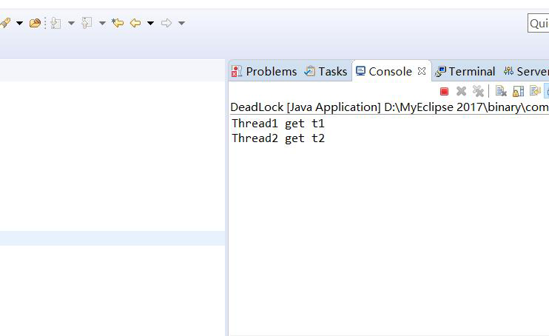](https://m.baidu.com/from=1000539d/bd_page_type=1/ssid=0/uid=0/pu=usm%401%2Csz%401320_2001%2Cta%40iphone_1_13.3_25_13.0/baiduid=7928ADF31DBF258781C920C8AFD62990/w=0_10_/t=iphone/l=1/tc?clk_type=1&vit=osres&l=1&baiduid=7928ADF31DBF258781C920C8AFD62990&w=0_10_%E6%AD%BB%E9%94%81%E7%9A%84%E5%AE%9A%E4%B9%89&t=iphone&ref=www_iphone&from=1000539d&ssid=0&lid=9016965692933303622&bd_page_type=1&pu=usm%401%2Csz%401320_2001%2Cta%40iphone_1_13.3_25_13.0&order=1&fm=alop&cyc=1&isAtom=1&is_baidu=0&tj=AW9_1_0_10_l3&clk_info=%7B%22tplname%22%3A%22wenda_abstract%22%2C%22srcid%22%3A38421%2C%22t%22%3A1588557785468%2C%22xpath%22%3A%22div-article-section-div-div2(top1-paraphrase)-a-div2(para-row)%22%7D&wd=&eqid=7d22b286172c6d46100000035eaf77ca&w_qd=IlPT2AEptyoA_ykz9RkorwGvFS2SbJgmzzu&bdver=2&tcplug=1&dict=-1&sec=3266&di=701d5381036c10b3&bdenc=1&tch=124.0.31.382.0.0&nsrc=FydYV5L2%2FeGw6EM0C%2BbozP%2BEFpMajWLBTNRq2ogTUySLLbRpQTjAL3%2FQnjMkKHxenN%2BFM3tIptlpjIBCLPnNktAUCNt6H7cQXzEjQO165187%2BH9xsDGKiAVxHFcRBz%2FX" \t "_self)