Syntax error 语法错误

Precedence 优先级

Pseudocode (伪代码)

The operands ? and : form a conditional expression.

Shorthand of if…else

Terminate 结束

Increment and Decrement Operators

Preincrementing postincrementing

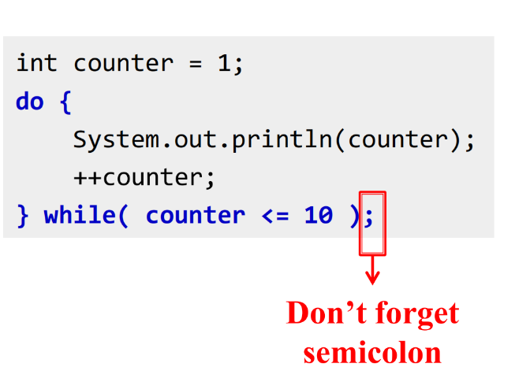

do…while: Condition is tested at the end of the loop; body will be executed at least once

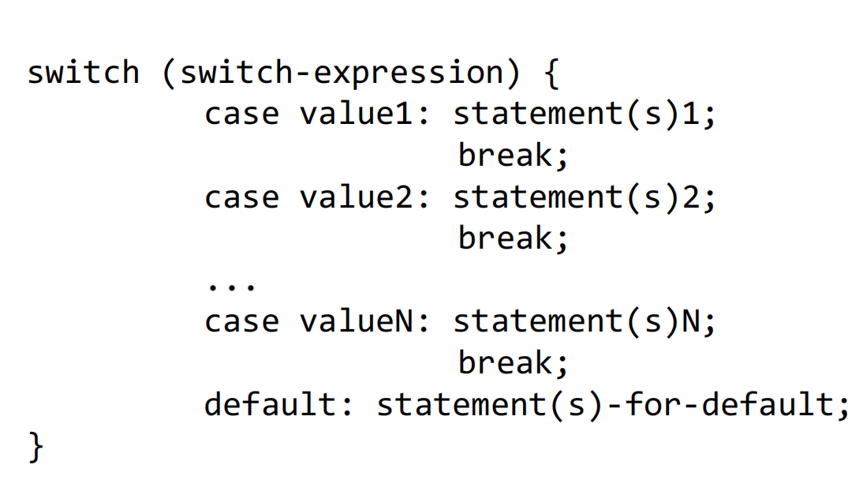

value1, . . ., and valueN are constant expressions,

meaning that they cannot contain variables, such

as 1 + x

^exclusive or 异或运算符，不同则输出1