Data Acquisition

**Aim**: To perform Data Acquisition using **FTK Imager** **tool** and **Encase Tool**.

**FTK imager tool Steps:**

**Step 1 :** Download and install FTK Imager tool

<https://accessdata-ftk-imager.software.informer.com/download/>

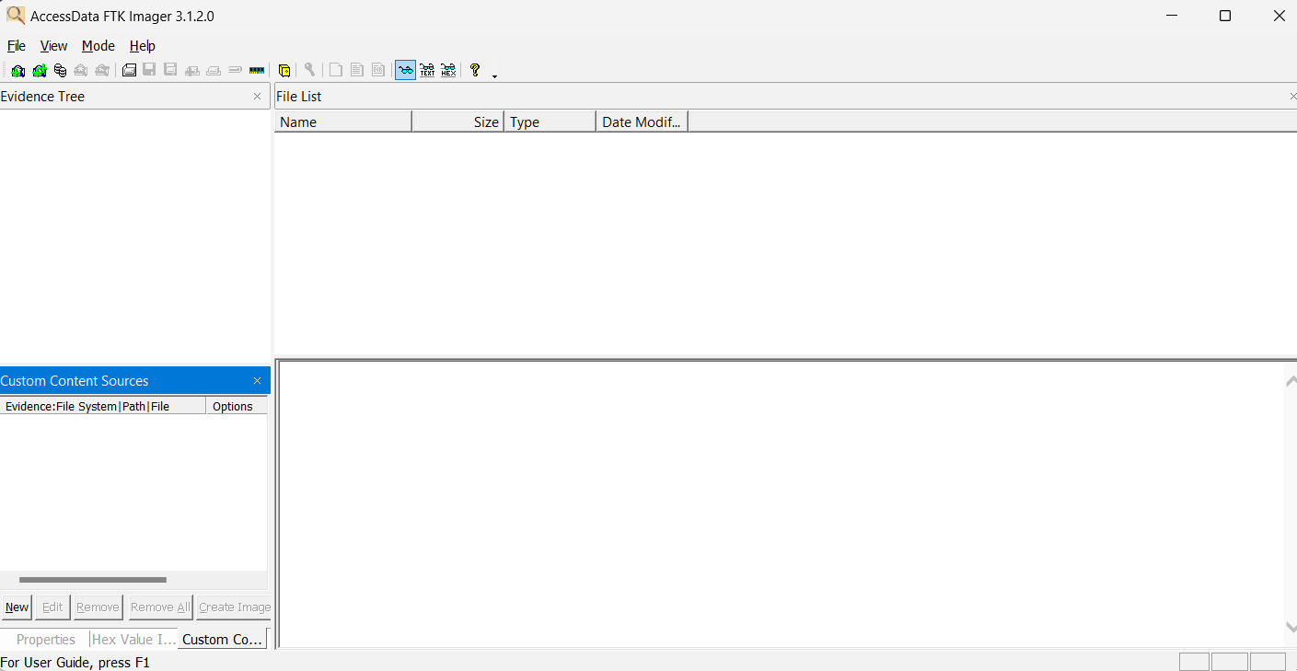

**Step 2 :** Add the evidence folder in the tool

Select **File** -> **Add evidence Item** -> **Contents of a folder**  and click on next

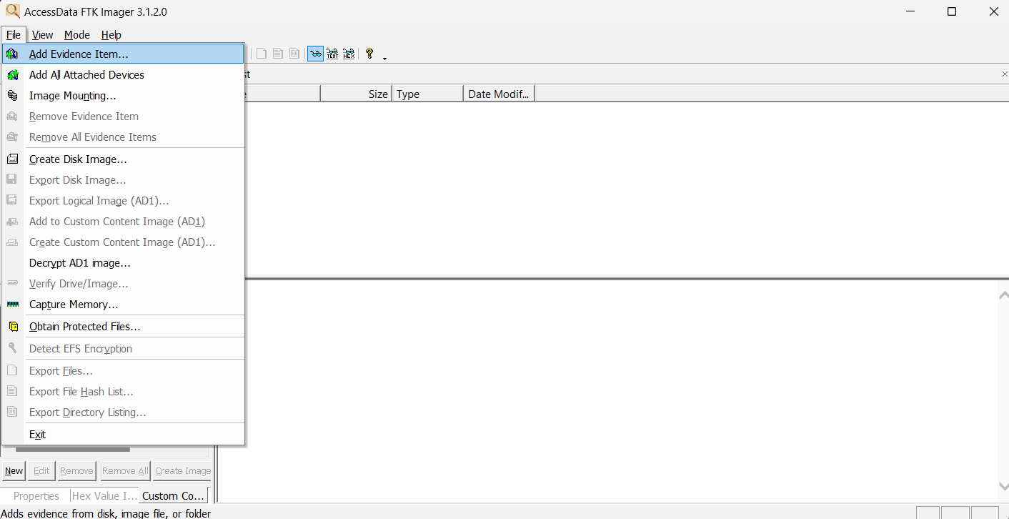

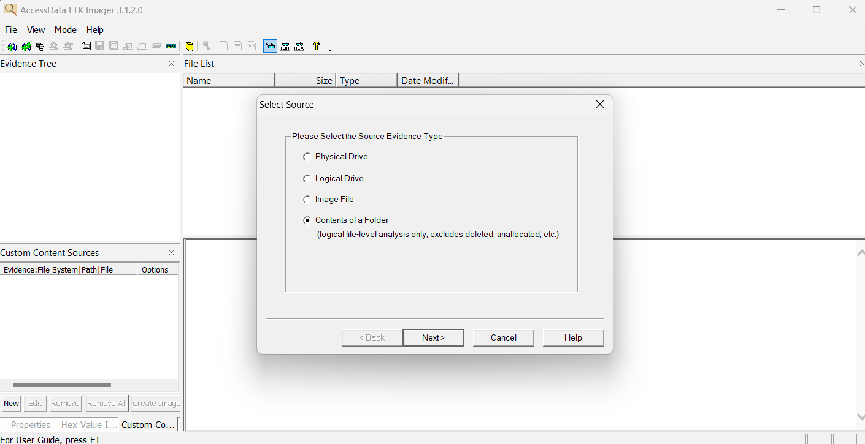

**Add path of the folder and click on finish**

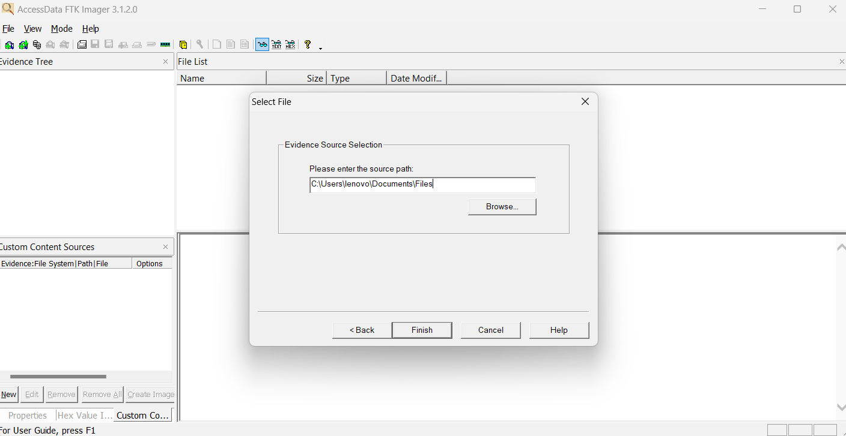

**File has been Added to the evidence tree**

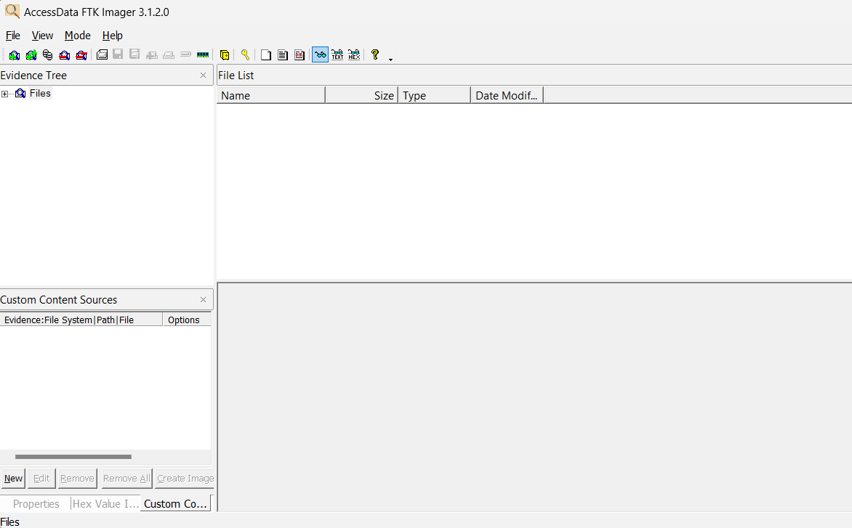

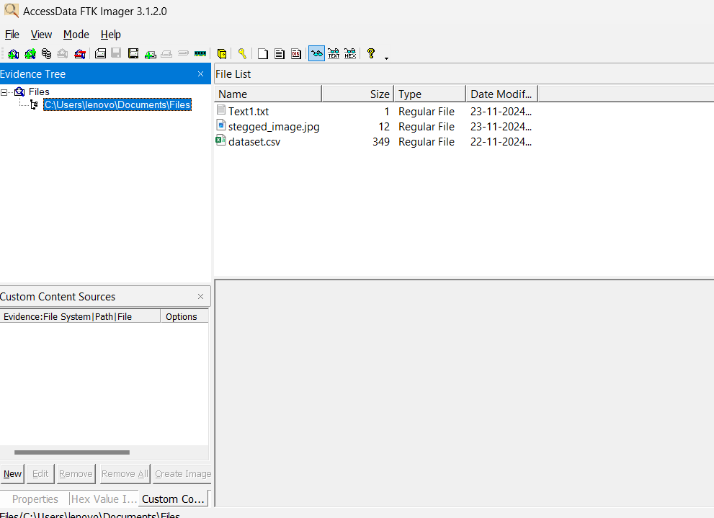

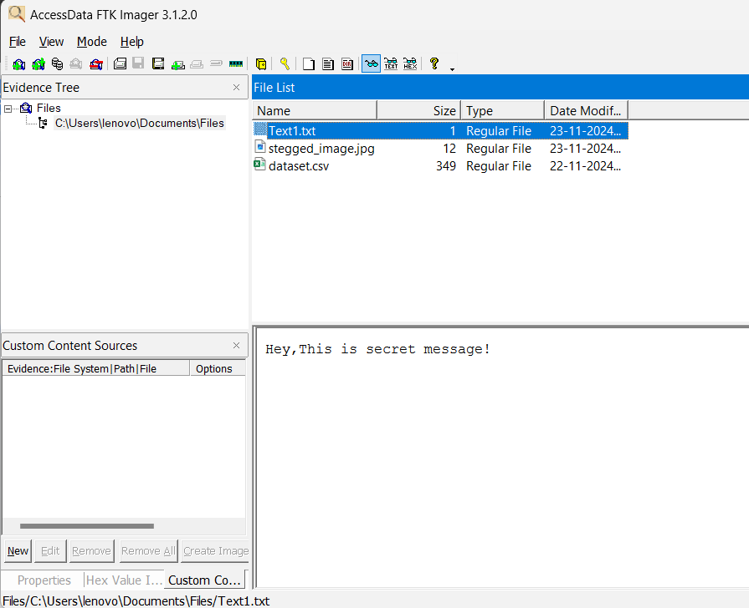

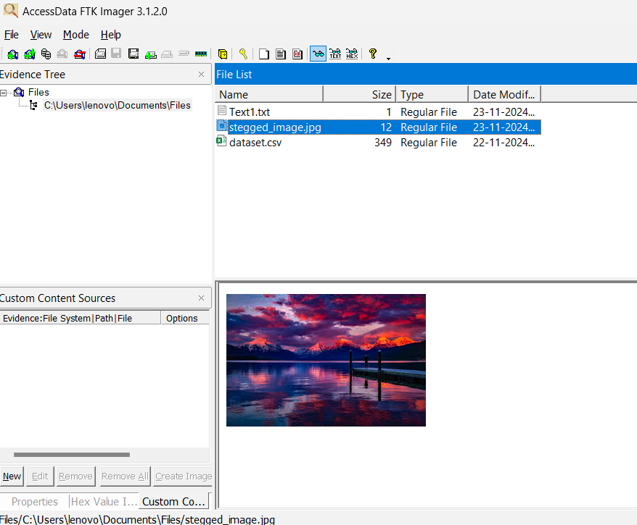

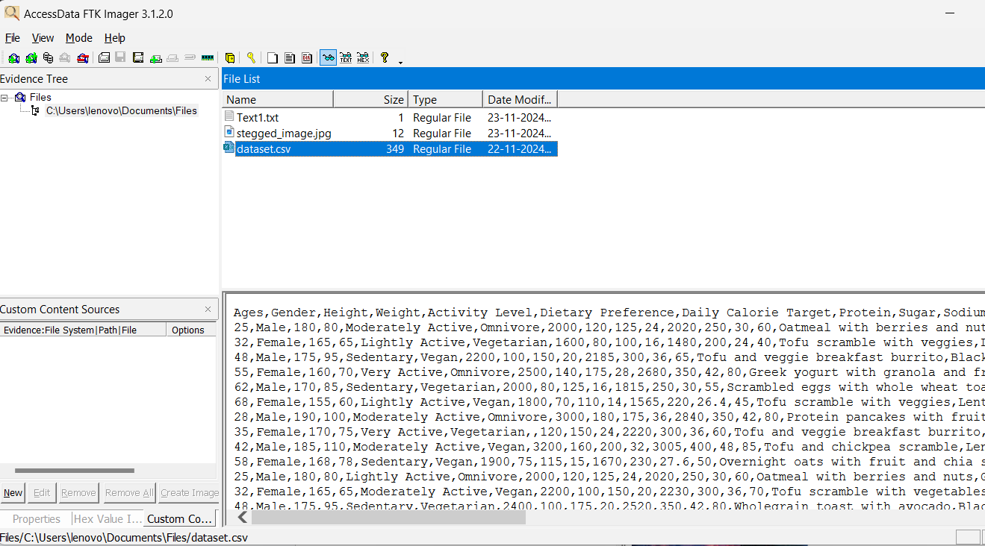

**Step 3 :** Now click on file and add the folder or file to make its copy for that click on the create Disk image

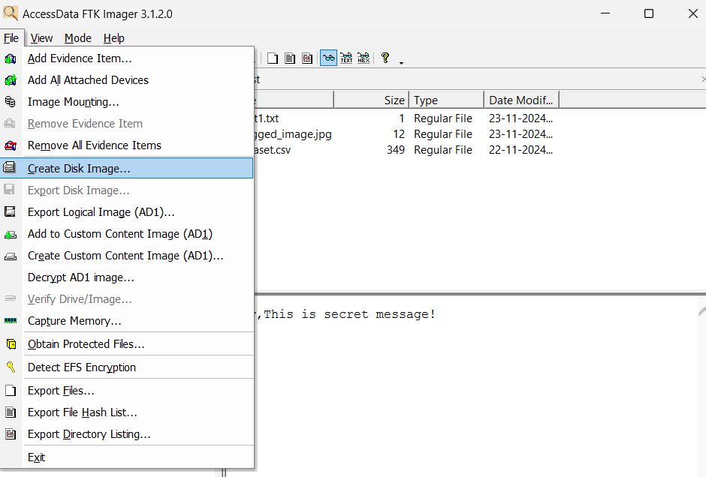

**Step 4 :** Choose the opinion Contents of a folder and Click next

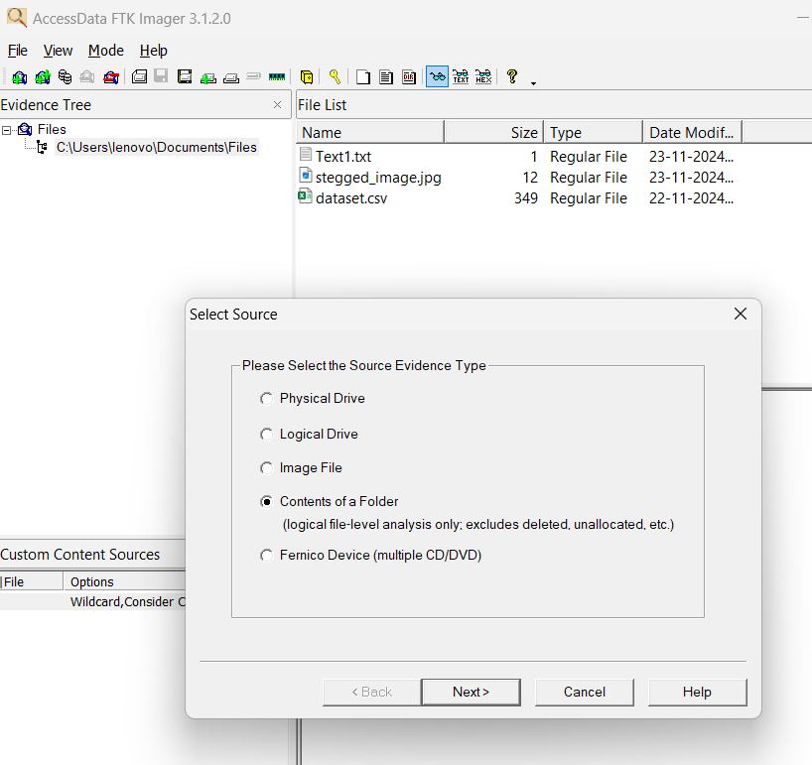

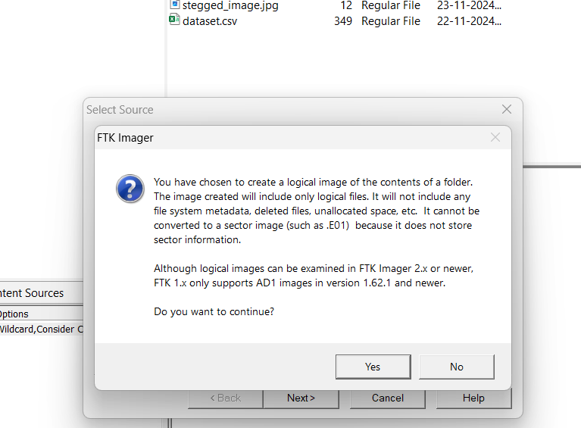

**Click yes**

**Step 5 :** Browse the folder which we want to make a copy and Click Finish

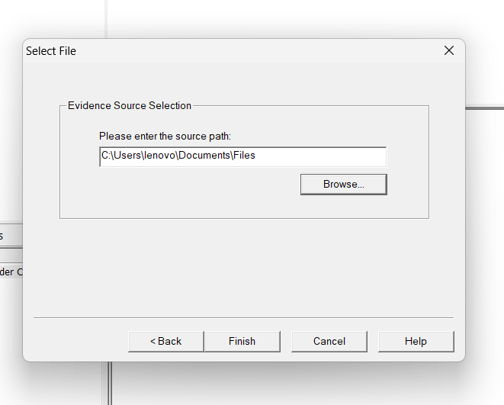

**Step 6:** Now Add the Location for the Copy Document to to store it for that **click on add**

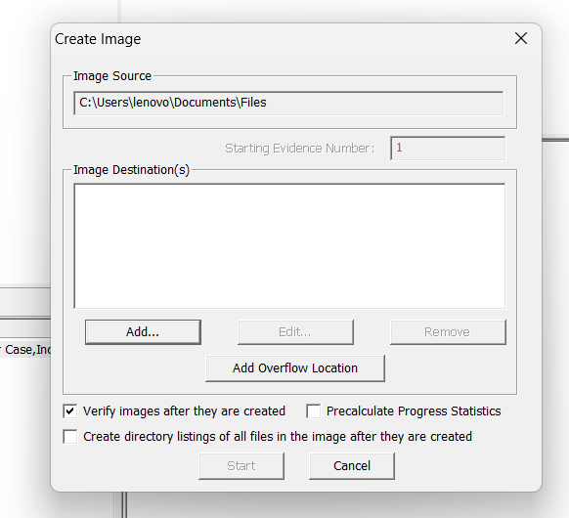

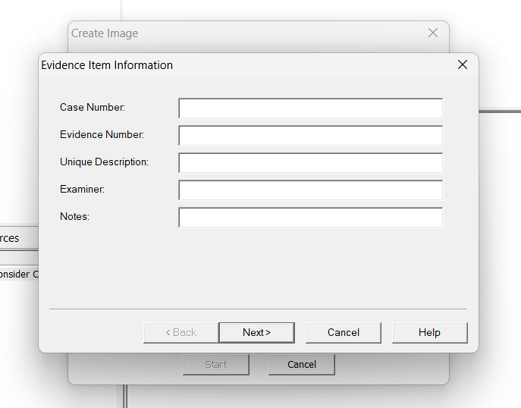

**Step 7:** Fill details

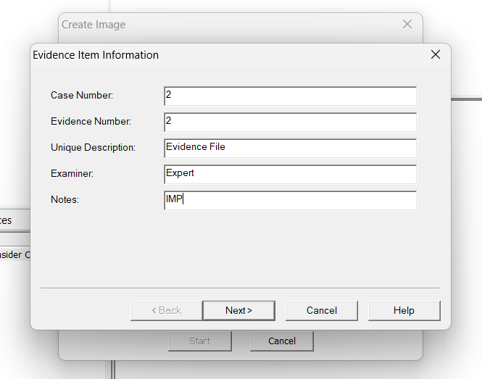

**Step 8:** After Click on Next Don't change anything just add the filename and Destination Folder

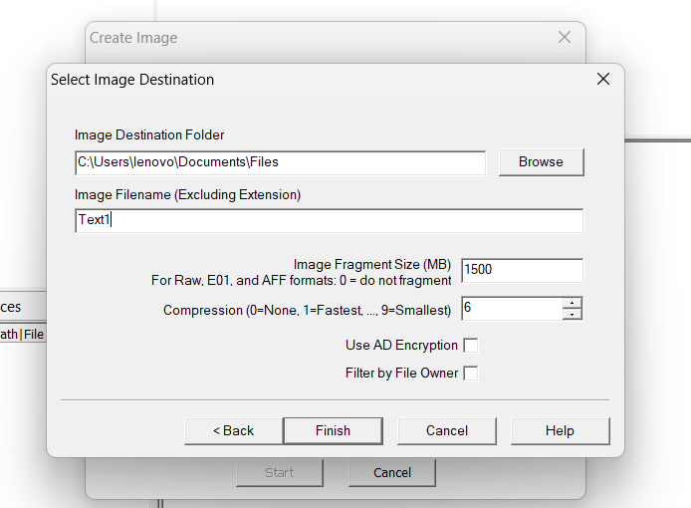

**Step 9:** After **Finish** we can see the below page

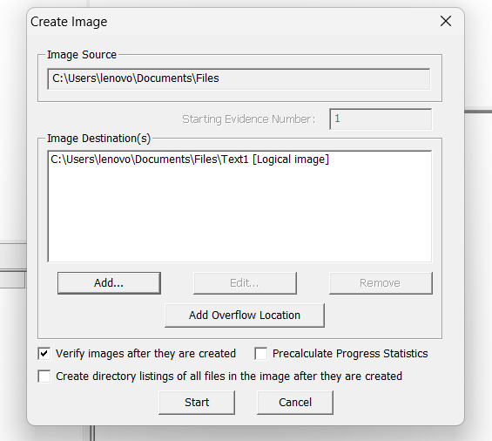

**Step 10:** Now click on the Start to copy the document

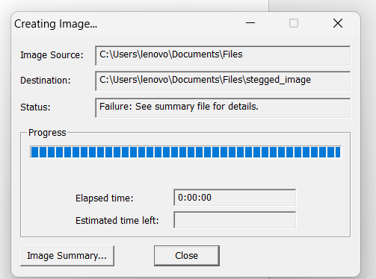

**Step 11:** Now the new popup will appear where we can verify the HASH values

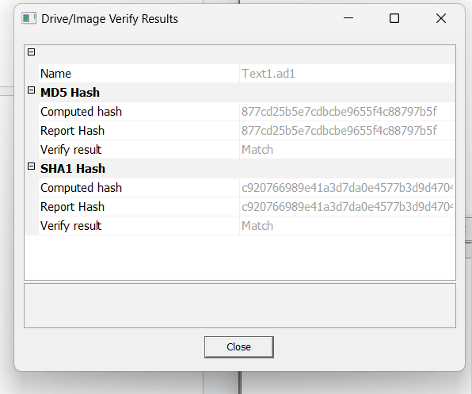

**Step 12:** We can see that the folder file copied on given location

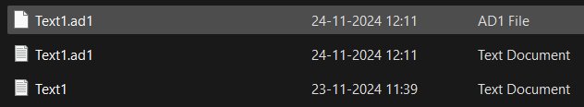

In that file we can see the details of the folder

