Practical No. 7

MySQL Backup and Restore using Python

**Q.1]** Implement back and restore for MySQL using Python.

**Database:**

CREATE DATABASE IF NOT EXISTS studentrepo;

USE studentrepo;



CREATE TABLE IF NOT EXISTS students (

id INT AUTO_INCREMENT PRIMARY KEY,

name VARCHAR(100),

age INT,

class VARCHAR(50),

city VARCHAR(100),

phoneno VARCHAR(20),

email VARCHAR(100)

);

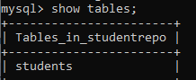

INSERT INTO students (name, age, class, city, phoneno, email) VALUES

('John Doe', 20, 'Physics', 'New York', '555-1234', 'johndoe@example.com'),

('Jane Smith', 22, 'Computer Science', 'Los Angeles', '555-5678', 'janesmith@example.com'),

('Sam Brown', 19, 'Mathematics', 'Chicago', '555-8765', 'sambrown@example.com'),

('Lucy Green', 21, 'Biology', 'Houston', '555-4321', 'lucygreen@example.com'),

('Tom White', 23, 'Chemistry', 'San Francisco', '555-3456', 'tomwhite@example.com');

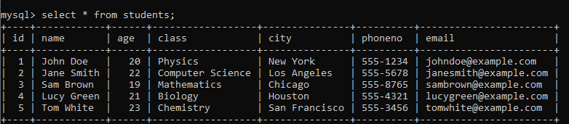

**Code:**

import os

MY_SQL_PATH = "C:/Program Files (x86)/MySQL/MySQL Server 5.5/bin"

def backup (user, password, database_name, backup_path, backup_file_name):

command = f"mysqldump -u{user} -p{password} {database_name} > {backup_path}/{backup_file_name}"

os.chdir(MY_SQL_PATH)

os.system(command)

print("Database Backup Successful")

def recovery(user, password, database_name, backup_path, backup_file_name):

command = f"mysql -u{user} -p{password} {database_name} < {backup_path}/{backup_file_name}"

os.chdir(MY_SQL_PATH)

os.system(command)

print("Database Recovery successful")

print("Select Operation: \n1. Backup\n2. Recovery")

operation=int(input("Enter operation: "))

if operation==1:

backup(

input("\nEnter username: "),

input("Enter password: "),

input("Enter Database Name: "),

input("Enter Backup Path: "),

input("Enter Backup Name: "),)

elif operation==2:

recovery(input("\nEnter username: "),

input("Enter password: "),

input("Enter Database Name: "),

input("Enter Backup Path: "),

input("Enter Backup Name: "),)

else:

print("Invalid Operation")

#C:/Users/student/Documents/MYSQLBackup

**Output:**

**Backup the database before dropping**

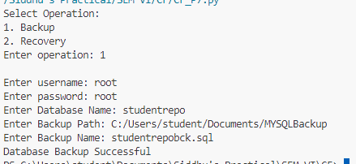

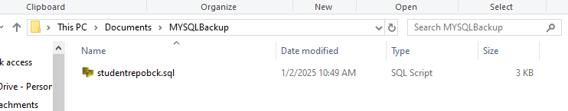

**Dropping the database**

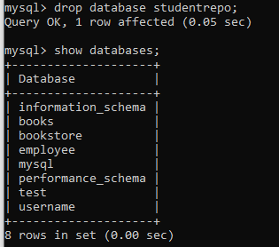

**Restoring the database**

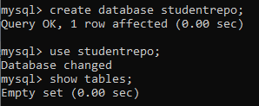

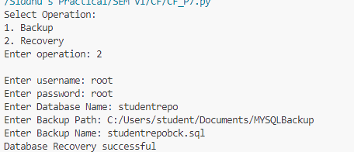

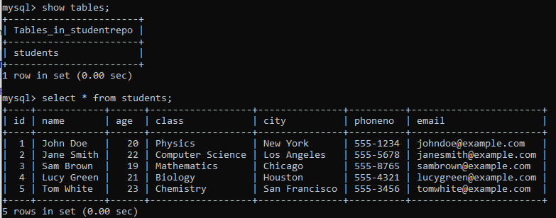

Backup and Restore using DriverImage XML

**Q.1]** Use DriveImage XML tool to do backup and restore on VHD

**Steps:**

1. Install DriverImage XML
2. Open Disk Management
3. Click Action > Create VHD
4. Select Location and size
5. Click Initialize Disk 1 by right click it

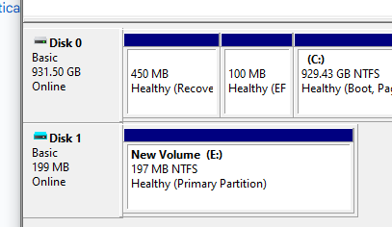

1. Right click unallocated space and Create a simple volume
2. **IMPORTANT: Select MBR as option**

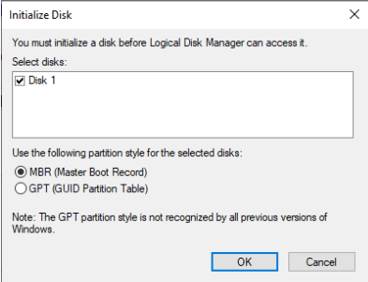

1. Then default steps
2. Create a text file in newly created file



1. Open the software
2. Click backup
3. Choose E drive (or that letter you assigned)

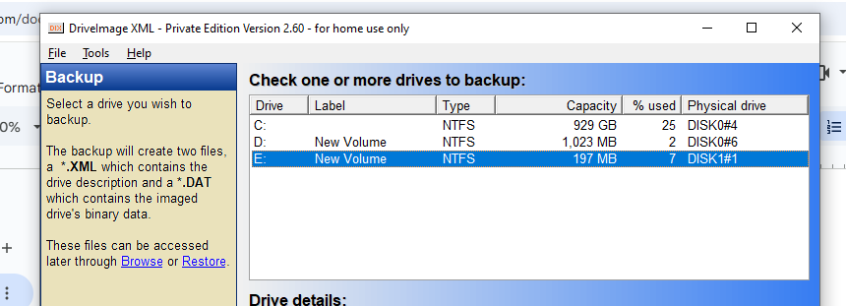

1. Click next

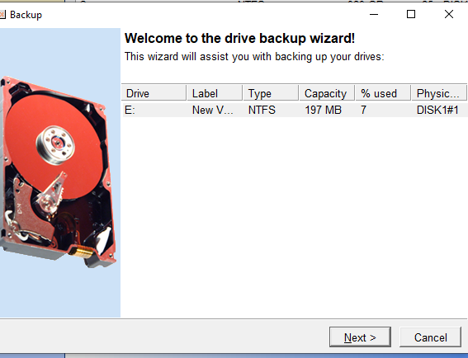

1. Click next

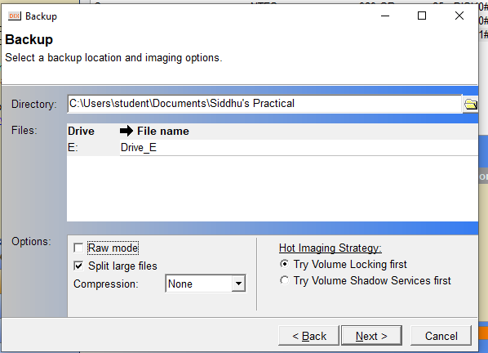

1. Now the delete everything in E Driver
2. Open software, Click restore

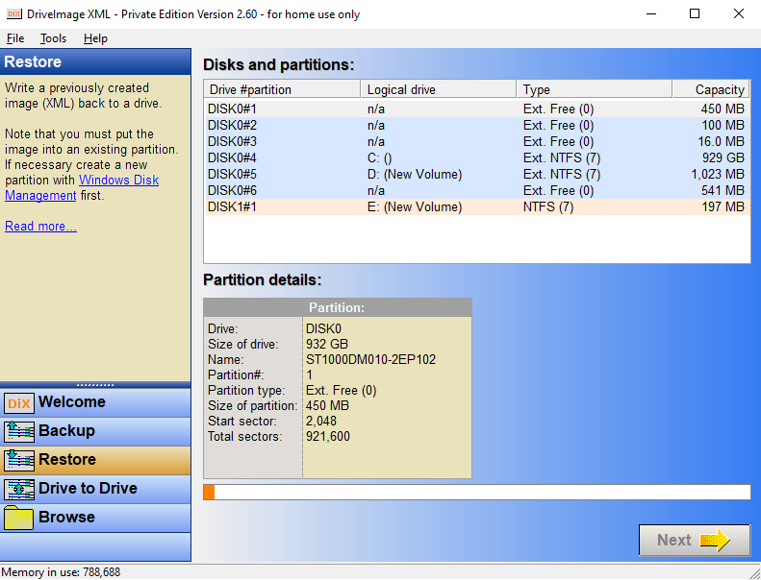

1. Select E Driver
2. Select backup.xml location

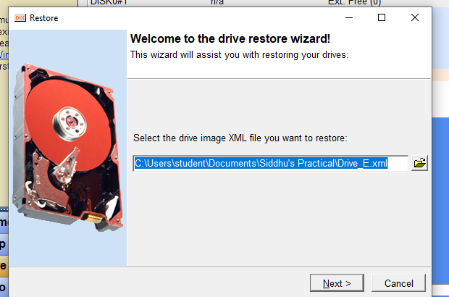

1. Select E Driver

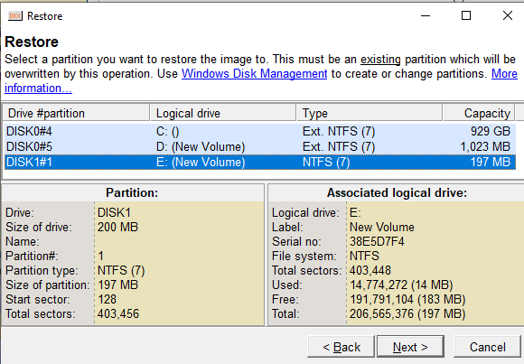

1. Click next

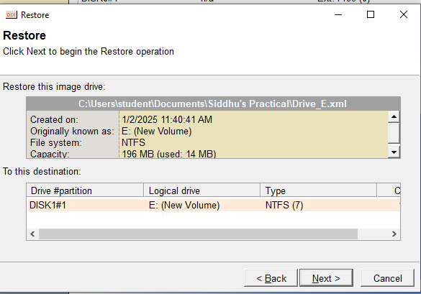

1. Click next and confirm

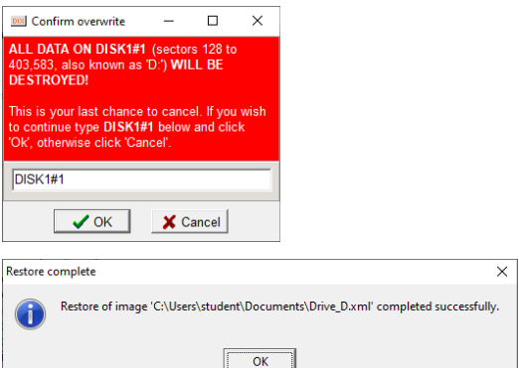

1. Now the drive will be restored

