# **PRACT 2.BUse Cain and Abel for cracking Windows account password using Dictionary attack and to decode wireless network passwords.**

1. Install Cain &amp; Abel from a trusted website. The file will contain a password to

extract. Use the password to extract the file and start the setup.

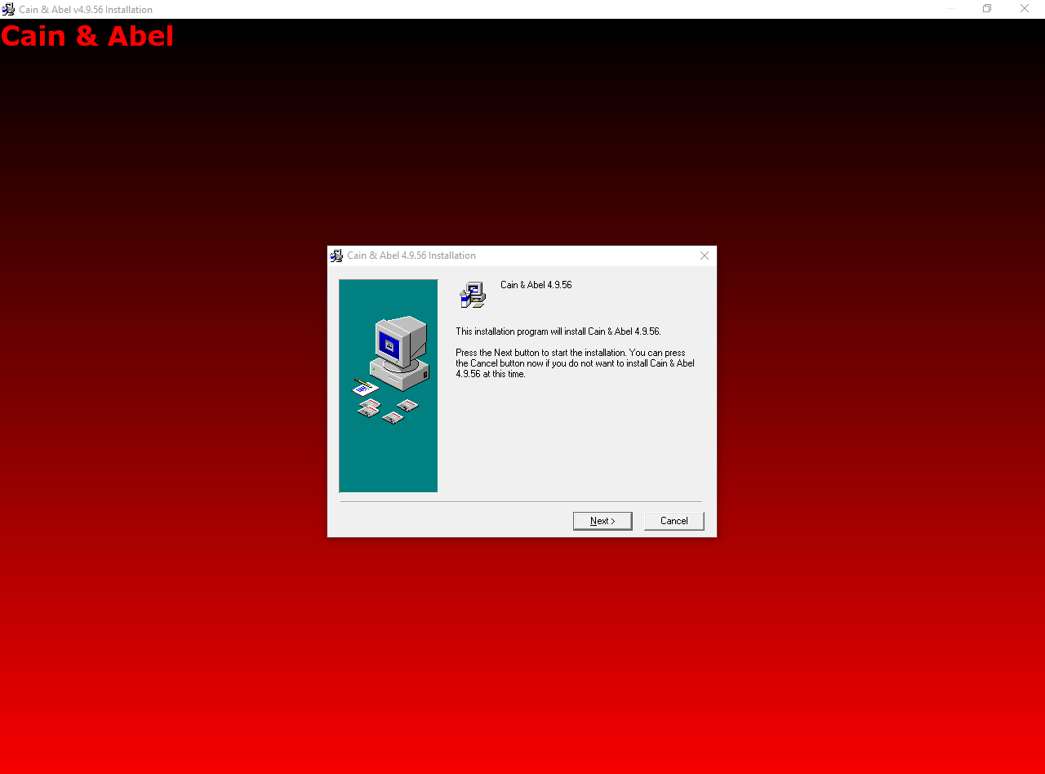

2. The setup will look like this once opened. Keep clicking on Next until the

installation occurs.

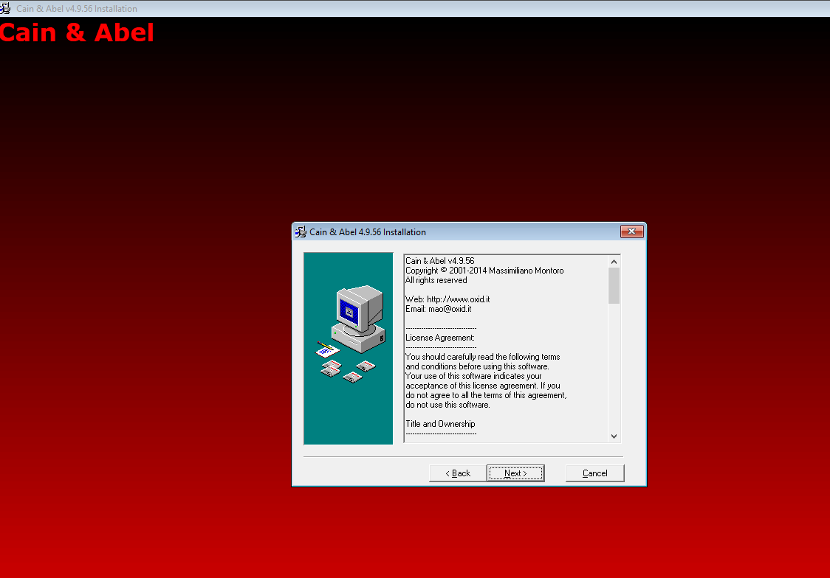

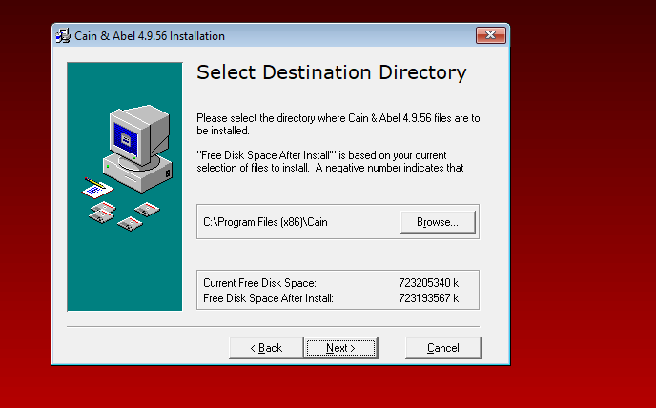

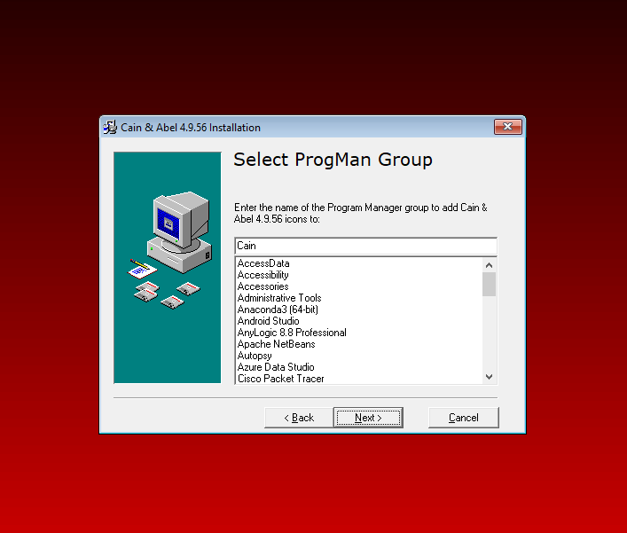

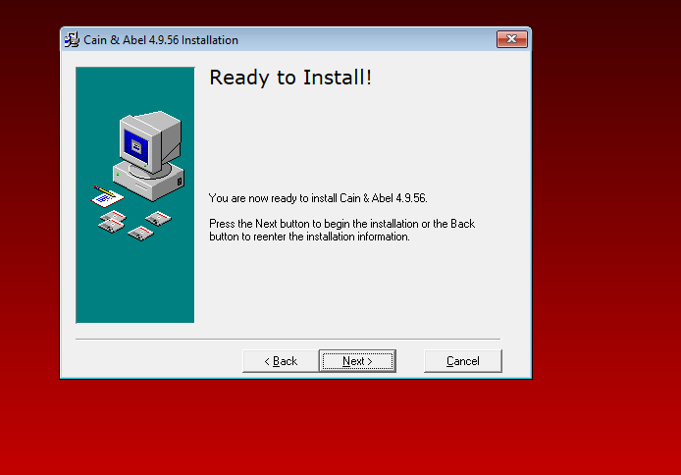

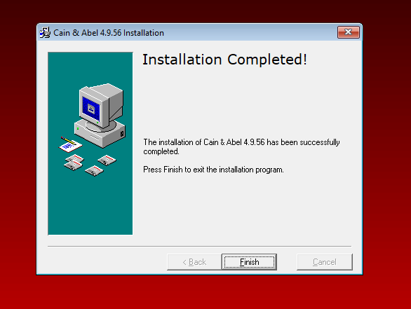



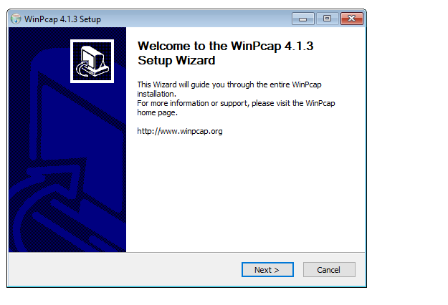

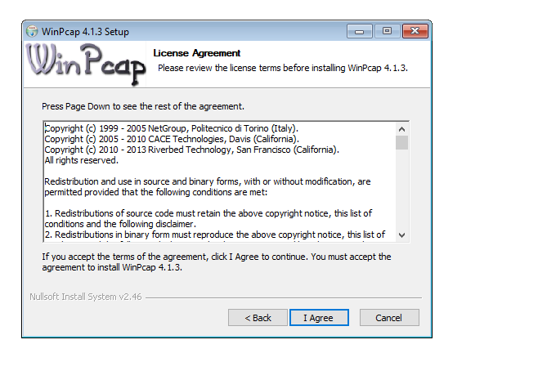

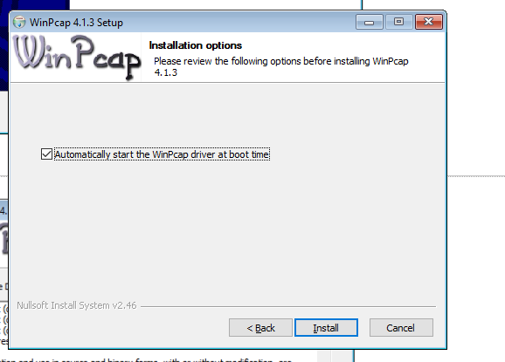

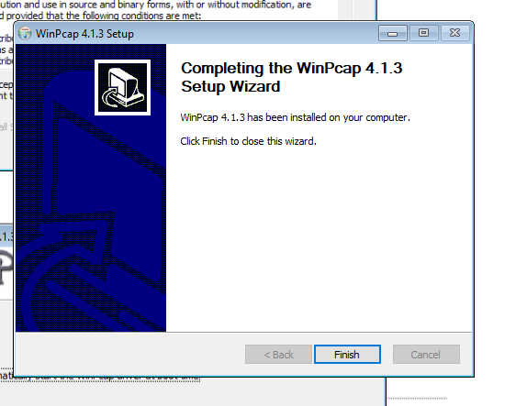

4. The main application by default looks like this.

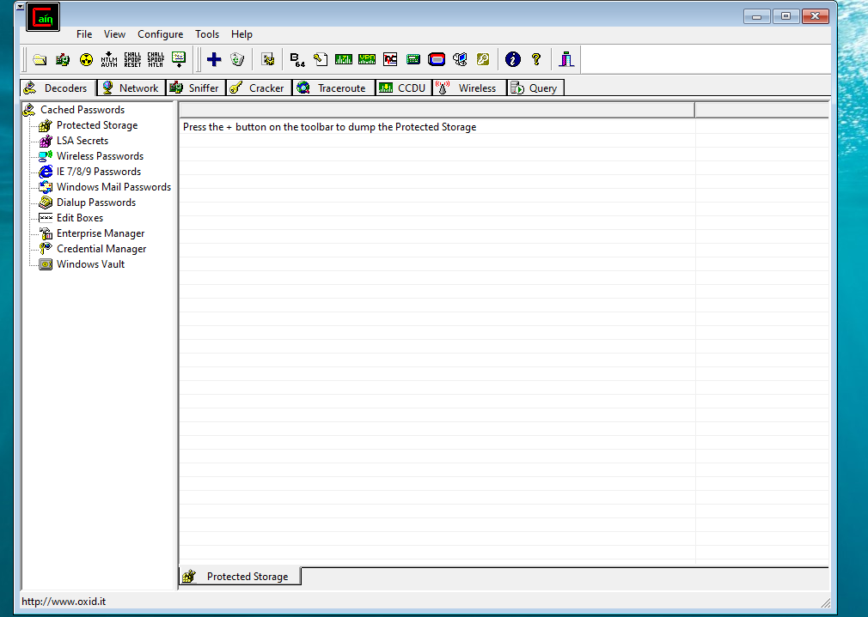

5. In the menu bar, there will be several icons displayed. Among them, there is an icon

for a Hash Calculator as shown in the screenshot below. Click on it.

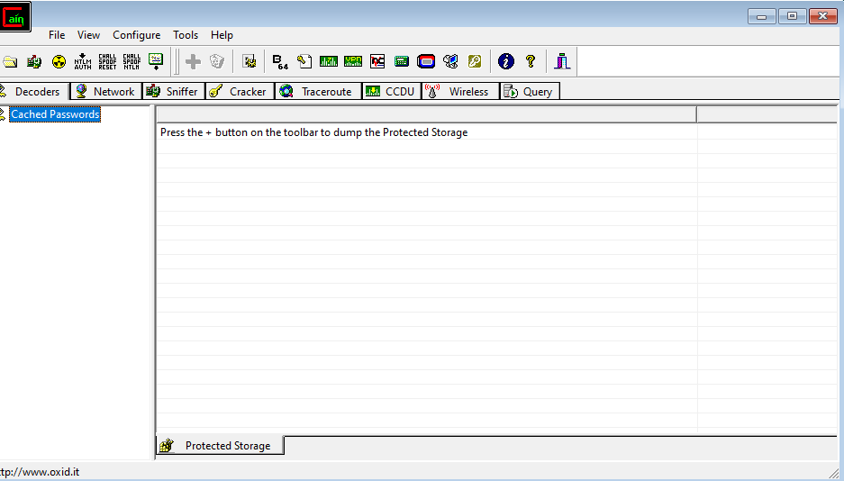

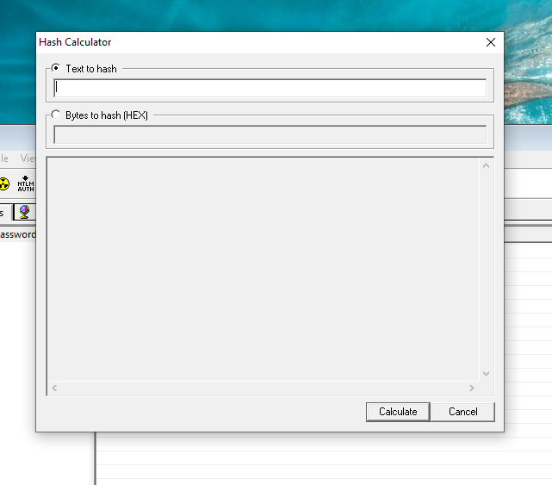

6. A dialog box will open where the user has to give some text input and the output

will be the hash value.

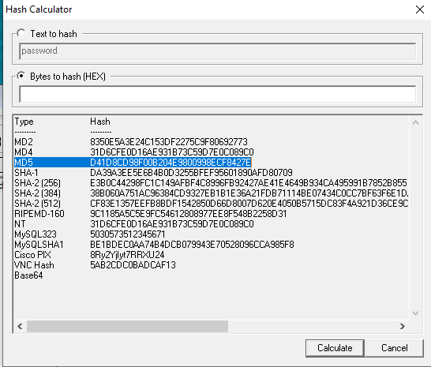

7. Here the example text being used is ‘password’. Type this into the input field and

let the software generate the hash values by clicking on ‘Calculate’.

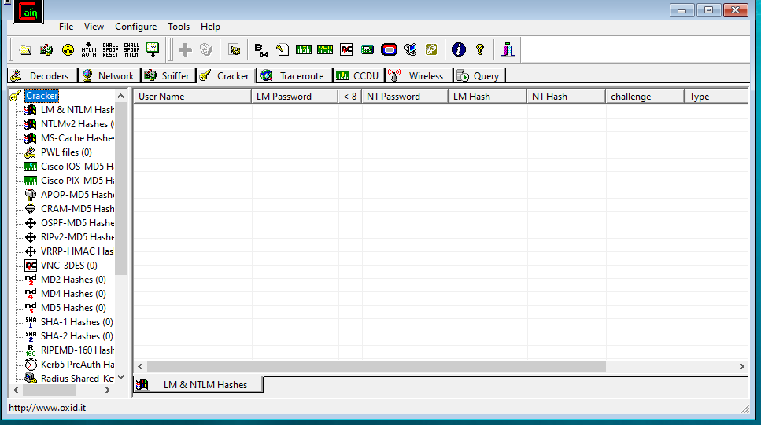

**9. Copy this hash value into the computer.**

**10. Now in the Cain application, go to the Cracker tab and click on the MD5 hashes (0)**

**option in the sidebar menu.**

**11. Click on MD5 Hashes in the top table title and click on ‘+’ on the toolbar to add a**

**new MD5 Hash value.**

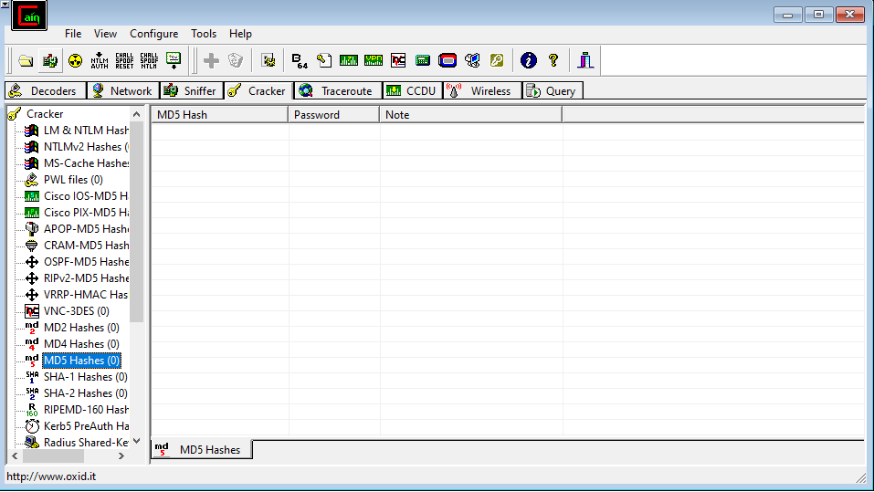

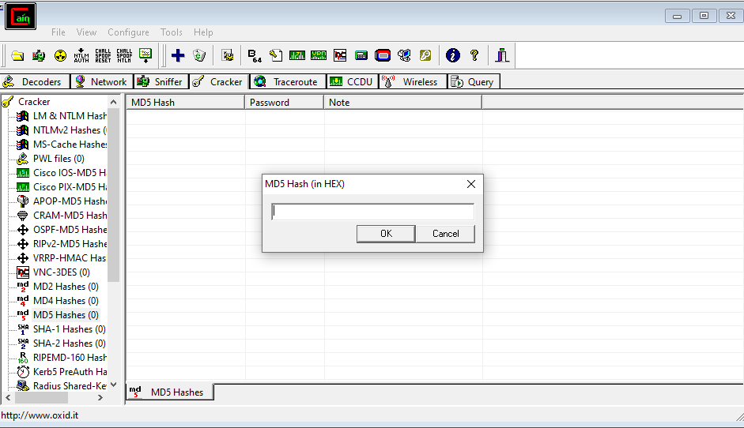

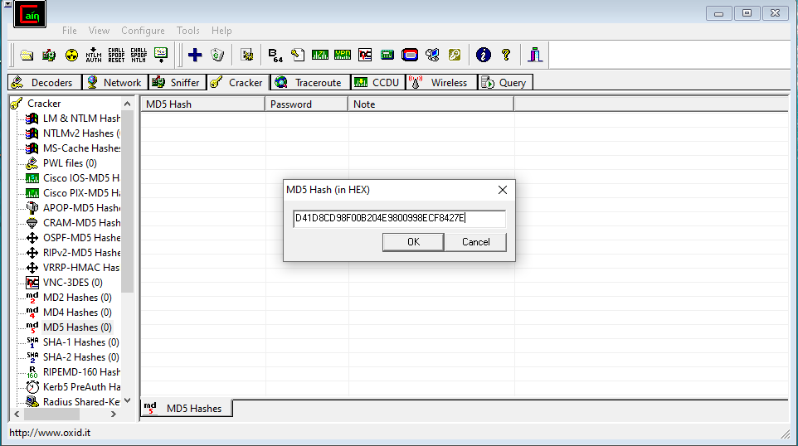**14. Right-click on the entry that was just added and click on the ‘Dictionary Attack’**

**option.**

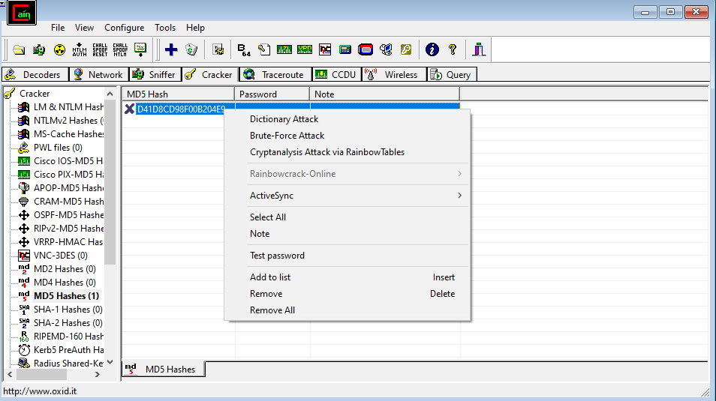

**15. A new dialog box will open.**

**16. Since it is a dictionary attack, there needs to be some word list source to scour**

**through passwords and find a match for the hash.**

**17. Right-click on the Dictionary area and choose ‘Add to list’ to use a reference to a**

**Word list.**

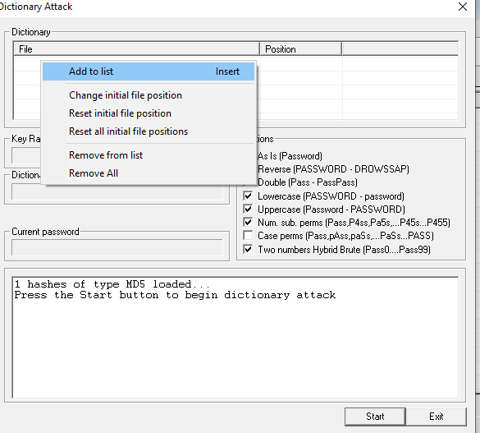

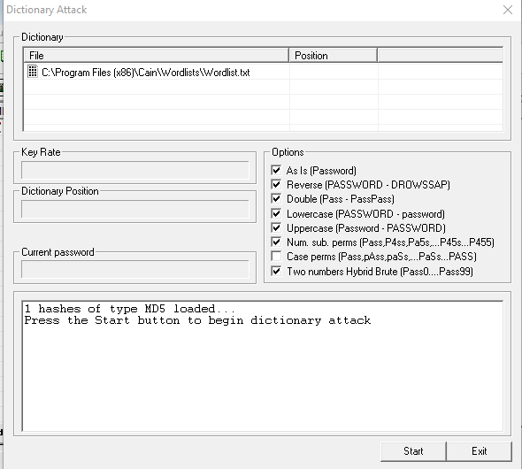

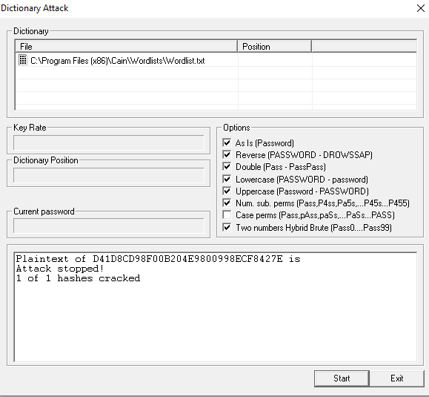

**21. Start the Dictionary attack and wait until it is over. The progress is shown on the**

**dictionary position section.**

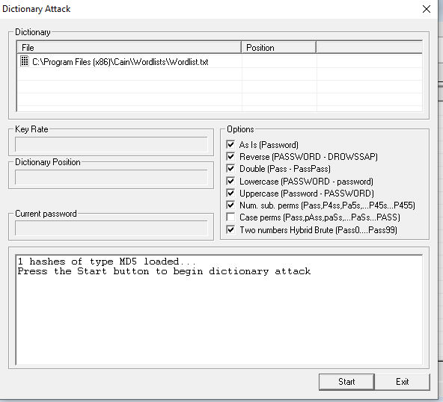

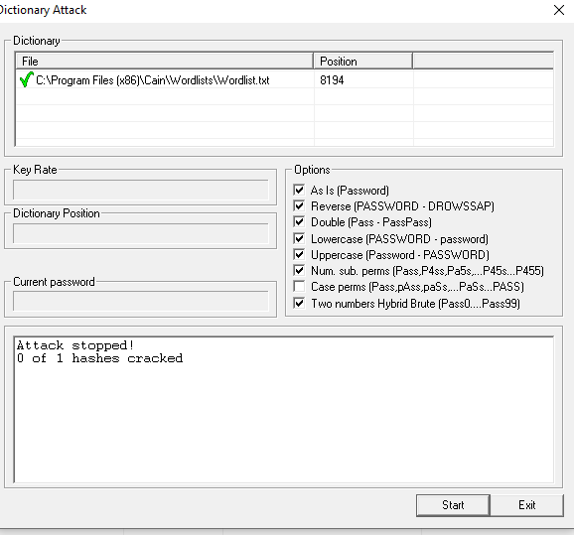

22. The dictionary attack is now complete and the original password is retrieved.