Forward: This is a short report presenting the figures requested in the various questions, and with short explanation of the procedures that I used to get them. None of figures in  
# Question 1&2 is requested to presented in the report, so only the question-solved codes in the python file are finished, and start straightforward from Question3.

# Question 3 is about the plot of a single pulse (i.e., the row of csv file), as requested, my plotting is as Figure 1:

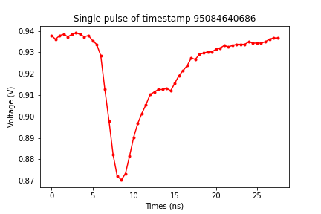

Figure 1. The plot of a single pulse

As the title of Figure 1 shows, this is a single pulse of timestamp 95084640686, which is the pulse of the 1st row (or should be 0th row in python’s language) of our data file. I have already plotted, added labels and title, display and save in the python code.

There are a total of 1000 rows in the csv data file, I have tested the plotting of rows other than the 0th row as well and it works well (the plotting test section has remained comment in the python file). But since Question 3 only asked us to included “a single pulse”, here I would only choose the 1st row (0th in python) as the presenting plot for this question, as demonstration.

The procedure: I first use len function to get the row and column numbers of data file. Then numpy function to load text, and get the data in array, I transpose it to get the correct row and column relation after, and use for loop to create the array for 0.5 ns intervals time for x-axis, also for loop by row and column number got previously in getting voltage transfer values in array. Lastly using plot function to plot and set the figure.

# Question 4 is about Baseline correction, I have finished all the requests as in the python codes, and none of figure is requested to include in the report.

# Question 5, repeat Question above, showing the values for a pulse with the baseline correction. Include this figure in my report as Figure 2 :

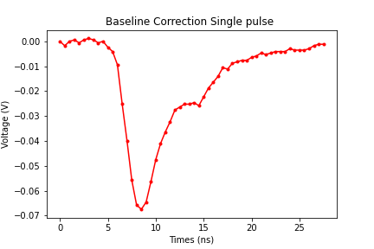

Figure 2. Baseline corrected single pulse

Here I still choose the same single pulse as I chose in Question 3. To compare them we can find out it achieve the baseline correction successfully. Also, in the python code I have tested the other rows that was also successful, and left the test section as comment in the python file.

The procedure: ﻿Find the mean value of 1st 10 values each pulse using 2 for loops by the row and column numbers found previously, also another 2 for loops to subtract that mean value each pulse. Both using 2 for loops since the data array is in 2 dimensions, then achieve the baseline correction and plot by plot function.

# In Question 6,  
The procedure, for each pulse in our data csv file, two distributions were asked to include in the report.

The 1st one using numpy.min() to find (baseline corrected) sensor reading maximum value. The 2nd one using numpy.sum() to add up the (baseline corrected) sensor reading values .

Then, using plot histogram function, I present my result of the sensor reading maximum value and the sum value of all sensor reading values as Figure 3 (a) and (b), in two plots:

|  |  |
| --- | --- |
| (a) | (b) |

Figure 3. Two distributions of all pulses. (a) Distribution of the baseline corrected sensor reading maximum value for each pulse. (b) Distribution of the sum up values of baseline corrected sensor reading values for each pulse.

Compare these two distributions in the histogram, their similarities or differences:  
Refer to Figure 3, there is a significant similar pattern, which is, they all show a trend of exponentially development in a certain range. They are in a slightly different range of showing exponent function. For max value is in the range from around -2 to 0, while the sum value is in range around -10 to 0.

The amplitude of the pulse is related to the maximum value of the detected signal voltage and the number of values different from the baseline to the length of the signal, which means the max value in Figure 3 (a) indicates a typical detectable enough pulse signal strength (~300 counts in the peak) voltage pulse shape, a better quality resolution for detection, as exponentially spread in 2 values range compare to 10 range of sum values.

The total area enclosed by the pulse (after baseline correction) corresponds to the energy deposited in the detector, which means the energy resolution we got here is not as good as the pulse amplitude but acceptable, as exponentially spread in 10 values range compare to around 2 for max.