**Methods**

Molecular dynamics (MD) simulations of two complexes PPARg-BBR and PPARg-PIO were performed by the LARMD server [1], which were performed using the AMBER 16 software package with the ff14SB force field. Each complex was immersed in a cubic box of TIP3P water model with an 8.0 Å minimum solute-wall distance. Na+ or Cl- ions were added to neutralize each complex system. The complex systems were optimized before the simulation as follows. First, the movement was allowed only for hydrogen atoms. Next, the side chains were relaxed. Finally, all atoms were permitted to move freely. In each stage, energy minimization was executed by the steepest descent method for the first 1000 steps and the conjugate gradient method for the subsequent 2000 steps. After that, the systems were set up to obtain stable MD trajectories. Complex systems were gradually heated from 10 K to 300 K in 200 ps and more than 500ps equilibrating calculation was executed at 1 atm and 300 K with applying periodic boundary conditions in the NPT ensemble to avoid edge effects. The 10ns MD simulation of each system was performed, the snapshots from each simulation frame were used to detect hydrogen bonds. The 2D ligand-protein interaction was analyzed and visualized by LIGPLOT program (LigPlot+ v2.2) [2]

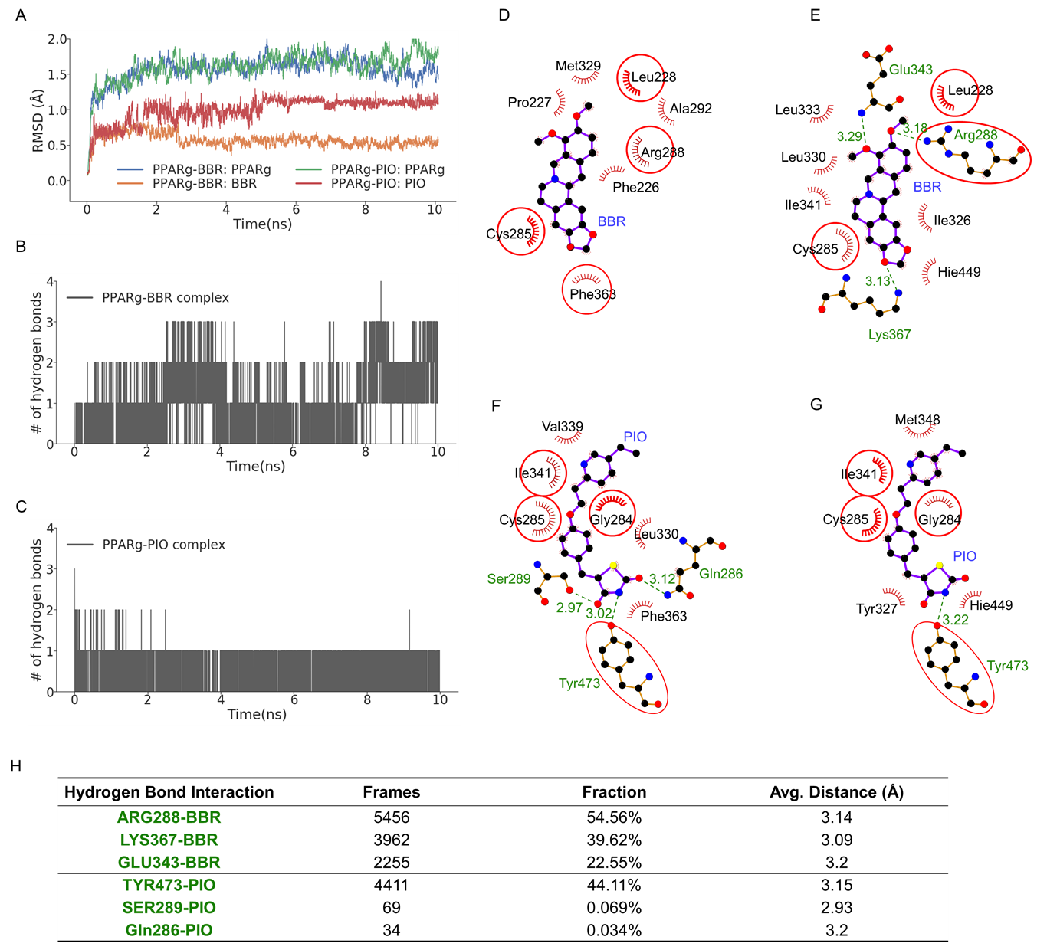

**Fig.4 The Molecular Dynamics Results for PPARg-BBR and PPARg-PIO Complexes.** (A). the RMSD values of the backbone (Cα atoms) of receptor proteins and heavy atoms of the ligands during the 10-ns simulation. (B) and (C): the number of hydrogen bonds during the simulation for the PPARg-BBR and PPARg-PIO complex, respectively. (D) and (E) are the hydrophobic and hydrogen bond contacts for the PPARg-BBR conformations in the initialization and equilibrium stage, respectively. The three hydrogen bond interactions have been observed in the equilibrium stages. The RMSD of the two ligands in (D) and (E) is 0.56 Å, and 1.63 Å for the two receptors. (F) and (G) are the hydrophobic and hydrogen bond contacts for the PPARg-PIO conformations in the initialization and equilibrium stage, respectively. The RMSD of the two ligands in (F) and (G) is 1.70 Å, and 1.19 Å for the two receptors. (H). The statistics of the hydrogen bond interactions for the two complexes. The red circles in (D), (E), (F), and (G) are the residues with equivalent side chains.

**Results**

The two systems took 2 ns to stabilize during the simulation (**Fig 4A**). It is clear that PPARg-PIO complex is more flexible than PPARg-BBR, maybe because BBR has fewer number of the rotatable bonds than PIO. MD results show that the PPARg-BBR has different binding patterns with respect to PPARg-PIO complex: the Arg-288, Lys-367 and Glu-343 are the major three residues forming hydrogen bond interactions with BBR, while Tyr-473 is the major residue forming hydrogen bond interactions with PIO **(Fig 4)**, but both of the two ligands have hydrophobic interactions with Cys-285 and Phe-363.

References

[1]. Yang, J. F.; Wang, F.; Chen, Y. Z.; Hao, G. F.; Yang, G. F., LARMD: integration of bioinformatic resources to profile ligand-driven protein dynamics with a case on the activation of estrogen receptor. Brief. Bioinformatics, 2019, Doi: 10.1093/bib/bbz141.

[2]. Laskowski R A, Swindells M B (2011). LigPlot+: multiple ligand-protein interaction diagrams for drug discovery. J. Chem. Inf. Model., 51, 2778-2786. [PubMed id: 21919503]