**Methods to generate the pharmacophore model:**

The three molecules were converted into 3D structures by open-source toolkit Rdkit (version 2021.03.1) [1], for each molecule, the 3D conformer with lowest energy was selected. After that the three molecules were aligned and o generate the pharmacophore model by PharmaGist webserver [2]. The model with highest score was selected, which the compounds c is the pivot molecule. This model contains 4 pharmacophore features: 2 aromatic feature, 1 HBA, 1 positive feature. The pharmacophore feature pairwise distances were measure by Pymol [3], and the visualizations of the pharmacophore was performed by the ZINCPharmer.

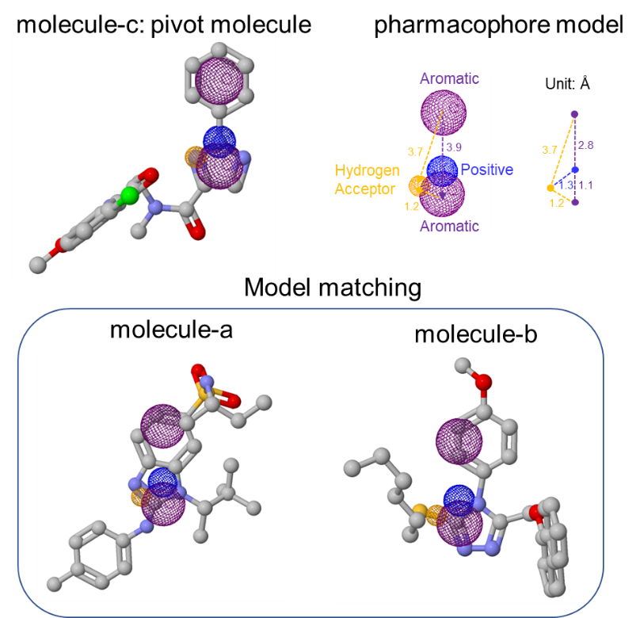

1. RDKit: Open-source cheminformatics; http://www.rdkit.org
2. Schneidman-Duhovny D, Dror O, Inbar Y, et al. PharmaGist: a webserver for ligand-based pharmacophore detection[J]. Nucleic acids research, 2008, 36(suppl_2): W223-W228.
3. DeLano W L. Pymol: An open-source molecular graphics tool[J]. CCP4 Newsletter on protein crystallography, 2002, 40(1): 82-92.
4. Koes D R, Camacho C J. ZINCPharmer: pharmacophore search of the ZINC database[J]. Nucleic acids research, 2012, 40(W1): W409-W414.