K-mer:15 K-mer:17

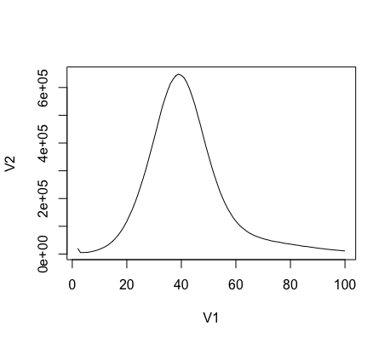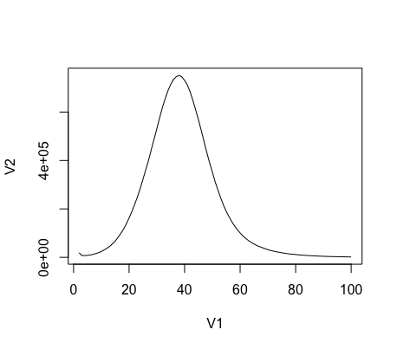

K-mer:19 K-mer:21

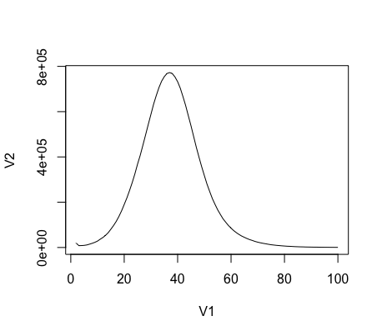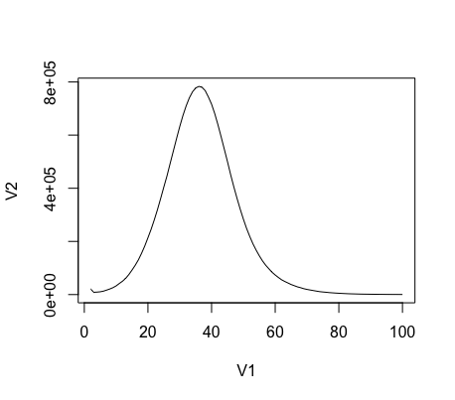

|  |  |  |  |  |
| --- | --- | --- | --- | --- |
|  | K-mer:15 | K-mer:17 | K-mer:19 | K-mer:21 |
| Single copy# | 2:98 | 2:80 | 2:73 | 2:71 |
| Total # | 2904 | 2715 | 2613 | 2503 |
| Genome size | 20968210 | 20962742 | 21004059 | 21086449 |
| Single/total | 0.0234124 | 0.02348538 | 0.0255376 | 0.02626937 |