各种IC封装形式图片
  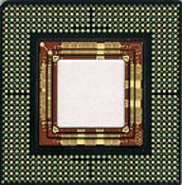 | BGA  Ball Grid Array
  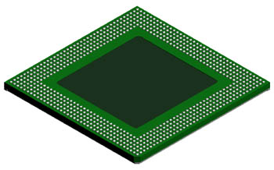 | EBGA 680L  详细规格
  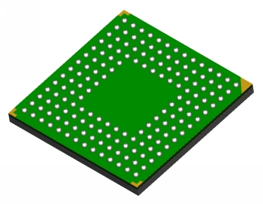 | LBGA 160L  详细规格
  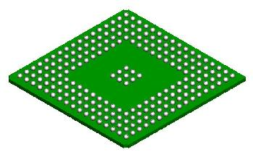 | PBGA 217L  Plastic Ball Grid Array  详细规格
  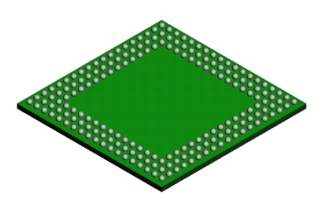 | SBGA 192L  详细规格
  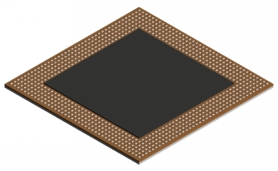 | TSBGA 680L  详细规格
  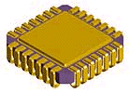 | CLCC  详细规格
  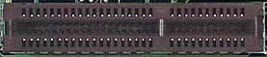 | CNR  Communication and Networking Riser Specification Revision 1.2  详细规格
  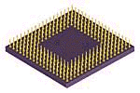 | CPGA  Ceramic Pin Grid Array
  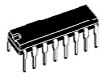 | DIP  Dual Inline Package  详细规格
  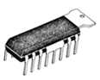 | DIP-tab  Dual Inline Package with Metal Heatsink
  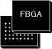 | FBGA
  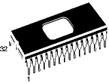 | FDIP
  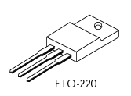 | FTO220
  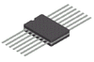 | Flat Pack
  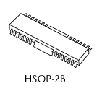 | HSOP28
  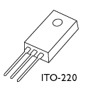 | ITO220
  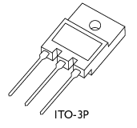 | ITO3p
  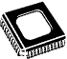 | JLCC
  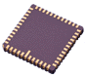 | LCC
  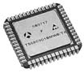 | LDCC
  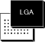 | LGA
  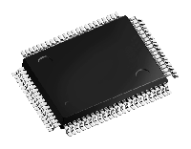 | LQFP
  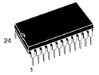 | PCDIP
  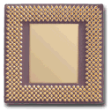 | PGA  Plastic Pin Grid Array  详细规格
  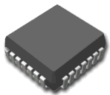 | PLCC  详细规格
   | PQFP
  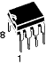 | PSDIP
  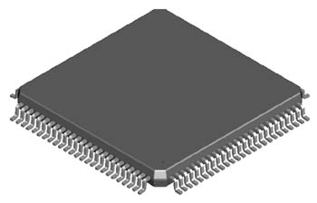 | LQFP 100L  详细规格
  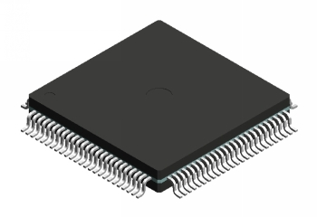 | METAL QUAD 100L  详细规格
  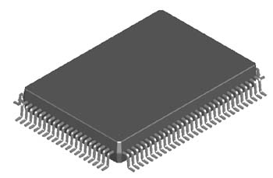 | PQFP 100L  详细规格
  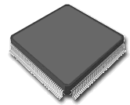 | QFP  Quad Flat Package
   | SOT143
   | SOT220
  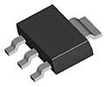 | SOT223
  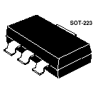 | SOT223
  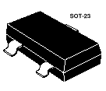 | SOT23
  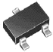 | SOT23/SOT323
   | SOT25/SOT353
  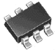 | SOT26/SOT363
  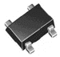 | SOT343
   | SOT523
  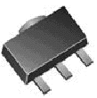 | SOT89
  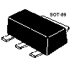 | SOT89
  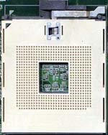 | Socket 603  Foster
  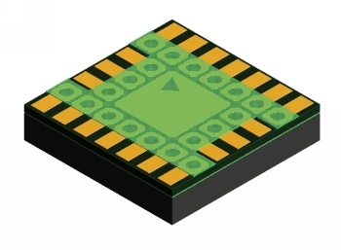 | LAMINATE TCSP 20L  Chip Scale Package  详细规格
  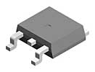 | TO252
  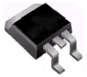 | TO263/TO268
  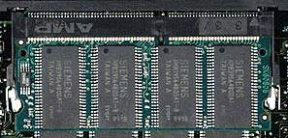 | SO DIMM  Small Outline Dual In-line Memory Module
  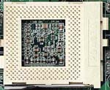 | SOCKET 370  For intel 370 pin PGA Pentium III & Celeron CPU
  SOCKET 423
  For intel 423 pin PGA Pentium 4 CPU
  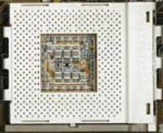 | SOCKET 462/SOCKET A  For PGA AMD Athlon & Duron CPU
  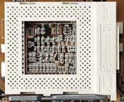 | SOCKET 7  For intel Pentium & MMX Pentium CPU
  QFP
  Quad Flat Package
  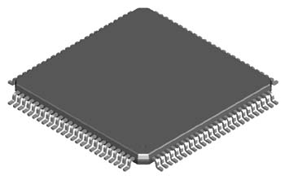 | TQFP 100L  详细规格
   | SBGA
  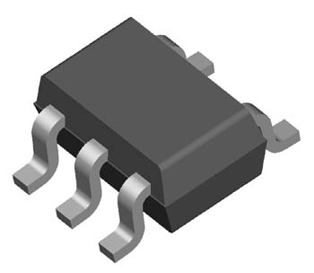 | SC-70 5L  详细规格
   | SDIP
  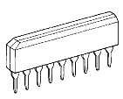 | SIP  Single Inline Package
  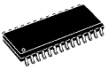 | SO  Small Outline Package
  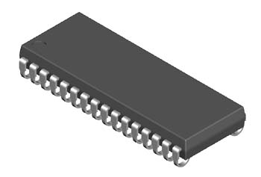 | SOJ 32L  详细规格
  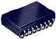 | SOJ
  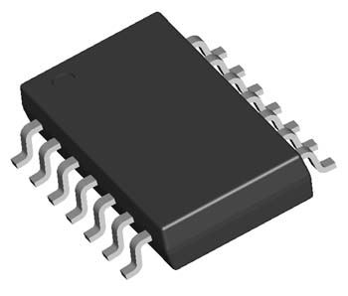 | SOP EIAJ TYPE II 14L  详细规格
  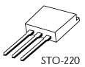 | SOT220
  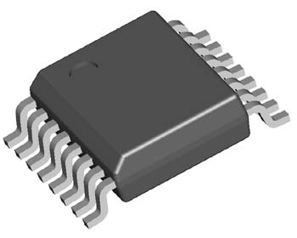 | SSOP 16L  详细规格
  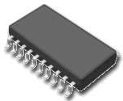 | SSOP
  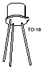 | TO18
  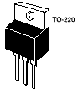 | TO220
  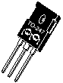 | TO247
  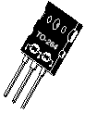 | TO264
   | TO3
  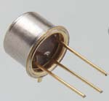 | TO5
  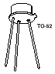 | TO52
  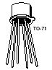 | TO71
  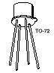 | TO72
  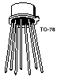 | TO78
  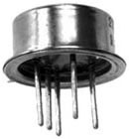 | TO8
  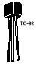 | TO92
  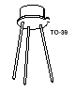 | TO93
  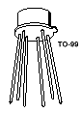 | TO99
  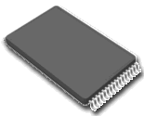 | TSOP  Thin Small Outline Package
  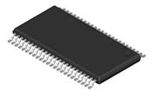 | TSSOP or TSOP II  Thin Shrink Outline Package
  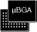 | uBGA  Micro Ball Grid Array
  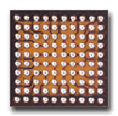 | uBGA  Micro Ball Grid Array
  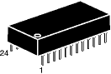
  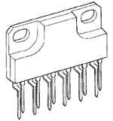 | ZIP  Zig-Zag Inline Package
  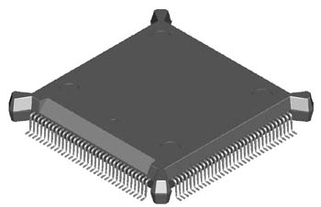 | BQFP132
  TEPBGA 288L | TEPBGA 288L  详细规格
  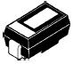 | C-Bend Lead
  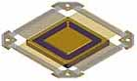 | CERQUAD  Ceramic Quad Flat Pack  详细规格
   | Ceramic Case
  LAMINATE CSP 112L
  Chip Scale Package
  详细规格
  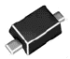 | Gull Wing Leads
  J-STD | J-STD  Joint IPC / JEDEC Standards
  JEP | JEP  JEDEC Publications
  JESD | JESD  JEDEC Standards
  LLP 8La
  详细规格
  PCI 32bit 5V
  Peripheral Component Interconnect
  详细规格
  PCI 64bit 3.3V
  Peripheral Component Interconnect
  详细规格
  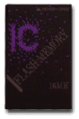 | PCMCIA
   | PDIP
  PLCC
  详细规格
  PS/2 | PS/2  mouse port pinout  详细规格
  SIMM30 | SIMM30  Pinout  详细规格
  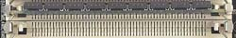 | SIMM30  Single In-line Memory Module
  SIMM72 | SIMM72  Pinout  详细规格
  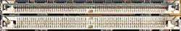 | SIMM72  Single In-line Memory Module
  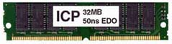 | SIMM72  Single In-line Memory Module
  SLOT 1
  For intel Pentium II Pentium III & Celeron CPU
  SLOT A
  For AMD Athlon CPU
   | SNAPTK
   | SNAPTK
   | SNAPZP

