方法1
1、配置属性-》常规-》输出目录和中间目录
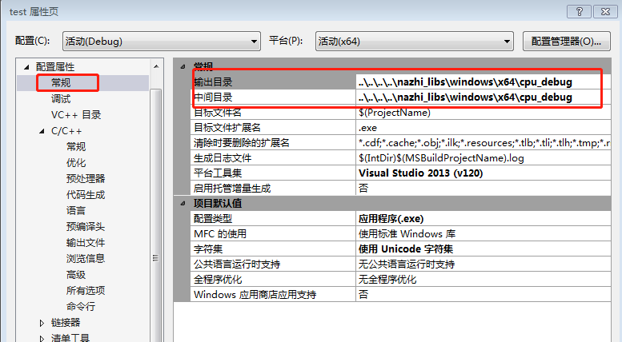
2、配置属性-》调试-》工作目录
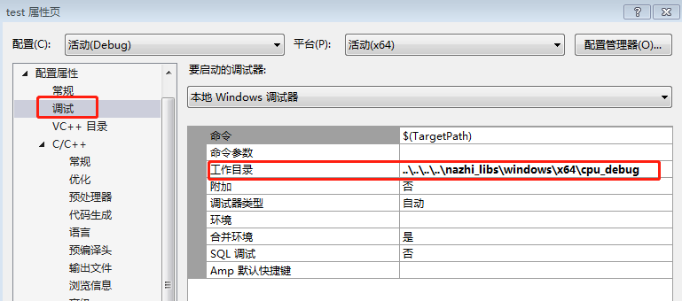
3、配置属性-》c++-》附加包含目录
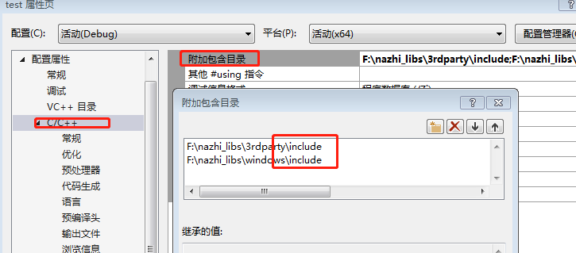
4、项目、属性、链接器、常规、附加库目录：填写附加依赖库所在目录 分号间隔多项
项目、属性、链接器、输入、附加依赖项：填写附加依赖库的名字.lib 空格或分号间隔多项
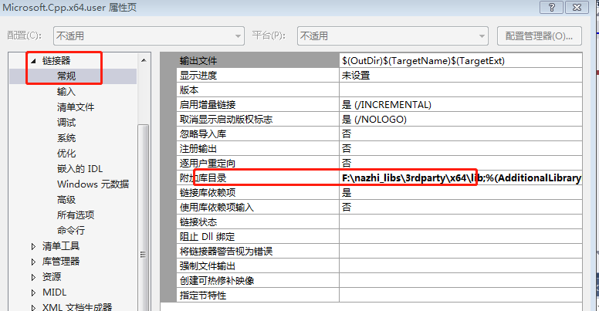

opencv_calib3d320d.lib
opencv_core320d.lib
opencv_dnn320d.lib
opencv_features2d320d.lib
opencv_flann320d.lib
opencv_highgui320d.lib
opencv_imgcodecs320d.lib
opencv_imgproc320d.lib
opencv_ml320d.lib
opencv_objdetect320d.lib
opencv_photo320d.lib
opencv_shape320d.lib
opencv_stitching320d.lib
opencv_superres320d.lib
opencv_video320d.lib
opencv_videoio320d.lib
opencv_videostab320d.lib
方法2
参考
https://blog.csdn.net/jinian2614/article/details/78176704?locationNum=2&fps=1

