Introduction to Software Development
Fall, 2018

Homework one

Instructor Wei Fang

READ INSTRUCTIONS AND FOLLOW CAREFULLY!

Write down your name here: Yi Shen
Write down your email address here: yi.shen@rutgers.edu

Assignment one of three (5% of towards the final course grade)

Instructions

This assignment is due promptly by 11:59:59 PM on September 26, 2018. We will go over answers during the lecture on September 27.

Please write down your answers clearly and carefully.

You need to submit this file to the course’s page on the Blackboard. No email or print submission will be accepted.

Question 1, 2 and3 programs’ have bugs. It is your task to debug and compile. Insert snapshot of your working programs.

Question 4 and 5 are pseudo codes, you don’t need to include your full working codes.

Question 7 and 8, you need to write your completed codes.

This is a Word document. Insert your answers right below the questions.
Q1. What is the exact output of the program below? Indicate a blank space in the output by writing the symbol SP Indicate a blank line in the output. For example n - n, will be written as nSP-SPn

#include <iostream>
int main()
{
int n = 4, k = 2;
cout << ++n << endl;
cout << n << endl;
cout << n++ << endl;
cout << n << endl;
cout << -n << endl;
cout << n << endl;
cout << --n << endl;
cout << n << endl;
cout << n-- << endl;
cout << n << endl;
cout << n + k << endl;
cout << n << endl;
cout << k << endl;
cout << n << k << endl;
cout << n << endl;
cout << "SP" << n << endl;
cout << "SPn" << endl;
cout << "\n" << endl;
cout << "SPnSP*SPnSP=SP"; //CAREFUL!
cout << n * n << endl;
cout << 'n' << endl;
return 0;
}
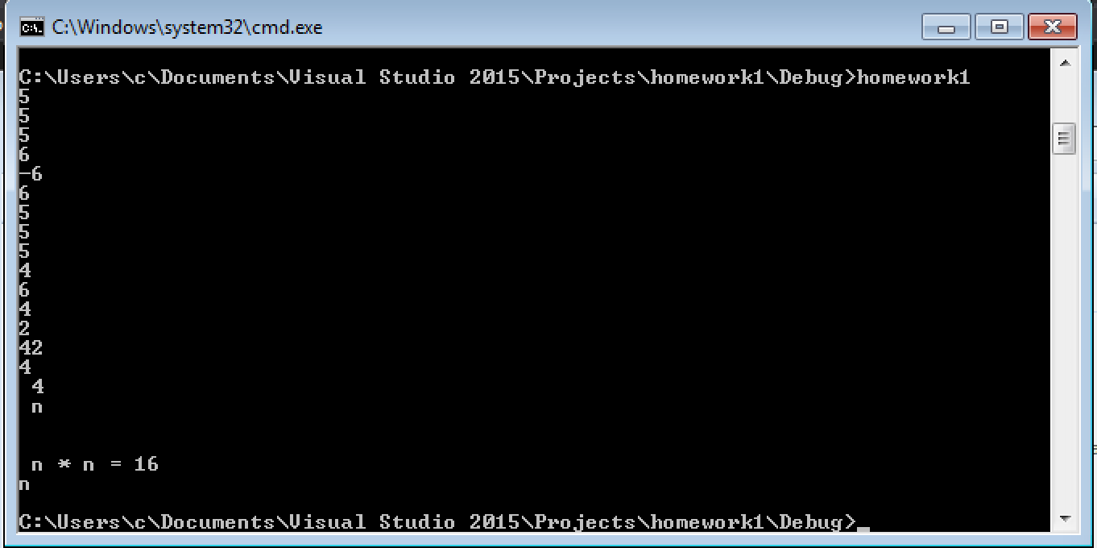
5
5
5
6
-6
6
5
5
5
4
6
4
2
42
4
SP4
SPn

SPnSP*SPnSP=SP16
n

Q2. What is the output of the program below?
#include <iostream>
# include””;
Int main()
{
int n = 3;
while (n >= 0)
{
cout << n * n << endl;
--n;
}
cout << n << endl;
while (n < 4)
cout << ++n << endl;
cout << n << endl;
while (n >= 0){
cout << (n /= 2) << endl;
}
return 0;

}

﻿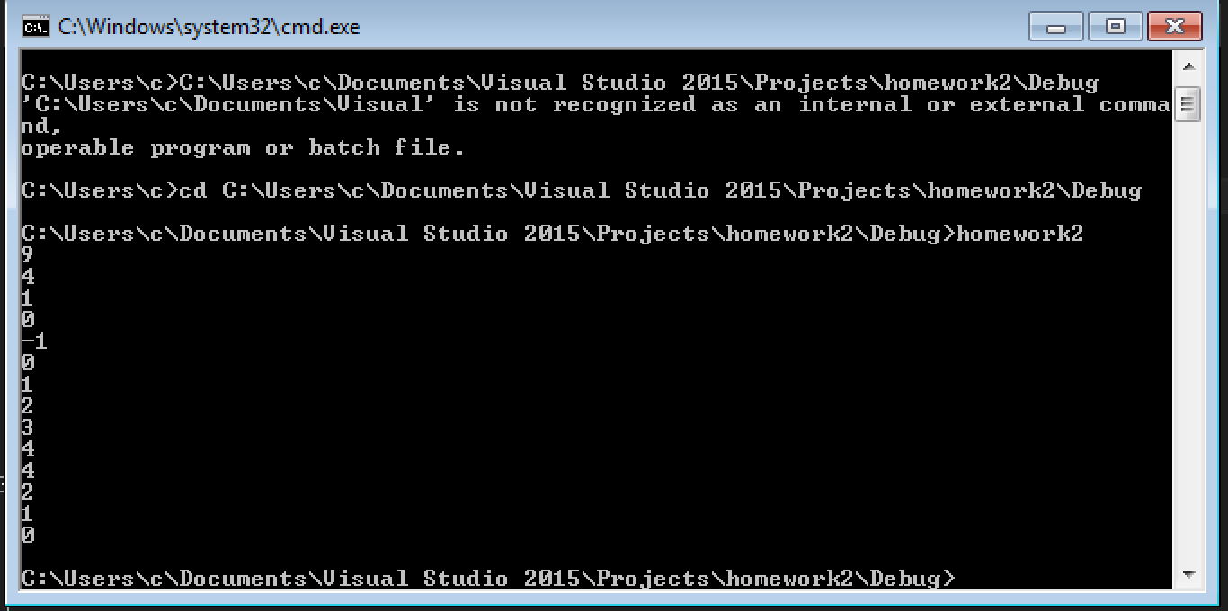

Q3. What is the output of the program below?
#include <iostream>
using namespace std;
int main()
{
int n=0;
cout << (n = 4) << endl;
cout << (n == 4) << endl;
cout << (n > 3) << endl;
cout << (n < 4) << endl;
cout << (n = 0) << endl;
cout << (n == 0) << endl;
cout << (n > 0) << endl;
cout << (n && 4) << endl;
cout << (n || 4) << endl;
cout << (!n) << endl;
return 0;
}

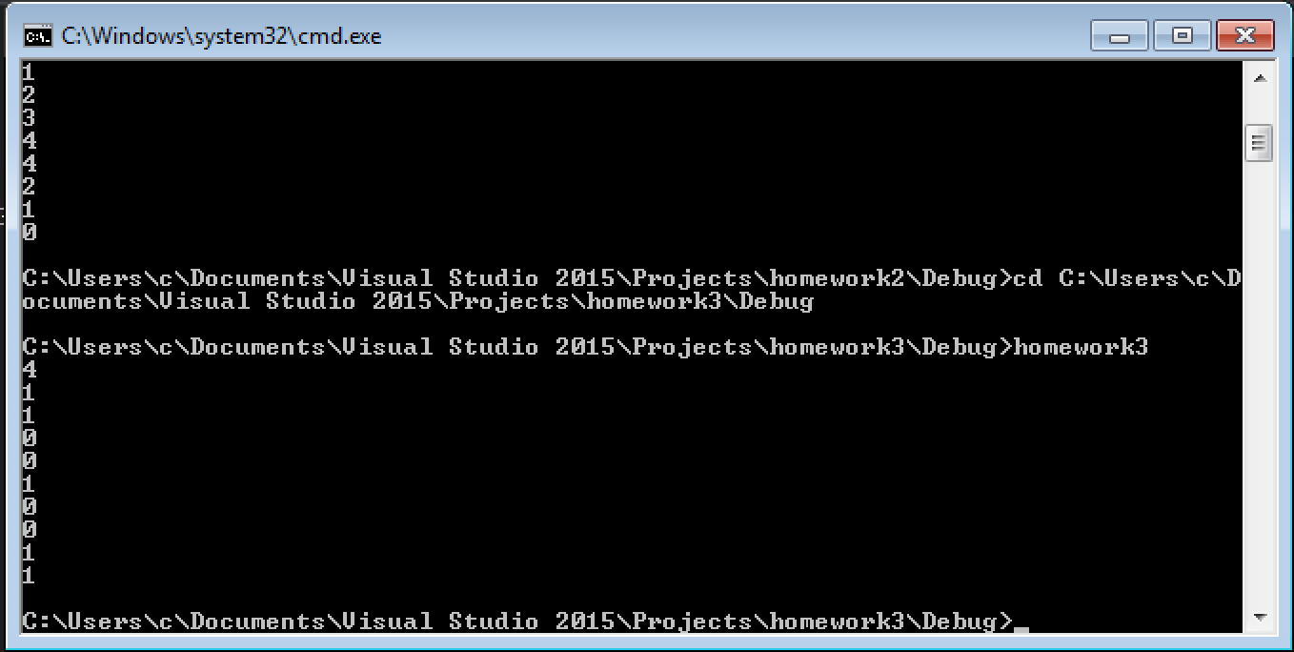

Q4. What is the output when the following code fragment is executed?
int i = 5, j = 6, k = 7, n = 3;
cout << i + j * k - k % n << endl;
cout << i / n << endl;

46
1

Q5. Answer the questions below concerning the following fragment of code.
int n;
cout << "Enter an integer: ";
cin >> n;
if (n < 10)
cout << "less than 10" << endl;
else if (n > 5)
cout << "greater than 5" << endl;
else
cout << "not interesting" << endl;
a. What will be the output of the fragment above if the interactive user enters the integer value 0 ?
b. What will be the output of the fragment above if the interactive user enters the integer value 15 ?
c. What will be the output of the fragment above if the interactive user enters the integer value 7 ?
d. What values for n will cause the output of the fragment above to be "not interesting"?

- less than 10
b. greater than 5
c. less than 10
d. There is no “n “ qualified.

Q6. Write a statement (or comment) to accomplish each of the following (assume that using
declarations have been used for cin, cout and endl):
a) Document that a program calculates the product of three integers.
ANS:
/* calculates the product of three integers */

b) Declare the variables x, y, z and result to be of type int (in separate statements) and initialize each to 0.
ANS:
int x=0;
int y=0;
int z=0;

c) Prompt the user to enter three integers.
ANS: cout<<”Please enter three integers:”<<endl;

d) Read three integers from the keyboard and store them in the variables x, y and z.
ANS: cin>>x>>y>>z>>endl;

e) Compute the product of the three integers contained in variables x, y and z, and assign the result to the variable result.

ANS:
Int p=0;
p=x*y*z;
cout<<p<<endl;

f) Print "The product is " followed by the value of the variable result.
ANS: cout<<”The product is”<<n<<endl;

g) Return a value from main indicating that the program terminated successfully.
ANS: return 0;

Q7. Using the statements you wrote in Q6, write a complete program that calculates and displays the product of three integers. Add comments to the code where appropriate. [Note: You can use the Course’s header file or the STL header file.]

﻿#include"std_lib_facilities.h";
int main() {
int x = 0;
int y = 0;
int z = 0;
int p = 0;
cout << "Please enter three integers:" << endl;
cin >> x >> y >> z;
p= x*y*z;
cout << "The product is" << p << endl;
keep_window_open();
return 0;

}

Q8. Using a loop to shorter the program below. Write your completed codes.
#include “std_lib_facilities.h”// allows program to perform input and output

int main()
{
int number{0}; // integer to square and cube

cout << "integer\tsquare\tcube\n"; // output column heads

// output the integer, its square and its cube
cout << number << '\t' << number * number << '\t'
<< number * number * number << "\n";

number = 1; // set number to 1
cout << number << '\t' << number * number << '\t'
<< number * number * number << "\n";

number = 2; // set number to 2
cout << number << '\t' << number * number << '\t'
<< number * number * number << "\n";

number = 3; // set number to 3
cout << number << '\t' << number * number << '\t'
<< number * number * number << "\n";

number = 4; // set number to 4
cout << number << '\t' << number * number << '\t'
<< number * number * number << "\n";

number = 5; // set number to 5
cout << number << '\t' << number * number << '\t'
<< number * number * number << "\n";

number = 6; // set number to 6
cout << number << '\t' << number * number << '\t'
<< number * number * number << "\n";

number = 7; // set number to 7
cout << number << '\t' << number * number << '\t'
<< number * number * number << "\n";

number = 8; // set number to 8
cout << number << '\t' << number * number << '\t'
<< number * number * number << "\n";

number = 9; // set number to 9
cout << number << '\t' << number * number << '\t'
<< number * number * number << "\n";

number = 10; // set number to 10
cout << number << '\t' << number * number << '\t'
<< number * number * number << endl;
}

Write your codes below:
﻿#include"std_lib_facilities.h";
int main() {
int number = 0;
for (int number = 1; number <= 10; number++){
cout << number << '\t' << number * number << '\t'<< number * number * number << "\n";
}
return 0;
}

