Part C: Performance Analysis of Hybrid Merge Sort
Objective. This section evaluates the hybrid Merge Sort experimentally by studying (i) how the number of key comparisons changes with input size, (ii) how the threshold S affects key comparisons, and (iii) how a practical optimal threshold can be selected using running-time experiments.

C(i): Key Comparisons with Increasing Input Size
The threshold was fixed at S = 16. Random integer arrays of increasing sizes from 1,000 to 10,000,000 were generated, and the number of key comparisons made by the hybrid sorting algorithm was recorded. A logarithmic scale was used so that the full range of input sizes and comparison counts could be viewed clearly.
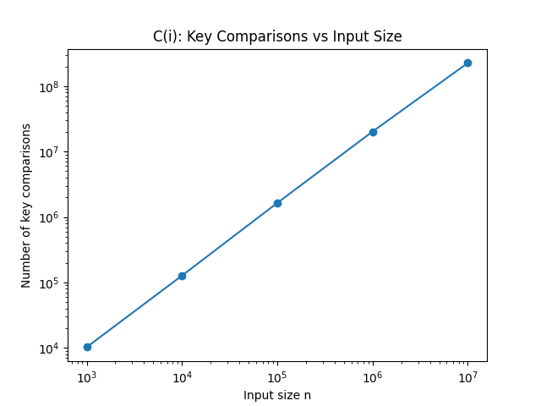
Figure 1. Number of key comparisons against input size n for fixed S = 16.
Figure 1 shows that the number of key comparisons increases steadily with n. On the log-log plot, the measurements form an approximately straight increasing trend. For the hybrid algorithm, the Merge Sort portion requires approximately O(n log(n/S)) work, while the collection of Insertion Sort leaves contributes approximately O(nS). Thus:
T(n, S) = O(n log(n/S) + nS)
When S is fixed, this simplifies asymptotically to O(n log n). Therefore, the empirical trend is consistent with the theoretical time-complexity analysis.

C(ii): Key Comparisons with Different Threshold Values
The input size was fixed at n = 100,000 and S was varied over {1, 2, 3, 4, 5, 6, 8, 16, 32}. For fairness, the same original random array was copied before testing each threshold, so differences in the result were caused by S rather than by different random inputs.
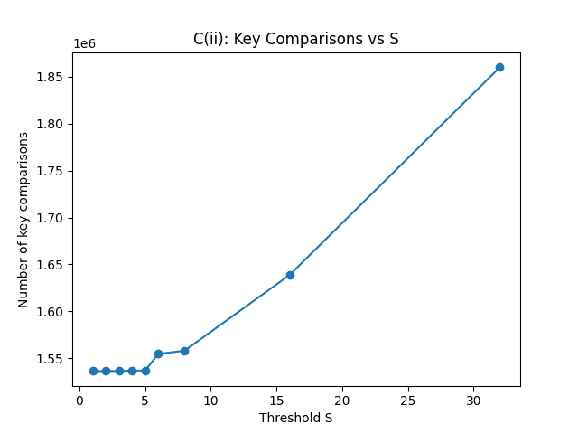
Figure 2. Number of key comparisons against threshold S for fixed n = 100,000.
For small S, the number of key comparisons remains almost constant. Once S becomes larger, the comparison count increases more noticeably. Increasing S reduces the number of Merge Sort recursion levels, but it also causes larger subarrays to be handled by Insertion Sort. Since Insertion Sort has quadratic comparison cost within a subarray, the insertion-sort contribution grows as S increases. This agrees with the theoretical trade-off in O(n log(n/S) + nS).

C(iii): Determining a Practical Optimal Threshold

Initial Method and Problems Observed
The initial approach measured running time for several values of S at different input sizes. At first, repeated executions were summarized using average running time, and the S with the smallest time was treated as the optimum. However, repeated complete experiments did not always select the same threshold. The fastest value could move among approximately S = 6, S = 8 and S = 16 even though their times were often very close.
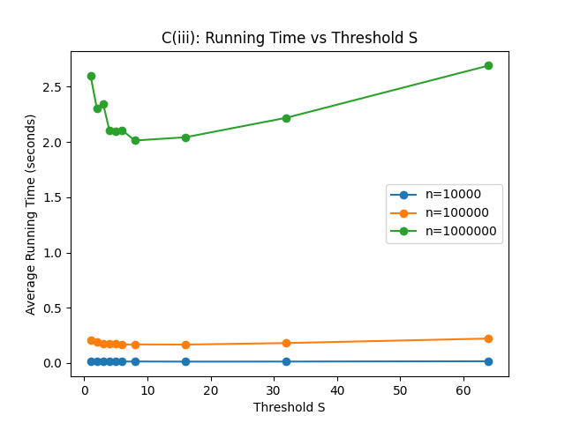
Figure 3. C(iii) experiment using average running time before the final refinement.
The initial runs also showed occasional variation and timing outliers; representative console outputs from the refinement process are provided in Appendix A.

Refinement Strategy
To make the selection more robust, the experimental procedure was refined step by step. Each (n, S) configuration was executed repeatedly rather than relying on a single measurement. For each input size, the three fastest thresholds were retained and assigned 3, 2 and 1 points for first, second and third place. Scores were aggregated across input sizes. If total scores were tied, the threshold appearing in the Top 3 more frequently was preferred; if both criteria were tied, either threshold could be selected.
The most important final change was replacing the arithmetic mean with the median of seven executions for every (n, S) configuration. The median is much less sensitive to an occasional abnormally slow run and therefore provides a more robust estimate of typical elapsed running time.

Final Method and Results
After the refinement, three complete independent runs all selected S = 8 as the overall practical optimum. One corresponding plot was saved, showing the general U-shaped trade-off for the largest input: very small S values incur greater Merge Sort recursion overhead, while very large S values increase the work performed by Insertion Sort. Supporting console outputs are provided in Appendix A.
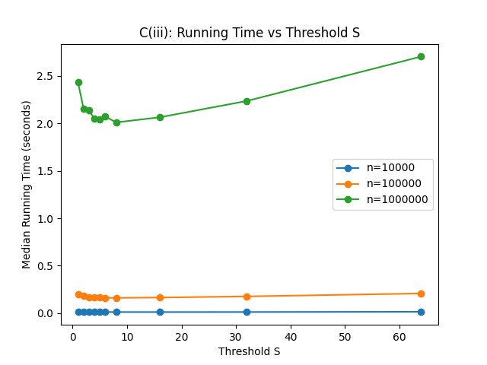
Figure 4. Final C(iii) experiment using the median of seven runs; S = 8 was selected.

Overall C(iii) Selection
Complete run | Final selected S | Observation
Run 1 | 8 | S = 8 achieved the highest overall ranking.
Run 2 | 8 | S = 8 remained the most consistent overall choice.
Run 3 | 8 | S = 8 ranked first for all three tested input sizes (score = 9).
Final practical threshold: S = 8.
The practical running-time optimum should not be confused with the threshold that minimizes only key comparisons. Actual elapsed time also includes recursion, function-call overhead, list slicing, assignments, data movement and other implementation costs. Therefore, a threshold can achieve better running time even if it does not produce the absolute minimum number of key comparisons.

Part C Conclusion
The experiments are consistent with the expected behaviour of Hybrid Merge Sort. With fixed S, the comparison growth follows the expected O(n log n) trend. Increasing S creates a trade-off: it reduces Merge Sort recursion but increases the amount of work delegated to Insertion Sort. The initial timing method showed noticeable run-to-run variation and sensitivity to outliers. After using seven repetitions, median timing, Top-3 scoring and frequency-based tie-breaking, the selection became substantially more stable. Since all three complete final-method experiments selected S = 8, S = 8 is used as the practical optimal threshold for the comparison with original Merge Sort in Part D.

Appendix A: Console Outputs for C(iii) Refinement
The following console outputs are retained as supporting evidence for the development and repeatability of the C(iii) timing method. They are separated from the main discussion to keep the report concise.
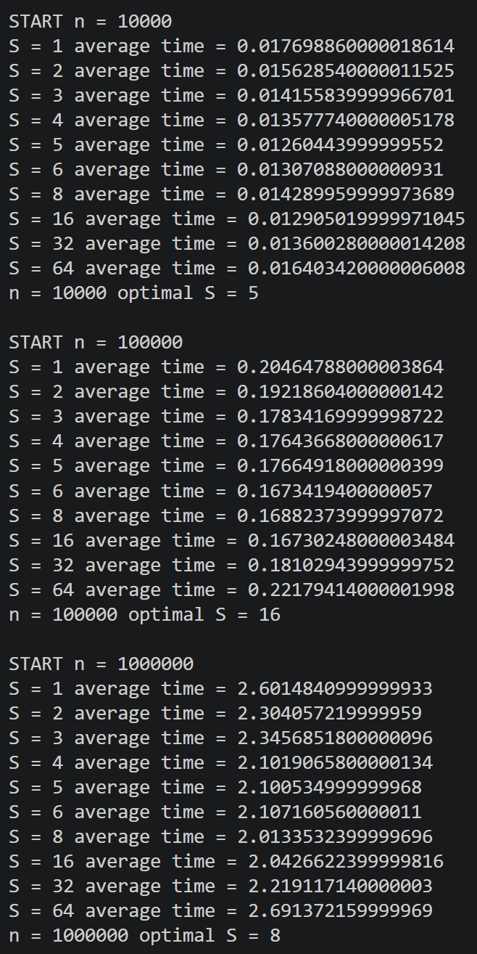
Figure A1. Initial output: the individually fastest S varies with input size.
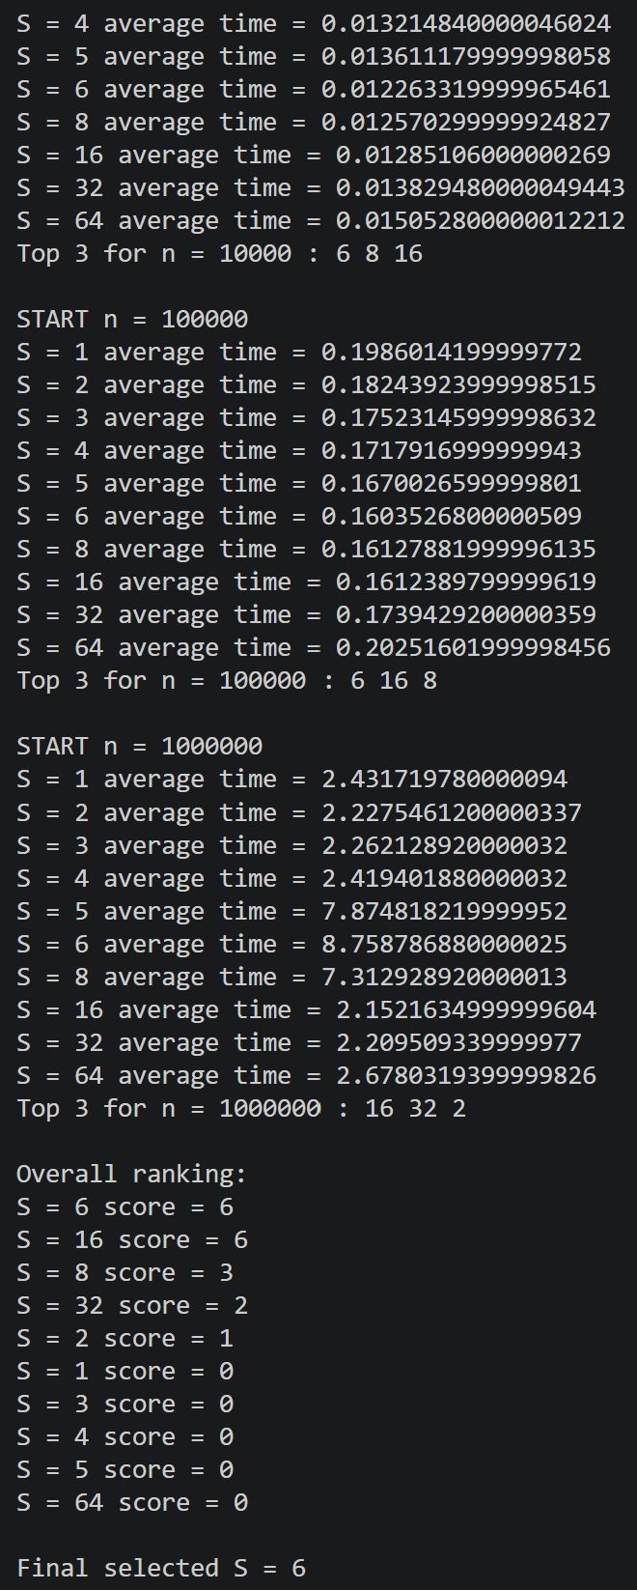
Figure A2. Intermediate output after Top-3 scoring: S = 6 and S = 16 obtain the same score.
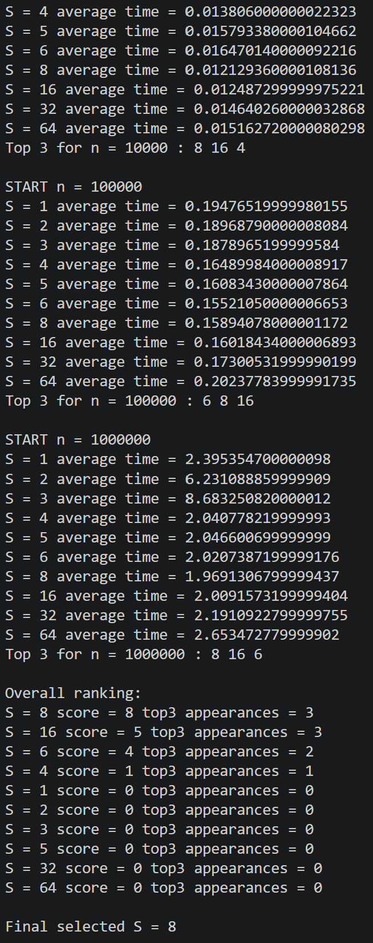
Figure A3. Intermediate output after adding Top-3 appearance tie-breaking; abnormal timing values are also visible.
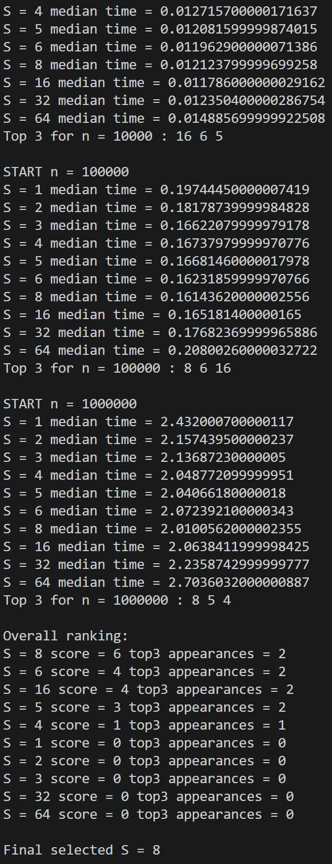
Figure A4. Final-method output, complete run 1: S = 8 selected.
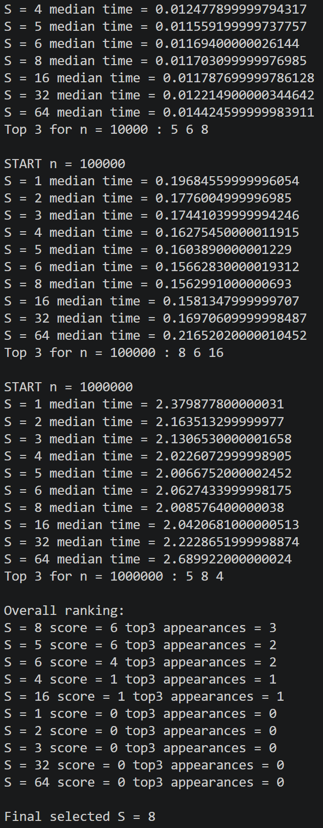
Figure A5. Final-method output, complete run 2: S = 8 selected.
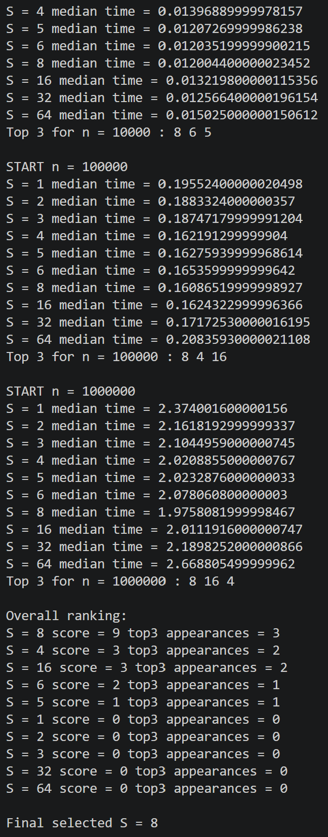
Figure A6. Final-method output, complete run 3: S = 8 selected.

