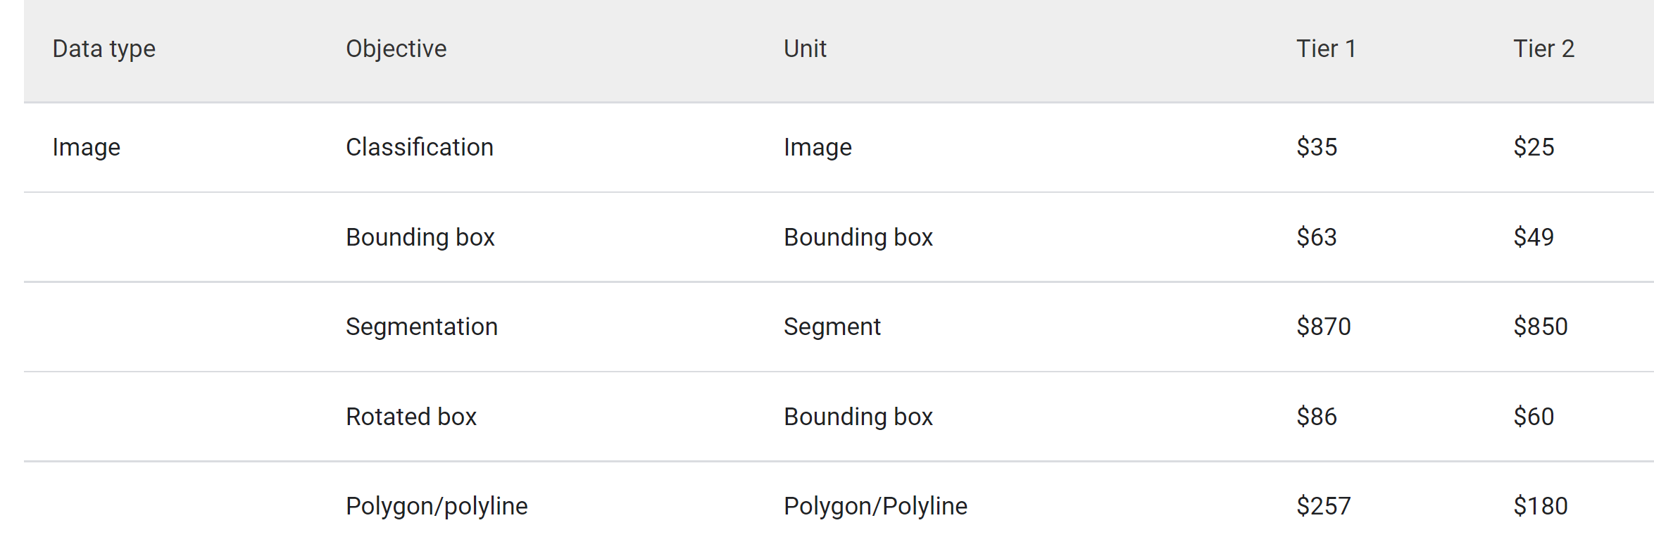

<https://cloud.google.com/ai-platform/data-labeling/pricing>

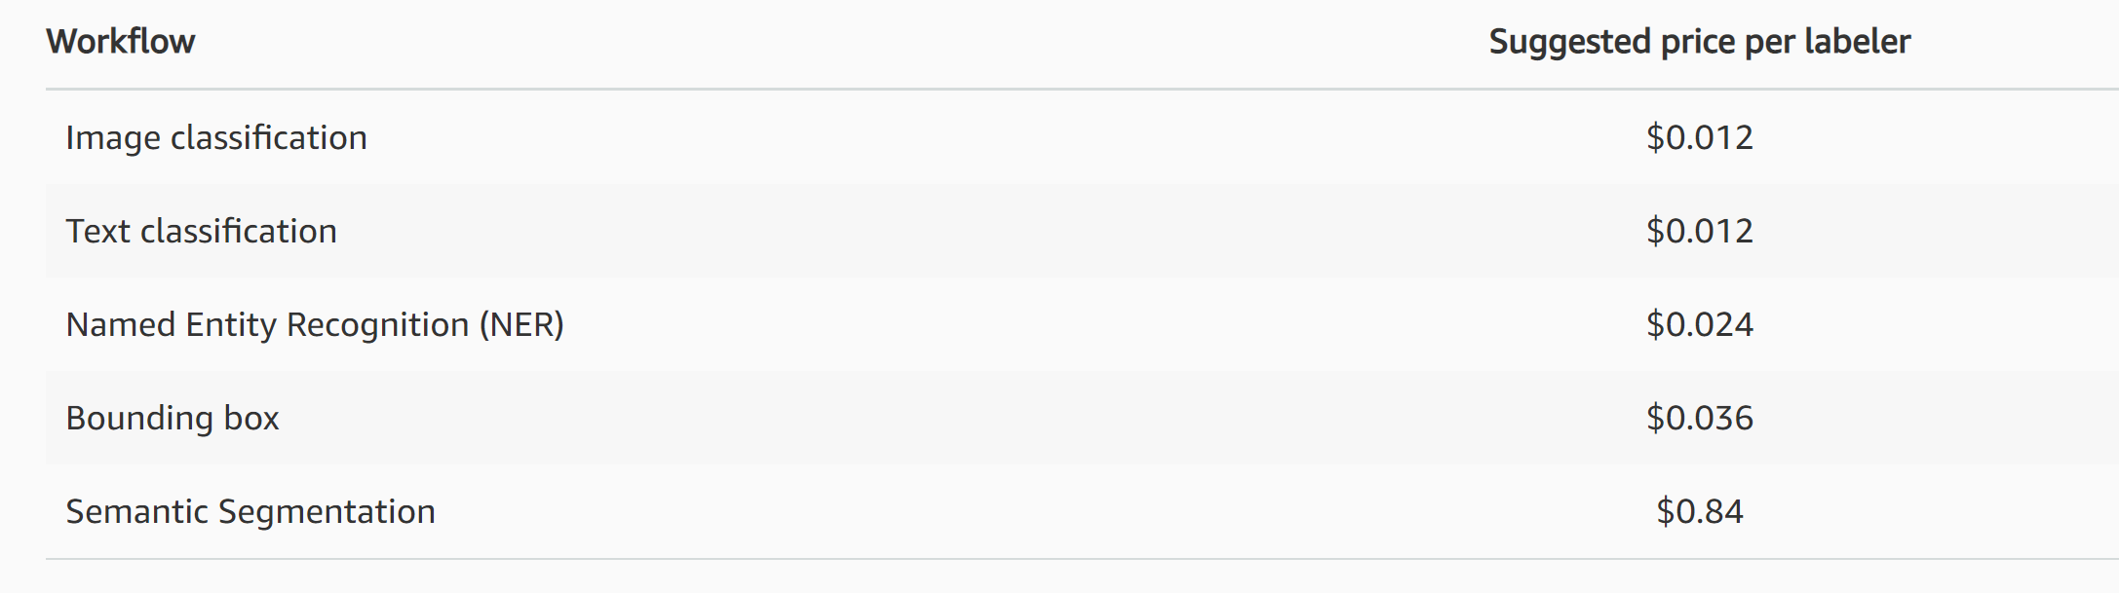

<https://aws.amazon.com/sagemaker/data-labeling/pricing/>

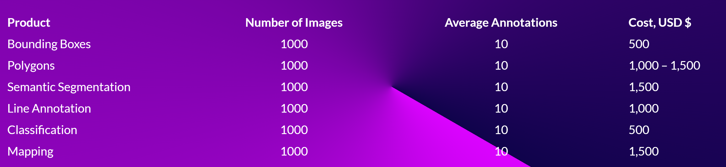

<https://taqadam.io/pricing>

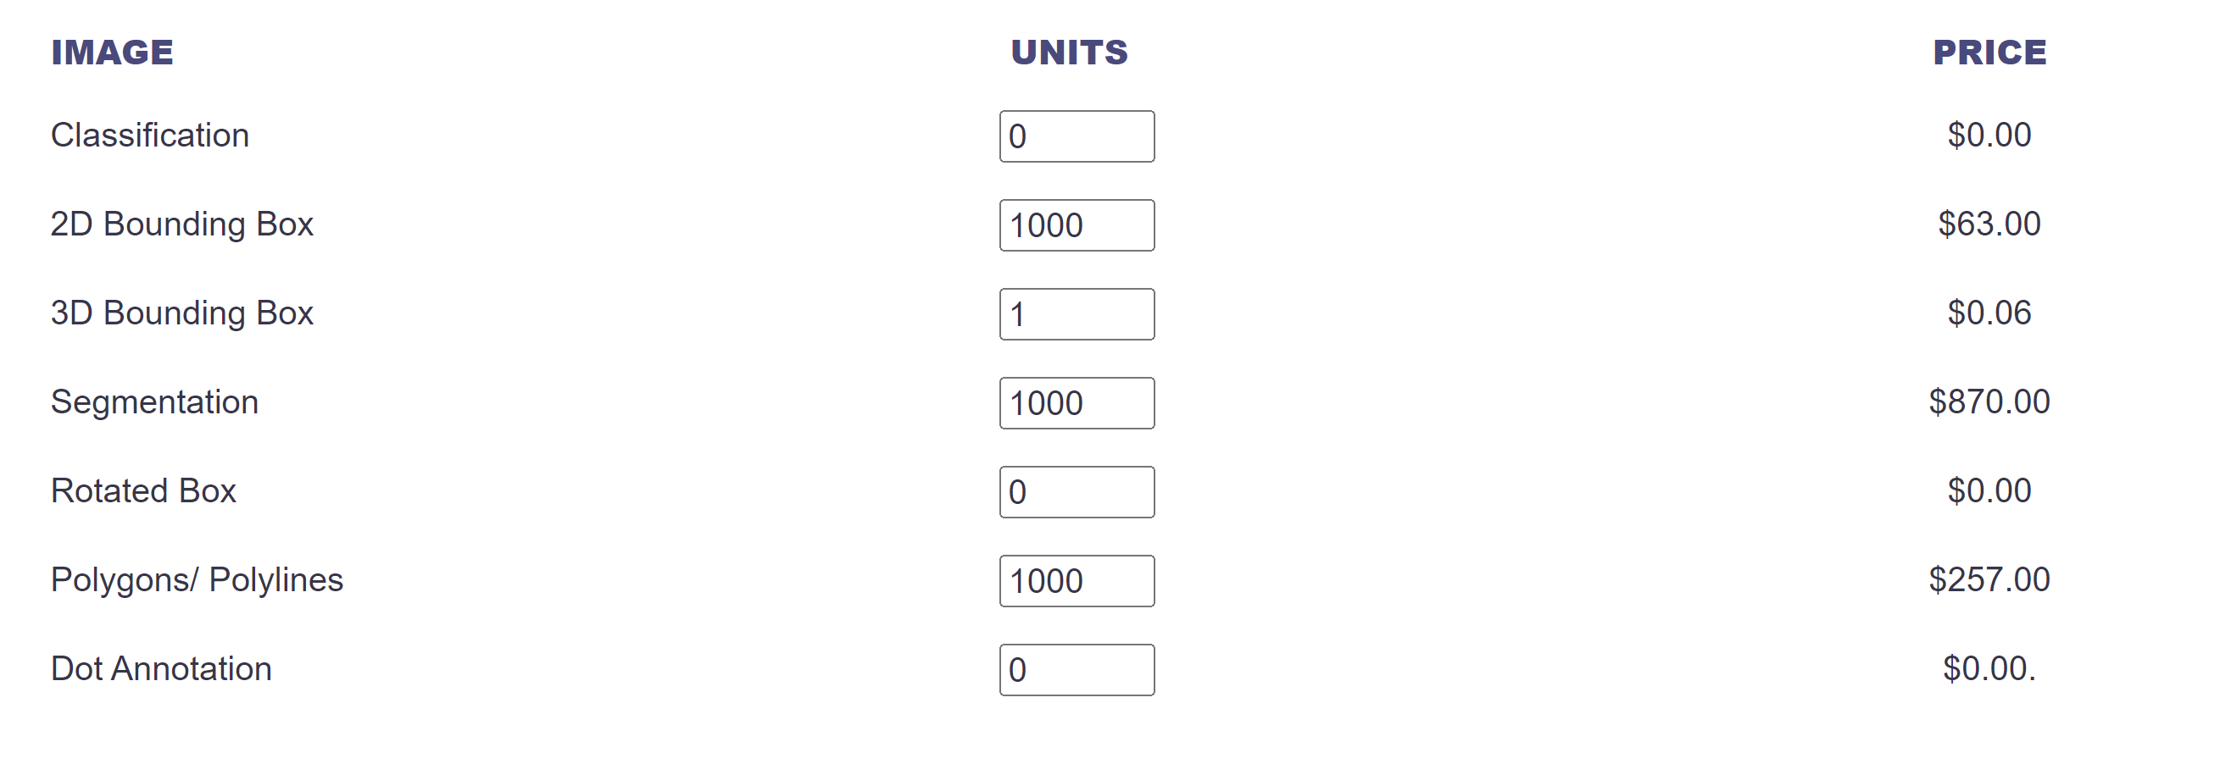

<https://www.labellerr.com/pricing>

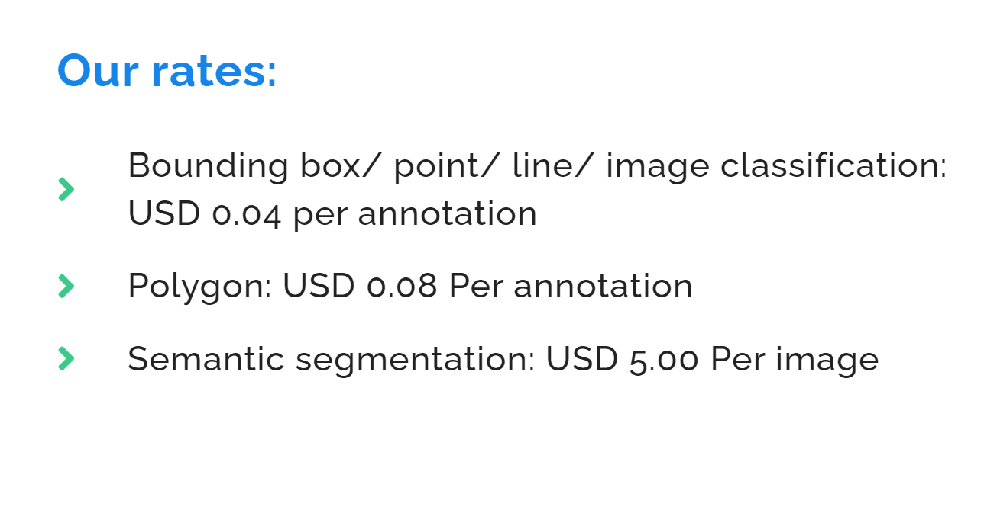

https://dyto.ai

Hi, I need to annotate around 15k images with 600 \* 800 pixels. The target is a river or sea. One instance for one image. I need each image annotated in one of the three potential annotation methods: pixel-wise annotation, approximate polygon, and bounding box. By approximate polygon, I mean the annotator could ignore the details like the waves. I would like to check the approximate price for each method.

<https://scale.com/pricing>

<https://www.cogitotech.com/services/image-annotation>

<https://desicrew.in/datalabeling>

<https://info.cloudfactory.com/>

<https://www.sama.com/accurate-image-annotation-services>

<https://www.alegion.com/pricing>

<https://www.shaip.com/blog/image-annotation-for-computer-vision>

format: company (pricing for) pixel-wise : polygons style : bounding box

cotigo 120:80:50

shaip 500:350:120

hive 4000: 700:300