

Project Report
On
Password Strength Checker using Python

Name: Shashi Sheoran
Registration No: 25BEC10009
University: VIT Bhopal University
Submission Date: 29 March 2026

1. Introduction

In the modern digital world, passwords play an important role in protecting online accounts and personal information. Most online platforms such as email services, banking applications, and social media rely on passwords for authentication.

However, many users tend to create weak passwords that are easy to remember but also easy to guess. Weak passwords make accounts vulnerable to cyber-attacks such as brute force attacks and password guessing.

The aim of this project is to develop a simple Python program that helps users analyze the strength of their passwords and encourages them to create stronger passwords.

2. Problem Statement

Many people are unaware of how secure their passwords are. They often use simple passwords such as names, dates of birth, or common words.

Such passwords can easily be cracked by attackers using automated tools. Therefore, it is important to build a system that can evaluate password strength and guide users toward better password practices.

3. Objectives

The objectives of this project are:

- To analyze the strength of user passwords
- To identify weak password patterns
- To generate strong random passwords
- To apply Python programming concepts to solve a real-world problem

4. Methodology

The project is implemented using Python programming language. The password strength checker evaluates several criteria to determine password security.

These criteria include:

- Password length
- Presence of uppercase letters
- Presence of lowercase letters
- Presence of numbers
- Presence of special characters

Each condition increases the password score. Based on the final score, the password is categorized as weak, moderate, or strong.

Additionally, a password generator program was implemented to create random secure passwords using Python’s random and string modules.

5. Implementation

The project consists of three main Python files.

password_checker.py
This file contains the main program responsible for checking password strength.
Example:
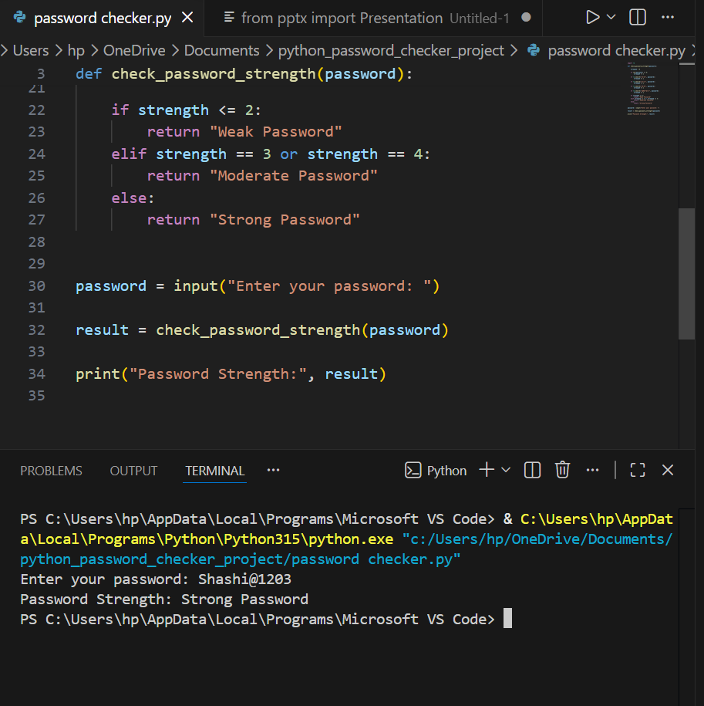

password_generator.py
This program generates random passwords based on user-defined length.
Example:
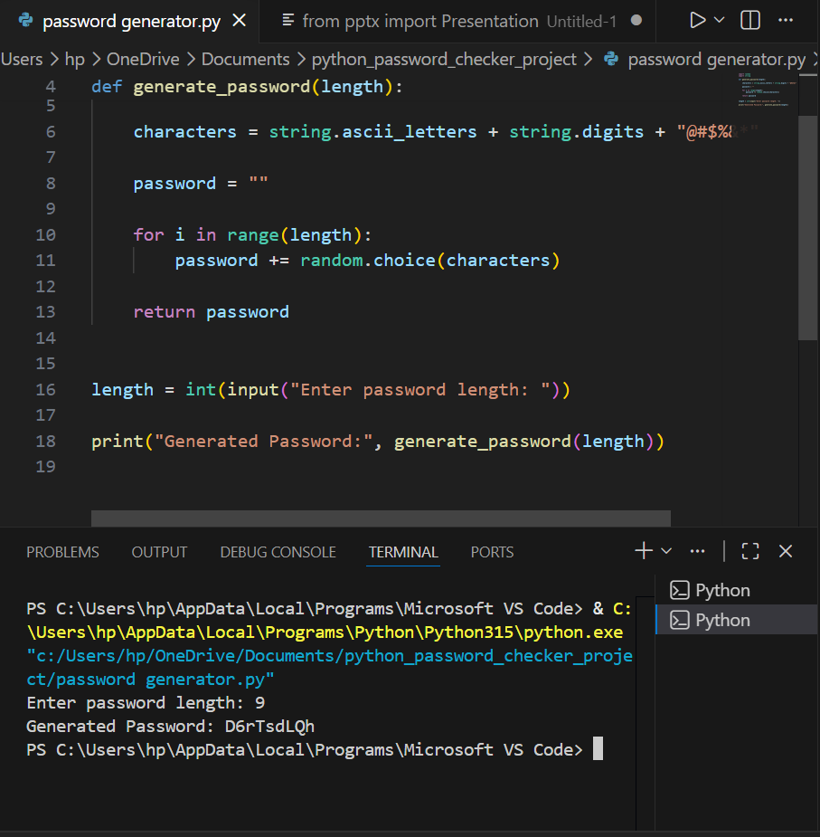

utils.py
This file contains helper functions that check whether a password contains uppercase letters, lowercase letters, numbers, or special characters.

By separating these functions into a utility module, the project becomes more organized and easier to maintain.

6. Challenges Faced

During the development of this project, one of the challenges was identifying different types of characters in the password string.

Initially, it was difficult to detect uppercase letters, numbers, and special characters separately. This issue was solved by using Python’s regular expression module (re) which allows pattern matching within strings.

7. Learning Outcomes

This project helped in improving understanding of several programming concepts, including:

- Python functions and modular programming
- String manipulation techniques
- Use of Python libraries such as random and re
- Basic cybersecurity concepts related to password security

8. Conclusion

The password strength checker project demonstrates how simple Python programs can help improve digital security practices. By analyzing password strength and generating secure passwords, the system encourages users to adopt better password habits.

Although the current implementation is simple, the project can be extended in the future by adding graphical interfaces and more advanced password analysis techniques.

