

Contents
1. Network Topology
2. Objective 1 — Interface Addressing
3. Objectives 2 & 3 — Static Routing (Austin, Round Rock, San Marcos)
4. Trouble-Ticket Scenario — Diagnosis & Correction
5. Verification — show ip route (All Three Routers)
6. Connectivity Testing — Router & PC Ping Results
7. DHCP Server Configuration
8. DHCP Client Verification (All 8 PCs)
9. Bonus — OSPF Dynamic Routing Configuration & Verification
10. Part 1 — Address Resolution Protocol (ARP) Questions
11. Part 2 — Layer 2 vs. Layer 3 Addressing Questions
12. Part 3 — OSPF Protocol Behavior Questions

1. Network Topology
The completed topology below shows all three sites — Austin Headquarters (hub), the Round Rock Sales Office, and the San Marcos Warehouse (spokes) — with routers, access/distribution switches, the HQ inventory database (ATX-Server), the DHCP server, all end-user PCs, and the technician's Test Laptop (connected to ATX-R by console cable for CLI configuration access).
Figure 1. Final Lone Star Logistics topology, fully cabled and addressed.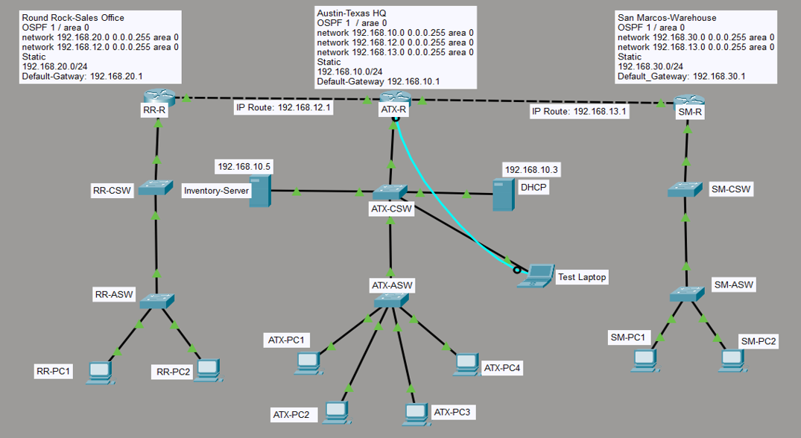

2. Objective 1 — Interface Addressing
The first usable address in each subnet (.1 for Austin's own interfaces, .2 for the spoke router's WAN side) was applied to the correct router interface, and every interface was brought up with no shutdown.
Router | Interface | IP Address | Subnet Mask | Connects To
ATX-R (HQ) | GigabitEthernet0/0 | 192.168.10.1 | 255.255.255.0 | ATX-CSW (LAN)
ATX-R (HQ) | GigabitEthernet0/1 | 192.168.12.1 | 255.255.255.0 | RR-R (WAN — Sales link)
ATX-R (HQ) | GigabitEthernet0/2 | 192.168.13.1 | 255.255.255.0 | SM-R (WAN — Warehouse link)
RR-R (Sales) | GigabitEthernet0/1 | 192.168.20.1 | 255.255.255.0 | RR-CSW (LAN)
RR-R (Sales) | GigabitEthernet0/0 | 192.168.12.2 | 255.255.255.0 | ATX-R (WAN)
SM-R (Warehouse) | GigabitEthernet0/1 | 192.168.30.1 | 255.255.255.0 | SM-CSW (LAN)
SM-R (Warehouse) | GigabitEthernet0/0 | 192.168.13.2 | 255.255.255.0 | ATX-R (WAN)

Sample configuration commands (ATX-R)
enable
configure terminal
hostname ATX-R
interface GigabitEthernet0/0
ip address 192.168.10.1 255.255.255.0
no shutdown
exit
interface GigabitEthernet0/1
ip address 192.168.12.1 255.255.255.0
no shutdown
exit
interface GigabitEthernet0/2
ip address 192.168.13.1 255.255.255.0
no shutdown
exit
end
copy running-config startup-config

Confirmation — show ip interface brief (ATX-R)
ATX-R#show ip interface brief
Interface IP-Address OK? Method Status Protocol
GigabitEthernet0/0 192.168.10.1 YES manual up up
GigabitEthernet0/1 192.168.12.1 YES manual up up
GigabitEthernet0/2 192.168.13.1 YES manual up up

3. Objectives 2 & 3 — Static Routing
Because Sales and Warehouse are single-homed "spoke" sites, each needs a static route back to Austin, plus a static route to the other branch's LAN (reachable only through HQ). Austin needs a static route to each branch LAN. In addition, each spoke needs a route to the other spoke's WAN transit subnet — this was the piece that broke router-originated (and, in the trouble-ticket scenario, PC-originated) traffic between the two branches; see Section 4.

3.1 — ATX-R (Austin Headquarters)
ip route 192.168.20.0 255.255.255.0 192.168.12.2
ip route 192.168.30.0 255.255.255.0 192.168.13.2

3.2 — RR-R (Round Rock Sales Office)
ip route 192.168.10.0 255.255.255.0 192.168.12.1
ip route 192.168.30.0 255.255.255.0 192.168.12.1
ip route 192.168.13.0 255.255.255.0 192.168.12.1

3.3 — SM-R (San Marcos Warehouse)
ip route 192.168.10.0 255.255.255.0 192.168.13.1
ip route 192.168.20.0 255.255.255.0 192.168.13.1
ip route 192.168.12.0 255.255.255.0 192.168.13.1

Router | Total Static Routes | Reaches HQ LAN | Reaches Other Branch LAN | Reaches Other Branch WAN Link
ATX-R | 2 | n/a (local) | Yes — both branches | n/a (directly connected)
RR-R | 3 | Yes | Yes (via HQ) | Yes (via HQ)
SM-R | 3 | Yes | Yes (via HQ) | Yes (via HQ)

4. Trouble-Ticket Scenario — Diagnosis & Correction
Per the scenario, a junior technician's weekend configuration left three symptoms: HQ could reach the Warehouse but not Sales; Sales could not reach the Warehouse; and the Warehouse could reach HQ but could not send print jobs to Sales. The network was reviewed methodically using show ip route, ping, and traceroute on all three routers.

Diagnostic steps taken
1. Confirmed every interface was correctly addressed and in an up/up state with show ip interface brief on all three routers.
2. Verified each router's routing table with show ip route, comparing the static routes present against the routes required for full reachability.
3. Ran ping tests from ATX-R to both branch LAN interfaces (192.168.20.1 and 192.168.30.1) — both succeeded, confirming HQ's own routes were correct.
4. Ran ping 192.168.30.1 from RR-R — failed 100%. Ran traceroute 192.168.30.1 from RR-R — the packet reached ATX-R (hop 1) but never reached SM-R (hop 2 timed out).
5. Used an extended ping on ATX-R, sourced from its Sales-facing interface (192.168.12.1) toward 192.168.30.1, to simulate transit traffic. This also failed, isolating the fault to the return path rather than the outbound path.

Root cause identified
SM-R's routing table had routes to the HQ LAN (192.168.10.0/24) and the Sales LAN (192.168.20.0/24), but no route to the Sales-side WAN transit subnet (192.168.12.0/24). Likewise, RR-R had no route to the Warehouse-side WAN transit subnet (192.168.13.0/24). Traffic sourced directly from a router's own WAN interface uses that transit subnet as its source address — with no return route to it, replies from the far router were silently dropped.

Corrective action
Added one static route on each spoke router for the other branch's WAN transit subnet:
! On RR-R:
ip route 192.168.13.0 255.255.255.0 192.168.12.1

! On SM-R:
ip route 192.168.12.0 255.255.255.0 192.168.13.1

After adding these two routes, ping and traceroute tests from RR-R to 192.168.30.1 and from SM-R to 192.168.20.1 both succeeded at 100%, with a clean two-hop path in each direction. See Section 6 for full results.

5. Verification — show ip route (All Three Routers)

ATX-R (Austin Headquarters)
ATX-R#show ip route
Gateway of last resort is not set

192.168.10.0/24 is variably subnetted, 2 subnets, 2 masks
C 192.168.10.0/24 is directly connected, GigabitEthernet0/0
L 192.168.10.1/32 is directly connected, GigabitEthernet0/0
192.168.12.0/24 is variably subnetted, 2 subnets, 2 masks
C 192.168.12.0/24 is directly connected, GigabitEthernet0/1
L 192.168.12.1/32 is directly connected, GigabitEthernet0/1
192.168.13.0/24 is variably subnetted, 2 subnets, 2 masks
C 192.168.13.0/24 is directly connected, GigabitEthernet0/2
L 192.168.13.1/32 is directly connected, GigabitEthernet0/2
S 192.168.20.0/24 [1/0] via 192.168.12.2
S 192.168.30.0/24 [1/0] via 192.168.13.2

RR-R (Round Rock Sales Office)
RR-R#show ip route
Gateway of last resort is not set

S 192.168.10.0/24 [1/0] via 192.168.12.1
192.168.12.0/24 is variably subnetted, 2 subnets, 2 masks
C 192.168.12.0/24 is directly connected, GigabitEthernet0/0
L 192.168.12.2/32 is directly connected, GigabitEthernet0/0
S 192.168.13.0/24 [1/0] via 192.168.12.1
192.168.20.0/24 is variably subnetted, 2 subnets, 2 masks
C 192.168.20.0/24 is directly connected, GigabitEthernet0/1
L 192.168.20.1/32 is directly connected, GigabitEthernet0/1
S 192.168.30.0/24 [1/0] via 192.168.12.1

SM-R (San Marcos Warehouse)
SM-R#show ip route
Gateway of last resort is not set

S 192.168.10.0/24 [1/0] via 192.168.13.1
192.168.13.0/24 is variably subnetted, 2 subnets, 2 masks
C 192.168.13.0/24 is directly connected, GigabitEthernet0/0
L 192.168.13.2/32 is directly connected, GigabitEthernet0/0
S 192.168.12.0/24 [1/0] via 192.168.13.1
192.168.30.0/24 is variably subnetted, 2 subnets, 2 masks
C 192.168.30.0/24 is directly connected, GigabitEthernet0/1
L 192.168.30.1/32 is directly connected, GigabitEthernet0/1

6. Connectivity Testing — Router & PC Ping Results

6.1 — Router-to-router LAN reachability (from ATX-R)
ATX-R#ping 192.168.20.1
Success rate is 80 percent (4/5) [first packet: normal ARP delay]
ATX-R#ping 192.168.30.1
Success rate is 100 percent (5/5)

6.2 — Cross-branch reachability (the trouble-ticket fix, confirmed)
RR-R#ping 192.168.30.1
Success rate is 100 percent (5/5), round-trip min/avg/max = 4/4/4 ms

RR-R#traceroute 192.168.30.1
1 192.168.12.1 2 msec 2 msec 2 msec
2 192.168.13.2 4 msec 4 msec

SM-R#ping 192.168.20.1
Success rate is 100 percent (5/5), round-trip min/avg/max = 0/2/4 ms

6.3 — PC-to-PC and PC-to-server, all three sites
Command Prompt ping tests were run directly from end-user PCs (not just the routers) to prove real host-level traffic — not just router-to-router traffic — crosses the network correctly.
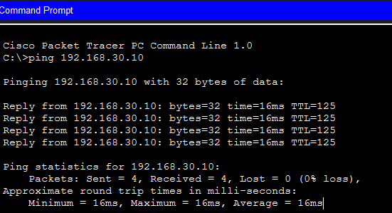
Sales PC → Warehouse PC (192.168.30.10) — 0% loss.
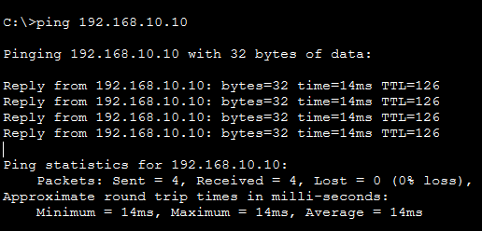
Warehouse PC → HQ PC (192.168.10.10) — 0% loss.
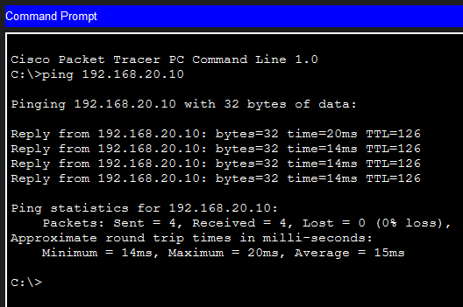
HQ PC → Sales PC (192.168.20.10) — 0% loss.
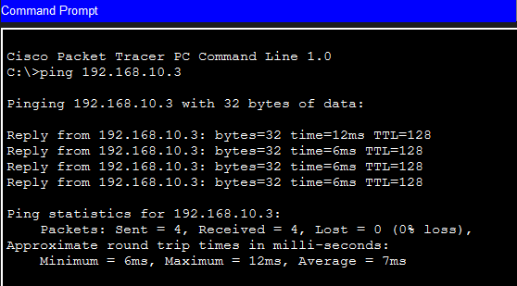
HQ PC → DHCP Server (192.168.10.3) — 0% loss.
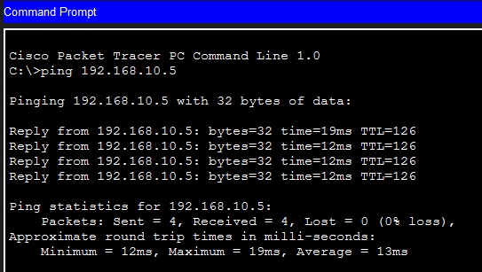
Warehouse PC → ATX-Server / inventory database (192.168.10.5) — 0% loss.

7. DHCP Server Configuration
The DHCP server (192.168.10.3, static, gateway 192.168.10.1) hosts three scopes — one per site — so that client PCs at every location receive an address, subnet mask, and default gateway appropriate to their own site automatically.
Pool Name | Default Gateway | Start IP Address | Subnet Mask | Max Users
HQ-POOL | 192.168.10.1 | 192.168.10.10 | 255.255.255.0 | 50
SALES-POOL | 192.168.20.1 | 192.168.20.10 | 255.255.255.0 | 50
WAREHOUSE-POOL | 192.168.30.1 | 192.168.30.10 | 255.255.255.0 | 50

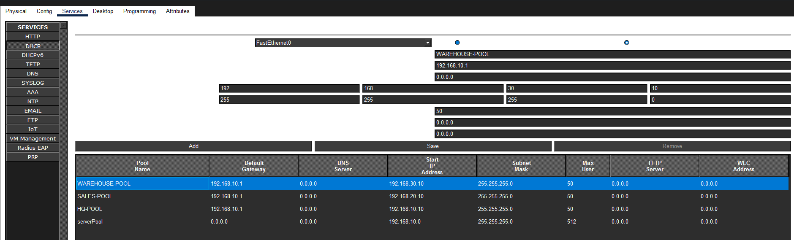
Figure 2. DHCP scopes as configured on the server (early state — see note below).
Note: Packet Tracer auto-creates a default pool named “serverPool.” Because its subnet (192.168.10.0/24) overlapped HQ-POOL and its gateway field was blank (0.0.0.0), it briefly caused one HQ PC to receive a gateway of 0.0.0.0 instead of 192.168.10.1. Removing serverPool resolved the conflict; see the SOP manual, Section “Common Pitfalls,” for the exact fix.

DHCP relay (ip helper-address)
Since DHCP client broadcasts do not cross router boundaries on their own, each spoke router's LAN-facing interface relays them to the server at HQ:
! On RR-R:
interface GigabitEthernet0/1
ip helper-address 192.168.10.3

! On SM-R:
interface GigabitEthernet0/1
ip helper-address 192.168.10.3

ATX-R's own LAN does not need a helper-address, since the DHCP server sits directly on that same subnet (192.168.10.0/24).

8. DHCP Client Verification (All 8 PCs)
Every PC at every site was switched from Static to DHCP and confirmed to receive the correct address, subnet mask, and default gateway for its own site.
Site | PC | IP Address | Default Gateway
Sales | RR-PC1 | 192.168.20.10 | 192.168.20.1
Sales | RR-PC2 | 192.168.20.11 | 192.168.20.1
HQ | ATX-PC1 / PC2 | 192.168.10.10 | 192.168.10.1
HQ | ATX-PC2 / PC3 | 192.168.10.11 | 192.168.10.1
HQ | ATX-PC3 / PC4 | 192.168.10.12 | 192.168.10.1
HQ | ATX-PC4 / PC8 | 192.168.10.13 | 192.168.10.1
Warehouse | SM-PC1 | 192.168.30.10 | 192.168.30.1
Warehouse | SM-PC2 | 192.168.30.11 | 192.168.30.1

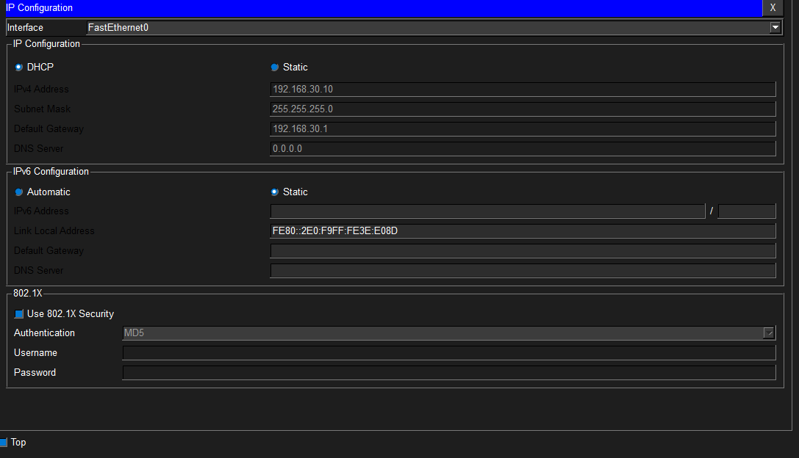
SM-PC1 — DHCP request successful, 192.168.30.10 / gateway 192.168.30.1.
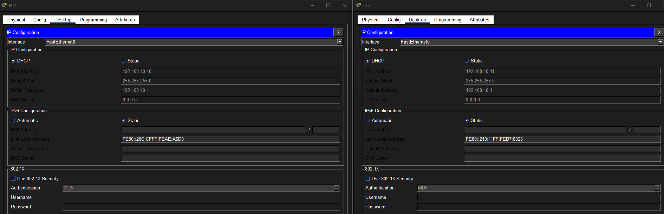
ATX-PC2 & ATX-PC3 — DHCP request successful, HQ subnet.
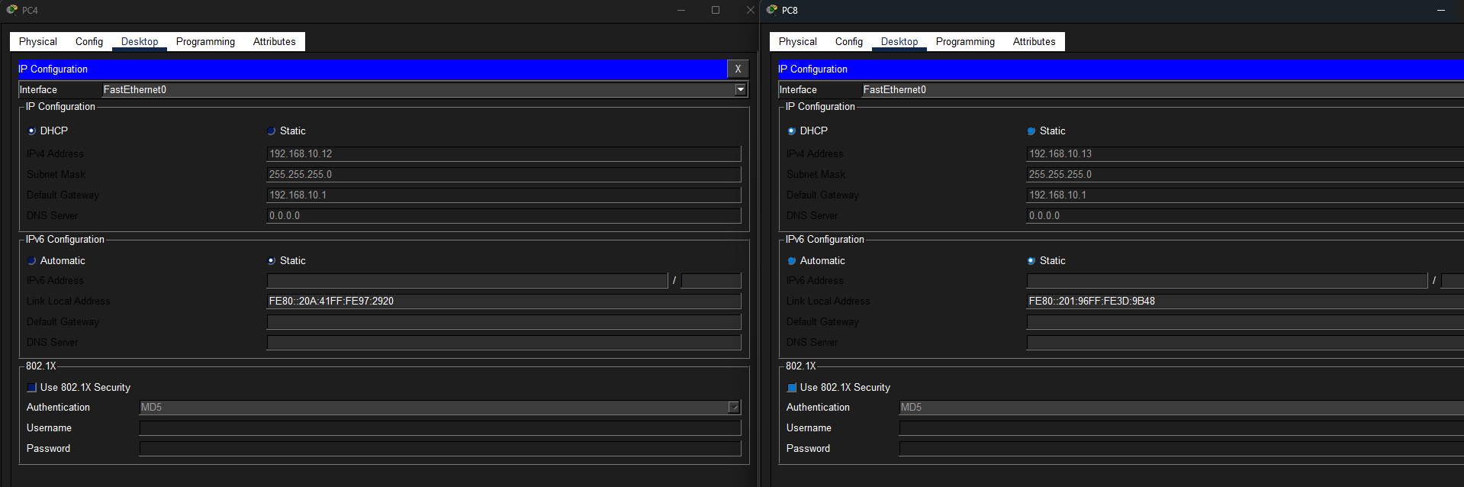
ATX-PC4 & ATX-PC8 — DHCP request successful, HQ subnet.
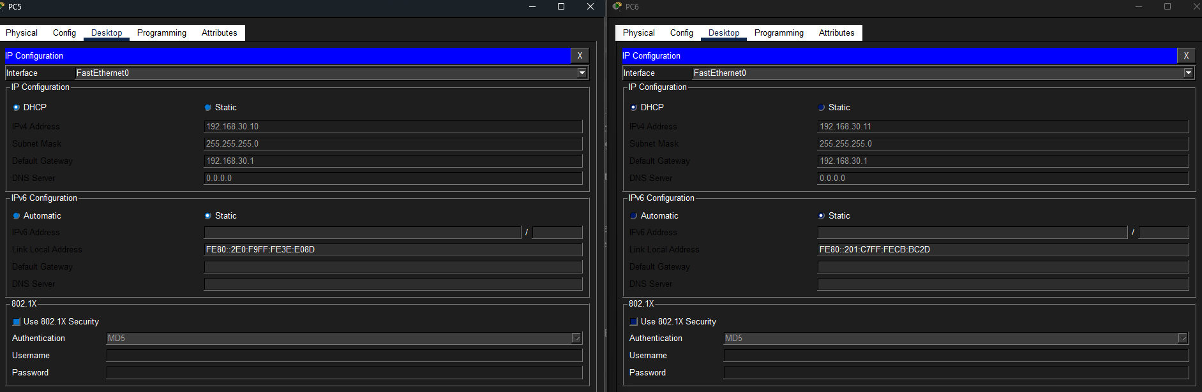
SM-PC1 & SM-PC2 — DHCP request successful, Warehouse subnet.

9. Bonus — OSPF Dynamic Routing Configuration & Verification
OSPF area 0 was enabled on all three routers in addition to the required static routes, to demonstrate a working dynamic-routing solution and to answer the Part 3 protocol-behavior questions. Because static routes carry a lower administrative distance (1) than OSPF (110), the static routes remain the routes actually installed and used for forwarding; OSPF runs alongside them as a fully-converged backup that would take over automatically if the static routes were ever removed.

9.1 — Configuration
! ATX-R:
router ospf 1
network 192.168.10.0 0.0.0.255 area 0
network 192.168.12.0 0.0.0.255 area 0
network 192.168.13.0 0.0.0.255 area 0

! RR-R:
router ospf 1
network 192.168.20.0 0.0.0.255 area 0
network 192.168.12.0 0.0.0.255 area 0

! SM-R:
router ospf 1
network 192.168.30.0 0.0.0.255 area 0
network 192.168.13.0 0.0.0.255 area 0

9.2 — show ip ospf neighbor
As expected, Austin shows two neighbors (Round Rock and San Marcos), while each spoke shows exactly one neighbor (Austin).
ATX-R#show ip ospf neighbor
Neighbor ID Pri State Dead Time Address Interface
192.168.30.1 1 FULL/BDR 00:00:39 192.168.13.2 GigabitEthernet0/2
192.168.20.1 1 FULL/DR 00:00:34 192.168.12.2 GigabitEthernet0/1

RR-R#show ip ospf neighbor
Neighbor ID Pri State Address Interface
192.168.13.1 1 FULL/BDR 192.168.12.1 GigabitEthernet0/0

SM-R#show ip ospf neighbor
Neighbor ID Pri State Address Interface
192.168.13.1 1 FULL/DR 192.168.13.1 GigabitEthernet0/0

9.3 — show ip route ospf and show ip ospf database
show ip route ospf returns no entries — this is expected and correct: OSPF-learned routes (AD 110) are outranked by the existing static routes (AD 1) to the same destinations, so OSPF's routes are calculated but not installed in the forwarding table. show ip ospf database confirms OSPF has nonetheless learned the full topology from all three routers:
ATX-R#show ip ospf database
OSPF Router with ID (192.168.13.1) (Process ID 1)

Router Link States (Area 0)
Link ID ADV Router Age Seq# Checksum Link count
192.168.20.1 192.168.20.1 640 0x80000003 0x009840 2
192.168.13.1 192.168.13.1 440 0x80000005 0x008d63 3
192.168.30.1 192.168.30.1 440 0x80000003 0x005663 2

Net Link States (Area 0)
Link ID ADV Router Age Seq# Checksum
192.168.12.2 192.168.20.1 640 0x80000001 0x007f2c
192.168.13.1 192.168.13.1 440 0x80000001

10. Part 1 — Address Resolution Protocol (ARP)
Question 1: When you generate the first ping, an ARP packet is created before the ICMP packet can leave the router. Why does the router need to use ARP before sending the ping?
Answer: Ethernet frames can only be delivered using MAC addresses, not IP addresses — the Layer 2 header has no field for a destination IP. Before the router (or PC) can build a frame to carry the ICMP Echo Request, it needs to know the MAC address of the next hop. If that destination's MAC address is not already in the ARP cache, the device sends an ARP Request to discover it before the ICMP packet can be encapsulated and transmitted.
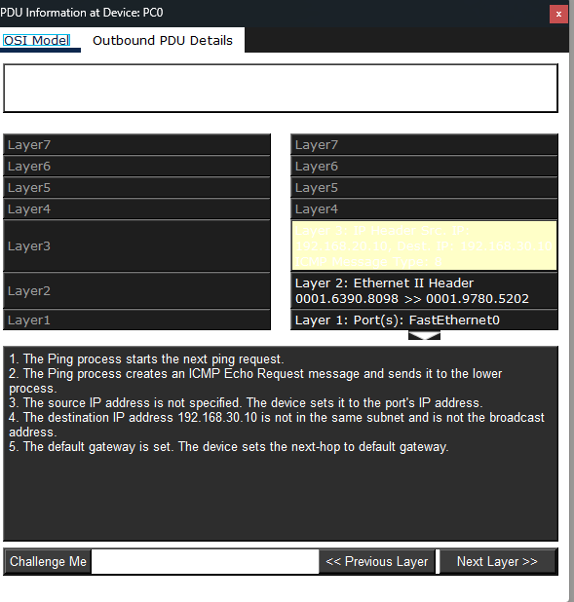
PDU walkthrough on PC0 showing the ping process determining that the destination is off-subnet and must be sent to the default gateway.

Question 2: Open the PDU details for the outbound ARP Request. What destination MAC address does the ARP request use, and why?
Answer: FFFF.FFFF.FFFF — the Ethernet broadcast address. The sender does not yet know which specific device owns the target IP address, so it cannot address the frame to one host. Broadcasting the request lets every device on the local segment receive it; only the device that actually owns that IP address replies (via unicast) with its real MAC address.
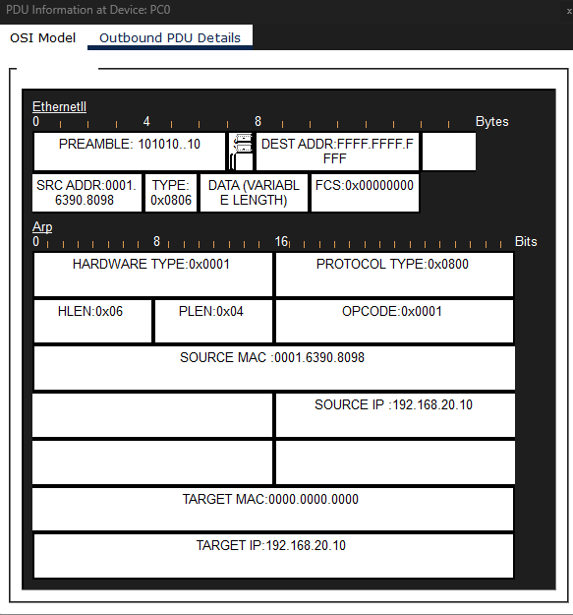
Outbound ARP Request from RR-PC1: DEST ADDR FFFF.FFFF.FFFF, OPCODE 0x0001 (Request), TARGET MAC 0000.0000.0000 (unknown/being resolved).

11. Part 2 — Layer 2 vs. Layer 3 Addressing (The “Hop-by-Hop” Rule)
Question 3: Open the Inbound PDU details when the ICMP Echo Request arrives at Austin Router, and then look at the Outbound PDU details as it leaves Austin and San Marcos routers. What happened to the Source and Destination IP addresses?
Answer: Nothing — they stayed exactly the same at every hop (Source 192.168.20.10, Destination 192.168.30.10, both inbound and outbound). Layer 3 (IP) addressing identifies the original sender and the ultimate destination end-to-end and is never rewritten by an intermediate router; only the TTL field changes (decremented by 1 per hop — see Question 5).
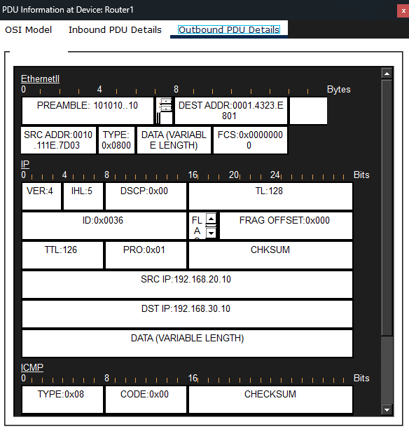
ATX-R (Router1) Outbound: SRC IP 192.168.20.10, DST IP 192.168.30.10, TTL 126.
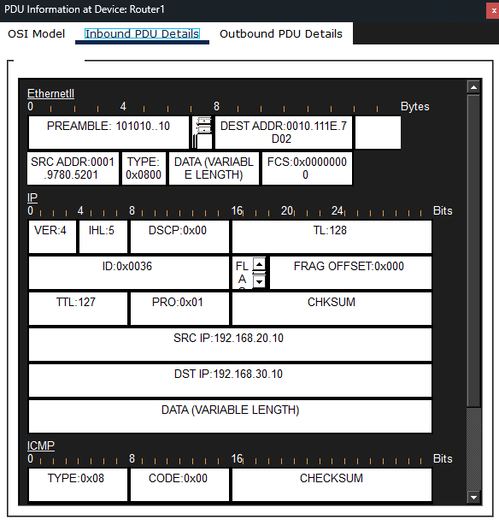
ATX-R (Router1) Inbound: same SRC/DST IP, TTL 127 — one higher than the outbound frame.

Question 4: Looking at that same PDU on the RoundRock router, what happened to the Source and Destination MAC addresses between the Inbound and Outbound frame?
Answer: They changed completely. Inbound, the frame was addressed from the sending PC's own NIC (0001.6390.8098) to RR-R's LAN interface (0001.9780.5202) — the only MAC addresses Layer 2 knows about at that point. After RR-R makes its routing decision, it discards that Ethernet header entirely and builds a brand-new one for the next hop: source = RR-R's own WAN interface (0001.9780.5201), destination = ATX-R's WAN interface (0010.111E.7D02). This is the “hop-by-hop” rule — Layer 2 addressing is rewritten at every router, while the Layer 3 IP addressing underneath rides along unchanged.
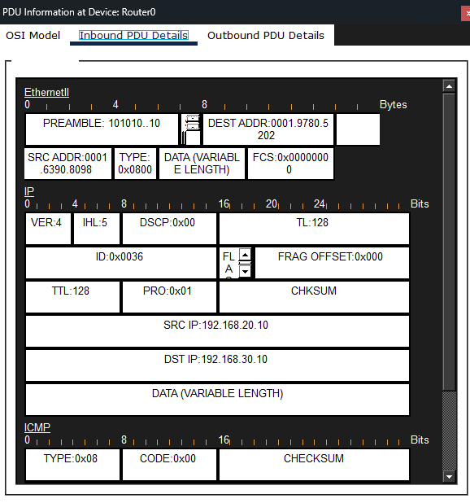
RR-R (Router0) Inbound Ethernet header — PC's MAC to RR-R's LAN MAC.
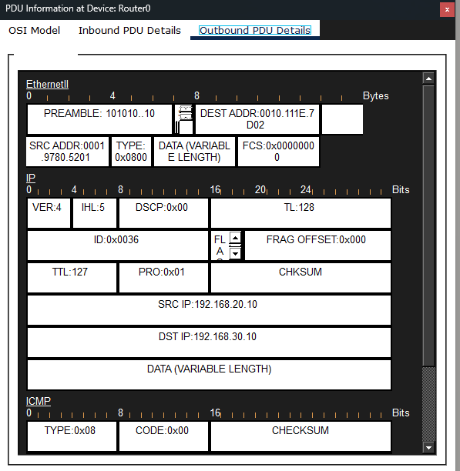
RR-R (Router0) Outbound Ethernet header — RR-R's WAN MAC to ATX-R's WAN MAC.
Question 5: Examine the Layer 3 IPv4 header in the Outbound PDU at each hop. What happens to the TTL (Time to Live) value as the packet passes through Austin Router(s)?
Answer: TTL decrements by exactly 1 at every router hop. The packet left the source PC with TTL 128; arriving at RR-R it still read 128, and RR-R forwarded it with TTL 127; arriving at ATX-R it read 127, and ATX-R forwarded it with TTL 126. This mechanism exists so a packet caught in a routing loop is eventually discarded (when TTL reaches 0) rather than circulating the network forever.

12. Part 3 — OSPF Protocol Behavior
Question 6: Click on an outbound OSPF Hello packet leaving Austin and San Marcos routers. What is the Destination IP address, and what does this specific address signify?
Answer: 224.0.0.5 — the reserved “All OSPF Routers” multicast address. Every OSPF-enabled router listens for this address on its OSPF-active interfaces, so a router can announce itself and discover neighbors without needing to already know their individual IP addresses; any OSPF speaker on the segment receives and processes the Hello.
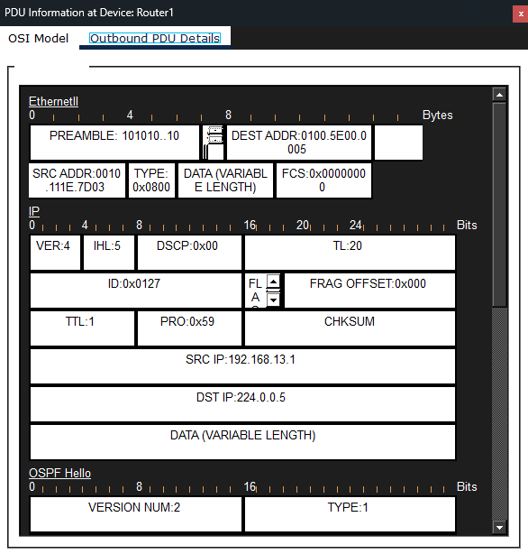
Outbound OSPF Hello leaving ATX-R (Router1): DST IP 224.0.0.5, TTL 1, multicast MAC 0100.5E00.0005.
Question 7: Looking at the Layer 4/Layer 3 details of the OSPF packet, does OSPF use TCP or UDP for transport?
Answer: Neither. The IP header's protocol field reads 0x59 (decimal 89), which is OSPF's own dedicated IP protocol number. OSPF rides directly on top of IP rather than using a Layer 4 transport protocol such as TCP (6) or UDP (17).
Question 8: Why do you not see any OSPF Hello packets being sent out of the GigabitEthernet 0/2 interfaces (the local LANs)?
Answer: OSPF only sends Hellos on interfaces that are enabled for OSPF and face another router capable of forming an adjacency. The LAN-facing interfaces connect only to end-user PCs and servers, none of which run OSPF or can ever become a neighbor, so Hellos there would serve no purpose. Marking those interfaces passive-interface (or simply never advertising a router-facing neighbor on them) suppresses this multicast traffic on the LAN as a deliberate best practice — it reduces unnecessary broadcast/multicast load on end-user segments and prevents a rogue device from ever attempting to form a false OSPF adjacency.
— End of Submission —

