**Documentation**  
21.11.2023 Prog. Tech. Assignment 2  
Shepelenko Mykhailo DN36E8

**Task 2**

Pebble is a two-player game, played on a board consists of n x n fields. Initially, n white and n black

pebbles are placed on the board randomly. Each color belongs to only one player. The players take

turns choosing one of its pebble, and then move it horizontally or vertically. The movement also

affects the neighbouring pebbles in the direction (the pebble on the edge falls off). The objective of

the game is to push out as much pebbles of the opponent from the board as we can, within a given

number of turns (5n). A player wins, if he has more pebbles on the board at the end than his

opponent. The game is draw, if they have the same number of pebbles on the board.

Implement this game, and let the board size be selectable (3x3, 4x4, 6x6 → turns are 15, 20, 30). The

game should recognize if it is ended, and it has to show the name of the winner in a message box (if

the game is not ended with draw), and automatically begin a new game

**Diagram**

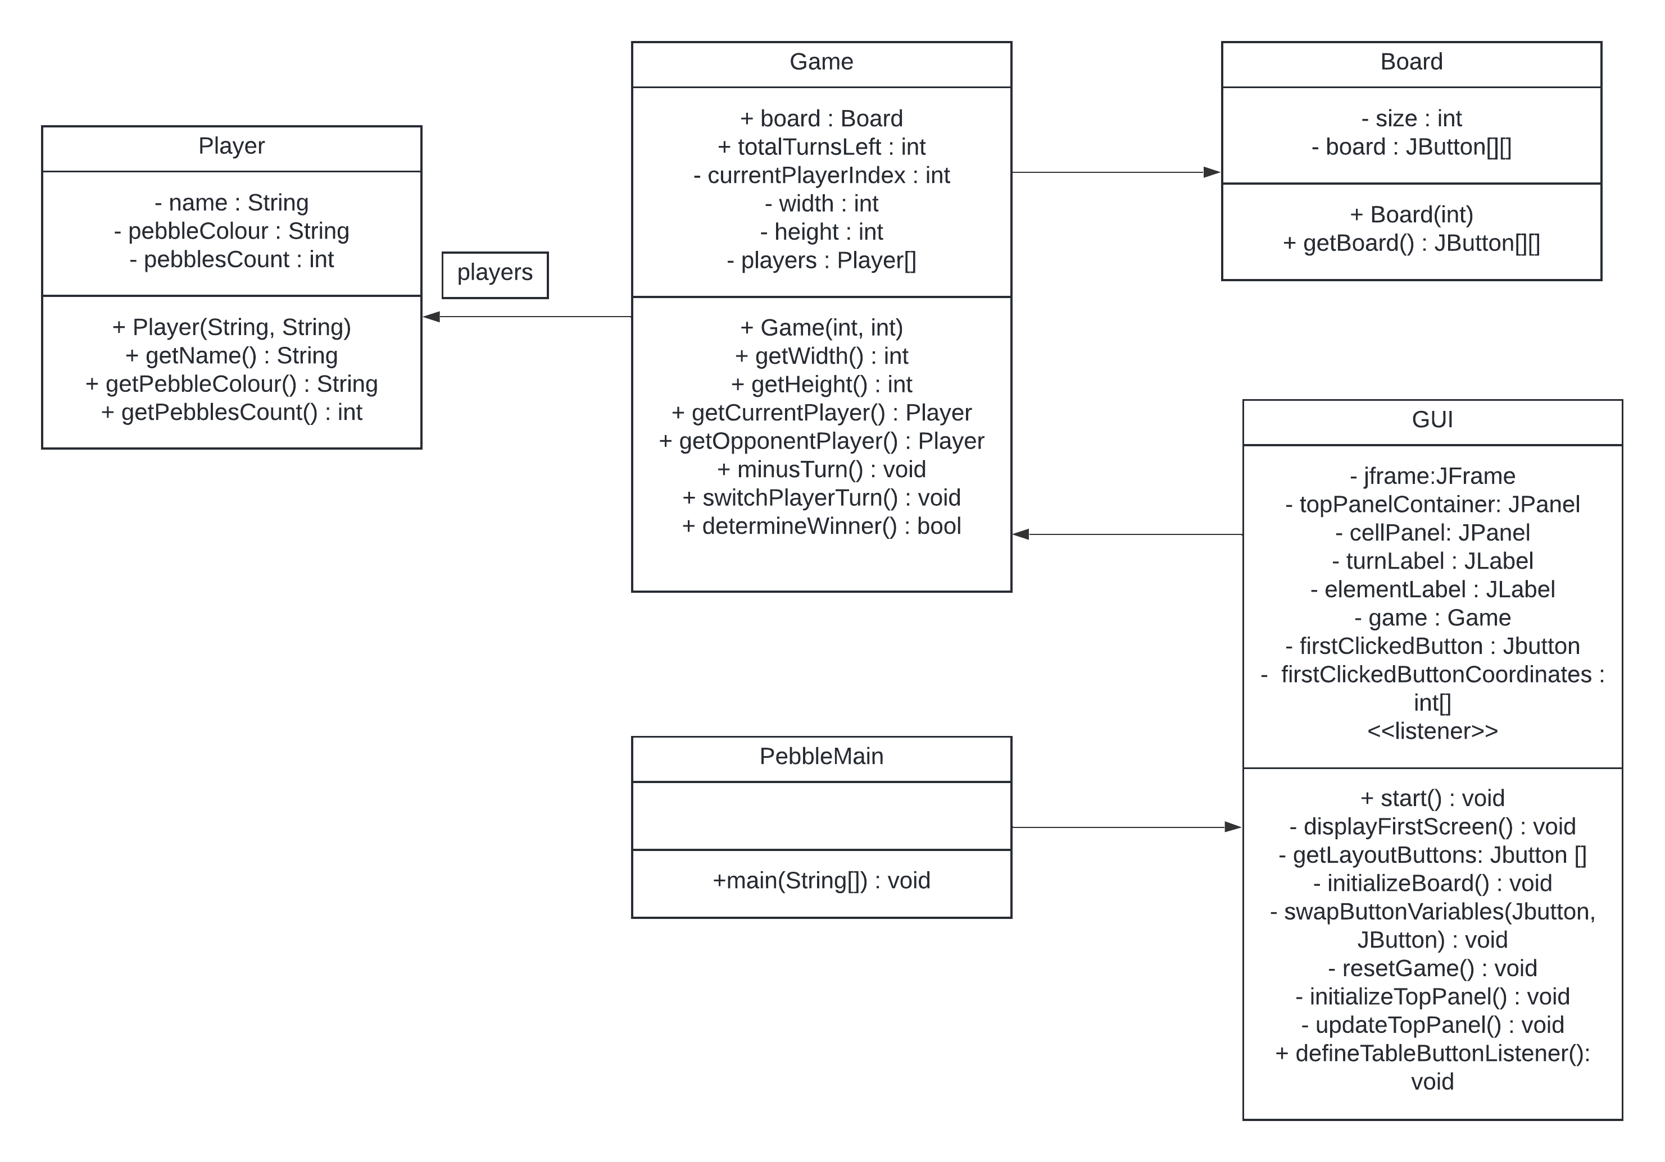

**Tests**

After running the program user sees this frame:



User can choose the board’s size.

Depending on the chosen size, user sees these boards:

3x3:

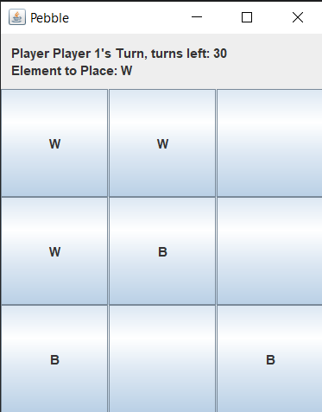

4x4:

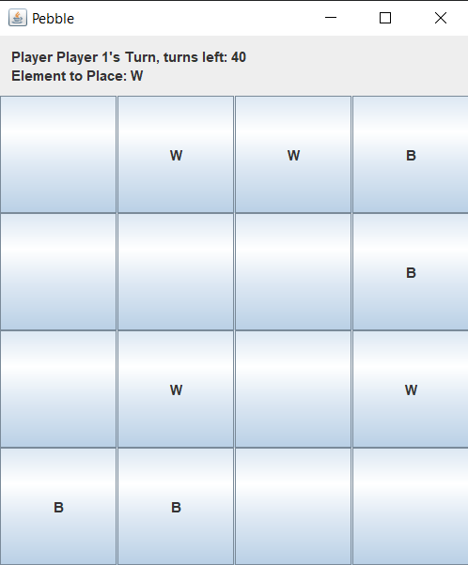

6x6:

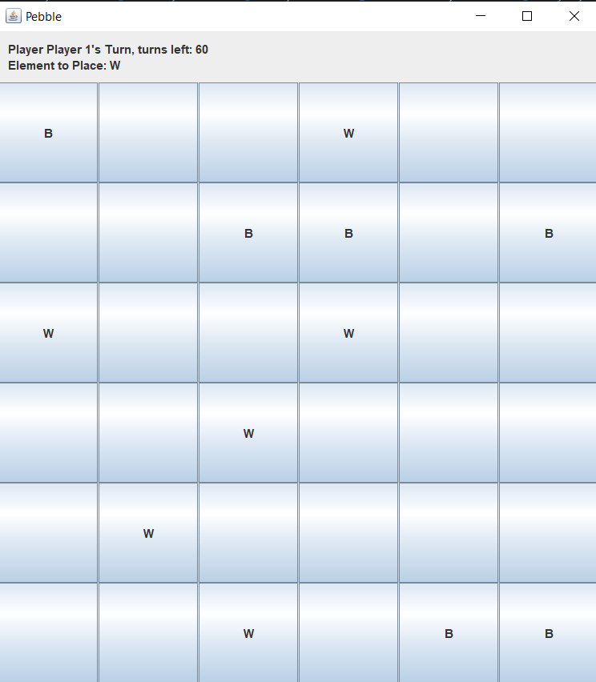

According to the game rules, the pebbles are arranged randomly.

There are a turn’s counter and an elements to move and a hint to know whose the turn is on the top panel.

User can make a move according to the rules written in the task by clicking on desired pebble and the adjacent empty cell.

If there are opponent’s pebbles on the adjacent cells, they removes.

Before the move:

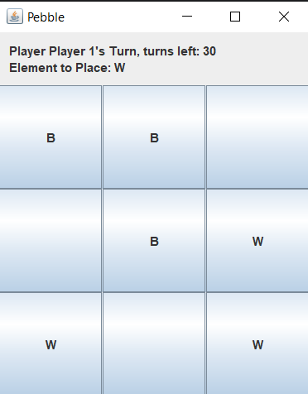

After the move:

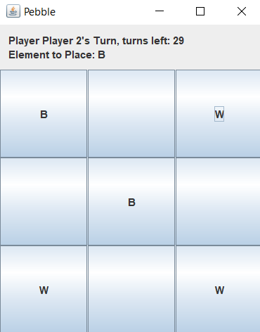

The white pebble was moved to the right top corner, the neighboring black cell was removed.

According to the rules game finishes if there are no turns left or there are no pebbles of any player left.

After the game over, a new game automatically starts.

Player having white pebbles won:

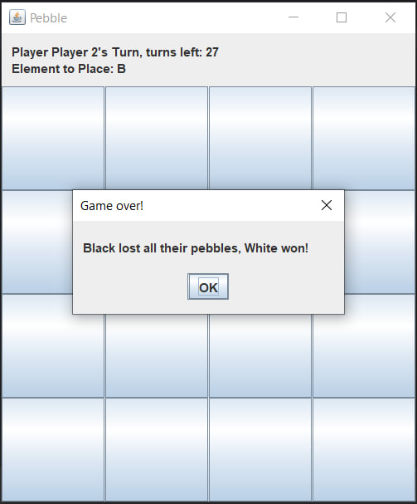

Player having black pebbles won:

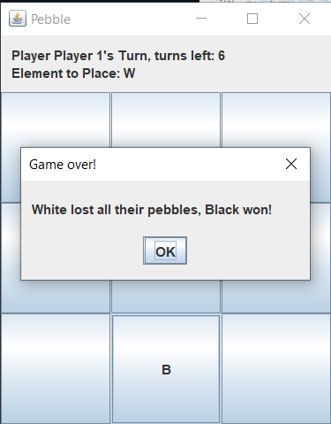

Draw:

