NAME: SHER ALI
ROLL NO: P21-8024

TASK 1:

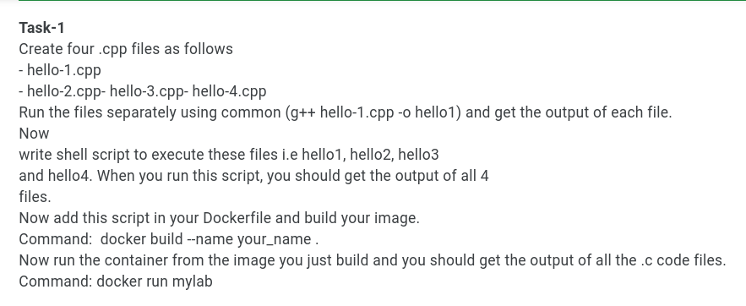

TASK 2:

