Birmingham City University
Faculty of Computing, Engineering and the Built Environment
Fewer Agents, Measured: Protocol-Mediated Multi-Agent Travel Planning and the Cost of Delegating Retrieval to a Language Model
CMP7200 Individual Master's Project
Assessment 2: Project Dissertation
Student Number: 25182589
Submitted in partial fulfilment of the requirements for the degree of MSc Artificial Intelligence
7 September 2026
All quantitative results in this dissertation were produced by gemini/gemini-3.6-flash across 1 of 20 designed evaluation scenarios, with the API layer in replay mode. Every figure and table is generated from the committed result files; no value in this document is typed by hand.

Abstract
Travel planning is a natural test of whether a language model can be trusted with a task that has verifiable answers. A plan names flights, hotels, prices and dates, and each of those either corresponds to something bookable or does not. Current single-model assistants perform badly on exactly this: the strongest single-agent baseline on the TravelPlanner benchmark completes 0.6% of tasks, failing largely through invented venues and fabricated prices (Xie et al., 2024). This dissertation asks a narrower question than "can agents plan travel", namely: given a schema-validated tool layer and a typed inter-agent protocol, what does delegating data retrieval to a language model actually cost, and what does it buy?
A working system was built and then evaluated against itself in four configurations: a single model with no tools, a six-agent design in the naive configuration first implemented, the same six-agent design after its prompt economics were tuned, and a three-agent design that keeps both protocols but performs retrieval in ordinary Python. All four share one Model Context Protocol server exposing twelve tools over three live travel APIs, and one typed agent-to-agent message layer. Every language model request is counted by provider callback rather than estimated, and every HTTP response is recorded so results replay without an API key.
Three findings matter, and the second is not the expected one. First, retrieval delegated to a model costs measurably more without being measurably better. Against the tuned six-agent arm the three-agent design used 79.2% fewer model requests, 37.1% less wall-clock time and 42.7% less money, with cost and latency intervals that do not overlap across 5 runs of each. Its groundedness interval does overlap the tuned arm's, so the saving comes at no quality penalty this evidence can detect — though the tuned arm's mean is the higher of the two, and that is recorded rather than rounded away. Second, most of the multi-agent penalty was implementation rather than architecture: tuning alone cut the six-agent arm's token use by 88.8%, which narrows the defensible claim considerably. Third, tool access is what separates a plausible itinerary from a usable one — the tool-less arm quoted 29 prices and matched 0 of them to anything real.
The evaluation also turned on the system that produced it. A conformance audit of the project's own protocol layer passed 3 of 9 checks: message priority is declared on every message and never honoured, and 3 of 12 tool schemas disagree with their implementations. The budget feasibility gate, evaluated across all twenty designed scenarios, reached a Cohen's kappa of 0.643 against the intent the scenarios were written with, and the reason is traceable: its cheapest-fare anchor sits 52% below the cheapest fare the flight API actually returned for the one route where real fares are recorded. These are defects in the artefact, found by measuring it, and they are the most useful evidence the project produced.
The principal limitation is stated plainly and early, and it is breadth rather than depth. Monthly free-tier quotas on the flight and hotel APIs mean the four-arm comparison rests on 1 recorded scenario of 20 designed. Repeats replay recorded responses and so cost no quota, which is why every figure has an interval; additional scenarios cannot be bought the same way. Differences on this scenario are therefore measurable, and generalisation to other trips is not established. The protocol and budget-gate experiments are quota-free and therefore cover the full scenario set. The contribution is a reproducible harness and a measured, appropriately narrow finding, not a benchmark result.

Contents
Right-click here and choose 'Update Field' to build the table of contents.

1. Introduction

1.1 Background
International tourism receipts returned to roughly 1.5 trillion US dollars in 2023, and arrivals recovered to close to their pre-pandemic level (UN Tourism, 2024). The industry grew back. The planning experience did not change with it. Assembling a week away still means reconciling a flight search, a hotel search, an attractions list and a budget across several tabs, then redoing most of it when one price moves. The task is tedious rather than difficult, which is precisely the profile of work that automation should suit.
Large language models look like the obvious instrument, and for the conversational part of the task they are: interpreting "a week in Bangkok for two thousand dollars, we like markets and temples" is what they do well. The difficulty appears at the next step. A travel plan is not writing to be judged on fluency; it is a set of claims about the world. A named flight either exists at that price on that date or it does not. That makes travel planning a useful test case, because unlike summarisation the output can be checked against an authority.
Checked that way, current systems do poorly. On TravelPlanner, a benchmark of 1,225 travel-planning tasks with hard commonsense and budget constraints, the strongest single-agent configuration of GPT-4 completed 0.6% of tasks end to end (Xie et al., 2024). The failures were not stylistic. Plans referred to venues that do not exist, quoted prices that were never offered, and violated the budget they had been given. The same survey literature that documents hallucination in text generation generally (Ji et al., 2023) describes a sharper version of the problem here: a fluent itinerary that cannot be booked is worse than no itinerary, because it looks finished.

1.2 The specific problem
Two structural responses to this are well established. Tool use lets a model fetch facts instead of recalling them (Schick et al., 2023), and multi-agent decomposition gives each part of a task to a component with a narrow remit (Wu et al., 2023). Both are widely adopted. What is much less settled is how they interact, and at what price. Delegating a data lookup to an agent means the lookup now happens inside a reasoning loop: the model decides which tool to call, with what arguments, and whether to call it again. Every one of those decisions is a model request, and every request re-sends the accumulated context.
That cost is rarely reported. Framework documentation counts agents and tasks; papers report task success. Neither answers whether the reasoning loop earns its cost at the point where it is applied. Retrieving a flight price is not a judgement call: once the request is parsed the parameters are fixed, the endpoint is deterministic, and there is exactly one correct call to make. A recent analysis of multi-agent failures argues from taxonomy rather than cost that a large share arise from specification and coordination rather than from model capability (Cemri et al., 2025). This project treats the matter as an empirical question about one system, which needs a system worth measuring, an instrument that counts what is spent, and a quality measure that stops cheapness being mistaken for merit.

1.3 Aim
The aim of this project is to design, build and evaluate a multi-agent travel planning system that produces day-by-day itineraries grounded in live flight, hotel and venue data through a schema-validated Model Context Protocol tool layer and a typed agent-to-agent message protocol, and to measure what delegating data retrieval to a language model costs and what it contributes.

1.4 Objectives
The objectives below are stated as they were finally met. Five differ from the proposal, and Section 7.3 tabulates every difference with its reason and its evidence rather than leaving a reader to compare the two documents.
- Build a Model Context Protocol server exposing the project's travel tools over JSON-RPC with a declared input schema for each, and audit those schemas against their implementations.
- Design and implement a typed agent-to-agent protocol with agent cards, six message types, permission validation and conversation tracking, and test its conformance rather than assert it.
- Implement the agent layer and instrument every model request so that call counts, token counts and cost are measured rather than estimated.
- Build a record-and-replay layer over every outbound HTTP request, with a hard ceiling on live calls, so the evaluation reproduces without API keys and cannot exhaust a monthly quota by accident.
- Deliver a working demonstration through both a command-line and a web interface.
- Evaluate four architectures on identical inputs — a tool-less single model, a naive six-agent design, the same design after tuning, and a three-agent design with direct retrieval — measuring requests, tokens, cost, latency and the groundedness of the resulting itinerary.
- Evaluate the components that can be measured without API quota across the full designed scenario set: protocol conformance and the budget feasibility gate.

1.5 Scope
Table 1.1: Project scope, and the reason for each exclusion.
In scope | Out of scope | Why excluded
English free-text requests | Multilingual input | A translation failure mode that does not bear on the question
Three live APIs behind one tool server | Global distribution systems | Commercial agreements are unobtainable for a student project
Read-only search and planning | Booking and payment | Payment data would require ethical approval and PCI scope
Scripted scenarios | A study with human participants | No ethical approval sought, so no human-subject data collected
Cost, latency and groundedness | Whether a traveller would enjoy it | Preference satisfaction needs participants; groundedness does not
20 designed scenarios | A four-arm pass over all twenty | Free-tier API quota, quantified in Section 6.1

One exclusion limits what can be claimed and is therefore worth stating twice. The system is a planning aid. It books nothing, and it is not evaluated on whether a traveller would choose its plans — only on whether what it names was actually retrieved. Groundedness is necessary for a usable plan, not sufficient.

1.6 Contributions
Three things are offered. The first is a reproducible measurement harness: every model request is counted through provider callbacks, every HTTP response is recorded and committed, and the whole comparison replays from disk with no credentials, so the numbers here can be checked rather than trusted. The second is a comparison that includes its own fair baseline — the multi-agent arm was tuned before being used as a comparator, which weakened the headline result and is reported anyway. The third is a conformance audit of the project's own protocol layer, which found 6 defects in work this dissertation would otherwise have described as complete.

1.7 Structure of this dissertation
Chapter 2 reviews five streams of literature and closes with a conceptual framework linking each documented failure mode to a design decision taken against it. Chapters 3 and 4 give the research approach, the evaluation design and the architecture, in each case with the alternatives that were rejected. Chapter 5 covers implementation, concentrating on the failures that shaped the system. Chapter 6 reports the experiments and their threats to validity, Chapter 7 assesses each objective against evidence, and Chapter 8 orders future work by how much each item would strengthen the claims made here.

2. Literature Review
Five bodies of work bear on the design of this system: how a single model uses tools, how multiple models are orchestrated, how tool and inter-agent interfaces are specified, how travel planning has been evaluated as a task, and how groundedness is measured. Each is examined for what it establishes and where it stops, because the gaps are what the design has to answer. The chapter closes by drawing the five together into the framework that governed the build.

2.1 Tool use by a single model, and where it stops scaling
The founding result is that a model can learn when to call an external function. Toolformer showed this could be self-supervised: the model annotates its own training text with API calls and keeps the ones that reduce perplexity (Schick et al., 2023). ReAct made the control flow explicit, interleaving a reasoning trace with actions so that observations feed back into the next decision (Yao et al., 2023), and Reflexion added a self-critique step that lets an agent revise after a failure (Shinn et al., 2023). Together these establish the mechanism this project depends on: a model can be given a tool and will use it.
The limit is structural rather than a matter of model quality. Each ReAct iteration appends its observation to the transcript and re-sends the whole thing, so context grows monotonically with the number of tool calls. The economic consequence is rarely stated in these papers, whose evaluations report task success rather than request counts: a loop that iterates eight times costs eight requests, each larger than the last. The behavioural consequence is that models attend unevenly across a long context, recovering material in the middle least reliably (Liu et al., 2024), so an instruction issued at the start of a planning task competes with API output accumulated since, and loses.
Reflexion is instructive about what these papers do not settle. Its self-critique improves outcomes where success is ambiguous enough for the model to reason about. Retrieving a flight price is not such a task: there is one correct call, and a critique step adds a request without adding information. This literature establishes that a model can decide to call a tool; it does not establish that it should be the thing deciding when the decision is already determined. That distinction is the hypothesis this project set out to measure.

2.2 Multi-agent orchestration: four positions on the same trade-off
Multi-agent frameworks divide a task among specialised components, and differ mainly in how tightly they constrain what those components say to each other. AutoGen sits at the permissive end, with agents conversing in natural language (Wu et al., 2023); the flexibility is real, and so is the cost, because an unconstrained channel can carry a malformed or misinterpreted message as easily as a correct one. MetaGPT takes the opposite position, assigning each role a standard operating procedure and passing structured documents between stages (Hong et al., 2024), which reduces ambiguity at the price of a workflow that must be specified in advance. GPTSwarm reframes the question entirely, treating the agent topology as a graph to be optimised rather than designed (Zhuge et al., 2024) — elegant, and dependent on a reward signal that a travel plan does not obviously supply. CrewAI occupies the pragmatic middle with roles, goals and tools (CrewAI, 2024).
Read together, these four are positions on one trade-off: expressiveness against verifiability. The surveys of the area map the design space thoroughly (Wang et al., 2024; Xi et al., 2023) but are organised by capability rather than cost, documenting what architectures can do and not what they spend. That framing has been challenged directly: an analysis of 200 traces across seven frameworks attributes most failures to specification and inter-agent misalignment rather than to model capability (Cemri et al., 2025), which reverses the usual inference. Adding agents adds coordination surface, and coordination surface is where these systems break — the strongest available argument for the position this project tests, that a component should be added only where judgement is required.
CrewAI was selected on practical rather than theoretical grounds, and Section 4.5 records what that cost. The relevant point here is that none of these four frameworks publishes the measurement a designer needs: what one agent, on one task, adds to the request count.

2.3 Interface specification: schemas below, message types above
Two layers need specifying in a system like this, and the literature treats them very differently. Below the agents, the Model Context Protocol standardises how a tool is described and invoked, giving each tool a JSON-RPC entry point and a declared input schema (Anthropic, 2024). The appeal is straightforward: a malformed call is rejected at the boundary rather than reaching an API as a silent error. MCP is young, however, and an early analysis of its landscape notes that the specification governs the transport and the schema declaration while leaving the correspondence between a declared schema and the code behind it entirely to the implementer (Hou et al., 2025). That is not a small gap, and Section 6.4 reports what auditing it found in this project's own server.
Above the agents there is no equivalent standard. The nearest thing is much older: the FIPA Communicative Act Library defines a typed vocabulary of speech acts for agent messaging — request, inform, agree, refuse and others — precisely so that the intent of a message is not left to interpretation (FIPA, 2002). Modern LLM frameworks largely abandoned this in favour of free text, and the observed consequence is what motivated the reintroduction of typing here. In a study of twenty-five generative agents, information transmitted between agents as natural language degraded across successive hops as each recipient paraphrased what it had received (Park et al., 2023).
This project adopts both layers — schema validation below, typed envelopes above — which is not novel in either half. What it allows is a test of whether the combination behaves as its advocates claim, and that requires treating conformance as something to measure rather than something the presence of a protocol guarantees. Section 6.4 reports that distinction mattering.

2.4 Travel planning as an evaluated task
Itinerary generation has a long pre-LLM history, generally as constrained optimisation over a fixed catalogue of points of interest (Lim et al., 2019). Those systems were sound about constraints and closed about data: nothing they produced could be booked. The current literature inverts both properties.
TravelPlanner is the reference point. It supplies 1,225 tasks with explicit budget and commonsense constraints and a sandboxed environment, and reports that the best single-agent GPT-4 configuration achieves a 0.6% final pass rate (Xie et al., 2024). The value of the benchmark is that it separates plausibility from correctness. Its limit, for a project like this one, is that its environment is a frozen snapshot: an agent that performs well on it has not demonstrated it can cope with a live API that returns a session identifier instead of results, or ignores a parameter it does not recognise. Both of those happened here, and Chapter 5 documents them.
Two follow-ups accept the benchmark's diagnosis and disagree about the remedy. One compiles the constraints into a satisfiability problem and uses a formal solver, reporting large gains and arguing that constraint satisfaction is not what a language model should be doing (Hao et al., 2024). The other keeps the model in the loop but surrounds it with external critics that verify and re-prompt, an arrangement its authors call LLM-Modulo (Gundawar et al., 2024). Both concede the same ground: the model is unreliable at the deterministic parts of the task and should be relieved of them. Both, however, apply that reasoning to constraint checking rather than to retrieval, which is the earlier and more expensive step. Extending the argument to retrieval, and measuring the result on live APIs, is where this project sits.

2.5 Measuring whether output is grounded
If the failure is invention, the evaluation has to detect invention, and surveys of hallucination in generated text make clear that fluency measures will not (Ji et al., 2023). Two approaches are relevant. FActScore decomposes generated text into atomic factual claims and verifies each against a knowledge source, reporting precision over claims rather than a single verdict per document (Min et al., 2023). RAGAS applies a related idea to retrieval-augmented generation, scoring faithfulness by asking whether each statement is supported by the retrieved context (Es et al., 2024).
Both use a language model as the judge, which is reasonable for open-domain prose and unnecessary here. Travel data has a property general text does not: the ground truth is numeric and was retrieved minutes earlier. Whether a quoted fare matches a fare the API returned is a comparison rather than an inference, and it avoids importing a second model's errors into the measurement. The metric used here follows the FActScore principle — score the atomic claims, not the document — while substituting exact matching against recorded responses for model-based adjudication. Its weakness, set out in Section 3.4, is that it measures whether named entities were retrieved and not whether they were well chosen.

2.6 Conceptual framework and the gap addressed
The five streams converge on four failure modes, each with a documented cause and each admitting a design response. Context bloat follows from the ReAct loop's monotonic transcript growth (Schick et al., 2023) and from uneven attention over long inputs (Liu et al., 2024); the response is to distil tool output and narrow each component's tool set. Protocol fragility follows from unvalidated tool invocation (Anthropic, 2024; Hou et al., 2025); the response is a declared schema per tool. Semantic drift follows from free-text handoff between agents (Park et al., 2023); the response is a typed envelope with validated permissions, in the FIPA tradition (FIPA, 2002). Hallucinated venues and fares follow from generating what should be retrieved (Xie et al., 2024); the response is to ground every claim in a recorded API response and to score what can be traced back to one.
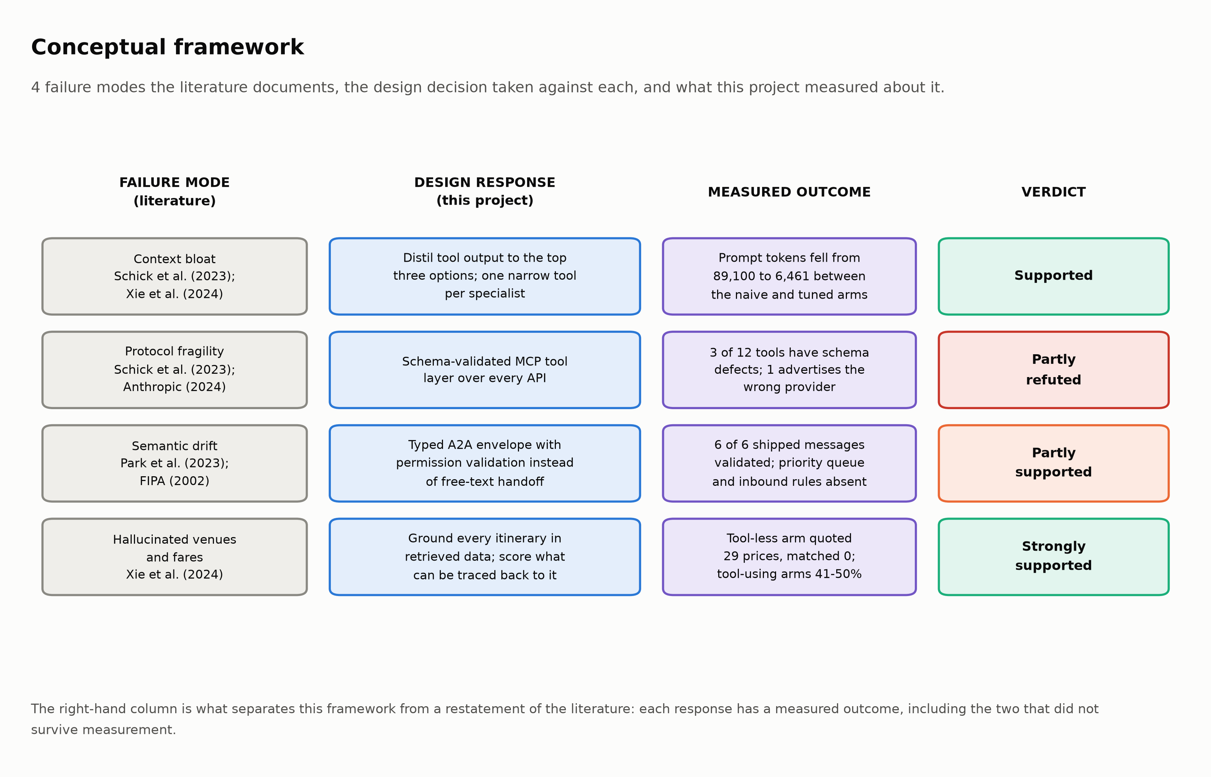
Figure 2.1: The conceptual framework. Each documented failure mode, the design decision taken against it, and the measured outcome. Two of the four responses did not survive measurement.
The fourth column is what distinguishes this framework from a restatement of its sources. Each response was tested, and two did not hold. The schema layer that was supposed to prevent malformed invocation contains 3 tools whose declared schemas disagree with their implementations, and the typed message layer honours its permission rules while ignoring the priority ordering it advertises — 3 of 9 conformance checks pass. Adopting a protocol is not the same as conforming to it, and the literature reviewed above offers no method for telling the difference. Section 6.4 supplies one.
The gap this dissertation addresses can now be stated precisely. The tool literature establishes that models can retrieve; the multi-agent literature establishes that tasks can be decomposed; the travel literature establishes that ungrounded planning fails; and the most recent failure analysis suggests coordination is where multi-agent systems break (Cemri et al., 2025). None of them measures what a language model costs at a step where no judgement is required, on live consumer APIs, against a multi-agent baseline that has been tuned first so the comparison is fair. That measurement is the contribution, and its narrowness is deliberate: Chapter 6 reports that tuning the baseline removed most of the difference the project expected to find.

3. Methodology

3.1 Research approach
The contribution of this project is a working system and what measuring it revealed, which places it in design science: knowledge is produced by building an artefact and evaluating it against the problem it was built for (Hevner et al., 2004). The six-activity process model — problem identification, objective definition, design and development, demonstration, evaluation, communication — supplies the structure, and its authors are explicit that the process is iterative, with evaluation feeding back into design (Peffers et al., 2007). That iteration is the part that mattered here, because two of the three cycles ended by contradicting the design that entered them.
Two alternatives were rejected. A comparative user study of commercial assistants would have produced findings about products rather than architecture, and needed ethical approval the question did not warrant. A formal treatment would have avoided the quota problem and produced no evidence that any of it works against a live endpoint, which is where every interesting failure in Chapter 5 occurred.
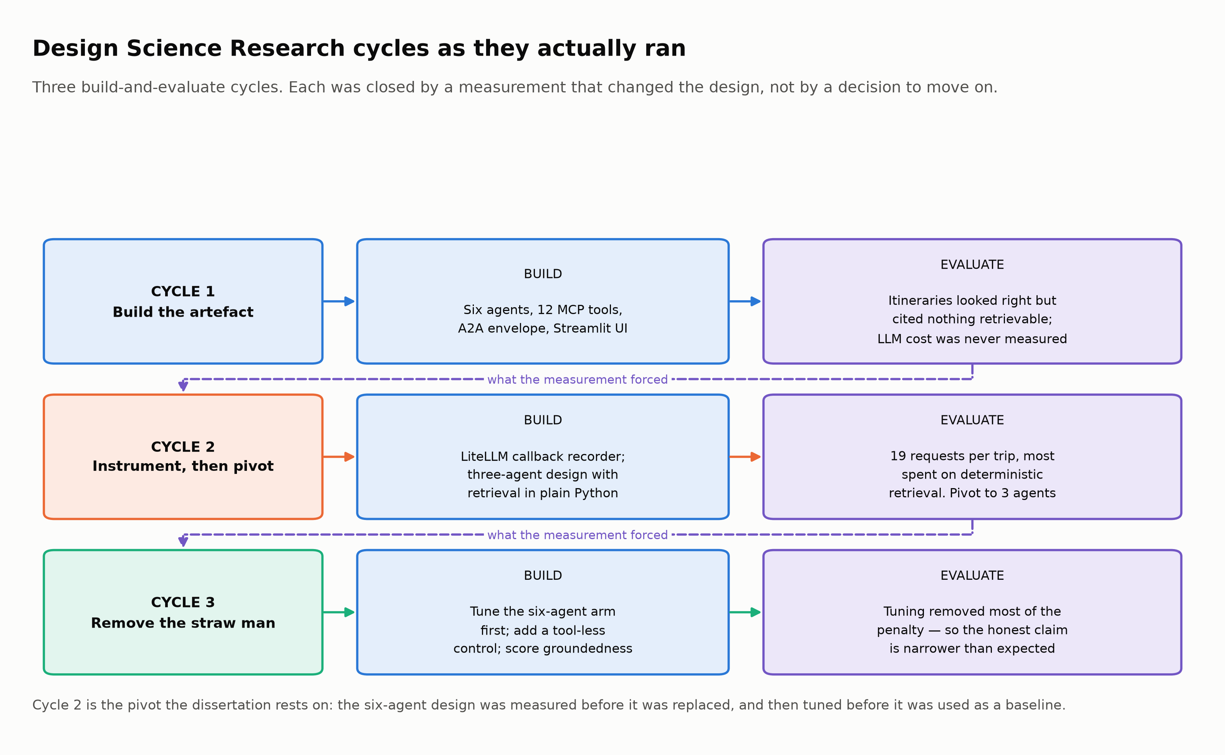
Figure 3.1: The three design-science cycles as they actually ran. Each was closed by a measurement that changed the design rather than by a decision to move on.
Cycle one built the artefact the proposal specified and ended when the system was found producing confident itineraries that cited nothing retrievable, because a path defect meant every tool call was failing silently. Cycle two added instrumentation, and the resulting count motivated the three-agent design. Cycle three removed the obvious objection to that comparison by tuning the six-agent arm first, and produced the result that weakened the project's own thesis.

3.2 Why four architectures rather than two
The comparison could have been run as three agents against six, and that design is unsound in two directions at once. Against the six-agent implementation as first written, any advantage the three-agent design showed is open to the objection that the baseline was badly configured. Without a tool-less control, nothing establishes that the tool layer contributes at all, and the cheapest architecture appears to win while its output is unverifiable.
Four arms follow. A is the control with no tools at all, establishing what the tool layer buys and what a plan looks like when nothing in it was retrieved. B is the six-agent design as first implemented — its cost is what motivated the pivot, so removing it would hide the reasoning. C is the same six roles tuned: one narrow tool each, distilled results, concurrent execution, shorter prompts. D is the three-agent design with retrieval in ordinary Python, which is the claim under test. Appendix L tabulates the role each plays.
Arm C is the methodological centre of the evaluation and it was expensive to include: building it meant implementing three commitments the proposal had made and the first implementation had not, then handing the improved version the strongest possible position before comparing against it. It also produced the result in Section 6.3, that most of the difference the project set out to demonstrate was implementation quality rather than architecture. Arm C is what makes that finding available; its absence is what would have made the headline claim indefensible under questioning.
One control is imperfect and is declared here rather than in a footnote. The six-agent arms instantiate five agents: the conversational agent is omitted so every arm receives one identical request string, since a multi-turn dialogue cannot be held identical across four architectures. The comparison is therefore between three agents and a five-agent ablation of the six-agent design. The omitted role is the same in both multi-agent arms and absent from the other two, so it does not bias the contrast — but the arms are named for the design they represent, and the difference should be visible.

3.3 Scenario design
20 scenarios were written before any measurement, to span the axes that change an itinerary's difficulty rather than to sample uniformly: trip length from three to fourteen nights, distance from short-haul Dubai to long-haul Tokyo, party size from solo to a family of four, destination price tier, multi-city routes, and budgets from generous down to deliberately impossible. Every arm receives the identical request string, so nothing in the comparison depends on phrasing.
Two scenarios were written to be unaffordable, deliberately: an architecture that confidently plans a trip nobody could afford is failing in the way the literature describes (Xie et al., 2024), and only an impossible case exposes it. Those two made the budget-gate result in Section 6.5 possible, and they also caught a defect in the gate itself. Each scenario further records the facts a reader extracts from its request — origin, legs, nights, date, budget, party — as declared ground truth. No arm reads that field; it exists so the gate can be evaluated with exact parameters rather than parsed guesses.

3.4 Metrics, and what each one cannot tell you
Seven metrics are collected, and each is recorded together with what it cannot establish; Appendix H tabulates all seven with their provenance and their limits. Four concern cost — model requests, prompt and completion tokens, dollar cost and wall-clock latency — and all four are obtained by instrument rather than by inference, which is what makes them comparable across arms. Two concern quality: the proportion of quoted prices matching a retrieved fare, and the proportion of named hotels and airlines appearing in the retrieved results. The seventh is protocol conformance, a count of executable checks passed.
The groundedness measure's asymmetry needs stating plainly, because reporting its two halves as equals would overstate the result. Matching a name is weak evidence: on the recorded scenario the arm with no tool access named a real airline for the route, having called nothing. Matching a price is strong, because landing within 2% of a fare quoted minutes earlier is not something prior knowledge delivers. The tolerance exists because an itinerary legitimately rounds and sums nightly rates into totals, and it is narrow enough that invention does not pass it. Price grounding carries the claim.

3.5 Controls, fairness and reproducibility
Four properties are enforced by the harness rather than by care. Every arm receives the byte-identical request, and every arm is measured by the same instrument, so a hand-counted figure can never be compared against a measured one. The arm with deterministic retrieval runs first in each scenario, which populates the response cache with canonical parameters so the agent arms replay rather than issuing slightly different live queries. Results are checkpointed after each scenario, so an interrupted run keeps what it has already paid for. Section 5.5 describes the mechanisms.
The weakness of replay is worth naming here, because it qualifies one of the four headline metrics. Replayed retrieval takes milliseconds, so latency figures understate a live run and the direct arm's retrieval phase reads as effectively zero. Comparisons between arms remain valid, since all four replay the same responses; they are not estimates of production latency.

3.6 Data strategy and its limits
The evaluation data is machine-generated — recorded API responses and measured metrics — with no human-subject data of any kind. The binding constraint is quota: the flight API allows thirty requests a month and the hotel API fifty, on free tiers that cannot be topped up, and a single flight search costs two because the endpoint is asynchronous and must be polled. One scenario therefore consumes roughly four of eighty monthly requests, and recording all 20 designed scenarios spans more than one monthly cycle. 1 is recorded, which is the real sample size for the cost comparison and is quoted as such wherever those numbers appear.
This shaped what could be claimed. The response was not to present one scenario as twenty, but to ask which questions can be answered without quota and answer those completely: protocol conformance needs no network, and the feasibility gate needs neither network nor model. Both are evaluated across the full scenario set, and both produced negative findings that the quota-limited comparison could not have produced. Quota was also this project's largest risk: Appendix N holds the register, the controls built before the arms were, and which risks occurred regardless.

3.7 Ethics and professional considerations
No human participants were involved, no personal data was collected and no ethical approval was required; this was confirmed with the supervisor at the first check-in. All API use is read-only and within published free-tier terms, and no endpoint was scraped. The response cache holds third-party commercial data — hotel names, review scores, fares — locally and solely to reproduce the reported results; it contains no personal data, and request headers carrying credentials are excluded from what is written to disk.
One obligation runs beyond compliance and shaped a measurement. The BCS code requires members not to misrepresent what their work can do (BCS, 2022), and a system that prints prices invites the reading that those prices are bookable. That is why groundedness is measured rather than assumed. Section 7.5 returns to the professional and legal position with the measured result in hand.

4. Design

4.1 Architecture
The system is layered by the kind of work each layer does rather than by the technology it uses. Layer one accepts a request. Layer two turns free text into a typed structure. Layer three retrieves data. Layer four assembles a plan. The division matters because the research question is about layer three: it is the only layer whose implementation differs between the four evaluated arms, and holding the other three constant is what makes the comparison mean anything.
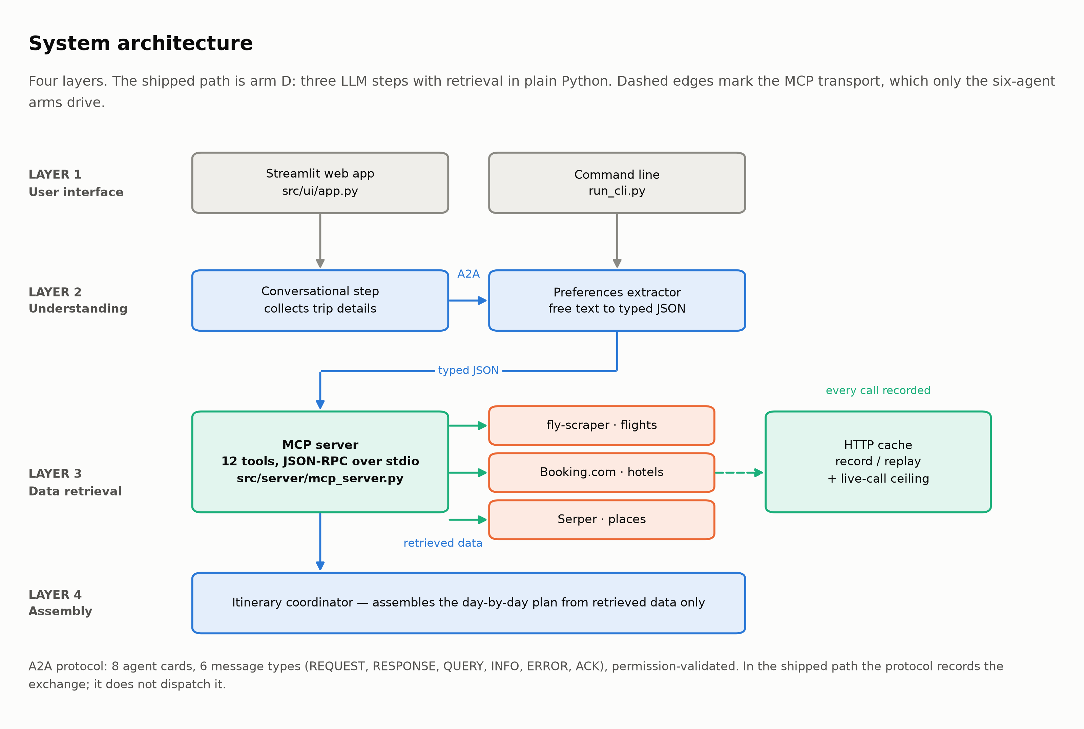
Figure 4.1: System architecture. The shipped configuration performs retrieval in ordinary Python; the JSON-RPC transport is exercised by the six-agent arms.
One property of the diagram was misdrawn in an earlier version of this project's documentation, so it is worth stating explicitly: the tool server is not the only route to an external API. The shipped path imports the tool functions and calls them in process, and the flight tool reaches its upstream endpoint without passing through the server at all. The JSON-RPC transport is genuinely exercised, but only by the naive six-agent arm, whose agents hold wrappers that spawn the server as a subprocess. Section 7.2 assesses what that means for the objective the server was built to satisfy.
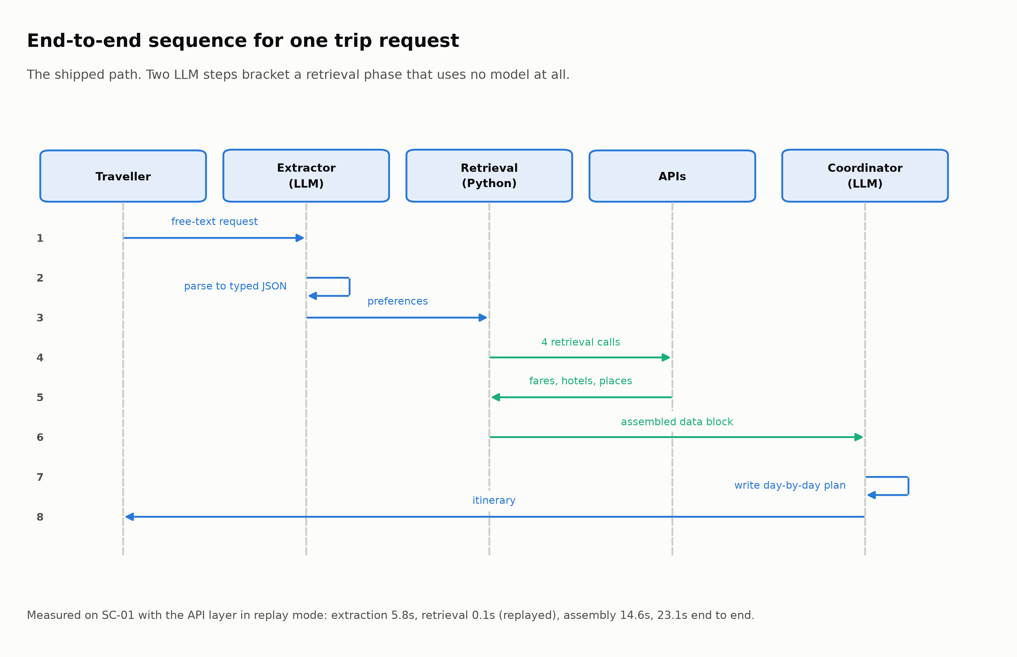
Figure 4.2: End-to-end sequence for one request in the shipped configuration, with measured phase timings.
The sequence makes the design argument visible. Two model steps bracket a retrieval phase that uses no model. Both model steps have genuine work: turning "for two adults, leaving on the fifteenth" into structured fields, and arranging retrieved options into a plan whose pacing and proximity make sense. Between them there is nothing to decide — the parameters are fixed, and four calls fetch flights, hotels, attractions and restaurants.
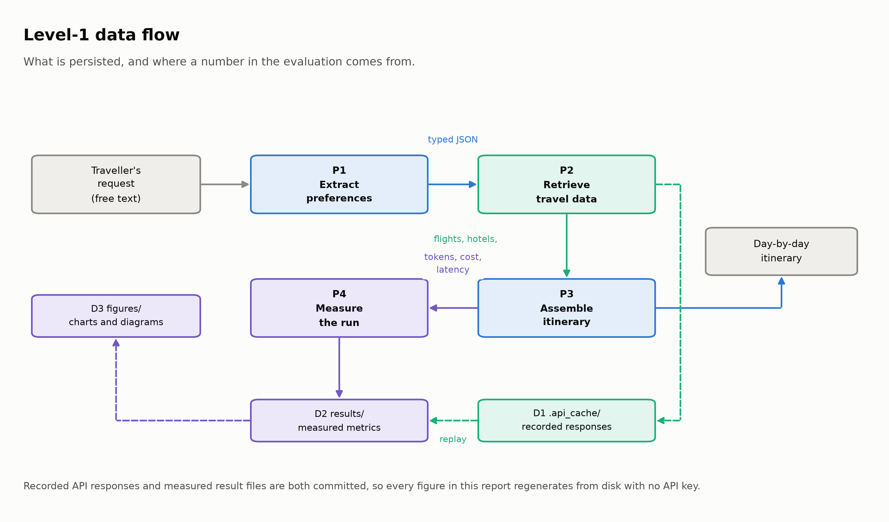
Figure 4.3: Level-1 data flow, showing the three persisted stores that make the reported results reproducible.

4.2 Module decomposition
The implementation is 24,798 lines of Python across 83 files; Appendix E maps every module to its responsibility. Two boundaries in that map were placed deliberately, and both had been violated earlier in development. Measurement is separated from the code being measured, because an early version incremented a counter inside the arm it was measuring and produced a figure that counted tasks rather than requests. Evaluation code is kept out of the shipped path, because the distillation helpers written for the tuned arm are meaningful only as an experimental treatment and would have become production behaviour had they been placed in the tool layer.
Three further separations carry weight. The message layer is identical across all four arms, so it must not depend on any of them — that independence is what lets the comparison isolate retrieval. The tool server runs as a subprocess and cannot import from its caller's context, which caused the failure in Section 5.2. And every outbound call passes through one caching chokepoint, because a quota guarantee any call site can bypass is not a guarantee.

4.3 Interface contracts

4.3.1 The tool interface
Each tool declares a name, a description and a JSON input schema, and is invoked over JSON-RPC with an arguments object. The contract's value is that a malformed call fails at the boundary with a schema error rather than reaching a third-party API as a well-formed request with wrong content. Its weakness is that the schema is a declaration and nothing in the protocol requires it to match the function behind it (Anthropic, 2024; Hou et al., 2025), which is the gap Section 6.4 measured.
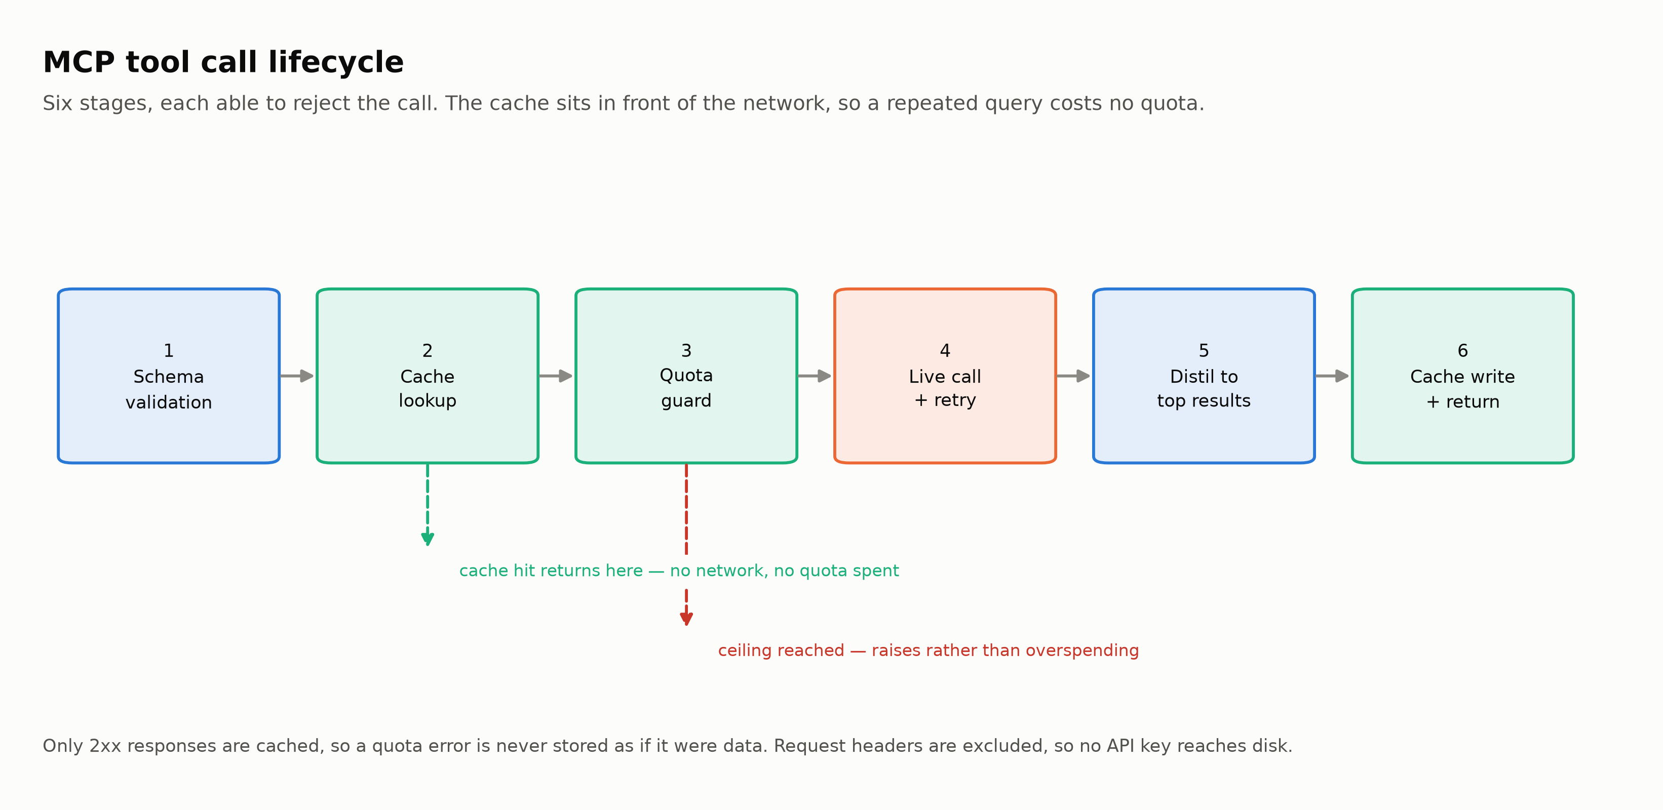
Figure 4.4: The six-stage tool call lifecycle. Two stages can return early: a cache hit avoids the network entirely, and the quota guard refuses rather than overspending.
The cache position is the consequential design choice. Placing it in front of the network rather than inside each tool means every tool inherits both replay and quota protection without knowing either exists, and adding a tool cannot accidentally bypass them. The cost is that the cache key is computed from method, URL, parameters and body, so a semantically equivalent call with reordered parameters misses — acceptable here because the deterministic arm issues canonical parameters, and the reason that arm runs first.

4.3.2 The inter-agent interface
Every inter-agent message carries a sender, a receiver, one of six types, a conversation identifier, a timestamp, a priority and a typed payload. Before delivery, the sender's agent card is consulted to confirm the recipient is permitted. The types follow the speech-act tradition (FIPA, 2002): a request expects action, a response carries a result, an error reports a failure, and an acknowledgement confirms receipt.
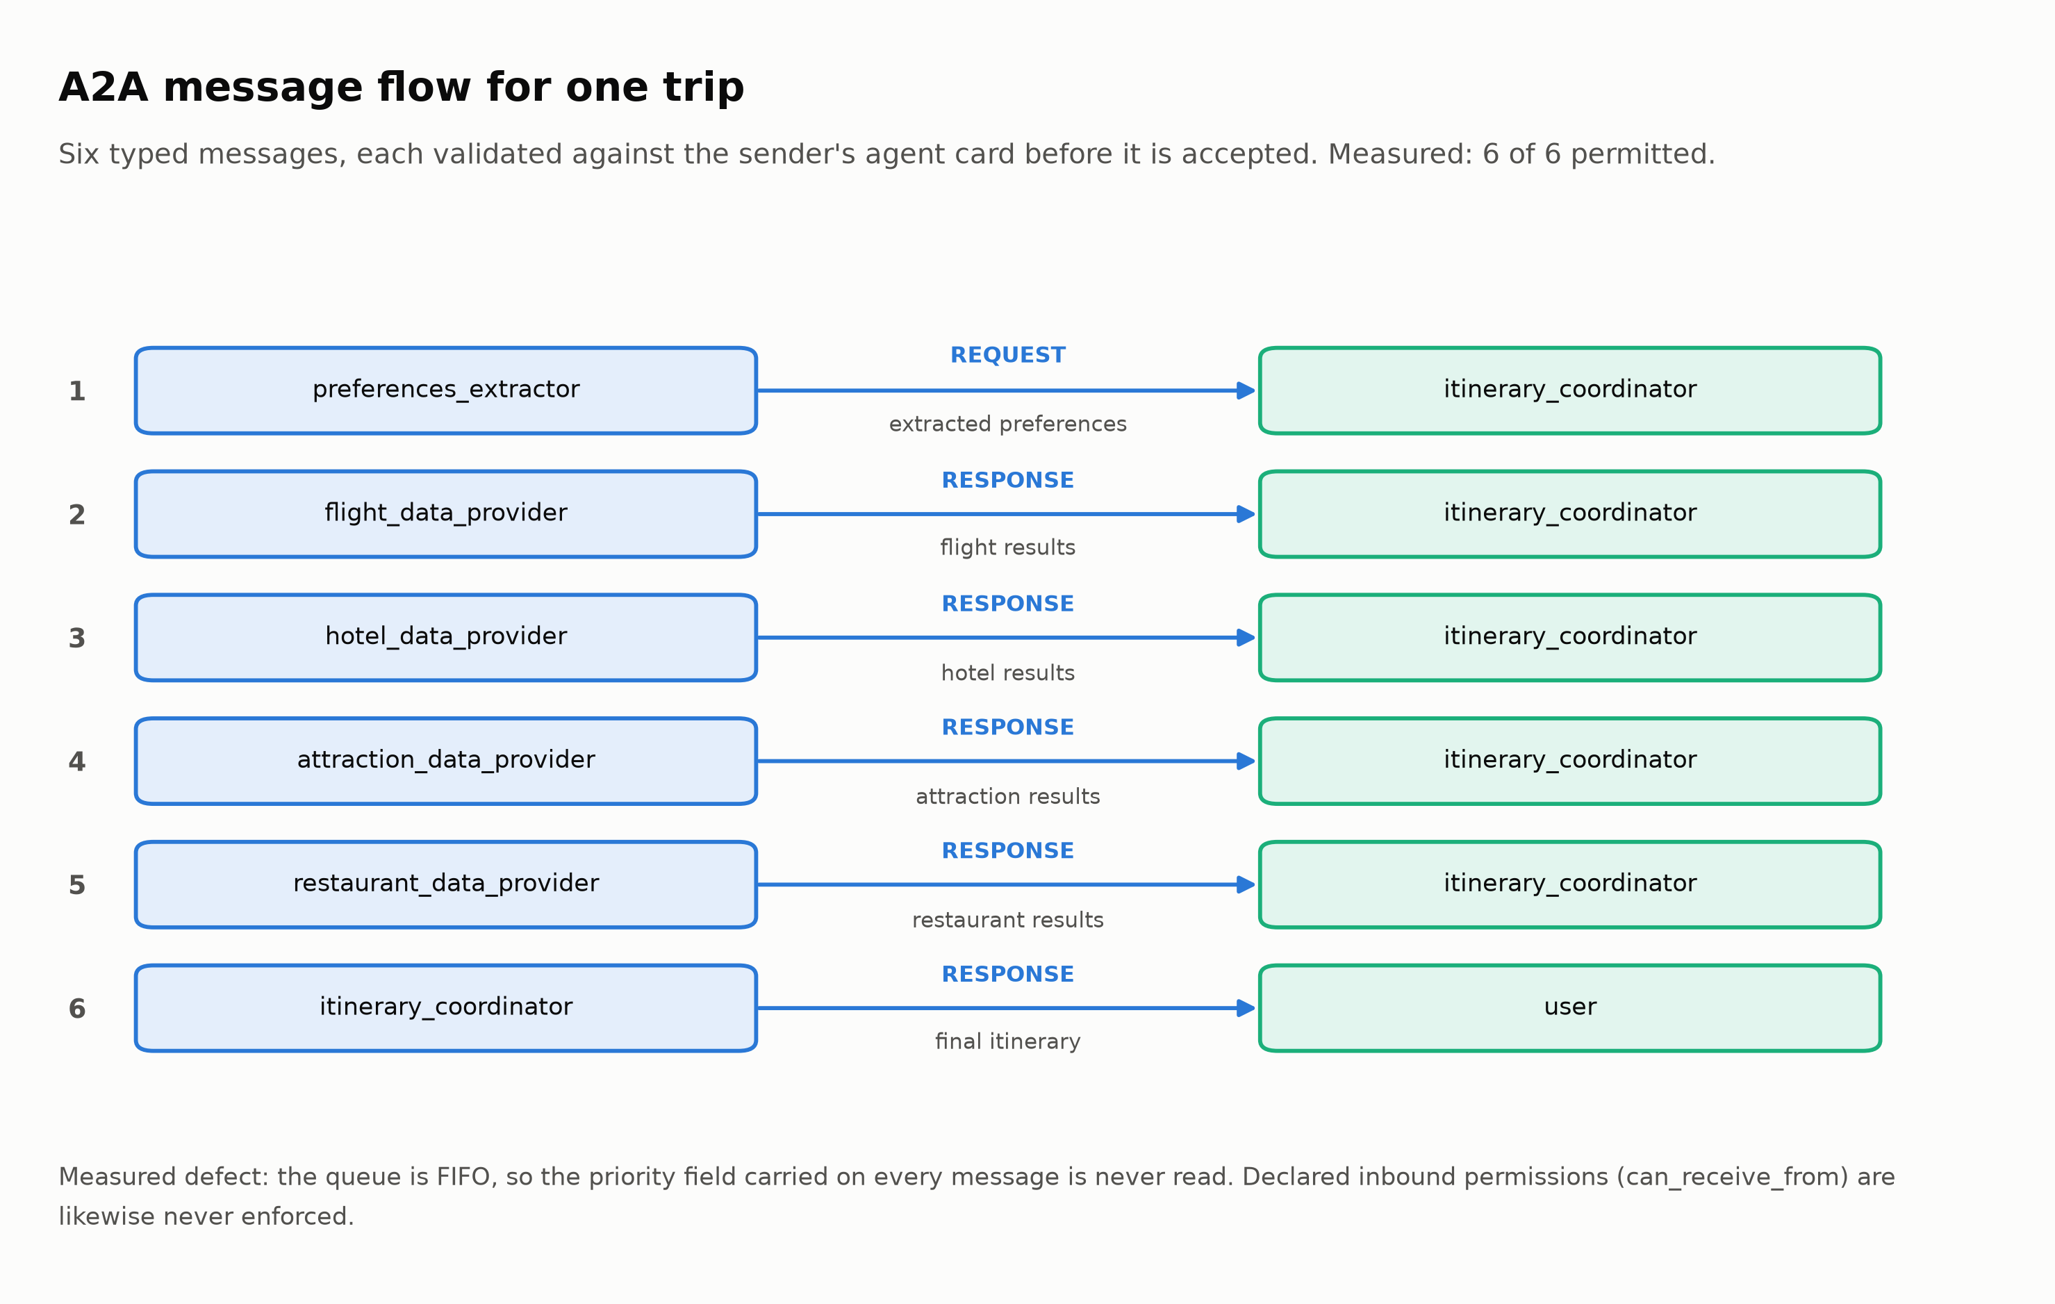
Figure 4.5: The six messages exchanged for one trip, with the measured conformance result and the two declared behaviours that are not implemented.
The contract holds in the direction that is exercised and not in the directions that are not. Permission validation works: an undeclared edge and an empty payload are both refused, and all 6 messages the shipped path emits are permitted. Two declared behaviours are absent. The priority field is written on every message and never read, because the queue is first-in-first-out. Each agent card declares which senders it accepts, and that declaration is never consulted, because validation examines only the sender's outbound list. Both are reported in Section 6.4 and neither was known before the conformance audit was written.

4.4 Key design decisions

4.4.1 Where a language model is used, and where it is not
The governing decision is a test applied to each step: does this step require a judgement that cannot be expressed as code? Interpreting a free-text request does, because the mapping from phrasing to fields is open-ended. Composing a day-by-day plan does, because there is no single correct ordering and the trade-offs between proximity, pacing and budget are matters of taste. Fetching a fare for a known route on a known date does not. The three-agent design follows directly from applying that test consistently, and the comparison in Chapter 6 is a test of whether the test was right.
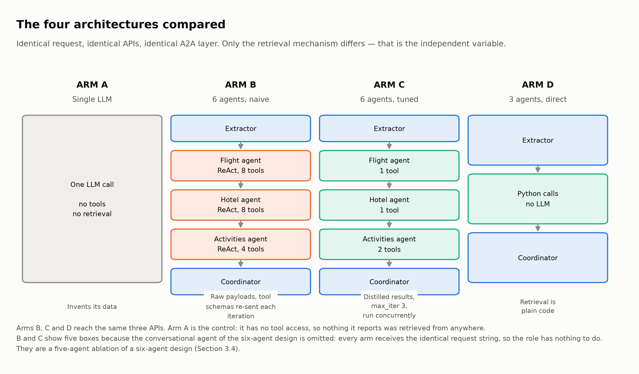
Figure 4.6: The four evaluated configurations. Only the retrieval mechanism differs; the request, the APIs and the message layer are held constant.

4.4.2 Budget allocation derived from cost, not from a fixed split
The system must decide how much of a stated budget goes to flights, accommodation, food and activities. The original implementation used one fixed percentage split for every trip, which is wrong in a way that compounds: airfare is incurred per person and scales with distance, while accommodation is incurred per night and is shared between travellers. A split that suits a solo short-haul trip therefore misallocates badly for a family travelling far. The replacement derives the split from what the components of that specific trip cost, and honours an explicit split when the traveller gives one, because a user who says how to divide their money has expressed a preference and not made an error.

4.4.3 A feasibility floor rather than a rejection rule
A budget below what a trip can possibly cost should be refused, because planning it produces a fiction. The first implementation refused on a fixed formula that ignored the destination entirely, judging a seven hundred dollar trip to Bangkok and a seven hundred dollar trip to London by the same threshold and accepting both. The replacement estimates the cost of the specific trip at three standards — minimum, comfortable and luxury — from destination price tier, flight distance band, nights, party size and room sharing, then refuses only below the minimum. Above it, a tight budget produces a warning and proceeds, because tightness is a legitimate choice and only impossibility is not. Section 6.5 reports how well this works, including the case it gets wrong and why.

4.4.4 Validation of output structure in code, not in the prompt
A five-night trip needs five days in its itinerary. The original approach instructed the model in capital letters to write every day, which fails intermittently and silently. The current approach counts the day headings in the generated text, compares against the extracted duration, and appends an explicit notice when days are missing. A check that can fail loudly is worth more than an instruction that can be ignored quietly, and this is the smallest example of the chapter's general principle.

4.5 Technology choices, with their costs
Table 4.1: Technology decisions. The final column is the one that matters for Chapter 7: every choice constrained something later.
Decision | Selected (rejected) | What it bought | What it cost
Agent framework | CrewAI (AutoGen, MetaGPT, LangGraph) | Roles map onto travel sub-tasks; tool binding is a few lines | Its reasoning loop is not directly controllable, so request counts vary between runs and must be measured, never assumed
Tool protocol | MCP over JSON-RPC (vendor function-calling, bespoke REST) | Vendor-neutral, declared schemas, one server for every tool | A subprocess boundary, a serialisation limit on large payloads, and no guarantee a schema matches its implementation
Inter-agent messaging | Typed envelope with agent cards (free text, framework threads) | Permission validation and a full audit trail per conversation | In the shipped path it records rather than dispatches, so part of the library is unexercised
Model | Gemini 3.6 Flash (the proposal's GPT-4o split, Claude) | A free tier that made repeated evaluation affordable, and callbacks exposing per-request usage | Output tokens dominate its cost, so cost tracks verbosity; results are specific to this model; and a per-minute rate limit forced the harness to pace itself
Flights | fly-scraper (Kiwi.com as proposed, Amadeus) | A free tier still available when Kiwi withdrew theirs | Thirty requests a month, an asynchronous two-phase search, and parameters ignored rather than rejected
Hotels | Booking.com (Hotels.com, Expedia) | One provider covering search, review scores and nearby venues | Fifty requests a month; enrichment costs two extra requests per hotel, so it is disabled by default
Venue search | Serper.dev (Bing, Brave, scraping) | A quota generous enough never to constrain the evaluation | Results are web snippets, so venue data is less structured than flight or hotel data
Interface | Streamlit and a command-line client (Gradio, Flask, React) | Fastest route to a demonstrable artefact | Its rerun model does not suit a streaming conversation, so the web interface asks a fixed question sequence

The model choice altered the project's economics rather than merely its provider. The proposal specified a two-model split — expensive for dialogue and synthesis, cheap for extraction and search — with a target under one dollar per itinerary. A free tier removed the reason for that complexity, and with a single model the arms differ only in architecture, which makes the comparison cleaner than the proposal's design would have been.
One consequence of the framework choice governs the difference between the naive and tuned arms, so it is worth naming here and quantifying in Section 6.3. Every tool bound to an agent contributes its name, description and JSON schema to that agent's prompt, and the prompt is re-sent on every iteration of its reasoning loop. In the naive configuration the hotel agent holds eight tools, so eight schemas are re-serialised on each of up to ten iterations. The framework makes tool binding trivial, which is exactly why the cost of binding many tools stays invisible until it is measured.

5. Implementation
This chapter is organised around what went wrong, because that is where the engineering was. Six failures are described in detail. Four were silent: the system reported success, produced plausible output, and was wrong. Silent failures are the interesting category, because the work is not in fixing them but in noticing that anything needs fixing.

5.1 Build order and environment
The system is 24,798 lines of Python across 83 files, developed over 115 commits, and Appendix E breaks it down by area. It was built in the order the layers depend on each other: the tool server first, because nothing can be retrieved without it; then the message layer, the agents and the interfaces; and last, later than it should have been, the measurement infrastructure. That ordering is the root of the first failure below, and Section 7.6 argues it should have been reversed.

5.2 The tool server failed silently, and the system hid it
The first working end-to-end run produced a complete, confident, well-formatted itinerary with named hotels and specific fares. None of it was real. Every tool call was failing, and the system reported nothing wrong.
The symptom was a message from the client wrapper: every invocation returned "Connection lost". The cause was mundane. The tool server runs as a subprocess launched by path, so the project root is not on the module search path when the interpreter starts it, and the first import from the project's own package raises. The server died during startup, the client saw a closed pipe, and reported a transport error. The fix is three lines inserting the project root into the search path before any first-party import.
The fix is trivial and the lesson is not. The failure was invisible from outside because of how the agents behaved when a tool returned an error: they proceeded, and wrote the itinerary from model knowledge instead. This is precisely what the literature reports (Xie et al., 2024), reproduced accidentally inside a system built to prevent it, and undetectable by inspecting the output. A plausible itinerary is not evidence that retrieval worked, which is why groundedness scoring exists at all — it is the only check that would have caught this, and it was written because this happened.

5.3 Two bugs in one endpoint, both returning HTTP 200
Flight search failed in two independent ways, and both returned a success status. The recorded response cache preserves all of it, so the sequence can be verified rather than asserted.

5.3.1 Date parameters that are ignored rather than rejected
The endpoint documents its origin and destination as camelCase and its dates likewise. The first implementation sent snake_case date parameters. The API accepted the request, returned HTTP 200, ignored the dates it did not recognise, and searched a default window instead. Nothing anywhere reported an error; the itineraries simply carried dates the traveller had not asked for.
The cache holds 2 recordings made with the snake_case parameters. Both are small — 703 and 3,269 bytes — and both contain 0 itineraries. The recording made after the parameters were corrected is 80,363 bytes and contains 10. This is a class of API defect worth naming: a parameter that is rejected costs minutes, and a parameter that is silently discarded can cost weeks, because every observable signal says the call succeeded.

5.3.2 A search endpoint that does not return results
Correcting the parameters was not sufficient. The endpoint is asynchronous: the search request starts a search and returns a session identifier with a status of "incomplete", and results must be collected from a second endpoint using that identifier. The first implementation treated the initial response as final, so flight search returned nothing on every single call.
The evidence is again in the cache. The corrected search response carries 10 itineraries and a status of "incomplete"; the poll that follows it returns 2,348,924 bytes containing 173 itineraries with a status of "complete". Reading only the first response therefore discarded most of the available fares even once the parameters were right. A third defect compounded the diagnosis: the provider's console lists these paths in the singular while only the plural form resolves, so an exploratory call made from the documentation returns 404 and suggests the endpoint does not exist.
What made this expensive was a coincidence. For a long period the credential had exhausted its monthly allowance, so the call was rejected before reaching the parsing code and the empty result looked like a quota problem rather than a parsing one. Two independent faults with the same observable symptom is the worst case for diagnosis. The cache now stores only successful responses for exactly this reason: a quota rejection must never be replayed as though it were data.

5.4 The headline metric was not being measured
The comparison's central claim is about model requests, and for a period that number was fabricated by the harness. The code incremented a counter by a constant after each phase; one line carried the comment that the figure was simulated. It counted tasks, not requests. Since the whole point of the criticism levelled at the multi-agent arm is that its reasoning loops issue many requests per task, the measurement was blind to the effect it existed to detect.
The replacement registers callbacks with the model client, which every completion passes through, and records model, prompt tokens, completion tokens, cost and latency per request. The difference was not marginal. The naive six-agent arm, credited with a request per task, actually issues 21 for a single trip. Two earlier claims in this project's own documentation — a request count and a cost per itinerary — were wrong by roughly a factor of four once real counting began.
Instrumenting correctly then exposed a second-order problem. The client dispatches its callbacks off the calling thread, so reading the counters immediately after a run undercounts: an early check observed three completions and only two callbacks. The session now drains before reporting, blocking until no new event has arrived for a quiet period. This matters most for the tuned arm, whose three specialists run concurrently, and draining before releasing a session also stops a late callback being attributed to the next scenario.
A detail from the recorded data confirms the concurrency works as designed. The tuned arm's summed model time is 51.0 seconds while its wall-clock time is 36.8 seconds. Summed request time exceeding elapsed time is only possible if requests overlapped, which is direct evidence of the thread pool doing its job — a claim the proposal made and could not previously support.

5.5 Quota as a first-class engineering constraint
The flight and hotel APIs allow thirty and fifty requests a month. A single careless run can consume a month's allowance in under a minute, and it cannot be bought back. This is not a nuisance to be handled with care; care is exactly what fails at two in the morning. It had to become a property of the code.
Three mechanisms were built. Every outbound request passes through one cache with three modes — replay never touches the network, record calls live only on a miss, live refreshes deliberately. A ceiling on live calls raises rather than proceeding. And the runner checkpoints after every run. The cache holds 30 recorded responses, and the published comparison replays from them with no credentials at all.
One design decision in the retrieval layer came directly from quota arithmetic. Hotel search originally enriched each result with a review breakdown and a nearby-venues lookup, at two additional requests per hotel. For a ten-hotel result that is twenty requests against a fifty-request monthly allowance, and none of the enrichment reached the itinerary, because the assembly step never used those fields. Enrichment is now off by default behind an environment variable. This is the clearest case in the project of a feature whose cost was invisible until the cost was counted.
A related decision protects the credential rather than the quota. The model is called over a URL carrying the key as a query parameter, and the HTTP client logs every request line at information level, which the agent framework enables. A normal run therefore printed a live API key into any terminal, screenshot or log it touched. Raising the level of the third-party loggers responsible fixes it without altering the project's own logging.

5.6 Two smaller defects that changed how things are checked
The first was a sign error with an impossible output. The direct-execution arm reports per-phase timings, and the extraction phase subtracted the run's start time from a value that was already an elapsed duration, writing a large negative number into the results file. A negative duration cannot occur, and nothing in the harness objected. Values that cannot occur should be asserted rather than trusted.
The second was in the figure generator and produced a wrong chart that looked right. Three panels each built a tick formatter inside a loop, and each closure captured the loop variable rather than its value at definition, so every panel rendered with whichever formatter the loop finished on — the currency one. The request-count axis was labelled in dollars. Nothing failed; the chart was simply false. Figures are code, and code that produces a document can be wrong like any other.
Both lessons were acted on together. Figure layout is now mechanical rather than estimated: text is measured with the renderer at its actual size, boxes grow to fit their measured contents, a header band is reserved so a title cannot collide with content, connectors route orthogonally, labels carry opaque backgrounds so no line strikes through them, and a validation pass raises on any overlap, any content outside the frame, and any text larger than the box around it. That validator caught a box positioned outside the canvas on its first run — something the previous character-count estimate would have exported without complaint.

5.7 Testing, and an honest account of what it covers
The suite contains 393 tests and they pass. What they cover is narrower than that number suggests, and the gap is worth stating because it bears on how much weight the suite can carry as evidence.
Appendix H tabulates coverage by area. The pattern is that the budget allocation, cost estimation and validation modules are tested thoroughly because they are pure functions needing no network and no model, while the message layer, the tool server, the record-and-replay cache and the metric collector have no unit tests at all. The four arms have none either, because each run costs model quota. Coverage followed what was cheap to test rather than what a defect would cost, and Section 6.4 reports where the defects turned out to be.
One case is worth setting out in full, because it shows how a passing suite can conceal exactly the defect it appears to cover. The calculator tool is the only place in this system where text produced by a model is evaluated as code. A block of tests verified that a syntax-tree evaluator rejects malicious input — and that evaluator was defined inside the test file. The tool the agents could actually call filtered the input against a permitted character set and then called the interpreter's own expression evaluator.
The character filter blocks name lookups, so code injection was never reachable — genuinely the hard part. What it cannot block is resource exhaustion: 9**9**9 is eight characters, passes any character allowlist, and occupies the interpreter indefinitely while allocating memory until the process dies. The two implementations had also drifted, the test copy having omitted unary plus, so a test asserted a rejection that production did not make.
This one was fixed rather than recorded, because the remedy is confined and verifiable. The evaluator now lives in one module, the tool delegates to it, exponentiation is bounded before evaluation rather than after, and the tests import the shipped code — one of them asserting that the server's tool is that code and not a copy, so the two cannot drift again. The measurements in Chapter 6 predate the change and are unaffected: the fix alters which expressions are refused, not the value returned for any well-formed one.

6. Evaluation

6.1 Experimental design and what it can support
Five experiments answer five questions. E1 compares what each architecture costs per trip and how grounded its output is. E2 and E3 re-read E1's records to ask where the token spend goes and how much of the multi-agent penalty is implementation rather than architecture. E4 audits whether the protocol layer behaves as the design claims. E5 asks whether the budget gate refuses budgets that cannot buy the trip, and whether its cost model is externally valid. Appendix M tabulates each with its coverage and what it costs to run. Only E1 spends model quota; E4 and E5 touch no network at all, which is why they cover the full scenario set and E1 does not.
E1's sample is uneven in a way that must be stated before its numbers are read. Every architecture was run 5 times, so every figure carries a standard deviation and a 95% interval — but those repeats sit on 1 of 20 designed scenarios, because repeats replay recorded responses free while each new scenario costs about four of the eighty API requests a month allows. Differences between architectures on this trip can therefore be judged against their own noise; generalisation to other trips cannot, and this remains a single-case study in the sense used in empirical software engineering (Runeson and Host, 2009; Wohlin et al., 2012).
Intervals are Student-t rather than normal, because at 5 observations the normal approximation is too narrow, and an interval quoted too tightly is worse than none. Rather than a significance test, which would claim more precision than five observations hold, differences are judged by whether two arms' intervals overlap — a conservative reading, reported in both directions below.

6.2 E1: what each architecture costs
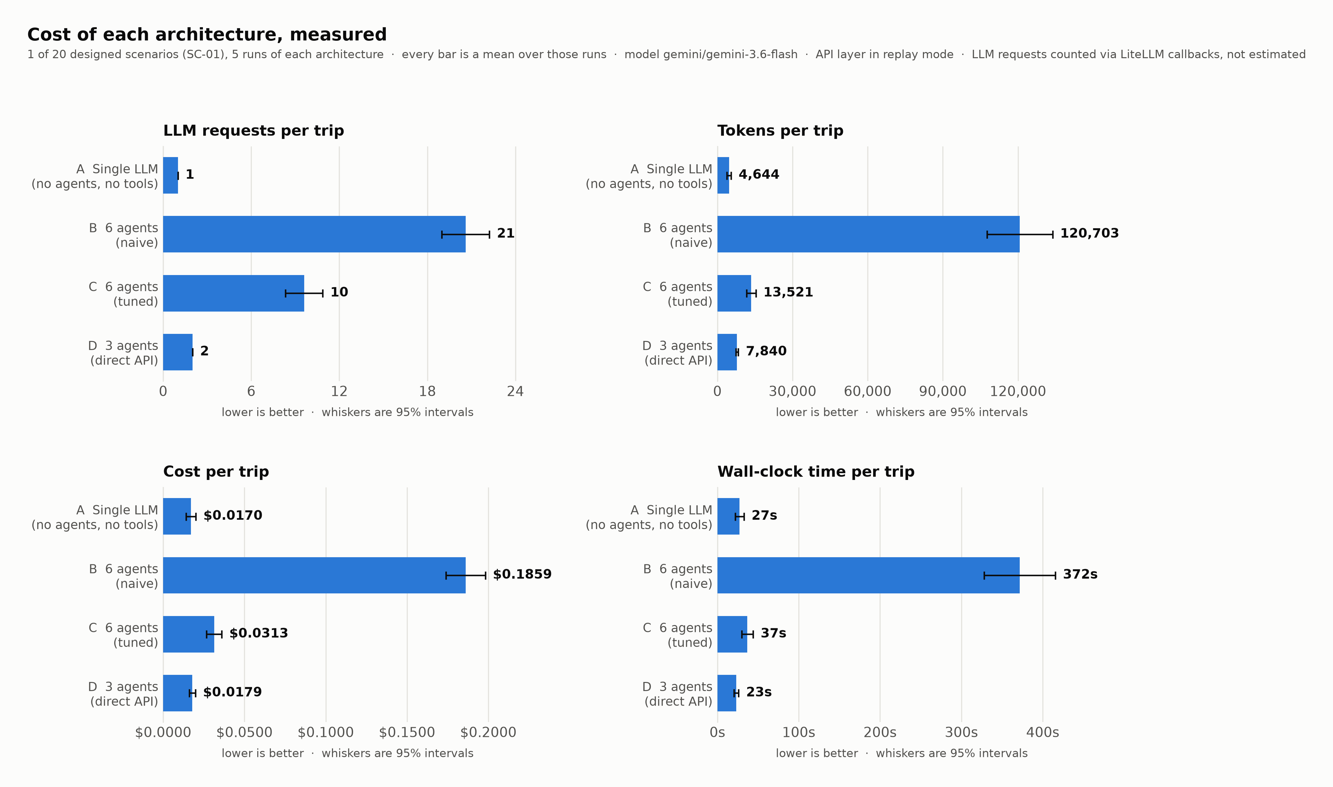
Figure 6.1: Model requests, tokens, cost and wall-clock time per trip for all four architectures.
Table 6.1: E1 results on SC-01, mean ± one standard deviation over 5 runs of each architecture. Requests are counted by provider callback. Retrieval is replayed, so latency excludes network time.
Architecture | Requests | Tokens | Cost (USD) | Seconds | Prices grounded (%)
A SINGLE LLM | 1.0 ± 0.0 | 4,644 ± 568 | 0.0170 ± 0.0021 | 27 ± 4 | 2 ± 3
B 6 AGENTS (naive) | 20.6 ± 1.1 | 120,703 ± 9,210 | 0.1859 ± 0.0085 | 372 ± 31 | 23 ± 2
C 6 AGENTS (optimised) | 9.6 ± 0.9 | 13,521 ± 1,280 | 0.0313 ± 0.0033 | 37 ± 5 | 56 ± 7
D 3 AGENTS (direct API) | 2.0 ± 0.0 | 7,840 ± 357 | 0.0179 ± 0.0013 | 23 ± 2 | 47 ± 8

Two standard deviations are zero, and that is a result rather than rounding. The tool-less arm issues exactly 1 request and the direct arm exactly 2 on every run, because neither contains a loop deciding how many requests to make. The agent arms cannot offer that — the naive arm varies by 5.5% and the tuned arm by 9.3%. For anyone budgeting, predictability is a property in its own right.
Against the tuned six-agent arm, the three-agent design used 79.2% fewer model requests, 37.1% less wall-clock time, 42.7% less money and 42.0% fewer tokens. Against the naive arm every gap is larger — 93.5% fewer tokens — and Section 6.3 explains why that is the wrong comparison to lead with.
With repeats, those percentages can be tested against their own noise instead of being asserted, and the answer separates cleanly into two kinds. Cost intervals do not overlap: the tuned arm sits in [$0.0266, $0.0360] and the direct arm in [$0.0160, $0.0198]. Latency intervals do not overlap either — [29.7, 43.9] seconds against [20.2, 26.1]. Both differences are therefore larger than run-to-run variation.
Groundedness behaves the other way, and this is the result the chapter turns on. The tuned arm's interval is [46.7, 65.9]% and the direct arm's is [35.4, 57.8]%. They overlap substantially. The tuned arm's mean is higher — 56.3% against 46.6% — and with five observations apiece that difference cannot be distinguished from noise. The honest reading is not that the two are equal but that this evidence cannot separate them, and the direction of the means is worth recording in case more data resolves it against the direct arm.
So the supported claim is narrow and specific: removing the model from deterministic retrieval buys a decisive saving in cost, latency and request count, makes request cost exactly predictable, and costs no groundedness this evidence can detect. It does not show better-grounded plans, and the means lean slightly the other way.
One result runs against the expected direction. The tool-less arm is not the cheapest: it cost $0.0170 against the direct arm's $0.0179 despite issuing one request rather than two, and it was the slowest arm at 27 seconds. The next section explains why.

6.3 E2 and E3: where the tokens go, and what tuning removed
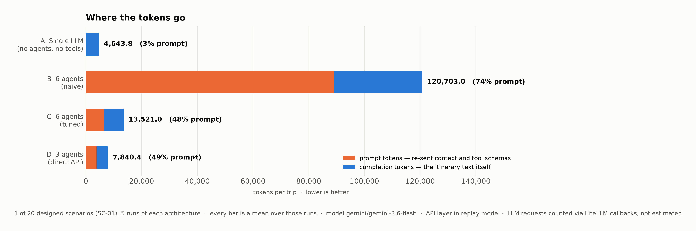
Figure 6.2: Prompt and completion tokens per architecture. Prompt tokens are re-sent context and tool schemas; completion tokens are the generated itinerary.
The decomposition explains the anomalies. The tool-less arm spent 126 prompt tokens against 4,518 completion: with no data to work from it invented detail to fill the requested structure. Output is billed at several times the rate of input, so an arm that reads nothing and writes a great deal is expensive, and its latency follows for the same reason.
The naive six-agent arm has the opposite profile: 89,100 prompt tokens against 31,603 completion, so 74% of its spend is re-sent context. Raw tool output for the whole scenario is a small fraction of that, so the payload is not the problem — re-sending the accumulated transcript plus every bound tool's schema on every reasoning iteration is. This is the context-bloat mechanism from Section 2.1, measured (Schick et al., 2023; Liu et al., 2024).
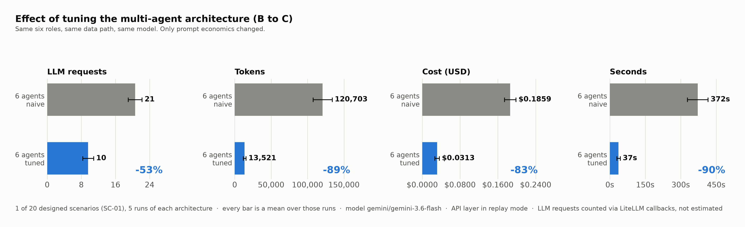
Figure 6.3: The tuning ablation. Same six roles, same data path, same model; only prompt economics changed.
E3 is the result that most constrains what this dissertation can claim. Tuning the six-agent arm — one narrow tool per specialist instead of up to eight, an iteration ceiling of three instead of up to fifteen, distilled tool results, shorter role descriptions, and the three specialists run concurrently — reduced its tokens by 88.8%, its cost by 83.2% and its request count by 53.4%, with the same architecture and the same retrieved data. Prompt tokens fell from 89,100 to 6,461.
Most of the penalty attributed to the multi-agent design was therefore implementation quality, not architecture. Run against the naive arm alone the comparison would have reported a 93.5% token advantage, and the conclusion would have been unattributable: a reader could not tell how much came from removing agents and how much from configuring them competently. The defensible claim is narrower. Against a competently configured multi-agent baseline, removing the model from deterministic retrieval saves request count and latency decisively and cost only modestly, at no measured loss of groundedness. That claim survives the obvious objection; the wider one does not.

6.4 E4: does the protocol layer do what the design says?
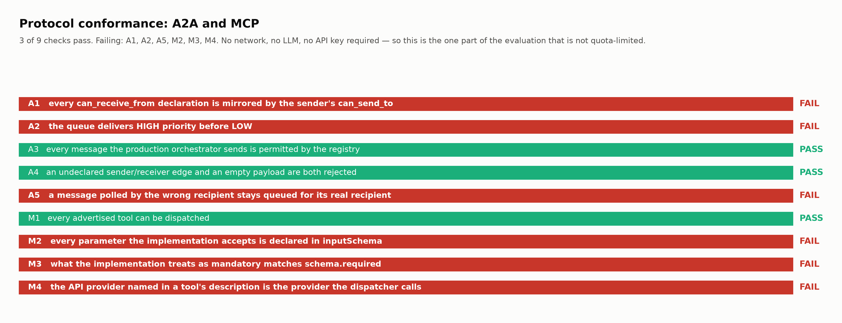
Figure 6.4: Nine conformance checks over the message layer and the tool schemas. Six fail.
3 of 9 checks pass. The proposal committed to a schema pass rate of 100% and an inter-agent error rate below 1%; the second is met on the path that ships and the first is not met at all. The six failures are findings about this artefact, not incidental defects.
Three failures are in the message layer. Priority is declared on every message and never honoured, because the queue is first-in-first-out: enqueued ['low', 'high'], delivered ['low', 'high']. Declared inbound permissions have no effect, since validation consults only the sender's outbound list, leaving 5 of 8 declared edges asymmetric. And a message polled by the wrong recipient is destroyed, because the receive path removes it from the queue before checking the address.
Three are in the tool layer. 3 of 12 tools accept parameters their schema omits — 6 in total — so an agent cannot set them and they silently take defaults, which is precisely the class of mismatch the schema layer was adopted to prevent. One tool treats a parameter as mandatory that its schema does not list as required. And one advertises the flight scraper in its description while its dispatcher calls the hotel provider's flight endpoint, so an agent choosing it on that description gets a different backend. Appendix B gives every check and its observation.
Two general readings follow. Adopting a protocol is not conforming to it: the specification governs how a schema is declared and transported and leaves its correspondence with the code behind it to the implementer (Anthropic, 2024; Hou et al., 2025), and nothing warned. And the message-layer defects sit in code the shipped path never executes, which is how they survived a passing suite. All six were found in an afternoon by an experiment needing no network, no model and no credentials, after weeks in which none was noticed.

6.5 E5: the budget gate, and a calibration failure behind it
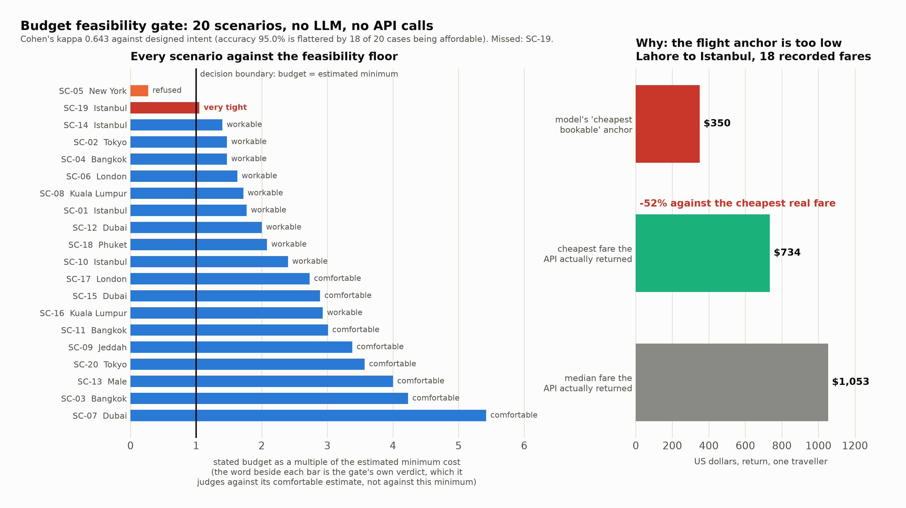
Figure 6.5: The gate's decision on all twenty scenarios, and the flight-cost anchor that explains the one it gets wrong.
Two of the twenty scenarios were written to be unaffordable. The gate refused 1 of them and accepted 18 of the eighteen affordable ones, with 0 false refusals and 1 miss. Raw agreement of 95.0% is a misleading figure, because with eighteen of twenty cases affordable a gate that refused nothing would score 86%. Cohen's kappa corrects for chance agreement (Cohen, 1960) and gives 0.643 — substantial rather than good on the conventional interpretation (Landis and Koch, 1977).
The missed case is SC-19: $500 for 5 nights in Istanbul for one traveller. The gate estimated a minimum of $476, judged the budget 1.05 times that floor, returned a verdict of "very tight" and proceeded.
The cause is measurable rather than a matter of opinion, and it is the most useful result in this chapter. The gate's cost model rests on anchor values for the cheapest realistically bookable fare in each distance band. For the one route where real fares are recorded — Lahore to Istanbul, with 18 fares in the response cache — the model's anchor is $350 while the cheapest fare the API actually returned was $734 and the median was $1,053. The anchor is 52% below the cheapest real fare.
That mis-calibration accounts for the missed decision arithmetically: with the flight floor at less than half the real airfare, the estimated minimum comes out at $476 when the airfare alone would consume the entire $500. The gate reasons correctly from a wrong number. It is also internally consistent — a monotonicity check over 198 cases found 0 violations — so the structure is right and the constants are wrong, which is far more tractable than the reverse.
The obvious response is to raise the anchor, and it has deliberately not been done. One route cannot calibrate three distance bands. Correcting the medium-haul constant against the single route for which fares are recorded would be tuning a model on its only validation point, leaving the short-haul and long-haul constants as unvalidated as before while making the whole model appear checked.

6.6 A worked example
Following one scenario through shows how the measures interact. The request is a four-night trip from Lahore to Istanbul for one traveller on eight hundred dollars, with an interest in history, food and shopping. Extraction produces structured fields. The gate estimates a minimum of $453 and a comfortable figure of $1,145, returns a verdict of workable, warns and proceeds. Retrieval returns 10 hotels, 2 airlines and 13 distinct prices, and that set becomes the ground truth for every arm. Six typed messages are exchanged and all six pass permission validation.
The four arms then diverge on the same request. The direct arm quoted 17 prices, of which 7 match a retrieved fare or nightly rate. The tool-less arm quoted 29 — more than twice as many — and matched 0. It named a real airline for the route despite calling no API, which is why entity matching is reported as weak evidence.
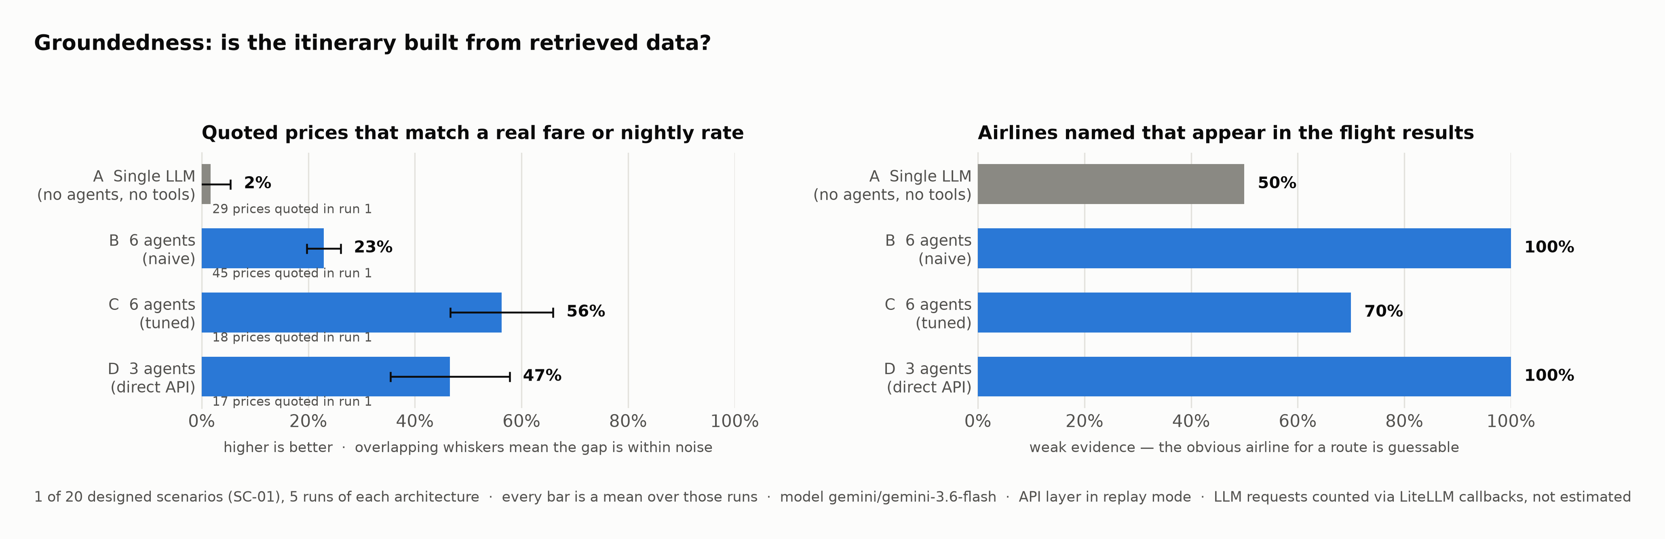
Figure 6.6: Groundedness by architecture. The left panel carries the claim; the right panel shows why entity matching cannot.
This is the clearest result in the project and the least surprising: the cheapest way to produce an itinerary is to invent it, and the difference between a plausible plan and a usable one is the tool layer.

6.7 Threats to validity
One threat stopped being hypothetical, and handling it produced the repeats this chapter relies on. The model the first round of measurements used was withdrawn from new API keys, and its replacement refuses any request whose message list ends with a model turn — precisely how the agent framework's reasoning loop prompts. The three-agent arm was unaffected, having no such loop; the six-agent arms could not run at all. A compatibility layer now adjusts only requests that would otherwise be rejected, passes the rest through untouched, and counts what it changed. Two consequences: these figures are not comparable with the earlier round because the model differs, and an architecture evaluated against someone else's hosted model inherits that model's lifetime — a stronger argument for the recorded response cache than the one originally made for it.
Appendix J tabulates every threat with its remedy, classified after Wohlin et al. (2012). The three that most limit this chapter are breadth, the overlap, and the author. Breadth: the repeats give depth on one scenario and nothing about other trips. The overlap: the tuned and direct arms cannot be separated on groundedness, so "no measurable penalty" is the claim, not "equal". And the author designed, built, measured and interpreted all of it. The design offers a partial answer to the last rather than a defence — the conformance audit compares declarations against implementations, and the gate evaluation compares decisions against intent recorded before any measurement. Neither outcome was chosen and both went against the design. A study that produced 6 failures against its own author is harder to dismiss than one that confirmed everything.

7. Critical Reflection

7.1 Achievement against each objective
Table 7.1: Objectives against evidence. Three of seven are qualified.
Objective | Status | Honest assessment, with the evidence
1. Tool server with schema-validated tools | Met with defects | Twelve tools advertised and dispatchable, but only 8 of 11 inspectable schemas match their implementation (Section 6.4). The server works; the validation guarantee it was built for is weaker than claimed
2. Typed protocol with priority queuing | Partly met | Eight agent cards, six message types and permission validation all work, and every shipped message is permitted. Priority queuing was specified and is not implemented — the queue is FIFO (Section 6.4)
3. Agent layer with measured model usage | Met | Provider callbacks capture every request, including those inside reasoning loops. The strongest part of the work: it replaced a hardcoded count that had been reported as a measurement
4. Record/replay with a live-call ceiling | Met | 30 committed responses; the comparison replays with no credentials. Load-bearing — without it there would be no reproducible result at all
5. Working demonstration | Met | Command-line and web interfaces both drive the shipped configuration. The web interface uses a fixed question sequence rather than the conversational agent (Section 7.3)
6. Four-architecture comparison | Met, with intervals | All four arms runnable and reproducible, measured 5 times each on 1 of 20 scenarios, so every figure has a standard deviation and a 95% interval. Breadth is the remaining gap
7. Evaluation across twenty scenarios | Met for two of three experiments | Sections 6.4 and 6.5 cover all twenty; Section 6.2 does not. No rearrangement of the work would have changed that, because the constraint is a monthly quota

Objective 1 is the one whose single-word status misleads. It was met as an artefact and undermined as a guarantee: a server exists, exposes tools, and validates nothing about the correspondence between what it advertises and what it runs.

7.2 Where the protocols ended up in the shipped path
An uncomfortable observation belongs here. The two protocols this project is named for are less load-bearing in the shipped configuration than the proposal implied. The message layer records the exchange and never dispatches it: the orchestrator sends messages and reads the conversation history but never dequeues, so the delivery machinery, the executor class and the message-processing loop are all unreachable in production. The tool server is driven over JSON-RPC only by the naive six-agent arm; the shipped path imports the same functions and calls them in process.
This follows directly from the pivot rather than from carelessness. Once retrieval stopped being performed by agents there was nothing left for agents to send each other about retrieval, so the message layer's role narrowed to an audit trail — genuinely useful, since it is what makes the exchange inspectable, and not what was promised. The pivot that produced the project's main result also hollowed out two of its stated deliverables.

7.3 Deviations from the proposal
Eight commitments changed between the proposal and delivery, and Appendix I tabulates each with its reason and its evidence. Three were forced from outside: the proposed flight provider withdrew free access mid-project, which also collapsed two planned flight tools into one, and the model changed to a free tier that made repeated evaluation affordable while removing model choice as a confound between arms. Two followed from measurement: six agents became three because instrumentation showed most requests were spent on deterministic retrieval, and scenario coverage fell to 1 for the cost comparison because the monthly quota permits no more. One was a framework constraint: the web interface asks a fixed question sequence because its rerun model does not suit a streaming dialogue.
The remaining two are failures of delivery rather than changes of plan, and should be read as such. Priority queuing was promised and not built. The proposal's bookability target — re-query success — was replaced by groundedness, a weaker measure, because the stronger one needed quota the project did not have. Presenting either as a considered design revision would be dishonest; what can fairly be claimed is that both were found by measurement rather than left for a marker to notice.

7.4 Limitations
The cost comparison covers 1 scenario, measured 5 times per architecture. Depth is therefore adequate and breadth is not: differences on this trip are supported by intervals, and nothing establishes that they hold for a longer stay, a cheaper destination or a larger party. Latency excludes network time because retrieval is replayed. All results are specific to one model whose input and output prices differ by a large factor, which is what makes the tool-less arm expensive; a flatter price ratio would compress the differences in Section 6.2. Groundedness measures whether named entities were retrieved, not whether they were well chosen, so nothing here shows the plans are good — only that they are real. The gate's cost model is validated against one route, the scenarios are author-written, and there is no user study.
The test suite's coverage is narrower than its size implies: thorough on the pure-Python modules, absent on the protocol layer, the record-and-replay cache and the metric collector. Six protocol defects were found by a purpose-written experiment and none by the suite that passed throughout. One further defect — a test block exercising a copy of the calculator rather than the shipped one — was found by the same audit and has been closed (Section 5.7); the rest are recorded rather than repaired, for the reason given above.

7.5 Professional, legal and ethical reflection
The professional obligation comes first: the BCS code requires members not to misrepresent what their work can do (BCS, 2022). A system that prints prices invites the reading that those prices are bookable, and Section 6.6 shows how badly that reading can fail — an arm with no tool access produced 29 confident prices, none corresponding to anything. The design response is that groundedness is measured rather than assumed. The delivery gap is that although the repository's documentation states plainly that the system is a planning aid, the web interface itself carries no such notice, and the proposal committed to one. That is an unmet commitment, and it is listed in Section 8.3.
A deployed version would sit in a materially different legal position. Giving consumers travel information through automated processing falls within the transparency expectations of the AI Act, which requires that users know they are interacting with an AI system and that its limitations are disclosed (European Union, 2024). Data protection guidance becomes relevant the moment real requests are stored, because a travel itinerary reveals location, dates, household composition and financial capacity — a rich profile from a short conversation (Information Commissioner's Office, 2023). This project avoids all of it by processing no personal data, which makes its ethical footprint small rather than the problem easy.
A last point of professional honesty concerns the cached data. Holding third-party fares locally is defensible for academic reproduction and would not be defensible as the basis of a service, because a cached fare presented to a user as current is a misrepresentation however it was obtained.

7.6 Personal reflection
The clearest mistake was ordering. Measurement was built in the second cycle, after the system worked, and until then every claim about cost was a guess — one of which had been written into the project's own documentation as a result. Had the request counter existed on the first day, the pivot this dissertation is built on would have been visible in week two rather than week six, and there would have been quota left for the scenario coverage the evaluation now lacks. Instrumentation is not a reporting concern to add when writing up; it is what tells you what to build next.
The second mistake was treating a passing test suite as evidence about the system. 393 tests pass, and they pass on the parts that were easy to test: pure functions with no network and no model. The parts carrying the research claim had no tests, and the defects were exactly where the tests were not. Writing the conformance audit took an afternoon and found six. Coverage should have been chosen by what a defect would cost, not by what was convenient to write.
The judgement I would defend is including arm C. Tuning the baseline before comparing against it cost several days and substantially weakened the result: the honest claim shrank from a large advantage over multi-agent retrieval to a decisive advantage in request count and latency with a modest one in cost. The temptation to compare against the naive arm and report the larger number was real. The narrower claim is the one that survives the first question a viva would ask, and a result that cannot survive that question is not worth having.

8. Conclusion

8.1 What was found
This project asked what it costs to delegate data retrieval to a language model in a system that already has a schema-validated tool layer and a typed inter-agent protocol. On the one scenario for which all four architectures are recorded, removing the model from retrieval reduced requests by 79.2% and wall-clock time by 37.1% against a tuned six-agent baseline, while cost fell only 42.7% and groundedness was unchanged. The answer is therefore yes, with a qualification that matters: the saving is in requests and latency, not primarily in money.
The more useful finding narrowed the claim. Tuning the six-agent arm, without changing its architecture, data or model, removed 88.8% of its token spend. Most of what would have been reported as the cost of multi-agent architecture was the cost of binding eight tools to an agent and letting it iterate fifteen times. Any comparison of this kind that does not tune its baseline first is measuring implementation quality and calling it architecture.
Tool access, by contrast, was decisive. The arm with no tools quoted 29 prices and matched 0 to anything retrieved, reproducing under measurement the failure the benchmark literature reports (Xie et al., 2024). The gap between a plausible itinerary and a usable one is entirely the retrieval layer; what is negotiable is whether a language model should operate it.
Measuring the artefact against its own design then found 6 defects in it: declared message priorities never honoured, inbound permissions never enforced, a receive path that destroys misaddressed messages, 3 tool schemas that disagree with their implementations, and a cost model whose flight anchor sits 52% below the cheapest fare its own API returned — which is why the gate accepts one budget it should refuse. None was found by a passing test suite.

8.2 Contribution
The contribution is threefold and deliberately modest. First, a working protocol-mediated travel planner whose every reported number regenerates from committed data, so the results can be checked rather than believed. Second, a comparison that includes its own fair baseline and reports the weaker conclusion that followed. Third, a demonstration that conformance to a tool protocol is a property to be tested rather than an outcome of adopting one, together with an executable method for testing it that costs nothing to run.

8.3 Future work, ordered by how much each would strengthen the claims
- Repeat runs, on a model that can execute every arm. Five per arm would give a mean, a standard deviation and a confidence interval. This was attempted and could not be completed: the model the results were measured on has been withdrawn, and its replacement refuses the prompt shape the agent framework's reasoning loop produces (Section 6.7). It now needs either a framework version that reshapes those requests or a provider still serving a compatible model — and all four arms must then be re-run together, because a mean pooled across two models means nothing.
- Record the remaining 19 scenarios. Roughly four requests each against eighty a month means two monthly cycles, or a paid tier at trivial cost. Recordings accumulate, so this extends coverage without re-running what exists, turning a single-case measurement into a comparison across trip lengths and party sizes.
- Recalibrate the cost model against real fares on several routes per distance band. Correcting the one measured anchor alone would be fitting a model to its only validation point. Once recalibrated, the gate should be re-evaluated on the same twenty scenarios to see whether the missed case is caught and whether any correct refusal is lost.
- Repair the six conformance defects and re-run the audit. Generating each tool's schema from its implementation signature, rather than declaring it separately, would make that class of defect unrepresentable rather than merely fixed.
- Add the interface notice the proposal committed to: that the system is a planning aid, that prices were retrieved at a point in time, and that nothing shown is bookable.
- Build and measure a hybrid arm. A model adds cost where retrieval is deterministic, but retrieval is not always deterministic — when a first search returns nothing, choosing between wider dates, a relaxed budget and a nearby airport is a judgement. An arm that invokes an agent only on that path would test whether the boundary drawn in Section 4.4 is in the right place. It is the most interesting item here and deliberately not the first, because it extends the work rather than strengthening what is claimed.
- Validate against human judgement. Groundedness establishes that a plan is real, not that it is good. Travellers ranking itineraries from the four arms would test whether the measured quality equivalence holds for the people the plans are for. It needs ethical approval and is the largest item here.

8.4 Closing
The result this project set out to demonstrate turned out to be smaller than expected, and the results it did not set out to find turned out to be the useful ones. A fair baseline removed most of the advantage the pivot was supposed to show. An afternoon's worth of conformance checking found 6 defects in a system whose 393 passing tests had said nothing about any of them. Both outcomes came from the same decision, which was to measure the artefact rather than describe it, and to report what the measurement said.

References
Anthropic (2024) Model Context Protocol specification. Available at: https://modelcontextprotocol.io/specification (Accessed: 12 August 2026)
BCS, The Chartered Institute for IT (2022) BCS code of conduct for members. Swindon: BCS. Available at: https://www.bcs.org/membership-and-registrations/become-a-member/bcs-code-of-conduct/ (Accessed: 10 August 2026)
Cemri, M., Pan, M.Z., Yang, S., Agrawal, L.A., Chopra, B., Tiwari, R., Keutzer, K., Parameswaran, A., Klein, D., Ramchandran, K., Zaharia, M., Gonzalez, J.E. and Stoica, I. (2025) 'Why do multi-agent LLM systems fail?'. arXiv:2503.13657
Cohen, J. (1960) 'A coefficient of agreement for nominal scales', Educational and Psychological Measurement, 20(1), pp. 37-46. doi:10.1177/001316446002000104
CrewAI (2024) CrewAI documentation: agents, tasks, crews and tools. Available at: https://docs.crewai.com (Accessed: 3 August 2026)
Es, S., James, J., Espinosa-Anke, L. and Schockaert, S. (2024) 'RAGAS: automated evaluation of retrieval augmented generation', in Proceedings of the 18th Conference of the European Chapter of the Association for Computational Linguistics: System Demonstrations. St Julians, Malta, 17-22 March, pp. 150-158. arXiv:2309.15217
European Union (2024) Regulation (EU) 2024/1689 of the European Parliament and of the Council of 13 June 2024 laying down harmonised rules on artificial intelligence (Artificial Intelligence Act). Official Journal of the European Union, L 1689. Available at: https://eur-lex.europa.eu/eli/reg/2024/1689/oj (Accessed: 10 August 2026)
Foundation for Intelligent Physical Agents (2002) FIPA Communicative Act Library specification, SC00037J. Geneva: FIPA. Available at: http://www.fipa.org/specs/fipa00037/SC00037J.html (Accessed: 12 August 2026)
Gundawar, A., Verma, M., Guan, L., Valmeekam, K., Bhambri, S. and Kambhampati, S. (2024) 'Robust planning with LLM-Modulo framework: case study in trip planning'. arXiv:2405.20625
Hao, Y., Chen, Y., Zhang, Y. and Fan, C. (2024) 'Large language models can plan your travels rigorously with formal verification tools'. arXiv:2404.11891
Hevner, A.R., March, S.T., Park, J. and Ram, S. (2004) 'Design science in information systems research', MIS Quarterly, 28(1), pp. 75-105. doi:10.2307/25148625
Hong, S., Zhuge, M., Chen, J., Zheng, X., Cheng, Y., Wang, J., Zhang, C., Wang, Z., Yau, S.K.S., Lin, Z., Zhou, L., Ran, C., Xiao, L., Wu, C. and Schmidhuber, J. (2024) 'MetaGPT: meta programming for a multi-agent collaborative framework', in Proceedings of the Twelfth International Conference on Learning Representations (ICLR 2024). Vienna, Austria, 7-11 May. arXiv:2308.00352
Hou, X., Zhao, Y., Wang, S. and Wang, H. (2025) 'Model Context Protocol (MCP): landscape, security threats, and future research directions'. arXiv:2503.23278
Information Commissioner's Office (2023) Guidance on AI and data protection. Wilmslow: ICO. Available at: https://ico.org.uk/for-organisations/uk-gdpr-guidance-and-resources/artificial-intelligence/guidance-on-ai-and-data-protection/ (Accessed: 10 August 2026)
Ji, Z., Lee, N., Frieske, R., Yu, T., Su, D., Xu, Y., Ishii, E., Bang, Y.J., Madotto, A. and Fung, P. (2023) 'Survey of hallucination in natural language generation', ACM Computing Surveys, 55(12), pp. 1-38. doi:10.1145/3571730
Landis, J.R. and Koch, G.G. (1977) 'The measurement of observer agreement for categorical data', Biometrics, 33(1), pp. 159-174. doi:10.2307/2529310
Lim, K.H., Chan, J., Leckie, C. and Karunasekera, S. (2019) 'Tour recommendation and trip planning using location-based social media: a survey', Knowledge and Information Systems, 60(3), pp. 1247-1275. doi:10.1007/s10115-018-1297-4
Liu, N.F., Lin, K., Hewitt, J., Paranjape, A., Bevilacqua, M., Petroni, F. and Liang, P. (2024) 'Lost in the middle: how language models use long contexts', Transactions of the Association for Computational Linguistics, 12, pp. 157-173. doi:10.1162/tacl_a_00638
Min, S., Krishna, K., Lyu, X., Lewis, M., Yih, W., Koh, P.W., Iyyer, M., Zettlemoyer, L. and Hajishirzi, H. (2023) 'FActScore: fine-grained atomic evaluation of factual precision in long form text generation', in Proceedings of the 2023 Conference on Empirical Methods in Natural Language Processing. Singapore, 6-10 December, pp. 12076-12100. arXiv:2305.14251
Park, J.S., O'Brien, J., Cai, C.J., Morris, M.R., Liang, P. and Bernstein, M.S. (2023) 'Generative agents: interactive simulacra of human behaviour', in Proceedings of the 36th Annual ACM Symposium on User Interface Software and Technology (UIST 2023). San Francisco, CA, 29 October - 1 November. New York: ACM, pp. 1-22. doi:10.1145/3586183.3606763
Peffers, K., Tuunanen, T., Rothenberger, M.A. and Chatterjee, S. (2007) 'A design science research methodology for information systems research', Journal of Management Information Systems, 24(3), pp. 45-77. doi:10.2753/MIS0742-1222240302
Runeson, P. and Host, M. (2009) 'Guidelines for conducting and reporting case study research in software engineering', Empirical Software Engineering, 14(2), pp. 131-164. doi:10.1007/s10664-008-9102-8
Schick, T., Dwivedi-Yu, J., Dessi, R., Raileanu, R., Lomeli, M., Hambro, E., Zettlemoyer, L., Cancedda, N. and Scialom, T. (2023) 'Toolformer: language models can teach themselves to use tools', Advances in Neural Information Processing Systems, 36, pp. 68539-68551. arXiv:2302.04761
Shinn, N., Cassano, F., Gopinath, A., Narasimhan, K. and Yao, S. (2023) 'Reflexion: language agents with verbal reinforcement learning', Advances in Neural Information Processing Systems, 36, pp. 8634-8652. arXiv:2303.11366
UN Tourism (2024) World Tourism Barometer, volume 22, issue 1. Madrid: World Tourism Organization. doi:10.18111/wtobarometereng
Wang, L., Ma, C., Feng, X., Zhang, Z., Yang, H., Zhang, J., Chen, Z., Tang, J., Chen, X., Lin, Y., Zhao, W.X., Wei, Z. and Wen, J. (2024) 'A survey on large language model based autonomous agents', Frontiers of Computer Science, 18(6), 186345. doi:10.1007/s11704-024-40231-1
Wohlin, C., Runeson, P., Host, M., Ohlsson, M.C., Regnell, B. and Wesslen, A. (2012) Experimentation in software engineering. Berlin: Springer. doi:10.1007/978-3-642-29044-2
Wu, Q., Bansal, G., Zhang, J., Wu, Y., Zhang, S., Zhu, E., Li, B., Jiang, L., Zhang, X. and Wang, C. (2023) 'AutoGen: enabling next-generation LLM applications via multi-agent conversation'. arXiv:2308.08155
Xi, Z., Chen, W., Guo, X., He, W., Ding, Y., Hong, B., Zhang, M., Wang, J., Jin, S., Zhou, E. and others (2023) 'The rise and potential of large language model based agents: a survey'. arXiv:2309.07864
Xie, J., Zhang, K., Chen, J., Zhu, T., Lou, R., Tian, Y., Xiao, Y. and Su, Y. (2024) 'TravelPlanner: a benchmark for real-world planning with language agents', in Proceedings of the 41st International Conference on Machine Learning (ICML 2024). Vienna, Austria, 21-27 July, pp. 54590-54613. arXiv:2402.01622
Yao, S., Zhao, J., Yu, D., Du, N., Shafran, I., Narasimhan, K. and Cao, Y. (2023) 'ReAct: synergizing reasoning and acting in language models', in Proceedings of the Eleventh International Conference on Learning Representations (ICLR 2023). Kigali, Rwanda, 1-5 May. arXiv:2210.03629
Zhuge, M., Wang, W., Kirsch, L., Faccio, F., Khizbullin, D. and Schmidhuber, J. (2024) 'GPTSwarm: language agents as optimizable graphs', in Proceedings of the 41st International Conference on Machine Learning (ICML 2024). Vienna, Austria, 21-27 July. arXiv:2402.16823

Appendix A — Reproducing every number in this dissertation
No credentials are required. The recorded API responses are committed, so the whole evaluation replays from disk. Run the commands in this order; each writes the data file the next one reads, and the document is rebuilt last.
run.bat # sets up everything, then a menu
python -m pytest -q # the test suite
python -m evaluation.exp_protocol # protocol conformance (free)
python -m evaluation.exp_budget_gate # budget gate, 20 scenarios (free)
python demos/compare_all_approaches.py # all four, from the recordings
python report/build/make_diagrams.py # 8 diagrams, 300 dpi, validated
python report/build/make_charts.py # 6 charts from measured data
python -m report.build.build_report # this document
python -m report.build.verify_no_hardcoded_numbers # perturbation check
# Re-measuring the four arms needs a model that can run all of them.
# See Section 6.7: the model these results came from has been withdrawn.
set TRIP_PLANNER_API_MODE=replay
set TRIP_PLANNER_MAX_LIVE_CALLS=0
python -m evaluation.run_comparison SC-01 --force --repeats 5
The report build refuses to complete if a figure is missing, if a citation has no reference entry, if a reference is never cited, or if any diagram fails geometric validation. It also re-runs the test suite and reports the real pass count rather than a remembered one.

Appendix B — Full protocol conformance results
Table 8.1: Every conformance check, its claim, its result and the observation behind it.
ID | Claim tested | Result | Observation
A1 | every can_receive_from declaration is mirrored by the sender's can_send_to | FAIL | 5 inbound declarations have no matching outbound permission, so can_receive_from is never enforced: validate_communication() consults only the sender's can_send_to.
A2 | the queue delivers HIGH priority before LOW (proposal Objective 2: 'priority queuing') | FAIL | MessageQueue wraps queue.Queue, which is FIFO. The priority field is carried on every message and never read.
A3 | every message the production orchestrator sends is permitted by the registry | PASS | 6/6 messages in the shipped sequence pass permission validation.
A4 | an undeclared sender/receiver edge and an empty payload are both rejected | PASS | Permission validation and the empty-content guard both reject as designed.
A5 | a message polled by the wrong recipient stays queued for its real recipient | FAIL | receive_message() dequeues before checking the recipient and discards the message when it does not match, so a single wrong poll destroys it. Not reached in production, which is why it never surfaced: the orchestrator uses the protocol as an audit log and never dequeues.
M1 | every advertised tool can be dispatched | PASS | 12 tools advertised, 12 dispatchable.
M2 | every parameter the implementation accepts is declared in inputSchema (proposal S3.10 target: 100% schema pass rate) | FAIL | 8/11 inspectable tools are clean. 6 implementation parameters are absent from their schema, so an agent cannot set them and they silently take defaults.
M3 | what the implementation treats as mandatory matches schema.required | FAIL | 1 parameter(s) are mandatory in the implementation but absent from schema.required.
M4 | the API provider named in a tool's description is the provider the dispatcher calls | FAIL | 1 tool(s) advertise one provider and call another. An agent selecting a tool on its description gets a different backend.

Table 8.2: Per-tool schema audit. 8 of 11 inspectable tools are clean; 6 implementation parameters are undeclared in total.
Tool | Dispatches to | Parameters missing from schema | Required mismatch
search_flights | _call_booking_flights_api | none | none
search_hotels_comprehensive | search_hotels_comprehensive | currency_code | none
search_accommodations_with_location | search_accommodations_with_location | adults, currency_code, rooms | none
search_car_rentals | search_car_rentals | none | none
search_internet | search_internet | none | none
search_attractions | search_attractions | none | none
search_restaurants | search_restaurants | none | none
calculate | calculate | none | none
search_hotel_destination | search_hotel_destination | none | none
search_hotels_by_destination | search_hotels_by_destination | children_age, page_number | search_type
get_hotel_reviews | get_hotel_reviews | none | none
get_attractions_near_hotel | get_attractions_near_hotel | none | none

Appendix C — Full budget gate decision table
Table 8.3: The feasibility gate's decision on all twenty designed scenarios.
Scenario | Destination | Budget | Nights | Travellers | Minimum | Comfortable | Budget/min | Verdict | Agrees
SC-01 | Istanbul | $800 | 4 | 1 | $453 | $1,145 | 1.77 | workable | yes
SC-02 | Tokyo | $3,000 | 8 | 2 | $2,046 | $5,090 | 1.47 | workable | yes
SC-03 | Bangkok | $2,500 | 10 | 1 | $591 | $1,745 | 4.23 | comfortable | yes
SC-04 | Bangkok | $700 | 5 | 1 | $476 | $1,245 | 1.47 | workable | yes
SC-05 | New York | $300 | 7 | 1 | $1,131 | $2,930 | 0.27 | impossible | yes
SC-06 | London | $3,500 | 9 | 2 | $2,145 | $5,440 | 1.63 | workable | yes
SC-07 | Dubai | $4,000 | 5 | 2 | $738 | $2,005 | 5.42 | comfortable | yes
SC-08 | Kuala Lumpur | $900 | 7 | 1 | $522 | $1,445 | 1.72 | workable | yes
SC-09 | Jeddah | $1,500 | 5 | 1 | $444 | $1,265 | 3.38 | comfortable | yes
SC-10 | Istanbul | $1,200 | 6 | 1 | $499 | $1,345 | 2.40 | workable | yes
SC-11 | Bangkok | $1,500 | 6 | 1 | $499 | $1,345 | 3.01 | comfortable | yes
SC-12 | Dubai | $3,500 | 7 | 4 | $1,748 | $4,990 | 2.00 | workable | yes
SC-13 | Male | $5,000 | 5 | 2 | $1,249 | $3,340 | 4.00 | comfortable | yes
SC-14 | Istanbul | $2,000 | 6 | 3 | $1,425 | $3,705 | 1.40 | workable | yes
SC-15 | Dubai | $1,000 | 3 | 1 | $346 | $915 | 2.89 | comfortable | yes
SC-16 | Kuala Lumpur | $2,000 | 14 | 1 | $683 | $2,145 | 2.93 | workable | yes
SC-17 | London | $2,500 | 4 | 1 | $915 | $2,165 | 2.73 | comfortable | yes
SC-18 | Phuket | $2,000 | 7 | 2 | $960 | $2,505 | 2.08 | workable | yes
SC-19 | Istanbul | $500 | 5 | 1 | $476 | $1,245 | 1.05 | very tight | NO
SC-20 | Tokyo | $8,000 | 10 | 2 | $2,244 | $5,790 | 3.57 | comfortable | yes

Table 8.4: Agreement statistics for the feasibility gate.
Quantity | Value
Scenarios evaluated | 20
Correctly refused (true positive) | 1
Correctly accepted (true negative) | 18
Wrongly refused (false positive) | 0
Wrongly accepted (false negative) | 1
Observed agreement | 0.950
Chance agreement | 0.860
Cohen's kappa | 0.643
Precision | 1.000
Recall | 0.500

Appendix D — Per-arm measured detail
Table 8.5: Full measured detail per arm. Note that the tuned arm's summed model time exceeds its wall-clock time, which is direct evidence of concurrent execution.
Arm | Requests | Prompt tok | Completion tok | Cost | Model s | Wall s | Prices quoted | Grounded | Grounded %
A SINGLE LLM | 1 | 126 | 4,518 | $0.0170 | 27.3 | 27.3 | 29 | 0 | 0.0%
B 6 AGENTS (naive) | 21 | 89,100 | 31,603 | $0.1859 | 229.9 | 371.7 | 45 | 10 | 22.2%
C 6 AGENTS (optimised) | 10 | 6,461 | 7,060 | $0.0313 | 51.0 | 36.8 | 18 | 9 | 50.0%
D 3 AGENTS (direct API) | 2 | 3,821 | 4,019 | $0.0179 | 22.8 | 23.1 | 17 | 7 | 41.2%

The ground truth for the recorded scenario, extracted from what the APIs actually returned and used to score every arm: 10 hotels, 2 airlines and 13 distinct prices ranging from $33.09 to $1,285.10.

Appendix E — Code map and test summary
Table 8.6: Code map by area.
Area | Files | Lines | Purpose
trip_planner | 27 | 8,591 | the application itself
evaluation | 14 | 3,231 | the four architectures and the experiments
demos | 8 | 1,033 | demonstration scripts
testing | 14 | 3,930 | test suite
report | 20 | 8,013 | report and figure generators
Total | 83 | 24,798

Module decomposition, referenced from Section 4.2. The right-hand column is the reason each boundary exists rather than a description of what the module contains.
Table 8.7: Module decomposition and the reason for each boundary.
Module | Responsibility | Why it is separate
trip_planner/orchestrator.py | The workflow: conversation, extraction, retrieval, assembly | The only component that knows the order of operations. Both entry points run one method; they were two sharing 74% of their text
trip_planner/agents.py, trip_planner/tasks.py | The three agents that need a model, and their prompts | Prompts change far more often than control flow
trip_planner/comms/ | Typed messages, agent cards, permission validation | Identical across all four arms, so it must not depend on any of them
trip_planner/server/mcp_server.py | The tool server: twelve tools over JSON-RPC and stdio | Runs as a subprocess, so it cannot import from the caller's context
trip_planner/tools/ | MCP client, direct HTTP clients, agent tool wrappers — one file each | They were one 986-line module; split so the dependency is visible
trip_planner/core/http_cache.py | Record and replay, plus the live-call ceiling | Every API call must pass one chokepoint or the guarantee is void
trip_planner/core/llm_metrics.py | Request, token and cost accounting | Measurement must not live inside the thing being measured
trip_planner/core/trip_cost.py, budget.py | What a trip costs, and how a budget is split | Testable in isolation, with no model and no network
trip_planner/core/validators.py, resilience.py, log_setup.py | Output validation, retry classification, credential-safe logging | Cross-cutting concerns that no single caller owns
evaluation/ | The four arms, the scenarios, the metrics, the runner | Evaluation code must not be reachable from the shipped path
report/build/make_*.py | Figure generation with mechanical layout validation | A document generator is code, and can be wrong like any other
report/build/ | One module per chapter, plus shared helpers | Every number is interpolated from measured data, never typed

The suite collects 393 tests. Section 5.7 sets out what they cover and, more importantly, what they do not: the message layer, the tool server, the record-and-replay cache and the metric collector have no unit tests, and are covered instead by the conformance experiment in Appendix B.
Table 8.8: Recorded API responses by host, 2,870 kB committed in total. These are what make the results reproducible without credentials.
Host | Recorded responses
booking-com15.p.rapidapi.com | 16
fly-scraper.p.rapidapi.com | 8
google.serper.dev | 6
Total | 30

Appendix F — Forensic evidence from the recorded flight responses
The response cache doubles as a record of the flight-search defects described in Section 5.3. The three kinds of recording can be compared directly.
Table 8.9: Recorded evidence for the two silent flight-search defects. Both fixes were necessary; neither was signalled by an error.
Recording | Bytes | Itineraries returned | What it demonstrates
Search with snake_case date parameters | 703 / 3,269 | 0 | The API accepted the request, returned HTTP 200, and ignored the dates
Search with camelCase date parameters | 80,363 | 10 | Correct dates, but status is still 'incomplete' — the search has only started
Poll of the incomplete search | 2,348,924 | 173 | Status 'complete'. Reading only the first response discards most available fares

Appendix G — Metrics, their provenance and their limits
Referenced from Section 3.4. The right-hand column governs how strongly Chapter 6 states its conclusions, and is the reason price grounding carries the quality claim while entity grounding is reported only as support.
Table 8.10: The seven metrics, their provenance, and the limit of each.
Metric | How it is obtained | What it cannot establish
Model requests per trip | Counted by provider callback on every completion, including those issued inside reasoning loops and internal retries | Nothing about whether a request was useful — only that it happened
Prompt and completion tokens | Read from the provider's usage field per request | Cost equivalence: on this model output tokens are billed several times input, so a token total conceals which kind it is made of
Cost in US dollars | Computed by the client library from its own price table | Portability. A different provider or tier changes every figure
Wall-clock latency | Measured per arm and per phase | The network component, since retrieval is replayed from disk and a live run would be slower
Prices grounded | Proportion of prices quoted in the itinerary matching a recorded fare or nightly rate within 2% | Whether the option chosen was a good one, or whether the plan is internally consistent
Entities grounded | Hotel and airline names in the itinerary appearing in the retrieved results | Much at all on its own — the obvious airline for a route is guessable, so this is supporting evidence only
Protocol conformance | Nine executable checks over the message layer and the tool schemas | Whether a conforming protocol produces better plans

Appendix H — Test coverage by area
Referenced from Section 5.7. The modules with most tests are the ones least central to the research claim, which is a consequence of their being the cheapest to test rather than a judgement about where defects were likely.
Table 8.11: Test coverage by area.
Area | Covered by the suite | Assessment
Budget allocation and splitting | Yes, extensively | Pure functions with no network or model, so cheap to test thoroughly
Trip cost estimation and the feasibility floor | Yes | Tested against the module's own thresholds, which is why Section 6.5 evaluates it against real fares instead
Itinerary day-count validation | Yes | Straightforward and adequate
Documentation accuracy | Yes | Tests that documented files exist and documented counts match the code — unusual, and it has caught real drift
Safe arithmetic evaluation | Yes, since the audit | Previously the tests exercised a copy inside the test file while the tool used a character allowlist and a bare eval. One module now, and a test asserts the server's tool IS that module (Section 5.7)
The message layer | No | Covered instead by the conformance experiment, which found three defects
The tool server and its schemas | No | Covered instead by the conformance experiment, which found four defective schemas
Record and replay, and metric collection | No | Exercised on every evaluation run but never asserted
The four arms | No | Each run costs model quota, so no automated test drives them

Appendix I — Every deviation from the proposal
Referenced from Section 7.3, which groups these by cause and argues the two that are delivery failures rather than design changes.
Table 8.12: Every deviation from the proposal, with its reason and its evidence.
Proposed | Delivered | Why it changed, and where the evidence sits
Six agents in production | Three; six retained for evaluation | Instrumentation showed most requests were spent on deterministic retrieval. The six-agent design was measured before it was replaced and tuned before being used as a baseline (Sections 6.2, 6.3)
Kiwi.com for flights | fly-scraper via RapidAPI | Kiwi withdrew free API access during the project; this was the only remaining free option with return-fare search (Section 5.3)
GPT-4o and GPT-4o-mini split | Gemini 3.6 Flash throughout | A free tier made repeated evaluation affordable, and one model removes model choice as a confound between arms (Appendix K)
Thirteen tools | Twelve | Two proposed flight tools collapsed into one when the provider changed (Section 6.4)
Priority queuing, four levels | Three levels, no ordering | Not implemented. Found by the conformance audit rather than by recollection, and reported rather than dropped (Section 6.4, check A2)
Search agents call the APIs via the MCP server | Only the naive six-agent arm does; the shipped path calls the same functions in process | The proposal's Figure 1 put the MCP server on the retrieval path of three parallel search agents. Removing retrieval from the agents left no agent to route through it, so the shipped path imports the server's tool functions instead. The JSON-RPC transport is still exercised by the naive arm and by the conformance audit, which tests all twelve declared schemas against their implementations (Sections 4.2, 7.2)
Three search agents running in parallel | Parallel in the tuned arm; sequential in the naive arm; absent from the shipped path | Concurrency was one of the three proposal commitments missing from the naive implementation, which is why that arm was tuned before being used as a baseline rather than compared against as first built (Section 6.3)
Bookability at least 80% | 41% of quoted prices grounded | The proposal defined bookability as re-query success, which needs quota this project did not have. Groundedness is a weaker but measurable substitute, and the substitution reduces ambition (Section 6.6)
Twenty scenarios everywhere | Twenty for two experiments, 1 for the cost comparison | Monthly free-tier quota. Recordings accumulate, so coverage grows without re-running what exists (Section 6.1)
Conversational agent in the web interface | Fixed question sequence there | The interface framework re-runs its whole script on each interaction, which does not suit a streaming dialogue. The conversational agent remains in the command-line path (Section 4.5)

Appendix L — The four arms and why each is in the design
Referenced from Section 3.2, which argues why four arms are needed rather than two.
Table 8.13: The four arms and the role each plays in the argument.
Arm | Configuration | Why it is in the design
A | One model request, no tools, no agents, no protocols | Control. Establishes what the tool layer buys, and what a plan looks like when nothing in it was retrieved.
B | Six roles, naive configuration as first implemented | The starting point. Its cost is what motivated the pivot, so removing it would hide the reasoning.
C | Six roles, tuned: one narrow tool each, distilled results, concurrent execution, shorter prompts | The fair baseline. Answers the objection that the multi-agent arm lost through misconfiguration.
D | Three roles; retrieval in ordinary Python | The proposed design. The claim under test.

Appendix M — Experimental design
Referenced from Section 6.1, which argues what each experiment can and cannot support.
Table 8.14: Experimental design. Three of five cost nothing to run, which is why they cover the full scenario set while E1 does not.
# | Experiment and question | Coverage | Cost to run
E1 | Four-arm comparison: what does each architecture cost per trip, and is its output grounded? | 1 of 20 scenarios, 5 run each | Model quota; responses replayed
E2 | Token decomposition: where does each architecture's spend go? | E1's records | None
E3 | Tuning ablation: how much of the multi-agent penalty is implementation rather than architecture? | E1's records | None
E4 | Conformance audit: does the protocol layer behave as the design claims? | 9 executable checks | None — no network, no model
E5 | Feasibility gate: does it refuse budgets that cannot buy the trip, and is its cost model externally valid? | All 20 scenarios | None — no network, no model

Appendix J — Threats to validity, with remedies
Referenced from Section 6.7, which gives each threat and its effect. This appendix adds what would resolve it, ordered as in the body.
Table 8.15: Threats to validity, their effect and their remedies.
Threat | Type | Effect on the claims | What would resolve it
One scenario, run once | Internal | No variance estimate; small differences between arms cannot be separated from noise, though order-of-magnitude ones can | Repeat runs for a confidence interval, then the remaining scenarios for generality. The first needs no API quota
Naive arm observed varying 19-23 requests in development notes | Internal | Quantifies the noise informally and confirms it is smaller than the gap it would need to close | Recording repeats rather than relying on a note made at the time
Retrieval is replayed from disk | Internal | Latency understates a live run; the direct arm's retrieval phase reads as near zero | A live timing pass once quota permits, reported separately
Results come from one model | External | Cost tracks this model's input-to-output price ratio; a flatter ratio would compress the differences | Re-running the harness against a second provider; the client layer is already provider-agnostic
Scenarios are author-written | External | Phrasing may be easier to parse than genuine user text | Requests collected from real users, which needs ethical approval
The cost model covers about sixty cities | External | Destinations outside it fall back to mid-tier defaults; all twenty scenarios happen to be inside it | Deriving price tiers from live data rather than a fixed table
Groundedness is recall of retrieved entities | Construct | Measures whether a plan was built from real data, not whether the options chosen were good | Preference judgements from participants ranking itineraries
Entity matching is guessable | Construct | Cannot carry a claim on its own | Already mitigated by reporting the two signals separately and letting price matching carry the claim
The author designed, built, measured and interpreted everything | Construct | Experimenter bias, partly offset by executable checks whose outcome was not chosen | Independent replication from the committed response cache, which needs no credentials

Appendix N — Risk analysis and the risk register
Signposted from Section 3.6. Risks are recorded here with what was done about them and what then happened, because a register listing only intentions is untestable. Likelihood and impact are the values assigned at the start of the project; the final column is the outcome, and three of these risks occurred.
The binding risk was never technical difficulty. It was the monthly request allowance on the travel APIs: 30 flight searches and 50 hotel searches, on free tiers that cannot be topped up and reset only at the end of a billing cycle. One flight search costs two requests, because the provider's endpoint is asynchronous and has to be polled for the fares. A single evaluated scenario therefore consumes about 6 requests through the shipped arm, and far more through the agent-driven arms, where a reasoning loop decides how many calls to make and made 24 model requests on the run recorded here.
The consequence is that quota exhaustion is not a delay but a hard stop of up to a month, arriving without warning in the middle of a measurement. Two controls were built before the arms were: every HTTP call passes through a record-and-replay layer, so a response is bought once and reused for ever, and a hard ceiling on live calls per process fails the run loudly rather than spending an allowance it cannot recover. 30 responses are committed, which is why the whole evaluation replays from disk with no credentials, and why the figures in this dissertation can be reproduced by a marker who has no API keys at all.
The controls worked and the risk still bit. At the last reading the flight allowance stood at 13 of 30 and the hotel allowance at 27 of 50, and recording all 20 designed scenarios needs more than one monthly cycle. Coverage of the cost comparison is therefore 1 scenario, stated as such in the abstract, in Section 6.1 and on every chart rather than smoothed over. That is the honest residual: the mitigation protected reproducibility, not breadth, and no amount of caching creates requests that were never made.
Table 8.16: Risk register: the assessment made at the start, the control built for it, and the outcome. Three of the eight risks occurred.
Risk | Likelihood | Impact | Mitigation built | What actually happened
Travel API monthly allowance exhausted mid-measurement | High | High | Record-and-replay of every HTTP call; hard per-process ceiling on live calls; quota read from response headers and committed to a file | OCCURRED. Both allowances were fully spent during development. The cache (30 responses) kept every result reproducible, but coverage of the cost comparison is 1 of 20 scenarios
A single accidental run drains a month's allowance | Medium | High | TRIP_PLANNER_MAX_LIVE_CALLS refuses the call rather than spending it; replay is the default mode for every demonstration | Prevented, then nearly caused anyway by a free price lookup that resolved a city name through a live endpoint. One hotel request was spent before a test was added to forbid it (Section 5.6)
Model provider withdraws or changes the model mid-project | Medium | High | One module holds the model string and the request-shape compatibility layer, so a change is edited in a single place | OCCURRED. The model named in the proposal was withdrawn. The arms were restored by editing one constant; the affected requests are counted and reported rather than silently repaired
Tool calls fail silently and the model answers from memory | Medium | High | Groundedness measured as recall of retrieved entities, so a plan built without data scores low even when it reads well | OCCURRED on the first end-to-end run: every tool call was failing and the itinerary looked complete. This is why the metric exists (Section 5.2)
Reported numbers drift away from the measured data | Medium | High | Every figure interpolated from the results files at build time, and a perturbation test that corrupts the data and fails if any printed number does not move | Controlled. The proof runs on every build and is reported in Appendix K
Credentials committed to version control or printed in logs | Medium | High | Keys confined to an ignored .env; request headers excluded from the response cache; third-party loggers raised above INFO because the model key travels in the URL | Controlled. No credential appears in any tracked file or committed response
Scope too large for one part-time project | High | Medium | Four architectures reduced to the minimum that still isolates the variable; questions answerable without quota answered in full | Managed. Protocol conformance and the feasibility gate were evaluated across all 20 scenarios because neither needs the network, and both produced negative findings
Single point of failure: one laptop, one author | Medium | Medium | Everything in version control; the evaluation reproducible from the committed cache with no credentials | Controlled, with a residual: the repository is the only copy until it is pushed to a remote

Appendix K — Provenance of the reported results
Table 8.17: Provenance of every quantitative result in this dissertation.
Field | Value
Model | gemini/gemini-3.6-flash
API layer mode | replay
Result set status | complete
Scenarios measured | 1 of 20 (5.0%)
Scenario identifiers | SC-01
Repeat runs per arm | 5
Recorded API responses | 30
Live API calls during the recorded run | 0
Commits | 115
First commit | 2025-12-30
Last commit | 2026-08-25

The comparison was run with the API layer in replay mode and zero live calls, which is why the reported figures can be reproduced exactly rather than approximately. A live run would return different fares and therefore different groundedness scores; the recorded responses fix the ground truth so that the architectures are compared against identical data.

Figures
Figure 2.1 The conceptual framework. Each documented failure mode, the design decision taken against it, and the measured outcome. Two of the four responses did not survive measurement.
Figure 3.1 The three design-science cycles as they actually ran. Each was closed by a measurement that changed the design rather than by a decision to move on.
Figure 4.1 System architecture. The shipped configuration performs retrieval in ordinary Python; the JSON-RPC transport is exercised by the six-agent arms.
Figure 4.2 End-to-end sequence for one request in the shipped configuration, with measured phase timings.
Figure 4.3 Level-1 data flow, showing the three persisted stores that make the reported results reproducible.
Figure 4.4 The six-stage tool call lifecycle. Two stages can return early: a cache hit avoids the network entirely, and the quota guard refuses rather than overspending.
Figure 4.5 The six messages exchanged for one trip, with the measured conformance result and the two declared behaviours that are not implemented.
Figure 4.6 The four evaluated configurations. Only the retrieval mechanism differs; the request, the APIs and the message layer are held constant.
Figure 6.1 Model requests, tokens, cost and wall-clock time per trip for all four architectures.
Figure 6.2 Prompt and completion tokens per architecture. Prompt tokens are re-sent context and tool schemas; completion tokens are the generated itinerary.
Figure 6.3 The tuning ablation. Same six roles, same data path, same model; only prompt economics changed.
Figure 6.4 Nine conformance checks over the message layer and the tool schemas. Six fail.
Figure 6.5 The gate's decision on all twenty scenarios, and the flight-cost anchor that explains the one it gets wrong.
Figure 6.6 Groundedness by architecture. The left panel carries the claim; the right panel shows why entity matching cannot.

Tables
Table 1.1 Project scope, and the reason for each exclusion.
Table 4.1 Technology decisions. The final column is the one that matters for Chapter 7: every choice constrained something later.
Table 6.1 E1 results on SC-01, mean ± one standard deviation over 5 runs of each architecture. Requests are counted by provider callback. Retrieval is replayed, so latency excludes network time.
Table 7.1 Objectives against evidence. Three of seven are qualified.
Table 8.1 Every conformance check, its claim, its result and the observation behind it.
Table 8.2 Per-tool schema audit. 8 of 11 inspectable tools are clean; 6 implementation parameters are undeclared in total.
Table 8.3 The feasibility gate's decision on all twenty designed scenarios.
Table 8.4 Agreement statistics for the feasibility gate.
Table 8.5 Full measured detail per arm. Note that the tuned arm's summed model time exceeds its wall-clock time, which is direct evidence of concurrent execution.
Table 8.6 Code map by area.
Table 8.7 Module decomposition and the reason for each boundary.
Table 8.8 Recorded API responses by host, 2,870 kB committed in total. These are what make the results reproducible without credentials.
Table 8.9 Recorded evidence for the two silent flight-search defects. Both fixes were necessary; neither was signalled by an error.
Table 8.10 The seven metrics, their provenance, and the limit of each.
Table 8.11 Test coverage by area.
Table 8.12 Every deviation from the proposal, with its reason and its evidence.
Table 8.13 The four arms and the role each plays in the argument.
Table 8.14 Experimental design. Three of five cost nothing to run, which is why they cover the full scenario set while E1 does not.
Table 8.15 Threats to validity, their effect and their remedies.
Table 8.16 Risk register: the assessment made at the start, the control built for it, and the outcome. Three of the eight risks occurred.
Table 8.17 Provenance of every quantitative result in this dissertation.

