AI Trip Planner
A Multi-Agent Travel Planning System on the Model Context Protocol and a Typed Agent-to-Agent Protocol
Project document — implementation and evaluation of the artefact.
All measurements in this document were produced by gemini/gemini-2.5-flash across 1 evaluation scenario(s) (SC-01), recorded with the API layer in 'replay' mode. Result set status: complete.
Note: 1 of 20 scenarios have been recorded so far. Figures below are measurements of that subset, not of the full scenario set.

1. Problem statement
Planning a short trip is a task people still do largely by hand. A traveller with a destination, some dates and a budget must reconcile live flight prices, hotel availability, opening times and a fixed total spend — information that lives on several sites at once and changes while they work. The task is tedious rather than difficult, which is exactly the kind of task worth automating.
A single large language model is an obvious candidate and a poor one. Asked to plan a trip, it will produce a fluent, confident itinerary containing flights that do not exist at prices that were never quoted. The TravelPlanner benchmark records a 0.6% final-pass rate for the best single-LLM agent, with failures dominated by hallucinated venues, fabricated prices and violated budget constraints (Xie et al., 2024).
The three failure modes this project targets
Failure mode | What goes wrong | How the design answers it
Context bloat | A single hotel API response can exceed 8 kB of raw JSON. Feed several into one context and earlier reasoning is pushed out. | Tool results are distilled to the few options that matter before they reach the model.
Protocol fragility | A model asked to call an API freely emits malformed parameters. | Every tool call passes a schema before it can reach an external service.
Semantic drift | Free text handed between cooperating agents degrades at each handoff. | Agents exchange typed, permission-validated messages, never prose.

Problem statement
Given a travel request in ordinary English, produce a day-by-day itinerary in which every flight, hotel, activity and price is traceable to data actually retrieved from a live source, within a total budget the user controls — and determine what architecture delivers that at acceptable cost.

2. Scope
In scope | Out of scope
English natural-language input | Multilingual input
Three live APIs: flights, hotels, web search | GDS systems (Sabre, Amadeus)
Twelve schema-validated MCP tools | Booking or payment transactions
Typed A2A messaging between agents | User accounts and authentication
Web (Streamlit) and command-line interfaces | Native mobile applications
Retrospective evaluation over scripted scenarios | Live user study
User-controlled budget allocation | Currency conversion

The system is a planning aid. It does not book anything, and the interface states so.

3. The solution
The system is organised in four layers. A conversational layer collects the request; an extraction layer converts it to typed JSON; a retrieval layer obtains real data through a Model Context Protocol (MCP) server; a coordination layer assembles the itinerary from that data and nothing else.
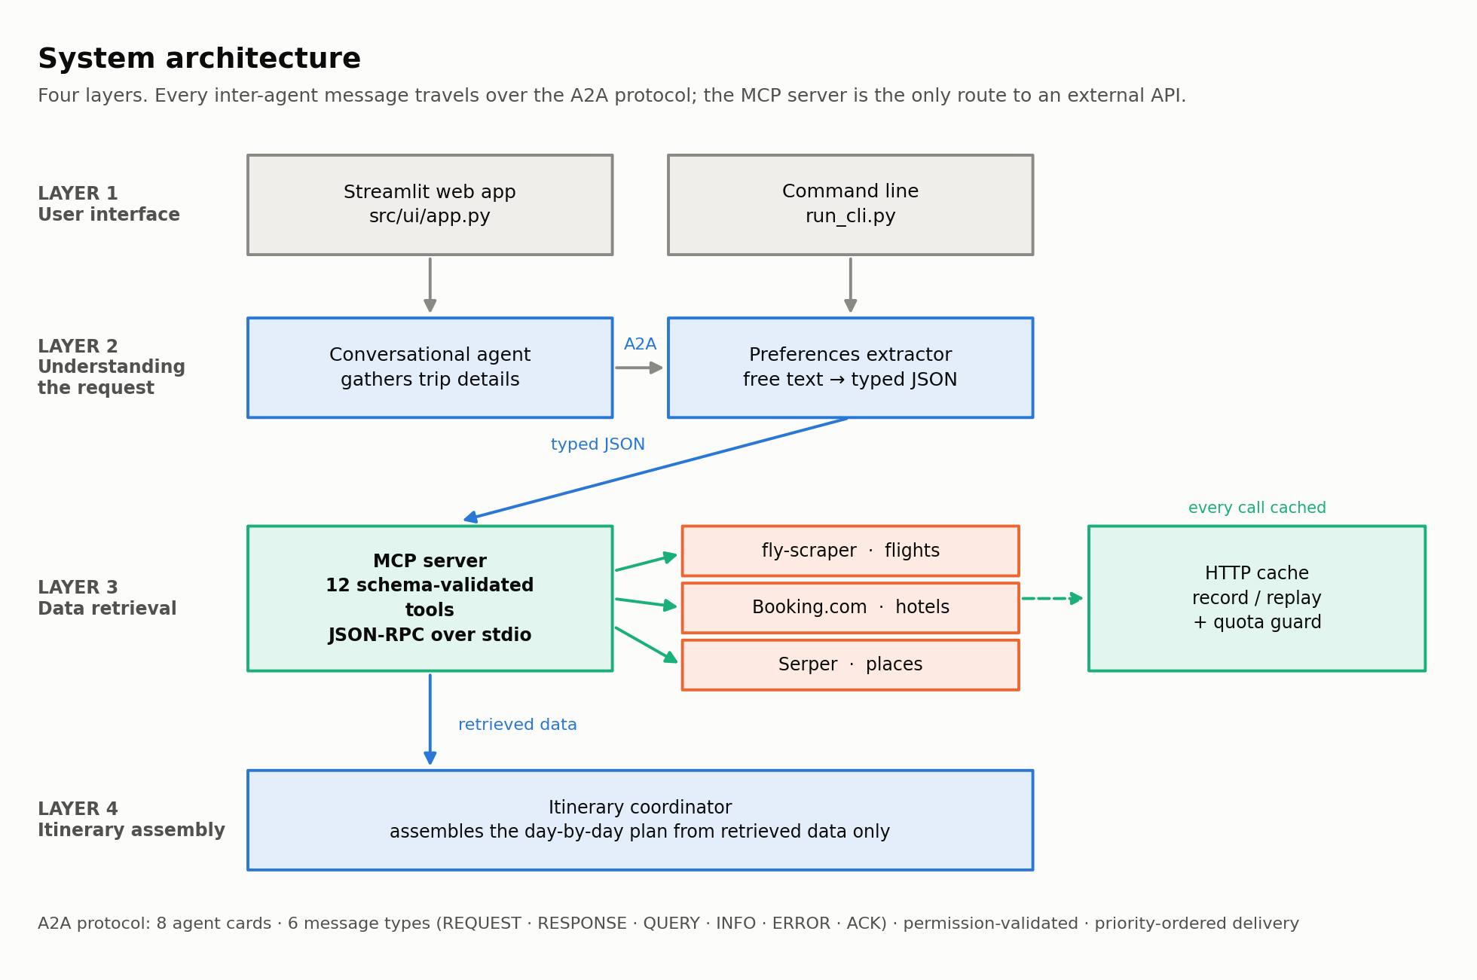
Figure 1 — System architecture. The MCP server is the only route to an external API; every inter-agent message travels over the A2A protocol.
3.1 The MCP server
A subprocess exposing twelve schema-validated tools over JSON-RPC on stdio. Each tool declares its parameters, so a malformed call is rejected before it can reach a paid external service. Responses pass through a cache and a distillation stage on the way back.
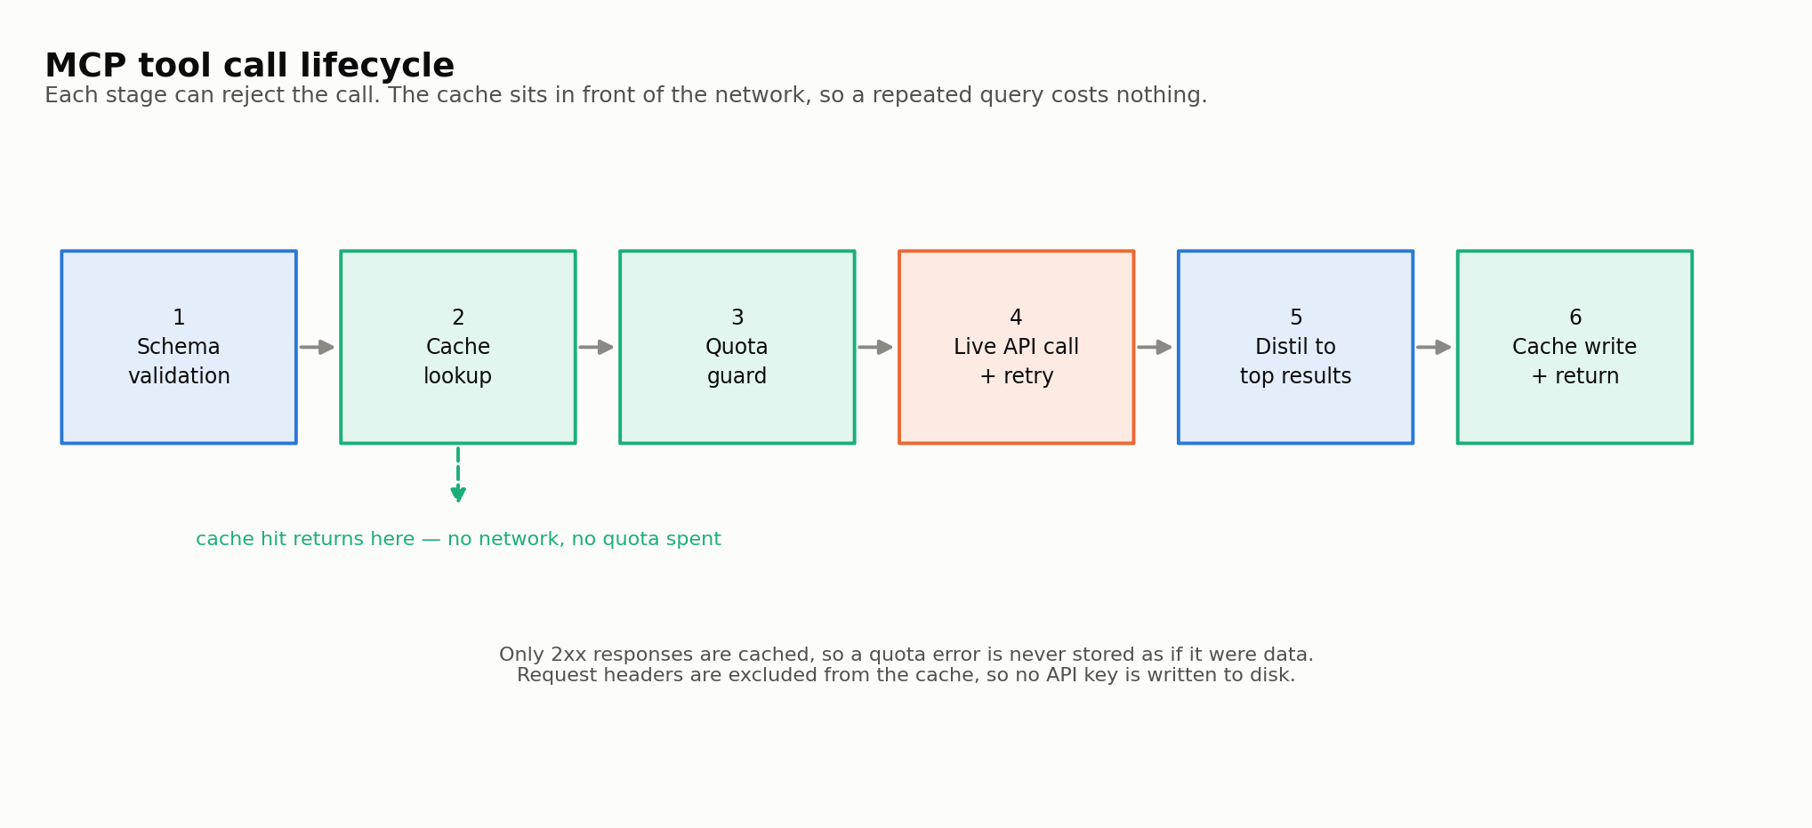
Figure 2 — The six stages of a tool call. The cache sits in front of the network, so a repeated query costs nothing.
3.2 The A2A protocol
Agents never hand each other free text. Every message carries an identifier, a sender, a receiver, one of six types, a priority, a conversation identifier and a typed payload. A registry of agent cards declares who may send what to whom, and a message that violates it is rejected rather than delivered.
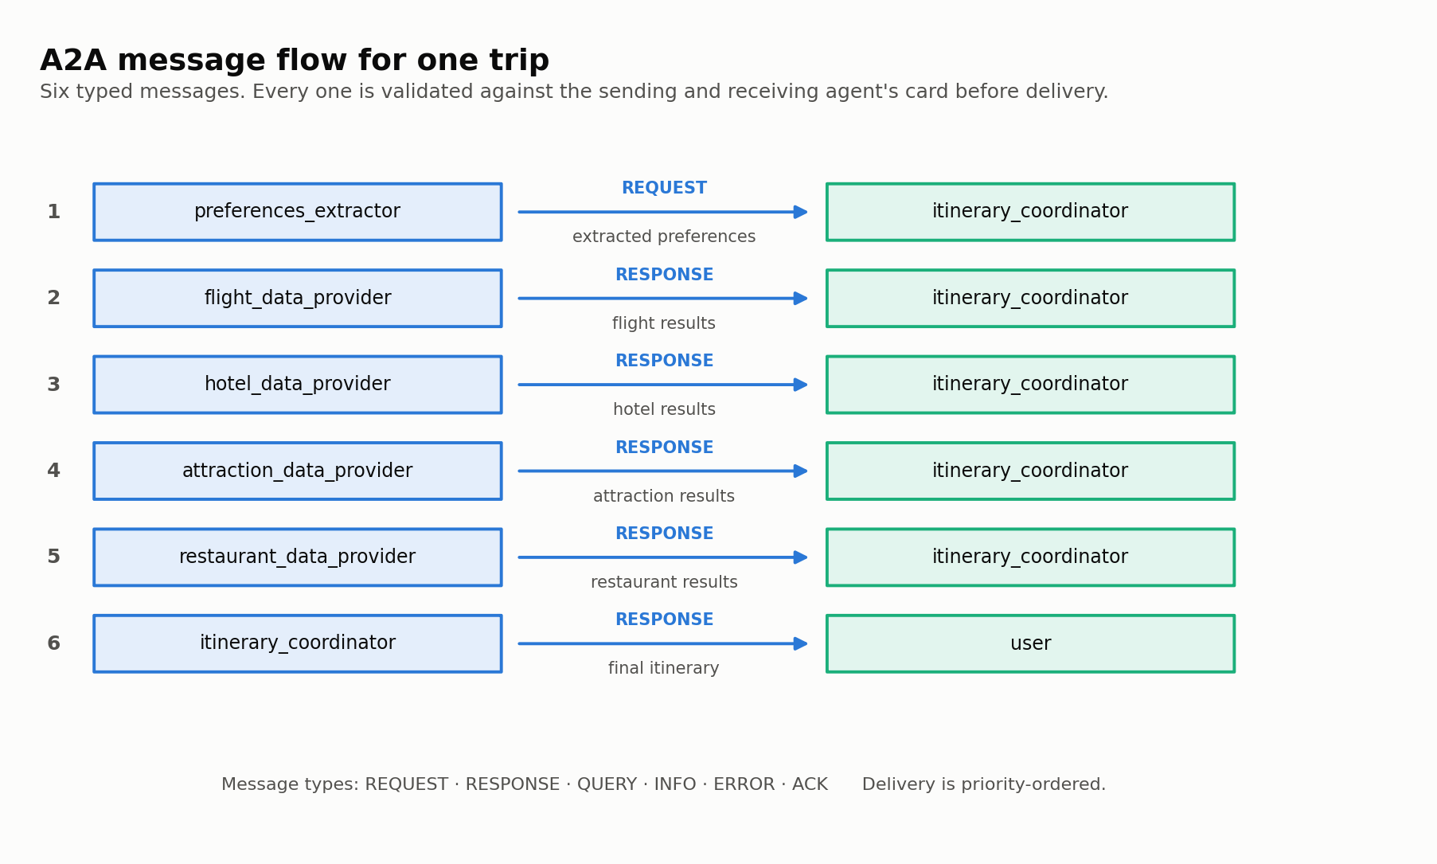
Figure 3 — The six A2A messages exchanged during one trip request.
This layer is identical in every architecture evaluated below. That is deliberate: holding the protocol constant is what allows the differences measured later to be attributed to the retrieval strategy rather than to how components communicate.

4. Approaches evaluated
The proposal specified a six-agent architecture. Once that was built and instrumented, most of its LLM calls turned out to be spent on data retrieval rather than on reasoning. Rather than assert that a smaller design is better, four architectures were built and measured against the same requests.
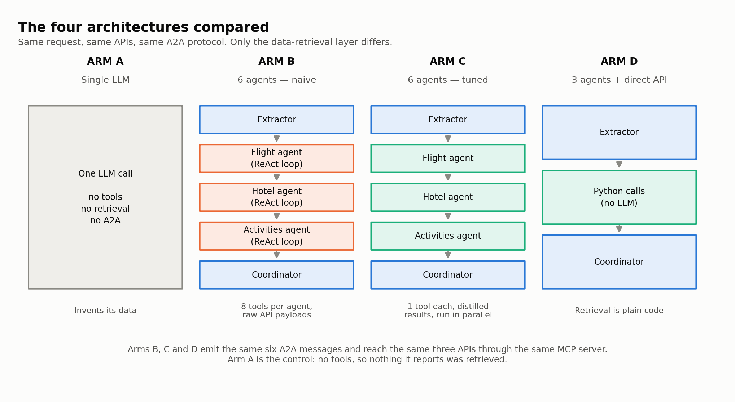
Figure 4 — The four architectures. Same request, same APIs, same protocol; only the retrieval layer differs.
Why four rather than two
Comparing the three-agent design only against the naive six-agent build would invite an obvious objection: that the multi-agent arm lost because it was configured badly, not because the architecture is worse. Arm C removes that objection by implementing three commitments the proposal made that the first build never did — distilled tool output, concurrent specialists, and distillation as a stage of the MCP lifecycle. Arm A, a single model with no tools, anchors the other end and shows what the tool layer buys.
4.1 Pros and cons
Arm | Strengths | Weaknesses
A — Single LLM | Simplest possible; one request; no infrastructure. | No access to real data. Cites venues and prices that were never retrieved, which is the failure this project exists to avoid.
B — Six agents, naive | Full agent autonomy: a specialist can re-search when a result disappoints. Faithful to the proposal's agent decomposition. | Each specialist carries up to eight tool schemas, re-sent on every reasoning step. Raw API payloads enter the context. Highest cost of the four on every measure.
C — Six agents, tuned | Keeps agent autonomy while removing most of the cost. Specialists run concurrently. Demonstrates that the multi-agent penalty is largely an implementation artefact. | Still spends several LLM calls deciding which tool to use — work that involves no judgement. Slower than direct execution.
D — Three agents, direct API | LLM used only where judgement is required: understanding the request and assembling the plan. Fewest calls, lowest latency. Retrieval is deterministic and testable. | Cannot adapt its search: if results disappoint, it cannot widen the dates and try again. That autonomy is genuinely lost.

5. Enhancement: user-controlled budget allocation
Following supervisor feedback, control over how the budget is divided was moved from the system to the user.
The problem with the original behaviour
The system applied one fixed split to every trip — flights 35%, accommodation 35%, activities 20%, meals 10% — written into seven places in the codebase, with no source behind the figures and no way for a user to change them.
That split is also wrong for most trips, because the two largest categories scale on different axes. Airfare is charged per person and set by distance; it does not care how many nights are stayed. Accommodation is charged per night and normally shared between travellers; it does not care how far anyone flew. A three-night trip to a nearby city and a fourteen-night long-haul trip cannot sensibly use the same percentages.
What was implemented
Before | After
One fixed split for every trip | A split derived from what the trip's own components actually cost
Written into seven places | One module, with the cost model as the single source
Never explained to the user | Each category explained, with the reasoning for the suggested figures
No way to change it | Accepts percentages, named categories, partial input, or cash amounts
Budget feasibility judged by a fixed formula ignoring destination | Feasibility judged against the estimated cost of that specific trip

Because the suggestion is derived rather than tuned, it responds to the trip. A two-night trip to Dubai puts roughly a third of the budget on flights; a fourteen-night trip to the same city puts under a fifth there, because the one-off airfare is spread across far more nights.
Feasibility, and a floor that is genuinely a floor
The previous check applied the same threshold regardless of destination, so a modest budget was judged identically for a nearby city and a long-haul one — and both were accepted, meaning the impossible trip produced a confident but fictional itinerary. Cost is now estimated for the specific destination, and a budget below the true minimum is refused with an explanation of the shortfall and concrete alternatives. Anything above that floor proceeds: a tight budget is a legitimate choice and is warned about, not blocked.

6. Measured results
Every LLM request is counted through provider callbacks at runtime; none of these figures is an estimate. Costs and latencies are means over the recorded scenarios.
Architecture | LLM calls | Tokens | Cost (USD) | Time | Real prices
A — SINGLE LLM | 1 | 11,392 | $0.0282 | 93s | 0%
B — 6 AGENTS (naive) | 19 | 63,926 | $0.0527 | 86s | 13%
C — 6 AGENTS (optimised) | 9 | 10,808 | $0.0151 | 66s | 59%
D — 3 AGENTS (direct API) | 2 | 7,813 | $0.0112 | 18s | 57%

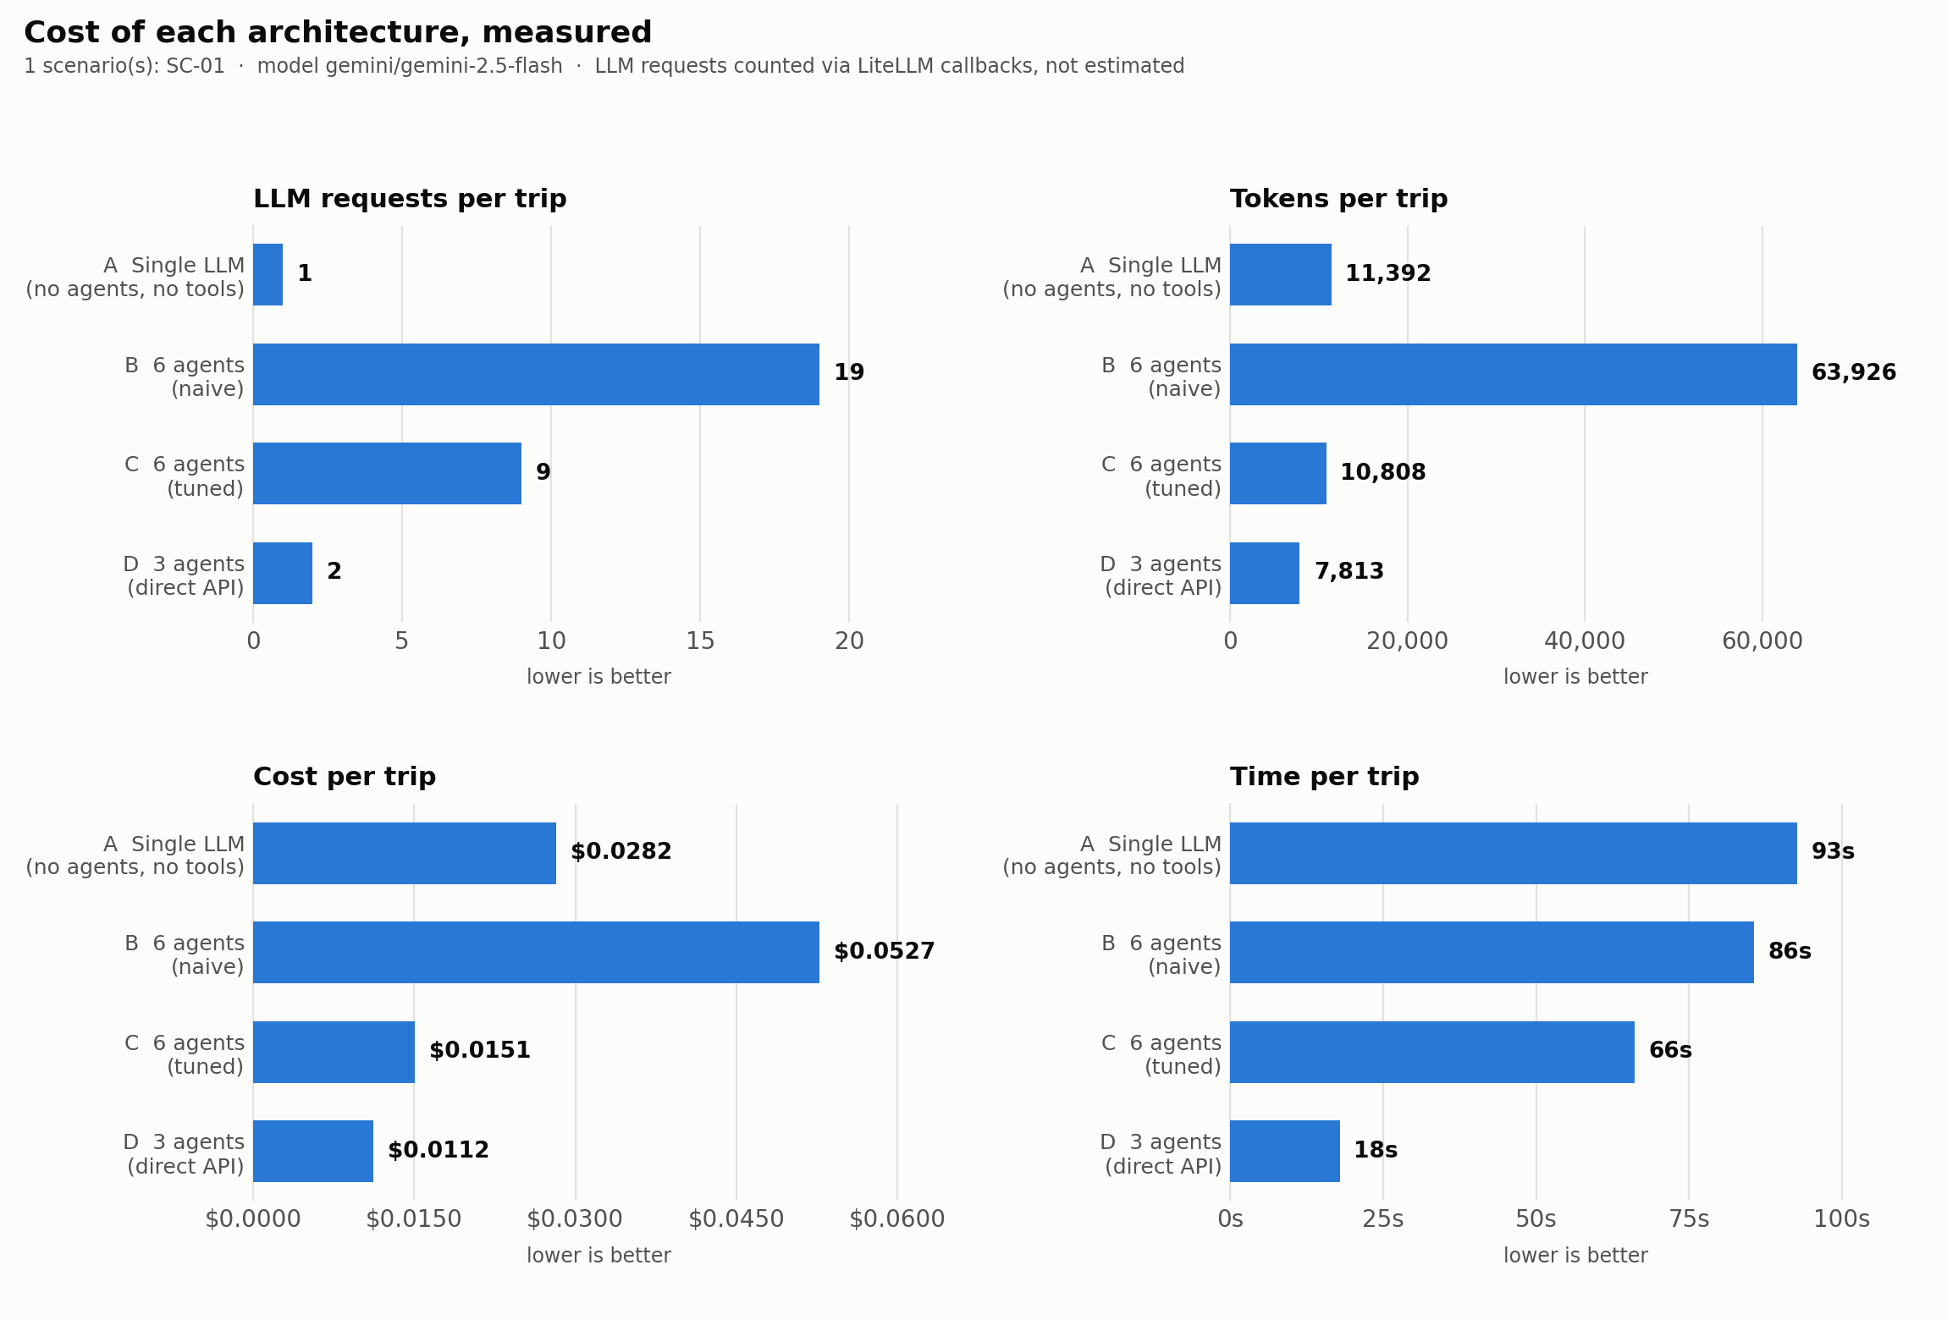
Figure 5 — Cost of each architecture across four measures. Presented as separate panels because the quantities share no scale.
6.1 Tuning accounts for most of the multi-agent penalty
Arms B and C contain the same six agents and reach the same APIs. Only the prompt economics differ: one narrow tool per specialist instead of up to eight, distilled results instead of raw payloads, and a cap on reasoning iterations.
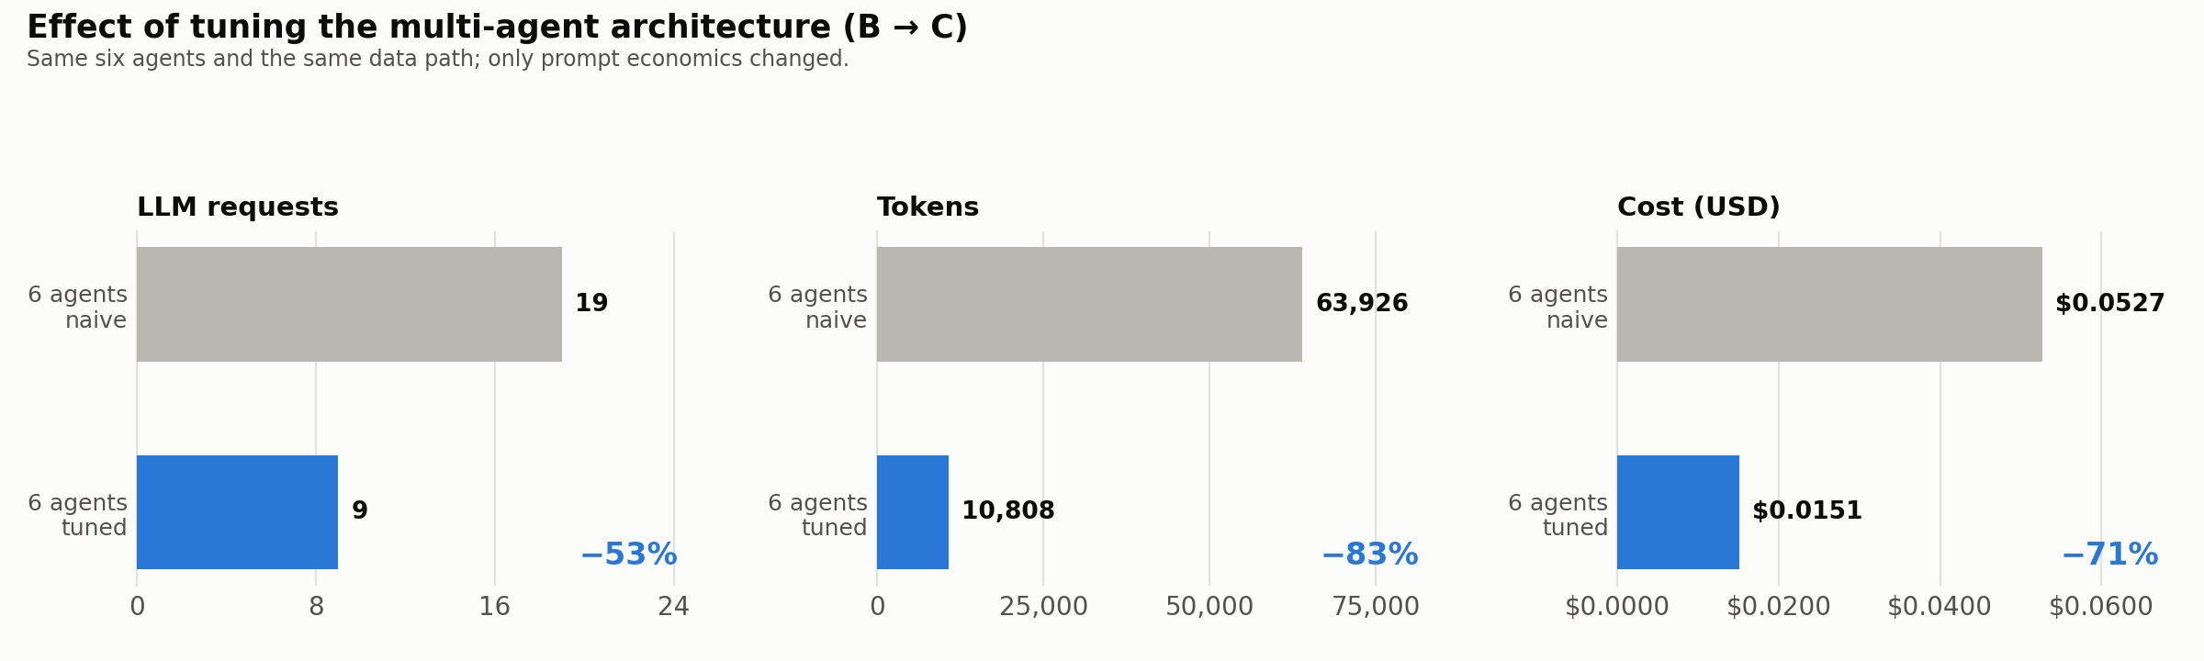
Figure 6 — Effect of tuning alone, with the architecture unchanged.
This matters for the conclusion. Most of the cost difference between the naive multi-agent build and direct execution is an implementation artefact, not a property of multi-agent design. Compared against the tuned arm rather than the naive one, direct execution still wins clearly on call count and latency, but only modestly on cost.
6.2 Cost alone would rank the worst system first
The single-LLM arm is inexpensive precisely because it retrieves nothing. Reporting its cost without reporting what it produced would invert the conclusion, so each itinerary is also scored on whether the prices it quotes match fares and rates actually returned by the APIs.
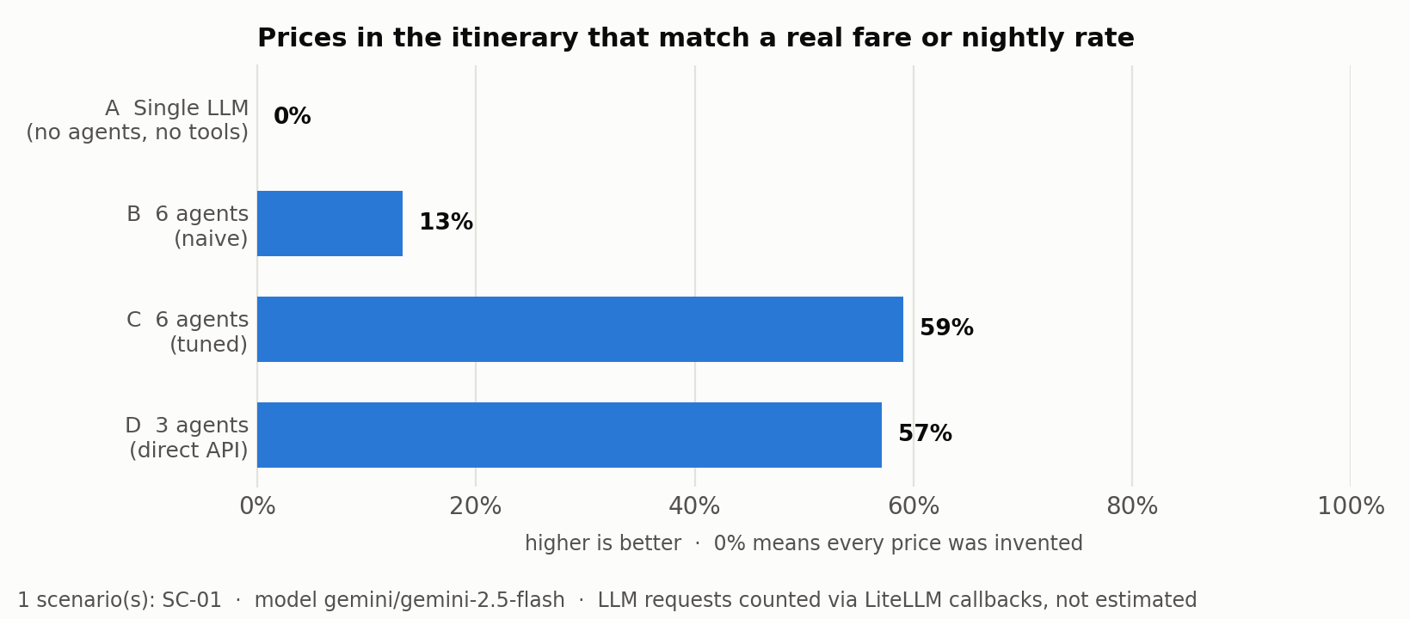
Figure 7 — Share of quoted prices traceable to retrieved data.
The tool-less arm scores 0%. Every price it printed was invented — the hallucination failure described in the literature, measured directly rather than assumed.
6.3 Interpreting the two groundedness signals
Price matching is the robust signal: landing within 2% of a real quoted fare is not something prior knowledge delivers. Name matching is weaker and is reported only as supporting detail — a model with no tool access can still name a real airline by guessing the obvious carrier for a route, which is exactly what the tool-less arm did.

7. Reproducibility
Every HTTP response the evaluation depends on is recorded and committed to the repository. The entire evaluation can therefore be re-run by anyone, producing identical numbers, with no API keys at all:
TRIP_PLANNER_API_MODE=replay python -m comparison.run_comparison
Property | How it is guaranteed
Numbers cannot drift from the data | This document and every figure are generated from the results file.
Results reproduce without credentials | Recorded API responses are committed; replay mode never touches the network.
Errors are never mistaken for data | Only successful responses are cached, so a quota failure is never stored.
No credentials reach disk | Request headers are excluded from both the cache key and the stored file.
A run cannot exhaust a monthly allowance | Live calls and LLM requests are both capped, and runs stop between scenarios.
An interrupted run loses nothing | Results are checkpointed per scenario; a re-run reuses what is recorded.

8. Repository structure
Location | Contents
src/ | Application code — orchestrator, agents, tasks, interfaces
src/comms/ | A2A protocol: message envelope, agent registry, priority queue
src/server/ | MCP server — twelve schema-validated tools over JSON-RPC
src/tools/ | Tool wrappers exposed to agents
src/core/ | Caching, measurement, retry policy, budget and cost models
src/ui/ | Streamlit interface
comparison/ | The experiment: four architectures, scenarios, metrics, results
testing/ | Automated test suite
figures/ | Generated charts and diagrams, with their generators
demos/ | Walkthrough scripts for demonstration
docs/ | Proposal, assignment brief, this document and its generator
.api_cache/ | Recorded API responses, committed for reproducibility

Entry points
Command | Purpose
python run_cli.py | Interactive planner in the terminal
python run_web.py | Streamlit web interface
python demos/demo_comparison.py | All four architectures side by side
python -m comparison.run_comparison | The full evaluation
python -m pytest | Test suite
python figures/make_charts.py | Regenerate results charts
python docs/generate_docx.py | Regenerate this document

9. Known limitations
Stated here rather than left to be discovered.
Limitation | Detail
Scenario coverage | 1 of 20 scenarios recorded so far. Reported figures describe that subset.
Run-to-run variance | The naive multi-agent arm varied between 19 and 23 LLM calls on identical input, reflecting the non-determinism of iterative reasoning loops. Figures are single-run measurements.
Destination price data | Cost estimation uses a curated table of roughly sixty cities. Unrecognised destinations receive mid-tier defaults, and the system says so rather than presenting them as derived.
Groundedness by name | Matching venue and airline names is weak evidence, since well-known names can be guessed. Price matching carries the claim.
Evaluation design | Scripted scenarios rather than a live user study, which limits external validity.

References
Anthropic (2024) Model Context Protocol Specification. Available at: https://modelcontextprotocol.io
Xie, J., Zhang, K., Chen, J., Zhu, T., Lou, R., Tian, Y., Xiao, Y. and Su, Y. (2024) 'TravelPlanner: A Benchmark for Real-World Planning with Language Agents', ICML 2024.
CrewAI (2024) CrewAI Documentation: Agents, Tasks and Crews. Available at: https://docs.crewai.com

