[DISSERTATION TITLE]
[Subtitle, if used]

[STUDENT NUMBER]

CMP7200 Individual Master's Project
Faculty of Computing, Engineering and the Built Environment
Birmingham City University

[SUBMISSION DATE]

GUIDANCE — delete this box before submitting
The brief states this assessment is marked anonymously: student number only, no name.
Attach the BCU cover sheet in front of this page.
Body text is already set to 11 pt with 1.5 line spacing, as the brief requires.

Abstract
GUIDANCE — delete this box before submitting
Not counted in the word limit. Around 250-300 words.
Cover: the problem, what was built, how it was evaluated, the headline result,
and what it means. Write this last, once the results are final.

[Abstract]

Acknowledgements
[Acknowledgements]

Table of Contents
GUIDANCE — delete this box before submitting
In Word: References > Table of Contents > Automatic Table.
It populates from the Heading styles already applied throughout this file.
Update it (right-click > Update Field) after every edit.

[Insert automatic table of contents]

List of Figures
GUIDANCE — delete this box before submitting
In Word: References > Insert Table of Figures, using the caption style.

[Insert table of figures]

1. Introduction
approximately 1,200 words

1.1 Background and motivation
GUIDANCE — delete this box before submitting
Why trip planning is worth automating. Keep it grounded — the reader
wants the problem, not a tourism-industry essay.

[Write this section here.]

1.2 Problem statement
GUIDANCE — delete this box before submitting
State it as one testable proposition.
Source: PROJECT_GUIDE.docx section 1 states the problem as implemented.

[Write this section here.]

1.3 Aim and objectives
GUIDANCE — delete this box before submitting
Restate from the proposal. Mark any objective that changed and say why —
a marker comparing the two documents will notice, and an explained
deviation reads as control while an unexplained one reads as drift.

[Write this section here.]

1.4 Scope
GUIDANCE — delete this box before submitting
In scope and out of scope. Source: PROJECT_GUIDE.docx section 2.

[Write this section here.]

1.5 Contributions
GUIDANCE — delete this box before submitting
What this work adds. Be specific and modest — three concrete claims
beat one grand one.

[Write this section here.]

1.6 Structure of the dissertation
GUIDANCE — delete this box before submitting
One short paragraph per chapter.

[Write this section here.]

2. Literature Review
approximately 2,500 words — LO2, 25% of the mark

2.1 Single-LLM tool use and its limits
GUIDANCE — delete this box before submitting
Toolformer, ReAct, Reflexion, and the evidence on where single-model
tool use breaks down.

[Write this section here.]

2.2 Multi-agent frameworks
GUIDANCE — delete this box before submitting
AutoGen, MetaGPT, CrewAI, GPTSwarm. Justify the framework you chose.

[Write this section here.]

2.3 Tool and messaging protocols
GUIDANCE — delete this box before submitting
MCP, schema-validated function calling, FIPA-ACL as the antecedent for
typed inter-agent messaging.

[Write this section here.]

2.4 AI travel planning systems
GUIDANCE — delete this box before submitting
TravelPlanner and its 0.6% final-pass rate; prior itinerary systems;
what none of them do together.

[Write this section here.]

2.5 Conceptual model and research gap
GUIDANCE — delete this box before submitting
This subsection is where the marks are. The criteria distinguish
'compares literature' from 'constructs a conceptual model derived from
these sources' — aim for the second.
For each of the three failure modes you designed against — context bloat,
protocol fragility, semantic drift — name the work that identifies it and
the design decision that answers it. Your measurements let you close that
loop with evidence, which most projects cannot do.

[Write this section here.]

3. Research Methodology
approximately 2,000 words — LO3, 35% of the mark

3.1 Research paradigm
GUIDANCE — delete this box before submitting
Design Science Research (Hevner et al., 2004): build an artefact,
evaluate it, learn from it. Say why it fits and what you rejected.

[Write this section here.]

3.2 Why four architectures
GUIDANCE — delete this box before submitting
The most important argument in the chapter.
Source: comparison/README.md justifies each arm individually.
Land this point: arm C exists so the comparison is not against a straw
man. A marker could otherwise object that the multi-agent arm lost
through misconfiguration. Making that argument yourself is worth more
than the result it protects.
State plainly that the six-agent arms instantiate five agents — the
conversational agent is omitted so every arm receives an identical
request — and call it a five-agent ablation of the six-agent design.

[Write this section here.]

3.3 Scenario design
GUIDANCE — delete this box before submitting
Twenty scenarios spanning trip length, distance, party size, destination
price tier and budget, including deliberately infeasible ones.
Source: the docstring in comparison/scenarios.py explains the axes.

[Write this section here.]

3.4 Metrics
GUIDANCE — delete this box before submitting
Cost, latency, and groundedness. Explain why cost alone would rank the
worst system first, and why price matching is stronger evidence than
name matching.
Source: comparison/metrics.py documents both, including the limitation.

[Write this section here.]

3.5 Controls and fairness
GUIDANCE — delete this box before submitting
Identical request strings, one shared retry policy, LLM usage counted
rather than estimated, budget allocation held constant across arms.
Source: comparison/run_comparison.py and its README.

[Write this section here.]

3.6 Reproducibility
GUIDANCE — delete this box before submitting
Record and replay: the evaluation re-runs from committed responses with
no API keys. Source: PROJECT_GUIDE.docx section 7.

[Write this section here.]

3.7 Ethics and limitations of the method
GUIDANCE — delete this box before submitting
Read-only API use within free tiers, no personal data, planning aid
rather than a booking system, scripted scenarios rather than a user study.

[Write this section here.]

4. Design and Implementation
approximately 2,800 words — LO4, 40% of the mark

4.1 System architecture
GUIDANCE — delete this box before submitting
Walk through the four layers. The figure is inserted below — reference it
in your text as Figure 4.1 and explain what the reader should take from it.

[Write this section here.]
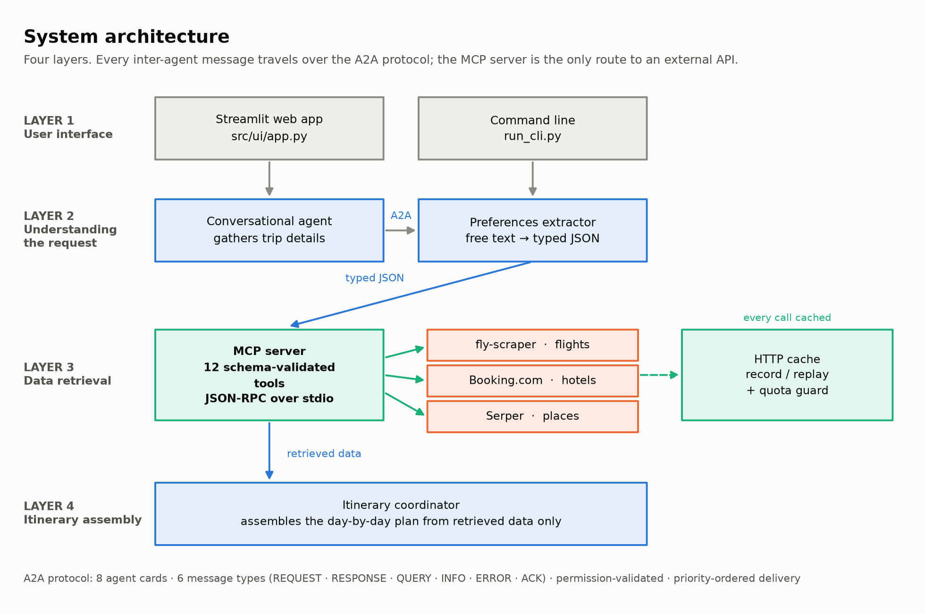
Figure 4.1 — System architecture.

4.2 The MCP server
GUIDANCE — delete this box before submitting
Twelve schema-validated tools over JSON-RPC on stdio, and the six-stage
lifecycle of a call.

[Write this section here.]
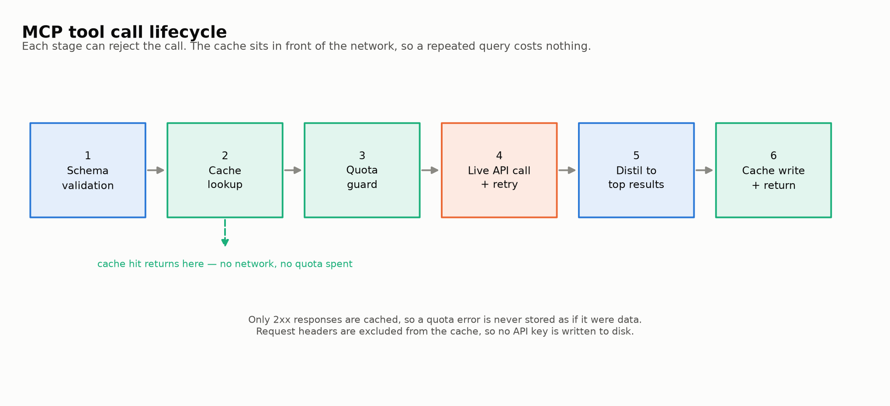
Figure 4.2 — MCP tool call lifecycle.

4.3 The A2A protocol
GUIDANCE — delete this box before submitting
Envelope, six message types, agent cards, permission validation.
Make the point that this layer is identical in every arm — that is what
lets the comparison attribute differences to retrieval strategy.

[Write this section here.]
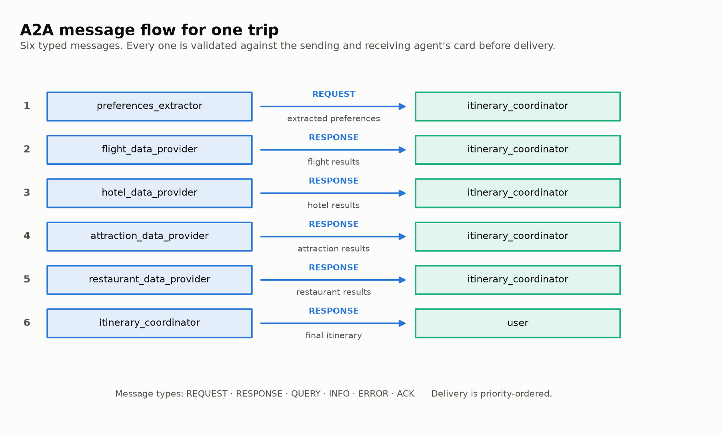
Figure 4.3 — A2A message flow for one trip.

4.4 The four architectures
GUIDANCE — delete this box before submitting
How each one differs, and what each gives up.

[Write this section here.]
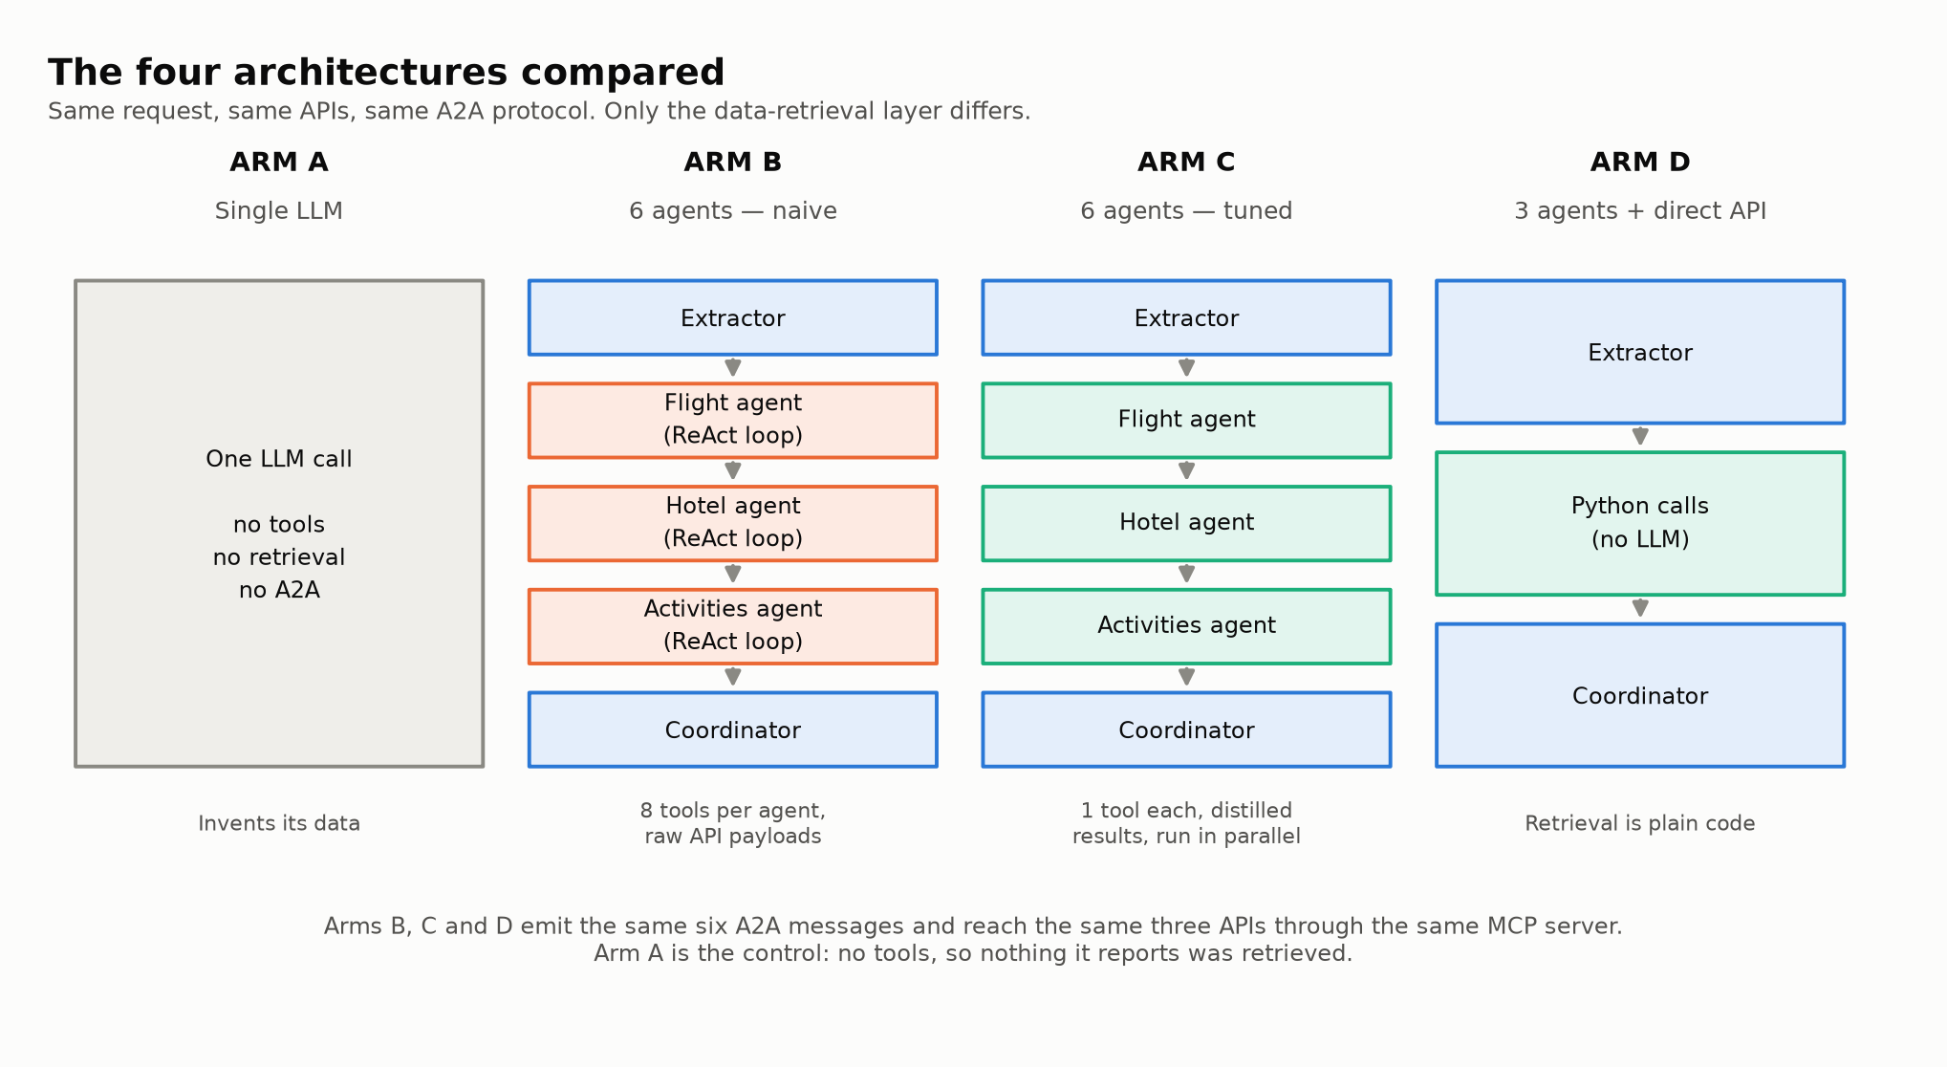
Figure 4.4 — The four architectures compared.

4.5 Budget allocation and feasibility
GUIDANCE — delete this box before submitting
Your supervisor's requested change.
Cover why one fixed split was wrong: airfare scales per person and by
distance, accommodation scales per night and is shared, so a short
long-haul trip and a long regional trip cannot use the same percentages.
Then what replaced it, and that the feasibility floor is now
destination-specific rather than one hardcoded threshold.
Source: PROJECT_GUIDE.docx section 5.

[Write this section here.]

4.6 Implementation problems and their resolution
GUIDANCE — delete this box before submitting
Give this real space — it is among the strongest material available.
The valuable cases are the quiet failures: dates silently ignored behind
an HTTP 200, twelve tools returning 'Connection lost' while the system
produced confident itineraries anyway, a reported cost that had never
been measured. Each shows diagnosis rather than coding.
Source: PROJECT_GUIDE.docx section 8 lists them with resolutions.

[Write this section here.]

4.7 Testing
GUIDANCE — delete this box before submitting
What is covered, what is deliberately not (nothing calls a live API),
and why the documentation itself is tested.

[Write this section here.]

5. Evaluation and Results
approximately 2,200 words

5.1 Experimental setup
GUIDANCE — delete this box before submitting
Model, API mode, how many scenarios were recorded, and the date.
Check 'status' and 'scenario_ids' in comparison/results/
comparison_results.json and state the coverage honestly here. If the run
is partial, say so — do not let a reader assume twenty.

[Write this section here.]

5.2 Cost across architectures
GUIDANCE — delete this box before submitting
Interpret the figure below. Do not just restate the numbers — say what
they mean and why the pattern occurs.

[Write this section here.]
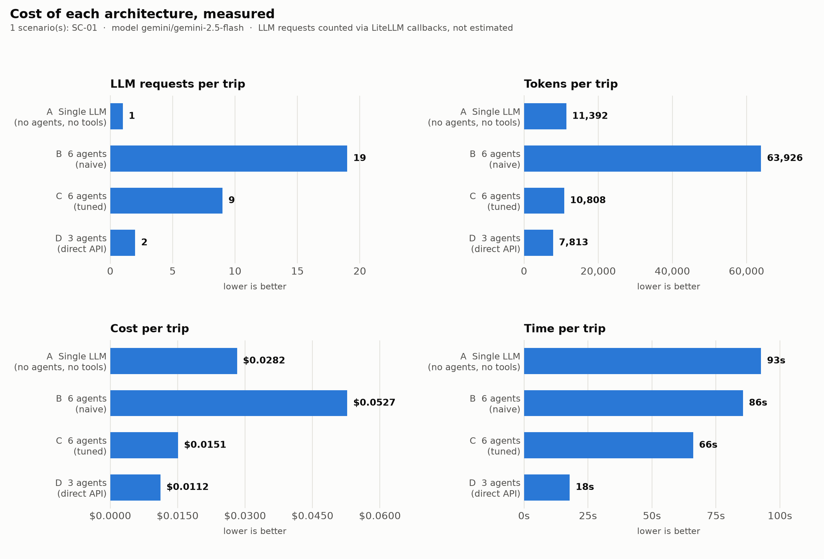
Figure 5.1 — Cost of each architecture.

5.3 The effect of tuning
GUIDANCE — delete this box before submitting
Arms B and C contain the same six agents and reach the same APIs; only
the prompt economics differ. This is the most interesting result you have.

[Write this section here.]
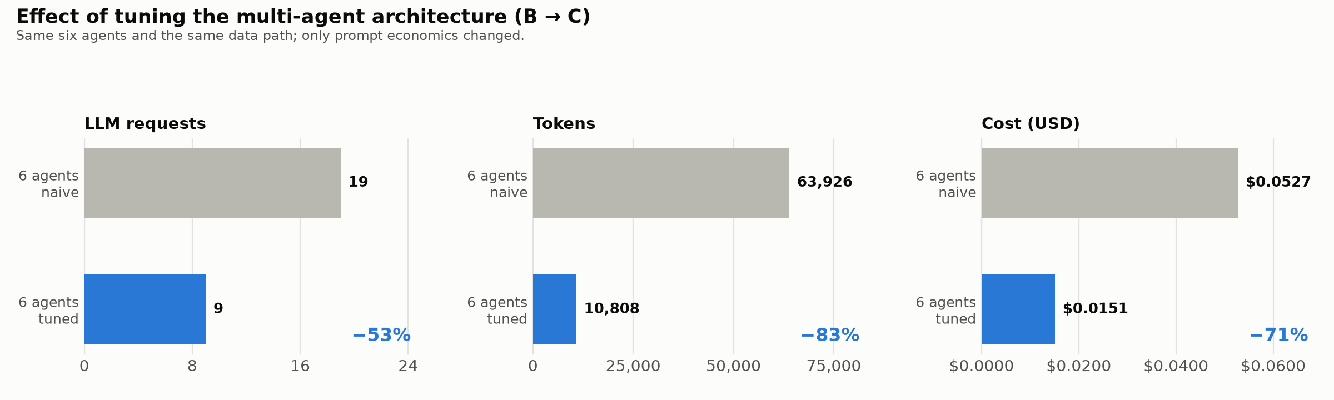
Figure 5.2 — Effect of tuning (arm B to arm C).

5.4 Groundedness
GUIDANCE — delete this box before submitting
The counterweight to cost. Explain what a zero here means.

[Write this section here.]
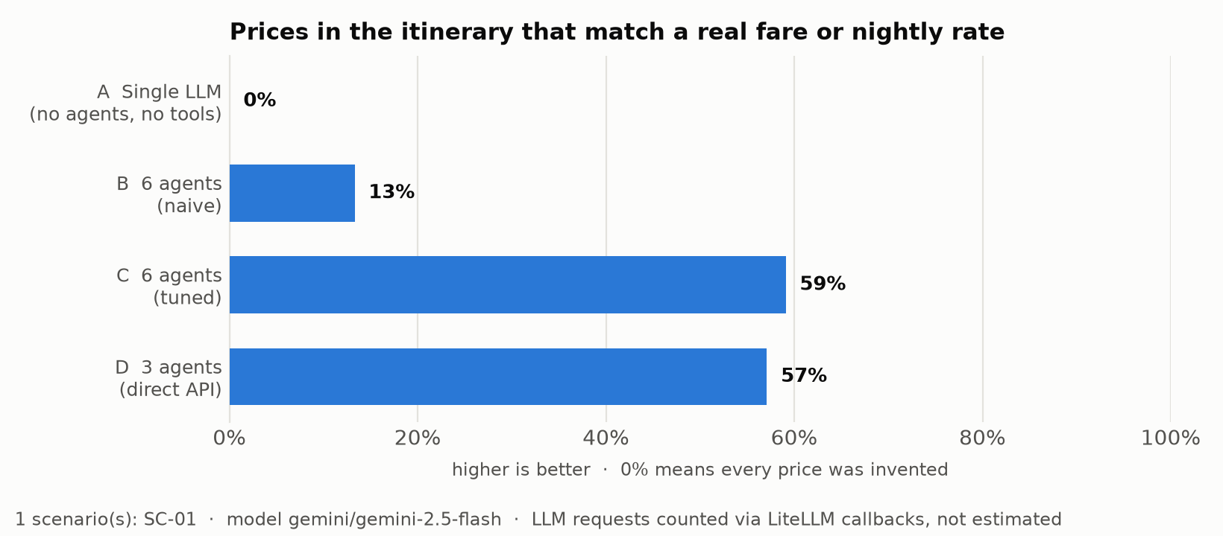
Figure 5.3 — Prices traceable to retrieved data.

5.5 Threats to validity
GUIDANCE — delete this box before submitting
Cover all five, in your own words:
run-to-run variance (arm B varied 19-23 calls on identical input,
so the figures are single-run measurements);
scenario coverage;
destination price data (a ~60-city table; unknown cities get defaults);
name-based groundedness being weak evidence;
scripted scenarios rather than a live user study.
Naming these yourself is worth more than hoping they go unnoticed.

[Write this section here.]

6. Discussion
approximately 900 words

6.1 Interpretation of the results
GUIDANCE — delete this box before submitting
Argue the narrower claim, because it is the one the data supports:
tuning removed most of the multi-agent penalty, so the surviving finding
is about call count and latency rather than a large cost difference.
That is harder to attack than 'fewer agents win'.

[Write this section here.]

6.2 Relation to the literature
GUIDANCE — delete this box before submitting
Tie the groundedness result back to the hallucination findings in
chapter 2. This is where LO2 marks are earned a second time.

[Write this section here.]

6.3 Deviations from the proposal
GUIDANCE — delete this box before submitting
Kiwi.com to fly-scraper, GPT-4o to Gemini, thirteen tools to twelve,
six agents to three in production. Each with its reason.
Source: proposal/README.md tabulates them.

[Write this section here.]

7. Conclusion and Future Work
approximately 400 words

7.1 Objectives revisited
GUIDANCE — delete this box before submitting
Take each objective from chapter 1 and say whether it was met.

[Write this section here.]

7.2 Contributions
GUIDANCE — delete this box before submitting
Restate briefly. No new material here.

[Write this section here.]

7.3 Future work
GUIDANCE — delete this box before submitting
Ground each in a real limitation: deriving destination price tiers from
live data rather than a fixed table; a hybrid architecture that uses an
agent only when a first search fails; a live user study.

[Write this section here.]

References
GUIDANCE — delete this box before submitting
BCU Harvard. Not counted in the word limit.
Carry over everything cited in the proposal, plus whatever chapter 2 adds.

[References]

Appendices
GUIDANCE — delete this box before submitting
Not counted in the word limit. Candidates:
A — The twenty evaluation scenarios (comparison/scenarios.py)
B — Full results table (comparison/results/comparison_results.json)
C — Repository structure and file listing (PROJECT_GUIDE.docx section 10)
D — Link to the repository

[Appendices]

