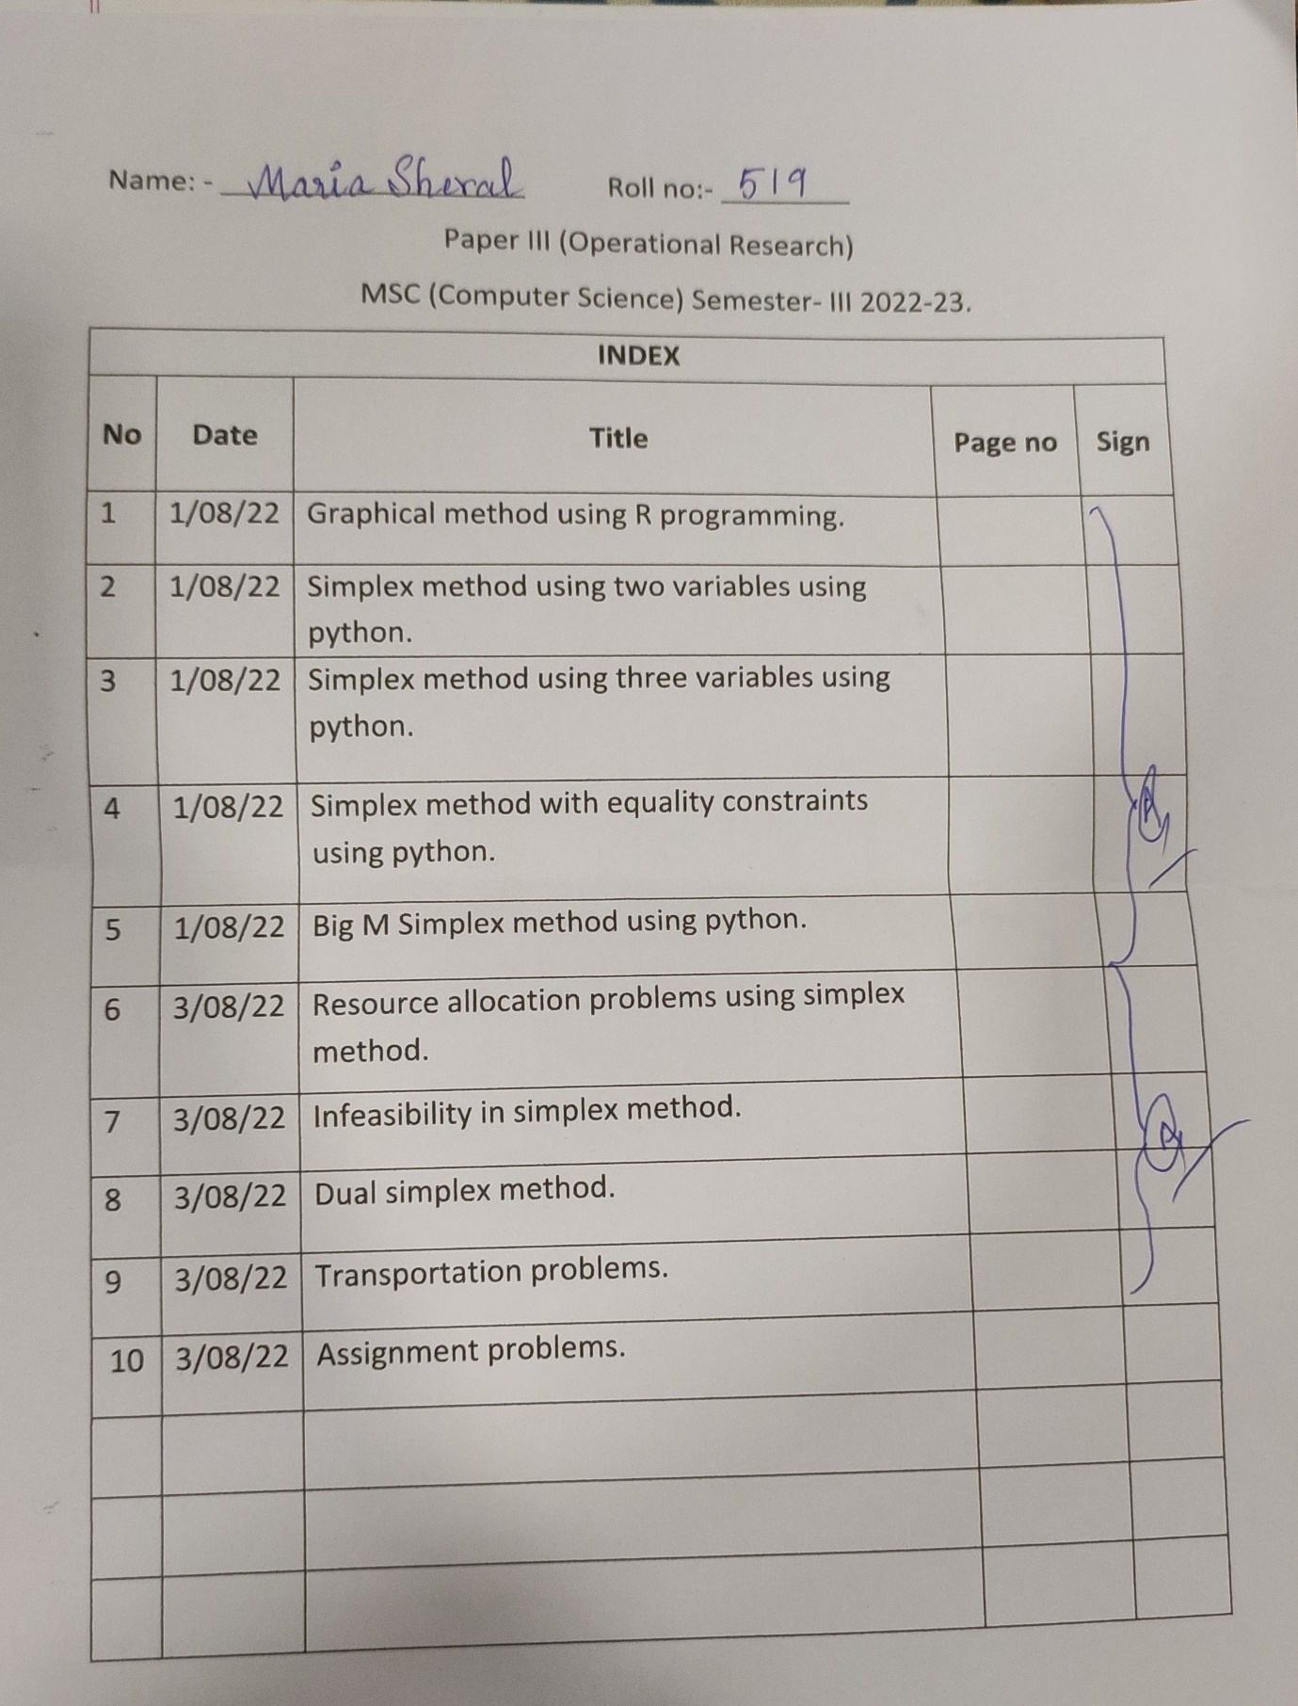

**OR PRACS**

**Practical 1**

**AIM: GRAPHICAL METHOD USING R PROGRAMMING**

**Code:-**

install.packages("lpSolve")

#prac1

#R program

#Find a geometrical interpretation and solution as well for the following LP problem

#Max z= 3x1+5x2

#subject to constraints:

#x1+2x2<=2000

#x1+x2<=1500

#x2<=600

#x1,x2>=0

#Load lpSolve

require(lpSolve)

## Set the coefficients of the decision variables -> C of objective function

C <- c(3,5)

#Create constraint matrix B

A <- matrix(c(1,2,

1,1,

0,1

),nrow=3,byrow=TRUE)

#Right hand side for the constraints

B <- c(2000,1500,600)

#Direction of the constraints

constraints_direction <- c("<=","<=","<=")

#Create empty example plot

plot.new()

plot.window(xlim=c(0,2000),ylim=c(0,2000))

axis(1)

axis(2)

title(main="LPP using Graphical method")

title(xlab="X axis")

title(ylab="y AXIS")

box()

#Draw one line

segments(x0=2000,y0=0,x1=0,y1=1000,col="green")

segments(x0=1500,y0=0,x1=0,y1=1500,col="green")

segments(x0=0,y0=0,x1=0,y1=0,col="green")

#Find the optimal solution

optimum <- lp(direction="max",

objective.in=C,

const.mat=A,

const.dir=constraints_direction,

const.rhs=B,

all.int=T)

#Print status: 0= success, 2=no feasible solution

print(optimum$status)

#Display the optimum values forx1,x2

best_sol<- optimum$solution

names(best_sol)<-c("x1","x2")

print(best_sol)

#Check the value of objective function at optimal point

print(paste("Total cost:",optimum$objval,sep=""))

**Output:-**

#prac1

> #R program

> #Find a geometrical interpretation and solution as well for the following LP problem

> #Max z= 3x1+5x2

> #subject to constraints:

> #x1+2x2<=2000

> #x1+x2<=1500

> #x2<=600

> #x1,x2>=0

> #Load lpSolve

> require(lpSolve)

Loading required package: lpSolve

> ## Set the coefficients of the decision variables -> C of objective function

> C <- c(3,5)

> #Create constraint matrix B

> A <- matrix(c(1,2,

+ 1,1,

+ 0,1

+ ),nrow=3,byrow=TRUE)

> #Right hand side for the constraints

> B <- c(2000,1500,600)

> #Direction of the constraints

> constraints_direction <- c("<=","<=","<=")

> #Create empty example plot

> plot.new()

> plot.window(xlim=c(0,2000),ylim=c(0,2000))

> axis(1)

> axis(2)

> title(main="LPP using Graphical method")

> title(xlab="X axis")

> title(ylab="y AXIS")

> box()

> #Draw one line

> segments(x0=2000,y0=0,x1=0,y1=1000,col="green")

> segments(x0=1500,y0=0,x1=0,y1=1500,col="green")

> segments(x0=0,y0=0,x1=0,y1=0,col="green")

> #Find the optimal solution

> optimum <- lp(direction="max",

+ objective.in=C,

+ const.mat=A,

+ const.dir=constraints_direction,

+ const.rhs=B,

+ all.int=T)

> #Print status: 0= success, 2=no feasible solution

> print(optimum$status)

[1] 0

> #Display the optimum values forx1,x2

> best_sol<- optimum$solution

> names(best_sol)<-c("x1","x2")

> print(best_sol)

x1 x2

1000 500

> #Check the value of objective function at optimal point

> print(paste("Total cost:",optimum$objval,sep=""))

[1] "Total cost:5500"

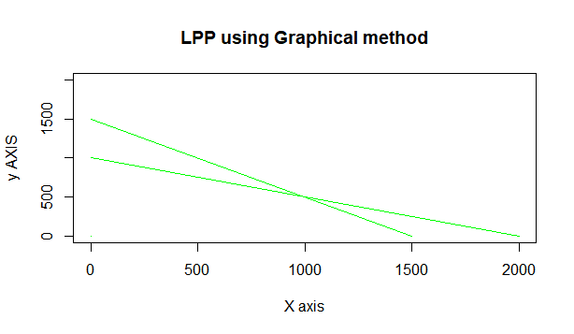

**Practical 2**

**AIM: Simplex Method with 2 variables using Python**

**Code:-**

%pip install scipy

from scipy.optimize import linprog

#Max z=3x1+2x2

#subject to

#x1 + x2 <=4

#x1 - x2 <=2

#x1,x2>=0

obj = [-3, -2]

lhs_ineq = [[ 1, 1], # Red constraint left side

... [1, -1]] # Blue constraint left side

rhs_ineq = [4, # Red constraint right side

... 2] # Blue constraint right side

bnd = [(0, float("inf")), # Bounds of x

... (0, float("inf"))] # Bounds of y

opt = linprog(c=obj, A_ub=lhs_ineq, b_ub=rhs_ineq,

... bounds=bnd,method="revised simplex")

opt

opt.fun

opt.success

opt.x

**Output:-**

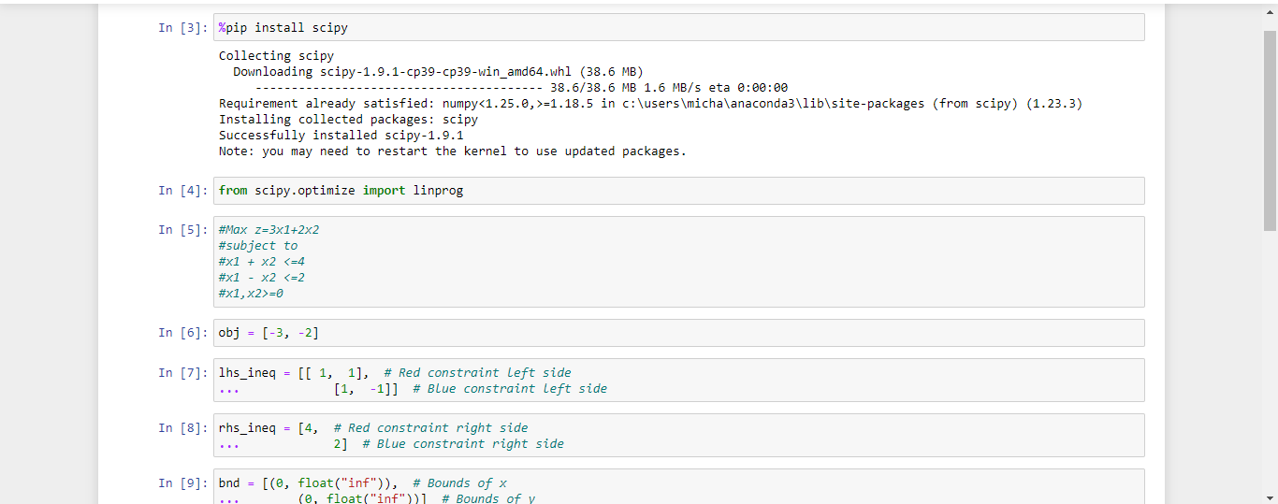

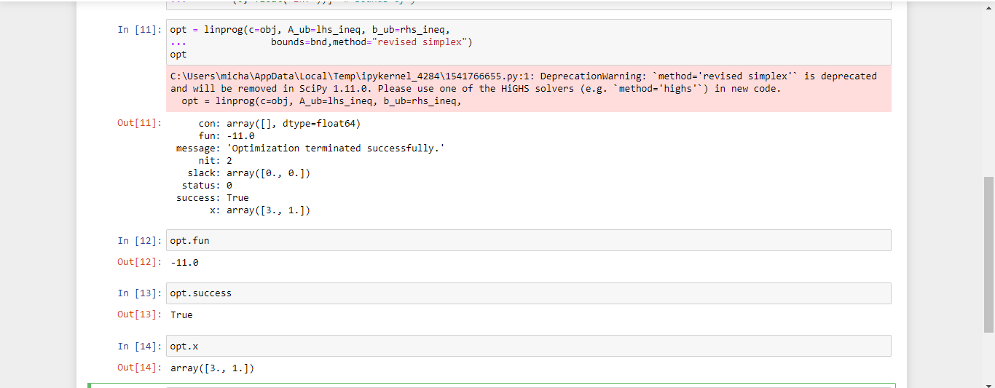

**Practical 3**

**AIM: Simplex Method with 3 variables using Python**

**Code:-**

%pip install scipy

from scipy.optimize import linprog

#Min z= x1-3x2+2x3

#subject to

#3x1-x2+3x3<=7

#-2x1+4x2<=12

#-4x1+3x2+8x3<=10

#x1,x2,x3>=0

obj = [1, -3, 2]

lhs_ineq = [[ 3, -1, 3], # Red constraint left side

... [-2, 4, 0], # Blue constraint left side

... [ -4, 3, 8]] # Yellow constraint left side

rhs_ineq = [7, # Red constraint right side

... 12, # Blue constraint right side

... 10] # Yellow constraint right side

bnd = [(0, float("inf")), # Bounds of x

... (0, float("inf")),

... (0, float("inf"))] # Bounds of y

opt = linprog(c=obj, A_ub=lhs_ineq, b_ub=rhs_ineq,

... bounds=bnd,

... method="revised simplex")

Opt

**Ouput:-**

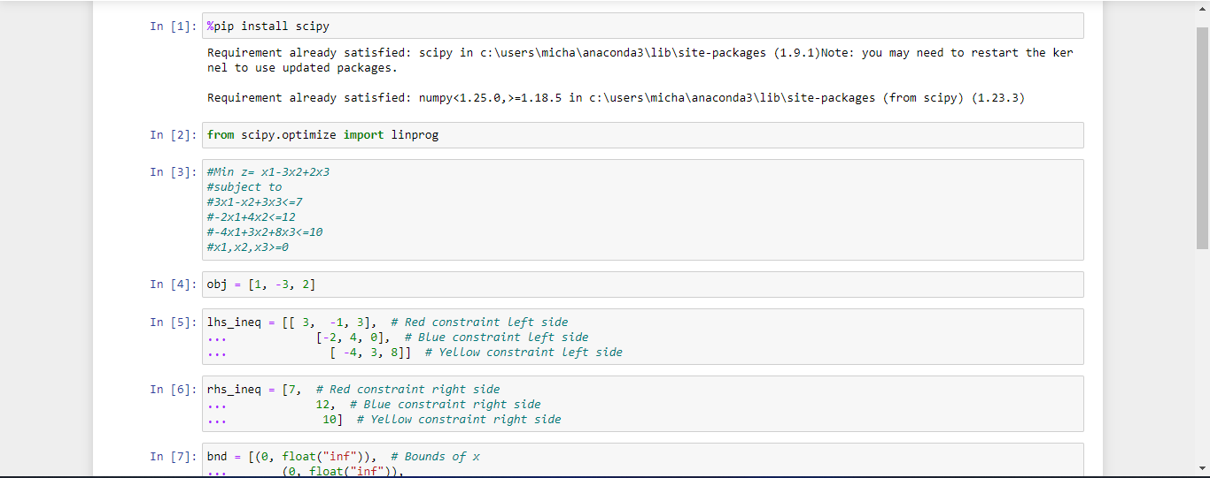

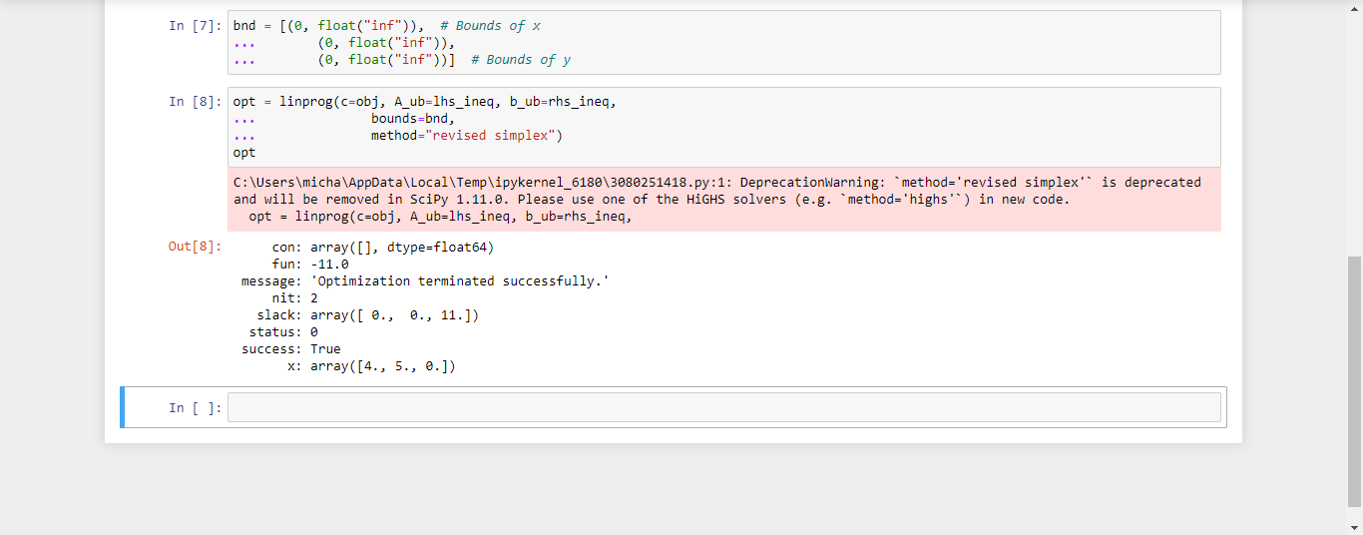

**Practical 4**

**AIM: Simplex Method with Equality Constraints Using Python**

**Code:-**

%pip install scipy

from scipy.optimize import linprog

#Max z=x+2y

#subject to

#2x+y<=20

#-4x+5y<=10

#-x+2y>=-2

#-x+5y=15

#x,y>=0

obj = [-1, -2]

lhs_ineq = [[ 2, 1], # Red constraint left side

... [-4, 5], # Blue constraint left side

... [ 1, -2]] # Yellow constraint left side

rhs_ineq = [20, # Red constraint right side

... 10, # Blue constraint right side

... 2] # Yellow constraint right side

lhs_eq = [[-1, 5]] # Green constraint left side

rhs_eq = [15] # Green constraint right side

bnd = [(0, float("inf")), # Bounds of x

... (0, float("inf"))] # Bounds of y

opt = linprog(c=obj, A_ub=lhs_ineq, b_ub=rhs_ineq,

... A_eq=lhs_eq, b_eq=rhs_eq, bounds=bnd,

... method="revised simplex")

Opt

**Output:-**

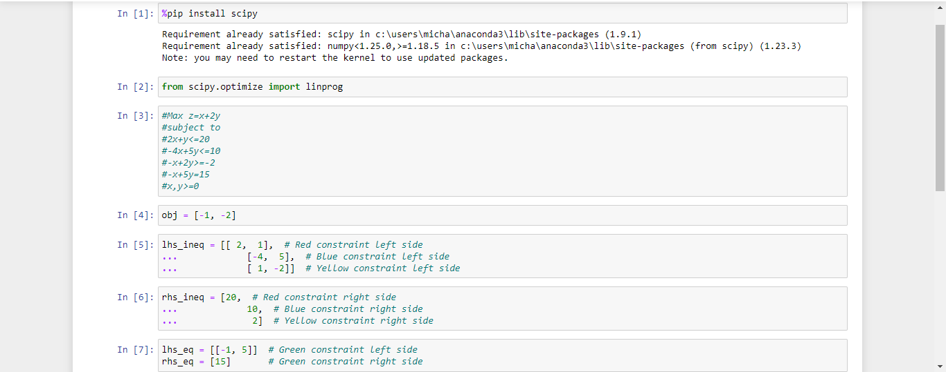

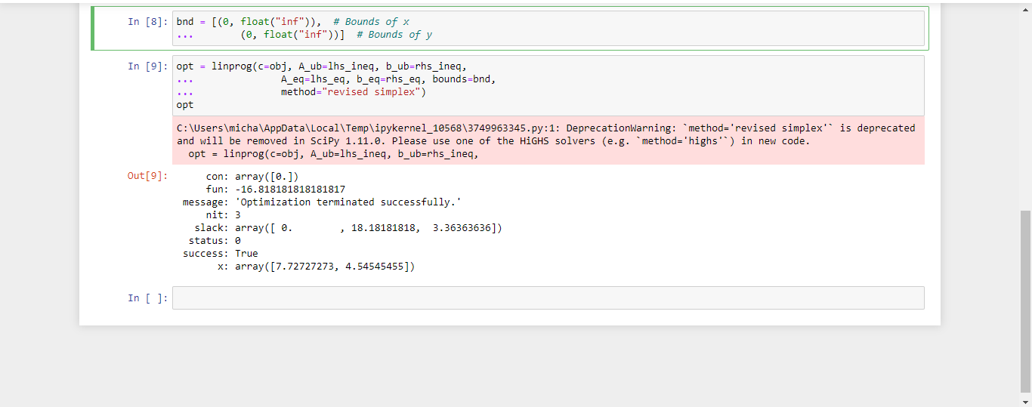

**Practical 5**

**AIM: BigM Simplex Method using Python**

**Solve Following linear programming problem using Big M Simplex method.**

**Code:-**

#Min z= 4x1 + x2

#subjected to:

#3x1 + 4x2 >= 20

#x1 + 5x2 >= 15

#x1, x2 >= 0

%pip install scipy

from scipy.optimize import linprog

obj = [4, 1]

lhs_ineq = [[ -3, -4], # left side of first constraint

... [-1, -5]] # right side of first constraint

rhs_ineq = [-20, # right side of first constraint

... -15] # right side of Second constraint

bnd = [(0, float("inf")), # Bounds of x1

... (0, float("inf"))] # Bounds of x2

opt = linprog(c=obj, A_ub=lhs_ineq, b_ub=rhs_ineq,

... bounds=bnd,method="interior-point")

Opt

**Output:-**

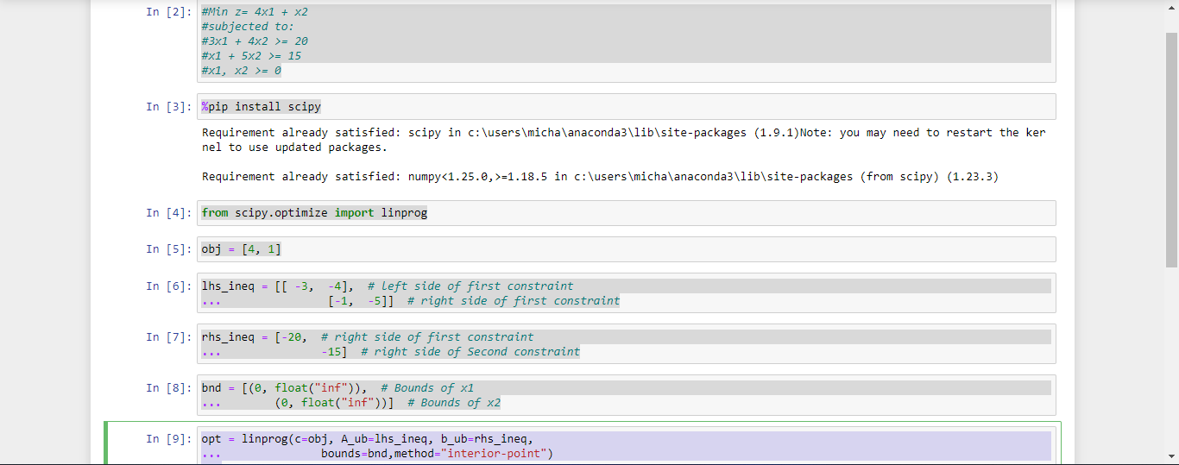

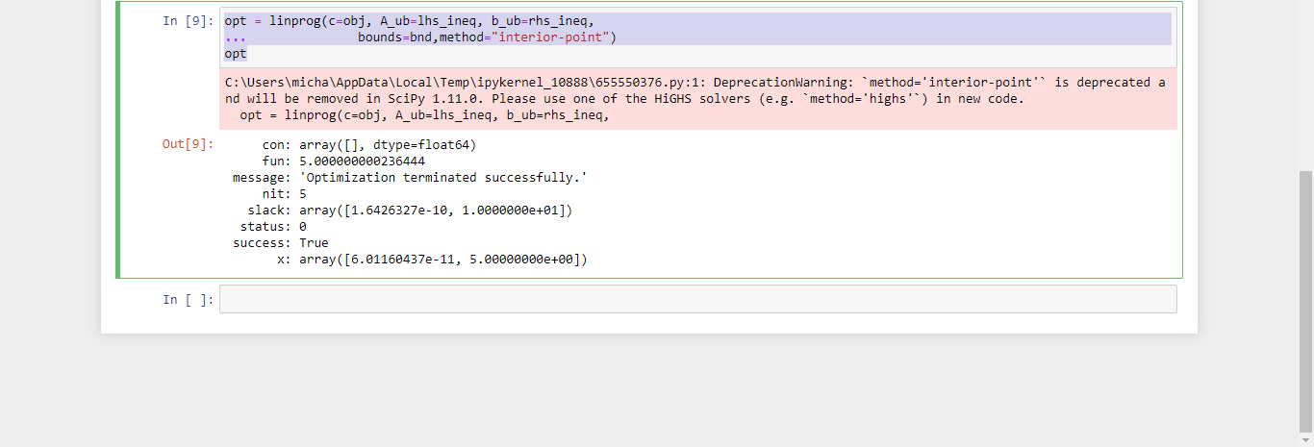

**Practical 6**

**AIM: RESOURCE ALLOCATION PROBLEM BY SIMPLEX METHOD**

**Code:-**

#Max z= 20x1 + 12x2 +40x3 + 25x4 .............(profit)

#subjected to:

#x1 + x2 + x3 + x4 <= 50 -------------(manpower)

#3x1 + 2x2 + x3 <= 100 -------------(material A)

# x2 + 2x3 <= 90 -------------(material B)

# x1, x2, x3, x4 >= 0

%pip install scipy

from scipy.optimize import linprog

obj = [-20, -12, -40, -25] #profit objective function

lhs_ineq = [[1, 1, 1, 1], # Manpower

... [3, 2, 1, 0], # Material A

... [0, 1, 2, 3]] # Material B

rhs_ineq = [ 50, # Manpower

... 100, # Material A

... 90] # Material B

opt = linprog(c=obj, A_ub=lhs_ineq, b_ub=rhs_ineq,

... method="revised simplex")

Opt

**Output:-**

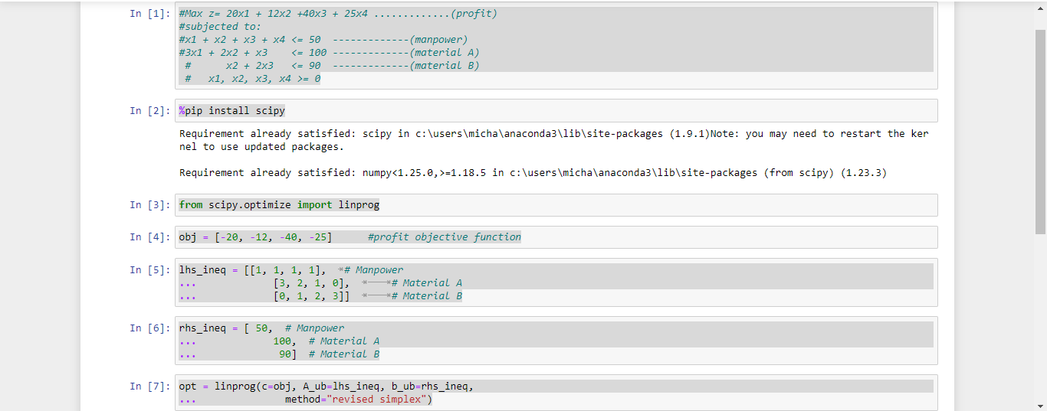

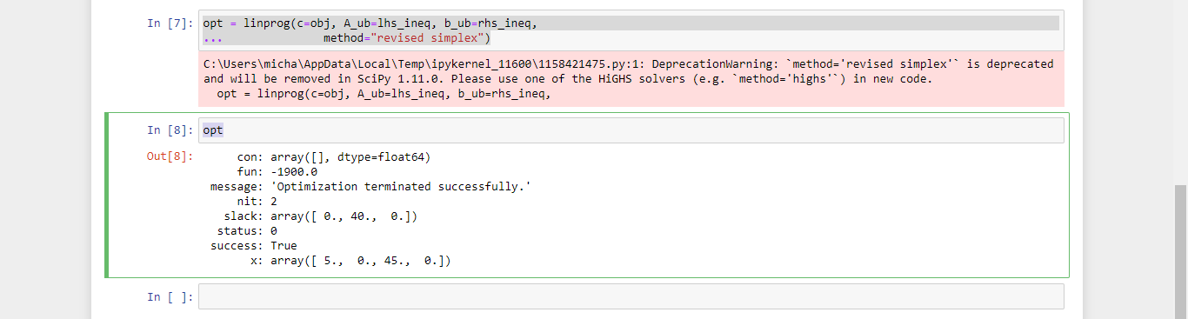

**Practical 7**

**INFEASIBILITY IN SIMPLEX METHOD**

**AIM: # Solve following linear programming problem using Simplex method**

**WHILE SOLVING LINEAR PROGRAMMING PROBLEM USING SIMPLEX METHOD, IF ONE OR MORE ARTIFICIAL VARIABLES REMAIN IN THE BASIS AT POSITIVE LEVEL AT THE END OF PHASE 1 COMPUTATION , THE PROBLEM HAS NO FEASIBLE SOLUTION( INFEASIBLE SOLUTION).**

**Code:-**

#Max z= 200x - 300y

#subject to

#2x+3y>=1200

#x+y<=400

#2x+3/2y>=900

#x,y>=0

%pip install scipy

from scipy.optimize import linprog

obj = [-200, 300]

lhs_ineq = [[ -2, -3], # Red constraint left side

... [1, 1], # Blue constraint left side

... [ -2, -1.5]] # Yellow constraint left side

rhs_ineq = [-1200, # Red constraint right side

... 400, # Blue constraint right side

... -900] # Yellow constraint right side

bnd = [(0, float("inf")), # Bounds of x

... (0, float("inf"))] # Bounds of y

opt = linprog(c=obj, A_ub=lhs_ineq, b_ub=rhs_ineq,

... bounds=bnd,

... method="revised simplex")

Opt

**Output:-**

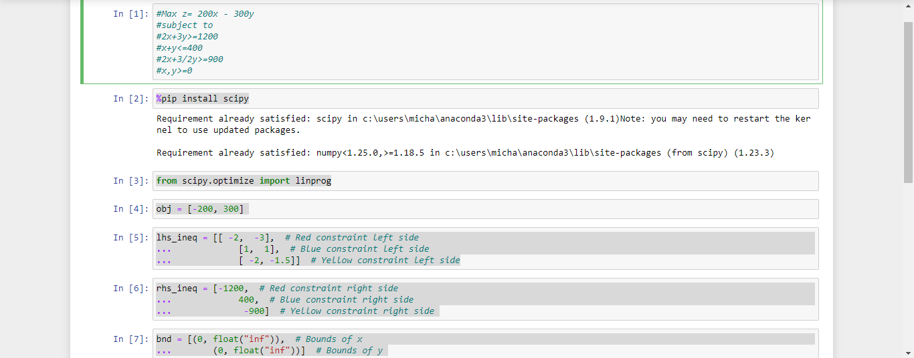

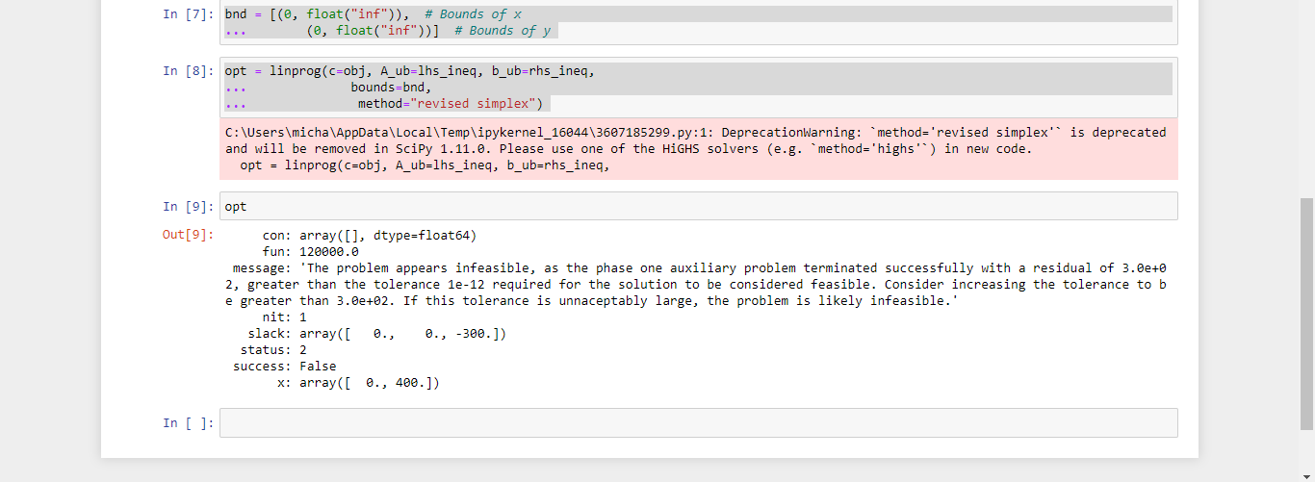

**Practical 8**

**AIM: DUAL SIMPLEX METHOD**

**Code:-**

install.packages("lpSolve")

##SOLVE FOLLOWING LINEAR PROGRAMMING PROBLEM USING DUAL SIMPLEX METHOD USING R PROGRAMMING

# Max z=40x1+50x2

#subject to

#2x1 + 3x2 <= 3

#8x1 + 4x2 <= 5

# x1, x2>=0

# Import lpSolve package

library(lpSolve)

# Set coefficients of the objective function

f.obj <- c(40, 50)

# Set matrix corresponding to coefficients of constraints by rows

# Do not consider the non-negative constraint; it is automatically assumed

f.con <- matrix(c(2, 3,

8, 4), nrow = 2, byrow = TRUE)

# Set unequality signs

f.dir <- c("<=",

"<=")

# Set right hand side coefficients

f.rhs <- c(3,

5)

# Final value (z)

lp("max", f.obj, f.con, f.dir, f.rhs)

# Variables final values

lp("max", f.obj, f.con, f.dir, f.rhs)$solution

# Sensitivities

lp("max", f.obj, f.con, f.dir, f.rhs, compute.sens=TRUE)$sens.coef.from

lp("max", f.obj, f.con, f.dir, f.rhs, compute.sens=TRUE)$sens.coef.to

# Dual Values (first dual of the constraints and then dual of the variables)

# Duals of the constraints and variables are mixed

lp("max", f.obj, f.con, f.dir, f.rhs, compute.sens=TRUE)$duals

# Duals lower and upper limits

lp("max", f.obj, f.con, f.dir, f.rhs, compute.sens=TRUE)$duals.from

lp("max", f.obj, f.con, f.dir, f.rhs, compute.sens=TRUE)$duals.to

**Output:-**

install.packages("lpSolve")

WARNING: Rtools is required to build R packages but is not currently installed. Please download and install the appropriate version of Rtools before proceeding:

https://cran.rstudio.com/bin/windows/Rtools/

Installing package into ‘C:/Users/micha/AppData/Local/R/win-library/4.2’

(as ‘lib’ is unspecified)

trying URL 'https://cran.rstudio.com/bin/windows/contrib/4.2/lpSolve_5.6.16.zip'

Content type 'application/zip' length 360585 bytes (352 KB)

downloaded 352 KB

package ‘lpSolve’ successfully unpacked and MD5 sums checked

The downloaded binary packages are in

C:\Users\micha\AppData\Local\Temp\RtmpI71FqS\downloaded_packages

> # Import lpSolve package

> library(lpSolve)

> # Set coefficients of the objective function

> f.obj <- c(40, 50)

> # Set matrix corresponding to coefficients of constraints by rows

> # Do not consider the non-negative constraint; it is automatically assumed

> f.con <- matrix(c(2, 3,

+ 8, 4), nrow = 2, byrow = TRUE)

> # Set unequality signs

> f.dir <- c("<=",

+ "<=")

> # Set right hand side coefficients

> f.rhs <- c(3,

+ 5)

> # Final value (z)

> lp("max", f.obj, f.con, f.dir, f.rhs)

Success: the objective function is 51.25

> # Variables final values

> lp("max", f.obj, f.con, f.dir, f.rhs)$solution

[1] 0.1875 0.8750

> # Sensitivities

> lp("max", f.obj, f.con, f.dir, f.rhs, compute.sens=TRUE)$sens.coef.from

[1] 33.33333 20.00000

> lp("max", f.obj, f.con, f.dir, f.rhs, compute.sens=TRUE)$sens.coef.to

[1] 100 60

> # Dual Values (first dual of the constraints and then dual of the variables)

> # Duals of the constraints and variables are mixed

> lp("max", f.obj, f.con, f.dir, f.rhs, compute.sens=TRUE)$duals

[1] 15.00 1.25 0.00 0.00

> # Duals lower and upper limits

> lp("max", f.obj, f.con, f.dir, f.rhs, compute.sens=TRUE)$duals.from

[1] 1.25e+00 4.00e+00 -1.00e+30 -1.00e+30

> lp("max", f.obj, f.con, f.dir, f.rhs, compute.sens=TRUE)$duals.to

[1] 3.75e+00 1.20e+01 1.00e+30 1.00e+30

**Practical 9:-**

**AIM: TRANSPORTATION PROBLEM**

**Code:-**

install.packages("lpSolve")

##SOLVE FOLLOWING TRANSPORTATION PROBLEM IN WHICH CELL ENTRIES REPRESENT UNIT COSTS USING R PROGRAMMING.

# "Customer 1", "Customer 2", "Customer 3", "Customer 4" SUPPLY

#sUPPLIER 1 10 2 20 11 15

#sUPPLIER 1 12 7 9 20 25

#sUPPLIER 1 4 14 16 18 10

#DEMAND 5 15 15 15

# Import lpSolve package

library(lpSolve)

# Set transportation costs matrix

costs <- matrix(c(10, 2, 20, 11,

12, 7, 9, 20,

4, 14 , 16, 18), nrow = 3, byrow = TRUE)

# Set customers and suppliers' names

colnames(costs) <- c("Customer 1", "Customer 2", "Customer 3", "Customer 4")

rownames(costs) <- c("Supplier 1", "Supplier 2", "Supplier 3")

# Set unequality/equality signs for suppliers

row.signs <- rep("<=", 3)

# Set right hand side coefficients for suppliers

row.rhs <- c(15, 25, 10)

# Set unequality/equality signs for customers

col.signs <- rep(">=", 4)

# Set right hand side coefficients for customers

col.rhs <- c(5, 15, 15, 15)

# Final value (z)

TotalCost <- lp.transport(costs, "min", row.signs, row.rhs, col.signs, col.rhs)

# Variables final values

lp.transport(costs, "min", row.signs, row.rhs, col.signs, col.rhs)$solution

print(TotalCost)

**Output:-**

install.packages("lpSolve")

WARNING: Rtools is required to build R packages but is not currently installed. Please download and install the appropriate version of Rtools before proceeding:

https://cran.rstudio.com/bin/windows/Rtools/

Installing package into ‘C:/Users/micha/AppData/Local/R/win-library/4.2’

(as ‘lib’ is unspecified)

trying URL 'https://cran.rstudio.com/bin/windows/contrib/4.2/lpSolve_5.6.16.zip'

Content type 'application/zip' length 360585 bytes (352 KB)

downloaded 352 KB

package ‘lpSolve’ successfully unpacked and MD5 sums checked

The downloaded binary packages are in

C:\Users\micha\AppData\Local\Temp\RtmpUpGVNv\downloaded_packages

> # Import lpSolve package

> library(lpSolve)

> # Set transportation costs matrix

> costs <- matrix(c(10, 2, 20, 11,

+ 12, 7, 9, 20,

+ 4, 14 , 16, 18), nrow = 3, byrow = TRUE)

> # Set customers and suppliers' names

> colnames(costs) <- c("Customer 1", "Customer 2", "Customer 3", "Customer 4")

> rownames(costs) <- c("Supplier 1", "Supplier 2", "Supplier 3")

> # Set unequality/equality signs for suppliers

> row.signs <- rep("<=", 3)

> # Set right hand side coefficients for suppliers

> row.rhs <- c(15, 25, 10)

> # Set unequality/equality signs for customers

> col.signs <- rep(">=", 4)

> # Set right hand side coefficients for customers

> col.rhs <- c(5, 15, 15, 15)

> # Final value (z)

> TotalCost <- lp.transport(costs, "min", row.signs, row.rhs, col.signs, col.rhs)

> # Variables final values

> lp.transport(costs, "min", row.signs, row.rhs, col.signs, col.rhs)$solution

[,1] [,2] [,3] [,4]

[1,] 0 5 0 10

[2,] 0 10 15 0

[3,] 5 0 0 5

> print(TotalCost)

Success: the objective function is 435

**Practical 10**

**AIM: ASSIGNMENT PROBLEM**

**Code:-**

install.packages("lpSolve")

#SOLVE FOLLOWING ASSIGNMENT PROBLEM REPRESENTED IN FOLLOWING MATRIX USING R PROGRAMMING

# Assignment Problem

# JOB1 JOB2 JOB3

#W1 15 10 9

#W2 9 15 10

#W3 10 12 8

# Import lpSolve package

library(lpSolve)

# Set assignment costs matrix

costs <- matrix(c(15, 10, 9,

9, 15, 10,

10, 12 ,8), nrow = 3, byrow = TRUE)

# Print assignment costs matrix

costs

# Final value (z)

lp.assign(costs)

# Variables final values

lp.assign(costs)$solution

**Output:-**

install.packages("lpSolve")

WARNING: Rtools is required to build R packages but is not currently installed. Please download and install the appropriate version of Rtools before proceeding:

https://cran.rstudio.com/bin/windows/Rtools/

Installing package into ‘C:/Users/micha/AppData/Local/R/win-library/4.2’

(as ‘lib’ is unspecified)

trying URL 'https://cran.rstudio.com/bin/windows/contrib/4.2/lpSolve_5.6.16.zip'

Content type 'application/zip' length 360585 bytes (352 KB)

downloaded 352 KB

package ‘lpSolve’ successfully unpacked and MD5 sums checked

The downloaded binary packages are in

C:\Users\micha\AppData\Local\Temp\RtmpK4blgU\downloaded_packages

> # Import lpSolve package

> library(lpSolve)

> # Set assignment costs matrix

> costs <- matrix(c(15, 10, 9,

+ 9, 15, 10,

+ 10, 12 ,8), nrow = 3, byrow = TRUE)

> # Print assignment costs matrix

> costs

[,1] [,2] [,3]

[1,] 15 10 9

[2,] 9 15 10

[3,] 10 12 8

> # Final value (z)

> lp.assign(costs)

Success: the objective function is 27

> # Variables final values

> lp.assign(costs)$solution

[,1] [,2] [,3]

[1,] 0 1 0

[2,] 1 0 0

[3,] 0 0 1