TestBoard 7953 Test Summary
  - Management report Updated 9 October 2026
The board achieves 16.9 kHz per channel for two full arrays at 20 MHz SPI. At 20 MHz, Vmid insertion greatly reduces manual ghosting: four of six routes show none, while ADC1 shows less than 20% and ADC3 about 5%. The latest four-ADC controls show that channel 11 depends on selection history and SPI speed, while measured Vmid remains stable.

Board description
Teensy 4.1 with four 16-channel, 12-bit ADS7953 ADCs on two SPI buses; 50 sensor channels, 25 per array. OPA365 unity buffers drive the ADC inputs. REF2025 supplies 2.5 V Vref and 1.25 V Vmid. ADC analog supplies and buffers use USB 5 V through ferrite beads and capacitors.
Array / ADC | Shared Vmid bias | Connector channels | PZT groups
1 / ADC1 | 1 MΩ | 0-9 | 6, 7
1 / ADC2 | 470 kΩ | 0-14 | 1, 3, 5
2 / ADC3 | 470 kΩ | 0-9 | 6, 7
2 / ADC4 | 249 kΩ | 0-14 | 1, 3, 5

One resistor biases each shared MXO / buffer input; individual disconnected MUX inputs are floating. Channel 15 is the Vmid reference. ADC3/4 are the first/second ADCs of Array 2.

Tests performed
Sampling and timing across engines, arrays and 5-30 MHz; USB stalls and GUI replay; charger/battery and scope controls; scan-order and continuous-selection controls; 40 four-ADC channel-11/reference captures; manual pressing with Vmid off at 5/10/20 MHz and on at 20 MHz.
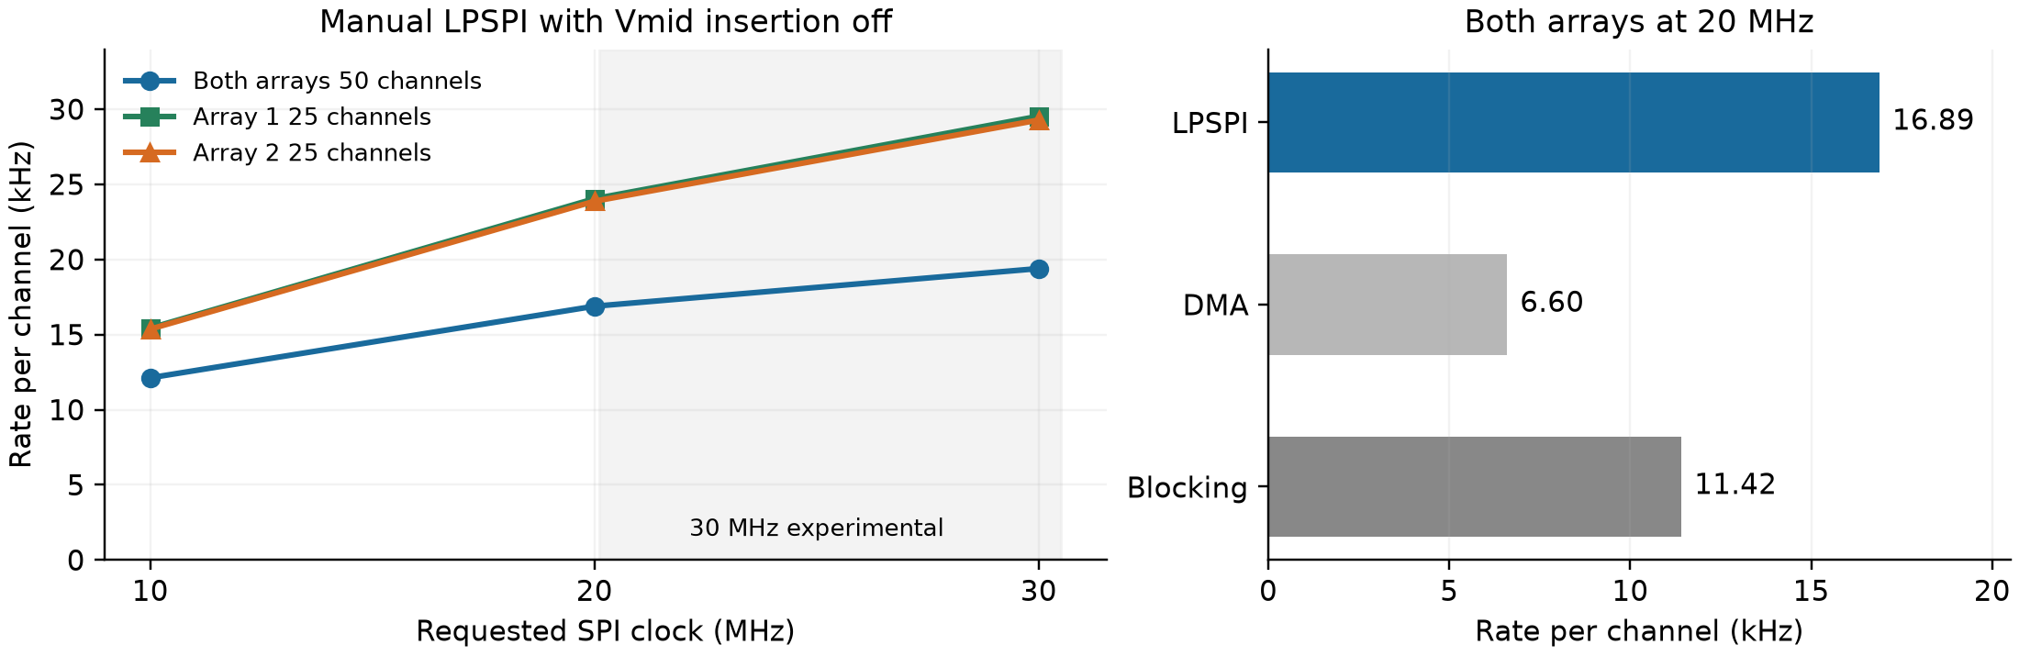
Figure 1 Latest manual sampling results, Vmid insertion off. Median sustained rates from three captures per configuration. 30 MHz is experimental. Manual LPSPI at 20 MHz is 60.5% faster than the original firmware.

Sampling rates and timing
Rate is sustained received sweeps per second, equal to samples per second per channel. Sweep is mean ADC acquisition time; Total is device elapsed time per received sweep, including overhead and any omitted transmissions. Overhead = Total − Sweep. These are device timings, not PC export time. Table values are medians of three repetitions.

Latest firmware with Vmid insertion off
Selection | SPI  MHz | Rate  kHz per ch | Sweep  µs | Total  µs | Overhead  µs | Clock gain
Both arrays | 10 | 12.12 | 81.0 | 82.5 | 1.5 | —
Both arrays | 20 | 16.89 | 57.7 | 59.2 | 1.6 | +39.3%
Both arrays | 30 | 19.39 | 50.0 | 51.6 | 1.6 | +14.8%
Array 1 | 10 | 15.43 | 63.5 | 64.8 | 1.3 | —
Array 1 | 20 | 24.04 | 40.3 | 41.6 | 1.3 | +55.8%
Array 1 | 30 | 29.53 | 32.6 | 33.9 | 1.3 | +22.8%
Array 2 | 10 | 15.36 | 63.8 | 65.1 | 1.3 | —
Array 2 | 20 | 23.87 | 40.6 | 41.9 | 1.3 | +55.4%
Array 2 | 30 | 29.28 | 32.9 | 34.2 | 1.3 | +22.6%

Both arrays = 50 channels; each single array = 25. Clock gain compares 20 with 10 MHz, or 30 with 20 MHz, within the same selection and firmware family. Doubling SPI clock does not double the sampling rate.

Earlier firmware with Vmid insertion on
Historical 1 October measurements below predate the firmware optimizations and USB repair. They establish the tested Vmid-on clock trend but must not be compared directly with the table above as the cost of toggling Vmid today.
Selection | SPI  MHz | Rate  kHz per ch | Sweep  µs | Total  µs | Overhead  µs | Clock gain
Both arrays | 10 | 3.46 | 285.2 | 289.2 | 4.0 | —
Both arrays | 20 | 4.56 | 215.4 | 219.5 | 4.1 | +31.7%
Both arrays | 30 | 4.97 | 197.1 | 201.4 | 4.3 | +9.0%
Array 1 | 10 | 4.75 | 208.0 | 210.4 | 2.4 | —
Array 1 | 20 | 6.76 | 145.1 | 148.0 | 2.9 | +42.1%
Array 1 | 30 | 7.68 | 127.4 | 130.3 | 2.9 | +13.6%
Array 2 | 10 | 4.59 | 214.4 | 217.8 | 3.3 | —
Array 2 | 20 | 6.53 | 150.9 | 153.1 | 2.2 | +42.2%
Array 2 | 30 | 7.85 | 124.5 | 127.4 | 2.9 | +20.2%

Matched Vmid cost and lower clock check
With attached sensors at 10 MHz blocking, Vmid off gives 7.35 kHz per channel (134.1 µs sweep, 136.0 µs total, 2.0 µs overhead). Vmid on gives 2.89 kHz (345.0 / 346.0 / 1.0 µs): a 61% rate reduction.
Vmid-on inserts two discarded channel 15 conversions between sensor channels; reference values are not added to the transmitted payload.
The separate 5 MHz blocking GUI run with both arrays and Vmid off achieved 4.36 kHz per channel (228.0 µs sweep, 229.5 µs total, 1.5 µs overhead). The 10 MHz blocking rate is about 69% higher; the different host capture contexts limit a clock-only attribution.
20 MHz is the rated limit and throughput baseline. Manual ghosting is substantial with Vmid off and greatly reduced with Vmid on. Treat 30 MHz as experimental: digital checks passed, but analog level shifts and variation still need validation. [1]

Noise and USB power
Noise bursts occur together on both arrays and recur about every 1.32 s with the charger connected. They reproduce in standalone benchmarks across all three SPI engines and single-ADC tests. Removing the charger suppresses the regular burst pattern but leaves nearly continuous noise; reconnecting it restores the bursts.
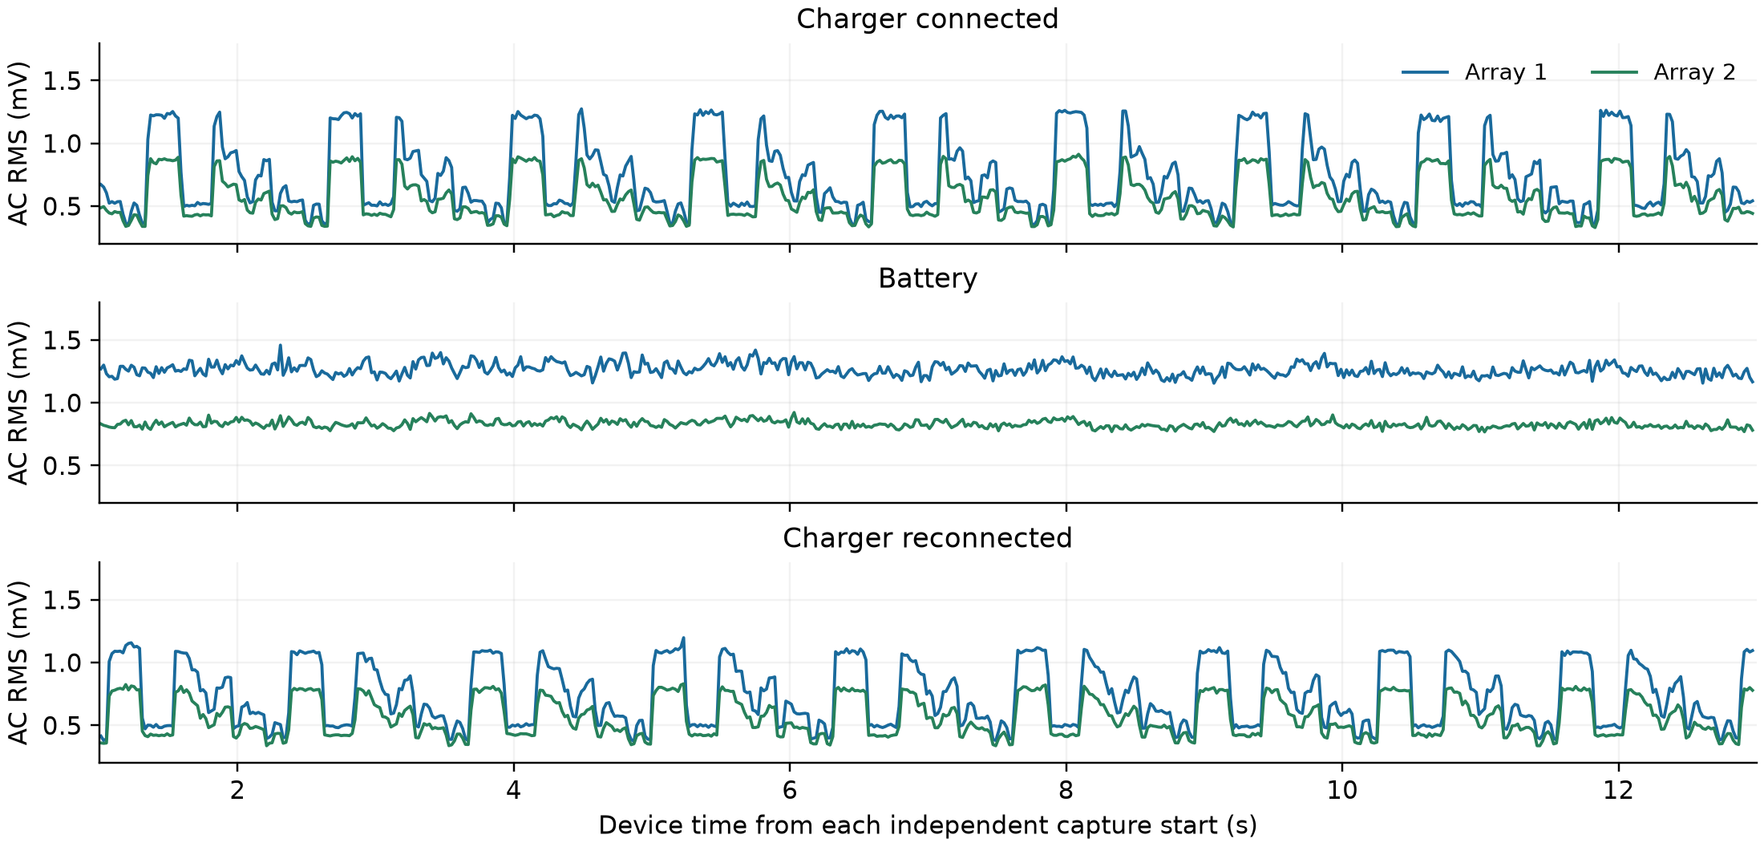
Figure 2 Measured ADC input-equivalent AC variation with strips unplugged. Same 10 MHz blocking configuration in three separate 12 s measurement windows; no filtering or interpolation. Each trace is the median of 25 channel standard deviations in 20 ms windows.
Condition | A1 RMS  mV | A2 RMS  mV | A1 peak to peak  mV | A2 peak to peak  mV
Charger quiet | 0.46 | 0.39 | 1.83 | 1.83
Charger typical | 0.63 | 0.49 | 3.05 | 2.44
Charger bursts | 1.24 | 0.88 | 4.27 | 3.05
Battery typical | 1.26 | 0.83 | 4.88 | 3.05
Battery high | 1.36 | 0.88 | 4.88 | 3.66
Charger return bursts | 1.10 | 0.80 | 4.27 | 3.05

RMS is local standard deviation about each channel mean, an estimate of AC RMS variation. Peak to peak is the measured local maximum minus minimum, not a multiple of RMS. Quiet / typical / high mean the 10th / 50th / 95th percentile across 20 ms windows.
Typical battery noise is about 2.0× / 1.7× the charger-connected typical level on arrays 1 / 2. Scope measurements after the PCB beads and capacitors show 61.3 mV peak to peak on battery and 53.0 mV with the charger. The displayed approximately 5.14 V RMS includes DC; AC rail RMS is unavailable. The scope sample rates differed, so those ripple amplitudes are indicative rather than a controlled comparison.
The evidence links the noise pattern to USB power conditions and supports regulated ADC and buffer supplies in the next board revision. It does not isolate rail ripple from ground coupling or host activity. These separate scope and ADC measurements were not synchronized.

Channel 11 all channel baselines
The 9 October matrix tested every ADC, channels 0-14, at 5/10/20 MHz with Vmid off/on. Both strips were unplugged, the charger was connected, and manual/blocking/repeat 1 was used. Each run had 1 s warm-up and 12 s measurement.
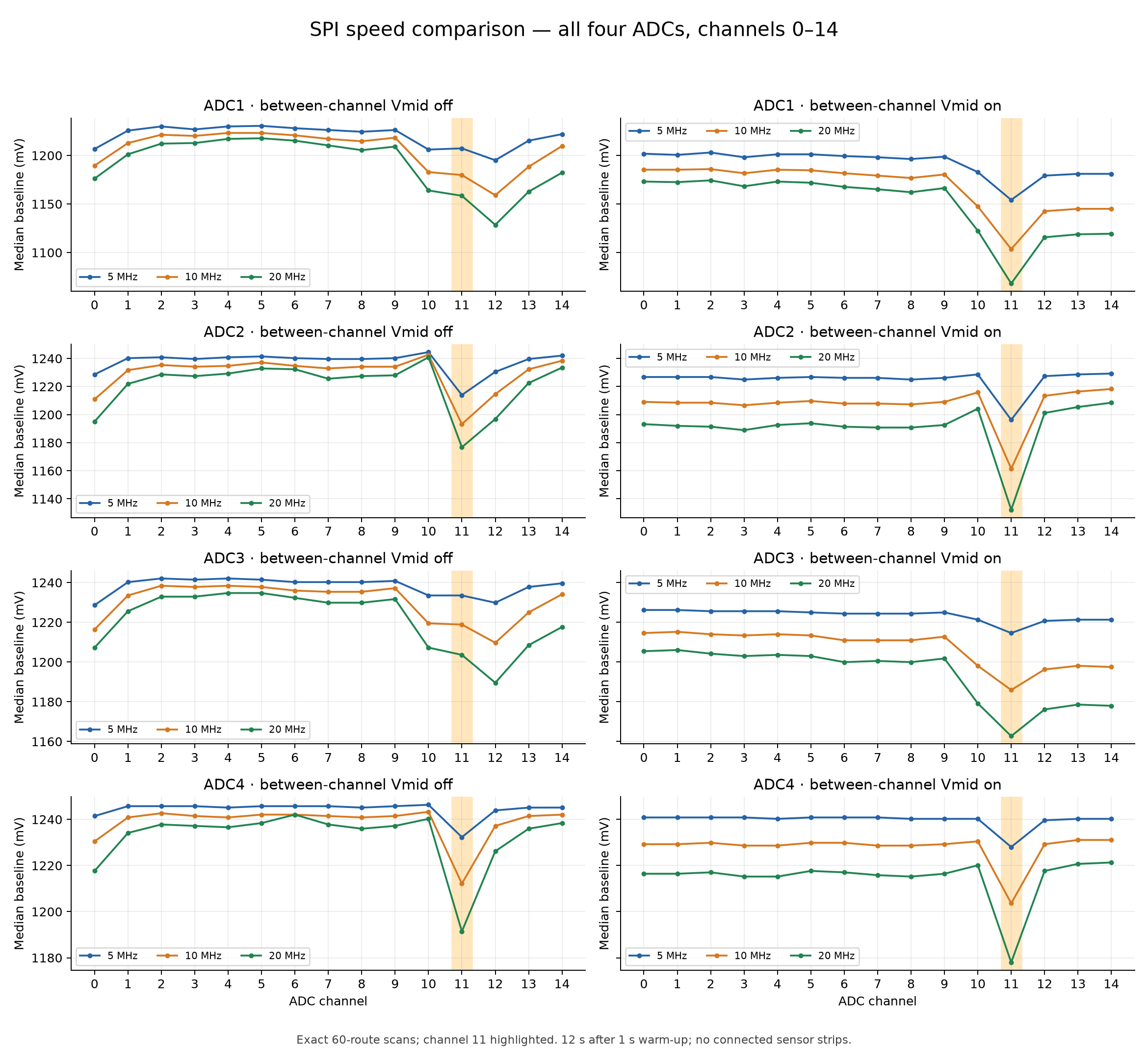
Figure 3 Original all-channel baseline graph from the channel-11 investigation. Rows are ADC1-4; left is Vmid off and right is Vmid on. Each panel overlays 5, 10 and 20 MHz in nominal mV. The shaded band marks channel 11, exposing its dip relative to the other channels.
With Vmid off, ADC2/4 show the channel-11 dip; ADC1/3 instead have a deeper channel-12 dip in their unused 10-14 region. With Vmid on, channel 11 is below its neighbors on every ADC. Faster clocks lower the baselines and generally deepen the dip.

All channel baselines with Vmid off and on
These are the same full 60-route scans, arranged to compare Vmid off/on directly at each SPI clock. All channels 0-14 remain visible; channel 11 is highlighted.
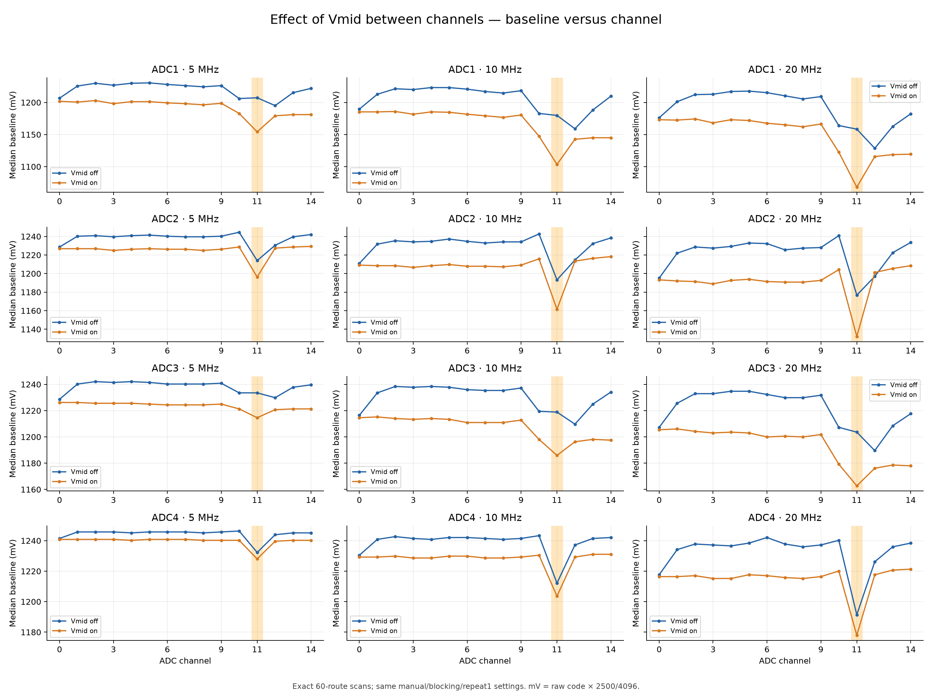
Figure 4 Original Vmid comparison graph. Rows are ADC1-4; columns are 5, 10 and 20 MHz. Blue is Vmid off and orange is Vmid on. Values are median baselines in nominal mV, using raw code × 2500/4096. The complete channel profile distinguishes an overall baseline shift from the local channel-11 dip.
Vmid insertion does not correct channel 11. These disconnected-input results depend on floating-node selection history; they do not establish the effect of Vmid on pressed-sensor ghosting. The later manual tests separately show greatly reduced ghosting with Vmid on at 20 MHz.

Channel 11 relative to neighboring channels
The full-channel profiles above are summarized here as channel 11 minus the mean of channels 10 and 12. Single-ADC continuous-selection and retained-reference controls are summarized on the next page.
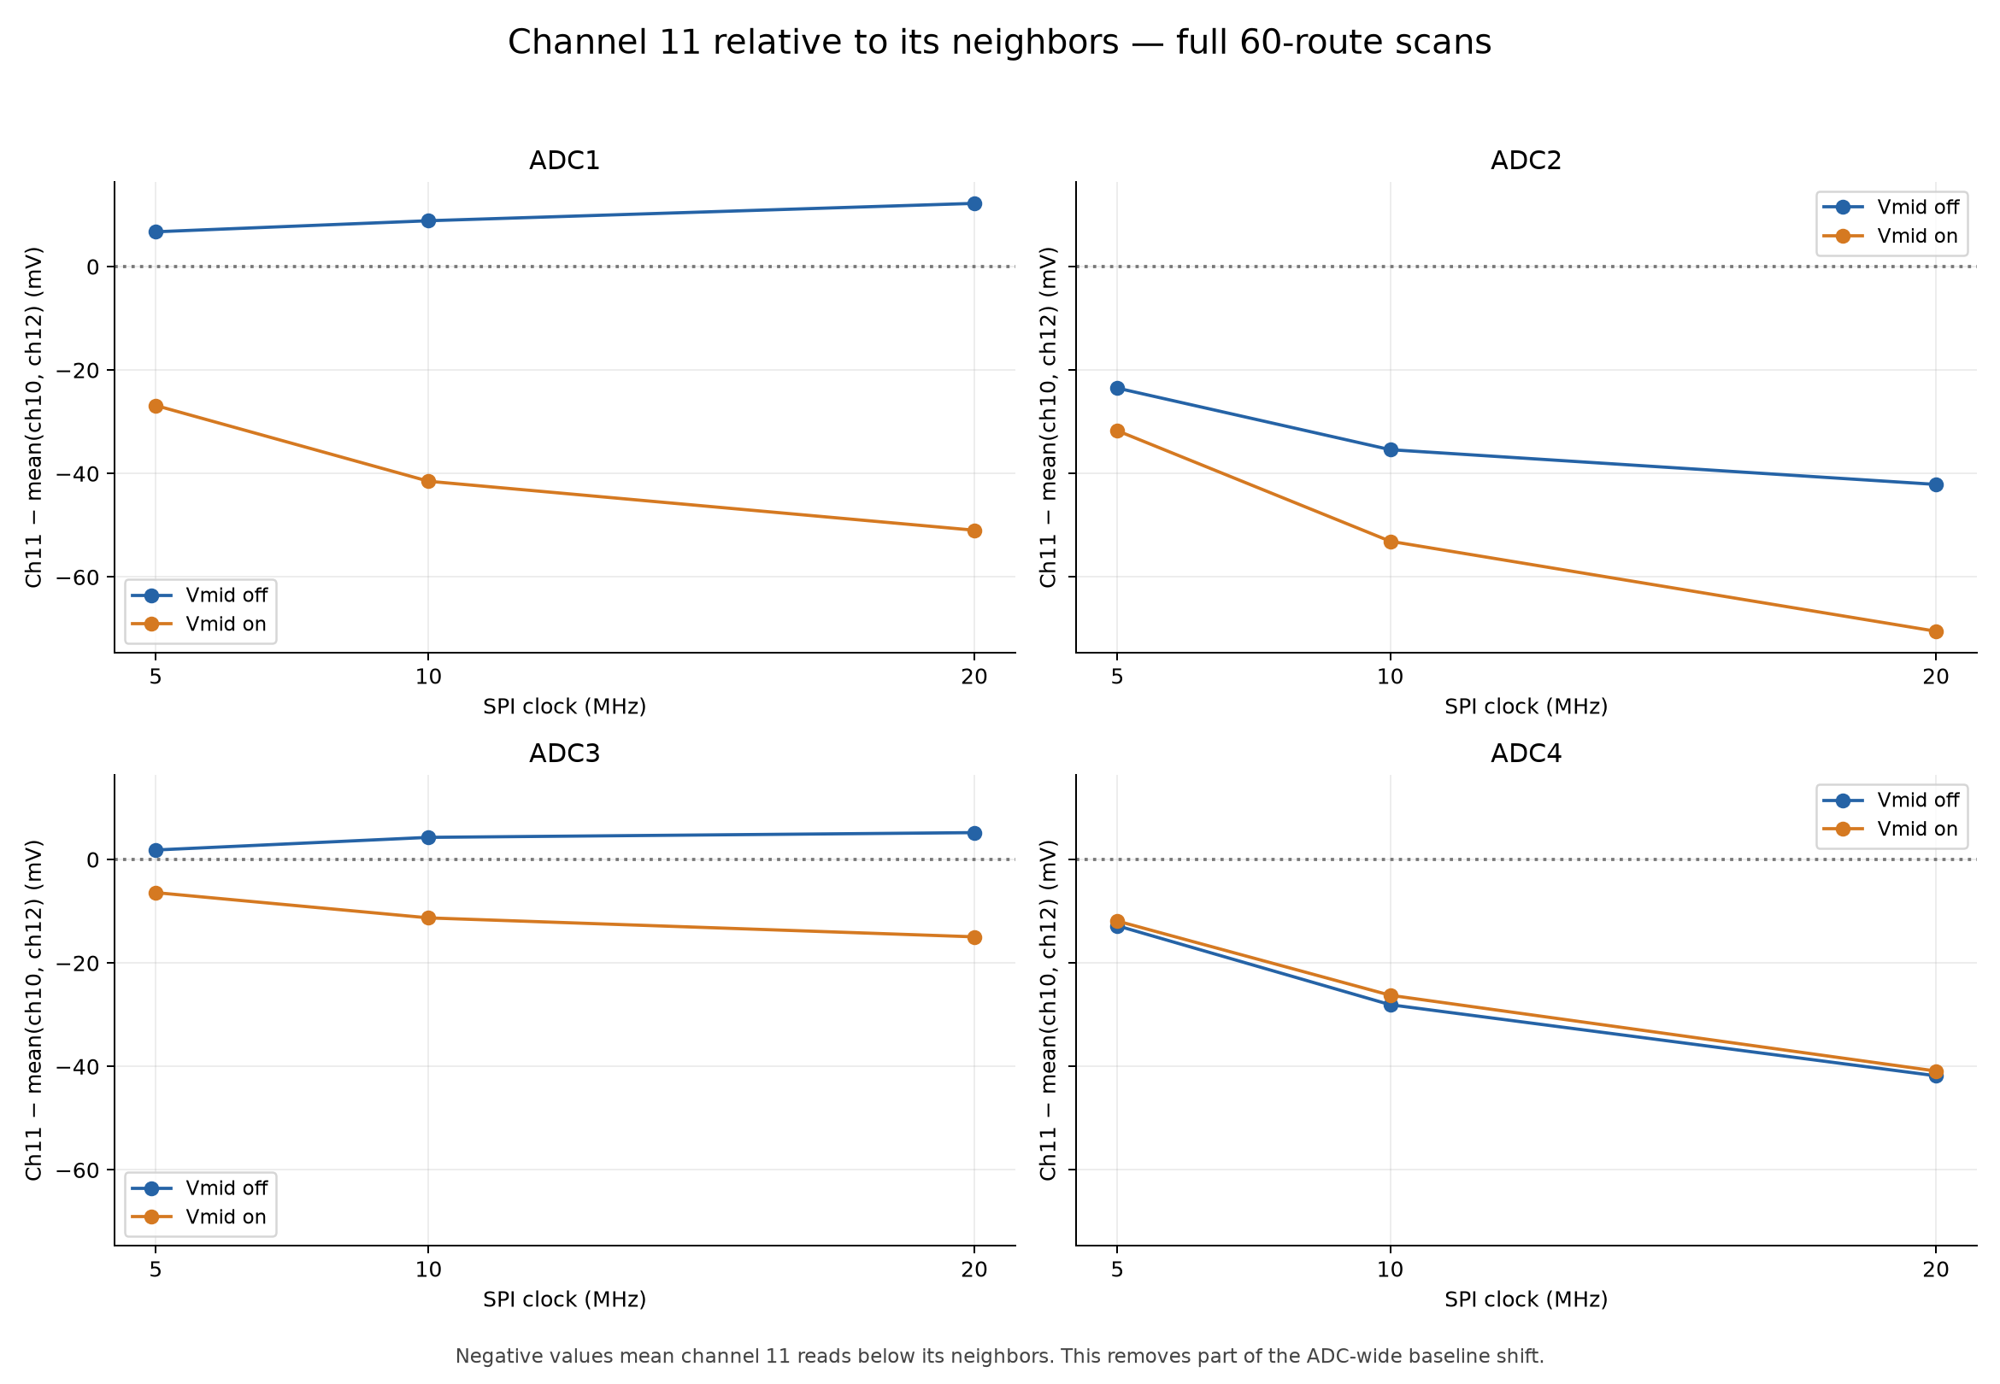
Figure 5 Channel 11 minus the mean of channels 10 and 12 in full scans, in mV. Vmid off: channel 11 is lower on ADC2/4, but slightly higher on ADC1/3. Vmid on: all four have a deficit.
ADC / bias | 5 MHz off | 10 MHz off | 20 MHz off | 20 MHz on
1 / 1 MΩ | +6.71 | +8.85 | +12.21 | -50.96
2 / 470 kΩ | -23.50 | -35.40 | -42.11 | -70.50
3 / 470 kΩ | +1.83 | +4.27 | +5.19 | -14.95
4 / 249 kΩ | -12.82 | -28.08 | -41.81 | -40.89

All table entries are differences in mV, not absolute baselines. ADC1/3 instead have a lower channel 12 in the unused 10-14 region. The measured channel-15 reference is 1248.78-1249.39 mV across the reference captures, close to nominal 1250 mV.
All 40 captures passed independent wire/value checks: 39,615,388 received sweeps and 90,768,414 retained values. The end-of-matrix drift check changed channel medians by at most 0.61 mV. Firmware reported 3,638 whole-frame USB discards (0.0092% of acquired sweeps), zero ADC/SPI/USB-write errors and zero sampling periods above 1 ms.
The reviewed firmware has no channel-11-specific timing or arithmetic. The results support a dynamic analog settling / charge-history explanation, but do not establish the exact mechanism. Floating-input baselines are not a measurement of sensor accuracy.

Channel 11 full scanning versus continuous selection
Full scan: all four ADCs scan channels 0-14; the graph shows only channel 11. Hold: one ADC alone repeatedly selects channel 11. With Vmid on, the hold repeats 11 → 15 → 15 and retains only channel 11. At 10 MHz, full-scan results arrive about every 159 µs off or 415 µs on; either hold mode gives one retained result about every 8 µs. Scan versus hold therefore changes both selection history and cadence.
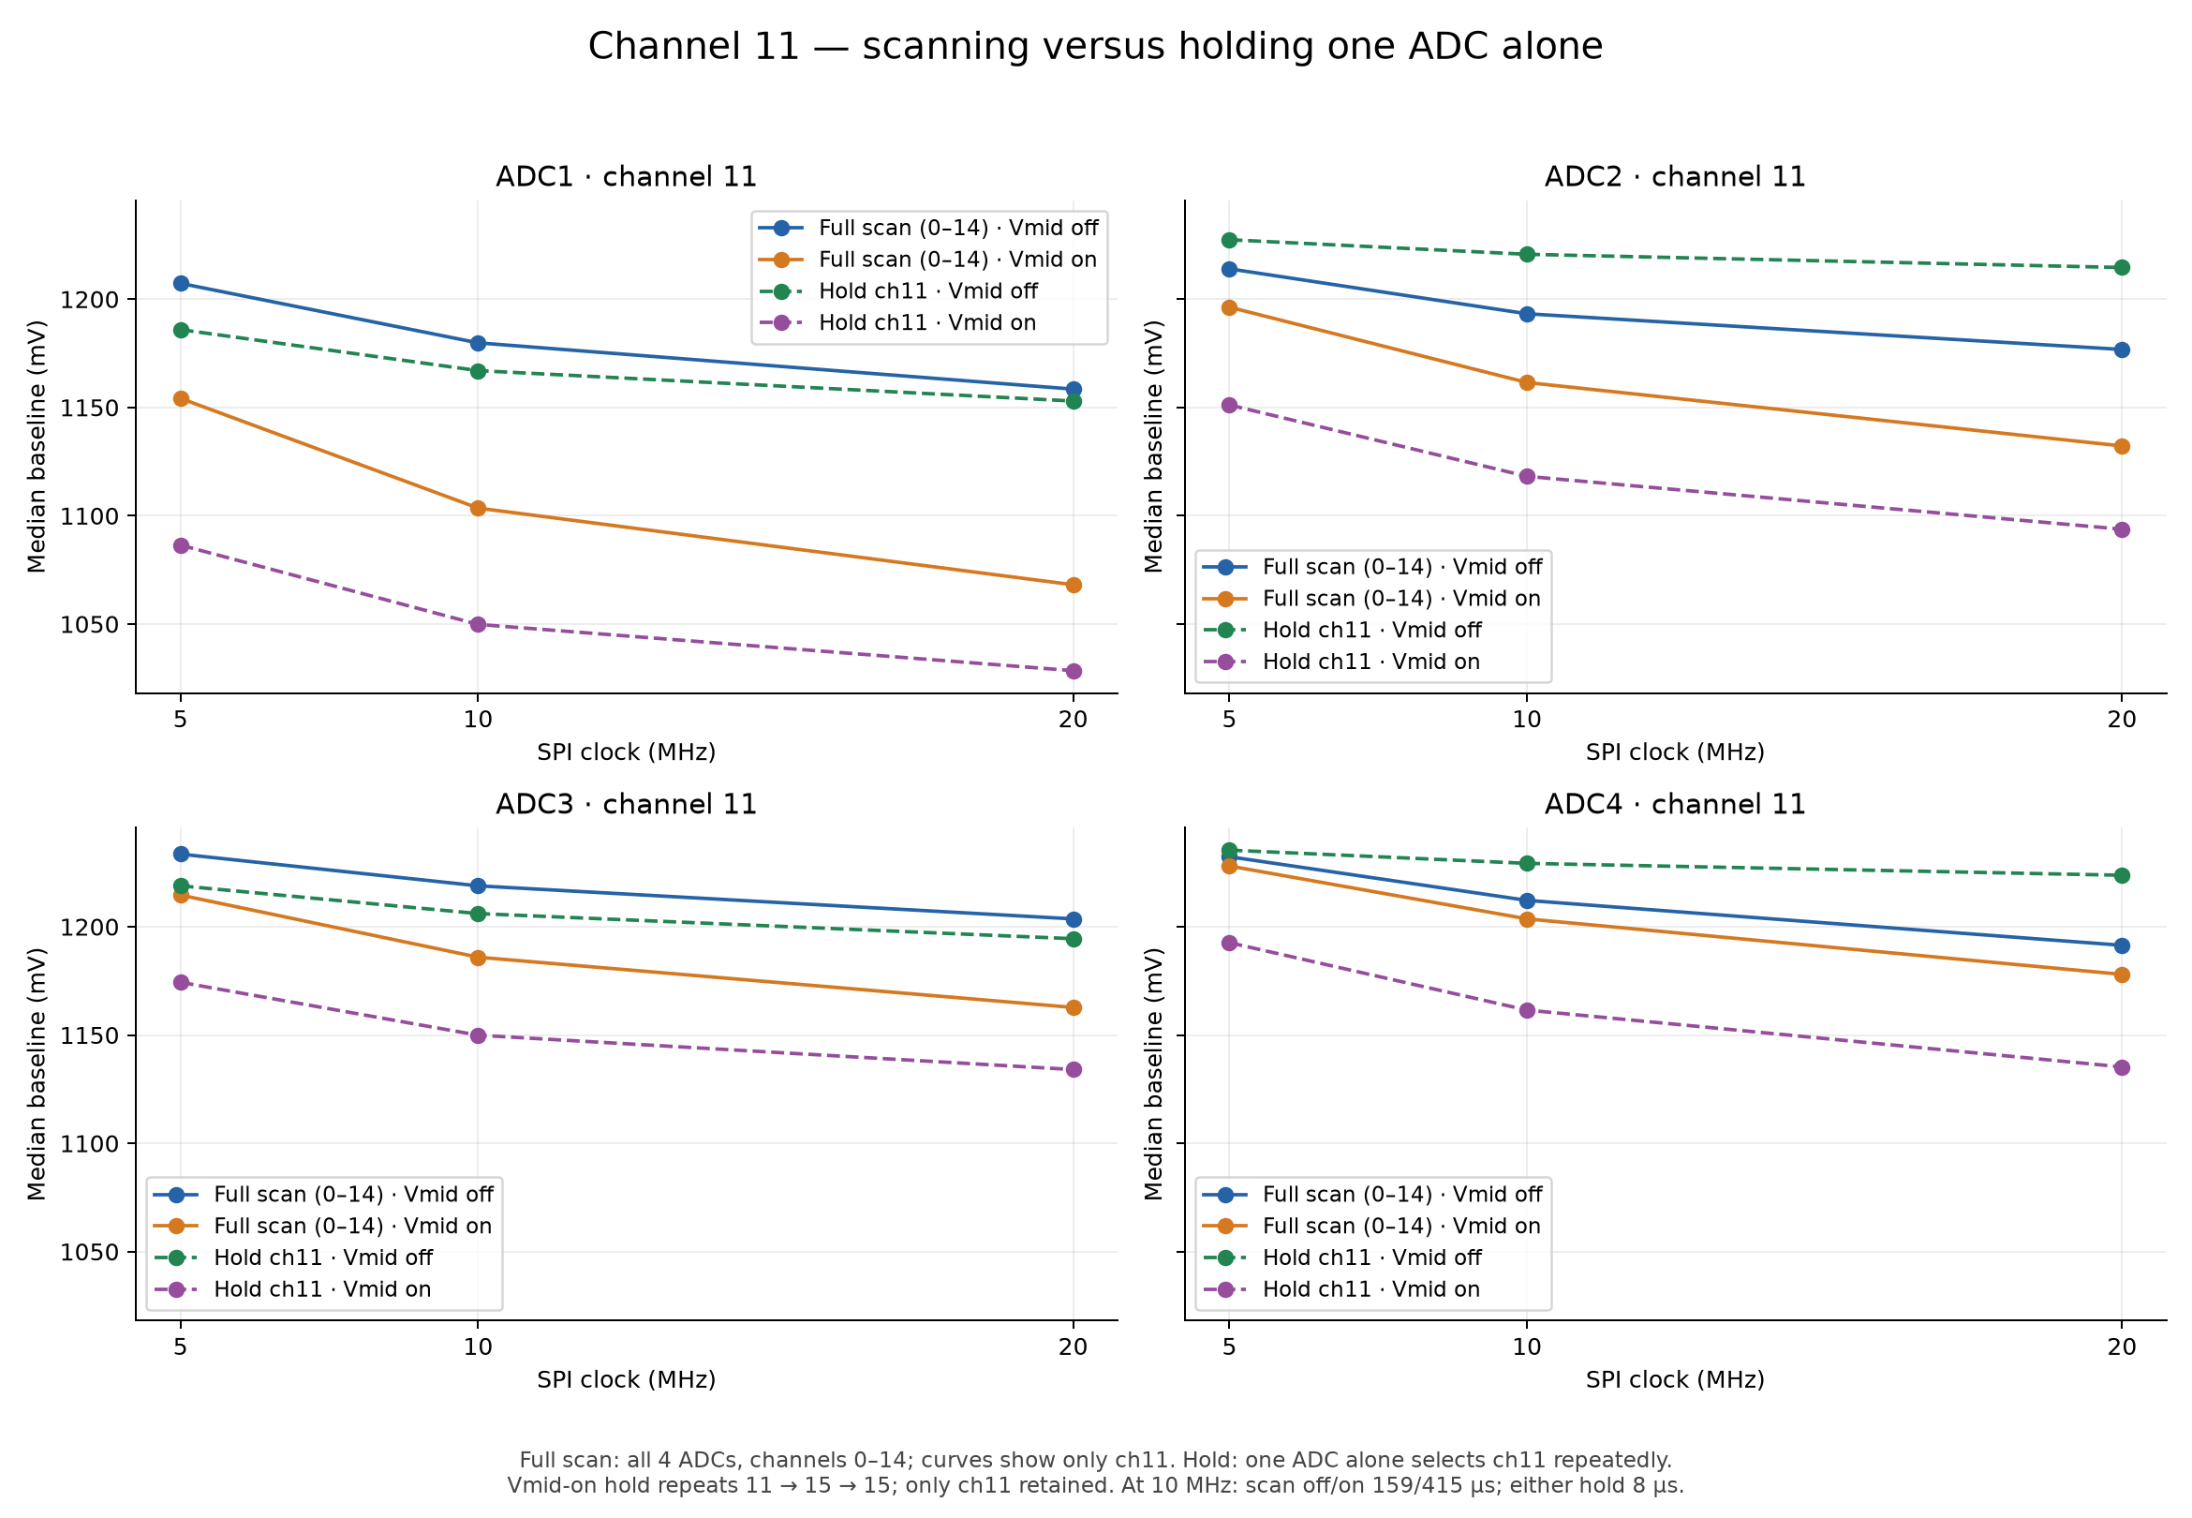
Figure 6 Channel-11 median baseline, all ADCs and clocks, in mV. Vmid insertion lowers the baseline in every single-ADC hold pair.
10 MHz ADC | Scan off mV | Scan on mV | Hold off mV | Hold on mV
1 | 1179.81 | 1103.52 | 1166.99 | 1049.80
2 | 1193.24 | 1161.50 | 1220.70 | 1118.16
3 | 1218.87 | 1185.91 | 1206.05 | 1149.90
4 | 1212.16 | 1203.61 | 1229.25 | 1161.50

Vmid with sensors attached
The earlier attached-strip off/on/off test remains consistent with Vmid not fixing channel 11: ADC2 falls by 3.05 mV and returns exactly; its peer-channel deficit stays about 58.9 mV. ADC4 rises slightly but does not reverse after disabling Vmid. ADC2 channel 12 improves reversibly by 13.43 mV. At 10 MHz blocking, Vmid insertion reduces the measured attached-strip rate by about 61%.
Nominal voltage conversion is raw code × 2500/4096 mV. The temporary reference-route diagnostic build was removed; production firmware was restored and verified. Production still discards inserted Vmid conversions.

Manual sensor pressing and ghosting
Press each TOP sensor and observe the next sensor’s BOTTOM and LEFT channels in MUX order. The table covers six routes at 5/10/20 MHz; percentages are the tester’s visual estimates, not calibrated transfer ratios. Vmid insertion was off. Repeat, scan-order and engine settings were not recorded in these notes.
Press → observe / bias | 5 MHz | 10 MHz | 20 MHz
A1 / ADC1  1 MΩ  6_T → 7_B, 7_L | ~30% at B; also at L | Almost 50% at B; also at L | >50% at B; also at L
A1 / ADC2  470 kΩ  1_T → 3_B, 3_L | <20% at B; none at L | ~40% at B; also at L | ~40% at B; also at L
A1 / ADC2  470 kΩ  3_T → 5_B, 5_L | ~20% at B; small at L | ~30% at B; also at L | >50% at B; also at L
A2 / ADC3  470 kΩ  6_T → 7_B, 7_L | Some at B; small at L | ~40% at B; also at L | >50% at B; also at L
A2 / ADC4  249 kΩ  1_T → 3_B, 3_L | Very small at B; none at L | Small; more than at 5 MHz; barely at L | More than at 10 MHz; below 470 kΩ / 1 MΩ; very small at L
A2 / ADC4  249 kΩ  3_T → 5_B, 5_L | Very small at B; none at L | Small; more than at 5 MHz; barely at L | More than at 10 MHz; below 470 kΩ / 1 MΩ; very small at L

Route key: 6_T / 1_T = ch4; 7_B / 3_B = ch5; 7_L / 3_L = ch6; 3_T = ch9; 5_B = ch10; 5_L = ch11. Array 2 uses global ADC3/4. The first Array-2 5 MHz note’s next-channel label is interpreted as PZT7_L, matching the stated route.
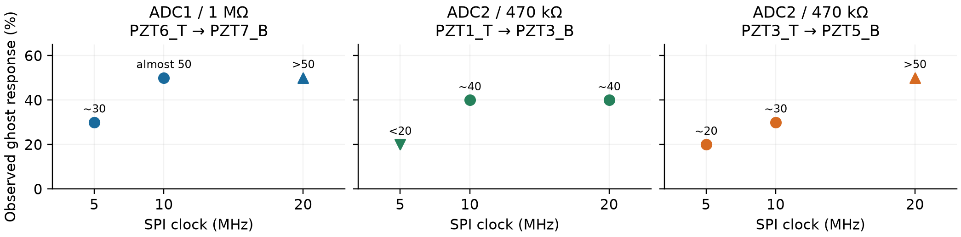
Figure 7 Only the three Array-1 routes with numerical estimates at every speed are plotted. Triangles and labels show upper/lower bounds; no percentage is invented for qualitative Array-2 results.
No ghosting was noticed on earlier channels or across different ADC/MUXs. Within one sensor, manual pressing cannot reliably separate electrical ghosting from physical coupling. Increasing SPI speed worsens forward carryover; the lower-resistance path shows less carryover. This is consistent with shared-node recovery / settling, but resistor value is confounded with ADC and routing.

Manual ghosting with Vmid on at 20 MHz
The same six pressing routes were repeated with Vmid insertion on at 20 MHz. The improvement was sufficient that the tester did not repeat the lower clocks. Results remain manual visual observations; engine, scan order and channel repeat were not supplied.
Route / shared bias | 20 MHz Vmid off | 20 MHz Vmid on
A1 ADC1 / 1 MΩ  6_T → 7_B | >50%; also follows to 7_L | <20% at 7_B; none follows to 7_L
A1 ADC2 / 470 kΩ  1_T → 3_B | ~40%; also follows to 3_L | No ghosting observed at 3_B
A1 ADC2 / 470 kΩ  3_T → 5_B | >50%; also follows to 5_L | No ghosting observed at 5_B
A2 ADC3 / 470 kΩ  6_T → 7_B | >50%; also follows to 7_L | Almost none: ~5% at 7_B
A2 ADC4 / 249 kΩ  1_T → 3_B | More than at 10 MHz; very small at 3_L | No ghosting observed at 3_B
A2 ADC4 / 249 kΩ  3_T → 5_B | More than at 10 MHz; very small at 5_L | No ghosting observed at 5_B

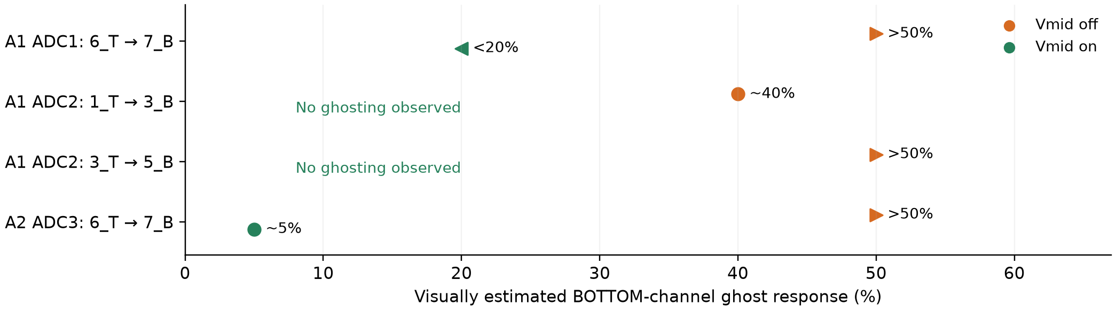
Figure 8 Vmid off/on at 20 MHz for routes with numerical Vmid-off estimates. Arrows represent reported bounds. “No ghosting observed” is a qualitative result, not a measured zero. The ADC4 routes are kept qualitative in the table. Percentages are visual estimates of the BOTTOM response.
Vmid on suppresses the forward response substantially on all six routes. Residual ghosting remains on the 1 MΩ path (<20%) and the Array-2 470 kΩ path (~5%). No following LEFT response was reported for ADC1; LEFT-channel outcomes were not specified for the other Vmid-on routes.
This supports Vmid insertion as a practical mitigation for the observed ghosting at 20 MHz, while leaving the channel-11 baseline problem separate. Quantify residual responses with raw traces and a repeatable input before defining acceptance limits. The measured rate cost of Vmid must be included when choosing operating settings.

Conclusions and next work
- Use manual LPSPI at 20 MHz as the validated speed baseline: 16.9 kHz per channel for both arrays and about 24 kHz for one array. Faster requested SPI gives diminishing gains; 30 MHz remains experimental.
- Firmware USB changes keep sampling continuous under backpressure by omitting complete transmissions when necessary. Received gaps must stay visible. The GUI repair separates capture from display work and preserves raw archives; it does not repair missing transmissions.
- USB power conditions change the common noise pattern. Regulate ADC analog and buffer supplies in the next revision, as already done on the second board design. The channel 11 DC offset requires separate investigation.
- Vmid insertion changes baseline and scan history but does not correct channel 11. With attached strips it reduces the tested 10 MHz blocking output rate by approximately 61%.
- At 20 MHz, Vmid on greatly reduces manual ghosting: none observed on four routes, <20% on ADC1 and ~5% on ADC3. Use Vmid insertion when low ghosting is required, subject to measured rate and residual-response acceptance.

Remaining tests
- The Vmid-on manual comparison is complete at 20 MHz; lower-clock repeats are not planned because the observed result was satisfactory. Quantify residual ghosting, especially the 1 MΩ path, using raw traces and a repeatable input. Document engine, scan order and repeat; separate electrical carryover from physical coupling.
- Channel 11 isolation: scan a known low-impedance Vmid input on channel 11 and compare channels 10 and 12; observe CS together with MXO or the buffer output to separate voltage and timing effects.
- Complete analog acceptance at 20 MHz. If 30 MHz is pursued, compare 20 → 30 → 20 MHz with repeatable pressed or driven inputs, settling checks and longer captures. Repeat one-array and two-array Vmid-on timing on the latest firmware before adopting historical rates as current targets.

Remaining firmware and GUI development
Add configurable sweep repetition with per-channel median transmission. Acquire N complete sweeps, calculate each channel’s median across those N values, and transmit one result frame. Preserve a selectable raw mode; expose N and raw or median mode in the GUI. This differs from the existing channel repeat setting, which retains the last conversion rather than computing a median.
At an unchanged acquisition rate, N sweeps per frame would reduce transmitted values and display updates to approximately 1/N. Expected random-noise reduction must be measured; median reduction does not inherently remove a DC offset or coherent supply disturbance. Validate processing overhead, ghosting, peak retention and the added latency before selecting defaults. Coordinate firmware, parser and archive metadata so timestamps describe the aggregation interval and downstream analysis knows the effective output rate.

Evidence and measurement notes
Source captures are retained in the TestBoard_7953 benchmarks directory. Timing tables were independently recalculated from selected raw frames. The production and 30 MHz matrices were previously independently checked in full. Baseline controls validate all 150 medians per off on off experiment against benchmark channel CSVs. Digital PASS is not analog accuracy sign off.
Timing sources: live_usb_production_adc_10_20 and live_usb_production_manual_lpspi_adc30, 7 October; historical Vmid-on source: 20261001T164158Z, 1 October. Noise sources: noise_engine_topology_20261008, noise_laptop_battery_20261008 and noise_charger_reconnected_20261008. Manual ghosting: board designer observations supplied 9 October; Vmid off at 5/10/20 MHz and on at 20 MHz, visual estimates; other acquisition modifiers unrecorded. Latest baseline source: channel11_four_adc, 9 October. Earlier baseline sources: channel order, continuous-selection and both Vmid control sessions, 8 October. Supporting scope photos were supplied by the board designer.
[1] Texas Instruments ADS7953 datasheet SLAS605C, SPI limit and timing requirements.

