TestBoard 7953 Test Summary
  - Management report 30 September to 8 October 2026
The board now delivers 16.9 kHz per channel across two full arrays at 20 MHz SPI. Experimental 30 MHz reaches 19.4 kHz. USB sampling continuity and GUI capture have improved; power tests support regulated analog supplies in the next revision. The channel 11 baseline offset and pressed-sensor ghosting remain to be validated.

Board description
TestBoard_7953 uses a Teensy 4.1 and four 16-channel, 12-bit ADS7953 ADCs on two SPI buses. The tested configuration reads 50 sensor channels, 25 per array. OPA365 unity buffers drive the ADC inputs. REF2025 provides 2.5 V Vref and 1.25 V Vmid; ADC analog supplies and buffers use USB 5 V through ferrite beads and capacitors. Each ADC has one shared MXO bias resistor: 1 MΩ, 470 kΩ, 470 kΩ and 249 kΩ for ADC1–4.

Tests performed
- Sampling and timing: blocking, DMA and direct LPSPI; manual and Auto 1 sequences; full arrays, single ADCs and sparse selections; SPI clocks from 5 to 30 MHz; channel repeat and Vmid controls.
- Stream robustness: production matrix of 252 captures, 21 captures at 30 MHz, forced 500 ms reader stalls, raw-frame checks, archive and GUI replay validation.
- Signal quality: 21 engine and topology controls; both strips attached, one unplugged and both unplugged; charger removal and return; scope rail measurements; channel order swaps, reversals and continuous selection; Vmid off on off controls.

Performance overview
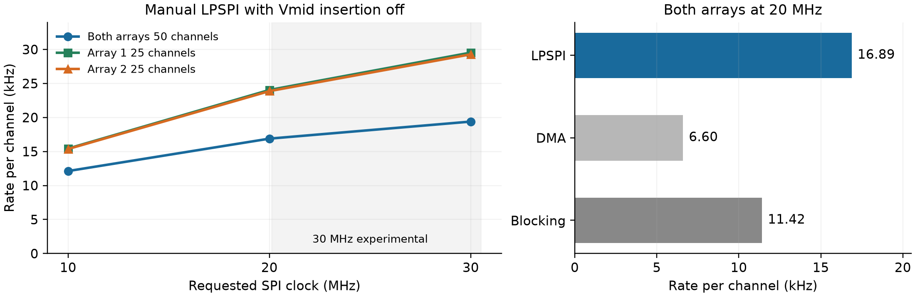
Figure 1 Latest manual acquisition results with optional Vmid insertion off. Each point is the median sustained received rate from three captures. A full sweep contains one value per selected channel.
Manual LPSPI is the fastest tested full-array path. At 20 MHz it is 60.5% faster than the original firmware (10.5 → 16.9 kHz per channel). The latest 252-capture matrix passed digital integrity checks; 0.011% of sweeps were intentionally omitted when USB was busy, while all three both-array 20 MHz manual LPSPI captures omitted none.

Sampling rates and timing
Rate is sustained received sweeps per second, equal to samples per second per channel. Sweep is mean ADC acquisition time; Total is device elapsed time per received sweep, including overhead and any omitted transmissions. Overhead = Total − Sweep. These are device timings, not PC export time. Table values are medians of three repetitions.

Latest firmware with Vmid insertion off
Selection | SPI  MHz | Rate  kHz per ch | Sweep  µs | Total  µs | Overhead  µs | Clock gain
Both arrays | 10 | 12.12 | 81.0 | 82.5 | 1.5 | —
Both arrays | 20 | 16.89 | 57.7 | 59.2 | 1.6 | +39.3%
Both arrays | 30 | 19.39 | 50.0 | 51.6 | 1.6 | +14.8%
Array 1 | 10 | 15.43 | 63.5 | 64.8 | 1.3 | —
Array 1 | 20 | 24.04 | 40.3 | 41.6 | 1.3 | +55.8%
Array 1 | 30 | 29.53 | 32.6 | 33.9 | 1.3 | +22.8%
Array 2 | 10 | 15.36 | 63.8 | 65.1 | 1.3 | —
Array 2 | 20 | 23.87 | 40.6 | 41.9 | 1.3 | +55.4%
Array 2 | 30 | 29.28 | 32.9 | 34.2 | 1.3 | +22.6%

Both arrays = 50 channels; each single array = 25. Clock gain compares 20 with 10 MHz, or 30 with 20 MHz, within the same selection and firmware family. Doubling SPI clock does not double the sampling rate.

Earlier firmware with Vmid insertion on
Historical 1 October measurements below predate the firmware optimizations and USB repair. They establish the tested Vmid-on clock trend but must not be compared directly with the table above as the cost of toggling Vmid today.
Selection | SPI  MHz | Rate  kHz per ch | Sweep  µs | Total  µs | Overhead  µs | Clock gain
Both arrays | 10 | 3.46 | 285.2 | 289.2 | 4.0 | —
Both arrays | 20 | 4.56 | 215.4 | 219.5 | 4.1 | +31.7%
Both arrays | 30 | 4.97 | 197.1 | 201.4 | 4.3 | +9.0%
Array 1 | 10 | 4.75 | 208.0 | 210.4 | 2.4 | —
Array 1 | 20 | 6.76 | 145.1 | 148.0 | 2.9 | +42.1%
Array 1 | 30 | 7.68 | 127.4 | 130.3 | 2.9 | +13.6%
Array 2 | 10 | 4.59 | 214.4 | 217.8 | 3.3 | —
Array 2 | 20 | 6.53 | 150.9 | 153.1 | 2.2 | +42.2%
Array 2 | 30 | 7.85 | 124.5 | 127.4 | 2.9 | +20.2%

Matched Vmid cost and lower clock check
With attached sensors at 10 MHz blocking, Vmid off gives 7.35 kHz per channel (134.1 µs sweep, 136.0 µs total, 2.0 µs overhead). Vmid on gives 2.89 kHz (345.0 / 346.0 / 1.0 µs): a 61% rate reduction.
Vmid-on inserts two discarded channel 15 conversions between sensor channels; reference values are not added to the transmitted payload.
The separate 5 MHz blocking GUI run with both arrays and Vmid off achieved 4.36 kHz per channel (228.0 µs sweep, 229.5 µs total, 1.5 µs overhead). The 10 MHz blocking rate is about 69% higher; the different host capture contexts limit a clock-only attribution.
Use 20 MHz for production. The ADS7953 specifies a 20 MHz maximum SPI clock; 30 MHz is experimental. The 30 MHz captures passed digital checks, but showed small level shifts and higher both-array variation, so analog accuracy still needs validation. [1]

Noise and USB power
Noise bursts occur together on both arrays and recur about every 1.32 s with the charger connected. They reproduce in standalone benchmarks across all three SPI engines and single-ADC tests. Removing the charger suppresses the regular burst pattern but leaves nearly continuous noise; reconnecting it restores the bursts.
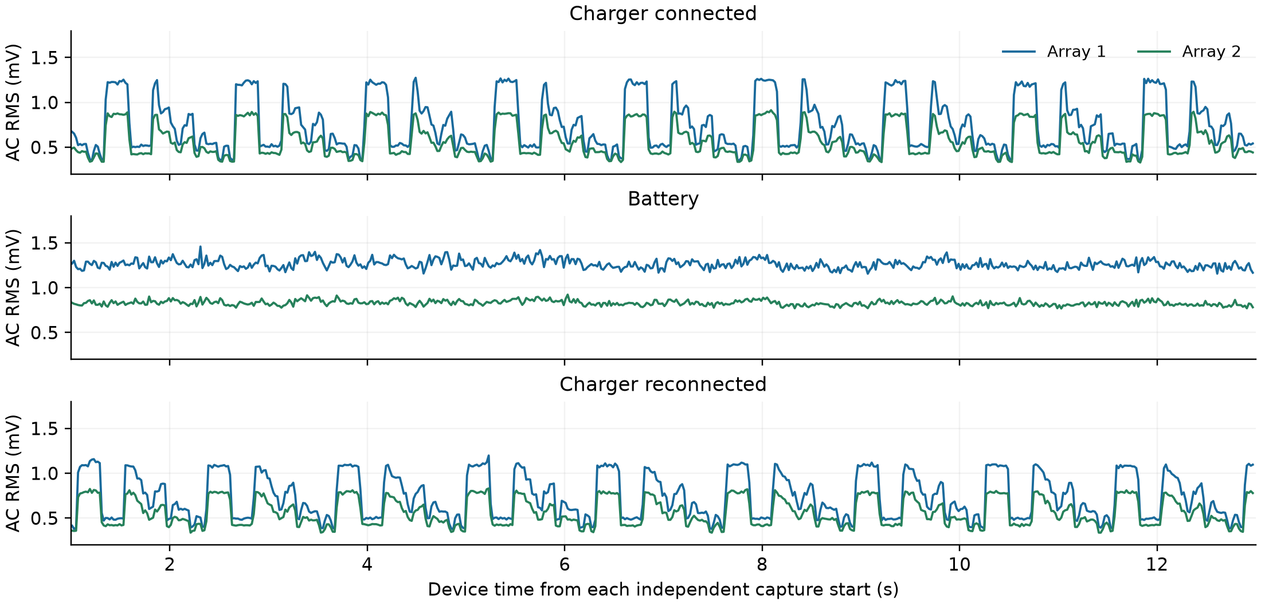
Figure 2 Measured ADC input-equivalent AC variation with strips unplugged. Same 10 MHz blocking configuration in three separate 12 s measurement windows; no filtering or interpolation. Each trace is the median of 25 channel standard deviations in 20 ms windows.
Condition | A1 RMS  mV | A2 RMS  mV | A1 peak to peak  mV | A2 peak to peak  mV
Charger quiet | 0.46 | 0.39 | 1.83 | 1.83
Charger typical | 0.63 | 0.49 | 3.05 | 2.44
Charger bursts | 1.24 | 0.88 | 4.27 | 3.05
Battery typical | 1.26 | 0.83 | 4.88 | 3.05
Battery high | 1.36 | 0.88 | 4.88 | 3.66
Charger return bursts | 1.10 | 0.80 | 4.27 | 3.05

RMS is local standard deviation about each channel mean, an estimate of AC RMS variation. Peak to peak is the measured local maximum minus minimum, not a multiple of RMS. Quiet / typical / high mean the 10th / 50th / 95th percentile across 20 ms windows.
Typical battery noise is about 2.0× / 1.7× the charger-connected typical level on arrays 1 / 2. Scope measurements after the PCB beads and capacitors show 61.3 mV peak to peak on battery and 53.0 mV with the charger. The displayed approximately 5.14 V RMS includes DC; AC rail RMS is unavailable. The scope sample rates differed, so those ripple amplitudes are indicative rather than a controlled comparison.
The evidence links the noise pattern to USB power conditions and supports regulated ADC and buffer supplies in the next board revision. It does not isolate rail ripple from ground coupling or host activity. These separate scope and ADC measurements were not synchronized.

Channel 11 baseline and Vmid insertion
PZT5_L maps to channel 11 on ADC2 and ADC4. In normal scans both remain low across engines, clocks and sensor connection states. The firmware review found no channel 11 specific delay, arithmetic correction or payload mapping difference.
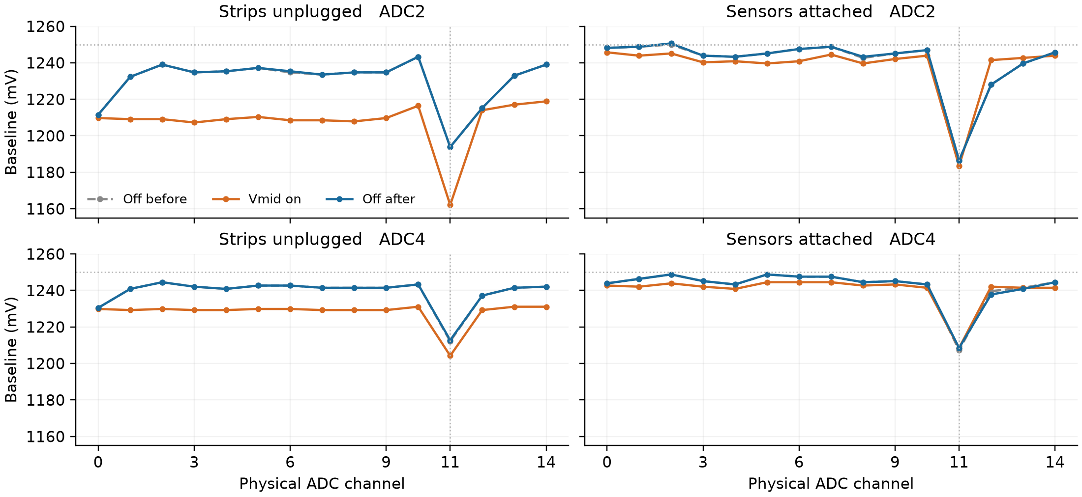
Figure 3 Off on off controls at 10 MHz blocking, repeat 1. Channel 11 is marked vertically; nominal Vmid is 1250 mV. Voltage conversion uses nominal 2.5 V Vref and 12-bit scaling.
Channel 11 condition | Off before  mV | Vmid on  mV | Off after  mV | On minus off  mV
Unplugged ADC2 | 1193.8 | 1162.1 | 1193.8 | -31.74
Unplugged ADC4 | 1212.2 | 1204.2 | 1212.8 | -8.24
Attached ADC2 | 1186.5 | 1183.5 | 1186.5 | -3.05
Attached ADC4 | 1207.3 | 1208.5 | 1208.5 | +0.61

With attached sensors, ADC2 channel 11 falls by 3.05 mV and returns exactly; its deficit relative to peer channels stays about 58.9 mV. ADC4 rises slightly but stays at that value after Vmid is disabled, so its increase is not a clear reversible improvement. Channel 11 remains lowest on both ADCs. ADC2 channel 12 improves reversibly by 13.43 mV.

What the additional controls establish
- Changing channel order raises channel 11 by roughly 12–19 mV without changing full-scan cadence. The deficit follows physical channel 11 rather than its original scan slot; a depressed reading also affects its successor.
- Holding a single channel selected removes most of the channel 11 disparity: versus held channel 10, channel 11 is only 3.66 mV lower on ADC2 and 0.61 mV lower on ADC4. This test also changes cadence and active ADC count.
The shared MXO bias and scan history are therefore important. One resistor biases the common node, not each disconnected channel separately. Dynamic MUX settling, charge history and address-dependent coupling remain candidates. Attached sensors do not remove the offset, and Vmid insertion is not a baseline fix. The precise physical cause remains unresolved.

Conclusions and next work
- Use manual LPSPI at 20 MHz as the validated speed baseline: 16.9 kHz per channel for both arrays and about 24 kHz for one array. Faster requested SPI gives diminishing gains; 30 MHz remains experimental.
- Firmware USB changes keep sampling continuous under backpressure by omitting complete transmissions when necessary. Received gaps must stay visible. The GUI repair separates capture from display work and preserves raw archives; it does not repair missing transmissions.
- USB power conditions change the common noise pattern. Regulate ADC analog and buffer supplies in the next revision, as already done on the second board design. The channel 11 DC offset requires separate investigation.
- Vmid insertion changes baseline and scan history but does not correct channel 11. With attached strips it also reduces the tested 10 MHz blocking output rate by approximately 61%.

Remaining tests
- Ghosting with manual sensor pressing: press one sensor location at a time, record the intended response and all neighboring channels on both arrays, and compare Vmid off and on plus channel repeat settings. Check amplitude, delay, recovery and false responses.
- Channel 11 isolation: scan a known low-impedance Vmid input on channel 11 and compare channels 10 and 12; observe CS together with MXO or the buffer output to separate voltage and timing effects.
- Complete analog acceptance at 20 MHz. If 30 MHz is pursued, compare 20 → 30 → 20 MHz with repeatable pressed or driven inputs, settling checks and longer captures. Repeat one-array and two-array Vmid-on timing on the latest firmware before adopting historical rates as current targets.

Remaining firmware and GUI development
Add configurable sweep repetition with per-channel median transmission. Acquire N complete sweeps, calculate each channel’s median across those N values, and transmit one result frame. Preserve a selectable raw mode; expose N and raw or median mode in the GUI. This differs from the existing channel repeat setting, which retains the last conversion rather than computing a median.
At an unchanged acquisition rate, N sweeps per frame would reduce transmitted values and display updates to approximately 1/N. Expected random-noise reduction must be measured; median reduction does not inherently remove a DC offset or coherent supply disturbance. Validate processing overhead, ghosting, peak retention and the added latency before selecting defaults. Coordinate firmware, parser and archive metadata so timestamps describe the aggregation interval and downstream analysis knows the effective output rate.

Evidence and measurement notes
Source captures are retained in the TestBoard_7953 benchmarks directory. Timing tables were independently recalculated from selected raw frames. The production and 30 MHz matrices were previously independently checked in full. Baseline controls validate all 150 medians per off on off experiment against benchmark channel CSVs. Digital PASS is not analog accuracy sign off.
Timing sources: live_usb_production_adc_10_20 and live_usb_production_manual_lpspi_adc30, 7 October; historical Vmid-on source: 20261001T164158Z, 1 October. Noise sources: noise_engine_topology_20261008, noise_laptop_battery_20261008 and noise_charger_reconnected_20261008. Baseline sources: channel order, continuous-selection and both Vmid control sessions, 8 October. Supporting scope photos were supplied by the board designer.
[1] Texas Instruments ADS7953 datasheet SLAS605C, SPI limit and timing requirements. TI source

