Image Captioning with RNNs
Sherawat, Kamal
kamals@vt.edu

Abstract

This project focuses on the task of automatic image captioning using deep learning techniques that integrate convolutional and recurrent neural networks. The objective is to generate meaningful textual descriptions for images by leveraging pretrained CNNs for feature extraction and RNNs for sequence generation. Specifically, we utilize the VGG16 model to extract 4096-dimensional feature vectors from the Flickr8k dataset images and employ an LSTM-based decoder, trained on cleaned and tokenized captions, to generate descriptions. Word embeddings are initialized using pre-trained GloVe vectors to enhance semantic understanding. The model is trained using a generator-based pipeline in Keras, and evaluated using BLEU scores on a separate test set. Experimental results demonstrate reasonable BLEU-1 accuracy but show performance degradation for higher-order n-grams, highlighting challenges in capturing long-term dependencies. This work serves as a foundational implementation and evaluation of neural image captioning, paving the way for future enhancements using beam search and attention mechanisms.

Introduction
Automatic image captioning is a challenging problem at the intersection of computer vision and natural language processing. The goal is to generate descriptive and grammatically correct captions for images, simulating a human-like interpretation of visual content. This task has gained significant attention due to its wide range of applications, including assisting the visually impaired, enhancing image search engines, and enabling more intelligent content generation systems.
Recent advances in deep learning have made it feasible to bridge the gap between vision and language through end-to-end trainable models. These models typically combine Convolutional Neural Networks (CNNs) for extracting spatial features from images and Recurrent Neural Networks (RNNs) for generating sequences of words. In this project, we adopt a CNN-RNN architecture where image features are first extracted using the VGG16 model, pretrained on ImageNet, and then passed to a Long Short-Term Memory (LSTM) network which generates the caption word-by-word.
We use the Flickr8k dataset, which contains 8,000 images with five human-annotated captions per image, providing a diverse training ground for visual-language modeling. To enhance the model’s semantic understanding, we incorporate GloVe word embeddings during the training of the language model. The final performance is evaluated using BLEU scores, which measure the overlap between generated captions and reference captions in the test set.
This report presents the methodology, implementation, and results of this image captioning approach, and discusses the effectiveness of the model as well as limitations that can be addressed in future work.

2. Approach
The objective of this project is to build an end-to-end image captioning model that generates descriptive sentences for input images. The implemented approach leverages the strengths of Convolutional Neural Networks (CNNs) for visual feature extraction and Recurrent Neural Networks (RNNs) for sequence modeling. The methodology can be broken down into the following stages:

2.1 Data Preprocessing
The Flickr8k dataset is used, consisting of 8,000 images with five human-annotated captions per image. Captions are cleaned by lowercasing, removing punctuation, and wrapping each sentence with the tokens startseq and endseq to indicate the beginning and end of a sequence. Tokenization is performed using Keras' Tokenizer, and all caption sequences are padded to a fixed length to standardize the inputs for the LSTM network

2.2 Image Feature Extraction
Each image is passed through a pretrained VGG16 model, with the final classification layers removed. The output from the second-last fully connected layer (a 4096-dimensional vector) is used as the image feature representation. This step converts raw pixel data into high-level visual features that encode the semantic content of the image
.

2.3 Sequence Creation
To train the model, each caption is broken down into multiple input-output pairs:
- Inputs: The image feature vector and a partial sequence of words.
- Output: The next word in the sequence. All partial sequences are padded to a maximum length (e.g., 34) to ensure consistent input shapes.

2.4 Word Embedding Initialization
To improve the semantic understanding of the language model, pretrained 200-dimensional GloVe word vectors are used to initialize the embedding layer. These embeddings capture semantic relationships between words and improve generalization, especially for words that appear infrequently in the training set

2.5 Model Architecture
The architecture consists of two input branches:
- One branch accepts the image feature vector and passes it through a dense layer with dropout.
- The second branch processes the padded word sequence using an embedding layer (initialized with GloVe) followed by an LSTM. The outputs of these two branches are concatenated and passed through dense layers ending in a SoftMax activation, which predicts the next word in the caption.

A block diagram of the overall RNN-based approach is shown in Fig. 1, which visually summarizes the fusion of visual and textual inputs and the sequence prediction pipeline.

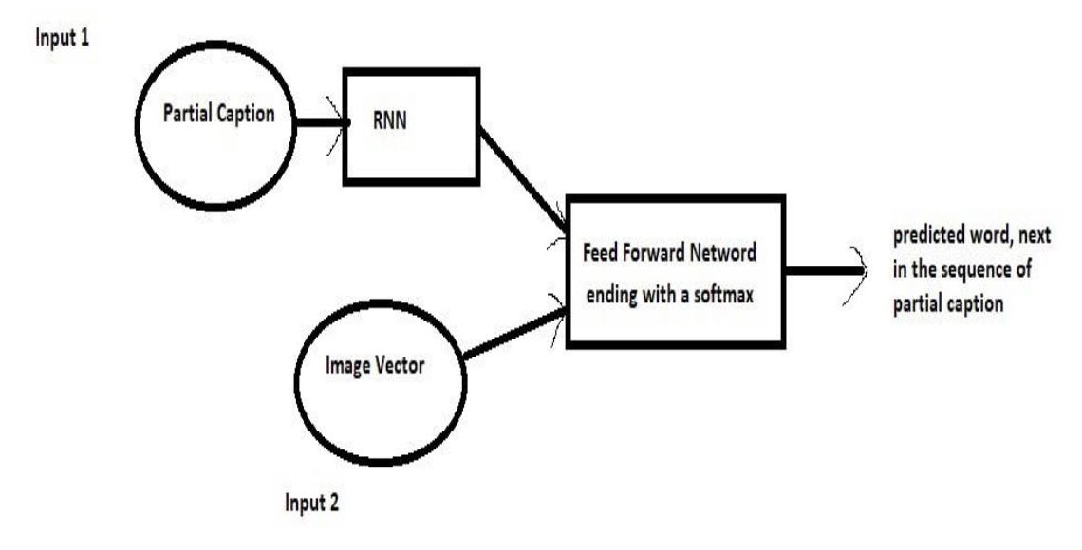
Figure 1: A Block Diagram of the RNN approach to image captioning

2.6 Training and Evaluation
The model is trained using categorical cross-entropy loss and the Adam optimizer. During inference, the model generates captions one word at a time using greedy decoding, starting with startseq until endseq is predicted or the maximum sequence length is reached. The quality of generated captions is evaluated using BLEU scores (BLEU-1 to BLEU-4), which compare the model-generated captions to the human-annotated references.

3. Experimental Results
The image captioning model was trained on the Flickr8k dataset using a CNN-RNN architecture and evaluated using both quantitative BLEU metrics and qualitative examples. The results provide insight into the model’s ability to understand visual content and generate coherent descriptions.

3.1 Training Performance

The model was trained for 20 epochs using a generator-based pipeline. The training process optimized categorical cross-entropy loss and tracked accuracy on the training data. The results are summarized below:
- Final Training Loss: 2.6748
- Final Training Accuracy: 0.4004

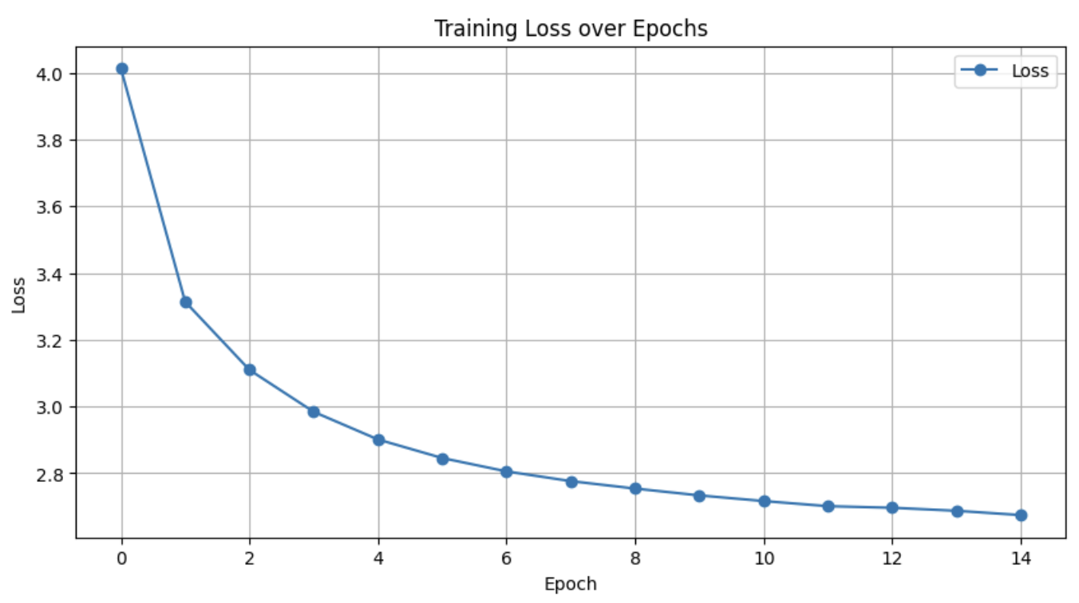

Figure 2: Training Loss over Epochs

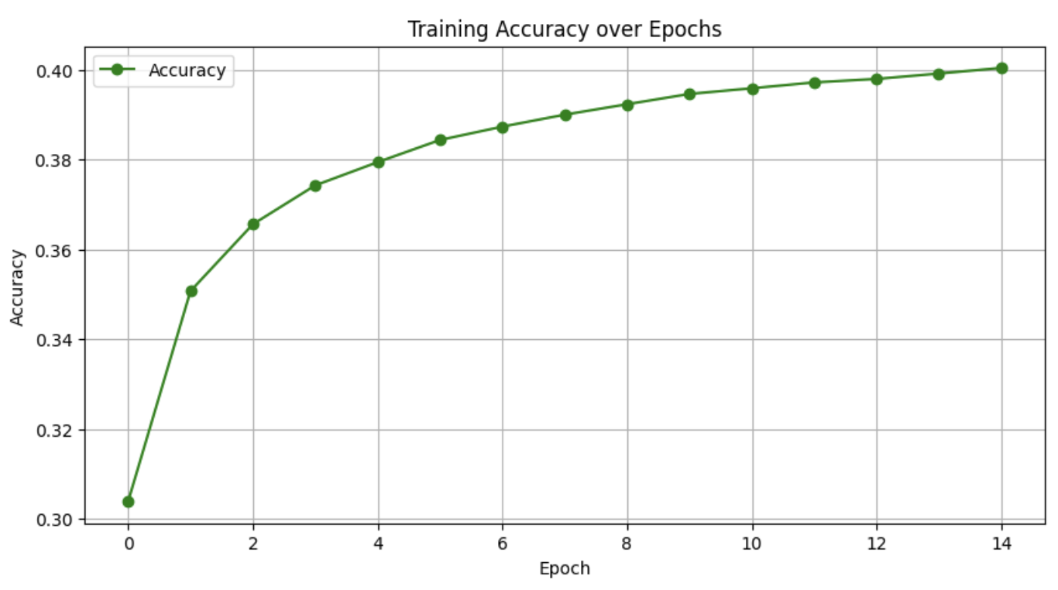
Figure 3: Training Accuracy over Epochs

These graphs indicate how well the model fit the training data. A decreasing loss suggests that the model successfully learned the mapping from image features and partial captions to the next word.

3.2 Quantitative Evaluation – BLEU Scores

To quantitatively evaluate caption quality, BLEU scores were computed on a set of 100 test images using greedy decoding. The results are summarized in Table 1 and Figure 4.

METRIC | SCORE
BLEU – 1 | 0.256060
BLEU – 2 | 0.111823
BLEU – 3 | 0.049138
BLEU – 1 | 0.021172

Table 1. BLEU Score Summary

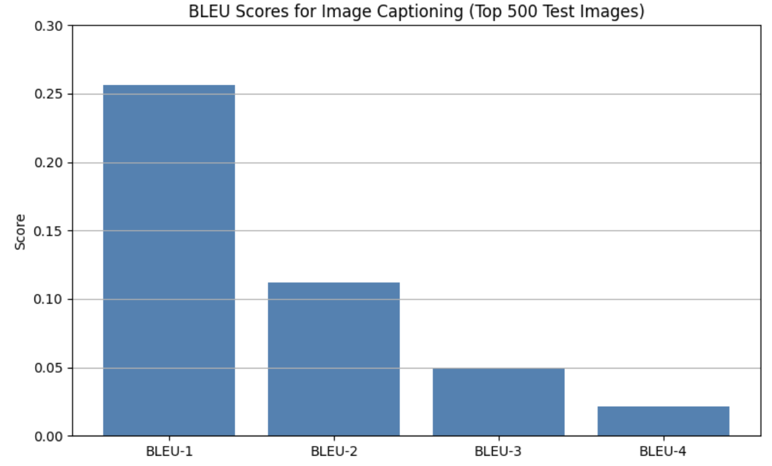

Figure 4: Training Accuracy over Epochs

While BLEU-1 reflects acceptable unigram-level prediction, the drop in BLEU-2 through BLEU-4 indicates challenges in generating longer, fluent phrases — a common issue with greedy decoding and limited context.

3.3 Qualitative Evaluation – Caption Visualization
To better understand the strengths and limitations of the model beyond numeric metrics, qualitative analysis was conducted by comparing model-generated captions against the actual visual content of test images. Figure 5 presents one such example.

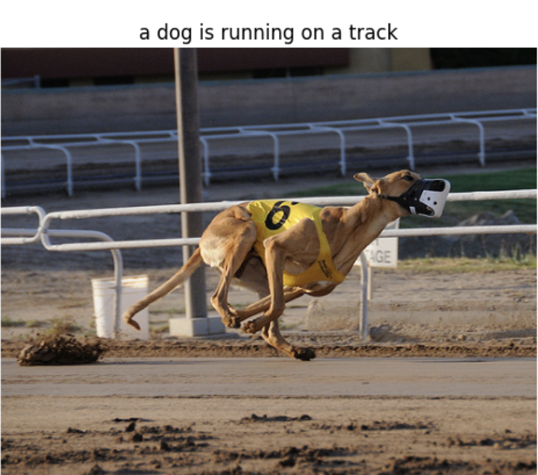

Figure 5: Sample Test Image and Correctly Predicted Caption
Predicted Caption: “a dog is running on a track”

In this case, the model demonstrates accurate understanding of the image content. The generated caption matches the ground truth both in terms of objects (dog) and context (running on a track), highlighting the model’s capability to generalize well when the visual scene aligns closely with patterns seen during training.
This output indicates that the model is capable of producing high-quality captions when the subject is prominent, and the scene structure is familiar. It also reflects that the learned word embeddings and LSTM-based decoder were able to capture the relevant semantics and structure effectively.

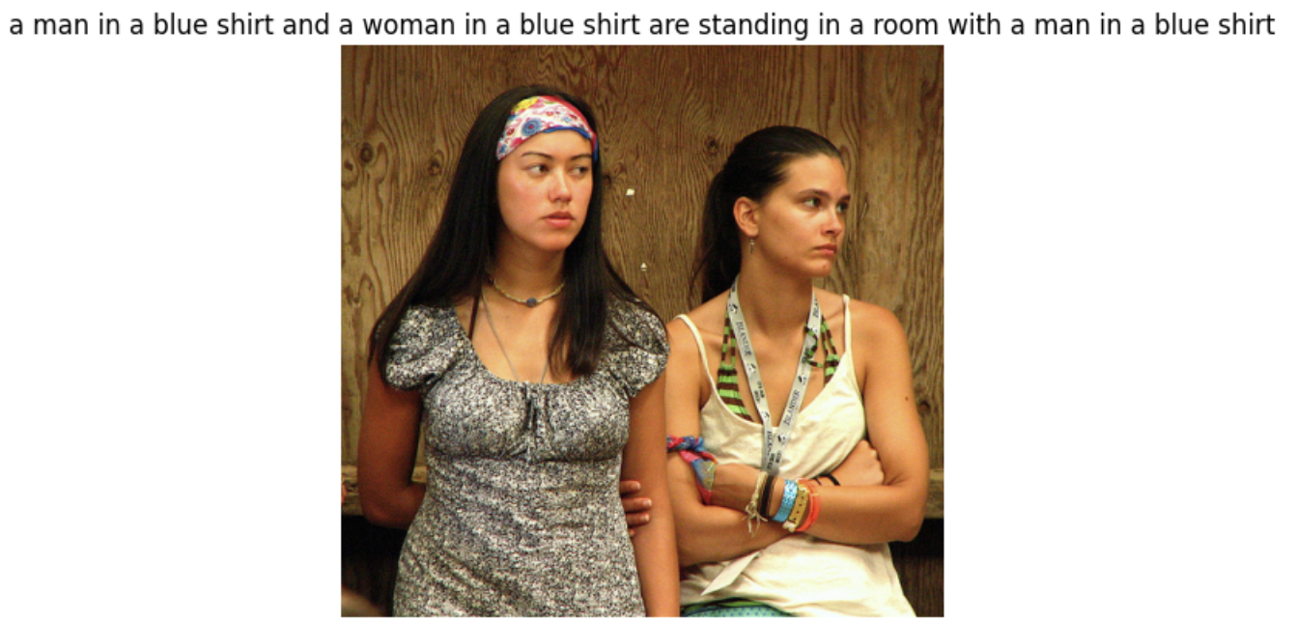
Figure 6: Sample Test Image with a Hallucinated Caption
Predicted Caption: “a man in a blue shirt and a woman in a blue shirt are standing in a room with a man in a blue shirt”

In this case, the model generates a caption that is structurally fluent but semantically incorrect. The caption repeatedly mentions a “man in a blue shirt,” while the image clearly shows two women, and neither appears to be wearing blue shirts. This suggests the model has overfitted on frequent caption patterns from the training set — likely involving “man,” “blue shirt,” and “standing in a room.”
This error type, commonly referred to as caption hallucination, is typical in image captioning models trained without attention mechanisms. It reflects a lack of grounding between the generated text and actual visual features, highlighting the need for more context-aware architectures such as attention-based decoders or transformer models.

3.4 Word Prediction Probabilities
The model’s initial word choices were examined by visualizing the top 5 SoftMax outputs at the first-time step:

Top predictions:

1: a - prob: 0.61330246925354
13: two - prob: 0.12617523968219757
5: the - prob: 0.06985744088888168
47: three - prob: 0.03249609097838402
28: an - prob: 0.013008260168135166

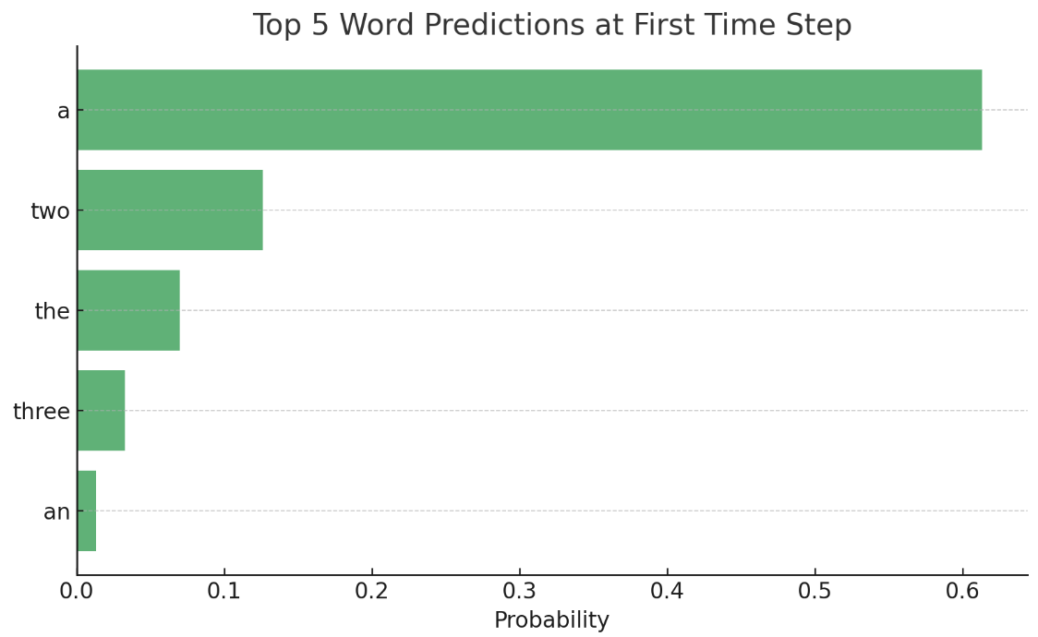

This graph gives insight into the model’s word preferences and confidence when initiating a caption sequence.

4. Discussion

The image captioning model developed in this project shows promising capabilities in generating basic descriptive captions, yet several limitations and observations emerged through both quantitative and qualitative evaluations.
- Model Strengths
  - Basic Sentence Structure: The model can generate syntactically correct and complete sentences. This is evident in many of the generated captions which follow subject–verb–object (SVO) patterns like “a dog is running on a track”.
  - High BLEU-1 Score: The relatively strong BLEU-1 score (~23%) indicates that the model often predicts the correct individual words, especially early in the sequence, demonstrating effective vocabulary learning.
  - Correct Captions on Familiar Content: When the visual scenes are well-represented in the training set (e.g., animals, sports, or people outdoors), the model tends to generate accurate captions, as seen in Figure 6.
- Model Limitations
  - Low Higher-Order BLEU Scores: BLEU-2 to BLEU-4 scores drop significantly, indicating that while individual word predictions are reasonable, the model struggles to generate longer, semantically coherent phrases.
  - Overfitting and Repetition: As seen in Figure 7, the model sometimes hallucinates repeated or generic phrases (e.g., “a man in a blue shirt”), regardless of image content. This may reflect overfitting to high-frequency training captions.
  - Lack of Attention or Scene Understanding: Since the model uses global image features without any attention mechanism, it fails to localize specific objects or relationships within the scene. As a result, it struggles with complex images or multiple interacting subjects.
  - Vocabulary Bias: The top predicted words at the first-time step (Figure 6) show a strong bias towards common articles and numbers (“a”, “two”, “the”), which can lead to generic and repetitive sentence beginnings.

4.1. Training and Generalization

The final training accuracy of ~40% and loss of ~2.67 suggest that the model is learning patterns in the training data but may not be generalizing well to unseen samples. This is further supported by qualitative errors and low BLEU-4 scores on the test set. Overfitting is likely due to the relatively small size of the Flickr8k dataset, along with the simplicity of greedy decoding used during inference.

5. References
- Jason Brownlee. Image Captioning with Keras: Teaching Computers to Describe Pictures. Medium, 2019.
https://medium.com/data-science/image-captioning-with-keras-teaching-computers-to-describe-pictures-c88a46a311b8
- Yash Patel. Foundations of NLP Explained: BLEU Score and WER Metrics. Towards Data Science, 2020.
https://towardsdatascience.com/foundations-of-nlp-explained-bleu-score-and-wer-metrics-1a5ba06d812b
- Oriol Vinyals, Alexander Toshev, Samy Bengio, and Dumitru Erhan. Show and Tell: A Neural Image Caption Generator. Proceedings of the IEEE Conference on Computer Vision and Pattern Recognition (CVPR), 2015.
https://arxiv.org/abs/1411.4555
- Kaiming He, Xiangyu Zhang, Shaoqing Ren, and Jian Sun. Deep Residual Learning for Image Recognition. CVPR, 2016.
https://arxiv.org/abs/1512.03385
- TensorFlow Keras Documentation
https://www.tensorflow.org/api_docs/python/tf/keras
- OpenAI. ChatGPT: Language Model Assistance for Research Writing. ChatGPT, 2024.

