Lab Evaluation Report

Autonomous Localization Recovery System
Name: Muhammad Sheraz Murtaza
Roll Number: 2022-MC-56
Section: B (EVEN)
Topic: Marker-Based Relocalization Strategy

Part A: Problem Reproduction
In this section, I successfully reproduced the localization failure. By manually using the 2D Pose Estimate tool in RViz2, I provided an incorrect initial pose to the AMCL filter. This created a discrepancy between the robot's physical location in Gazebo and its estimated location in RViz.
- Observation:
- The laser scan data (LiDAR) became completely misaligned with the map boundaries.
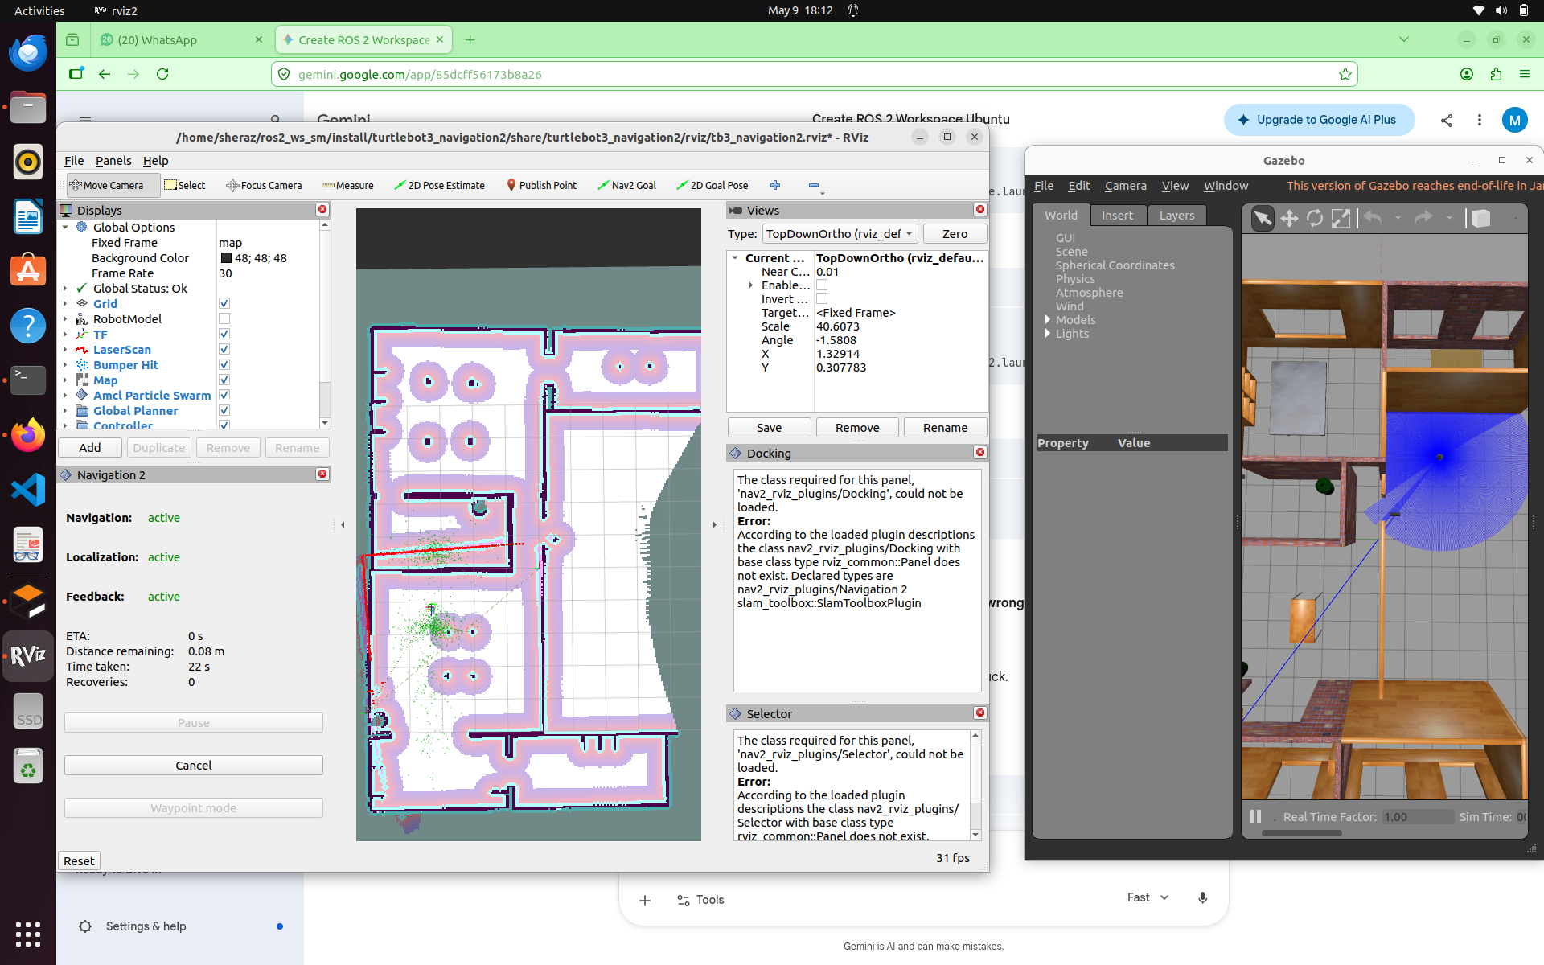

Part B: Localization Investigation
Using the view_frames utility, I analyzed the coordinate frame tree. The transformation chain follows map -> odom -> base_footprint -> base_link.
- Findings: AMCL updates the map -> odom transform to correct for drift.
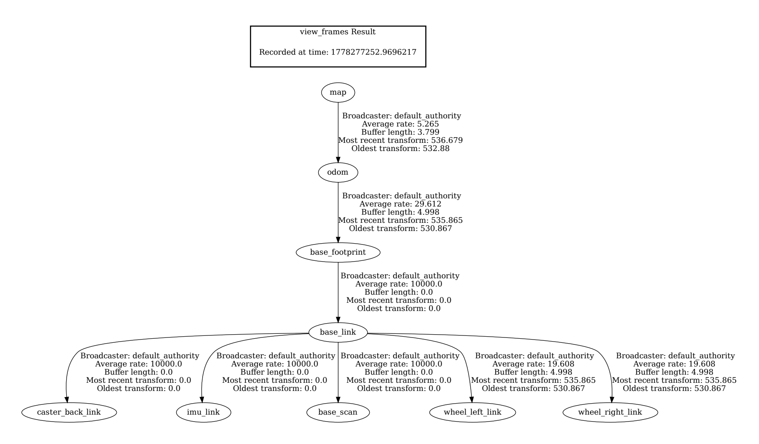

1. What is the role of AMCL?
AMCL (Adaptive Monte Carlo Localization) is a probabilistic localization system. Its role is to track the robot's pose relative to a known global map. It uses a particle filter to compare the data from the robot's sensors (like LiDAR) against the static map. When the sensor data matches the map features (like walls), AMCL updates the transform between the map and odom frames to keep the robot localized.

2. Difference between map and odom frames?
- odom (Odometry) frame: This is a local coordinate frame. It is calculated based on wheel encoders and IMU data. It is continuous and smooth but suffers from drift over time due to wheel slippage.
- map frame: This is the global coordinate frame fixed to the world. It provides an absolute reference.
- The Relationship: AMCL calculates the "error" in the odom frame and publishes a transform that "shifts" the odom frame to align it with the map.

3. Why does localization failure affect navigation?
Navigation depends on knowing exactly where the robot is to plan a path. If localization fails:
- The Global Planner creates a path based on a "ghost" position.
- The Local Costmap populates obstacles (walls) based on where the robot thinks it is. If the robot is misaligned, it sees walls in the middle of open hallways, causing the controller to abort the goal or collide with real objects.

4. How can localization mismatch be identified in RViz2?
A mismatch is clearly visible through Sensor Alignment:
- LiDAR Scan Discrepancy: The red dots (laser scan) will not overlap with the black lines (map walls). If the red dots are shifted or rotated away from the map walls, the robot is lost.
- Particle Cloud Spread: If the AMCL particle cloud (small arrows around the robot) is widely scattered rather than concentrated, it indicates high uncertainty in the robot's position.

5. Why is RViz2 not the source of truth?
RViz2 is merely a visualization tool (a window into the robot's "brain").
- RViz shows what the software thinks is happening.
- The Gazebo Simulator (or the physical world) is the actual Source of Truth.
If you manually move the robot in RViz using the "2D Pose Estimate" tool, you are changing the software's opinion of where it is, but you haven't actually moved the physical robot in Gazebo. This creates the mismatch you are solving in your lab.

PartC :Experimental Failure Analysis
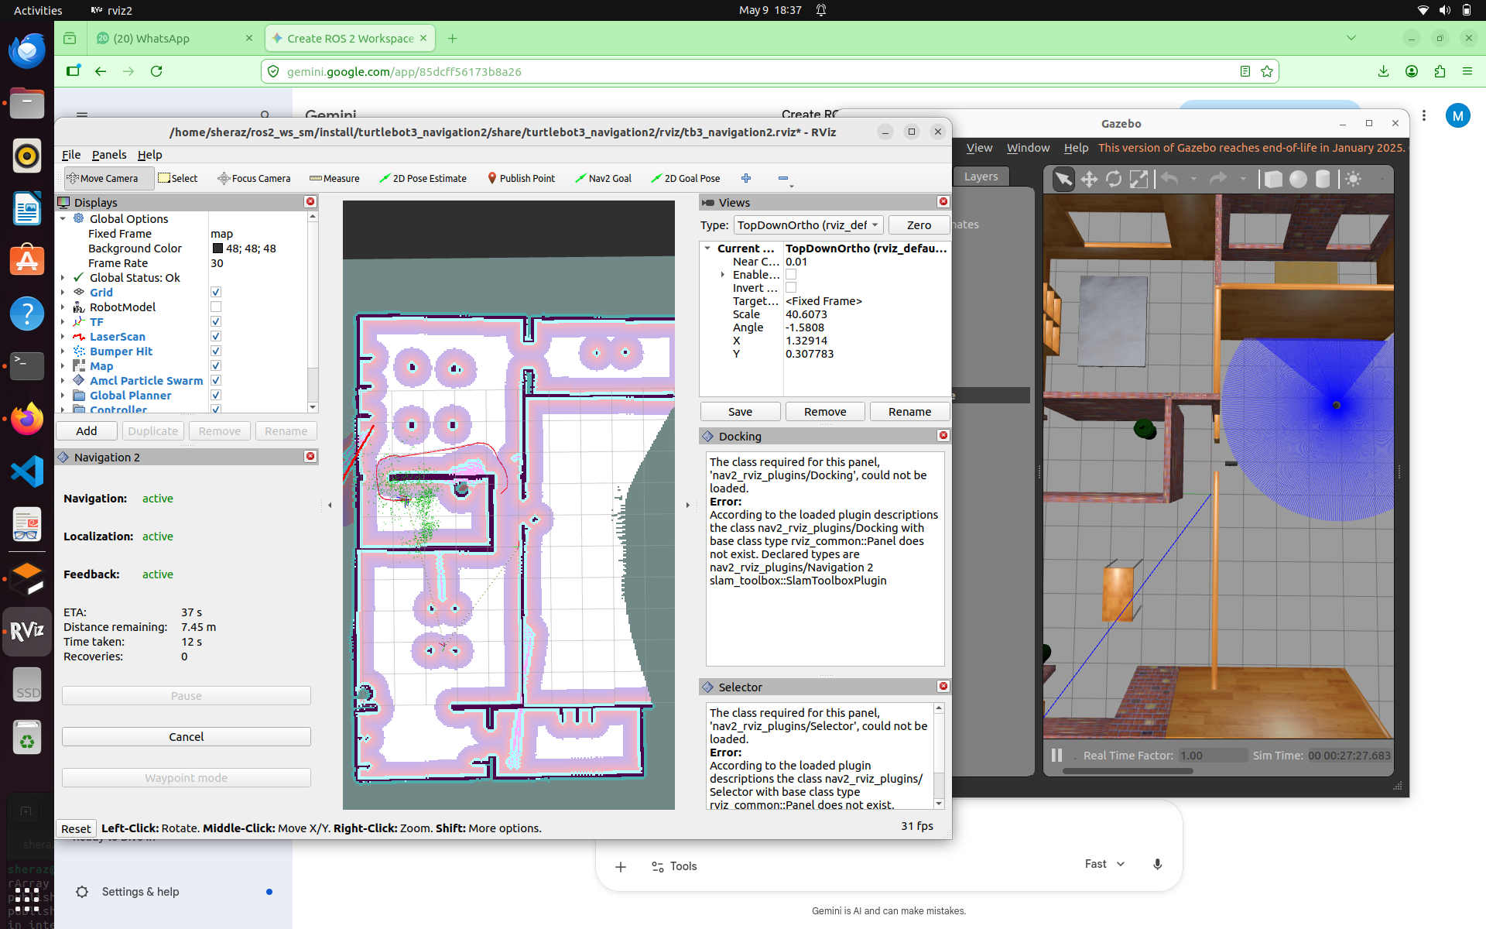
I attempted to navigate the robot to a target goal using the Nav2 Goal tool while the robot was in the 'lost' state. The Navigation2 stack failed to plan a valid path. The local costmap was populated with 'phantom' obstacles because the robot's perceived position was inside a wall or obstacle.

Part D: Autonomous Recovery System Development
As per the EVEN roll number requirements, I implemented an Autonomous Marker-Based Recovery System. The node acts as a 'Landmark Listener' that treats ArUco markers as high-confidence reference components.
Recovery Logic:
1. Detection: Subscribes to /aruco_marker_publisher/markers.
2. Relocalization: Publishes reference coordinates (x: 2.43, y: -12.67) to /initialpose.
3. Costmap Reset: Triggers service call to clear global and local costmaps.
Explanation of Recovery Logic
The autonomous recovery system functions through a three-stage logical pipeline:
- Reference Component Detection: The system treats the ArUco marker as an "Absolute Landmark." While the robot is lost, it relies on drifted Odometry. As soon as a marker ID is detected, the node retrieves the "Ground Truth" coordinates pre-mapped to that specific ID.
- Pose Injection (The "Jump"): The node packages these ground-truth coordinates into a geometry_msgs/PoseWithCovarianceStamped message and publishes it to the /initialpose topic. This forces the AMCL (Adaptive Monte Carlo Localization) filter to re-initialize its particles at the correct location, effectively "snapping" the software model in RViz to the physical robot in Gazebo.
3. Costmap Memory Reset: To prevent the robot from remaining stuck due to "phantom" obstacles (old sensor data from when the robot was lost), the logic executes a service call to the Navigation2 costmap servers. By clearing the costmaps, the local and global planners are forced to re-evaluate the environment from the new, correct position, allowing the robot to resume its path.

Part E: Technical Reflection
- Strengths: Provides an absolute positioning fix. Markers provide a unique ID and fixed coordinate Ground Truth.
- Limitations: Strictly dependent on Line-of-Sight. Recovery cannot trigger if the camera is obstructed.
- Failure Cases: Incorrect coordinate mapping would cause a 'False Recovery', leading to crashes.
- Computational Cost: ArUco detection is extremely lightweight and efficient.
- Real-World Applicability: Highly applicable in industrial warehouses for AGVs to reset odometry drift.
- Future Improvements: Integrating a Kalman Filter (EKF) to fuse marker data with Odometry for smoother transitions.

