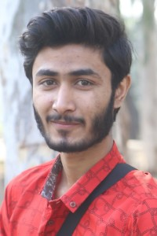

**Skills**

**Information**

**Education**

**Virtual University of Pakistan**

Started studying Bachelor of Science in Software Engineering, 2019

Successfully completed 5 semesters

Cumulative GPA of 3.61

**Activities**

**Summary**

Results-oriented software engineer with a focus on the design and implementation of relational database systems. 1.5+ years of experience in developing cutting-edge engineering solutions with a wide range of eCommerce and technology features. Skilled in agile processes, backend and frontend development, and creating eCommerce websites that integrate with Paypal, Stripe and other payment APIs.

Development Programs for micro and small enterprises

Organize an exhibition of individual works of development

Take part in many programming competitions

* Programming
* Architecture
* Design
* Book reading
* Solving analytical problems
* Drama and Theater

**Interests**

* Problem Solving
* Object oriented programming
* Data Structures and Algorithms
* Database Management System
* Critical Thinking
* Fast learner
* Collaboration
* Email: sherazp995@gmail.com
* Phone: +92302-0484960
* Address: House # 20 Imran street adj. Iqbal street kot khawaja saeed Lahore
* Facebook: @sherazp995

**Sheraz**

**Web developer**

**Programming Languages**

* HTML
* CSS
* bootstrap
* JavaScript
* jQuery
* react js
* SQL
* PHP
* Ruby on rails