INTRO TO SOFTWARE ENGINEERING

(Sprint 2)

Deliverable 3

**MASOOD GHAURI (21I-1198)**

**MUHAMMAD EMAN (21I-1140)**

**SHERAZ TARIQ (21I-1188)**

**Typing tutor**

Our project is a **Typing Tutor** which teaches through

lessons, and games, and also takes typing test to test

the typing speed of Users.

**Sprint 2** (Typing Tests)

In our second sprint of this project, **we had to make all**

**the Typing Tests of this typing tutor**. It will have **3**

**difficulty levels- Easy, Medium, Hard**.

User can select the difficulty level as per his expertise or

choice. This test results will include the **Typing Speed of User, Accuracy, Time taken** to complete the test. It will also calculate the Total Score/Points (Typing speed +Accuracy+time).

This Module also include a new feature of **User Profiles**

in **previous Module (Lessons)**. By this feature user can **make**

his profile or he can **open existing profiles** and continue where

it was left or can save his progress.

**User Stories**

**Title:**

User Profiles

**Priority:**

10

**Story ID:**

**01**

**User Story:**

*As a* **user**

*I want* **to have User Profiles**

*So that* **I can save my progress**.

**Acceptance criteria:**

*If it works,* then it **should create or open the User Profies.**

*else*

*it should* **display an error message “Enable to create/open User Profile” or display nothing.**

**Title:**

Create New User Profiles

**Priority:**

10

**Story ID:**

**1.1**

**User Story:**

*As a* **user**

*I want to* **create my new User Profile**

*So that* **I can save my progress and continue later.**

**Acceptance criteria:**

*If it works,* **it should start process of creating new**

**User Profile.**

*Else*

*it should* **display an error message “error creating profile" or return to intro menu.**

**Title:**

Open Existing Profiles

**Priority:**

10

**Story ID:**

**1.2**

**User Story:**

*As a* **user**

*I want* **to open/show** **my existing profiles**

*So that* **I can continue where it was left.**

**Acceptance criteria:**

*If it works, then it* **should display/open my existing profiles.**

*else*

*it should* **display error message “error opening profiles” or return to intro Menu.**

**Title:**

Typing Tests

**Priority:**

8

**Story ID:**

**02**

**User Story:**

*As a* **user**

*I want to* **have typing tests**

*So that* **I can test my typing speed and skills.**

**Acceptance criteria:**

*If it works, then it* **should show the typing test level tab**

*else*

*it should* **return to intro tab.**

**Title:**

Easy Typing Test

**Priority:**

6

**Story ID:**

**2.1**

**User Story:**

*As a* **user**

*I want to* **have an easy difficulty level typing test**

*So that* **I can test my typing skills.**

**Acceptance criteria:**

*If it works, then it* **should start easy level typing test**

*else*

*it should* **return back to test tab.**

**Title:**

Medium Level Test

**Priority:**

6

**Story ID:**

**2.2**

**User Story:**

*As a* **user**

*I want to* **have a medium difficulty level typing test**

*So that* **I can test my typing skills.**

**Acceptance criteria:**

*If it works, then it* **should start medium level typing test**

*else*

*it should* **return back to test tab.**

**Title:**

High Level Test

**Priority:**

6

**Story ID:**

**2.3**

**User Story:**

*As a* **user**

*I want to* **have a high difficulty level typing test**

*So that* **I can test my typing skills.**

**Acceptance criteria:**

*If it works, then it* **should start high level typing test**

*else*

*it should* **return back to test tab.**

**Title:**

Test Results

**Priority:**

4

**Story ID:**

**03**

**User Story:**

*As a* **user**

*I want to* **have my test results (speed accuracy, etc.)**

*So that* **I can have an idea of my typing skills.**

**Acceptance criteria:**

*If it works, then it* **should display the test results**

*else*

*it should* **return to intro menu.**

**Title:**

High Score

**Priority:**

2

**Story ID:**

**04**

**User Story:**

*As a* **user**

*I want to* **be informed if I make a high score**

*So that* **it can be updated.**

**Acceptance criteria:**

*If it works, then it* **should show me a message and update the previous high score.**

*else*

*it should* **display and do nothing.**

**Trello**

**Snapshots**

**FIRST SNAPSHOT**

**SECOND SNAPSHOT**

**THIRD SNAPSHOT**

**Use Case**

**Diagram**

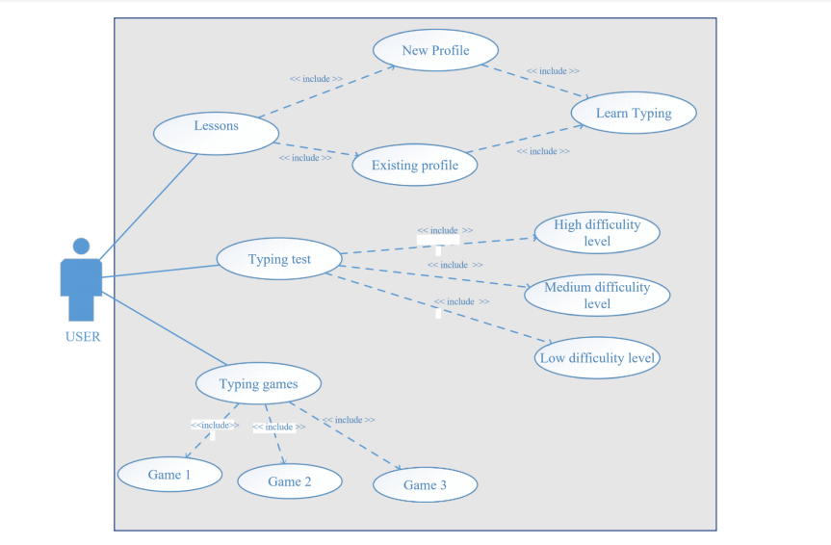

**Activity**

**Diagram**

**For Typing Tests**

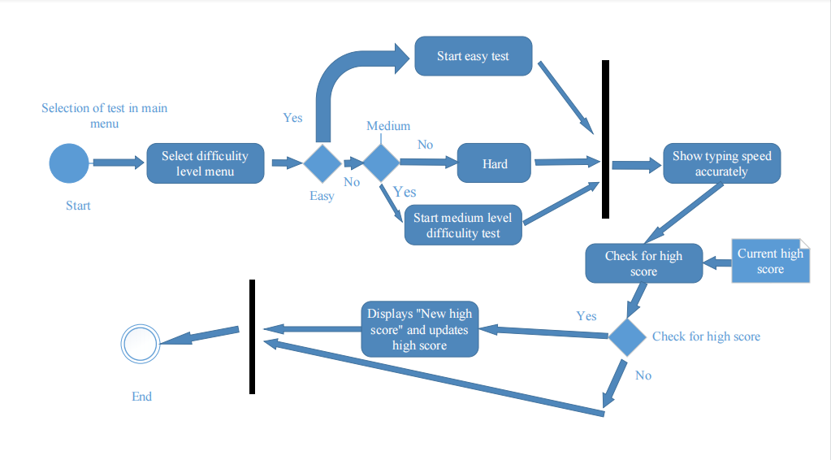

**For Lessons**

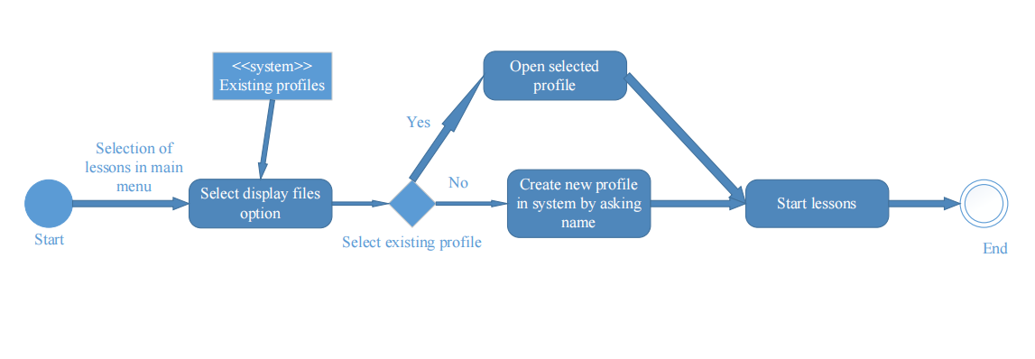

**For Typing Games**

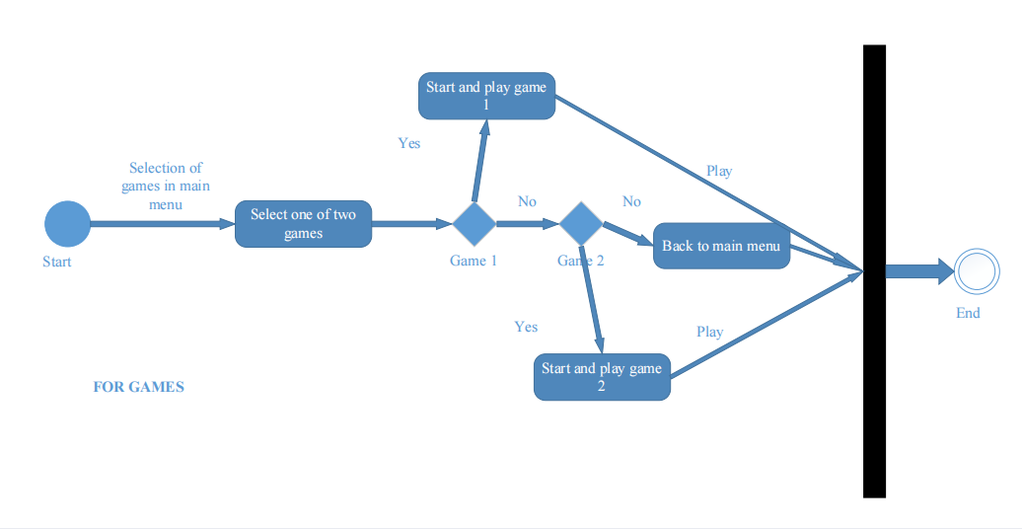

**Sequence**

**Diagram**

**For creating new User Profile**

**For starting a typing test**

**For opening an existing**

**User Profile**

**There is no Class Diagram in our project as we are not using OOP concepts**