Week2ICPMSLab

library(tidyverse)

## ── Attaching packages ─────────────────────────────────────── tidyverse 1.3.0 ──

## ✓ ggplot2 3.3.2 ✓ purrr 0.3.4  
## ✓ tibble 3.0.4 ✓ dplyr 1.0.2  
## ✓ tidyr 1.1.2 ✓ stringr 1.4.0  
## ✓ readr 1.4.0 ✓ forcats 0.5.0

## Warning: package 'ggplot2' was built under R version 3.6.2

## Warning: package 'tibble' was built under R version 3.6.2

## Warning: package 'tidyr' was built under R version 3.6.2

## Warning: package 'readr' was built under R version 3.6.2

## Warning: package 'purrr' was built under R version 3.6.2

## Warning: package 'dplyr' was built under R version 3.6.2

## ── Conflicts ────────────────────────────────────────── tidyverse_conflicts() ──  
## x dplyr::filter() masks stats::filter()  
## x dplyr::lag() masks stats::lag()

library(reshape2)

## Warning: package 'reshape2' was built under R version 3.6.2

##   
## Attaching package: 'reshape2'

## The following object is masked from 'package:tidyr':  
##   
## smiths

ICPMS<-read.csv("~/ICPMSArielle/Data/ICPMS_tidy_example.csv")

sample_site<- unique(filter(ICPMS, site!= "MB", site!="")$site)  
#excluding method blank and quality control from the list of sites  
metals_analyzed<- unique(ICPMS$metal)  
  
#preveiw the lists to check for potential issues  
sample_site

## [1] F QC D E C B A   
## Levels: A B C D E F MB QC

metals_analyzed

## [1] Cr53 Pb208 As75 Cd111 Cr52 Cd114  
## Levels: As75 Cd111 Cd114 Cr52 Cr53 Pb208

ICPMS_cal <- NULL  
for (unique_metal in metals_analyzed) {  
 #filtering for a single metal then selecting variables of interest  
 cal <- ICPMS %>%  
 filter(type == "Cal1" | type == "Cal2" | type == "Cal3") %>%  
 filter(metal == unique_metal) %>%  
 select(concentration, cps, rsd)  
 #weighted linear regression  
 w <- 1/(cal$cps*cal$rsd)^2  
 model <- lm(cal$cps ~ cal$concentration, weights = w)  
 #pulling out relevant info from model  
 slope <- model$coefficients[2]  
 intercept <- model$coefficients[1]  
 slope_std <- summary(model)$coefficients[2,2]  
 intercept_std <- summary(model)$coefficients[1,2]  
 #plotting cal curve  
 plot(cal$cps ~ cal$concentration,  
 xlab = paste("Concentration of ", unique_metal, "(ppb)"),  
 ylab = "Counts per Second") +  
 abline(model, col = "red") +  
 title(paste("Calibration for ", unique_metal))  
 #storing info from calibration curve  
 equation <- tibble(metal = unique_metal, slope, slope_std, intercept, intercept_std)  
 ICPMS_cal <- rbind(ICPMS_cal, equation)  
}

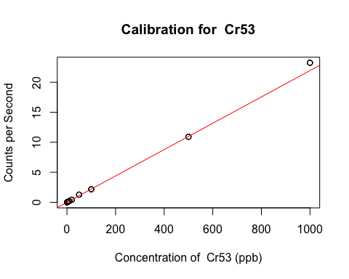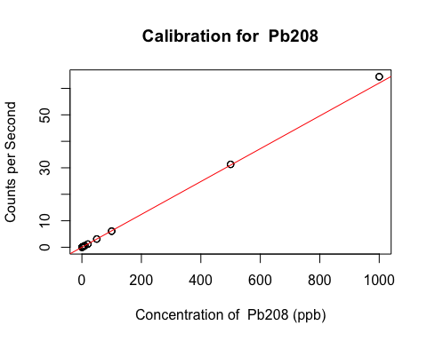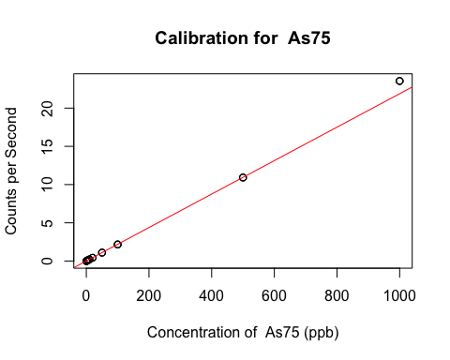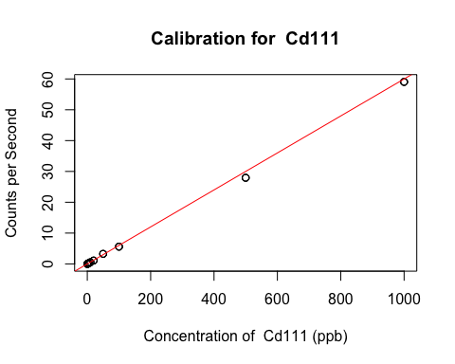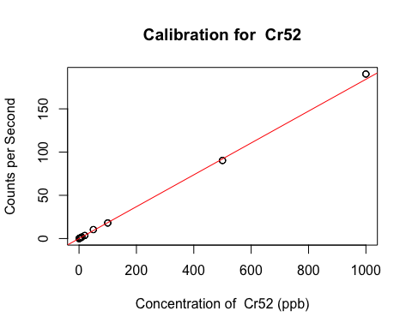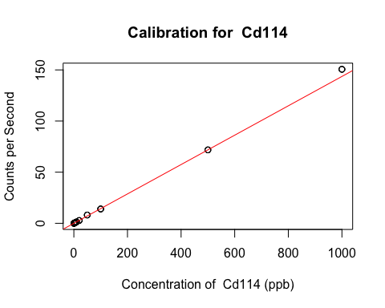

ICPMS_cal

## # A tibble: 6 x 5  
## metal slope slope_std intercept intercept_std  
## <chr> <dbl> <dbl> <dbl> <dbl>  
## 1 Cr53 0.0219 0.000161 0.00199 0.00115   
## 2 Pb208 0.0620 0.000216 0.00736 0.000269   
## 3 As75 0.0219 0.0000284 0.00522 0.000160   
## 4 Cd111 0.0600 0.000858 0.0000272 0.0000887  
## 5 Cr52 0.184 0.00204 0.0150 0.00713   
## 6 Cd114 0.144 0.00141 0.0000761 0.0000750

remove (equation, cal, slope, slope_std, intercept, intercept_std, w, model, unique_metal)

#function to analyze the samples and add a comment with the inputs and outputs of the functions  
#inputs: unique_site (as a character, ex. "A")  
#outputs: concentration vector  
  
sample_analysis<-function(unique_site){  
 #initiated "for loops" to select a specific sample and a specific metal  
 concentration_data <- NULL  
 for (unique_metal in metals_analyzed){  
 sample <- filter(ICPMS, metal == unique_metal, site == unique_site)  
 data <- NULL  
   
 for (ID in sample$sample_key) {  
 sample_data <- filter(sample, sample_key == ID)  
 cal <- filter(ICPMS_cal, metal == unique_metal)  
 #convert the cps readings into concentrations  
 #sample analysis  
 m <- cal$slope  
 b <- cal$intercept  
 y <- sample_data$cps  
 b_e <- cal$intercept_std  
 m_e <- cal$slope_std  
 x <- (y-b)/m #The units are dependent on the calibration standards (Kg/mL)  
 RSD <- ((sample_data$rsd/100)*sample_data$cps)  
 CPS <- sample_data$cps   
 #propagate the error in the concetration  
 #error propagation  
 e_yb <- sqrt((RSD)^2 + (b_e)^2) #error in y-b from calibration  
 yb <- CPS - b  
 e_x <- x*sqrt((e_yb/yb)^2 +(m_e/m)^2) #error in x from calibration  
 #if the "site is not eh method blank, store the concentration data  
   
 data <- rbind(data, data.frame(sample_key = ID, x, e_x))  
 if (unique_site != "MB"){  
 concentration_data <- data_frame(sample_key = sample_data$sample_key,  
 analyst = sample_data$analyst,  
 metal = unique_metal,  
 site = unique_site,  
 conc_dil = x,  
 conc_dil_error = e_x) %>%  
 rbind(concentration_data)  
 }  
 }  
 #if the site is the method blank, average the concentrations and then store the data  
 if (unique_site == "MB"){  
 x <- mean(data$x)  
 e_x <- sd(data$x)  
 concentration_data <- data_frame(metal = unique_metal,  
 site = unique_site,  
 conc_dil = x,  
 conc_dil_error = e_x) %>%  
 rbind(concentration_data)  
 }  
 }  
 return(concentration_data)  
  
   
}

#create a function that runs a different function on each of the soil sample sites  
  
#inputs: a function  
#outputs: a data frame with the function outputs from each site  
  
run_sites<-function(Function){  
 value <- NULL  
 for(sites in sample_site){  
 site_value <- Function(sites)  
 value <-rbind(site_value, value)  
 }  
 return(value)  
}

#analyze the method blank and all the samples  
MB<- sample_analysis("MB") #ug/kg

## Warning: `data_frame()` is deprecated as of tibble 1.1.0.  
## Please use `tibble()` instead.  
## This warning is displayed once every 8 hours.  
## Call `lifecycle::last_warnings()` to see where this warning was generated.

uncor_sample<- run_sites(sample_analysis)  
#values do not account for dilutns  
MB

## # A tibble: 6 x 4  
## metal site conc_dil conc_dil_error  
## <chr> <chr> <dbl> <dbl>  
## 1 Cd114 MB 0.00657 0.00674  
## 2 Cr52 MB 0.535 0.0570   
## 3 Cd111 MB 0.00511 0.00560  
## 4 As75 MB 0.0475 0.0550   
## 5 Pb208 MB 0.455 0.739   
## 6 Cr53 MB 0.543 0.0637

uncor_sample

## # A tibble: 204 x 6  
## sample_key analyst metal site conc_dil conc_dil_error  
## <int> <fct> <chr> <chr> <dbl> <dbl>  
## 1 56 AVM Cd114 A 0.140 0.00279  
## 2 54 LAK Cd114 A 0.0638 0.00126  
## 3 48 AH Cd114 A 0.0788 0.00216  
## 4 46 LML Cd114 A 0.0864 0.00253  
## 5 56 AVM Cr52 A 6.74 0.139   
## 6 54 LAK Cr52 A 6.92 0.0969   
## 7 48 AH Cr52 A 12.1 0.151   
## 8 46 LML Cr52 A 9.56 0.133   
## 9 56 AVM Cd111 A 0.0507 0.00537  
## 10 54 LAK Cd111 A 0.0399 0.00273  
## # … with 194 more rows

#correct for the method blank and perform error propagation as needed  
sample_data_mb <- NULL  
for(unique_metal in metals_analyzed){  
 MB_metal <- filter(MB, metal==unique_metal)  
 sample_metal<- filter(uncor_sample, metal==unique_metal)  
 conc_dil_blanked<- sample_metal$conc_dil-MB_metal$conc_dil  
   
 #error propogation: subtraticoon of MB  
 conc_dil_blanked_error <- sqrt((sample_metal$conc_dil_error)^2 +(MB_metal$conc_dil_error)^2)  
   
 sample_data_mb<-sample_metal%>%  
 mutate(conc_dil_blanked, conc_dil_blanked_error)%>%  
 rbind(sample_data_mb)  
  
}  
sample_data_mb

## # A tibble: 204 x 8  
## sample_key analyst metal site conc_dil conc_dil_error conc_dil_blanked  
## <int> <fct> <chr> <chr> <dbl> <dbl> <dbl>  
## 1 56 AVM Cd114 A 0.140 0.00279 0.133   
## 2 54 LAK Cd114 A 0.0638 0.00126 0.0573  
## 3 48 AH Cd114 A 0.0788 0.00216 0.0722  
## 4 46 LML Cd114 A 0.0864 0.00253 0.0798  
## 5 58 SS Cd114 B 0.0848 0.00117 0.0782  
## 6 52 MF Cd114 B 0.149 0.00166 0.143   
## 7 45 KAD Cd114 B 0.116 0.00498 0.109   
## 8 41 LF Cd114 B 0.146 0.00370 0.139   
## 9 40 AB Cd114 B 0.0798 0.000987 0.0732  
## 10 6 MRMJ Cd114 C 0.0818 0.00187 0.0752  
## # … with 194 more rows, and 1 more variable: conc_dil_blanked_error <dbl>

#define the dilution factors and measuremnt errors  
#error propagation  
vol_e <- 1  
mass_e <- 0.001  
dil_1010_e <- sqrt(1^2 + 10^2)  
dil_e <- sqrt((dil_1010_e/1010)^2 + (1/10)^2) #error in 101 dilution factor  
  
#correct for dilutions and propagate error  
sample_data <- merge(ICPMS, sample_data_mb) %>%  
 unique() %>%  
 mutate(conc_blanked = conc_dil_blanked*(total_volume/1000)/(mass_of_soil/1000)*101,  
 #101 is the factor diluted by at OHSU to make the solutions dilute enought to run the ICPMS on  
 conc_blanked_error = conc_blanked *   
 sqrt((conc_dil_blanked_error/conc_dil_blanked)^2 +   
 (dil_e/101)^2 +  
 (mass_e/mass_of_soil)^2 +  
 (vol_e/total_volume)^2),  
 conc_unblanked = conc_dil*(total_volume/1000)/(mass_of_soil/1000)*101,  
 conc_unblanked_error = conc_unblanked*  
 sqrt((conc_dil_error/conc_dil)^2 +  
 (dil_e/101)^2 +  
 (mass_e/mass_of_soil)^2 +  
 (vol_e/total_volume)^2)) %>%  
 select(-concentration, #removing uneccesary columns  
 -type,  
 -mass_of_soil,  
 -total_volume,  
 -cps,  
 -rsd,  
 -conc_dil_blanked,  
 -conc_dil_blanked_error,  
 -conc_dil,  
 -conc_dil_error)

#cleaning up the environment  
rm(list=ls()[!(ls()%in% c("ICPMS", "sample_data"))])

#now i am going to take the averages of all the metals and create a new data frame with that, not sure if I will be able to make a fucntion, i may just do it by hand  
  
###Just testing this method, not really what I need  
##sample_data2<-aggregate(sample_data[, 6:9], list(sample_data$metal), mean)  
  
#just grouping by metals for avgs, no qc site or mb  
#similar to gillians code  
AVG_concMETAL<- sample_data%>%  
 filter(site!= "QC")%>%  
 group_by(metal)%>%  
 summarise(mean_conc = mean(conc_blanked), sd_conc = sd(conc_blanked), n = n()) %>%  
 mutate(CI = qnorm(0.975)*sd_conc/sqrt(n),  
 lower_ci = mean_conc - CI,  
 upper_ci = mean_conc + CI)

## `summarise()` ungrouping output (override with `.groups` argument)

#avg of metla per site  
AVG_concSITE<- sample_data%>%  
  
 group_by(metal,site)%>%  
 summarise(mean_conc = mean(conc_blanked), sd_conc = sd(conc_blanked), n = n()) %>%  
 mutate(CI = qnorm(0.975)*sd_conc/sqrt(n),  
 lower_ci = mean_conc - CI,  
 upper_ci = mean_conc + CI)

## `summarise()` regrouping output by 'metal' (override with `.groups` argument)

#QC site avgs  
AVG_concQC<- sample_data%>%  
 filter(site== "QC")%>%  
 group_by(metal)%>%  
 summarise(mean_conc = mean(conc_blanked), sd_conc = sd(conc_blanked), n = n()) %>%  
 mutate(CI = qnorm(0.975)*sd_conc/sqrt(n),  
 lower_ci = mean_conc - CI,  
 upper_ci = mean_conc + CI)

## `summarise()` ungrouping output (override with `.groups` argument)

AVG_concSITE <- AVG_concSITE %>%  
 mutate(CI = CI/1000)  
write.csv(AVG_concSITE, "~/ICPMSArielle/Data/AVG_concSITE.csv")

AVG_concSITE <- AVG_concSITE %>%  
 mutate(mean_conc = mean_conc/1000,  
 sd_conc = sd_conc/1000,  
 lower_ci = lower_ci/1000,  
 upper_ci = upper_ci/1000,   
 CI = CI/1000  
 )  
  
AVG_concMETAL <- AVG_concMETAL %>%  
 mutate(mean_conc = mean_conc/1000,  
 sd_conc = sd_conc/1000,  
 lower_ci = lower_ci/1000,  
 upper_ci = upper_ci/1000,   
 CI = CI/1000  
 )  
AVG_concSITE_PB <- AVG_concSITE %>%  
 filter(metal == "Pb208")  
  
AVG_concSITE_AS <- AVG_concSITE %>%  
 filter(metal == "As75")  
  
AVG_concSITE_CD111 <- AVG_concSITE %>%  
 filter(metal == "Cd111")  
  
AVG_concSITE_CD114 <- AVG_concSITE %>%  
 filter(metal == "Cd114")  
  
AVG_concSITE_Cr52 <- AVG_concSITE %>%  
 filter(metal == "Cr52")  
  
AVG_concSITE_Cr53 <- AVG_concSITE %>%  
 filter(metal == "Cr53")

##plots  
  
p = ggplot(data=AVG_concSITE_PB,  
 aes(x = site,y = mean_conc, ymin = lower_ci, ymax = upper_ci ))+  
 geom_pointrange(aes(col=site))+  
 geom_hline(aes(fill=site),yintercept =269.5352927, linetype=2)+  
 xlab('Metal')+ ylab("")+  
 geom_errorbar(aes(ymin=lower_ci, ymax=upper_ci,col=site),width=0.5,cex=1)+   
 facet_wrap(~metal,strip.position="left",nrow=9,scales = "free_y") +  
 theme(plot.title=element_text(size=16,face="bold"),  
 axis.text.y=element_blank(),  
 axis.ticks.y=element_blank(),  
)+ coord_flip()

## Warning: geom_hline(): Ignoring `mapping` because `yintercept` was provided.

p

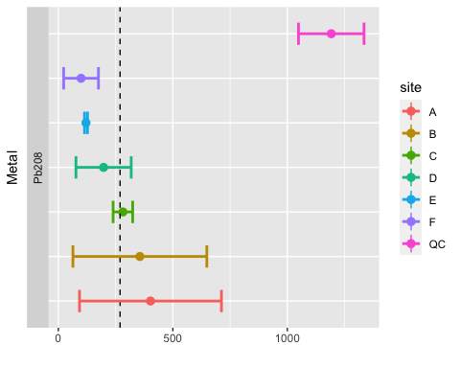

p = ggplot(data=AVG_concSITE_AS,  
 aes(x = site,y = mean_conc, ymin = lower_ci, ymax = upper_ci ))+  
 geom_pointrange(aes(col=site))+  
 geom_hline(aes(fill=site),yintercept =3.2445059, linetype=2)+  
 xlab('Metal')+ ylab("")+  
 geom_errorbar(aes(ymin=lower_ci, ymax=upper_ci,col=site),width=0.5,cex=1)+   
 facet_wrap(~metal,strip.position="left",nrow=9,scales = "free_y") +  
 theme(plot.title=element_text(size=16,face="bold"),  
 axis.text.y=element_blank(),  
 axis.ticks.y=element_blank(),  
)+ coord_flip()

## Warning: geom_hline(): Ignoring `mapping` because `yintercept` was provided.

p

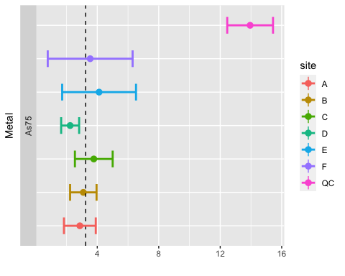

p = ggplot(data=AVG_concSITE_CD111,  
 aes(x = site,y = mean_conc, ymin = lower_ci, ymax = upper_ci ))+  
 geom_pointrange(aes(col=site))+  
 geom_hline(aes(fill=site),yintercept =0.1310686, linetype=2)+  
 xlab('Metal')+ ylab("")+  
 geom_errorbar(aes(ymin=lower_ci, ymax=upper_ci,col=site),width=0.5,cex=1)+   
 facet_wrap(~metal,strip.position="left",nrow=9,scales = "free_y") +  
 theme(plot.title=element_text(size=16,face="bold"),  
 axis.text.y=element_blank(),  
 axis.ticks.y=element_blank(),  
)+ coord_flip()

## Warning: geom_hline(): Ignoring `mapping` because `yintercept` was provided.

p

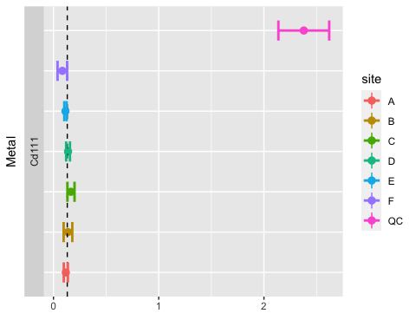

p = ggplot(data=AVG_concSITE_CD114,  
 aes(x = site,y = mean_conc, ymin = lower_ci, ymax = upper_ci ))+  
 geom_pointrange(aes(col=site))+  
 geom_hline(aes(fill=site),yintercept =0.2303492, linetype=2)+  
 xlab('Metal')+ ylab("")+  
 geom_errorbar(aes(ymin=lower_ci, ymax=upper_ci,col=site),width=0.5,cex=1)+   
 facet_wrap(~metal,strip.position="left",nrow=9,scales = "free_y") +  
 theme(plot.title=element_text(size=16,face="bold"),  
 axis.text.y=element_blank(),  
 axis.ticks.y=element_blank(),  
)+ coord_flip()

## Warning: geom_hline(): Ignoring `mapping` because `yintercept` was provided.

p

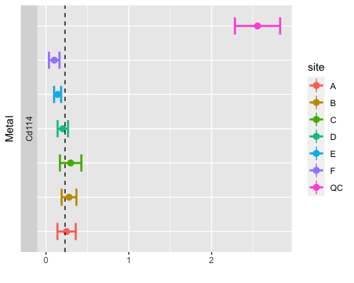

p = ggplot(data=AVG_concSITE_Cr52,  
 aes(x = site,y = mean_conc, ymin = lower_ci, ymax = upper_ci ))+  
 geom_pointrange(aes(col=site))+  
 geom_hline(aes(fill=site),yintercept =21.0045338, linetype=2)+  
 xlab('Metal')+ ylab("")+  
 geom_errorbar(aes(ymin=lower_ci, ymax=upper_ci,col=site),width=0.5,cex=1)+   
 facet_wrap(~metal,strip.position="left",nrow=9,scales = "free_y") +  
 theme(plot.title=element_text(size=16,face="bold"),  
 axis.text.y=element_blank(),  
 axis.ticks.y=element_blank(),  
)+ coord_flip()

## Warning: geom_hline(): Ignoring `mapping` because `yintercept` was provided.

p

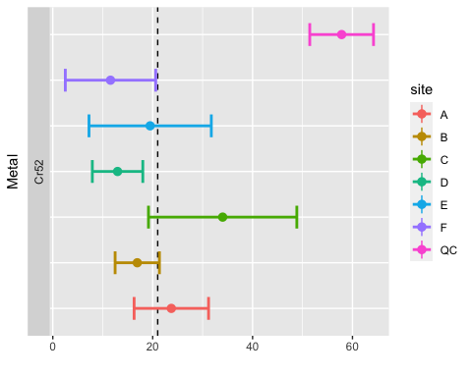

p = ggplot(data=AVG_concSITE_Cr53,  
 aes(x = site,y = mean_conc, ymin = lower_ci, ymax = upper_ci ))+  
 geom_pointrange(aes(col=site))+  
 geom_hline(aes(fill=site),yintercept =21.5752868, linetype=2)+  
 xlab('Metal')+ ylab("")+  
 geom_errorbar(aes(ymin=lower_ci, ymax=upper_ci,col=site),width=0.5,cex=1)+   
 facet_wrap(~metal,strip.position="left",nrow=9,scales = "free_y") +  
 theme(plot.title=element_text(size=16,face="bold"),  
 axis.text.y=element_blank(),  
 axis.ticks.y=element_blank(),  
)+ coord_flip()

## Warning: geom_hline(): Ignoring `mapping` because `yintercept` was provided.

p

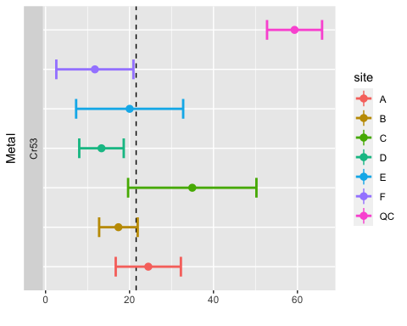

#Lets create somehting they have in commone to merge the two tables together  
AVG_concQC$site <- "QC"  
AVG_concMETAL$site <- "NA"  
#merging them  
AVG_conc=full_join(AVG_concMETAL,AVG_concQC,by=c("metal", "mean_conc", "sd_conc", "n", "CI", "lower_ci", "upper_ci", "site"))  
write.csv(AVG_conc, "~/ICPMSArielle/Data/AVG_conc.csv")  
write.csv(AVG_concSITE, "~/ICPMSArielle/Data/AVG_concSITE.csv")

##making some nicer loooking dataframes for export  
AVG_concSITE_TRANS <- AVG_concSITE %>%  
dplyr::select(site, mean_conc, metal,)  
  
AVG_concSITE_TRANS_SD <- AVG_concSITE %>%  
dplyr::select(site, sd_conc, metal,)  
AVG_concSITE_TRANS <- melt(AVG_concSITE_TRANS, id.vars = c("site", "metal"))  
  
AVG_concSITE_TRANS_SD <- melt(AVG_concSITE_TRANS_SD, id.vars = c("site", "metal"))  
AVG_concSITE_TRANS_SD <- dcast(AVG_concSITE_TRANS_SD, site ~ metal)  
  
AVG_concSITE_TRANS <- dcast(AVG_concSITE_TRANS, site ~ metal)  
write.csv(AVG_concSITE_TRANS, "~/ICPMSArielle/Data/AVG_concSITE_TRANS.csv")  
write.csv(AVG_concSITE_TRANS_SD, "~/ICPMSArielle/Data/AVG_concSITE_TRANS_SD.csv")

#I found this function on stack exchange  
#https://stats.stackexchange.com/questions/30394/how-to-perform-two-sample-t-tests-in-r-by-inputting-sample-statistics-rather-tha  
  
# m1, m2: the sample means  
# s1, s2: the sample standard deviations  
# n1, n2: the same sizes  
# m0: the null value for the difference in means to be tested for. Default is 0.   
# equal.variance: whether or not to assume equal variance. Default is FALSE.   
t.test2 <- function(m1,m2,s1,s2,n1,n2,m0=0,equal.variance=FALSE)  
{  
 if( equal.variance==FALSE )   
 {  
 se <- sqrt( (s1^2/n1) + (s2^2/n2) )  
 # welch-satterthwaite df  
 df <- ( (s1^2/n1 + s2^2/n2)^2 )/( (s1^2/n1)^2/(n1-1) + (s2^2/n2)^2/(n2-1) )  
 } else  
 {  
 # pooled standard deviation, scaled by the sample sizes  
 se <- sqrt( (1/n1 + 1/n2) * ((n1-1)*s1^2 + (n2-1)*s2^2)/(n1+n2-2) )   
 df <- n1+n2-2  
 }   
 t <- (m1-m2-m0)/se   
 dat <- c(m1-m2, se, t, 2*pt(-abs(t),df))   
 names(dat) <- c("Difference of means", "Std Error", "t", "p-value")  
 return(dat)   
}

#comaparing between metals  
t.test2(13945.41904, 3244.505905,2633.02005, 1335.144796,12, 22)

## Difference of means Std Error t p-value   
## 1.070091e+04 8.116407e+02 1.318430e+01 2.419866e-09

t.test2(2378.70526,131.068641, 426.7552319, 40.39792594, 12, 22 )

## Difference of means Std Error t p-value   
## 2.247637e+03 1.234943e+02 1.820032e+01 1.278064e-09

t.test2(2555.015649, 230.3492002,482.7139834,116.6396999, 12, 22 )

## Difference of means Std Error t p-value   
## 2.324666e+03 1.415490e+02 1.642305e+01 1.922390e-09

t.test2(57831.13336,21004.53376, 12140.64641, 482.7139834, 12, 22 )

## Difference of means Std Error t p-value   
## 3.682660e+04 3.506213e+03 1.050324e+01 4.449920e-07

t.test2(59315.0092,21575.28679, 11585.50655, 12516.89764,12, 22 )

## Difference of means Std Error t p-value   
## 3.773972e+04 4.278647e+03 8.820481e+00 4.822628e-09

t.test2(269535.2927, 1191817.581,222762.7727,252957.7849, 22,12 )

## Difference of means Std Error t p-value   
## -9.222823e+05 8.710859e+04 -1.058773e+01 9.867960e-10

t.test2(1191817.581, 269535.2927,252957.7849,222762.7727, 12,22 )

## Difference of means Std Error t p-value   
## 9.222823e+05 8.710859e+04 1.058773e+01 9.867960e-10

##Now lets compare the site c cr to each other  
  
#cr52  
t.test2(3.400937e+01, 21.0045338, 1.694230e+01, 12.14064641, 5,22 )

## Difference of means Std Error t p-value   
## 13.0048362 8.0067529 1.6242335 0.1655444

#Cr53  
t.test2(3.494743e+01,21.5752868, 1.743691e+01, 12.51689764, 5, 22)

## Difference of means Std Error t p-value   
## 13.3721432 8.2420054 1.6224380 0.1658855